Shallow Water Depth Estimation with Geographically Weighted Regression Model Using Multispectral Satellite Imagery

.

ABSTRACT

|  |
| --- |
| Shallow water depth estimation using passive remote-sensing method is an attractive alternative as it provides a time- and cost-effective solution to water depths estimation. Among all the models that have been presented in the literature for Satellite Derived Bathymetry (SDB), the algorithm proposed by Lyzenga et al. (2006) is still the most popular one, due to its physically intuitive nature. The common practice adopted in previous attempts on the Lyzenga et al. (2006) model has been to calibrate a single set of parameters using global regression model. But it's well known that the global inversion model's optical uniformity assumption is unrealistic and not suitable for coastal and inland water bodies where the bottom type and water quality vary spatially. To address this inadequacy, we use geographically adaptive approach of Lyzenga et al. (2006) model (local model) that takes into account local factors in determining model parameters in order to better estimate bottom depth. The accuracy assessment was based on the coefficient of determination R2 and the Root Mean Square Error (RMSE). Results demonstrate that the local inversion model performs well in estimating bathymetry of the shallow waters of the Bandama estuary, showing R2 of 0.993 and RMSE of 0.51 m. Thus, the results obtained indicate that the local inversion model may be able to provide an estimate of bathymetry for many coastal areas in Côte d’Ivoire. |

*Keywords: Geographically adaptive model; Satellite-Derived Bathymetry; Passive remote-sensing; Bandama estuary;* *Côte d’Ivoire*.

1. INTRODUCTION

There is a crucial need to update bathymetry, particularly in shallow coastal areas that represent a risk to navigation. Bathymetry is also essential for determining sediment movements and generating hydrographic charts for shipping safety purposes. “The traditional bathymetric surveying of shallow waters is frequently based on ship-borne echo sounding or airborne LIDAR which provide high accuracy bathymetry. However, the cost and logistical difficulties of obtaining nearshore bathymetry using these methods makes survey updates rare or allows them to be conducted only on sites of special interest” (Pacheco et al., 2014). “Ever since the 1970s, satellite remote sensing technology has been gradually adopted as an alternative tool to map the bathymetry of the ocean, because of its synoptic view, cost- and time-effectiveness and repetitiveness. Satellite-derived bathymetry of shallow waters using multispectral data has become a highly active field of research in recent years” (Figueiredo et al., 2015). “Bathymetry retrieval using remote sensing technology is new topic and still less explored in Cote d’Ivoire, particularly in the estuary of the River Bandama. This coastal area presents seasonal shallows disrupting fishing boats navigation” (Konan, 2013). “SDB can be used as an alternative to update the bathymetry data in order to regularly locate these shallows. This could be very helpful for fishing and nautical activities. Among all the models that have been presented in the literature for multispectral bathymetry, the log-linear inversion model proposed” by Lyzenga et al. (2006) is still the most popular one, due to its simplicity and physically intuitive nature (Figueiredo et al., 2015). Lyzenga's et al (2006) conventional global model provides reliable and satisfactory results in clear waters with homogeneous water quality and bottom type. The single set of model parameters (global parameters) is then representative of all parts of the study area. In complex coastal waters such as Bandama river estuary, the heterogeneity of bottom types and water quality influences the parameters by making them vary from one area to another in such a way that the conventional global model becomes unsuitable and inoperative. The aim of this paper is to implement geographically adaptive approach of Lyzenga's et al (2006) model in order to address spatial heterogeneity issues and provide improved bathymetric estimates for Bandama estuary turbid waters. In order to achieve this main objective, two specific goals have been considered, particularly: i) accuracy assessment of Lyzenga's et al (2006) local model using the coefficient of determination (R2) and the Root Mean Square Error (RMSE) and ii) Normalized Difference Turbidity Index (NDTI) computation will help to analyze the errors concerning turbidity.

2. material and methods

**2.1 Study Area**

The Bandama estuary is located in the eastern part of the Grand-Lahou lagoon, between 4°26 N and 5°20 N latitudes and 4° 20 W and 5°20 W longitudes. The Bandama estuary presents three channels separated by shoals emerging in period of low water level or by small islands (Fig. 1). These channels shallows are covered by fine and medium sands (Abé et *al*., 1993). Tides in the area are semi-diurnal, with average ranges of 0.6 m and 1.4 m for neap and spring tides, respectively. The mean sea level is 0.78 m. Wave energy is moderate with an annual offshore significant wave height (Hs) which fluctuates between 1.28 m and 1.65 m and a range of 9.4 s to 10.6 s for peak period (Tp).

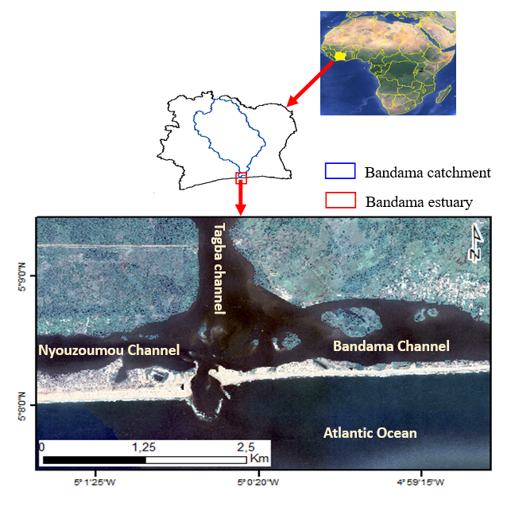**Fig. 1. Location map of study area**

**2.2 Multispectral imagery and bathymetric data**

The satellite image used is Landsat 7 imagery, which was downloaded from the United States Geological Survey (USGS) website. For this study blue (450 – 515 nm), green (525 – 605 nm), red (630 – 690 nm) and NIR (Near Infra-Red) (750 – 900 nm) bands of Landsat 7 satellite imagery are used. For this study, the 4 bands of the image will be symbolized as: B1 (blue band), B2 (green band), B3 (red band), B4 (NIR band). The images were acquired on a day close to the date of the bathymetric survey, namely January 6th, 2011 at 10:27:27.76 (UTC time) with spatial resolution of 30 m. Landsat satellite imagery is most commonly used for SDB products because it is a free and publicly available resource and all imageries are referenced to WGS84.

The bathymetric model was calibrated using echo sounding data. The survey of the bottom was accomplished through 3689 measurements of depths. Minimum and maximum depths are respectively 0.073 m and 18.78 m. The depth sounding was georeferenced and projected in WGS84 UTM zone 30 North. The bathymetric data were subset into two separate calibration and validation datasets (Fig. 2), each comprising half of the survey points.

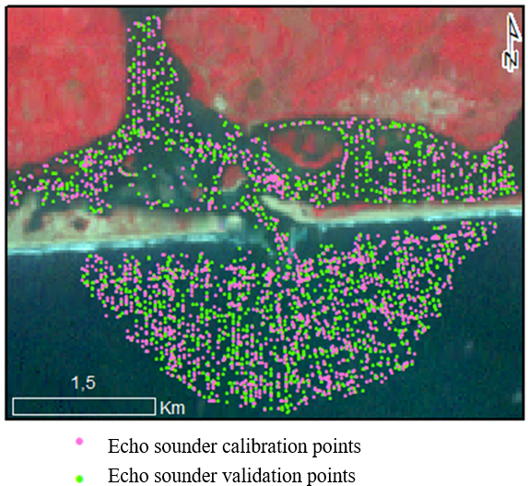

**Fig. 2. Spatial distribution of the reference bathymetric data used**

**2.3 Processing software**

ENVI version 5.1 remote sensing image processing software from ITT Solutions was used for the pre-processing (radiometric calibration, atmospheric correction, land mask) of the ETM+ imagery. ArcMap software version 10.5 with the support of Spatial Analyst Tool was the main software used for the processing stage. R version 3.4.3 (R CoreTeam, 2017) was the supporting software utilized for accuracy analysis, statistical exploration. R's "GWmodel" package (Gollini et al. 2013) was used to implement geographically weighted regression (GWR).

**2.4 Methods**

This section outlines the processes being adopted in this study to derive nearshore bathymetry from the remotely sensed satellite imagery. They included radiance conversion, atmospheric correction, land mask and the implementation of geographically adaptive approach of Lyzenga's et al (2006) model. The impact of turbidity on the Satellite Derived Bathymetry (SDB) was also assessed. (Fig. 3).

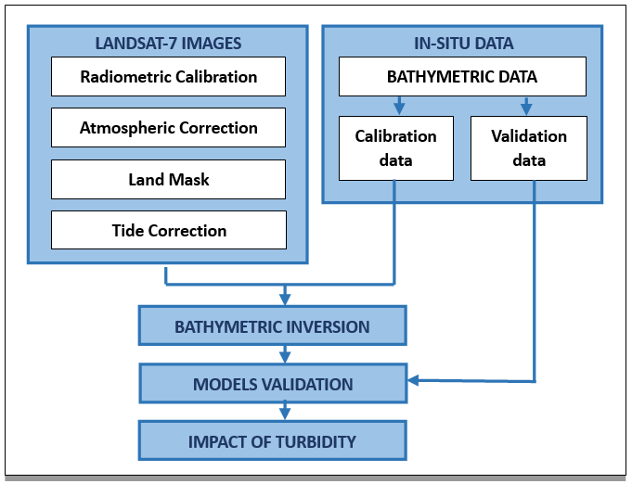

**Fig. 3. Methodological diagram for deriving the bathymetry of the Bandama estuary from Landsat 7 ETM+ images**

**2.4.1 Radiometric Calibration**

The standard Landsat 7 products provided by the USGS consist of quantized and calibrated Digital Numbers (DN) representing multi-spectral image data acquired with Enhanced Thematic Mapper Plus sensor (ETM+). These products need to be rescaled to Top Of Atmosphere (TOA) radiance as described in Equation 1.

(1)

$$L_{tOA\left(λ_{i}\right)}=Mρ\left(λ_{i}\right)DN+Aρ\left(λ_{i}\right)$$

where *LTOA*(*λi*) is TOA radiance, *Mρ*(*λi*) and *Aρ*(*λi*) are radiometric rescaling coefficients provided in the product metadata file (MTL. file) for the spectral band *λi*. Finally, Equation 2 is used to convert TOA spectral radiance to TOA spectral reflectance *RTOA*.

(2)

$$R_{TOA}=\frac{πd^{2}L(λ_{i})}{{I(λ_{i})}_{Sun}cosθ_{Sun}}$$

*d* is the Earth–Sun distance in astronomical units; *θSun* is the mean solar extra-atmospheric irradiance, *I*(*λi*)*Sun* is the exoatmospheric solar spectral irradiance for the spectral band *λi*.

**2.4.2 Atmospheric Correction**

For the present paper, atmospheric corrections were performed using the Dark Object Subtraction (DOS) method. DOS assumes that dark objects or pixel (e.g., deep water and shadows) have near-zero-percent reflectance. Thus, the signal recorded by the sensor from these features includes a substantial component of atmospheric scattering, which must be removed (Chavez, 1988). The atmospherically corrected pixel value *Rac* is then:

$$R_{corr}=R_{sat}-R_{os}$$

(3)

Where *Ri*is the initial pixel value and *Rdp* the dark pixel value.

**2.4.3 Developing a Mask Using the NDWI Index**

Before performing Lyzenga’s local inversion models, it is mandatory to mask the area covered by land and clip it to obtain the pixel values for the water body alone. For this, the Normalized Difference Water Index (NDWI) was used to delineate water features. NDWI is calculated for each pixel as follows:

(4)

$$NDWI= \frac{B2-B4}{B2+B4}$$

The reflectance of the green band of the water body is higher than that of the NIR band, while the reflectance of the NIR band of land areas is higher than that of the green band. Hence, the NDWI of a pixel representing the body of water is positive and that of the land area is negative (Fig. 4).

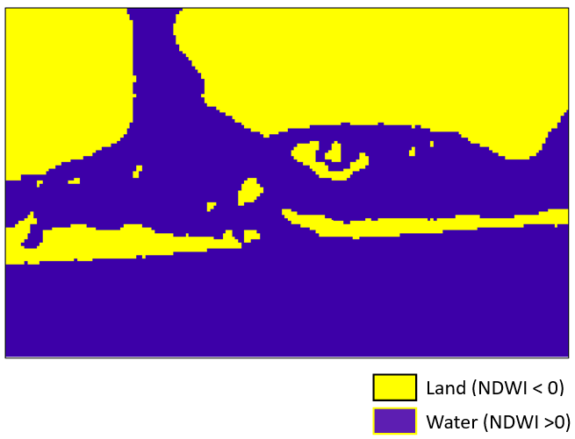

Fig. 4. Binary mask based on NDWI index

**2.4.4 Tidal Correction**

The ETM+ image recorded the water depth of the particular moments when the orbital sensor passed over the study area, whereas echo sounding data was already corrected to the Mean Sea Level (MSL). Therefore, the image-induced water depth needs to be standardized to the same datum. The tide values on the curve (Fig. 5) corresponding with the acquisition date and time of the imagery were marked and applied to correct the image bathymetry.

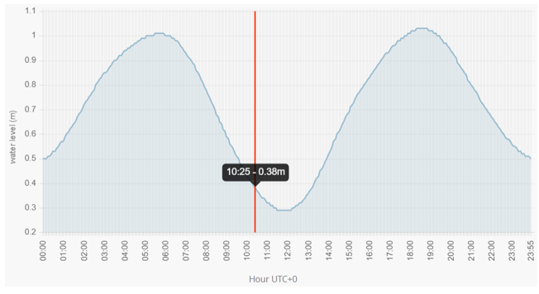

Fig. 5. Tidal prediction curve: 06-01-2011 at 10 :27 :27.76 UTC time (https://maree.shom.fr)

**2.4.5 Depth retrieval models**

The bathymetric inversion model derived by Lyzenga et al (2006) (or Lyzenga et al (2006) global model) for two or multiple spectral bands is given by:

(5)

$$Z=a_{0}+\sum_{i=1}^{N}{a_{i}ln\left[R_{w}\left(λ_{i}\right)-R_{∞}\left(λ_{i}\right)\right]}$$

where *z* is the depth;

*Rw* (*λi*): observed reflectance of the water surface for band *λi* after atmospheric correction, Rꚙ(λ*i*): column reflectance of optically deep water for band *λi*, *ai* (*i* = 0, 1. . . *N*) are the coefficients determined through multiple regression using the reference depths from the calibration data and the corresponding reflectance, and *N* is the number of bands. The set of model parameters *ai* (*i* = 0, 1. . . *N*) in equation 5 are considered to be constant coefficients over the entire scene. Reliable depth estimate is possible when the water is clear and when water quality and bottom types are homogeneous. However, bottom depth retrieval from Lyzenga global model in a heterogeneous environment such as the Grand-Lahou estuary would be prone to substantial errors. To address the inadequacy of Lyzenga’s et al (2006) conventional global model in Bandama estuary waters, we use a GWR model that takes into account local factors in determining the regression coefficients by varying the model parameters according to geographical location. GWR model is a weighted regression model that computes coefficient for each point of validation dataset. Model parameters are determined within the kernels, and points close to the centroids (x, y) of these kernels are weighted more heavily in the regression process than points far from the centroids (x, y). This is because the nearby points are more likely to have similar bottom type and water quality as the centroid point. In general, the weighting schemes are classified as continuous (Gaussian function) and discontinuous (bi-square function) depending on the function used. The most important thing to be considered was the spatial coverage of the kernel (bandwidth) because it will take effect on the weighting. The bandwidth can be set as fixed or adaptive. Fixed GWR used only one size of bandwidth in each kernel. Meanwhile, in Adaptive GWR, the size of the kernel is vary based on the density of the reference depth where it becomes smaller when the reference points are denser and vice versa (Vinayaraj et al., 2016). Due to the calibration point randomly distributed, this study used Adaptive GWR method to predict depth. The local bathymetric inversion model is expressed as follows:

(6)

$$Z=a_{0}\left(x,y\right)+\sum_{i=1}^{n}{a_{i}\left(x,y\right)ln\left[R_{w}\left(λ_{i}\right)-R_{∞}\left(λ_{i}\right)\right]}$$

where (*x*, *y*) represents the geographical coordinates of the centroid of each local area; *ai* (*x*, *y*) (*i* = 0, 1, . . ., *N*) are the model parameters of each local area with a centroid located at the coordinate position (*x*, *y*); and the other variables are the same as in equation 5. Despite the same mathematical form, the local inversion models have varying model parameter values, depending upon the geographical location.

2.4.6 Accuracy assessment

The assessment of accuracy is made by comparing the imagery derived bathymetry with the 1844 sounding points of the validation data set. The accuracy of Lyzenga’s et al (2006) local model is assessed using simple statistical models such as the RMSE and the R2. The RMSE and R2 equations are given below:

(7)

$$RMSE= \sqrt{\frac{\sum_{i=1}^{n}{{\left(x_{i}-y_{i}\right)}^{2}}}{n}}$$

(8)

$$R^{2}=1-\frac{\sum_{i=1}^{n}{{\left(x_{i}-y_{i}\right)}^{2}}}{\sum_{i=1}^{n}{{\left(y_{i}-\overline{y}\right)}^{2}}}$$

where *xi*= predicted depths (SDB data); *yi* = depth value from field measurement (echo sounder bathymetry data); $\overline{y}$ = mean value from field measurement; *n* = number of sample points. The better the model fit, the larger the R2 and the smaller the RMSE.

2.4.7 Assessment of turbidity and impact on SDB

Water turbidity is the most significant factor altering SDB precision by limiting light penetration through the water (Gao, 2009). We have therefore conducted an analysis using Normalized Difference Turbidity Index (NDTI) to assess the impact of turbidity on the depth estimation model. The NDTI method measures the concentrations of soil sediments, microalgae, and other suspended materials that contribute to water turbidity (Kwon et *al.,* 2024), utilizing the green and red band as defined in Equation 7:

(9)

$$NDTI= \frac{B3-B2}{B3+B2}$$

A higher NDTI value indicates greater water turbidity. Water turbidity based on statistical analysis of the NDTI (Garg et *al*., 2017), can be categorized into three levels:

• low turbidity (NDTI < mean - standard deviation);

• moderate turbidity (mean – standard deviation < NDTI < mean + standard deviation);

• high turbidity (NDTI > mean + standard deviation).

3. results and discussion

**3.1 RESULTS**

3.1.1 Model training

The visible and NIR bands of the ETM+ image and 1845 sounding points of the calibration data set were used to train the bathymetric inversion models. A preliminary test was performed in order to evaluate the significance of visible and NIR bands of ETM+ in the model. Initially, bands B1 and B2 were used to train the model. The coefficient of determination obtained from this training stage is 0.403. Thereafter, the inclusion of a third band, the red band, slightly increased the coefficient of determination (R2 = 0.697). Finally, the addition of the NIR band to the three previous bands significantly increases the coefficient of determination (R = 0.909). Therefore, the three visible bands and the NIR band were taken into account to calibrate the models in order to improve their accuracy. After, the spectral bands have been chosen. The Lyzenga's local bathymetric model was constructed using Adaptive GWR with circular bandwidth kernel that contains 39 bottom depth points. The weight for each bottom depth point in the kernel window was determined by the bi-square weighting function. The Figure 6 shows bathymetric map derived from local inversion models based on the Landsat ETM+ imagery.

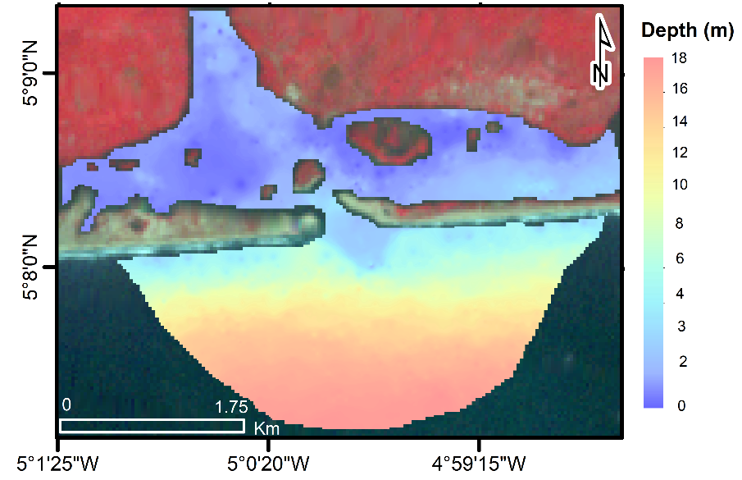

**Fig. 6. Bathymetric map derived from ETM+ image using local inversion model**

**3.1.2 Evaluation of SDB Results and Accuracy Affected by Turbidity (Models validation)**

As shown in Figure 7a, the link between the predicted bottom depth from Lyzenga’s et al (2006) local inversion model and the true bottom depths is excellent, and its coefficient of determination is high (0.993). Nevertheless, regions with slightly scattered points appeared in turbid (NDTI high value) shallow waters of lagoon bay in the 0 to 6 m depth range. In highly turbid shallow waters closer to the shore (Figure 7b), the RMSE values increasing from 0.51 m to 1.01 m (Table 1), resulting in heteroscedastic of errors. Conversely, the far sea (deeper waters) showcases low turbidity (NDTI low value). In this area, RMSE values remain relatively constants. The assumption of homoscedasticity of errors is then respected, attesting to the robustness of Lyzenga’s et al (2006) local model. In the area closer to the shore, the waters are characterized by suspended sediments, a factor that alter the results in the estimation of satellite bathymetry. In highly turbid areas, suspended sediments scatter photons useful for determining bathymetry.

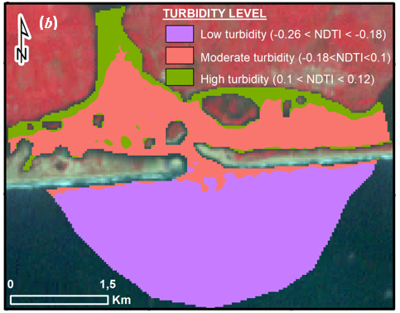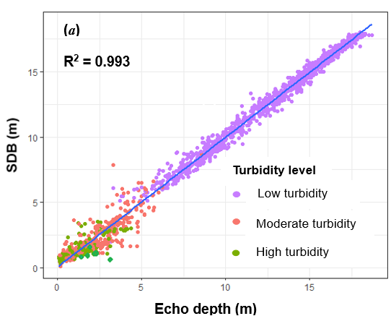

**Fig. 7. (a): Correlation between observed depths (validation points) and satellite derived depths and (b): Map identifying the areas of turbidity levels**

**Table 1. Root mean square error of Lyzenga’s local model according depth**

|  |  |
| --- | --- |
| **Depth (m)** | **RMSE (m)** |
| 0 - 3 | 0,51 |
| 3 – 6 | 1,01 |
| 6 – 9 | 0,49 |
| 9 – 12 | 0,46 |
| 12 – 15 | 0,41 |
| 15 - 18 | 0,27 |
| Overall | 0,51 |

**3.2 Discussion**

Lyzenga et al (2006) “model traditionally uses multiple linear regression on log-transformed reflectance in blue and green spectral bands and reference depths to determine coefficients”. “The derived coefficients are subsequently used to estimate depth from the transformed reflectance in clear waters” (Clark et *al*., 1988; Pacheco et *al.,* 2015). Adapting Lyzenga et al (2006) model to the coastal waters of the Bandama estuary requires a judicious choice of spectral bands. “The green and blue bands are commonly preferred in the literature for water depth predictions because of their deeper water penetration capabilities” (Pushparaj and Hegde, 2017). However, this study shows that the adjunction of NIR and red band to these aforementioned spectral bands of ETM+ significantly improves the performance of the Lyzenga et al (2006) model in Bandama turbid shallow waters. Caballero et al. (2019) used red band as a proxy for turbidity in order to retrieve bathymetry of several turbid coastal environments. According to Hala et al., (2018) the NIR and the red bands affect Lyzenga’s et al (2006) model for better estimation of depth values in coastal shallow waters. From all this, it follows that the NIR and the red band of ETM+ are crucial for deriving bathymetry in shallow and turbid waters. Furthermore, given the complex nature of the Grand-Lahou estuary, the model calibration strategy of using the NIR band in addition to the three visible bands helps to take into account the problem of heterogeneous water masses and benthic classes. Theoretically, “the number of significantly different bottom types and water masses for which this algorithm accounts are directly proportional to the number of bands used” (Lyzenga et al, 2006).

In this paper, we used the same validation and calibration data set and Landsat 7 images as those used by Kouadio et *al*. (2020) to derive the bathymetry of the Bandama estuary from the conventional Lyzenga global model. The coefficients of determination R2 and the RMSE obtained when validating this global model are respectively 0.605 and 3.87 m. A comparative analysis of the models’ performance shows that the RMSE of the local model is reduced by 87% relative to RMSE of the global model and R2 has increased by 38.8%. These results show a significant improvement in depth estimation and clearly demonstrate that the heterogeneity issues can be better addressed using local rather than global coefficients, indicating the robustness of Lyzenga's local model.

However, in shallow and turbid waters, the link between the predicted bottom depth by local model and true bottom depth measurements is weak leading to significant errors. “These errors could be tied to water quality across the study area. Indeed, the acquisition date of ETM+ images coincides with the great dry season in Bandama estuary. The phytoplankton tend to proliferate during this season” (Komoé et al, 2009). “The vertical distribution of phytoplankton could cause variance in attenuation coefficients with depth” (Bramante et al, 2013). This vertical stratification of phytoplankton could lead to some discrepancies in light attenuation with depth in the water column. Moreover, the Bandama river discharges cause high suspended sediment concentrations in the estuary. Suspended particles prevent light from reaching the seabed either by absorbing it or reflecting it (Casal et al., 2019; Chybicki, 2017). In these instances, “the number of photons detected by the sensor that have interacted with the seafloor will become negligibly small. At this point, there will be no information for the estimation of bathymetry” (Hamylton et *al*., 2015). This can lead to a discrepancy between the model predictions and actual depth measurements, thus limiting the accuracy of depth retrieval algorithm. Turbid water produces false shoaling in the imagery (Caballero et al. 2019).

4. Conclusion

In the present study, a cost-effective method for monitoring regularly Bandama estuary underwater topography using remote sensing technology was presented. The widely used Lyzenga et al (2006) model is limited by the spatial heterogeneity of the bottom type and water quality in complex coastal waters. Its adaptation to Bandama river estuary involved subdividing the study area into a set of small local areas in which the heterogeneity and variance of bottom type and water quality are reduced, then calibrating Lyzenga inversion model in each subunit. The local inversion model addresses the problem of spatial heterogeneity by improving the accuracy and the reliability of the bathymetric retrievals from Landsat 7 ETM+ satellite imagery. In shallow areas of the estuary, the accuracy of the model is reduced by turbidity. The NIR band proved to be most effective for deriving bathymetry in shallow and turbid waters of Bandama estuary. The use of sensor data from the Sentinel-2 constellation, whose spatial resolution (10 m) and temporal resolution (5 days) are much better than that of Landsat 7 ETM+ in futher studies, will not only improve the accuracy of bathymetric inversion models, but will also provide more detailed information on underwater topography and frequently update the bathymetry of the Bandama estuary.

DISCLAIMER (ARTIFICIAL INTELLIGENCE)

Author(s) hereby declare that NO generative AI technologies such as Large Language Models (ChatGPT, COPILOT, etc.) and text-to-image generators have been used during the writing or editing of this manuscript.

References

Abe, J., Bakayoko, S., Bamba, S.B., & Koffi, K.P. (1993). Morphology and Hydrodynamic in the Bandama Inlet. Journal Ivoirien d'Océanologie et de Limnologie. 2(2): 9-15.

Bramante, J. F., Raju, D. K. & Sin, T. M. (2013). Multispectral Derivation Bathymetry In Singapore's Shallow, Waters. International Journal of Remote Sensing, 34(6): 2070-2088. <https://dx.doi.org/10.1080/01431161.2012.734934>.

Caballero, I., & Stumpf, R. P. (2019). Retrieval of nearshore bathymetry from Sentinel-2A and 2B satellites in South Florida coastal waters. Estuarine, Coastal and Shelf Science, 226(6):106277.

<https://doi.org/10.1016/j.ecss.2019.106277>

Casal, G., Monteys, X., Hedley, J., Harris, P., Cahalane, C. & McCarthy, T. (2019). Assessment of empirical algorithms for bathymetry extraction using Sentinel-2 data. International Journal of Remote Sensing, 40(8): 2855‑2879.

<https://doi.org/10.1080/01431161.2018.1533660>

Chavez, P., S., Jr. (1988). An improved dark-object substraction technique for atmospheric scattering correction of multispectral data. Remote Sensing of Environnement. 24(3): 459-479.

<https://doi.org/10.1016/0034-4257(88)90019-3>

Chybicki, A. (2017). Mapping South Baltic Near-Shore Bathymetry Using Sentinel-2 Observations. Polish Maritime Research. 24(3): 15-25.

<https://doi.org/10.1515/pomr-2017-0086>

Clark, R. K., Fay, T. H., & Walker, C. L. (1988). Bathymetry Using Thematic Mapper Imagery. Society of Photo-Optical Instrumentation Engineers, Ocean Optics. 9(925):229-231.

<https://doi.org/10.1117/12.945728>

Figueiredo, I. N., Pinto, L., & Gonçalves. G. (2015). A modified lyzenga’s model for multispectral bathymetry using Tikhonov regularization. IEEE Geoscience and Remote Sensing Letters. 13(1):1-5.

<https://doi.org/10.1109/LGRS.2015.2496401>

Hala, M. E, Dina, S. A., & Mohammed A. S. (2018). Derivation of Bathymetry Models for Shallow Water Using Multispectral Sentinel-2A Images for Delta Coast of Egypt. Research Journal of Applied Sciences, Engineering and Technology. 15(2):81-90.

<https://doi.org/10.19026/rjaset.15.5418>

Hamylton, S. M., Hedley, J. D., & Beaman R. J. (2015). Derivation of High-Resolution Bathymetry from Multispectral Satellite Imagery: A Comparison of Empirical and Optimisation Methods through Geographical Error Analysis. Remote Sensing.7(12):16257-16273.

<https://doi.org/10.3390/rs71215829>

Garg V., Aggarwal, S P., & Chauhan P. (2020). Changes in turbidity along Ganga River using Sentinel-2 satellite data during lockdown associated with COVID-19. Geomatics, Natural Hazards and Risk. 11(1):1175-1195.

<https://doi.org/10.1080/19475705.2020.1782482>

Gao, J. (2009). Bathymetric Mapping by Means of Remote Sensing: Methods, Accuracy and Limitations. Physical Geography, 33(1): 103-116.

<http://dx.doi.org/10.1177/0309133309105657>

Gollini, I., Binbin, L., Charlton, M., Brunsdon, C., & Harris, P. (2015). GWmodel: An R Package for exploring spatial heterogeneity using geographically weighted models. Journal of Statistical Software 63(17):1548–7660.

<https://doi.org/10.18637/jss.v063.i17>

Komoé, K, Da K. P., Kouassi, A. M., Aka N. M., Kamanzi, A. K., & Ama, A. A. (2009). Seasonal Distribution of Phytoplankton in Grand-Lahou Lagoon. European Journal of scientific Research, 26(3): 329-341.

<https://www.researchgate.net/publication/288419162_Seasonal_Distribution_of_Phytoplankton_in_Grand-Lahou_Lagoon_Cote_d'Ivoire>

Konan, K. S., Kouassi, K. L., Kouamé, K. I., Kouassi, A. M., & Gnakri D. (2013). Water hydrology and hydrochemistry in the construction area of the Grand-Lahou fishing port channel, Ivory Coast. International Journal of Biological and Chemical Sciences, 7(2):819-831.

<http://dx.doi.org/10.4314/ijbcs.v7i2.37>

Kouadio, J. M., Yahiri, P. B., Mobio A. B., & Kouadio A. (2020). Satellite-derived bathymetry in the turbid and shallow waters of the Bandama estuary (Côte d’Ivoire) using a landsat 7 etm+ multispectral image. International Journal of Development Research, 10(9): 40427-40432.

https://doi.org/10.37118/ijdr.19878.09.2020

Kwon, J. Y., Shin, H. K, Kim, D. H, Lee, H. G, Bouk, J. K., Kim, J. H., & Kima, T. H. (2024). Estimation of shallow bathymetry using Sentinel-2 satellite data and random forest machine learning: a case study for Cheonsuman, Hallim, and Samcheok Coastal Seas. Journal of Applied Remote Sensing, 18(1):1-20.

<http://dx.doi.org/10.1117/1.JRS.18.014522>

Lyzenga, D. R., Malinas, N. R., & Tanis, F. J. (2006). Multispectral bathymetry using a simple physically based algorithm. IEEE Transactions on Geoscience and Remote Sensing. 44(8): 2251-2259.

<https://doi.org/10.1109/TGRS.2006.872909>

Pacheco, A., Horta, J., Loureiro, C., & Ferreira, Ó. (2015). Retrieval of Nearshore Bathymetry from Landsat 8 Images: A Tool for Coastal Monitoring In Shallow Waters. Remote Sensing of Environment, 159: 102 116.

<https://doi.org/10.1016/j.rse.2014.12.004>

Pushparaj, J., & Hegde, A. V. (2017). Estimation of bathymetry along the coast of Mangaluru using Landsat-8 imagery. The International Journal of Ocean and Climate Systems, 8(2):71-83.

<http://dx.doi.org/10.1177/1759313116679672>

Vinayaraj, P., Raghavan, V., & Masumoto, S. (2016). Satellite-Derived Bathymetry using Adaptive Geographically Weighted Regression Model. Marine Geodesy, 39:(6):458-478.

<https://doi.org/10.1080/01490419.2016.1245227>

Su H., Liu H., Lei W., Philipi M., & Heyman W., Beck A. (2013). Geographically adaptive inversion model for improving bathymetric retrieval from multispectral satellite imagery. IEEE Transaction on Geosciences and Remote Sensing 52(1):465–476.

<http://dx.doi.org/10.1109/TGRS.2013.2241772>

Stumpf, R. P., Holderied, K., & Sinclair, M. (2003). Determination of Water Depth with High-Resolution Satellite Imagery Over Variable Bottom Types. Limnology and Oceanography, 48(1): 547-556.

<https://doi.org/10.4319/lo.2003.48.1_part_2.0547>