Estimating the Economic Value of Water Supply Function of Forests Using the Contingent Valuation Method: The Case of Karabük Yenice Forests, Türkiye

.
ABSTRACT

Aims: This study aims to estimate the economic value of the water supply function of forests based on the example of Yenice Forests located within the borders of Karabük province. In the study, by using the contingent valuation method, the WTP for the protection and improvement of the water supply service of Yenice Forests was determined and the economic value was estimated.
Study design: As being one of the quantitative research methods, a survey is conducted for data collection with the people residing in Yenice district of Karabük province in Türkiye. For economic value estimation of ecosystem goods and services, total economic value approach including use values and non-use values components are generally used. The contingent valuation method is most preferred method, especially for non-use values.
Place and Duration of Study: Yenice district spans an area of 1150 km², of which nearly 85% is covered with productive forestlands. Water supply function of Yenice forest is crucial and so it is selected as the study area. The survey was conducted with the people residing in Yenice district center and villages and benefiting from the water supply function of Yenice Forests. The surveys were applied in 2024.
Methodology: The universe of the study consists of the population of Yenice district of Karabük province, and a total of 219 people were surveyed within the scope of the study. The surveys were applied by face-to-face interviews in 2024. All statistical analyses of the surveys were performed with IBM SPSS (Version 27) package program. In determining the willingness to pay value function, a multiple regression analysis model is used. There are some limitations of the study arising from the contingent valuation method such as being based on the theoretical market, having bias resources and not sufficiently reflecting the population.
Results: The survey results show that the majority of respondents recognize that the water resources in Yenice Forests provide an important ecosystem service for the region. The average willingness to pay for the economic value of the water supply service of Yenice Forests was estimated as 791.57 ₺/year. Total willingness to pay is estimated with two different scenarios (in first scenario, the total population and in the second scenario, the number of households are taken as universe) as 198 million ₺ and 74 million ₺ respectively.
Conclusion: The study's findings indicate that the economic value of the water supply service of the Yenice Forests is acknowledged by the local community; however, the willingness to contribute financially remains relatively low. This underscores the necessity of raising awareness about water resource conservation and encouraging active public participation in related processes.

Keywords: Ecosystem services, forest resources, economic valuation, willingness to pay, contingent valuation method
1. INTRODUCTION

Humans derive various benefits from nature, called ecosystem services. These services are important for sustaining human life and improving well-being. Ecosystem services are generally divided into four main categories: provisioning services (e.g. food, water, wood), regulating services (e.g. climate regulation, flood control), supporting services (e.g. soil formation, nutrient cycling) and cultural services (e.g. recreation, tourism). The economic value of many of these services is often underestimated because they do not have direct markets (Atkinson et al., 2012; Toffano & Zolin, 2021).

However, considering increasing environmental pressures and resource scarcity, estimating the economic value of these services is important in sustainable resource management and policy-making processes (Demirci, 2017; Uzunyayla, 2017). Economic valuation allows us to assign a value to these services and thus make more informed and rational conservation and sustainable management decisions (Tinch et al., 2019; Vo et al., 2012).

The methods used to estimate the economic value of ecosystem services are generally divided into two main groups according to whether they have market prices or not. For products with markets, economic value is estimated using market prices or shadow prices. The assessment of non-market ecosystem services is generally categorized under two main approaches as demand curve approaches and non-demand curve approaches. The methods with the demand curve approach are included in two subheadings, namely the stated preference methods and the revealed preference methods (Merlo and Croitoru, 2005; Gürlük, 2006; Deniz, 2012).

Ecosystems such as wetlands and forests provide a variety of ecosystem services, both marketable and non-marketable, such as water provision, biodiversity conservation, erosion control and air quality improvement. One of these ecosystem services, water provision, is particularly important in today's world where the availability of drinking water resources is increasingly diminishing and polluted. In order to leave healthy and sufficient water resources to future generations, it is necessary to protect existing watersheds and forest resources, which are vital for the protection of watersheds. A better understanding of the impact of forests on water quantity, quality and regime is possible by estimating the economic value of water production and watershed protection benefits of forest resources.

The water supply function of forest resources is one of the most difficult benefits to estimate the economic value of. Cost-based methods (such as the avoided loss cost method, replacement cost method, and preventive expenditure method), revealed preference methods (such as the travel cost method, hedonic pricing method and production function method) and willingness-to-pay (WTP) methods such as (the contingent valuation method (CVM) and choice modeling methods) are used to estimate the economic value of the water supply function of forest resources.

This study aims to estimate the economic value of the water supply function of forests based on the example of Yenice Forests located within the borders of Karabük province. In the study, by using the contingent valuation method, the WTP for the protection and improvement of the water supply service of Yenice Forests was determined and the economic value was estimated. The study also revealed the public perception of the functions provided by Yenice Forests and people's attitudes towards non-use values such as existence, bequest and option values of this area.

2. material and methods

The research was conducted in Yenice District of Karabük Province in the province's west part approximately 33 km away from the city center (Figure 1). The district covers an area of 1150 km² and about 81% of this area consists of productive forest areas (Figure 2) representing one of the greatest forest coverage rates in Türkiye (OGM, 2025). The area has steep and rugged topography and altitude differences between 100 and 1756 meters above sea level and limited plain areas (Ercanoğlu et al., 2016). The Yenice Forests belong to the Euro-Siberian phytogeographic region (subsection Euxine) and are listed as one of Türkiye's 122 Important Plant Areas and as a global biodiversity hotspot by WWF (WWF-Türkiye, 2006). The area has rich ecology and consists of old-growth deciduous and mixed forests with richly structured vegetation layers and endemic flora (Çoban, 2016).
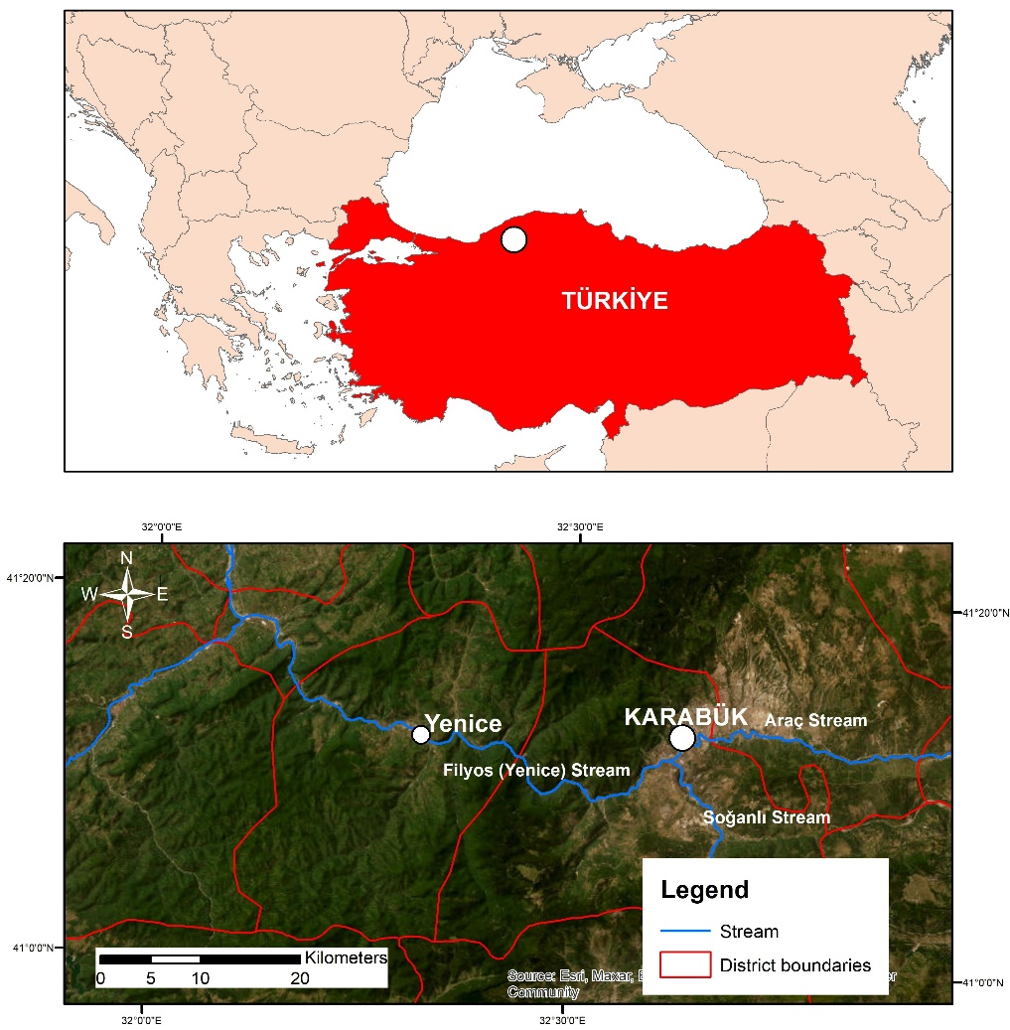
Figure 1. Location of the study area
The region has a rainy and wet climate, and the temperature and yearly rainfall vary from 6.2°C to 13.6°C and 489.8 mm to 1371.2 mm, respectively, based on local meteorological stations (MGM, 2025). The Araç and Soğanlı Streams become confluent and merge as the Yenice Stream hydrological network (Figure 1). The latter finally flows as part of the Filyos River, a main watershed of the West Black Sea Basin.
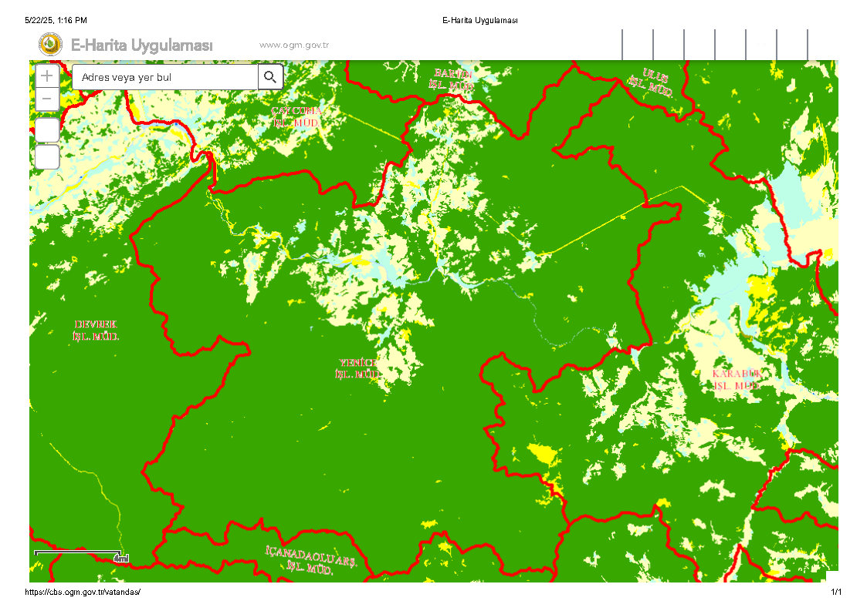
Figure 2.Forest cover map of Yenice District
The green areas in Figure 2 represent forest cover within the boundaries of the Yenice Forest Enterprise Directorate. These boundaries differ from the administrative borders of Yenice District and are based on forest management units.

Besides their rich ecologies, the Yenice Forests also experience some environmental risks that differ by region of the district. Specifically, according to scientific studies, a series of sub-regions, notably those in the upper regions of Yenice, experience high exposure to landslide risks due to the sloping geology and heavy rainfall regimes (Hasekiogullari & Ercanoglu, 2012). Conversely, regions of the district experience relatively lower levels of risk. Moreover, the Filyos River Basin crossing the forested terrain of Yenice has also emerged in recent research as a region at risk from both pluvial and fluvial flooding, especially under conditions of heavy rainfall (Akcin & Kose, 2024). While the risks themselves vary geographically from area to area in this region, they do create a localized hazard to both human habitation and the forest's ecologies and thus may determine the attitudes of local communities toward forest and water resources preservation.
In this study, which aims to estimate the economic value of the water supply function of forests, the primary data source of the research is the results obtained from the survey conducted with the people residing in Yenice district center and villages and benefiting from the water supply function in question. During the preparation of the surveys, the survey was developed by the researchers by utilizing the existing literature to a certain extent. The universe of the study consists of the population of Yenice district of Karabük province. According to the data of the Turkish Statistical Institute, Yenice district population in 2024 is 19446.
The following formula was used in the household sample size calculation:
$$\text{n=}\frac{\text{N.p.q.}{\text{t}}^{\text{2}}}{\text{(N-1).}{\text{d}}^{\text{2}}\text{ + p.q. }{\text{t}}^{\text{2}}}$$
Where:
n: sample size
N: research population size (7689 households)
p: probability of finding the feature (0.50)
q: 1-p (0.50)
t: theoretical value found according to the t table at α=0.05 significance level (1.96)
d: sampling error (0.10)
, and a total of 219 people were surveyed within the scope of the study.
According to the above formula, the sample size was calculated as 96. But it was thought that it would be more appropriate to work with a sample size more than calculated amount, a total of 219 people were surveyed within the scope of the study. The surveys were applied by face-to-face interviews in 2024. Then, all statistical analyses of the surveys were performed with IBM SPSS (Version 27) package program.
The survey form consists of four main sections. The first section includes questions to determine the demographic and socioeconomic characteristics of the respondents such as age, gender, education level, income level. In the second part of the survey, there are questions about the participants' perspectives on environmental problems and the water supply service of Yenice Forests. The third part of the survey includes questions to determine the participants' perspectives and value judgments about the existence, bequest and option values of Yenice Forests. In the last part of the survey, the theoretical scenario is given and questions are included to determine the WTP of the respondents.

3. results and discussion

The demographic characteristics of the respondents are shown in Table 1 and Table 2. While 70.8% of the participants were male, 29.2% were female. When the age groups of the respondents are analyzed, it is seen that most of the respondents are between the ages of 45-54 (27.9%) and 55-64 (22.8%). Regarding the educational status of the respondents, it is seen that most of them are primary school graduates or illiterate. In addition, the majority of the respondents (76.3%) are married and a significant part of them (30.6%) are retired when evaluated in terms of occupation. The proportion of laborers and housewives is also higher than other occupational groups.
Table 1. Demographic characteristics of the respondents (part-1)
 | Variables | Frequencies | %
Gender | Male | 155 | 70.8
 | Female | 64 | 29.2
 | Total | 219 | 100.0
Age | 18-24 | 16 | 7.3
 | 25-34 | 23 | 10.5
 | 35-44 | 33 | 15.1
 | 45-54 | 61 | 27.9
 | 55-64 | 50 | 22.8
 | 65 ve üstü | 36 | 16.4
 | Total | 219 | 100.0
Education | Illiterate | 62 | 28.3
 | Primary School | 62 | 28.3
 | Secondary School | 36 | 16.4
 | High School | 38 | 17.4
 | Associate Degree | 14 | 6.4
 | Undergraduate | 7 | 3.2
 | Postgraduate | - | -
 | Total | 219 | 100.0
Marital Status | Single | 49 | 22.4
 | Married | 167 | 76.3
 | Divorced | 3 | 1.4
 | Total | 219 | 100.0
Occupation | Officer | 7 | 3.2
 | Worker | 53 | 24.2
 | Craftsmen | 26 | 11.9
 | Farmer | 4 | 1.8
 | Retired | 67 | 30.6
 | Student | 7 | 3.2
 | Housewife | 53 | 24.2
 | Unemployed | 2 | 0.9
 | Total | 219 | 100.0

While 32.4% of the respondents' individual monthly income is between TL 15001-20000, 23.3% of them have an income of less than TL 5000. More than half of the respondents reside in the village, 29.2% of them stated that there are 2 people living in their household and 28.3% stated that there are 3 people living in their household (Table 2).
Table 2. Demographic characteristics of the respondents (Part-2)
 | Variables | Frequencies | %
Monthly Income | No income | 1 | 0.5
 | Less than 5000 TL | 51 | 23.3
 | 5001-10000 TL | 8 | 3.7
 | 10001-15000 TL | 51 | 23.3
 | 15001-20000 TL | 71 | 32.4
 | 20001-30000 TL | 26 | 11.9
 | More than 30001 TL zeri | 11 | 5.0
 | Total | 219 | 100.0
Residence Place | Village | 114 | 52.1
 | District | 58 | 26.5
 | Province center | 47 | 21.5
 | Total | 219 | 100.0
Number of people in the household | 1 | 10 | 4.6
 | 2 | 64 | 29.2
 | 3 | 62 | 28.3
 | 4 | 39 | 17.8
 | 5 and more | 44 | 20.1
 | Total | 219 | 100.0

Respondents are also asked whether they are members of any environmental protection association / non-governmental organization and only 1 respondent stated that he/she is a member. To the question “What is your level of knowledge about environmental pollution/water pollution?” the participants answered as shown in Table 3. Only 1.4% of the participants expressed themselves as very knowledgeable about environmental pollution and water pollution, while 7.3% of them think that they are quite knowledgeable.
Table 3. Respondents' level of knowledge on environmental pollution and water pollution
 | Variables | Frequencies | %
Level of knowledge | Very knowledgeable | 3 | 1.4
 | Highly knowledgeable | 16 | 7.3
 | Moderately knowledgeable | 102 | 46.6
 | Limited knowledge | 42 | 19.2
 | No information | 56 | 25.6
 | Total | 219 | 100.0

Within the scope of the survey, the participants are asked to rank various environmental problems according to the degree of importance in order to determine their perspectives and judgments on environmental problems in Karabük Province where Yenice Forests are located. 37% of the participants preferred “drinking water pollution” and 32% preferred “degradation of forests” as the first priority. As the second priority, “drinking water pollution” is again the most preferred problem. When the answers given to the prioritization of environmental problems are evaluated in general, “drought and water scarcity”, “drinking water pollution” and “destruction of forests” were preferred as the most important environmental problems, respectively. “Decrease in wildlife presence” and “decrease in plant biodiversity” are mentioned as prioritized problems by a limited number of participants (Table 4).
Table 4. The priority ranking of environmental problems according to the respondents
Environmental problems | 1st priority |  | 2nd priority |  | 3rd priority |  | 4th priority |  | 5th priority
 | No. | % | No. | % | No. | % | No. | % | No. | %
Degradation of forests | 70 | 32.0 | 19 | 8.7 | 32 | 14.7 | 33 | 15.1 | 13 | 6.0
Desertification and erosion | 1 | 0.5 | 7 | 3.2 | 8 | 3.7 | 22 | 10.1 | 11 | 5.0
Climate change | 6 | 2.7 | 11 | 5.0 | 9 | 4.1 | 14 | 6.4 | 23 | 10.6
Natural disasters such as flood, landslide | 9 | 4.1 | 13 | 6.0 | 25 | 11.5 | 31 | 14.2 | 46 | 21.1
Decline in plant biodiversity | - | - | 2 | 0.9 | 2 | 0.9 | 8 | 3.7 | 12 | 5.5
Pollution from waste | 5 | 2.3 | 6 | 2.8 | 7 | 3.2 | 8 | 3.7 | 13 | 6.0
Drinking water pollution | 81 | 37.0 | 59 | 27.1 | 16 | 7.4 | 11 | 5.0 | 8 | 3.7
Air pollution | 10 | 4.6 | 36 | 16.5 | 44 | 20.3 | 31 | 14.2 | 12 | 5.5
Drought and water scarcity | 36 | 16.4 | 52 | 23.9 | 50 | 23.0 | 19 | 8.7 | 24 | 11.0
Decline in agricultural production | 1 | 0.5 | 12 | 5.5 | 18 | 8.3 | 38 | 17.4 | 32 | 14.7
Decrease in wildlife presence | - | - | - | - | 6 | 2.8 | 3 | 1.4 | 22 | 10.1
Other | - | - | 1 | 0.5 | - | - | - | - | 2 | 0.9
Total |  | 100.0 |  | 100.0 |  | 100.0 |  | 100.0 |  | 100.0

Table 5 shows the answers to the question “Which precautions would you support for the protection and maintenance of the water supply service of Yenice Forests?”. The majority of the respondents (153 people) stated that precautions should be taken to protect water resources and keep them clean. In addition, declaring Yenice Forests as a protected area and limiting the commercial use of forests also come to the forefront as recommended precautions.
Table 5. Precautions to be taken to protect and maintain the water supply service of Yenice Forests
Variables | Frequencies
Protecting water resources and keeping them clean | 153
Declaration of Yenice Forests as a protected area | 57
Limiting the commercial use of forests | 55
Expansion and improvement of forest areas | 43
More local community voice in forest management | 42
Public education and information programs | 33
Sustainable forest management practices | 24
Legal and policy regulations | 9

In the survey form, the respondents are given various statements regarding the water supply service of Yenice Forests and their degree of agreement with these judgments is tried to be determined (Table 6). Accordingly, 76.3% of the respondents stated that the water supply service of Yenice Forests affects their daily life quality, 68.5% stated that Yenice Forests provide various benefits such as quality drinking water supply and agricultural irrigation, and 62.1% stated that the participation of the local community is important for the protection of the water supply service. However, the expectations of the people that the water supply service of Yenice Forests will continue in the same way in the future are not very positive.
Table 6. Responses to various statements regarding the water supply service of Yenice Forests
Statements |  | Strongly  Agree | Agree | Undecided | Disagree | Strongly Disagree | Total
The water supply function of Yenice Forests affects the quality of our daily lives. | Frequencies | 167 | 49 | 1 | 2 | - | 219
 | Ratio (%) | 76.3 | 22.4 | 0.5 | 0.9 | - | 100.0
Yenice Forests provide a variety of benefits such as quality drinking water supply and agricultural irrigation. | Frequencies | 150 | 22 | 36 | 8 | 3 | 219
 | Ratio (%) | 68.5 | 10.0 | 16.4 | 3.7 | 1.4 | 100.0
The water supply service of Yenice Forests will continue in the future. | Frequencies | 66 | 23 | 51 | 21 | 58 | 219
 | Ratio (%) | 30.1 | 10.5 | 23.3 | 9.6 | 26.5 | 100.0
Local community involvement is important to protect the water supply. | Frequencies | 136 | 60 | 16 | 3 | 3 | 219
 | Ratio (%) | 62.1 | 27.4 | 7.3 | 1.4 | 1.4 | 100.0

In the questionnaire form, 6 statements are asked to the respondents in order to reveal their perspectives on the intrinsic, bequest, option and existence values of Yenice Forests and the level of importance they attribute to these values. These statements and what they mean are as follows:

- S1 Intrinsic value: (If I do not benefit from forest areas of special importance, such as Yenice Forests, it is not important for me that these areas are damaged or lost.) Those who agree with this statement think that only when people benefit from forests should they not be destroyed.

- S2 Bequest values: (It is important for me that Yenice Forests are left to future generations (children, grandchildren, etc.) It is the value that people demand for forest resources that they intend to leave to future generations or have a tendency to pay for the protection of these resources.

- S3 Option value: (It is important to me that Yenice Forests will be able to produce goods and services that will benefit me in the future, even if I do not use them today.) The value of the benefit that arises from the possibility that people may use forest resources directly or indirectly in the future.

- S4 Existence Value: (It is important to me that forested areas in different regions of the world, such as the Yenice Forests, continue to exist today and in the future, even if I will never be able to visit, see or benefit from them.) It is the value that people attribute to a forested area because of its existence, even if they will never be able to visit it, see it or benefit from its resources.

- S5 Costs incurred: (It is important to spend money for the protection and improvement of natural resources (forests, lakes, etc.) and the designation of new areas in order to maintain ecologically, economically, culturally and socially balanced and sustainable relationships between humans and nature.) With this value judgment, it is determined whether people have a favorable opinion towards incurring costs for the protection, improvement and development of natural resources.

- S6 Incurring costs related to bequest value: (Monetary costs can be incurred now so that future generations can continue to benefit from forests in an ecologically, economically, culturally and socially balanced and sustainable way.) In this value judgment, again in relation to the heritage value, it is determined whether people have a positive view of incurring costs in advance.

Although the definitions of bequest value and option value are similar, option value refers to the potential for future use of the benefit by individuals themselves, whereas bequest value refers to the value that individuals attribute to the benefit not for themselves but for future generations (Merlo and Croitoru, 2005).

Within the scope of the survey study, the answers of the participants are obtained with a 5-point Likert scale (1: strongly agree, 2: agree, 3: undecided, 4: disagree, 5: strongly disagree). The scale value range and relationship degrees of the participants regarding the statements are determined as in similar studies (Demirci, 2017; Özmış, 2016; Başsüllü, 2014) (Table 7).
Table 7. Scale value range and relationship degrees of the respondents regarding the statements
Scale Value Range | Relationship Degrees
1.00–1.79 | Very Strong
1.80–2.59 | Strong
2.60–3.39 | Middle
3.40–4.19 | Low
4.20–5.00 | Very Low

The answers of the respondents to the statements including their perspectives on the intrinsic, bequest, option and existence values of Yenice Forests are given in Table 8. Accordingly, when the mean values of the answers given to the questions are considered, it is seen that the degree of the answers given to the first 4 statements is at the “very strong” level, while the degree of the answers given to the 5th and 6th statements is at the “strong” level. In addition, it is seen that the strongest degree of relationship (1.26) is observed for statement S3, i.e. the option value of forest resources. This statement is followed by the statements related to S2 (bequest value), S1 (intrinsic value) and S4 (existence value) of forest resources respectively.

When similar studies are examined, it is seen that in the study conducted by Demirci (2017), the degree of relationship for all value judgments is at the “very strong” level; and the strongest degree of relationship is seen in the judgment of DY1, that is, the intrinsic value of forest resources. On the other hand, in the studies conducted by Başsüllü (2014) and Özmış (2016), the bequest value of forest resources emerged as the strongest motive.
Table 8. Respondents' degree of agreement with the statements
Statements |  | Strongly  Agree | Agree | Undecided | Disagree | Strongly Disagree | Total | Average
S1*  Intrinsic value | Frequencies | 2 |  | 2 | 23 | 192 | 219 | 1.36
 | Ratio (%) | 0.9 | - | 0.9 | 10.5 | 87.7 | 100.0
S2  Bequest value | Frequencies | 157 | 61 | - | - | 1 | 219 | 1.29
 | Ratio (%) | 71.7 | 27.9 | - | - | 0.5 | 100.0
S3  Option value | Frequencies | 163 | 55 | 1 | - | - | 219 | 1.26
 | Ratio (%) | 74.4 | 25.1 | 0.5 | - | - | 100.0
S4  Existence value | Frequencies | 142 | 75 | 1 | 1 | - | 219 | 1.36
 | Ratio (%) | 64.8 | 34.2 | 0.5 | 0.5 | - | 100.0
S5  Costs incurred | Frequencies | 106 | 53 | 54 | 6 | - | 219 | 1.82
 | Ratio (%) | 48.4 | 24.2 | 24.7 | 2.8 | - | 100.0
S6  Incurring costs related to bequest value | Frequencies | 102 | 46 | 61 | 9 | 1 | 219 | 1.91
 | Ratio (%) | 46.6 | 21.0 | 27.9 | 4.1 | 0.5 | 100.0
* In the scaling for S1, since the judgment contains a negative statement, it was evaluated as 5: strongly agree,..., 1: strongly disagree.

In order to estimate the economic value of the water supply service of Yenice Forests, a theoretical scenario for the protection and improvement of Yenice Forests was presented to the respondents in the survey. In the scenario, it was stated that the Yenice Forests Protection and Development Project aims to maintain the important functions of forests such as providing clean drinking water, preventing erosion, flooding and landslides, and that financial resources are needed to realize the project, and the respondents were asked whether they would contribute financially to the project through donations in order to protect the values of Yenice Forests and preserve them for future generations. Only 36.1% (79 people) of the participants stated that they would donate, while 57.1% (125 people) stated that they would not donate (Table 9). According to similar studies in the literature, the rate of people who tend to donate is relatively low.
Table 9. Distribution of answers to the question on making donations
Variables | Frequencies | %
Yes | 80 | 36.5
No | 124 | 56.6
No opinion/no answer/don't know | 15 | 6.8
Total | 219 | 100.0

In the contingent valuation method, respondents' lack of willingness to pay is not always considered as a protest response, it can also be considered as a zero response. So the reasons for the answers given as “no” and “no opinion/no answer/don't know” to the question asked to determine the WTP were learned, and zero response and protest answers were distinguished. The distribution of the reasons given by the participants who do not have a WTP is as shown in Table 10. Participants were able to indicate more than one option. Among the respondents who answered “no” and “no opinion/no answer/don't know”, 56 people preferred only the reasons for zero WTP. Other respondents either gave only protest responses or both zero response and protest answers together. This group is not included in the statistical analysis. Instead, respondents who stated that they could not afford to pay and were not engaged in strategic behavior (giving zero responses) are included in the statistical analysis when calculating the average WTP value. In both the correlation analysis and the calculation of the average WTP, those with zero WTP were also included and the analyses were conducted on 136 respondents.
Table 10. Distribution of protest and zero responses to the question on WTP
 | Reasons | Frequencies
Zero response | I cannot afford to pay | 74
Protest answers | It is the duty of the state to protect such areas. | 58
 | I don't believe the project will be successful. | 12
 | Those who will benefit from the area should pay. | 11
 | I don't think the money collected will be used for its intended purpose. | 6

Correlation analysis is used to determine the variables that are effective in assessing the value of WTP. According to the results of the correlation analysis, the highest positive correlation is found between the participants' WTP amount and the independent variables of total monthly household income, education level and place of residence (Table 11). In a study aiming to provide a systematic review of the determinants with significant influence on the WTP for forest environmental services identified fifty-seven WTP determinants classified into four thematic domains: (i) socioeconomic characteristics, (ii) psychological and attitudinal factors, (iii) attributes, and (iv) other factors (Tien at al., 2024).

Also it has been put forward in many scientific studies around the world that income and education level have a positive effect on people's willingness to pay. For instance, in the studies such as those measuring willingness to pay for the creation of a potable water system (Jianjun et al., 2016; Bogale and Urgessa; 2012; Awad and Holländer, 2010; Adenike and Titus, 2009; Al-Ghuraiz and Enshassi, 2005), those measuring willingness to pay for the improvement of an existing potable water system to provide greater reliability (Vásquez, 2014; Peters et al., 2014; Ahmad et al., 2005) and those measuring willingness to pay for the improvement of an existing water system to achieve an environmental benefit not directly related to the welfare of water consumers (Almendarez-Hernández et al., 2013; Ojeda et al., 2008; Shultz and Soliz, 2007) have shown that income and education level have a positive effect on the WTP.

Though statistically calculated sample size and a balance of ages, income levels, and educational levels in the sample exist, the gender imbalance—where 70.8% of the sample consists of males—may simply be a matter of cultural acceptability of participation in rural areas and not a question of random sampling strictness. The limit on this has been noted and must be taken care of in future studies through stratified or quota sampling techniques so as to better account for demographics. Additional income distribution data in Table 2 above also indicate participation from multiple levels so as to provide socioeconomic variability. Demographic skewness and imbalances such as women underrepresentation and low-income or retired persons overrepresentation may also be possible and have influenced the WTP results. It has already been shown in existing studies that generally women value other environmental aspects and income levels define capacity-to-pay heavily. These aspects must be kept in mind at the time of interpretation of generalizability of findings.
Table 11. Correlation analysis results
 | Willingness to Pay
 | Pearson Correlation | Sig. (2-tailed) | N
Gender | -,178* | .038 | 136
Age range | -.151 | .080 | 136
Education status | .255** | .003 | 136
Occupation | -.300** | <.001 | 136
Marital status | -.217* | .011 | 136
Number of people in the household | -.038 | .664 | 136
Residence | .195* | .023 | 136
Monthly income | .293** | <.001 | 136
S1 (Intrinsic value) | -.038 | .664 | 136
S2 (Bequest value) | .132 | .124 | 136
S3 (Option value) | .065 | .453 | 136
S4 (Existence value) | -.016 | .856 | 136
S5 | .044 | .613 | 136
S6 | .004 | .965 | 136
*. Correlation is significant at 95% confidence level.
**. Correlation is significant at 99% confidence level.

In determining the WTP value function, a multiple regression analysis model is used. In this model, the WTP value is taken as the dependent variable and the demographic characteristics of the respondents and the judgment variables related to existence, bequest, option and intrinsic value are taken as independent variables. According to the regression analysis results, the regression model selected to determine the WTP function was found to be significant at the 0.05 level (Table 12).
Table 12. Regression model result table
Model |  | Sum of Squares | Deg. of Fre. | Mean Squares | F | Sig.
1 | Regression | 39899388.950 | 14 | 2849956.354 | 2.173 | .013
 | Residual | 154742211.050 | 118 | 1311374.670
 | Total | 194641600.000 | 132

The ratio of the independent variables in the regression analysis model to explain the propensity to pay was found to be 20% (R²= 0.205) (Table 13). Similar studies utilizing the contingent valuation method also found similar results regarding R². Indeed, in the studies of Demirci (2017), Başsüllü (2014) and Gürlük (2006), R² values were found to be 0.270, 0.311 and 0.214, respectively.

These results align with existing CVM forest ecosystem service studies, which tend to provide modest explanatory capacity for regression models. Demirci (2017) and Başsüllü (2014), for instance, identified comparable preference patterns for non-market forest benefits like carbon and water quality regulation. Consistency in the results validates CVM as a means of evaluation for assessing such services despite methodological weaknesses acknowledged by researchers.

Though CVM has extensive application for estimating non-market values, both use and non-use values, it also has its criticisms. Because CVM bases itself on hypothetical situations, it has the risk of introducing strategic responses or exaggeration. Actual behavior as found in revealed preference approaches, e.g., travel cost or hedonic pricing, diminishes potential biases but generally considers only the use values. CVM was used in this study on the strength of its capacity to capture non-use values associated with forest water services, while acknowledging the weaknesses of single-method analysis.

Also worth noting is the fact that WTP estimates obtained from CVM measurement may not reflect the Total Economic Value (TEV) of forest water supply services fully since TEV encompasses intangible elements like cultural, spiritual and intergenerational values that are hard to put a figure on. The values reported here may thus be conservative estimates and calls for complementing future studies with other methods of valuation.

These results should also be understood against the backdrop of existing environmental risks in the area, e.g., localized landslides and floods. Evidence shows that some areas in Yenice are more vulnerable than others to natural disasters (Hasekiogullari & Ercanoglu, 2012; Akcin & Kose, 2024). It is likely possible for such risks to underpin the perception of forest susceptibility among the general public and thus determine their willingness to pay for protective measure efforts. In areas where environmental risks tend to be observable or directly tangible, high value will be placed on ecosystem services such as water provision and strong willingness to pay will be exhibited. Local ecological conditions and related risks must then be understood when interpreting economic valuation outcomes and making informed policy and managerial decisions for forest and catchment areas.
Though the Yenice Forests themselves lie not in Alpine mountainous regions but rather in a region of extensive forestland and considerable hydrological function in the Filyos River Basin, they comprise one of the most ecologically intact forest ecosystems in Türkiye. Active surface runoff and infiltration dynamics due to the steep terrain and rainfall regime make the area suitable for assessing ecosystem services associated with water. Additionally, susceptibility of the area to landsliding and flooding events lends weight to the application of the policy focus on water resources protection.

Table 13. Regression model summary
Model | R | R² | Adjusted R² | Standard Error
1 | .453ª | .205 | .111 | 1145.15268

Table 14 presents information about coefficients in regression analysis model. Some demographic characteristics of the respondents such as gender, monthly income, age range and education status positively affect the WTP amount.
Table 14. Regression analysis results showing coefficients
 | Unstandardized Coefficients |  | Standardized Coefficients
 | B | Std. Error | Beta | t | Sig.
(Constant) | 664,781 | 1329,961 |  | ,500 | ,618
Gender | 268,722 | 317,741 | ,100 | ,846 | ,399
Age range | 71,376 | 113,340 | ,088 | ,630 | ,530
Education status | 82,269 | 119,141 | ,098 | ,691 | ,491
Occupation | -74,935 | 84,652 | -,122 | -,885 | ,378
Marital status | -634,339 | 291,890 | -,235 | -2,173 | ,032
Number of people in the household | -80,546 | 77,561 | -,091 | -1,038 | ,301
Residence | 151,433 | 161,063 | ,094 | ,940 | ,349
Monthly income | 184,179 | 104,561 | ,225 | 1,761 | ,081
S1 (Intrinsic value) | 8,976 | 186,283 | ,005 | ,048 | ,962
S2 (Bequest value) | 562,724 | 349,772 | ,207 | 1,609 | ,110
S3 (Option value) | -279,661 | 394,917 | -,106 | -,708 | ,480
S4 (Existence value) | -293,011 | 270,637 | -,121 | -1,083 | ,281
S5 | 665,517 | 319,967 | ,436 | 2,080 | ,040
S6 | -554,779 | 288,461 | -,377 | -1,923 | ,057

The average WTP for the economic value of the water supply service of Yenice Forests was estimated as 791.57 ₺/year (approximately 22.6 $/year). Based on the total population of Karabük province (according to TurkStat data, Karabük province population in 2024 is 250.478 people) as the universe in the study, the total WTP value is calculated as follows:

Total WTP = 250.478 x 791,57 ₺ =198.270.870 ₺

If we consider the WTP that emerged within the scope of the study on a household basis, then we need to take the number of households in Karabük Province as the universe of the study. According to TURKSTAT data, since the average household size in Karabük is 2.67, the number of households in the province is calculated as 93,812. In this case, the total WTP is;

Total WTP = 93.812 x 791,57 ₺ =74.258.753 ₺

At this point, it should be emphasized that value estimation with the contingent valuation method has some drawbacks when the universe is not directly known. In similar studies, inaccurate determination of the universe directly affects the reliability and validity of the total WTP value. Therefore, in this study, while estimating the economic value of the water supply service of Yenice Forests, since the direct beneficiaries of this benefit are the people residing in Karabük Province, the total WTP value was tried to be estimated according to two different universes. Nevertheless, in terms of similar studies, the most accurate comparison and interpretation will make sense if the individual WTP value is used.

4. Conclusion

In this study, the economic value of water supply service, which is one of the important ecosystem services provided by Yenice Forests located within the borders of Karabük province, was tried to be estimated by contingent valuation method. Within the scope of the study, local people's perceptions of water resources, usage habits, preferences and WTP were evaluated through a survey.

The survey results show that the majority of respondents recognize that the water resources in Yenice Forests provide an important ecosystem service for the region. 76.3% of the respondents stated that the water service provided by Yenice Forests directly affects their daily life quality, and 68.5% emphasized that the forest is important for drinking water supply and agricultural irrigation. However, the public expectation that the water supply function of the forests will continue in the same way in the future was found to be low, and 26.5% of the participants stated that they did not believe that this service would continue in the same way in the future.

When participants evaluated environmental issues, drinking water pollution (37%) and degradation of forests (32%) were identified as the most significant problems. In addition, drought and water scarcity ranked third among environmental threats. This indicates that the water supply service of the Yenice Forests is perceived by the local population as an important ecosystem component, while concerns persist regarding current and future threats.

An assessment of participants’ environmental awareness revealed that their level of knowledge on environmental issues was generally moderate. While 46.6% of respondents stated they had a moderate level of knowledge about environmental pollution, only 1.4% considered themselves to be highly knowledgeable. Moreover, direct participation in environmental protection activities was notably low, with only one participant reporting membership in an environmental protection association or a non-governmental organization. These results highlight the need for initiatives aimed at enhancing environmental education and awareness.

To estimate the economic value of the water supply service provided by the Yenice Forests, the contingent valuation method was employed. Responses to the WTP question in the survey showed that only 36.5% of participants were willing to contribute financially to the conservation of the Yenice Forests. In contrast, 56.6% indicated they were not willing to pay, while 6.8% were undecided.

Among the most frequently cited reasons for participants’ unwillingness to pay were the belief that the government should be responsible for protecting such areas (58%), insufficient financial means (74%), and distrust regarding the proper use of collected funds (6%). These findings suggest that although the public recognizes the economic value of water supply services, their willingness to pay is limited due to individual financial constraints and reliance on governmental responsibility.

An analysis of the factors influencing WTP revealed a significant positive relationship between WTP and total household income, education, and residence place. Individuals with higher income and education levels were found to be more willing to bear the financial cost of protecting forest resources for water.

The study's findings indicate that the economic value of the water supply service of the Yenice Forests is acknowledged by the local community; however, the willingness to contribute financially remains relatively low. This underscores the necessity of raising awareness about water resource conservation and encouraging active public participation in related processes.

In particular, the following strategies are proposed to ensure the sustainability of water provisioning services:

- Educational programs and local information campaigns should be organized to enhance environmental awareness and consciousness about water resource conservation.
- Local communities should be granted greater involvement in forest management, and participatory management models should be developed.
- Given the low levels of WTP, public-private partnership models for forest and water resource management should be developed and incentivized.
- The legal framework for water resource protection should be strengthened, including restrictions on the commercial exploitation of forested areas and the designation of protected areas.
- Economic incentives should be provided to local communities for protecting water resources, and sustainable development projects should be implemented to promote their active involvement.

In conclusion, the assessment of the economic value of the water provisioning service of the Yenice Forests provides valuable insight for the more effective and efficient management of natural resources. The data obtained from this study help identify the necessary steps for ensuring the sustainability of this natural asset. Targeted efforts are suggested to encourage increased involvement of the general public in forest and water resources planning and management. These efforts may include environmental education campaigns aimed at heightening awareness, involving local communities in forest planning processes, designing concepts of public-private partnering, and provision of financial incentives for local communities toward supporting conservation efforts. However, for the effective protection of water resources, not only economic valuation studies but also social, political, and administrative measures must be implemented.

Disclaimer (Artificial intelligence)
Option 1:
Author(s) hereby declare that NO generative AI technologies such as Large Language Models (ChatGPT, COPILOT, etc.) and text-to-image generators have been used during the writing or editing of this manuscript.
Option 2:
Author(s) hereby declare that generative AI technologies such as Large Language Models, etc. have been used during the writing or editing of manuscripts. This explanation will include the name, version, model, and source of the generative AI technology and as well as all input prompts provided to the generative AI technology
Details of the AI usage are given below:
1.
2.
3.

References

Adenike, A. A., & Titus, O. B. (2009). Determinants of willingness to pay for improved water supply in Osogbo Metropolis; Osun state, Nigeria. Research Journal of Social Sciences, 4, 1–6.
Ahmad, J., Goldar, B., & Misra, S. (2005). Value of arsenic-free drinking water to rural households in Bangladesh. Journal of Environmental Management, 74(2), 173–185.
Akcin, H., & Kose, R. T. (2024). Disaster risk assessment of fluvial and pluvial flood using the Google Earth Engine platform: A case study for the Filyos River Basin. PFG – Journal of Photogrammetry, Remote Sensing and Geoinformation Science, 92, 353–366. https://doi.org/10.1007/s41064-024-00277-z
Al-Ghuraiz, Y., & Enshassi, A. (2005). Ability and willingness to pay for water supply service in the Gaza strip. Building and Environment, 40(8), 1093–1102.
Almendarez-Hernández, M. A., Jaramillo-Mosqueira, L. A., Avilés Polanco, G., Beltrán-Morales, L. F., Hernández-Trejo, V., & Ortega-Rubio, A. (2013). Economic valuation of water in a natural protected area of an emerging economy: Recommendations for el Vizcaino Biosphere Reserve, Mexico. Interciencia, 38(4), 245–252.
Atkinson, G., Bateman, I. J., & Mourato, S. (2012). Recent advances in the valuation of ecosystem services and biodiversity. In Oxford Review of Economic Policy (Vol. 28, Issue 1, p. 22). Oxford University Press. https://doi.org/10.1093/oxrep/grs007
Awad, I., & Holländer, R. (2010). Applying contingent valuation method to measure the total economic value of domestic water services: A case study in Ramallah Governorate, Palestine. European Journal of Economics, Finance and Administrative Sciences, 20, 76–93.
Başsüllü, Ç., 2014. Ormancılıkta karbon ekonomisi ve borsası, Doktora Tezi, Süleyman Demirel Üniversitesi Fen Bilimleri Enstitüsü Orman Mühendisliği Anabilim Dalı, Isparta.
Bogale, A., & Urgessa, B. (2012). Households' willingness to pay for improved rural water service provision: Application of contingent valuation method in eastern Ethiopia. Journal of Human Ecology, 38(2), 145–154.
Çoban, S. (2016). Ecological indicator values of forest communities in Çitdere Region (Yenice-Karabük). Journal of the Faculty of Forestry Istanbul University, 66(1), 278–287. https://doi.org/10.17099/jffiu.60821
Demirci, U., 2017. Orman kaynaklarının toplam ekonomik değer tahmini: Camili Biyosfer Rezerv Alanı örneği, Doktora Tezi, Artvin Çoruh Üniversitesi Fen Bilimleri Enstitüsü Orman Mühendisliği Anabilim Dalı, Artvin.
Deniz, T. (2012). Erozyon Kontrolü Çalışmalarında Değer Analizi, Doktora Tezi, İstanbul Üniversitesi Fen Bilimleri Enstitüsü Orman Mühendisliği Anabilim Dalı, İstanbul, 218s.
Ercanoğlu, M., Sönmez, H., Özyurt, N. N., Özsayın, E., & Dağdelenler, G. (2016). Yenice ve Karabük arasındaki alanın taşkın ve heyelan potansiyelinin değerlendirilmesi ve bölgesel tehlike haritalarının üretilmesi. TÜBİTAK Projesi No: 113Y455.
Gürlük, S. (2006). Manyas Gölü ve Kuş Cenneti’nin Çevresel Değerlemesi Üzerine Bir Araştırma, Doktora Tezi, Uludağ Üniversitesi Fen Bilimleri Enstitüsü Tarım Ekonomisi Anabilim Dalı, Bursa, 133s.
Hasekiogullari, G. D., & Ercanoglu, M. (2012). A new approach to use AHP in landslide susceptibility mapping: A case study at Yenice (Karabuk, NW Turkey). Natural Hazards, 63(2), 1157–1179. https://doi.org/10.1007/s11069-012-0218-1
Jianjun, J., Wenyu, W., Ying, F., & Xiaomin, W. (2016). Measuring the willingness to pay for drinking water quality improvements: Results of a contingent valuation survey in Songzi, China. Journal of Water and Health, 14(3), 504–512.
Merlo, M., Croitoru, L. (2005). Concepts and Methodology: A First Attempt Towards Quantification, Valuing mediterranean forests: towards total economic value, 17-36.
MGM. (2025). Meteorolojik veriler arşivi. T.C. Meteoroloji Genel Müdürlüğü. https://www.mgm.gov.tr
Ojeda, M. I., Mayer, A. S., & Solomon, B. D. (2008). Economic valuation of environmental services sustained by water flows in the Yaqui River Delta. Ecological Economics, 65(1), 155–166.
Orman Bölge Müdürlüğü. (2025). Orman varlığı. T.C. Tarım ve Orman Bakanlığı Orman Genel Müdürlüğü. https://www.ogm.gov.tr/zonguldakobm/ormanlarimiz/orman-varligi
Özmış, M., 2016. Burdur yöresi erozyon kontrolü hizmetlerinin değerinin belirlenmesi, Yüksek Lisans Tezi, Süleyman Demirel Üniversitesi Fen Bilimleri Enstitüsü Orman Mühendisliği Anabilim Dalı, Isparta.
Peters, E., Despot, D., Ragbersingh, K., & Iyer, N. (2014). Willingness to pay for improved water services in Trinidad. Proceedings of the Institution of Civil Engineers, 167(5), 299.
Shultz, S., & Soliz, B. (2007). Stakeholder willingness to pay for watershed restoration in rural Bolivia. JAWRA Journal of the American Water Resources Association, 43(4), 947–956.
Tien, N. D., Duyen, T. N. L., Huyen, N. T. T., Thuy, P. T., Dat, L. Q., Oanh, N. T., ... & Lee, K. (2024). Willingness of payment for forest environmental services: a systematic literature review for determinants. Journal of Forest Research, 29(5), 327-342. https://doi.org/10.1080/13416979.2024.2358257
Tinch, R., Beaumont, N., Sunderland, T., Özdemiroğlu, E., Barton, D. N., Bowe, C., Börger, T., Burgess, P., Cooper, C. N., Faccioli, M., Failler, P., Gkolemi, I., Kumar, R., Longo, A., McVittie, A., Morris, J., Park, J., Ravenscroft, N., Schaafsma, M., … Ziv, G. (2019). Economic valuation of ecosystem goods and services: a review for decision makers [Review of Economic valuation of ecosystem goods and services: a review for decision makers]. Journal of Environmental Economics and Policy, 8(4), 359. Taylor & Francis. https://doi.org/10.1080/21606544.2019.1623083
Toffano, B., & Zolin, M. B. (2021). Ecosystem services value: a literature review [Review of Ecosystem services value: a literature review]. RePEc: Research Papers in Economics. Federal Reserve Bank of St. Louis. https://econpapers.repec.org/RePEc:ven:wpaper:2021:07
Uzunyayla, F. (2017). Ekosistem Hizmetlerinin Parasal Değerini Belirleme Yöntem ve Tartışmalarına İlişkin Bir İnceleme. Ekonomik Yaklaşım 2017, 28(105): 19-61
Vásquez, W. F. (2014). Willingness to pay and willingness to work for improvements of municipal and community-managed water services. Water Resources Research, 50(10), 8002–8014.
Vo, T. Q., Kuenzer, C., Minh, V. Q., Moder, F., & Oppelt, N. (2012). Review of valuation methods for mangrove ecosystem services. In Ecological Indicators (Vol. 23, p. 431). Elsevier BV. https://doi.org/10.1016/j.ecolind.2012.04.022
WWF-Türkiye. (2006). Türkiye’nin 122 Önemli Bitki Alanı. Doğal Hayatı Koruma Vakfı Yayını.

