Remote Sensing Based Soil Moisture Estimation Using In-Situ Probes in Varanasi District, India

ABSTRACT
Soil moisture helps to determine the crop growth, disaster management, climatology and ecology. Soil moisture is highly influenced by vegetation cover. The current study was performed in Varanasi district of Uttar Pradesh on March 29, 2023, to estimate soil moisture using Landsat 8 data and biophysical parameters. This study also assessed the relationship between the Normalized Difference Vegetation Index (NDVI) and Land Surface Temperature (LST) and their response to soil moisture. Additionally, it coupled NDVI-LST feature space-derived dry and wet edge best fit coefficient parameters with the Temperature Vegetation Dryness Index (TVDI) and Soil Moisture Index (SMI) equations to produce a spatial distribution of soil moisture availability. The LST and NDVI results help to extract Soil Surface Moisture (SSM) more effectively using an optical remote sensing approach. The soil moisture inversion model (TVDI) and SMI algorithm provide a better representation of the spatial distribution of soil moisture in Varanasi district. A linear and strong correlation exists between in-situ soil moisture data and TVDI (R² = 0.6812), as well as a positive relationship between in-situ soil moisture data and SMI (R² = 0.6848). It was found that LST and NDVI helped to generate the TVDI and SMI equations using the triangle model, and both equations demonstrated a strong correlation with in-situ data (R² of TVDI = 0.6812, R² of SMI = 0.6848).
Keywords: NDVI, LST, TVDI, SMI, SSM, Soil moisture

INTRODUCTION
Soil moisture is the available water content in the pores of soil. It can be referred as the quantity of water between the spaces of soil particles. Water content in the soil plays a major role in the transpiration of plants. Water is generally found up to 2 meters from the upper surface of the soil. The quantity of water retained particular soil is greatly influenced by its texture, structure and capacity. The land slope and aspect surface vegetation cover, and the pH of the soil are also responsible for water stress in the soil. Soil moisture shows variation due to the non-uniformity of the soil (Lann et al., 2024). Soil moisture is affected by both temporal (seasonal changes) and spatial variation across the surface. Generally, there are three major techniques to obtain soil moisture information: in-situ measurements, hydrological or land surface and remote sensing methods (Guan et al., 2023). Ordinarily, in-situ data or ground-based surveys are suitable for temporal-based studies but are not applicable for spatial variation-based studies. Hydrological models are commonly used for root-zone soil moisture estimation. Arya and Paris (1981) used a physico-empirical model (hydrological model) to estimate soil moisture and applied soil particle density to convert it into pore-size distribution. Neural network models used to solve field-scale flow and transport problems showed an RMSE of around 0.2 to 0.06 m³/m³ when estimating saturated hydraulic conductivity and water retention (Schaap et al., 1998). Due to the high input demands of hydrological models and the high cost and labour intensive nature of ground-based measurement, remote sensing is quite popular in the modern era. Remote sensing sensors provide continuous spatial and temporal data that are used to extract soil moisture information at different spatial scales (regional or global) (Vicente-Serrano et al., 2004). Peng et al., 2016 used Landsat-8 data, to calculate the TVDI (Temperature Vegetation Dryness Index) using NDVI (Normalized Difference Vegetation Index) and LST (Land Surface Temperature) and revealed that TVDI can reflect the soil moisture in the transition zone. Vegetation indices and surface temperature are key variables used to estimate soil moisture using optical remote sensing approaches (Carlson et al., 1995; Cayrol et al., 2000; Tagesson et al., 2017). Mu et al. (2023) suggested that soil moisture estimation showed good accuracy with an RMSE of 0.98 using neural networks and a prediction coefficient RMSE of 0.66 with various remote sensing data. Many researchers have found a positive relationship between soil moisture and vegetation indices (Petropoulos et al., 2009; Carlson et al. (1994, 1995). Wu et al. (2024) suggested that models incorporating multispectral, thermal, and microwave data produce higher accuracy in the soil moisture estimation. Vegetation indices are used for surface soil moisture retrieval as well as root zone soil moisture estimation (Petropoulos et al., 2009; Petropoulos et al., 2013; Zhao et al., 2017). The second key variable is surface radiance temperature. Researchers use many approaches include TVDI, Vegetation Temperature Condition Index (VTCI), LST-NDVI, Ts/NDVI, Surface Energy Balance Models, Empirical Regression Models to estimate soil moisture through temperature parameters (Sobrino et al., 2004; Skokovic et al., 2014; Rajeshwari and Mani, 2014; Latif, 2014; Yu et al., 2014). Meteorological conditions such as solar radiation, wind speed, relative humidity and air temperature highly affect the sensitivity of thermal inertia. The researchers claim a strong negative relationship between soil moisture and surface temperature. The combined application of optical and thermal infrared (TIR) bands is generally known as the “triangle method” or “surface temperature (TIR)/vegetation index (VI) method”. This is the best way to retrieve soil moisture using the optical approach, as both parameters - surface temperature and vegetation index - highly affect soil moisture content. This approach is frequently used to estimate soil moisture by downscaling soil moisture data from microwave sensors, either alone or in combination with other sensors (Tagesson et al., 2018; Peng et al., 2016). The concept triangle model to retrieve soil surface moisture availability using Advanced Very High Resolution Radiometer (AVHRR) data and then simulate soil moisture data with Soil Water Assessment Tool (SWAT) model was introduced by Carlson et al. (1994, 1995). The universal triangle model provides details of soil moisture availability in the form of isopleth lines that range from 0 to 1, where 0 indicates the lowest soil moisture (the driest part of the study area), and 1 indicates the highest soil moisture (the wettest part of the study area). A soil moisture value of 0 is known as the warm edge, and a value of 1 is known as the cold edge of the scatterplot between LST and VI. To minimize specific errors, many researchers have used normalized or scaled values of LST and VI (NDVI, Fr) to retrieve soil moisture data Carlson et al. (1994, 1995), while others have used non- scaled values of LST and VI for the triangle model and soil moisture retrieval (Younis and Iqbal, 2015; Potic et al., 2017; Zeng et al., 2004). Carlson (1995) have used a third-order polynomial regression to obtain the i and j coefficients. Researchers have found a high correlation between satellite-derived soil moisture (SM) data and ground-measured SM data, although errors can occur due to rapid soil drying conditions, which weaken the relationship with ground-measured data (Carlson et al. (1994, 1995)). Triangle-derived soil moisture is valid up to a 10cm depth at the surface, but the relationship with root zone layer soil moisture data is generally weak. The first triangle model was used by Carlson et al. (1995) to study of Mahantango Watershed in Pennsylvania using the NS001 multispectral scanner mounted on an aircraft. The derived SM data were then compared with in-situ SM data at two depths: 0.15m and 0.35m. They found a poor relationship between the data, with rapid dryness of the surface soil layers due to precipitation or irrigation being one of the main reasons. Gillies et al. (1997) also used the triangle model to estimate SM, utilizing NS001 data to extract SM information at depths of 0 to 5 cm from the FIFE and MONSOON ‘90 field programs. Jian et al. (2012) applied the triangle model of Carlson et al. (1995) to estimate SM data over China using MODIS data and an LST/NDVI feature space model, obtaining R² values ranging from 0.42 to 0.95 using a third-order polynomial regression relationship. Chauhan et al. (2003) proposed a new method for applying the triangle model by disaggregating passive microwave-derived SM to obtain finer spatial resolution. They used AVHRR and SMI data for the Southern Great Plains experiment regions and found a good relationship between SM estimated from the triangle model, with an RMSE of 5%. The advanced study also focuses on drone based applications in Soil moisture detection and application of fertilizers and irrigation has been wide grown in near future (Ashaq et al. 2024). With this background, due to the high evaporation rate during high-temperature conditions, this study focuses on estimating soil moisture in the upper surface layer of the Varanasi district using remote sensing. The objective is to develop a triangle-based to understand the relationship between NDVI and LST and its response to soil moisture, as well as to couple NDVI-LST feature space-derived dry and wet edge best-fit coefficient parameters with TVDI and SMI equations to produce a spatial distribution of soil moisture availability.
STUDY AREA

Varanasi district of Uttar Pradesh, India, is predominantly covered with loamy soil that varies from light loam to high clay soil. The total geographical area of the district is approximately 1,535 square kilometers. Geographically, Varanasi lies between the coordinates 82° 56'E to 83° 03'E and 25° 14'N to 25° 23.5'N. Clay soils are known as Matiyar or Domat. Due to the alluvial soil, Varanasi district is ideal for growing a variety of crops on a large scale. According to the Statistical Patrika, Varanasi (2004), 41.17% of the area is covered with Paddy, 56.01% with Wheat, 0.07% with Barley, 0.16% with Gram, 2.33% with Peas, 0.04% with Sugarcane, 0.21% with Mustard and 0.01% with Linseeds crops. These crops were irrigated over the total irrigated area (119,394 hectares out of the 152,674 hectares in Varanasi district). Soil moisture studies are important for understanding the spatial variability in soil structure and texture, which helps in determining the proper land use. They are also valuable for food security management and hydrology-based planning.
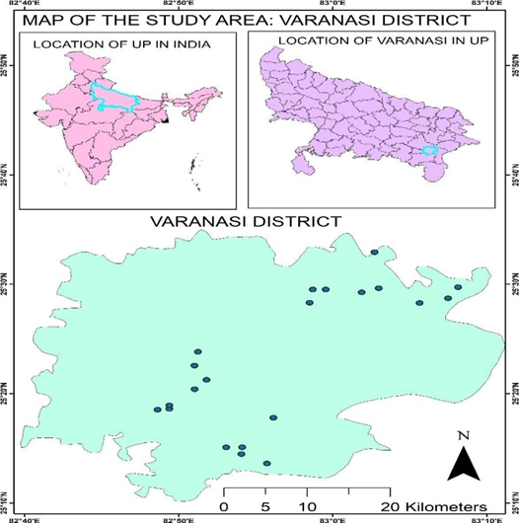

Figure 1 Location of the study area with Ground measured points: Varanasi district

The climate of Varanasi is humid subtropical. In summer, the temperature can reach up to 46° C, while in winter, it dips down to about 7°C. Varanasi experiences high diurnal temperature fluctuations. The monsoons usually arrive in late June or early July and last for about two months. The average annual rainfall is around 322.7 mm. The hottest month is June, with an average temperature of 35°C, the coldest month is January, with an average temperature of 16°C. July is considered the wettest month, with recording approximately 103.6 mm of rainfall.

METHODS AND MATERIALS
The study utilizes Soil Moisture Index (SMI) and Temperature-Vegetation Dryness Index (TVDI) were derived from optical data to measure soil moisture in the upper root zone. The index best represents in-situ soil moisture was used to develop a regression relationship to estimate soil moisture for March 29, 2023 over the Varanasi district.

The Materials used:
Satellite data: Data from Landsat 8 OLI satellite (30m spatial and 16-day temporal resolution) was used, with cloud cover less than 10% for the optical approach to estimate soil moisture in the upper layer. The two 2 tiles were acquired on March 29, 2023 (7 to 8am) from the Earth Explorer or GloVis websites (https://landsat.usgs.gov).
Ground-Measured probes: For in-situ measurement and validation, ground measurement probes were used to obtain upper-zone soil moisture information. Spatially distributed stratified sampling approach was chosen to select twenty-two points for ground measurements over the study area. The selection was done based on several factors like land cover, NDVI & LST range and accessibility. The ground measurements were taken on the same date as the Landsat 8 overpass of Varanasi district (March 29, 2023 by 7 to 8am). Soil moisture and surface temperature were calculated using ground measurement probes for validation with satellite-derived SSM (Surface Soil Moisture) and LST. GPS (Global Positioning System) was used for location.
The Software’s used are: R 3.5.0: 1. The R Programming language, version 3.5.0. was used for pre- processing (radiometric and radiance corrections) of raw data. It was also used to compute models of NDVI, LST and to create the triangle model using pixels from the study area. Additionally, this software was used for other mathematical processes and algorithms for TVDI and SMI. 2. ArcGIS 10.4.1: This software was used to create maps and layouts of the images. 3. ENVI: ENVI version 5.1.3 was used to mosaic different covers of the study area and to mask out the study area from that mosaic image.

The steps followed in the methodology are explained below:
1. Top of Atmospheric Spectral Radiance Correction: The initial step of the algorithm involves correcting the energy captured by a sensor ground from a specific angle of view. The following formula was used to retrieve Top of Atmospheric Spectral Radiance (L𝜆) from USGS Earth explorer, which provides the TOA Spectral Radiance correction for Band 10. This correction is used to indicate the amount of emitted, reflected, transmitted or received energy.
L𝜆 = M_{L}*Q_{cal} +AL (equation 1)
Where, ML = band-specific multiplicative rescaling factor, Qcal = band 10 image, AL = band-specific additive rescaling factor.

2. Conversion of Radiance to At-Sensor Temperature:
After converting the DN values of Band 10 into spectral radiance, the next step is to convert the spectral radiance into brightness temperature. We used the metadata file to obtain temperature constants. The following algorithm is used to convert radiance to brightness temperature (TB):
Temperature brightness (TB): T_{B} =$\frac{K_{2}}{ln(\frac{K_{1}}{L_{λ}}+1)}-273.1$ (equation 2)
Where, K₁ and K₂ is the band-specific thermal conversion constants from the metadata. The value -273.15 is used to convert the temperature to degree celcius (°C) instead of Kelvin.
The Band 4 ( 0.64-0.67mm) and Band 5 (0.85-0.88mm) were used to calculate NDVI. NDVI was then used for the retrieval of the Proportion Vegetation Condition (PVC) and emissivity (e) of the surface in order to estimate the land surface temperature over the study area. NDVI is considered an important variable due to its sensitivity to soil moisture conditions under fully vegetated, partly vegetated, and bare ground areas.
$$NDVI=\frac{NIR (Band 5)-R (Band 4)}{NIR (Band 5)+R (Band 4)}$$

Proportion Vegetation Condition (PVC)
This is used to obtain a scaled value of NDVI ranging from 0 to 1, and the reflectance error is reduced as a result.

3. NDVI method for Emissivity Correction
a. Top of Atmospheric Reflectance Correction: This method is used to remove the effects of scattering and absorption from the atmosphere in order to obtain surface reflectance energy. Similar to the conversion to radiance, the 16-bit integer values in the L1 product can also be converted to TOA reflectance. The following equation is used to convert Level 1 DN values to TOA reflectance: ML*Q_{cal}+AL/sin(ϴ)
where, ML is the radiance multiplicative scaling factor for the given band, AL is the radiance additive scaling factor for the given band, Qcal is the level-1 pixel value stored as DN values in the image, available for both OLI and TIRS bands.
b. NDVI calculation: NDVI calculation is important as it is a key indicator of vegetation condition and its presence over a specific area.

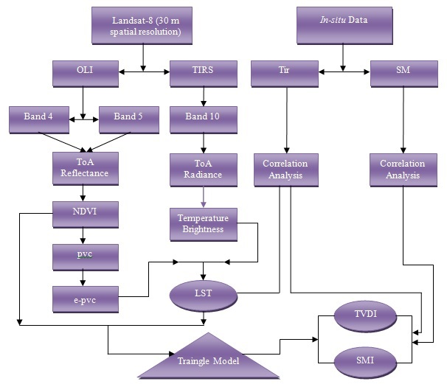
Figure 2 Flow chart of methodology

Land Surface Emissivity Calculation

LST validation: The ground-measured data compared with satellite-derived temperature data to validate its accuracy. There may be an error of up to 5°C when comparing the LST results with ground-measured data. Generally, the errors are ranged between 2°C up to 5°C when compared with ground-based surface temperature measurements. On the other hand, for ground-measured near-surface air temperature, the error is found to be around 0.7°C. We used a surface temperature measurement tool for the ground survey and utilized that data for LST validation, so the errors were found to be up to 5°C.
TVDI = $\frac{LST-LSTmin}{LSTmax-LSTmin}$………………………. (equation 3)
Where,
LST_{min}= a1 + b1 $×$NDVI ………………………. (equation 4)
LST_{max}= a2 + b2 $×$NDVI ………………………. (equation 5)

RESULT
In fig 2, satellite-derived soil moisture is plotted against satellite-derived NDVI and LST parameters within the triangle space. LST_{min} and LST_{max} refers to equations 4 and 5, respectively, in the figure, as introduced by Carlson et al. (1994). Twenty-two random points were selected from 30 points for modeling SMI. For accuracy assessment of the SM data, the correlation coefficient (R²) was used with in-situ SM data, while the correlations between TVDI, LST and NDVI (Table 1) were proposed to better represent the relationship between SM and the different parameters. SMI is the ratio of two temperature differences: (LST_{max}-LST_{min}) and (LST_{max}- LST_{min}) at a given pixel for a given NDVI (Sandholt et al., 2002). LST_{max}, LST_{min} are described in equations 4 and 5 above. SMI is widely used to determine soil wetness availability in an area. In the image analysis, the range of Soil Moisture Index varies from 0 to 1, where 0 represents no moisture and 1 represents 100% moisture in the soil surface layer.
Tir-NDVI Scatter plot: The scatter plot between surface temperature and Normalized Difference Vegetation Index (NDVI) was developed to define the relationship between LST, NDVI and SM (Sandholt et al., 2002). The Triangle model itself represents a wide range of soils within the study area, from wet to dry soil types. In the triangle model, it is necessary to define the warm and cold edges of the scatter plot. The warm edge of the scatter plot indicates the driest regions of the study area, while the cold edge indicates the wettest regions. In the scatter plot, moisture varies from 0 to 1 where 0 corresponds to the dry edge and 1 corresponds to the wet edge. Due to less vegetation cover and industrial involvement, higher surface radiant temperatures are found on the warm edge, resulting in low soil moisture availability. Cooler temperatures are found on the cold edge, resulting from high vegetation cover and transpiration. Clouds and water bodies (rivers, lakes) can distort the shape of the triangle model. Therefore, masking cloud-covered and water-dominated areas is necessary. The data was acquired on March 29, 2023, from Landsat 8 OLI data which had negligible cloud coverage over the study area. The NDVI and LST image was composed to do the analysis (Figure 3 & 4). Two time-dependent inversion models were developed to analyze ground-measured soil moisture data with the TVDI and SMI indices.

Figure 3 NDVI with Ground measured points (Date: 29/03/2023)

Figure 4 LST with Ground measured points (Date: 29/03/2023)
Table 1. Ground Measured (Easting) & Satellite derived points of Soil moisture, LST, NDVI & TVDI
S. No. | North Latitude | East Longitude | Ground measured Soil Moisture (%) | Satellite derived SMI | Ground measured LST (°C) | Satellite derived LST (°C) | Satellite derived NDVI | Satellite derived TVDI
1 | 25.29 | 82.94 | 11.00 | 0.58 | 34.90 | 35.10 | 0.31 | 0.47
2 | 25.31 | 82.94 | 9.00 | 0.57 | 35.10 | 35.20 | 0.30 | 0.48
3 | 25.23 | 82.93 | 9.00 | 0.53 | 35.00 | 35.50 | 0.27 | 0.49
4 | 25.24 | 82.90 | 12.00 | 0.60 | 35.20 | 35.30 | 0.33 | 0.46
5 | 25.25 | 82.90 | 12.00 | 0.59 | 35.50 | 35.80 | 0.28 | 0.49
6 | 25.26 | 82.88 | 8.00 | 0.44 | 34.90 | 34.60 | 0.30 | 0.52
7 | 25.31 | 82.82 | 9.00 | 0.57 | 35.50 | 35.80 | 0.28 | 0.47
8 | 25.32 | 82.82 | 10.00 | 0.59 | 34.90 | 35.10 | 0.31 | 0.47
9 | 25.31 | 82.81 | 9.00 | 0.54 | 36.60 | 36.60 | 0.27 | 0.50
10 | 25.35 | 82.85 | 11.00 | 0.60 | 34.30 | 34.40 | 0.38 | 0.45
11 | 25.35 | 82.86 | 10.00 | 0.57 | 35.80 | 35.05 | 0.29 | 0.47
12 | 25.38 | 82.85 | 8.00 | 0.40 | 36.00 | 36.10 | 0.26 | 0.52
13 | 25.40 | 82.85 | 8.00 | 0.37 | 35.80 | 35.70 | 0.26 | 0.54
14 | 25.47 | 82.97 | 13.00 | 0.67 | 33.60 | 33.30 | 0.42 | 0.40
15 | 25.47 | 83.08 | 11.00 | 0.59 | 35.40 | 35.50 | 0.33 | 0.46
16 | 25.49 | 83.13 | 7.00 | 0.34 | 35.50 | 35.00 | 0.24 | 0.56
17 | 25.50 | 83.14 | 11.00 | 0.56 | 36.40 | 35.30 | 0.33 | 0.48
18 | 25.55 | 83.05 | 8.00 | 0.38 | 37.50 | 36.30 | 0.25 | 0.54
19 | 25.48 | 83.04 | 9.00 | 0.54 | 35.50 | 36.00 | 0.27 | 0.49
20 | 25.49 | 83.03 | 10.00 | 0.59 | 35.50 | 35.40 | 0.29 | 0.47
21 | 25.49 | 82.98 | 11.00 | 0.54 | 35.80 | 35.40 | 0.27 | 0.49
22 | 25.49 | 82.98 | 9.00 | 0.44 | 36.00 | 35.60 | 0.26 | 0.53

Table 2. Regression analysis of extreme dry and wet edge of pixels in the triangle scatterplot
Date | Dry edge fitting equation | R2 | Wet edge fitting equation | R2
March 29, 2023 | y= (-18.657) x + (52.203) | 0.88 | y= (5.8240) x + (25.4520) | 0.92

Linear Regression Analysis Between Satellite-Derived Temperature and Ground Measured Temperature
Land surface temperature plays a major role in defining the amount of water in the soil. The higher the temperature, the lower the moisture content. In high-temperature zones, the evaporation rate increases rapidly, leading to a lack of moisture in the surface layer and resulting in water stress. Researchers have claimed that errors up to ±5°C are found during validation between satellite-derived and ground-measured temperature data. In the proposed project work, R² was found to be 0.6724 between Landsat-derived temperature and ground-measured temperature data. Most of the point location values lie in the range of 35–36.5°C (Figure 5A).
Linear Regression Analysis Between Satellite-Derived Temperature and NDVI
NDVI is another key element in deriving soil moisture through remote sensing. The higher the vegetation cover, the higher the moisture content in the soil's surface layer. Dense vegetation cover decreases the temperature of its surroundings. As shown in the triangle model, it is clear that LST and NDVI have a negative relationship. In the scatter plot, there is a negative relationship with R² of 0.7312. The range of NDVI varies from 0.2 to 0.45, while LST ranges from 30 to 37°C in the scatter plot. Most of the ground points are located in agricultural-dominated areas (Figure 5B).
Linear Regression Analysis Between Satellite-Derived Temperature and TVDI
The Temperature Vegetation Dryness Index (TVDI) is used to analyze water stress in the study area. There is a positive relationship between TVDI and LST. In the scatter plot below, there is a moderate relationship between both satellite-derived data, TVDI and LST, with R² of 0.4679 (Figure 5C).
Linear Regression Analysis Between NDVI and TVDI
As stated above, LST and TVDI have a positive relationship, which is why there is a negative relationship between NDVI and TVDI. In the chart below, R² is 0.7183 between both data sets (Figure 5C).
Linear Regression Analysis Between Ground-Measured SM and TVDI
TVDI and SM have an inverse relationship. In this scatter plot, there is a negative but strong relationship between SM and TVDI, with R² of 0.6812 (Figure 5D).
Linear Regression Analysis Between SM and SMI
Comparison of ground-measured soil moisture and satellite-derived soil moisture was done in the scatter plot. In this comparison, R² is 0.6848, indicating that satellite data can detect soil wetness over a moderate region with tolerable error (Figure 5E).
Linear Regression Analysis Between Satellite-Derived Temperature and SMI
From the triangle model, it is clear that the soil moisture index and temperature have an inverse relationship. Therefore, in the chart below, there is a negative relationship between SMI and LST, with R² of 0.2745 (Figure 5F).
Linear Regression Analysis Between Satellite-Derived Temperature and TVDI
From the triangle model, it is clear that the temperature and TVDI have a moderate relationship with R² of 0.4679 (Figure 5G).
Linear Regression Analysis Between SMI and NDVI
A positive relationship has been found between soil moisture and vegetation indices. In the chart below, there is a moderate relationship between SMI and NDVI derived from satellite data, with R² of 0.4969 (Figure 5H).
Spatial Distribution of Temperature Vegetation Dryness Index (TVDI)
TVDI, also known as the soil moisture inversion model, defines the spatial distribution of soil moisture in a negative relationship. Soil moisture increases as the TVDI rate decreases, while soil moisture decreases as the TVDI rate increases. Compared to LST, TVDI increases with the increase in LST data (Figure 6A).
Spatial Distribution of Soil Surface Moisture
Soil moisture tends to vary from one place to another due to differences in soil type, texture, color, land cover, and vegetation cover. The SMI algorithm is used to define the soil surface moisture availability in the study area (Figure 6B).
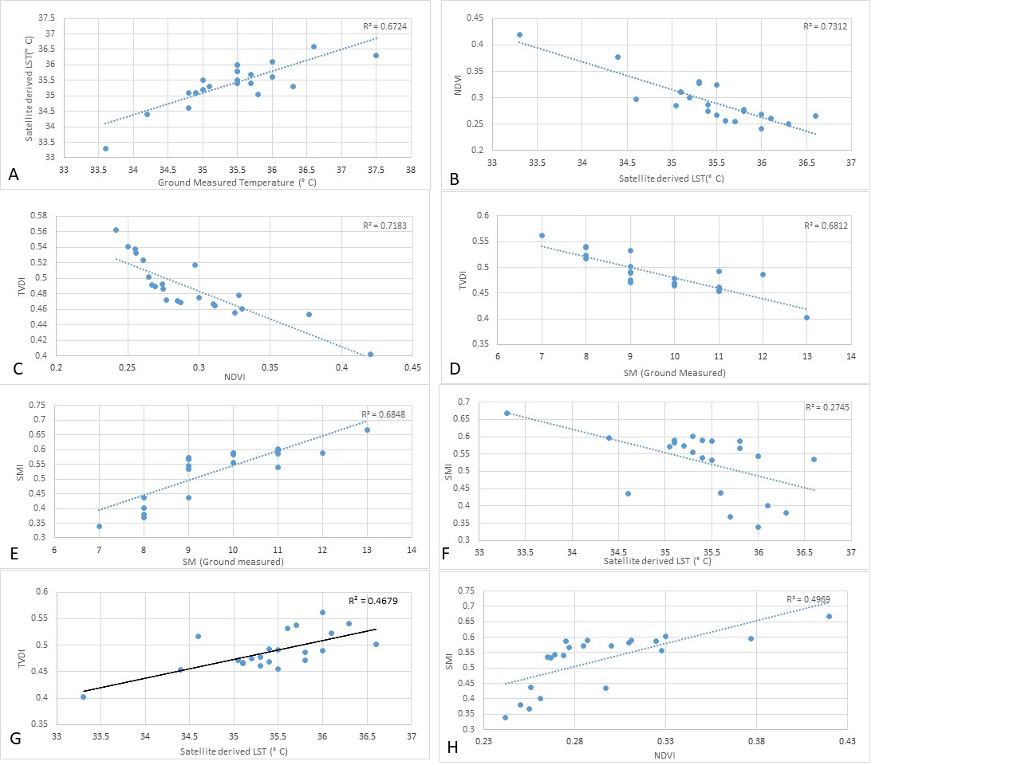

Figure 5. Linear regression analysis between (A) Temperature and satellite derived Temperature (B) LST and NDVI , (C) NDVI and TVDI, (D) between SM and TVDI (E) SM and SMI and (F) LST and SMI (G) TVDI and LST, and (H) SMI and NDVI.

Figure 6(A). Spatial distribution of TVDI Figure 6(B) Spatial distribution of Soil moisture
Triangle model
Fitting Ts-NDVI Feature Space Dry and Wet Edge Equations
The triangle model is used to explore the relationship between NDVI, LST, and soil moisture. It is also used to estimate energy flux. Carlson et al. (1994) has used the surface temperature–vegetation index triangle model (Ts-VI) to obtain both soil moisture and evaporation data. The R programming language is used to construct the triangle model by utilizing satellite-derived surface temperature data and vegetation index data. For the best fit line in the regression analysis of the wet and cold edges of the feature space, it is necessary to select the most appropriate pixels in the image. There is a strong negative and linear relationship was between LST and NDVI. LST values decreases with the increasing NDVI values. To define the wet edge, it is important to identify the minimum NDVI value in the study area. In this study area, the lowest NDVI value is typically around 0.2 corresponding to bare soil. Therefore, the dry and wet edges are extracted with the general NDVI range between 0.2 and 0.8. The maximum and minimum surface temperature values corresponding to the NDVI values of each pixel in the study area are extracted using R programming. Based on the least squares method, the dry and wet edge equations of the LST-NDVI feature space for the study area on March 29th, 2023 (Table 2) were fitted. The TVDI index of the study area was calculated using the equations of the dry-wet edges and the land surface emissivity formula. TVDI and SMI values were extracted from the image to analyze the relationship of TVDI and SMI with soil moisture (Table 1). R² is the correlation coefficient.

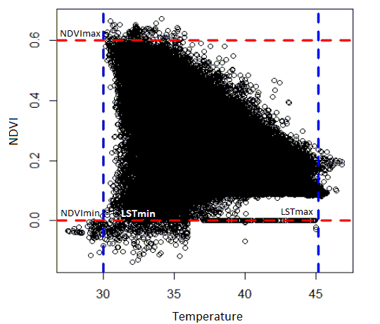

Figure 7. Triangle model established between estimated LST and NDVI derived for the study area
Soil Moisture Index
SMI= $\frac{LSTmax-LST}{LSTmax-LSTmin}$………………………. (equation 6)
SMI is the ratio of two temperature differences (LSTmax-LST) and (LSTmax-LSTmin) at a given pixel for a given NDVI. LSTmax, LSTmin are described in the equation 4 and 5 as above. SMI is widely used for determining the soil wetness availability in the area. In the image analysis, the range of Soil Moisture Index highly varies from 0 to 1 where 0 represents no moisture and 1 represents 100% moisture in the soil surface layer. Satellite derived soil moisture data points are mentioned (Table 3).

S. No. | North Latitude | East Longitude | SMI
1 | 25.29 | 82.93 | 0.583
2 | 25.29 | 82.93 | 0.573
3 | 25.22 | 82.92 | 0.533
4 | 25.24 | 82.90 | 0.612
5 | 25.25 | 82.90 | 0.588
6 | 25.25 | 82.88 | 0.436
7 | 25.31 | 82.82 | 0.567
8 | 25.31 | 82.82 | 0.589
9 | 25.30 | 82.81 | 0.535
10 | 25.34 | 82.85 | 0.596
11 | 25.35 | 82.8 | 0.571
12 | 25.37 | 82.85 | 0.401
13 | 25.39 | 82.85 | 0.368
14 | 25.47 | 82.97 | 0.668
15 | 25.47 | 83.09 | 0.587
16 | 25.47 | 83.12 | 0.329
17 | 25.49 | 83.13 | 0.556
18 | 25.54 | 83.04 | 0.381
19 | 25.49 | 83.04 | 0.543
20 | 25.48 | 83.03 | 0.598
21 | 25.49 | 82.99 | 0.540
22 | 25.49 | 82.97 | 0.437
Table 3 Satellite derived SMI data of Point locations
According to Potic et al. (2017), equation 6 is widely used for soil moisture mapping, which can identify water stress areas, where irrigation is necessary, and to monitor drought. The higher the SMI value, the higher the amount of soil moisture present in the location. Carlson et al. (1995) used SVAT to determine the cold and warm edges of the pixel distribution and to create isopleths of soil moisture availability ranging from 0 to 1. In the proposed triangle model, deriving the cold and warm edges of the scatterplot between VI and LST is a complex task. The TVDI for a given pixel in the triangle model is estimated from the ratio of line A to line B. Parameters a and b define the warm and cold edges as a linear fit to the data. Theoretically, the cold edge represents the wet area, while the warm edge represents the dry area within the study area. The maximum value of TVDI represents the warmest area of the entire region. The minimum and maximum values of TVDI lie between 0 and 1, and the same condition applies to SMI, where the maximum value of SMI represents the wettest area. There is a positive and strong relationship between TVDI and LST, while a strong negative relationship exists between TVDI and ground-measured SM data, and between TVDI and NDVI. On the other hand, a positive relationship is found between SMI and ground-measured SM, and between SMI and NDVI, while a negative relationship exists between SMI and LST.

DISCUSSION
Among many approaches, the triangle model is one of the most suitable methods to estimate surface soil moisture through remote sensing techniques. The main advantage of this approach is that it requires fewer parameters for soil wetness estimation and correlation analysis. The results showed that LST and NDVI were effective in extracting SSM using the optical remote sensing data. Landsat 8 data was suitable for regional-scale studies due to its fine spatial and temporal resolution. Both LST and NDVI, were used to develop the triangle model for further processing to retrieve soil moisture using the TVDI and SMI approaches. The soil moisture inversion model (TVDI) and the SMI algorithm for qualitative analysis of soil moisture in Varanasi district at a regional scale was established. Due to the increasing population, pollution, and global warming, the limited water resources are depleting. The SMI and TVDI were quite useful for water stress analysis, drought monitoring, and agricultural observations. TVDI and SMI algorithms were applied to better represent the spatial distribution of soil moisture in Varanasi district and found that the triangle model is the most appropriate method to retrieve satellite-derived soil moisture data. In the scatter plot, a positive and strong relationship has been found between satellite-derived surface temperature values and field-survey-measured surface temperature (Rajeshwari and Mani, 2014). There is a linear, negative correlation between in-situ soil moisture data and TVDI (R² = 0.6812). Also, found a linear, strong positive relationship between in-situ soil moisture data and SMI (R² = 0.6848). Both models were good indicators for soil moisture analysis and used for drought assessment studies. From the SMI map, it was clear that river basins and alluvial plains shown minimum values due to the rapid movement of river sediments (Potic et al., 2017). In contrast, regions with higher NDVI values in agricultural areas, were represented by higher values of SSM. On the other hand, urban areas, industrial zones, and highways are represented as drier areas. Overall, we can conclude that the triangle model is very helpful for SSM estimation, although it is challenging to identify the extreme wettest and bare soil areas within the study area. The triangle model does not require many parameters or complex procedures. TVDI and SMI algorithms can be significantly used for qualitative analysis of soil moisture estimation, and they have simple methodologies to produce results. From the entire analysis, it has been found that the number of field observation stations influences the correlation analysis between in-situ data and satellite-derived data. The correlation is stronger with a larger number of ground-measured stations (Unger et al., 2010). The results have shown the benefits of using biophysical parameters such as LST and VI for soil moisture estimation, as well as the significance of using optical remote sensing data. Both the TVDI and SMI equations can be used for monitoring and observing environmental and ecosystem conditions (Han et al., 2010). From the findings, it concluded that NDVI and LST could be used as parameters to develop a model for SSM estimation. The triangle model developed using NDVI and LST data to achieve better results for soil moisture estimation. Additionally, LST and NDVI helped to generate the TVDI and SMI equations using the triangle model, and both equations have a good correlation with in-situ data (comparing in-situ SM data: R² for TVDI = 0.6812, R² for SMI = 0.6848). TVDI can be used for drought monitoring, as it has a good correlation with in-situ LST data (R² = 0.437) and satellite-derived LST (R² = 0.4679).

CONCLUSION

The limitations of the present study are restricted to certain factors, which are not major issues to resolve. Landsat data products are useful for arid and semi-arid regions, but they are not very promising tools for estimating soil moisture (SM) in areas with moderate or dense vegetation. Additionally, optical data cannot be used during the rainy season or in high-cloud-cover conditions, as they cannot penetrate the clouds. Soil moisture studies are widely used for agricultural case studies, but due to vegetation cover, visible bands are unable to penetrate, which can lead to poor results. As a result, these data products are more suitable for estimating SM in bare soil-prone areas. Visible bands are not used to monitor root-zone soil moisture, so ground measurement probes or microwave data (around 10 cm depth from the surface) are required for deep-zone monitoring. Ground measurement probes always provide accurate and precise data, while there is always a possibility of inaccuracy in remote sensing models. Ground data is often needed to validate satellite data, which makes field surveys more rigorous compared to traditional methods. This becomes even more complicated when working on a macro or meso-scale area. Another issue with Landsat data is its coarse temporal resolution. Landsat data products have a 16-day temporal resolution, which is not suitable for daily monitoring studies or research.

Authors Contribution: All authors have contributed equally to this work.
Disclaimer (Artificial intelligence)
Option 1:
Author(s) hereby declare that NO generative AI technologies such as Large Language Models (ChatGPT, COPILOT, etc.) and text-to-image generators have been used during the writing or editing of this manuscript.

REFERENCES

Arya, L. M. and J. F. Paris. 1981. A Physicoempirical Model to Predict the Soil Moisture Characteristic from Particle-Size Distribution and Bulk Density Data 1. Soil Science Society of America Journal, 45(6): 1023-1030.
Ashaq, Mohd, Lalit Upadhyay, Lopamudra Jena, Vimal Kumar, Shatruhan Jaiswal, Juman Das, Reemashree Das, Anirban Dutta, Shivam Kumar Pandey, and Bal Veer Singh. 2024. “Drones for Monitoring Soil Moisture and Optimizing Irrigation Scheduling in Horticultural Farms”. Journal of Scientific Research and Reports. 30 (11):1118-35.
Carlson, T. N., R. R. Gillies and E. M. Perry. 1994. A method to make use of thermal infrared temperature and NDVI measurements to infer surface soil water content and fractional vegetation cover. Remote Sensing reviews, 9(1-2): 161-173.
Carlson, T. N., R. R. Gillies and T. J. Schmugge. 1995. An interpretation of methodologies for indirect measurement of soil water content. Agricultural and Forest Meteorology, 77(3-4): 191-205.
Cayrol, P., A. Chehbouni, L. Kergoat, G. Dedieu, P. Mordelet and Y. Nouvellon. 2000. Grassland modeling and monitoring with SPOT-4 Vegetation instrument during the 1997–1999 SALSA experiment. Agricultural and Forest Meteorology, 105(1-3): 91-115.
Chauhan, N., S. Miller and P. Ardanuy. 2003. Spaceborne soil moisture estimation at high resolution: a microwave-optical/IR synergistic approach. International Journal of Remote Sensing, 24(22): 4599-4622.
Gillies, R., W. Kustas and K. Humes. 1997. A verification of the triangle method for obtaining surface soil water content and energy fluxes from remote measurements of the Normalized Difference Vegetation Index (NDVI) and surface. International Journal of Remote Sensing, 18(15): 3145-3166.
Guan, Y., X. Gu, L. J. Slater, J. Li, D. Kong and X. Zhang. 2023. Spatio-temporal variations in global surface soil moisture based on multiple datasets: Intercomparison and climate drivers. Journal of Hydrology, 625: 130095.
Han, Y., Y. Wang and Y. Zhao. 2010. Estimating soil moisture conditions of the greater Changbai Mountains by land surface temperature and NDVI. IEEE Transactions on Geoscience and Remote Sensing, 48(6): 2509-2515.
Jian, J., W. Yang, H. Jiang, X. Wan, Y. Li and L. Peng. 2012. A model for retrieving soil moisture saturation with Landsat remotely sensed data. International Journal of Remote Sensing, 33(14): 4553-4566.
Lann, T., H. Bao, H. Lan, H. Zheng, C. Yan and J. Peng. 2024. Hydro-mechanical effects of vegetation on slope stability: A review. Science of the Total Environment, 926: 171691.
Latif, M. S. 2014. Land Surface Temperature Retrieval of Landsat-8 Data Using Split Window Algorithm-A Case Study of Ranchi District. International Journal of Engineering Development and Research, 2(4): 2840-3849.
Mu, Tianhao., G. Liu, X. Yang and Y. Yu. 2023. Soil-Moisture Estimation Based on Multiple-Source Remote-Sensing Images. Remote Sensing, 15: 139 – 161.
Peng, J., A. Loew, S. Zhang, J. Wang and J. Niesel. 2016. Spatial downscaling of satellite soil moisture data using a vegetation temperature condition index. IEEE Transactions on Geoscience and Remote Sensing, 54(1): 558-566.
Petropoulos, G. P., H. M. Griffiths and S. Tarantola. 2013. A sensitivity analysis of the SimSphere SVAT model in the context of EO-based operational products development. Environmental Modelling & Software, 49: 166-179.
Petropoulos, G., T. N. Carlson and M. J. Wooster. 2009. An overview of the use of the SimSphere Soil Vegetation Atmosphere Transfer (SVAT) Model for the study of land-atmosphere interactions. Sensors, 9(6): 4286-4308.
Potic, I., M. Bugarski and J. Matić-Varenica. 2017. Soil Moisture Determination using Remote Sensing Data For The Property Protection And Increase Of Agriculture Production. Proceedings of Annual World Bank Conference On Land And Poverty, Washington DC, USA, 20-24 March 2017, pp. 01-15.
Rajeshwari, A. and N. Mani. 2014. Estimation of land surface temperature of Dindigul district using Landsat 8 data. International Journal of Research in Engineering and Technology, 3(5): 122-126.
Sandholt, I., K. Rasmussen and J. Andersen. 2002. A simple interpretation of the surface temperature/vegetation index space for assessment of surface moisture status. Remote Sensing of Environment, 79(2-3): 213-224.
Schaap, M. G., F. J. Leij and M. T. Van Genuchten. 1998. Neural network analysis for hierarchical prediction of soil hydraulic properties. Soil Science Society of America Journal, 62(4): 847-855.
Skokovic, D., J. Sobrino, J. Jimenez-Munoz, G. Soria, Y. Juşien, C. Mattar and J. Cristóbal. 2014. Calibration and validation of land surface temperature for landsat8-tirs sensor. Proceedings of LPVE (Land Product Validation and Evolution, ESA/ESRIN, Frascati, Italy, 28-30 January 2014, pp. 01-27.
Sobrino, J. A., J. C. Jiménez-Muñoz and L. Paolini. 2004. Land surface temperature retrieval from LANDSAT TM 5. Remote Sensing of Environment, 90(4): 434-440.
Tagesson, T., S. Horion, V. Zaldo Fornies, G. Mendiguren Gonzalez, C. Bulgin, D. Ghent and R. Fensholt. 2018. Disaggregation of SMOS soil moisture over West Africa using the Temperature and Vegetation Dryness Index based on SEVIRI land surface parameters. Remote Sensing of Environment, 206(1):424-441.
Unger, J., T. M. Gál, J. Rakonczai, L. Mucsi, J. Szatmári, Z. Tobak, B. Van Leeuwen and K. Fiala. 2010. Modeling of the urban heat island pattern based on the relationship between surface and air temperatures. Journal of the Hungarian Meteorological Service, 114: 287-302.
Vicente-Serrano, S., X. Pons-Fernández and J. Cuadrat-Prats. 2004. Mapping soil moisture in the central Ebro river valley (northeast Spain) with Landsat and NOAA satellite imagery: A comparison with meteorological data. International Journal of Remote Sensing, 25(20): 4325-4350.
Wu, Z., N. Cui, W. Zhang, D. Gong, C. Liu, Q. Liu, S. Zheng, Z. Wang, L. Zhao and Y. Yang. 2024. Inversion of large scale citrus soil moisture using multi-temporal Sentinel-1 and Landsat-8 data. Agricultural Water Management, 294: 108718
Younis, S. M. Z. and J. Iqbal. 2015. Estimation of soil moisture using multispectral and FTIR techniques. The Egyptian Journal of Remote Sensing and Space Science, 18(2): 151-161.
Yu, X., X. Guo and Z. Wu. 2014. Land surface temperature retrieval from Landsat 8 TIRS—Comparison between radiative transfer equation-based method, split window algorithm and single channel method. Remote Sensing 6(10): 9829-9852.
Zeng, Y., Z. Feng and N. Xiang. 2004. Assessment of soil moisture using Landsat ETM+ temperature/vegetation index in semiarid environment. Proceedings of International Geoscience and Remote Sensing Symposium (IGARSS), Anchorage, USA, 20-24 September 2004, 6:4306-4309.
Zhao, W., A. Li and T. Zhao. 2017. Potential of Estimating Surface Soil Moisture with the Triangle-Based Empirical Relationship Model. IEEE Transactions on Geoscience and Remote Sensing, 55(11): 6494-6504

