Remote Sensing and GIS-Based Assessment of Morphometric Parameters for Watershed Management in Wakawali, India

Abstract:

The present study was carried out to study the morphometric characteristics of the Wakawali watershed using GIS techniques located in Dapoli tahsil of Ratnagiri district, Maharashtra, India. Geographic Information Systems (GIS) and remote sensing are essential tools for collecting and analysing large amounts of geographic data. In this study, the SRTM DEM was used to study the detailed morphometric characteristics of the Wakawali watershed. The total area of Wakawali is 685ha. The total twenty morphometric parameters linear, aerial and relief aspects of the watershed were calculated. The result revealed that the basin has a 4th-order drainage network. The mean bifurcation value of the watershed was 1.95 which indicates that the drainage pattern has strong structural control. The value of drainage density was 2.30 km/km², which falls in the Coarse drainage structure, which denotes the gentle to steep slope terrain, medium dense vegetation, and less permeable with medium precipitation. Form factor (0.56) and circularity ratio (0.25) indicate that the basin is elongated in shape. The value of the relief ratio of the watershed was 0.031 which indicates that the rolling and gentle slopes and the basin are less prone to erosion. This study helps in understanding the watershed hydrological behaviour, which directly influences runoff and soil loss.

Keywords: SRTM DEM, Morphometric parameter, Remote sensing and GIS.

Introduction:
In developing countries, problems with soil erosion and sedimentation threaten the sustainability of land management and the development of water resources. These problems lead to surface water pollution, dam and reservoir damage, and a loss of watershed storage capacity (Ninija 2017). In order to achieve sustainable development, “a watershed is the ideal unit for managing resources like land and water to mitigate the impact of natural disasters. An understanding of the drainage network process in the watershed can be gained through a study of morphometric parameters. The mathematical calculations and measurements of the sizes and shapes of specific landforms on the surface of the earth are known as morphometric characteristics. In order to properly plan a watershed, a quantitative morphometric characterisation of a drainage basin is the most satisfactory method because it allows us to compare different drainage basins developed in different geologic and climatic regimes and comprehend the relationship between various aspects of the drainage pattern of the basin” (Zende and Nagarajan, 2011, Adam et al. 2024). Morphometric analysis offers the opportunities to prioritize sub watersheds through evaluation of various linear and areal characteristics within the watershed (Gautam et al., 2021; Bhat et al. 2023). Geological structures, bedrock, and lithology are the main factors influencing morphometric parameters. Therefore, information about land use patterns, hydrology, geology, and geomorphology is very instructive for a reliable evaluation of the watershed's drainage pattern (Astras and Soulankellis, 1992). In the morphometric analysis of a drainage network, linear, areal, and relief aspects are taken into account. The linear aspect pertains to the number and length of stream segments, as well as the hierarchical stream order. According to (Khakhlari and Nandy (2016), “the areal aspect comprises the analysis of basin parameters and basin shape, both topological and geometrical (stream frequency, drainage density) and the relief aspect the relief aspect comprises the study of basin relief and relative relief and ruggedness number”. “Satellite remote sensing is an efficient tool for studying, monitoring, and observation of land cover changes, deforestation, and impacts of global climate change” (Qasimi et al., 2022). In India as well as around the world the use of remote sensing and GIS for morphometric analysis is increasing day by day. It is a crucial tool for delineation and the computation of morphometric parameters in the watershed. The goal of morphometric analysis of the watershed is to gather accurate and ideal information about the drainage system's assessable stream network features. This study was conducted using RS and GIS techniques for the Wakawali watershed, with a focus on the significance of geomorphological parameters in the watershed.

Material and Method:

Study Area:
Wakawali watershed is situated in Dapoli tehsil of Ratnagiri district, Maharashtra. It belongs to the Konkan region. The total geographical area of the Wakawali watershed which about 685ha. It is located between 17o 44’ to 17o 47’ N and 73o 16’ to 73o 18’ E, having an elevation of 250 m of above sea level. The area is recognized as having a hot and humid climate, with moderate temperatures ranging from as low as 11.9°C to as high as 37.3°C, and rainfall exceeding 3500mm, with over 90% of that falling between June and September. The location map of the Wakawali watershed is shown in Fig.1.

Data used
The morphometric parameters of the watershed were analysed using an integrated remote sensing and GIS approach. Using remote sensing and GIS to analyse morphometric parameters (linear, areal, and relief), DEM has been utilised to extract drainage patterns. The DEM

of Wakawali watershed was downloaded from https://Bhuvan nrsc.gov.in portal having 30 m resolution. The processing of the DEM was done using QGIS software.
UNDER PEER REVIEW
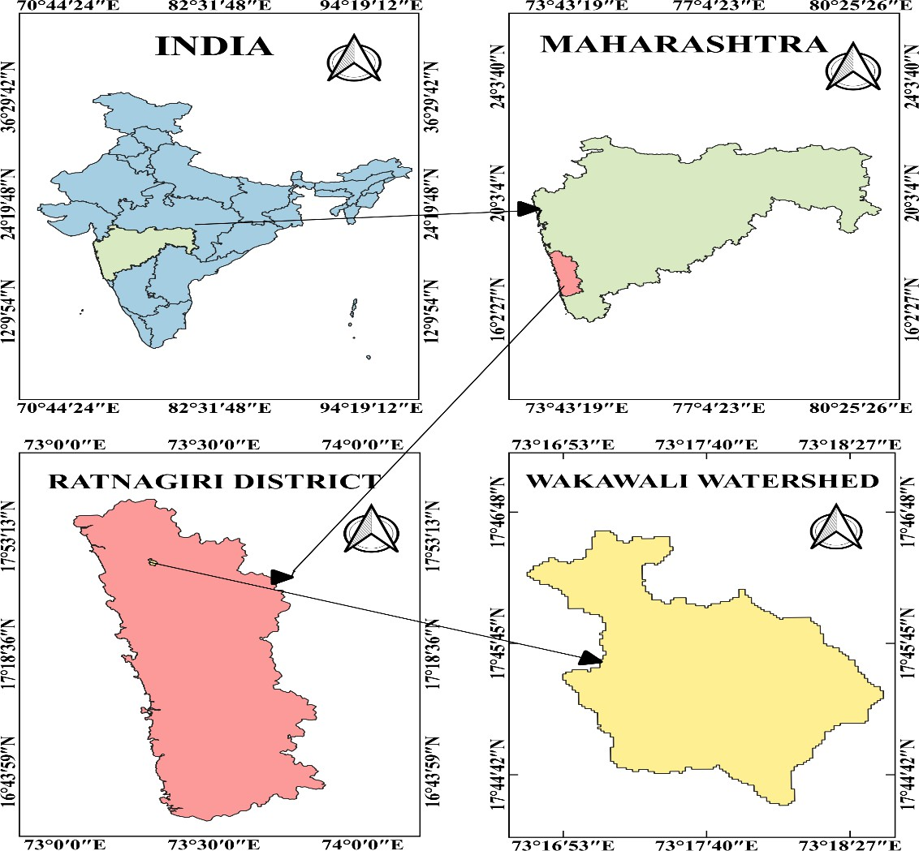
Fig.1: Location Map of Study Area

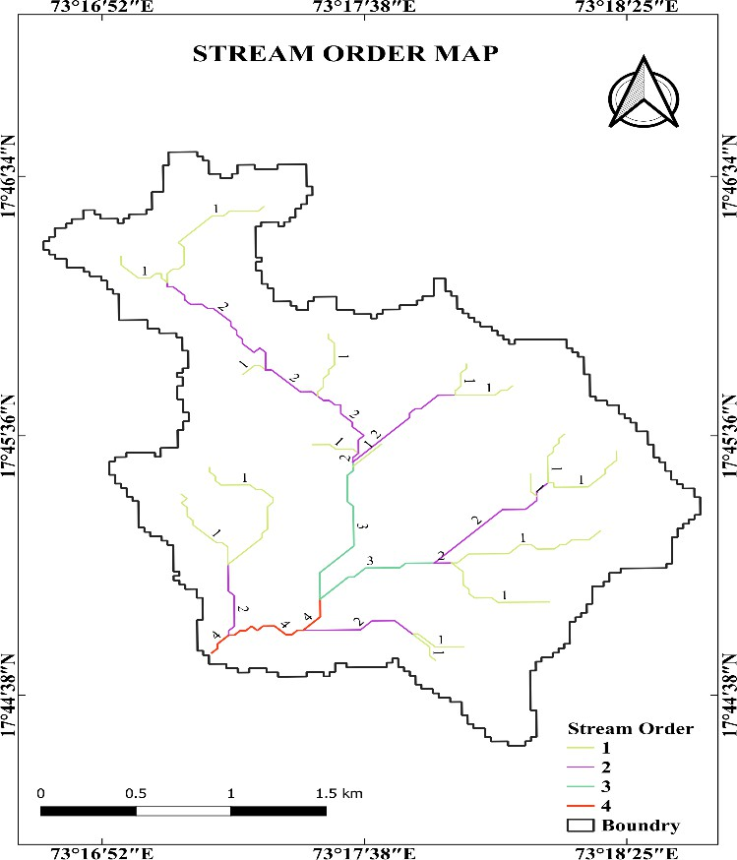
UNDER PEER REVIEW
Fig.2: Stream Order Map of Wakawali Watershed




Stream order map
Watershed
Stream to Feature
Vectorise by
selecting req. area)
Stream Order
Rater Conversion
(Vector to Raster)
Add Threshold
Upslope Area
Channel Network
& Drainage basin
Fill Sink
Fill Sink
Add DEM
Add DEM
QGIS
QGIS
Strahler Order
Fig 3: Flowchart for Preparation of Watershed and Stream Order

Table.1: Formulae of morphometric characteristics of linear, aerial and relief aspect
UNDER PEER REVIEW

Sr. No | Morphometric characteristic | Formula | Units | Reference
Basic Parameter
1. | Area of Basin (A) | QGIS Software | km2 | -
2. | Perimeter (P) | 𝐿𝑏 = 1.312 × 𝐴^{0.568} | km | -
3. | Length of Basin (Lb) | QGIS Software | km | Nookaratnam et al.(2005)
4. | Max. Elevation (H) | QGIS Software | m | -
5. | Min. Elevation (h) | QGIS Software | m | -
Linear Aspect
6. | Stream Order (u) | Hierarchical rank | Dimensionless | Strahler (1964)
7. | Stream number (Nu) | Number of Stream of order u | Dimensionless | Horton (1945)
8. | Stream length (Lu) | Lu=Lu1+Lu2+Lu3+… +Lun | m | Horton (1945)
9. | Stream Length Ratio (RL) | RL=Lu/Lu-1 | Dimensionless | Horton (1945)
10. | Bifurcation Ratio (Rb): | Rb=Nu/Nu+1 | Dimensionless | Schumm (1956)
Aerial Aspect
11. | Drainage Density (Dd): | 𝐷𝑑 = Lu/A | km/km2 | Horton (1945)
12. | Stream Frequency (Fs) | Fs =Nu/A | km-2 | Horton (1945
13. | Form Factor (Rf) | Rf =A/Lb² | Dimensionless | Horton (1945)
14. | Circularity Ratio (Rc) | Rc=4πA/P2 | Dimensionless | Miller (1953)
15. | Drainage Texture(T) | T=Nu/P | km-1 | Smith (1950)
16. | Drainage intensity (Di) | Di= Fs/ Dd | km-1 | Faniran (1968)
Relief Aspect
17. | Basin Relief(R) | R=H-h | m | Strahler (1952)
18. | Relief ratio (Rh) | Rh= H/Lb | Dimensionless | Schumm (1965)
19. | Relative Relief (Rr) | Rr=(H/P) ×100 | Dimensionless | Melton (1957)
20. | Ruggedness Number (Rn) | Rn = H/Dd | Dimensionless | Strahler (1956)

Result and Discussion
Morphological characteristics
An essential part of quantitative geomorphology is to examine the geometric properties of the landforms. Morphological characterization was a systematic description of the watershed‘s geometry. The Wakawali watershed has a 4th-order drainage network. The linear, aerial and relief aspects of the Wakawali watershed are shown in Tables 2 and 3.

Basic Morphometric Parameter:
Basic aspects of watershed include the Area of watershed (A), Perimeter of watershed (P) and Basin Length (Lb).

Watershed Area (A):
Area of the Wakawali Watershed was determined by using QGIS software and it was found to be 685 ha.

The perimeter of the watershed (P)
The perimeter is described as the watershed's outer periphery that includes the watershed area (A). The watershed's size and shape are determined from the value of P (Schumm, 1956). QGIS software is used to calculate the watershed's perimeter. The perimeter of the Wakawali watershed is 18.61 km.

Length of Basin (Lb):
The value of the length of the basin (Lb) for the Wakawali watershed is 3.49 km.

Linear Aspects of Watershed:
Table 2: Stream order of watershed

Stream order(u) | No. of  Streams (Nu) | Stream length km | Mean Stream  Length (km) | Stream  Length Ratio | Bifurcation ratio (Rb)
1 | 17 | 7.79 | 0.45 | - | -
2 | 6 | 4.74 | 0.79 | 0.60 | 2.83
3 | 2 | 2.37 | 1.18 | 0.5 | 3
4 | 1 | 0.88 | 0.88 | 0.37 | 2
Average |  |  |  | 0.49 | 1.95

Streamorder(u):
The first stage of morphometric analysis is known as "stream orders." There are no tributaries in the first-order streams. A second higher-order stream gets generated when two first-order streams merge. Third-order streams are generated when two second-order streams merge, and so forth. The Strahler (1964) method was used to perform the order of streams in this study. The highest order, a fourth-order stream network, was found in the Wakawali watershed. The stream order map is shown in Fig.2.

Stream Number (Nu):
Stream number is the total number of streams of each order in a particular watershed. According to Horton (1945), “the number of streams is inversely proportional to the order of streams”. Less permeability and infiltration resulted from the higher number of streams in the lower order. (Dandekar et., al.2017.) In the Wakawali watershed the total number of streams was found to be 26. There are 17 streams of Ist order, 6 streams of IInd order, 2 streams of IIIrd order and 1 stream of IVth order. 3.2.3Stream Length (Lu):
The total length of all streams of order ‘u’ is known as the stream length. The total stream length and mean of each order were calculated using QGIS. Stream order increases as stream length Decreases. Areas with finer textures and larger slopes tend to have streams of comparatively shorter lengths. In general, flatter gradients are indicated by longer stream lengths (Strahler 1964). The total Stream length of all the streams of the Wakawali watershed was 15. 78 km.

Stream Length Ratio (RL):

According to Horton (1945), “the stream length ratio is the ratio of the mean length of the stream segment (Lu) of order u to the mean length of the stream segment of the next lower order (Lu-1)”. An increasing trend in stream length ratio from lower order to higher order indicates their geographic stage. The stream length ratio for the Wakawali watershed varies from 0.37 to 0.60. The stream length ratio for order II/I was 0.60, III/II was 0.5, IV/III was 0.37.
UNDER PEER REVIEW

Bifurcation Ratio (Rb):
It is the ratio of total numbers all streams in one order (Nu) to the total numbers of all streams in the next higher order (Nu + 1). The Rb value ranges between 3.0 to 5.0. The value of the bifurcation ratio is higher in elongated basins and lower in circular basins (Schumm, 1956). It could measure watershed hydrographs and surface water potential. Lower bifurcation ratio values indicate the watersheds' characteristics of the watersheds, which show that the drainage pattern has not been distorted and that there are less structural disturbances. The mean Rb value of the watershed is 1.95 which shows the drainage pattern has strong structural control and has less structural disturbance.

Areal Aspects of Watershed
    - Drainage density (Dd):
The drainage density is defined as the ratio of the total area of a watershed to the total length of all streams of all orders within that watershed. Drainage density is higher in regions with weak subsurface strata, high relief, and sparse vegetation. It is lower in regions with low relief and dense vegetation cover. Permeability, vegetative cover, and infiltration capacity are all inversely correlated with drainage density (Horton 1945). According to Strahler (1957) the Dd is classified into four different categories: coarse (< 5 km−1), medium (between 5.0 to 13.7 km-1), fine (between 13.7 to 155.3 km−1), and ultra-fine (> 155 km−1). Low drainage density results from a coarse drainage texture, while high drainage density results from a fine drainage texture. The Wakawali watershed has a drainage density of 2.30 km/km2, falling within the coarse drainage structure, which denotes terrain with gentle to steep slopes, medium-dense vegetation, and less permeability with medium precipitation.

Stream frequency (Sf):
“The number of streams per unit area is known as the stream frequency or channel frequency. The drainage area has a direct impact on it” (Horton, 1945). While “it is directly correlated with runoff and the degree of dissection, it has an inverse relationship with mean annual rainfall and infiltration” (Pankaj and Kumar 2009). The stream frequency (Fs) of the Wakawali watershed is 3.79 km-2.

Form Factor (Ff):
According to (Horton,1945), “the Form factor is the ratio of the watershed area (A) to the square of watershed length (Lb)”. It is a shape of perimeter, which indicates that the watershed is elongated, oval or circular. “For Wakawali watershed value of the form factor is 0.56, which indicates the watershed is elongated. An elongated basin with a low form factor indicated that the basin had a flatter peak for a longer duration”. (Shinde et.al 2022)

Circularity Ratio (Rc):
It is defined as the ratio of the basin area to that of a circle with the same perimeter as that basin (Miller 1953). It is a dimensionless property. The range of circulatory ratio varies from 0 to 1. The slope basin relief geologic structure and land use land cover all have an impact on the circulatory ratio. The Rc value for the Wakawali watershed was 0.25 which indicated an elongated shape of the watershed.

Drainage texture (T):
According to (Horton, 1945), “texture ratio is the ratio total stream number of all orders and the perimeter of that area”. Smith (1950) “Drainage texture is influenced by the number of physical elements including factors like rainfall, type of soil, vegetative cover and relief”. “The drainage texture is categorized in drainage texture values into the five classes, very fine (> 8), fine (6–8), moderate (4–6), coarse (2–4), and very coarse (< 2)” (Smith 1950). The Drainage texture value of the watershed is 1.39 km-1, indicating that the watershed has a very coarse drainage texture.

Drainage intensity (Di):
“It is the ratio of stream frequency to the drainage density of the basin” (Faniran 1968). Drainage intensity value is eventually reduced by Lower drainage density and stream frequency values. The drainage intensity of the study area was 1.64 km-1, which is a relatively low value. This implies that the watershed does not quickly remove the surface runoff and has a good ability to absorb the water into the soil which helps increase the groundwater recharge. The low drainage intensity also implies the lower risk of flooding hence the water required more time to seep into the soil rather than the runoff on the surface. (Kumari et.al.2023).

Relief Aspects of Watershed

Basin relief (R):
The elevation difference between the highest and lowest point located in the drainage basin is known as basin relief. The basin topographic features including slope, drainage patterns, and erosion potential is the difference in elevation between the highest and lowest points in a basin. In the present study, the Basin relief of the Wakawali watershed is 111.54 m which shows very low relief of watershed.

Relief ratio (Rh):
The relief ratio is the ratio of the basin relief to the watershed's longest dimension parallel to the main flow path. A useful indicator of the watershed's gradient features, the relief ratio is a dimensionless ratio of basin length to basin relief (Schumm, 1956). It gives information about the slope's general steepness as well as the watershed slope that is prone to erosion. The watershed relief ratio of 0.031 indicates that the basin has a gentle, rolling slope making it less prone to erosion.

Relative relief (Rr):
The ratio of basin relief to the perimeter of the watershed is called relative relief (Melton1957). The relative relief is the variation in height. It displays the basin elevation from the highest point to the outlet point. The Relative relief of the watershed is 0.59. This relative value suggests that the catchment erosion and peak discharge rate are likely to be low.

Ruggedness number (Rn):
The drainage density is multiplied by relief gives the ruggedness number. The slope and drainage density determines the ruggedness number. The watershed has a high ruggedness number a steep long slope and a high drainage density. A lower ruggedness number indicates a lower stream velocity, which suggests a lower susceptibility to soil erosion, (Strahler 1956). In this study the value of Rn obtained by 0.25 which recommends less prone to soil erosion.

Table3: Morphometric Parameter of linear aerial and relief aspect of watershed.
UNDER PEER REVIEW

Sr. No | Morphometric characteristic | Units | Result
Basic Parameter
1. | Area of Basin (A) | ha | 6.85
2. | Perimeter (P) | km | 18.61
3. | Length of Basin (Lb) | km | 3.49
4. | Max. Elevation (H) | m | 189.33
5. | Min. Elevation (h) | m | 79.51
Linear Aspect
6. | Stream Order (u) | Dimensionless | 4th
7. | Stream number (Nu) | Dimensionless | 26
8. | Stream length (Lu) | m | 15.78
9. | Stream Length Ratio (RL) | Dimensionless | 0.37 to 0.60
10. | Bifurcation Ratio (Rb): | Dimensionless | 1.95
Aerial Aspect
11. | Drainage Density (Dd): | km/km2 | 2.30
12. | Stream Frequency (Fs) | km-2 | 3.79
13. | Form Factor (Rf) | Dimensionless | 0.56
14. | Circularity Ratio (Rc) | Dimensionless | 0.25
15. | Drainage Texture(T) | km-1 | 1.39
16. | Drainage intensity (Di) | km | 1.64
Relief Aspect
17. | Basin Relief(R) | m | 111.54
18. | Relief ratio (Rh) | Dimensionless | 0.031
19. | Relative Relief (Rr) | Dimensionless | 0.59
20. | Ruggedness Number (Rn) | Dimensionless | 0.25

Conclusion:
In conclusion, by applying GIS techniques, the morphometric characterization was done by measuring the linear, areal, and relief aspects of the Wakawali watershed. For the determination of morphological characteristics and watershed delineation, the SRTM DEM was used. The Wakawali watershed covers 685 hectares area and has a fourth-order drainage network. The total number of streams in the watershed are 26. As the stream order increases stream number decreases. The value of drainage density and Drainage texture for Wakawali watershed is 2.30 km/km2,1.39Km which falls within the coarse drainage structure, which denotes terrain with gentle to steep slopes, medium-dense vegetation, and less permeability with medium precipitation. Shape factors like Circularity Ratio and Form Factor indicates that the watershed is elongated in shape. Analysing linear, aerial and relief parameters can help to understand the watershed's geomorphological characteristics and how they affect erosion processes. This study
will be helpful in identifying areas that are prone to soil erosion, which is essential for implementing conservation measures.
UNDER PEER REVIEW

Disclaimer (Artificial intelligence)
Option 1:
Author(s) hereby declare that NO generative AI technologies such as Large Language Models (ChatGPT, COPILOT, etc.) and text-to-image generators have been used during the writing or editing of this manuscript.
Option 2:
Author(s) hereby declare that generative AI technologies such as Large Language Models, etc. have been used during the writing or editing of manuscripts. This explanation will include the name, version, model, and source of the generative AI technology and as well as all input prompts provided to the generative AI technology
Details of the AI usage are given below:
1.
2.
3.

References:
Astras, T. and Soulankellis N. (1992). Contribution of digital image analysis techniques on Landsat-5 TM imageries for drainage delineation. A case study from the Olympus Mountain, west Macedonia, Greece. In Proc. 18th Annual Conference. Remote Sensing Society, University of Dundee, 163-172.
Dandekar U.M., Nandgude S.B. and Mahale D.M.,2017. Geomorphological Studies of Morna River Catchment using Remote Sensing and Geographical Information System. Journal of Agricultural Physics, Vol. 17(1): 145-150.
Faniran A. (1968). The index of drainage intensity: a provisional new drainage factor. Aust. Journal Science.
Vol.31(9):326-330.

Horton R.E. (1945). Erosional development of streams and their drainage basins hydro physical approach to quantitative morphology. Bulletin Geological Society of America. vol. 56: 275-370.
Khakhlari, M. and Nandy, A. (2016). Morphometric Analysis of Barapani River Basin in Karbi Anglong District, Assam. International Journal of Scientific and Research Publications vol. 6(10):238-249.
Kumari N., Ayare B.L., Bhange H.N., Ingle P.M and Kasture M.C.2023. Geospatial analysis of morphometric parameters in the Kal River Basin, Western Konkan: Implications for hydrological characteristics. The Pharma Innovation Journal. Vol.12 (12):2657-2667.
Melton, M.A. (1957). A derivation of Strahler’s channel ordering. Journal of Geology. Vol.67: 345-346.

Miller V.C.A. (1953). Quantitative geomorphic study of drainage basin characteristics in the clinch Mountain area.
Varginia and Tennessee. Journal of Geology.Vol.65(1):389-402

Ninija M. R. (2017). Evaluation of sediment using GIS approach in Southern Tamilnadu, India. Indian Journal of Ecology vol.44: 179 184.
Nookaratnam, K., Srivastava Y. K., Venkateswarao V., Amminedu E., and Murthy K. S. (2005). Check dam positioning by prioritization of micro-watersheds using SYI model and morphometric analysis- remote sensing and GIS perspective. Journal of Indian Society of Remote Sensing .Vol. 33(1):25–38.
Pankaj A and Kumar P. (2009). Morphometric Analysis of Five Major Sub-Watershed of Song River, Dehradun District, Uttarakhand with Special Reference to Landslide Incidences. Journal of Indian Society of Remote Sensing. Vol. (37):157-166.
Schumm S.A. (1956). Evolution of drainage systems and slopes in bad lands at Port Amboy, New Jercy. Bulletin Geological Society of America. vol. 67: 597-646.
Shinde S.V., Bhange B.L. Ayare B.L., Patil S.T., Tharkar M.H. and Kolhe P. R. (2022). Morphometric analysis of Chatav watershed using GIS techniques. The Pharma Innovation Journal 2022; vol.11(11): 1135-1139.
Smith K.G. (1950) Standards for Grading Texture of Erosional Topography. American Journal of Science. Vol.248: 655-668.
Strahler A. N. (1952). Quantitative analysis of watershed geomorphology. Eos, Trans Am Geophys Union.
Vol.38:913-920.

Strahler A.N. (1964). Quantitative geomorphology of drainage basins and channel networks. In: V.T. Chow (ed.), Handbook of Applied Hydrology. McGraw Hill Book Company, New York, Section. Vol. (4)11.
Strahler AN.1957 Quantitative analysis of watershed. The Pharma Innovation Journal geomorphology. Eos. Trans Am Geophys Union.Vol.38:913-920.
Strahler, A.N. (1956). Quantitative analysis of watershed geomorphology. Transactions of American Geophysics Union.vol.38: 913-920.
Zende, A. N. and Nagarajan R. (2011). Drainage Morphology Approach for Water Resources Development of Sub Watershed in Krishna Basin. International Journal of Computer and Communication Technology. Vol.2(8), 13-21.
Bhat , A. G., Paradkar , V., Aishwarya M. S., Balley, P., & Rema K. P. (2023). Geospatial Analysis of Kurumanpuzha Sub Watershed in the Chaliyar River Basin: A Remote Sensing and GIS Approach for Geomorphological Assessment. Journal of Experimental Agriculture International, 45(11), 9–21. https://doi.org/10.9734/jeai/2023/v45i112230
Gautam, V. K., Kothari, M., Singh, P. K., Bhakar, S. R., & Yadav, K. K. (2021). Determination of geomorphological characteristics of Jakham River Basin using GIS technique. Indian Journal of Ecology, 48(6), 1627-1634.
Qasimi, A., Isazade, V., Kaplan, G., & Nadry, Z. (2022). Spatiotemporal and multi-sensor analysis of surface temperature, NDVI, and precipitation using Google Earth Engine cloud computing platform. Russian Journal of Earth Sciences, 6, 1-12.
Adam, T., Fetene, A., & Girma, M. (2024). Morphometric analysis: sub-watershed prioritization in the temcha watershed, upper Blue Nile Basin, Ethiopia. Sustainable Water Resources Management, 10(4), 155.

