Modelling and Mapping of Hydrological Flood Risk Areas: A Case Study of Chókwè City, Mozambique

ABSTRACT

With flooding on the rise in low-lying areas of the Chókwè city, as well as flooding on some access roads as a result of rising water levels in stormwater drainage basins, these flood-related problems bring a series of challenges to society. In recent years, various regions of the world, countries, cities or municipalities have faced problems with flooding in urban areas. The Chókwè City Municipality has shown itself to be prone to flooding. This study aims to contribute to flood management in the Chókwè city Municipality by providing information for decision-making. To this end, the relief was characterized by generating a Digital Elevation Model (DEM) using programmes related to Geographic Information Systems (GIS). Hydrological simulations were carried out in the region using the HEC-RAS hydrodynamic model. This made it possible to map the neighbourhoods most prone to flooding and their respective areas. The results show flood indices for the urban perimeter, with the 4th neighbourhood standing out, with an average flooded area of 25.2% and an elevation of 2.6 metres according to the return periods of 2, 5, 10 and 25 years. The 3rd neighbourhood, with an average flooded area of 2.7%, was the least prone neighbourhood compared to the 5th and 6th neighbourhoods, with a flooded area of 10.3% and 8% respectively. The mapping of flood areas generated by HEC-RAS was crucial in obtaining and exporting the results to geographic information software, allowing detailed mapping of flood spots according to the neighbourhoods under study, making it an important tool to help control and monitor scenarios arising from flood management in the urban area under study.

Keywords: Digital Elevation Model, GIS, HEC-RAS, Flooding, Mapping.

1. INTRODUCTION

Climate-related disasters are on the rise, they continue to claim lives of many, destroy infrastructure, damage property, and disrupt livelihood activities that eventually undermine the welfare of affected societies. Disaster risk is categorized into intensive and extensive risk. Intensive risk is associated with large impact events of low frequency. Extensive risk on the other hand involves small, frequent and widely spread hazard events such as landslides and floods. Such geo-hydrological hazard events rarely make it to national media, making their assessment challenging despite their cumulative impact being large (Sekajugo et al., 2022).
According to Matos (2018), a hydrographic basin is a natural catchment area for precipitation water, which converges the flows to a single outlet, its outflow, and is made up of watercourses that converge until they result in a single channel at the outflow, essentially a set of sloping surfaces and a drainage network.
A hydrographic basin is a natural catchment area for precipitation water, which converges the flows to a single outlet, its outflow, and is made up of watercourses that converge until they result in a single channel at the outflow. Hydrological risks have intensified under the dual pressures of urbanization and climatic variability, presenting formidable challenges globally, these challenges manifest in significant economic losses, infrastructural damage, and human fatalities (Wang et al., 2025).
The hydraulic system can be understood as a set of associated elements that pass hydraulic fluid as a means of transferring energy, allowing the transmission and control of forces and their movement (Couve et al. 2024).
Over the last few decades, they have been documented as a significant threat to human life, including a noteworthy number of fatalities as well as extended economic damages. Across the Mediterranean region, most commonly, flooding results from intense rainfall within a short duration of time, constituting a serious risk for human life, infrastructures and agricultural land (Psomiadis et al., 2020).
Globally, floods represent the most economically damaging natural disaster, accounting for 31% of losses. So Digital Elevation Models (DEM) and the Manning equation they can be used to estimate the average hydraulic geometry and discharge of river reaches (Gordon, 2023).
Flooding poses a severe global threat, necessitating advanced methodologies to assess and manage its risks effectively. This study introduces a novel approach that integrates Geographic Information System (GIS) with hydrologic-hydraulic modeling to evaluate the combined drivers of current and future flood risks (Tsegaye et al., 2024).
Flooding can also have indirect impacts that might be equally as damaging as the direct ones. For instance, it messes with supply chains and transportation networks, which drives up the cost of goods and services and slows down economic activity. Additionally, it leads to soil erosion, which can reduce agricultural productivity and lead to the loss of fertile land (Kumar et al., 2023).
Drainage systems, according to De Carvalho et al. (2019), are classified into (i) micro-drainage, which consists of the drainage projection of precipitation with moderate risk, defined by primary network rainwater conduits and (ii) macro-drainage, which has precipitation projections of more than 4km² or 400 ha Around 80,000 deaths are linked to flooding globally, affecting more than 1 billion individuals (Monte et al., 2016) in recent years. In Mozambique, the occurrence of intense rainfall, combined with the occupation of areas destined for water resource management and areas susceptible to flooding, has caused serious problems for the population in various regions of the country.
The problem of flooding is universal. For instance, in the United States, where flood mitigation and prediction are advanced, floods do about $6 billion worth of damage and kill about 140 people every year. A 2007 report by the Organization for Economic Cooperation and Development found that coastal flooding alonedoes some $3 trillion damage worldwide and in China’s Yellow River valley, where some of the world’s worst floods have occurred, millions of people have perished in floods in the last century. In Europe, noted that climate change is increasing flood risk with nearly 1 million people expected to be affected by flooding in the near future with significant economic damage in the range of hundreds of billions of Euros per year (Njoku et al. 2018).
In Mozambique, the occurrence of intense rainfall, combined with the occupation of areas destined for water resource management and areas susceptible to flooding, has caused serious problems for the population in various regions of the country.
Floods, one of the most economically destructive natural disasters, continue to evolve due to the ongoing effects of climate-land use-geomorphic changes, the construction of new hydraulic structures in rivers, and the growth of urban areas with its increasing exposed assets (Perrini et al., 2025).
Floods are the most common type of natural disaster in world and represent substantial risks to population life. Floods can impact urban populations, as many cities are located on river floodplains. It can also impact land used for agriculture, livestock, and industry. Thus, knowledge of the dynamics and extension of floodable areas for managers and decision makers is essential for the efficient management of these disasters (Alves et al., 2022).
With flooding on the rise in low-lying areas of the Chókwè city, as well as flooding on some access roads as a result of rising water levels in stormwater drainage basins, these flood-related problems bring a series of challenges to society. There is a constant need to take measures to prevent loss of life and damage to infrastructure and agriculture, for example. One of these challenges is the identification of flood-prone areas. This identification allows actions to be developed that range from the removal of riverside populations to the adoption of measures to build social resilience (Chicombo and Moreira, 2024).
The occupation of natural stormwater runoff areas resulting from population density and land occupation also contributes negatively to runoff, creating gaps in the efficiency of stormwater management systems (Batista and Boldrin, 2018).
Pluvial flood refers to the phenomenon induced byintense rainfall in which an area with undefined channelbanks experiences flooding due to diffuse overland flowor surface waterlogging (Perrini et al., 2025).
These floods are a result of extreme weather conditions, leading to the overflow of main rivers and their tributaries, inundating the surrounding riverine areas. Nevertheless, various approaches have been implemented to mitigate the effects of floods; by employing floodplain management strategies and leveraging scientific knowledge, it is possible to minimize the damage caused by floods (Ansarifard et al., 2024)
Mapping flooded areas, especially in urban areas or other regions where property damage can be extensive, such as agricultural areas, can serve as an important tool for territorial management and decision-making (Alves et al., 2022).
Timely mapping, monitoring and impact assessment of flood events are vital for the coordination of flood relief efforts and the elaboration of flood management, risk mitigation plans and many prevention initiatives. This knowledge is usually hard to obtain based on conventional approaches due to flood temporal and spatial characteristics (Psomiadis et al., 2020).
Flood inundation mapping can be utilized for assessing flood vulnerabilities and defining flood hazard zones The use of numerical models is crucial for creating a hydraulic model and carrying out hydraulic analysis of riverbeds through the Hydrologic Engineering Center’s River Analysis System (HEC-RAS) software, which is ideal for conducting hydraulic calculations in various channel systems, both natural and structural (Ansarifard et al., 2024).
The lack of consistent information on the modelling of flood-prone areas in the municipality of Chókwè has a direct influence on decision-making in relation to the safety protocol issued as a way of guaranteeing the physical integrity of the population, as well as on decision-making regarding flood management alternatives in the face of the floods recorded in the urban fabric to the south of the EN (National Road) 101 and EN 221 in the Chókwè city.
In this context, there is an urgent need to assess the performance of the South Drainage Ditch through the rainfall-runoff relationship with the help of GIS and the HEC-RAS Hydrological Modelling Programme, helping to generate settlement maps for flood control and monitoring, providing decision-making to reduce the impact of risks and improve urban rainwater sanitation in that city.
- methodology
  - Study area
Chókwè District is located in Gaza Province, in the middle reaches of the Limpopo River, with the Limpopo River to the north separating it from Massingir, Mabalane and Guijá Districts, the Bilene District to the south and the Mazimuchope River separating it from Magude District, Bilene and Chibuto Districts to the east and Magude and Massingir Districts to the west (Nhaca et al., 2025).
This site is served by a drainage ditch (South Drainage Ditch) that carries rainwater from the urban area of the Chókwè City Municipality. With the requalification of the drainage system responsible for the outflow of rainwater that transports the flow to the Limpopo River through the South Drainage Ditch and Drainage Ditch 2, under the Irrigation Canal, Figure 1, we intend to carry out a study centred on the South Drainage Ditch, affecting the 3rdA, 4th, 5th and 6th Bairro, with the National Road 101 (EN 101) to the north and south, and other major natural water drainage courses in Matuba and Bombofo as its boundaries.
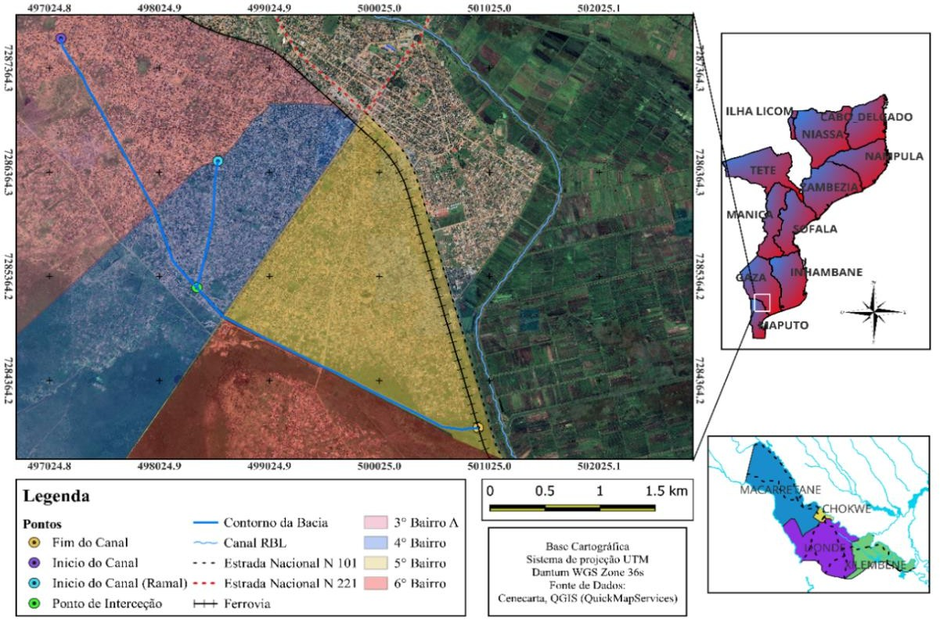
Fig 1: Map of the study area.
Source: Authors.
The methodology applied included estimating the design flow, obtaining the Digital Elevation Model (DEM) and hydrodynamic simulation in the HEC-RAS Hydraulic Model.
  - Estimated Flow Project
The estimate of the peak flow for the different return periods of 2, 5, 10 and 25 years was obtained by applying methodologies based on studies by (Guimarães and da Penha, 2009).
  - Meteorological data
Rainfall data for the region under study was obtained from information provided by INAM, the Mozambican National Institute of Meteorology, which is responsible for meteorological management. Data was made available (Figure 2) for monthly rainfall (mm) for the period from 1965 to 2023 (58 years) for Chókwè city.

Fig 2: Maximum annual rainfall from the historical series.
Source: INAM (2024).
According to the data provided, a maximum annual rainfall of 419.6 to 1967 has been recorded, 372.1 mm for 2021 being rainfall above 350 mm.
  - Gumbel distribution
To estimate the design rainfall, maximum annual rainfall data was used from the historical hydrological series for the Chókwè city, using the Gumbel Distribution to analyze extreme events between the different return periods (2, 5, 10 and 25 years), for durations of 5, 10, 15, 30 minutes and 1 and 24 hours, respectively. This method makes it possible to obtain project rainfall according to rainfall potential, which is necessary for estimating the maximum daily rainfall data for the Chókwè city. Using the Gumbel distribution, the maximum rainfall (Table 1) was determined for the return periods of 2, 5, 10 and 25 years for the Chókwè city. Expression 1 was used to determine rainfall.
Where:
(1)
𝑿̅ is the average maximum rainfall;
S is the Standard Deviation;
TR is the Return Period in years.
Table 1: Maximum rainfall using the Gumbel distribution as a function of each return period.
Maximum rainfall (mm)
Payback Period (Years) | 2 | 5 | 10 | 25
X (Precipitation) | 177.90 | 254.11 | 304.56 | 368.30
Source: Authors.
  - Maximum Rainfall Breakdown
The return periods considered for the duration of 5 min, 10 min, 15 min, 30 min, 60 min (1h) and 1440min (24h) were 2, 5, 10 and 25 years. Based on the study by Francisco et al., (2013), the durations considered for each return period are conditioned by the disaggregation coefficients, Table 2. The disaggregation method is important in obtaining the IDF Curve equation for the Chókwè city, considering Figure 3 where the IDF Curve values can be obtained from the mapping of Mozambique's Climate Zones.
Table 2: Breakdown coefficient of maximum daily rainfall for different durations.
Relationship between  durations | Breakdown coefficient
5min/ 1h | 0,29
10min/ 1h | 0.45
15min/ 1h | 0.57
30min/ 1h | 0.79
1h/ 24h | 0.40
24h/ 1day | 1.13
Source: Francisco et al. (2013).

According to Francisco et al. (2013), the conversion of the maximum rainfall obtained using Equation 1 into rainfall of less than 24 hours and the return periods were based on the coefficients shown in Table 2. This transformation takes into account the rainfall coefficient for each of Mozambique's Climate Zones.
The maximum daily rainfall (Table 3) and rainfall intensity (Table 4) for durations of 5 min, 10 min, 15 min, 30 min, 60 min and 1440 min were generated using the coefficients in Table 2, associated with the return times of 2, 5, 10 and 25 years for Chókwè city.
Table 3: Maximum daily rainfall for each return period as a function of duration.
Maximum Daily Precipitation (mm)
Return Time | Relationship between durations
Return Time | 5min/1h | 10min/h | 15min/1h | 30min/1h | 1h/24h | 24h/1day
2 | 23.32 | 36.19 | 45.84 | 63.53 | 80.41 | 201.03
5 | 33.31 | 51.69 | 65.47 | 90.74 | 114.86 | 287.14
10 | 39.92 | 61.95 | 78.47 | 108.75 | 137.66 | 344.15
25 | 48.28 | 74.91 | 94.89 | 131.51 | 166.47 | 416.18

Table 4: Precipitation intensity for each return period as a function of duration.
 | Precipitation Intensity (mm/min)
 | Duration
Return Time | 5min | 10min | 15min | 30min | 60min (1h) | 1440min (24h)
2 | 279.84 | 217.11 | 183.34 | 127.05 | 80.41 | 8.38
5 | 399.70 | 310.11 | 261.87 | 181.47 | 114.86 | 11.96
10 | 479.06 | 371.68 | 313.86 | 217.50 | 137.66 | 14.34
25 | 579.33 | 449.48 | 379.56 | 263.03 | 166.47 | 17.34

  - Expression for Intensity Duration Frequency Curves (IDF)
The expression of Intensity Duration Frequency Curves (IDF) was determined using rainfall data from the Gumbel distribution adjusted by parameters A, B and C, Table 5. Parameters A, B and C were determined using Equation (2), proposed by Aparicio (2018).
Table 5: Parameter A, B and C for Chókwè city.
A | K | 857.663
B | A | 0.258
C | B | 0.636
I=$\frac{A*T^{B}}{D^{c}}$ (2)
The expression of the IDF Curves for the Chókwè city, Figure 4, is given by the expression.
$I=\frac{857.663*T^{0.258}}{D^{0.636}}$
Where:
I - is the intensity in mm/min;
T - is the Return period in years;
D - is the Duration.

800.00
700.00
600.00
500.00
400.00
300.00
200.00
100.00
0.00
IDF curves
TR=2 Years TR=5 Years
TR=10Years
5 10
D1u5ration (m3i0n)
60
1440

Fig 3: IDF curves for different return times.
Source: Authors.

  - Unit hydrograph
According to Leitão et al. (2017), the Soil Conservation Service (SCS) Model, developed in the 1970s in the United States of America (USA), consists of estimating surplus rainfall as a function of accumulated precipitation, land use and cover, and antecedent moisture. This model is based on the unit hydrograph and the shape of the hydrograph can be estimated from the histogram. The physical characteristics of the river basins, Table 6, are incorporated into the model by the parameters: basin distribution area (ad), peak time (tp), peak flow (qp), concentration-time (tc), and response time (tr):
Using the basin's tc value, tr was estimated using the following relationship:
$tr=0.6tc$ (3)
The value of tp was estimated as a function of the discretization time (td) of the rainfall:
$tp=0.5td+tr$ (4)
The qp was calculated using the formula:
$qp=2.08 ad/tp$ (5)
With the peak flow qp, the hydrographs were estimated from the histograms using the SCS Unit Hydrograph method.
Table 6: Basin characteristics and input data.
Input Data |  | Unit
Slope length | 6.92 | Km
Upstream quota | 32 | M
Downstream quota | 28 | M
Slope (ΔH) | 4 | M
Return Time (TR) | 2; 5; 10 e 25 | Years
Duration time (tc) | 24 | H
Contribution area (ad) | 10.89 | Km²
Rain Discretization Time (td) | 1.20 | H

In order to estimate the unit hydrograph, it was necessary to determine: (1) Curve Number Parameter (CN) and (2) Soil Permeability:
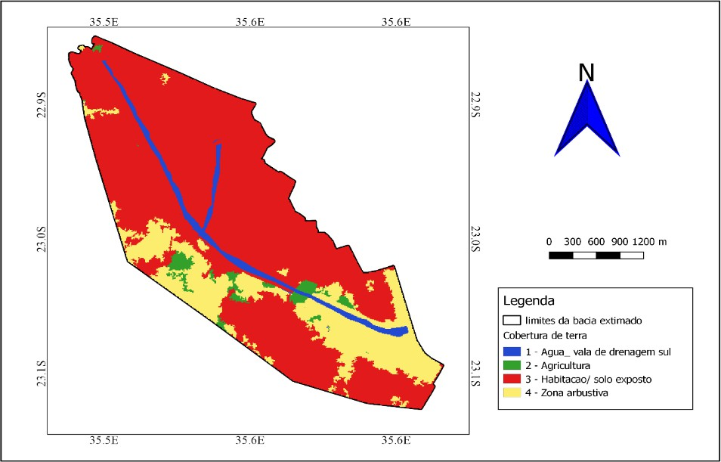
Curve Number (CN) parameter - is characteristic of each hydrological soil group, determined according to land use and land cover (Figure 5). This parameter indicates the probability of surface runoff occurring, taking into account the land use and land cover of the basin under study, considering Table 7 which classifies the hydrological groups and soil infiltration capacity.
Fig 4: Land use and land cover map of the study area.
Source: Authors.
Table 7. Different soil hydrology group and their soil infiltration capacity
Soil Hydrology Group | Soil Description | Infiltration capacity (cm/h)
A | Deep sands and gravels (h>1.50m), very permeable. They have a high infiltration rate even when saturated. Clay content up to 10%. | 1.20-0.80
B | Sandy soils with few fines, shallow (h<1.5m) and permeable. Clay content 10-20%. | 0.80-0.40
C | Shallow soils with subsurface layers that prevent the downward flow of water, or soils with a high percentage of clay (20-30%). | 0.40-0.15
D | Soils composed mainly of clays (above 30 per cent) or soils with a high water table, or soils with clay layers close to the surface, or shallow soils over impermeable layers. | 0.15-0.00
Source: Coutinho et al. (2019).
This parameter is determined using the weighted average expression:
$CN=\frac{\sum{{CN}_{i}A_{i}}}{\sum{A_{i}}}$ (6)
Where:
𝐴_{𝑖} is the area of type i;
𝐶𝑁_{𝑖} is the corresponding CN coefficient for the area of type i;
CN is the resulting CN coefficient.
Soil Permeability - considers the determination of soil type, obtained through laboratory analysis of hydraulic conductivity, carried out using the variable load permeameter, Figure 6, based on local samples from the region under study. This parameter is important in determining the degree of water percolation, which is necessary information for classifying the hydrological group of the soil in the study area (CN parameter). The soil samples were collected from a layer below 30 centimetres of the soil surface using a geological probe and stored in such a way as to maintain soil moisture.
Fig 5: Soil Permeability Test (ISPG Polytechnic Campus Laboratory).
Source: Authors.
  - Topographic Profile (Digital Elevation Model)
A step-by-step methodology was used to generate the Digital Elevation Model (DEM), using Google Earth Pro, TCX Converter 2.0.32 and the geographic information programme QGIS versions 2.18.21 and 3.28.4 as the main tools for characterizing the river basin. The Way tool (paths) was used in Google Earth Pro to pre-process the altitude of the study area in KML format. With the altitudes of the points collected using Google Earth Pro, the points were interpolated using QGIS 2.18.21 in order to have the topography of the terrain. The altitude information of the points collected was pre-processed in TCX-Converter 2.0.32 into CSV data, ensuring that the data could be read in subsequent software. QGIS 3.28.4 was used to define the perimeter of the study area and prepare the digital elevation model, starting with pre-processing to eliminate flaws in the DEM and improve its accuracy.
  - Digital Elevation Model calibration
Once the digital elevation model had been generated using geoprocessing software, the data was checked using Altimeter software version 4.62 in order to verify and validate the generated DEM, where elevations were obtained (Table 8). The Altimeter software has an SRTM (Shuttle Radar Misssion) system, making it possible to obtain terrestrial topography.

Table 8: Field data for calibration of the MDE (Digital Elevation Model).
Field Data (UTM Coordinates)
Main channel | Latitude | Longitude | Height (m)
 | 24.525155° S | 32.971645° L | 32
 | 24.529953° S | 32.974422° L | 30
 | 24.539004° S | 32.979608° L | 29
 | 24.545134° S | 32.982447° L | 29
 | 24.549387° S | 32.986744° L | 28
 | 24.552158° S | 32.993067° L | 28
 | 24.553415° S | 32.994999° L | 27
 | 24.555617° S | 32.999432° L | 27
 | 24.557753° S | 33.003847° L | 27
 | 24.558823° S | 33.006492° L | 27
 | 24.55906° S | 33.007952° L | 27
 | 24.559259° S | 33.008443° L | 26
 | 24.560326° S | 33.010148° L | 25
Secondary creek
1. | 24.535928° S | 32.985644° L | 30
2. | 24.540204° S | 32.985312° L | 29
3. | 24.542485° S | 32.984875° L | 29
4. | 24.546533° S | 32.983822° L | 28
Source: Authors.
  - Simulation and mapping of flood-prone areas
    - Hydrological Simulation
In order to carry out the hydrological-hydraulic simulations, a series of parameters of the basin in question were collected, as well as the information obtained from the geoprocessing of the data using the Google Earth Pro software, in order to carry out the modelling operations of the existing network. This information, according to Delci (2019), is organized in such a way as to obtain:
The digital elevation model (DEM), to represent the topography of the sub-basin;
Delimitation of the basin area and sub-basins of influence throughout the region;
Delimitation of a map of the type of soil in the region.
The Hydraulic Model HEC-RAS 6.5, a mathematical model that allows one-dimensional simulation in natural and artificial channels of laminar, critical or mixed flow in non-permanent and permanent regimes, among other possibilities (Cabrera, 2012). For Monte et al. (2016), they point out that in non-permanent regime studies, data such as flow rate, top bathymetric information for each cross-section, roughness coefficient in each cross-section and an MDE are necessary in the one-dimensional simulation plane.
The topography of the area under study was obtained by integrating two data sources, (i) Google Earth Pro and (ii) QGIS 2.28.21 and 3.28.4, allowing the Digital Elevation Model to be obtained. Pre-processing to define the cross-sections, channel and banks and geometry data was carried out using the GIS extension called HEC-GeoRAS 6.5, thus starting the hydraulic simulation.
    - Mapping flood areas
Based on the hydrological model, the flooded areas were generated. This process was made possible through the results obtained by the digital elevation model and mapped using the GIS programme QGIS 3.28.4 as a way of determining the flooded area of each neighbourhood as a function of the total area of administrative occupation.
The possibility of exporting the results obtained in the simulation within HEC-RAS was crucial in mapping the areas prone to flooding. In this context, using geoprocessing techniques, it was possible to indicate the area prone to flooding in each neighbourhood.
3. results and discussion
  - Project Flow
    - Project hydrograph
The design hydrograph (Figure 7) was crucial in calibrating the hydrological model for non-permanent surface runoff, taking into account the CN of 89 from the characteristics of the type and land use of the hypothetical basin used. The maximum flow was obtained from the IDF curve for each period for the Chókwè city and a time discretization of 1.2 hours. To determine the design hydrograph, the peak flow values for each return period were obtained. These flows comprise variations and return times of 44.46m³ /s for TR 2 years, 56.93m³ /s for TR 5 years, 68.47m³ /s for 10 years and 87.20m³ /s for TR 25 years.
Hydrogramme
100
80
60
40
20
0
TR 2 Years
TR 5 Years
TR 10 Years
TR 25 Years
Time (hours)

Flow (m3/s)

0
2.4
4.8
7.2
9.6
12
14.4
16.8
19.2
21.6
24
26.4
28.8
31.2
33.6
36
38.4
40.8
43.2
45.6

Fig. 6. Hydrographs of design flows for different return periods.
Source: Authors.
According to Delci (2019), the variation in design rainfall is common, taking into account the historical events of the region under study as a function of the projected return periods, recommending for urban drainage networks a duration of 24 hours and a return period of 25 years. This design rainfall was obtained using the Chókwè IDF Curve equation, discretized into 1.2-hour intervals and varying the return period between 2, 5, 10 and 25 years.
Bruno et al. (2022), studying about Hydrological and Hydraulic Modeling Applied to Flash Flood Events in a Small Urban Stream, related that the effects of flow velocity on potential damage caused by floods, suggesting that this indicator is the main one to be considered when dealing with damage to pavements. In the Prosa simulation, we see several points with the water velocity in the channel exceeding the standard limit of 3 m·s-1 for protecting plain concrete channels, which validates images of damaged sections after successive flood events. Among the critical stretches for damage caused by high speeds is the exit of the closed gallery of Via Parque (3.35 m·s-1), repeated steps in the downstream sections (6.02 m·s-1), and the exit of dam number 7 (5.39 m·s-1).
According to study realized by Nadhira Srikandi et al. (2024), the selected rainfall data corresponds to the month with the highest total rainfall over a year with a 10-year return periodThe design hydrograph was important for estimating the flow rate through a given section as a function of time and is important data for calibrating the HEC-RAS model in the non-permanent regime simulation.
3.2. Digital Elevation Model (DEM) of the Project
The Digital Elevation Model (DEM) of the project (Figure 8) generated using HEC-RAS software shows elevations ranging from 25.37 to 32.73 metres. The lower altitudes are predominantly in the area downstream of the study area and the higher altitudes are predominantly in the area upstream of the study area. In order to validate the MDE, the data was authenticated in situ using the Altimeter 4.62 software, and the internal data from the southern drainage ditch was obtained.
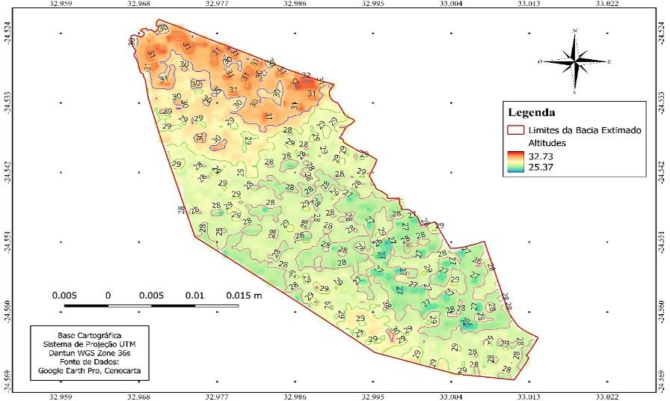
Fig 7. Digital Elevation Model (DEM).
Source: Authors.
The use of geoprocessing techniques to generate the model made it possible to obtain the topographic characteristics of the drainage ditch, however, Campos (2023), emphasizes that the use of high-resolution topographic bases to generate the digital elevation model provides accurate results that are closer to reality.
  - Risk Areas and Floodplain Mapping
With an area of 91Km² and around 67954 inhabitants, of Chókwè city is structured into seven neighbourhoods (1st Neighbourhood, 2nd Neighbourhood, 3rd Neighbourhood A and B, 4th Neighbourhood, 5th Neighbourhood, 6th Neighbourhood and 7th Neighbourhood), two of which have urban characteristics (1st and 2nd neighbourhoods). The 3rd, 4th, 5th and 6th neighbourhoods are semi-urban and the 7th neighbourhood is rural, having emerged after the floods of 2000 (Eurosis, 2020).

  - Areas at Risk of Flooding
According to the data obtained from the Local Urbanization and Construction Service, the 3rdA, 4th, 5th and 6th neighbourhoods have annual growth rates of 31%, 12%, 18% and 32% respectively, showing significant urban growth since the implementation of the southern drainage ditch to the present day at the time of the study of the project, considering Coutinho et al. (2019), the areas waterproofed by housing or access roads, the relief, the type and intensity of precipitation, vegetation cover, infiltration and drainage capacity, all contribute to the intensification of flooding areas.
Figures 8 and 9 illustrate the urban changes in Chókwè city over the last 24 years and Figure 10 illustrates the current situation during the research.
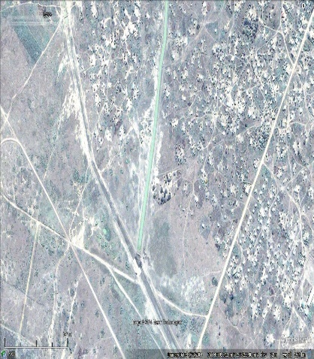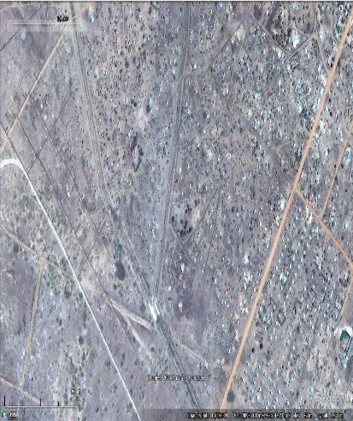
Fig 8. Urban situation of the area in 2004. Fig 9. Urban situation of the area in 2009.
Source: Google Earth Pro (2024).

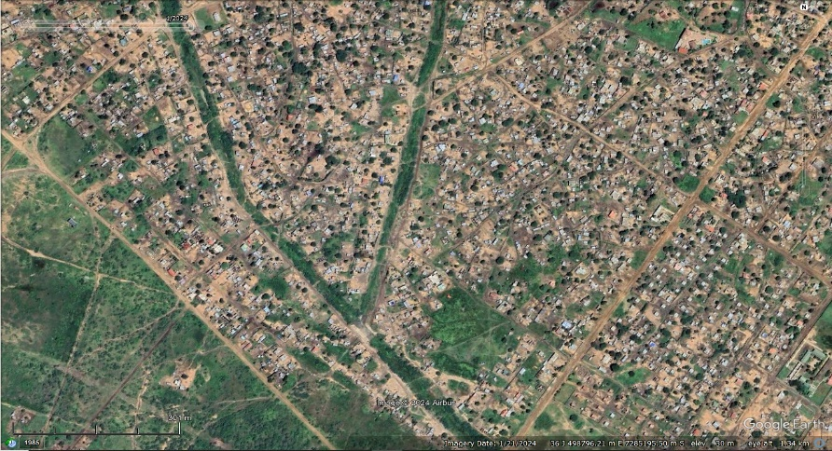
Fig 10. Current urban situation in the area.
Source: Google Earth Pro (2024).
Based on the illustrations of the evolution of the urban situation (Figures 9 to 10), it can be seen that there has been a considerably high level of urban growth, which has greatly impeded the course of the drainage system due to various factors, such as the implementation of infrastructures, disorderly vegetation, among others.
  - Floodplain mapping
Based on Table 9, the 3rd, 4th, 5th and 6th neighbourhoods have areas of 20.48Km²; 5.52Km²; 8.46Km² and 10.43Km², respectively. The 4th neighbourhood is the most affected, with 29.72% and 26.61% of the area flooded in relation to the total area for 2 and 5 year TRs, with maximum altitudes of 2.02 and 2.55 metres, and the 5th neighbourhood with 13.98% and 17.29% for 10 and 25-year TRs, with altitudes of 2.69 and 2.83 metres, with the 4th neighbourhood showing an inconsistent variation in flood spots and the 3rd, 5th and 6th neighbourhoods showing a consistent variation in the flood area as a function of the return periods. These results are based on the topography generated by the digital elevation model (Figure 9) of the study area. For these results, the flood peaks obtained from the HEC-RAS hydrodynamic model were taken into account.
Table 9: Characteristics of the flooded area for different return times.
Return Time | Neighbourhood | Total area (𝐊𝐦^{𝟐}) | Flooded area (𝐊𝐦^{𝟐}) | Percentage (%)
2 Years | 3-A | 20.48 | 0.45 | 2.22
2 Years | 4 | 5.52 | 1.64 | 29.72
2 Years | 5 | 8.46 | 0.13 | 1.64
2 Years | 6 | 10.43 | 0.19 | 1.88
5 Years | 3-A | 20.48 | 0.57 | 2.79
5 Years | 4 | 5.52 | 1.47 | 26.61
5 Years | 5 | 8.46 | 0.70 | 8.37
5 Years | 6 | 10.43 | 0.73 | 7.01
10 Years | 3-A | 20.48 | 0.42 | 2.06
10 Years | 4 | 5.52 | 1.06 | 19.22
10 Years | 5 | 8.46 | 1.18 | 13.98
10 Years | 6 | 10.43 | 1.10 | 10.54
25 Years | 3-A | 20.48 | 0.83 | 4.07
25 Years | 4 | 5.52 | 1.40 | 25.47
25 Years | 5 | 8.46 | 1.46 | 17.29
25 Years | 6 | 10.43 | 1.34 | 12.90

Bruno et al. (2022), studying about Hydrological and Hydraulic Modeling Applied to Flash Flood Events in a Small Urban Stream, reported that the duration of the flooding in this region (the test point being on the avenue, next to the stage sensor) was changed with the intensity of the rain, starting from 0.66 h in the calibration event, rising to 1.06 h, 1.23 h, 1.68 h, and 1.91 h in subsequent modeling. Note that in this region, the time in which the area was submerged was shorter, probably due to the greater capacity of the canalization project (in relation to the section of Via Parque). Considering the largest event computed, the time of arrival of the flood wave in nearby properties was 0.48 h, from the beginning of the rain.
Brito et al. (2024), when carrying out a study on hydraulic modelling applied to flood risk analysis in Brazilian urban areas: the case of the Lagamar Special Zone of Social Interest (ZEIS), Fortaleza (north-east Brazil), found that a 25-year return time is consistent with high rainfall, with a considerably low probability of occurrence (7%), but that rainfall equal to, greater than or very close to this value has already been recorded, such as in 1991, 2004 and 2014. The estimated value for TR 25 is taken as the rainfall benchmark when modelling areas of medium susceptibility to flooding.

Figures 11, 12, 13 and 14 illustrate the dispersion levels of the flood spots in the different TRs.

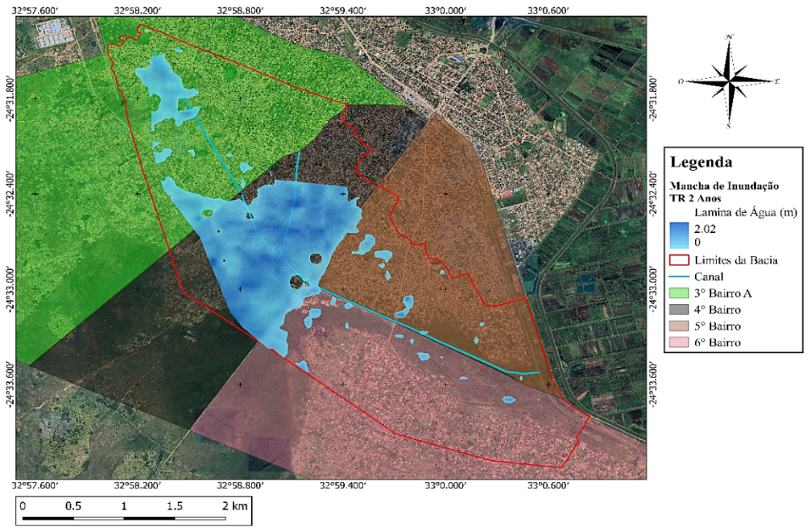
Fig 11. Flooded urban area for the 2-year return period.
Source: Authors.
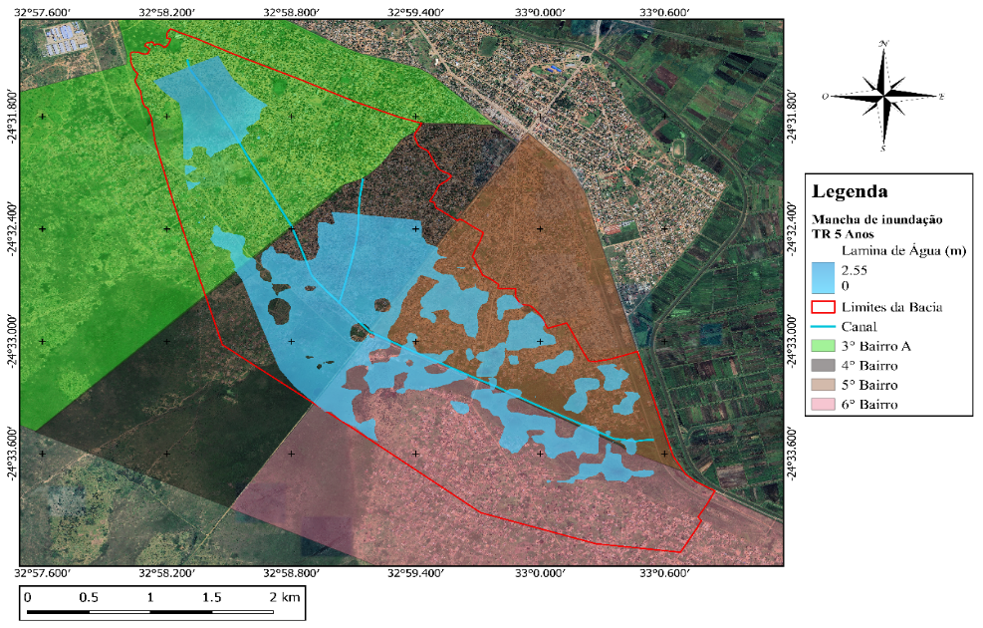
Fig 12. Flooded urban area for the 5-year return period.
Source: Authors.
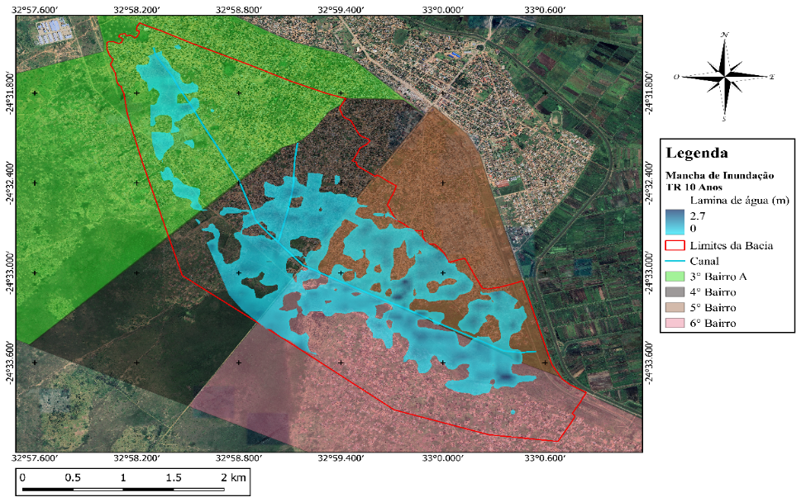
Fig 13. Flooded urban area for the 10-year return period.
Source: Authors.

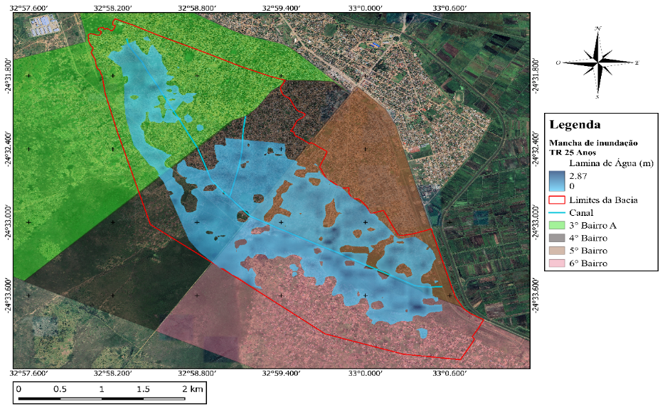
Fig 14. Flooded urban area for the 25-year return period.
Source: Authors.
The 3rd neighbourhood A with 2.2% was the least prone neighbourhood for 2 years, with the 5th and 6th neighbourhoods being the least prone to flooding compared to the 3rd neighbourhood A with 1.6% and 1.8% of flood area compared to the 4th neighbourhood the most affected for the 2-year return time, while for the 5, 10 and 25 return times larger areas were recorded with 8.3%; 13.9% and 17.2% for the 5th neighbourhood and 7%; 10.5% and 12.9% of flood area for the 6th neighbourhood.
These results, according to Trancoso et al. (2013), can be attributed to the topographical conditions of the area under study and the influence of factors such as the lack of urban planning, excessive waterproofing of public roads, waste disposal and pollution that condition the silting up of drainage ditches and springs close to the drainage network. Soil sealing as a result of urban growth contributes to slow surface runoff, especially in regions with soils characteristic of Chókwè city, leading to an increase in maximum flows. Once the flood peak has been reached, the water flows down the southern drainage ditch towards the 5th and 6th neighbourhoods, which in turn become vulnerable due to their location in relation to the catchment basins and the retention of runoff from the urban fabric.

  - Evolution of Floodplains
Based on the results obtained, an analysis was made of the evolution of flood spots in relation to the total area of the basin (Figure 15).
Flooded area (km²)
Basin area (km²)
Return Period
25 Years
10 Years
5 Years
2 Years
2

0
2.43
3.76
3.42
4
5.05
12

10

8

6
Evolution of stains

Fig 15. Evolution of stains at different return times.
Source: Authors.
The basin has a total area of 10.89Km² of hydrological contribution, and for TR 2 years of least impact with 2.43Km² of flooded area corresponding to 22.33% of the total area in relation to TR 5 and 10 years of medium impact, with 3.48Km² and 3.76Km² covering areas of 31.97% and 34.56% respectively and TR 25 years of greatest impact with 5.05Km² of flooded area covering 46.41% of the total area.
4. Conclusion

The MDE generated through the integration of geoprocessing software proved to be satisfactory in representing the topography of the area under study. The SCS method for estimating project flows proved to be applicable, showing increasing flows as a function of return time, with the maximum estimated flow at TR 25 years.
The application of the hydrological model using the SCS unit hydrograph method coupled with HEC-RAS made it possible to characterize the hydrodynamics of the drainage system in order to understand the basin's water intake and retention capacity. 4th district is the most susceptible to flooding, with an average flooded area of 25.2% and an elevation of 2.6 metres, depending on the return periods, since it is the area where the watercourses meet, given that the state of the infrastructure inevitably conditions hydraulic overtopping. The mapping of flood areas generated by HEC-RAS was crucial in obtaining and exporting the results to geographic information software, allowing detailed mapping of flood spots according to the neighbourhoods under study, making it an important tool to help control and monitor scenarios arising from flood management in the urban area under study.
Disclaimer (Artificial intelligence)
Option 1:
Author(s) hereby declare that NO generative AI technologies such as Large Language Models (ChatGPT, COPILOT, etc.) and text-to-image generators have been used during the writing or editing of this manuscript.
References
Alves, M. E. P., Fan, F. M., Paiva, R. C. D. de, Siqueira, V. A., Fleischmann, A. S., Brêda, J. P., Laipelt, L., & Araújo, A. A. (2022). Assessing the capacity of large-scale hydrologichydrodynamic models for mapping flood hazard in southern Brazil. Revista Brasileira de Recursos Hídricos, 27. https://doi.org/10.1590/2318-0331.272220220009.
Ansarifard, S., Eyvazi, M., Kalantari, M., Mohseni, B., Ghorbanifard, M., Moghaddam, H. J., & Nouri, M. (2024). Simulation of floods under the influence of effective factors in hydraulic and hydrological models using HEC-RAS and MIKE 21. Discover Water, 4(1), 1–31. https://doi.org/10.1007/s43832-024-00155-0.
Batista, J. A. do N., & Boldrin, A. J. (2018). Evaluation of the hydraulic performance of an urban rainwater drainage system. Sanitary and Environmental Engineering, 23(2), 263–273. https://doi.org/10.1590/s1413-41522018170663.
Brito, E. R. De, Bastos, F. de H., Cordeiro, A. M. N., Silva, Ícaro B. Da, Paula, D. P. DE, CARVALHO, R. G. DE, & SOARES, H. DOS S. (2025). modelagem hidráulica aplicada à análise de riscos de inundação em áreas urbanas brasileiras: o caso da zona especial de interesse social (zeis) do lagamar, fortaleza (nordeste do brasil). caminhos de geografia, 26(103), 320-340. https://doi.org/10.14393/rcg2610375334.
Bruno, L.S., Mattos, T.S., Oliveira, P.T.S., Almagro, A., Rodrigues, D.B.B. (2022). Hydrological and hydraulic modeling applied to flash flood events in a small urban stream. hydrology. 9, 223. https://doi.org/10.3390/hydrology9120223.
De Oliveira Queiroz, A., da Silva Freitas, F.W., & de Alencar Guedes, J. (2018). Impacts of urbanization on the Termas-Mossoró stream (RN). PENSAR Geogr. 2, 53-72.
Gordon, C. A. (2023). Deriving synthetic rating curves from a digital elevation model to delineate the inundated areas of small watersheds. Journal of Hydrology.
Kumar, V., Sharma, K. V., Caloiero, T., Mehta, D. J., & Singh, K. (2023). Comprehensive overview of flood modeling approaches: A review of recent advances. Hydrology, 10(7), 141
Matos, D. de A. ( 2018). Systemic analysis of the Riacho do Ipiranga-Presidente Tancredo Neves-Bahia sub-basin.
Nadhira, S., Handayani, H. H., Maulana, M. A. (2024). 3D City Modeling for Flood Inundation Analysis in Mayjen Sungkono Area, Surabaya. .IOP Conference Series: Earth and Environmental Science, Volume 1418, Geomatics International Conference GEOICON 2024. Earth Environ. Sci. 1418 012043. https://doi.org/10.1088/1755-1315/1418/1/012043.
Nhaca, E. J. M., José, A. E., Mutie, E. C., Bunga, J. S., & Massingue Júnior, A. A. (2025). Nutritional potential of warm season Lycopersicon esculentum (tomato) in Chókwè district. REVISTA DELOS, 18(65), e4555. https://doi.org/10.55905/rdelosv18.n65-146.

Njoku, C., Efiong, C., Uzoezie, J. C., Okeniyi, F., & Alagbe, A. (2018). A GIS Multi-Criteria Evaluation for Flood Risk-Vulnerability Mapping of Ikom Local Government Area, Cross River State. Journal of Geography, Environment and Earth Science International, 15(2), 1–17. https://doi.org/10.9734/JGEESI/2018/40527.
Perrini, P., Iacobellis, V., Gioia, A., & Cea, L. (2025). A tracer-aided 2D numerical framework to define fluvial and pluvial hazard mapping. Journal of Flood Risk Management, 18(1), e13039. https://doi.org/10.1111/jfr3.13039.
Psomiadis, E., Diakakis, M., & Soulis, K. X. (2020). Combining SAR and Optical Earth Observation with Hydraulic Simulation for Flood Mapping and Impact Assessment. Remote Sensing, 12(23), 3980. https://doi.org/10.3390/rs12233980.
Sekajugo, J., Kagoro-Rugunda, G., Mutyebere, R., Kabaseke, C., Namara, E., Dewitte, O., Kervyn, M., & Jacobs, L. (2022). Can citizen scientists provide a reliable geo-hydrological hazard inventory? An analysis of biases, sensitivity and precision for the Rwenzori Mountains, Uganda. Environmental Research Letters, 17(4), 045011. https://doi.org/10.1088/1748-9326/ac5bb5.
Tsegaye, S., Kebedew, M. G., Albrecht, K. K., Missimer, T. M., Thomas, S., & Elshall, A. S. (2024). Integrated GIS-hydrologic-hydraulic modeling to assess combined flood drivers in coastal regions: a case study of Bonita Bay, Florida. Frontiers in water, 6, 1468354.
Wang, M., Zhao, J., Su, J., Ikram, R. M. A., & Yang, M. (2025). Navigating Flooding Challenges in Historical Urban Contexts: Integrating Nature-Based Solutions with Spatial Multi-Criteria Assessments in Quanzhou. Land, 14(3), 452. https://doi.org/10.3390/land14030452.

