**Rainfall Trend Analysis and Contingent Crop Planning for Temporally Non-submerged Wetlands in North Bihar (Zone I), India**

**Abstract:**  
North Bihar, particularly Zone I, is highly susceptible to climatic extremes such as floods and dry spells, posing significant challenges to agricultural sustainability. This study analyzes 100 years of rainfall data (1923-2022) and develops season-specific contingent crop plans for temporally non-submerged wetlands. Using Weibull’s probability method and regression analysis, seasonal rainfall trends were quantified. In the pre-monsoon season, Sitamarhi, Madhubani, and West Champaran exhibited significant increasing trends of 1.12 mm/year, 0.98 mm/year, and 1.25 mm/year respectively (p < 0.05), while Araria and Supaul showed non-significant trends. Monsoonal rainfall was relatively stable, with minor variations: Supaul (+0.35 mm/year) and Araria (-0.42 mm/year), both statistically non-significant. In the post-monsoon period, significant declining trends were recorded in Madhubani (–0.86 mm/year), Sitamarhi (-0.73 mm/year), and West Champaran (-1.05 mm/year), indicating reduced late-season water availability. These district-specific rainfall patterns guided the development of adaptive crop strategies, such as short-duration and climate-resilient varieties, enhanced water-use efficiency, and cropping calendars synchronized with actual monsoon onset. The study underscores the necessity of rainfall-based planning to boost farm productivity and resilience in climate-vulnerable North Bihar.

**Keywords:** Rainfall variability, Weibull's method, regression analysis, contingent crop planning, North Bihar, climate-resilient agriculture, Zone-I

**1. Introduction**   
North Bihar is highly vulnerable to climatic extremes, particularly floods and dry spells, due to its complex monsoonal behavior and distinctive topographical features. Among its varied landscapes, temporally non-submerged wetlands-areas that remain largely free of waterlogging throughout the year-offer significant potential for adaptive agricultural practices. This study aims to analyze rainfall trends over the past 100 years in Zone I of North Bihar and to formulate season-wise contingent crop plans that mitigate climate risks and enhance farm productivity. Rainfall patterns in the region are highly variable and location-specific, necessitating regionally tailored contingency plans. Timely identification and understanding of rainfall variability are essential not only for agricultural planning but also for maintaining water quality, adjusting water supply and treatment methods, and complying with environmental standards (Horsner *et al.,* 2003). In agriculture, such insights are particularly valuable for selecting appropriate crops, scheduling sowing, and managing water and nutrients in rainfed systems (Parmer *et al.*, 2017). Therefore, effective planning and implementation of site-specific crop strategies-especially in response to diverse and unpredictable weather conditions-are critical for safeguarding the livelihoods of vulnerable smallholder farmers (Alipatra *et al.,* 2014). Rainfall serves as a fundamental climatic factor that governs the dynamics of the hydrological cycle, determines water resource availability, and directly impacts agricultural output, as also noted by Sahu *et al*. (2024). Precipitation over a region plays vital role in determining availability of water resource whereas study of spatiotemporal distribution of rainfall helps in managing precipitation associated risks like drought, flood etc. (singh *et al.,*2024). From November to April, Bihar usually experiences predominantly clear or mildly cloudy skies. Nevertheless, northern parts of the state tend to have more morning cloud cover compared to the afternoons (Climate of Bihar, IMD, Pune, n.d.). In light of these considerations, the present study was undertaken to assess long-term rainfall trends and develop location-specific, adaptive crop strategies for the temporally non-submerged wetlands of Zone I in North Bihar.

**2. Materials and Methods**

**2.1 Study Area**   
The Zone I of North Bihar comprises agriculturally significant districts prone to both drought and flooding. The area primarily depends on monsoonal rainfall for agricultural activities fig.1.

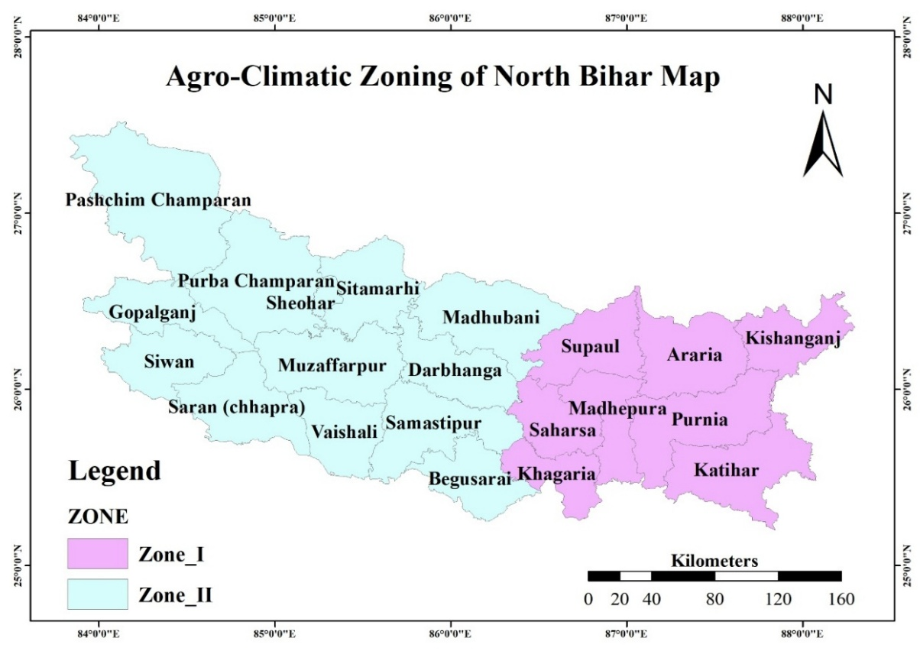

**Fig.1. Agro-Climatic Zoning of North Bihar Map**

**2.2 Data Collection**   
Rainfall data from 1923 to 2022 was collected and categorized into four temporal phases: winter, pre-monsoon, monsoon, and post-monsoon.

**2.3 Statistical Analysis**

* **Weibull's Method:** Used to estimate rainfall probabilities (50%, 70%, 90%) and return periods (25, 75, 100 years).Originally developed by Dr. Walodi Weibull to model the distribution of material breaking strength, the probabilistic Weibull model was later applied to analyze systems or events exhibiting variability. Its flexibility allows it to mimic the properties of various other statistical distributions (Teimouri *et al.,* 2013).
* **Regression Analysis:** Curve estimation is used to detect rainfall trends, with R² values reflecting the strength of these trends. The best-fitting model may take the form of a straight line, a polynomial of higher degree, or a logarithmic or exponential function. One common approach to model selection is the forward method, which begins with the simplest form-a linear model (Y = a + bX or Y = b0 + b1X) (Alexopoulos, 2010).

**3. Results and Discussion**

**3.1 Rainfall Estimation Using Weibull's Method**

* Rainfall decreases with increasing probability levels, indicating higher chances of low rainfall events table 1, 2.   
  **Table 1: The estimated rainfall values at different probabilities.**

| **Target Probability** | **Estimated Rainfall (cm)** |
| --- | --- |
| 50% | 249.00 |
| 70% | 228.00 |
| 90% | 184.00 |

**Table 2: Probable rainfall for selected return periods.**

| **Return Period (Years)** | **Probable Rainfall (mm)** |
| --- | --- |
| 25 | 312.55 |
| 75 | 457.72 |
| 100 | 530.30 |

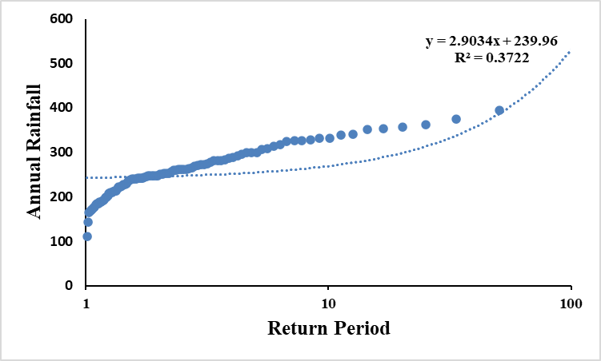

**Fig.2. Weibull's Rainfall Analysis for 100 Years for Zone I**

This fig. 2 illustrates the rainfall variability in Zone I over a century using Weibull’s probability distribution method. The graph highlights the frequency and distribution of annual rainfall, providing insights into the temporal dynamics and climatic trends in the region. The results indicate the occurrence of high variability, critical for flood risk and water management strategies in North Bihar. Understanding the probability density function (PDF) associated with wind speed is critically important for the effective design and implementation of wind energy systems. Over time, numerous probability density functions have been suggested to model and represent the variability and distribution of wind speed data accurately. Among these, the two-parameter Weibull distribution has gained widespread acceptance and is most commonly applied in wind energy assessments due to its simplicity, flexibility, and ability to closely fit observed wind speed patterns (Arslan *et al.*, 2014). Under dryland conditions, the primary cropping season coincides with the northeast monsoon. However, even within this period, the occurrence of dry spells can significantly restrict crop productivity. To address this challenge, providing supplemental irrigation-articularly during the early growth phase and at the maturity stage-can help mitigate the adverse effects of early and terminal droughts, which tend to shorten the effective growing period of crops (Pawar *et al.,* 2015). The Z-value derived from the Mann-Kendall (MK) test is used to indicate the statistical significance of any trend observed in rainfall data, whether increasing or decreasing. On the other hand, the Sen’s slope estimator is applied to quantify the actual rate or magnitude of change, showing how much rainfall has increased or decreased over time. Together, these two methods provide both the direction and strength of trends in rainfall patterns, as reported by Agarwal *et al.* (2021).

**3.2 Regression Analysis of Rainfall Trends**

The findings indicate a moderate level of variability in seasonal rainfall patterns, with the pre-monsoon period exhibiting the most notable upward trend, as shown in Table 3. During this phase, the likelihood of experiencing a wet week exceeds 50 percent, particularly between the Standard Meteorological Weeks (SMW) 23 to 28, 30 to 38, and week 40. This suggests that there is a relatively high probability of rainfall during these specific timeframes. Consequently, this period presents a favorable opportunity for harvesting rainwater, which can be effectively utilized for supplemental or protective irrigation purposes to support crop growth during water-stressed conditions (Sonawane *et al.,* 2021). Linear regression analysis, a widely used parametric statistical method, is one of the most common techniques for identifying and quantifying trends within a time series dataset. This method establishes a mathematical relationship between two variables-typically referred to as the independent and dependent variables-by fitting a straight-line equation to the observed values. Before applying the model, it is essential to determine whether a meaningful relationship exists between the selected variables. Analysis of monthly rainfall data during the rabi season revealed that rainfall in the months of October, December, and February exhibited a rising or increasing trend. In contrast, the months of November and January displayed a declining or downward trend in rainfall. Likewise, the analysis of summer season rainfall indicates a consistent upward trend across all the months of March, April, and May. These findings suggest notable seasonal variability in rainfall distribution (Sharma and Dubey, 2018). All these analytical approaches have systematically and clearly illustrated the varied and non-uniform patterns of rainfall distribution across different geographical regions of India. These findings highlight the need to shift attention from broad, generalized national-level rainfall forecasting systems toward more localized, region-specific forecasting strategies. In a country as vast, ecologically diverse, and agronomically complex as India, significant variations exist not only in rainfall patterns but also in crop types and cropping systems. Therefore, to effectively manage and respond to challenges arising from irregular or abnormal rainfall events, it is essential to develop tailored solutions that address the unique needs of each region. Regional-scale planning and forecasting can offer more accurate and actionable insights for sustainable agricultural practices (Saha *et al.,* 2018).

**Table.3 Summary table of regression equation with corresponding R2 value during 1923-2022 for Zone I**

| **Temporal Phase** | **Regression Equation** | **R²** | **Trend** |
| --- | --- | --- | --- |
| Winter | y = 99.37 - 0.05x | 0.039 | Slight decrease |
| Pre-Monsoon | y = 272 + 0.15x | 0.093 | Increasing |
| Monsoon | y = 400 - 0.07x | 0.001 | Stable |
| Post-Monsoon | y = 508 - 0.21x | 0.031 | Slight decrease |
| Annual Average | y = 184 - 0.04x | 0.005 | Minimal change |

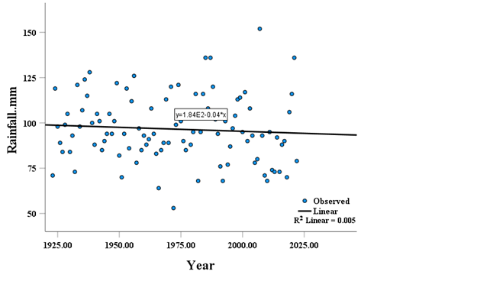

**Fig.3. Regression Analysis Using Curve Estimation for Zone I (Annual Rainfall vs. Year)**

This fig.3 presents the regression analysis of annual rainfall against year of 100 years in Zone I represents the annual rainfall trends in Zone I over a century. The regression analysis revealed a slight decline in rainfall, with an R² value of 0.005, indicating minimal explanatory power of the trendline for the observed data. Despite the weak trend, this figure emphasizes the importance of understanding long-term rainfall variability in the region. A positive value of the Sen’s slope estimator indicates the presence of an upward or increasing trend in the time series data, while a negative value signifies a downward or decreasing trend over the observed period (Panda and Sahu, 2019). 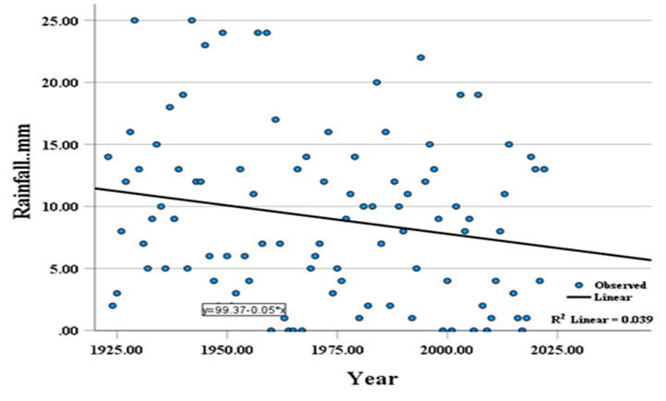

**Fig. 4. Winter Rainfall vs. Year for Zone I**

This fig.4 the plot between Winter Rainfall vs Year of 100 years in Zone I plots winter rainfall against years for Zone I. The regression equation indicates a slight decrease in rainfall over time, with an R² value of 0.039, suggesting weak but noticeable changes in winter rainfall patterns. This has implications for rabi crop cultivation in North Bihar.

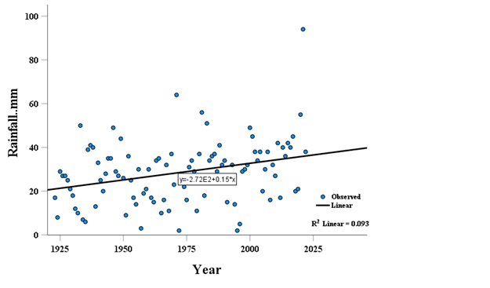

**Fig. 5. Pre-Monsoon Rainfall vs. Year for Zone I**

This fig.5 is the plot between Pre-Monsoon Rainfall vs Year of 100 years in Zone I shows pre-monsoon rainfall trends in Zone I over a century. The regression analysis highlights an increasing trend, with a higher R² value of 0.093, indicating some significance. The upward trend in pre-monsoon rainfall suggests changing climatic conditions that could influence kharif crop sowing periods.

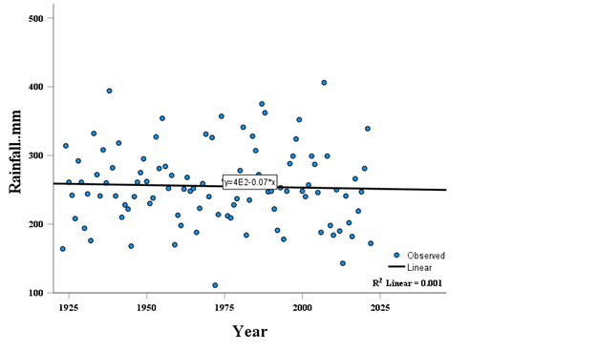

**Fig. 6. Monsoon Rainfall vs. Year for Zone I**

This fig.6 is the plot between Monsoon Rainfall vs Year of 100 years in Zone I captures monsoon rainfall variations in Zone I. The regression analysis revealed minimal change, with an R² value of 0.001, suggesting no significant trend. Monsoon rainfall remains a critical factor for agricultural productivity and flood occurrence in the region.

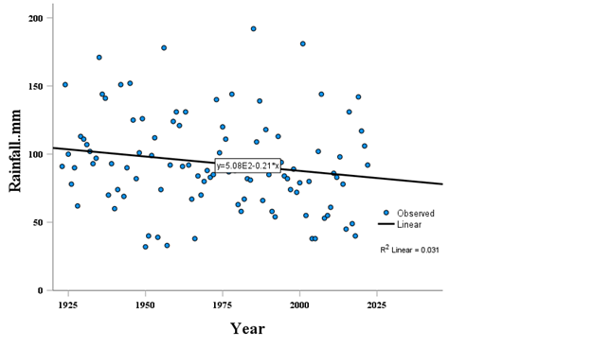

**Fig.7. Post-Monsoon Rainfall vs. Year for Zone I**

This fig.7 the plot between Post-Monsoon Rainfall vs Year of 100 years in Zone I illustrates post-monsoon rainfall trends for Zone I, with a regression analysis showing a slight decrease in rainfall and an R² value of 0.031. Post-monsoon rainfall plays a crucial role in determining overall water availability and directly influences the performance of winter cropping systems. Analysis shows that the area under agricultural land witnessed a significant expansion during the decade from 2000 to 2010, whereas in the following decade, from 2010 to 2020, the increase was relatively minor. In contrast, the extent of natural vegetation cover experienced a notable and sharp decline during the 2010–2020 period. At the same time, there was a considerable rise in settlement areas, indicating a rapid pace of urbanisation during this time (Kumar *et al.,* 2024).

**3.3 Contingent Crop Planning Recommendations**

Based on the analysis, it is evident that farmers have the opportunity to cultivate short-duration crops such as pulses, sorghum, maize, and millets during the summer season. These crops are capable of delivering a reasonably good yield while requiring relatively less water and are also more resilient to drought conditions. Therefore, considering the increasing impact of climate variability, there is a strong need to promote the cultivation and consumption of climate-resilient crops like maize, pulses, and millets to ensure sustainable agricultural practices and food security (Dharani *et al.,* 2023). The “onset of monsoon” method proved more effective and logical than the “meteorological” approach in analyzing rainfall for crop planning. It allows flexible crop scheduling based on the actual week of monsoon arrival and reduces rainfall variability. In contrast, the meteorological method promotes fixed planning, overlooks monsoon timing, and presents broader rainfall variability, limiting its usefulness. Correlation analysis shows a strong negative link (-0.91) between monsoon onset and rainy season duration, and a positive link (0.83) with water deficit. Hence, using the onset-based approach is better for rainfed agriculture to maximize rainfall productivity (Balyan *et al.,* 2018). climate change is now a reality, affecting different agriculture-production systems. To reduce the adverse impacts of climate change on agriculture, various adaptive strategies must be adopted. Adjusting cropping calendars and patterns by introducing suitable alternative crops and varieties can serve as an immediate response. Implementing new crop sequences, selecting early- or late-maturing varieties based on the season length, conserving soil moisture through effective methods, and adopting efficient rainwater harvesting techniques are also essential (Joshi and Kar, 2009). During heavy rains, surplus water can be collected in well-designed structures such as ponds and recharge wells for use during dry periods or critical crop stages to reduce losses. Short- and medium-duration kharif crops like pulses, pearl millet, sorghum, maize, sesame, groundnut, and vegetables can be effectively cultivated with proper farm management (Sevak *et al.,* 2018).

**Winter Season (Rabi Crops)**

The rainfall analysis indicates a slight decline in winter rainfall over time with an R² value of 0.039. Although winter rainfall contributes minimally, it is crucial for rabi crops like wheat, mustard, and lentils.

* Promote early sowing of wheat and mustard using residual soil moisture.
* Adopt water-saving techniques such as zero tillage.
* Provide supplemental irrigation through farm ponds or tube wells.
* It is advised to initiate various agricultural operations, including pre-sowing land preparation and related activities, between June 10 and June 25, considering the expected onset of the monsoon in that particular year. To safeguard the livelihoods of farmers reliant on crop production, it is essential to design and apply on-ground adaptation strategies in response to climate change (Singh, 2023). For upland areas, cultivating short-duration, extra-early, or early-maturing paddy varieties (ranging from 80 to 110 days) is considered appropriate. Given the persistent challenges brought about by climate change, especially in drought-prone regions, implementing climate-resilient strategies rooted in comprehensive rainfall pattern analysis becomes increasingly vital for securing food supplies and improving overall agricultural performance (Mohanty *et al.,* 2025).

**Pre-Monsoon Season**

The regression analysis shows an increasing trend in pre-monsoon rainfall, with an R² value of 0.093. This suggests opportunities for early crop establishment and improved water availability during this period:

* Introduce early-sown pulses like green gram and black gram.
* Apply moisture retention practices such as mulching.
* Encourage agroforestry systems to support rural livelihoods.

**Monsoon Season (Kharif Crops)**

Monsoon rainfall shows no significant trend (R² = 0.001), indicating stable but variable rainfall patterns. The monsoon is critical for paddy, the dominant kharif crop in North Bihar:

* Promote short-duration paddy varieties like 'Swarna Sub-1'.
* Develop village-level flood contingency plans.
* Encourage crop-livestock integration for resilience.

**Post-Monsoon Season**

Post-monsoon rainfall exhibits a slight decreasing trend (R² = 0.031). This season is crucial for residual soil moisture management and late-season crops:

* Promote late-sown pulses (chickpea, lentil) and oilseeds (mustard, linseed) to utilize residual moisture.
* Cultivate late-sown pulses and oilseeds using residual moisture.
* Use sprinkler and drip irrigation systems.
* Grow cover crops for soil fertility and erosion control.

**3.4 Flood Contingency Measures**  
For flood-prone areas:

* Use flood-tolerant varieties like 'CR Dhan 502'.
* Implement raised bed planting.
* Encourage direct-seeded rice after floods.

**General Recommendations:**

1. Establish community-managed seed banks with stress-tolerant varieties.
2. Strengthen irrigation infrastructure.
3. Train farmers in climate-resilient practices.
4. Disseminate weather-based agro-advisories.

**5.Conclusion**  
This study provides a comprehensive assessment of long-term rainfall patterns in Zone I of North Bihar and their implications for adaptive agricultural planning in temporally non-submerged wetlands. By utilizing historical rainfall data (1923-2022) and applying methods such as Weibull's probability analysis and regression-based trend estimation, the research identifies distinct seasonal rainfall variations and highlights opportunities for climate-resilient farming interventions. The results indicate a rising trend in pre-monsoon rainfall and slight declines during winter and post-monsoon periods, while monsoon rainfall appears relatively stable. These insights are critical for planning season-specific contingent crop strategies, such as early sowing of rabi crops using residual moisture, adoption of short-duration kharif crops, and improved water management practices. The study recommends promoting drought-resilient and flood-tolerant crop varieties, enhancing rainwater harvesting systems, and encouraging localized planning based on actual monsoon onset. Finally tailoring crop plans to local rainfall behavior-supported by long-term climatic data-can significantly strengthen the resilience of smallholder farmers in North Bihar against the increasing challenges posed by climate variability. The findings serve as a foundation for informed decision-making and sustainable agricultural development in flood- and drought-prone regions.

**Disclaimer (Artificial intelligence)**

Option 1:

Author(s) hereby declare that NO generative AI technologies such as Large Language Models (ChatGPT, COPILOT, etc.) and text-to-image generators have been used during the writing or editing of this manuscript.

**References**

Agarwal, S., Suchithra, A. S., & Singh, S. P. (2021). Analysis and interpretation of rainfall trend using Mann-Kendall's and Sen's slope method. *Indian Journal of Ecology*, *48*(2), 453-457.

Alexopoulos, E. C. (2010). Introduction to multivariate regression analysis. *Hippokratia*, *14*(Suppl 1), 23.

Alipatra, A., Banerjee, H., & Ray, K. (2014). Contingency crop planning for aberrant weather situtations. *Crop Improvement in the Era of Climate Change. IK International Publishing, Bangalore*, 164-180.

Arslan, T., Bulut, Y. M., & Yavuz, A. A. (2014). Comparative study of numerical methods for determining Weibull parameters for wind energy potential. *Renewable and Sustainable Energy Reviews*, *40*, 820-825.

Balyan, J. K., Kothari, A. K., & tar, R. (2018). Contingent Crop Planning for Proactive Monsoon Management under Rainfed Regions. *International Journal of Current Microbiology and Applied Sciences*, *7*(11), 845–854.

Dharani, C., Maragatham, N., Geethalakshmi, V., Ramanathan, S. P., & Kannan, B. (2023). Crop planning using rainfall variability and probability analysis for Madurai district of Tamil Nadu. *Indian Journal of Agricultural Research*, *57*(6), 740-747.

India Meteorological Department. (n.d.). Climate of Bihar. IMD, Pune. Retrieved May 10, 2025, from<https://imdpune.gov.in/library/public/Climate%20of%20Bihar.pdf>

Joshi, N. L., & Kar, A. (2009). Contingency crop planning for dryland areas in relation to climate change. Indian Journal of Agronomy, 54(2), 237-243.

Kumar, J., Rajesh, G. M., Singh, G., Sambasiva Rao, P., Kumar, P., & Ankit. (2024). Monitoring Land Use Dynamics and Agricultural Land Suitability in Samastipur District, Bihar Using Landsat Imagery and GIS. *Journal of Climate Change*, *10*(4), 43-53.

Mohanty, T. R., Nag, T., Sahu, C. K., & Panigrahi, G. (2025). Rainfall Trend and Variability Analysis for Resilient Crop Planning in Drought Prone Bolangir District of Odisha, India. *International Journal of Environment and Climate Change*, *15*(4), 16-23.

Panda, A., & Sahu, N. (2019). Trend analysis of seasonal rainfall and temperature pattern in Kalahandi, Bolangir and Koraput districts of Odisha, India. *Atmospheric Science Letters*, *20*(10), e932.

Parmar, S., Sharma, S. K., Nath, D., Chaudhary, R. S., & Patidar, N. K. (2017). Long-Term Rainfall Data Analysis for Contingency Crop Planning for Indore Region of Madhya Pradesh.

Pawar, P. B., Jadhav, J. D., Patil, S. R., & Amrutsagar, A. M. (2015). Weekly rainfall variability and probability analysis for Solapur in respect of crop planning. The Ecoscan, 9(1&2), 117-122.

Horsner, M., Ingeduld, P., & Svitak, Z. (2003). Real time analysis for early warning systems and contingency planning. *Vodni Hospodarstvi*, *53*(9), 235-240.

Saha, S., Chakraborty, D., Paul, R. K., Samanta, S., & Singh, S. B. (2018). Disparity in rainfall trend and patterns among different regions: analysis of 158 years’ time series of rainfall dataset across India. Theoretical and Applied Climatology, 134, 381-395.

Sevak, D., Patel, P. H., Chaudhary, M. G., & Desai, A. I. (2018). Variability and trend analysis of rainfall for crop planning and management. *Int. J. Agric. Sci*, *10*(6), 5554-5557.

Shankar, A., & Sharma, M. R. (2025). Rainfall variability and trends in different agroclimatic zones of Bihar, India. *Journal of Agrometeorology*, *27*(1), 100-103.

Sharma, K. K., Singh, A. K., & Dubey, S. K. (2018). Rainfall trend analysis for crop planning under rainfed conditions in district Agra of Uttar Pradesh. *Mausam*, *69*(4), 599-606.

Singh, P. (2023). Crop models for assessing impact and adaptation options under climate change. *Journal of Agrometeorology*, *25*(1), 18-33.

Singh, P., Mall, R. K., & Singh, K. K. (2024). District wise spatiotemporal analysis of precipitation trend during 1900-2022 in Bihar state, India. *MAUSAM*, *75*(4), 1059-1070.

Teimouri, M., Hoseini, S. M., & Nadarajah, S. (2013). Comparison of estimation methods for the Weibull distribution. *Statistics*, *47*(1), 93-109.

UR Sonawane, Kamble, A., BW Bhuibhar, & Jadhav, M. (2021). Dry and wet spell probability analysis by Markov chain model at Parbhani, Maharashtra. *International Journal of Chemical Studies*, *9*(4), 271–275.

Sahu, K. K., Chandniha, S. K., Nema, M. K., Das, G. K., V, H. L., & Warware, P. (2024). Block-level long-term rainfall variability using trend analysis in a state of central India. *Journal of Water and Climate Change*, *15*(1), 1-28.