Removal of Copper (ii) ions from Synthetic Waste Water Using Fe₂O₃ Magnetic Nanoparticles

.
Abstract

Many techniques have been developed to treat heavy metals, including adsorption. The present work aims to treat synthetic wastewater polluted with copper by magnetic nanoparticles. The range of the studied parameters is: pH 3-9, adsorbent dose 10-70 mg, contact time (CT) 5-60 minutes, magnetic field strength (MFS) 1.5-5.5 Tesla, and initial copper concentration(Co) 2-8 mg/L. Batch experiments were conducted using a jar test apparatus to obtain the best conditions for Copper removal. The results indicated that the highest removal efficiency for copper is 82.35% under the following operating conditions: pH 5, CT 20 minutes, Dose 50mg /l, MFS 3 T, and copper initial concentration(Co) 2 mg/l. It is found that the Langmuir adsorption model fairly fits the experimental data, which implies that there was a monolayer adsorption of Cu⁺². The adsorption capacity under the operating parameters that give maximum removal efficiency is 12.36 mg/g. However, the obtained adsorption capacity ranges from 9.10 to 855.58 mg/g. The results also indicate that copper removal is increased with time, dose, and magnetic field strength, while it decreases with copper concentration. Moreover, copper removal increases till the pH of 5 and then decreases.

Keywords: Copper; Magnetic nanoparticles, Adsorption, Isotherm, Wastewater

- Introduction
Pollution is always associated with technical and industrial development, resulting in many environmental challenges. Various industrial wastewater contains a non-biodegradable compound that cannot be easily removed (Giannakis et al, 2021). Water contamination and heavy metals have become a global environmental issue. Many industries, such as metal processing operations and oil refineries, represent significant sources of heavy metal emissions. Thus, the treatment of heavy metals is of great importance. In most cases, wastewater treatment plants in the petrochemical industry and oil refineries cannot bring wastewater within the required specifications, so there is a great need to treat industrial effluents containing heavy metals.
Technologies have been developed to solve this problem, including chemical precipitation (Gonzalez-Munoz et al, 2006), adsorption (Namasivayam and Sangeetha, 2006), membrane filtration (Suhyun et al, 2021), electrochemical treatment (Tran et al, 2017), ion exchange (Verbych et al, 2005), and magnetic nanoparticle treatment (Zargoosh et al, 2013). Different techniques are combined for better removal (Blöcher et al, 2013; Kanamarlapudi et al, 2018). Among these techniques, adsorption is one of the most extensively used.
“Nanomaterials have gained much attention since they have provided a promising approach to removing heavy metals from wastewater. Numerous nanomaterials have been exploited in many fields, including electron devices” (Fatikow et al, 2012), health care )Kumar et al, 2015), energy (Pumera, 2011), and the environmental protection field (Zargoosh et al, 2013). “In general, nanomaterials are materials whose external dimensions are in the nanoscale (usually 1–100 nm)” (Buzea and Pacheco, 2017). “Under the nanoscale, nanomaterials often exhibit some properties, such as a surface effect, small size effect, quantum effect, and macro quantum tunnel effect” (Sezgin, 2018). “These properties contribute to an excellent adsorption capacity and reactivity, both of which are favorable for the removal of heavy metals. Many studies on nanomaterials have been carried out to investigate their applications in heavy metal treatment and have exhibited great potential as a promising alternative to adsorb heavy metals” (Zargoosh et al, 2013; Kumar et al, 2015; Vunain et al, 2016; Kennedy et al, 2017; Al-Jabri et al, 2018; Lim et at, 2018; Aya et al, 2019; Olivija et al, 2019; Li-Ting et al, 2020; Anbalagan et al, 2021; Zhongbing et al, 2021; Sajid et al, 2022; Muradiye et al, 2023; Delasa et al, 2024; Mohammed, 2024; Jinghan et al, 2025). Nanomagnetic adsorbents have many advantages in water treatment, such as low treatment time and high removal efficiency (Shahmirzadi et al, 2018). Iron oxide nanoparticles have received substantial attention because of their optical, electrical, and magnetic capabilities at the nanometer scale.
A modified magnetic nanoparticle with benzotriazole is used by Jadidian et al, (2014) to remove copper from water and wastewater. The non-modified magnetic iron oxide nanoparticles give 49.6% copper removal, however, the modified magnetic nanoparticles improved the efficiency up to 99.7%. They found that the required time for complete copper removal is 5 minutes, and pH variation does not affect removal efficiency. Magnetite nanoparticles are synthesized by the co-precipitation method to remove copper from an aqueous solution by batch adsorption under various pH, contact times, stirring speed, adsorbent dosage, and influent concentration. The results show that copper removal increases with time, concentration, dose, and stirring speed while it decreases with pH (Al-Jabri et al, 2018). Magnetite Fe₃O₄ supported on activated carbon and oxidized activated carbon was prepared by Aya et al, (2019) using a co-precipitation method and used to remove copper ions from wastewater. They found that copper removal increases with time and dose, while it decreases with copper concentration. Moreover, they found that copper removal increases with the increase of pH until pH 5, then decreases. They got 96.5% removal within 30 minutes (Aya et al, 2019). A novel nano adsorbent, based on irreversibly linked amino-rich polymer onto previously silica-coated magnetic nanoparticles, is developed by Olivija et al, (2019) and used to remove copper 5-150 mg/l, dose 100 mg/l, pH 3-6. They found that adsorption capacity increases with increasing copper concentration and pH. Moreover, the prepared adsorbent can be regenerated for four cycles (Olivija et al, 2019). Low-Cost magnetic adsorbent is prepared by Li-Ting et al, (2020) to remove copper. The adsorption capacity is found to be 22.41 mg/g. They found that the adsorption capacity increases with time and pH. Moreover, they performed five consecutive adsorption-desorption cycles and found the adsorption capacity remained over 82% of the original value (Li-Ting et al, 2020). Maghemite (γ-Fe₂O₃) and magnetite (Fe₃O₄) nanoparticles were synthesized to remove copper and chromium. It is found that copper removal increases with time, dose, and pH, and maximum removal is 92 % (Anbalagan et al, 2020). A recyclable adsorbent is synthesized through the oxidation of an enhancer modified with magnetic nanoparticles and used to investigate the adsorption performance and mechanism in heavy metals removal. The adsorption results indicate that this adsorbent has a maximum adsorption capacity of 215.05 mg/g for Pb. They also found that Pb has a stronger attraction than Cu and Cd since the covalent index of Pb is (6.41), larger than that of Cu (2.98) and Cd (2.71). These data provide a new type of recyclable adsorbent for efficient treatment of heavy metal ions. They found that the adsorption capacity increases with time and pollutant concentration. However, it increases with pH until 7, then decreases. They also found the adsorption capacity for Pb, Cu, Cd, Ni, and Zn was reduced under competing conditions due to competition on the same adsorption sites (Zhuowen et al, 2022). “Cured epoxy resin- lignin, nanomagnetic interpenetrating polymer network derived from cured epoxy with amine hardener and Lignin was synthesized by sequential polymerization in the presence of Fe₃O₄” by Sajid et al, (2022). The prepared adsorbent was used to remove Cu, Pb, Co, and Cd under different conditions such as pH and time. They found that adsorption capacity increases with time and the optimum pH is 6. The experimental data agrees with the Langmuir model (Sajid et al, 2022). A synthesized silver magnetic iron/copper and iron oxide nanoparticles to remove Cd(II), Pb(II), Ni(II), and Cu(II) ions from aqueous phases. The results show that the order of removal was found to be 98.39, 75.52, 51.54, and 45.34%, for Pb(II) > Cu(II) > Cd(II) > Ni(II), respectively. Out of many models, the Langmuir model fits the experimental data. The adsorbent is unaffected after three regenerations (Muradiye et al, 2023). Abdulsalam et al. (2023) prepared two types of Organo-modified bentonite clay and used them to remove Emerging Contaminants (EC) from Kaduna Polytechnic female hostel wastewater. The surface area for directly modified bentonite clay and oxalic acid-pretreated bentonite clay adsorbent was found to be 625 m2/g and 349.2 m²/g, respectively. They found that the pollutant removal increases rapidly with the increase of time (till 40 minutes) and adsorbent dose (till 0.4g) and then tends to level out. The Freundlich model fit the experimental data better than the Langmuir model, indicating chemisorption. Abdullahi et al, (2023) prepared two types of organo-modified activated carbon from sugarcane bagasse and used it to remove emerging contaminants. The surface area of a direct modified activated carbon and the acid-pretreated activated carbon were 572 m²/g and 356 m²/g, respectively. They found that increasing contact time until 20 minutes for direct modified activated carbon will increase the pollutant removal, then it tends to level out. For acid-pretreated activated carbon, pollutant removal will increase up to 40 minutes, then it levels up. They found that increasing the dose up to 1 g will increase the pollutants removal for both adsorbent types, then it levels out. The Freundlich model fits the experimental data better than the Langmuir model, indicating chemisorption. An efficient adsorbent was prepared by Delasa et al, (2024) using a porous magnetic Graphene/EDTA composite. They used it to remove copper ions from wastewater. They stated that the high adsorption capacity (150.6 mg/g) assures its suitability for copper ion adsorption. The experimental data follow the pseudo-second-order kinetic model and the Langmuir isotherm model. The adsorption capacity increases with time until 4 hours and then levels out. Moreover, they found the desorption process efficiency of 95%, indicating good recyclability (Delasa et al, 2024). Silver nanoparticles were prepared using the extract plant “Albizia odoratissima by (Mohammed, 2024) and used to remove Pb and Cu ions from their aqueous solutions. The equilibrium time is 40 minutes. The adsorption capacity for Pb is higher than that for Cu. Subhashree et al, (2024) stated that pollution of water bodies has become an important issue since harmful pollutants find their way to water sources, reducing their quality. Thus, wastewater must be treated before its disposal. Adsorption is considered one of the most important treatment methods due to its simple in use and eco-friendly nature. He reviewed a lot of literature and said that there are different kinds of adsorbents. However, there is still a need to develop more suitable adsorbents with selective pollutant removal capacity and good economic feasibility. They mentioned that each adsorbent has its characteristics, including pore structure, porosity, and presence of various functional groups. They stated that a lot of waste materials can be used as adsorbents, such as fruit, coconut shells, scrap tires, bark, and other tannin-rich materials. However, adsorbents can be prepared from various plant and animal derivatives. They compared the adsorption capacities of different adsorbents and found that it depends highly on the nature of the adsorbent. Jinghan et al, (2025) applied magnetic precipitation separation to remove copper of ultra-low concentrations from wastewater. They used Fe₃O₄ nanoparticles and Na₂S and got 99.75 % copper removal within 30 seconds. Moreover, Fe₃O₄ nanoparticles were regenerated using ultrasound, maintaining 98 % removal efficiency of Cu⁺² after six consecutive cycles (Jinghan et al, 2025).
Baiji oil refinery suffers from high concentrations of heavy metals in the wastewater leaving the industrial wastewater treatment units, exceeding the permissible limits according to Iraqi specifications. There is no specialized unit for the treatment of heavy metals, so it is necessary to study the possibility of treating this wastewater to remove heavy metals using iron oxide nanoparticles, Fe₂O₃. In the present work, an effort is made to remove copper from synthetic water under various operating parameters: pH, initial copper concentration, contact time, dose of ferric oxide, and magnetic field strength.

2. Materials and Methods
2.1 Materials
- Wastewater Samples; Industrial wastewater was prepared using hydrated copper chloride
- Hydrated copper chloride; (purity >99.8%, CAS # 10125-13-0) purchased from Shandong/China.
- Sodium hydroxide pellets; (purity 96.70%, CAS # 1310-73-2) purchased from Sigma Aldrich/ Germany.
- Hydrochloric acid solution; (purity 37% ,CAS # 7647-01-0) purchased from Sigma Aldrich/ Germany.
- Iron Oxide Nano Particles α-Fe₂O₃; Iron Oxide Nano Particles (α-Fe₂O₃), supplied by Nanjing Nano Technology-China, is used as an adsorbent in the present work. This material is chosen because it is an effective absorbent, most widely used, and the least expensive; moreover, it is easily separated under a magnetic field. Figure 1 shows Iron oxide nanoparticles through the lens of the SEM device while Table 1 shows some of its properties.
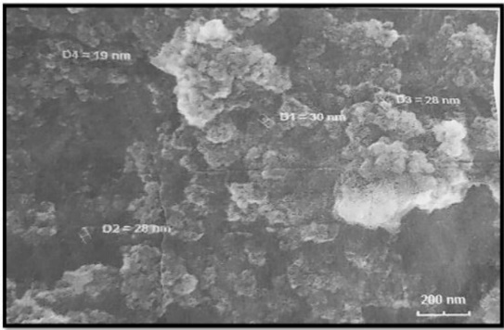

Figure 1. SEM for α-Fe₂O₃ particles
Table 1. Some properties of α-Fe₂O₃
Chemical formula | α-Fe₂O₃
Molar mass (g/mole) | 159.687
Appearance | Red-brown solid
Average particle size (nm) | 20-30
BET Surface area (m²/g) | 93.85
Specific gravity | 2.35

2.2 Apparatus and Tools
The jar test apparatus (Richmond model, Virgin A23230) was used to perform batch scheme experiments (Figure 2). Programmable jar testers are used in the current work. Its specifications are Phipps & Bird PB-900, made in the USA. It is present in the Tikrit University/Environmental Engineering Department. The device consists of six transparent cylindrical glass containers and six mixers, each with a blade length of 50 cm, a diameter of 1 cm, and a speed regulator ranging from 0-450 revolutions per minute.
An atomic absorption device (Figure 3), a flame emission spectrometer, Shimadzu, model AA-6200, Japan, is used to measure heavy metal concentration according to ASTM D1688-17.
Magnets permanent magnets (supplied by Nanjing Huajin Magnet Co. Ltd /China) are employed to provide a steady magnetic field. The bottom of the beaker has magnets linked to it. Figure 4 shows the used magnet while Table 2 includes the technical data of the magnets.
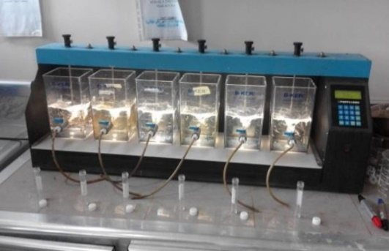

Figure 2. Jar test apparatus

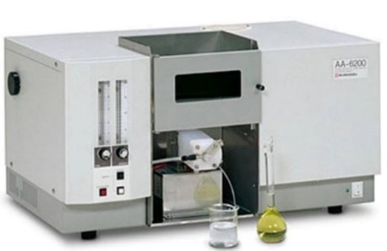

Figure 3. Atomic Absorption
Spectrophotometer
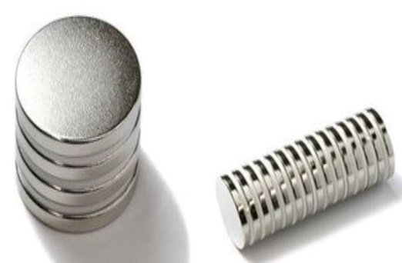

Figure 4. Magnets

Table 2. Technical data of the magnets
Item | Description
Material | Neodymium-Iron-boron (NdFeB)
Shape | Disc
Diameter | 25 mm
Thickness | 3 mm
Tolerance | ± 0.1 mm
Coating | Nickel-plated (Ni-Cu-Ni)
Maximum working temperature | 80 °C
Weight | 11 g
Magnetic flux density | 1.45-1.48 Tesla

pH – Temp. meter - Model HANNA (HI 83141) /Romania. pH of the solution is measured according to ASTM E70-19
Electrical Balance Adventure Pro AV 313C model, made in Japan.
2.3 Experimental setup
The most important parameters that affect the processes are initial concentration, contact time, pH, dose of adsorbent NPS Fe₂O₃, and magnetic field strength. The range of values of these operating variables is listed in Table 3. To employ a full factorial scheme,1280 experiments are required to cover the above-mentioned parameters. Moreover, additional experiments are required to investigate the effect of competing ions and the effect of NPS Fe₂O₃ regeneration on the removal efficiency. To minimize the number of experiments, a semi-full factorial scheme is followed.

Table 3. Operating parameters Range
Parameter | Values
Heavy metal | Cu
Initial copper concentration, mg/l | 2, 4, 6, 8
Dose of NPS, (mg) | 10, 30, 50, 70
Magnetic field strength, Tesla | 1.5, 3, 4.5, 5.5
pH | 3, 5, 6, 7, 8, 9
Contact time, (minutes) | 5, 10, 20, 30, 60

In the first scheme, many experiments are performed to investigate the effect of contact time on removal efficiency. Depending on the result of this scheme, the time is fixed for the next scheme. In the second scheme, the effect of pH on removal efficiency is investigated. pH that gives the best results is fixed for the next scheme. Many experiments are performed in the third scheme, in which pH and time are fixed depending on the results of the first and second schemes. Many experiments were performed to test the effect of initial pollutant concentration, magnetic field strength, and dose of MNPS Fe₂O₃ on the removal efficiency. In the fourth scheme, depending on the best result obtained from the previous schemes, many experiments are performed to investigate the effect of competing ions on the removal efficiency. Finally, nanoparticles are regenerated and employed to perform many experiments under the best conditions obtained from previous schemes to investigate the performance of NPs Fe₂O₃ nanoparticles at different stages of regeneration.

2.4 Experimental Procedure
Each Experiment was performed according to the following procedure:
1. Wash and clean all containers, the Jar test device, and accessories using distilled water.
2. Prepare the required Cu⁺² solution with the required concentration.
3. Put 500 ml of Cu⁺² polluted water into the jar test vessel.
4. Adjust the pH to the desired value using 1.0 N HCl or 1.0 N NaOH.
5. The required dose of nano particles Fe₂O₃ is added.
6. Apply rapid mixing at 250 rpm for 5 minutes followed by slow mixing at 30 rpm for 15 minutes.
7. Mixers are turned off, and the magnets are attached to the bottom of the beaker from the outside for 10 minutes.
8. Samples of wastewater are taken from the top of the beaker at different time intervals and analyzed to measure Cu concentration.

2.5 Calibration Curve Many
Samples of different known Cu concentrations are prepared and tested by an atomic absorption apparatus to determine the absorbance. These data are graphed in Figure 5, which is used to determine the concentration of Cu in the unknown sample.

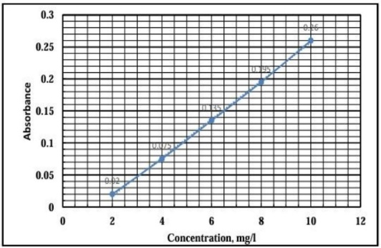

Figure 5. Calibration curve

2.6 Adsorption Models
The most famous models used to represent adsorption data are the Freundlich and Langmuir models (Equations 1 and 2, respectively), (Freundlich 1926, Langmuir 1918).
$$q_{e}=K{C_{e}}^{\frac{1}{n}}………..(1)$$
$$\frac{C_{e}}{q_{e}}=\frac{1}{a}C_{e}+\frac{1}{ab}……(2)$$
Where;
a = maximum adsorption capacity, mg/g
b = Langmuir constant, l/mg.
$C_{e}$= equilibrium concentration, mg/l
K = Freundlick model constant, (mg/g)(l/mg)1/n
n = Freundlich model constant, dimensionless
qe = adsorbed pollutant mass per unit mass of adsorbent, mg/g

Equation 1 can be written in the following formula;
$${log⁡(q}_{e})=logK+\frac{1}{n}\log{C_{e}}………..(3)$$
A plot of log(qe) versus log(Ce) will give a straight line of slope equal to 1/n and intercept of log(k). Similarly, a plot of Ce/qe versus Ce will give a straight line of aslope=1/a and intercept =1/(ab).

- Results and Discussions
To employ a full factorial scheme,1280 experiments are required to cover the studied parameters. Moreover, additional experiments are needed to investigate the effect of competing ions and the effect of MNPS Fe₂O₃ regeneration on the removal efficiency. To minimize the number of experiments, a semi-full factorial scheme is followed. For this purpose, the present work is divided into four schemes.
In the first scheme, many experiments are performed to investigate the effect of contact time on removal efficiency. Depending on the result of this scheme, the time is fixed for the next scheme. The effects of pH on removal efficiency are investigated in the second scheme. pH that gives the best results is fixed for the next scheme. Many experiments are performed in the third scheme, in which pH and time are fixed depending on the results of the first and second schemes. Many experiments were done to test the effect of initial pollutant concentration, magnetic field strength, and dose of MNPS Fe₂O₃ on the removal efficiency. In the fourth scheme, depending on the best result obtained from the previous schemes, many experiments are performed to investigate the effect of competing ions on the removal efficiency. Finally, Nanoparticles are regenerated and employed to assess the performance of MNPS Fe₂O₃ at different stages of regeneration under the best conditions obtained from previous schemes.

3.1. First Scheme; Effect of Contact Time on Removal Efficiency
Figure 6 represents the effect of contact time on copper removal. It is clear that copper removal increases with increasing contact time up to 20 minutes, then after it levels out. Therefore, 20 minutes of contact time is fixed for the next schemes. This trend agrees well with that of (Abdel-Shafy et al, 1989; Shi et al, 2015; Abu Auwal and Md. Rakib-uzZaman, 2018; Alasadi and Awwad, 2019; Al-Doury and Maadh, 2019; Li-Ting et al, 2020; Anbalagan et al, 2021; Fan et al, 2022; Abdulsalam et al. 2023; Abdullahi et al, 2023). The increase of copper removal with the increase of contact time is due to the availability of free adsorption sites that are saturated gradually until fully saturated at 20 minutes, giving no further copper removal. It is noticed that there is a sharp increase in removal efficiency at the beginning of the process, followed by a slow rate increase before it levels out. At the start of the process, there are a lot of empty adsorption sites available to be occupied by the pollutant. With time, adsorption sites become occupied and saturated (Jain et al, 2018; Hashem et al, 2024). The highest copper removal (80.13%) is obtained for an inlet copper concentration of 2 mg/l, Fe₂O₃ dose of 50 mg, magnetic field strength of 3 Tesla, and pH 7.

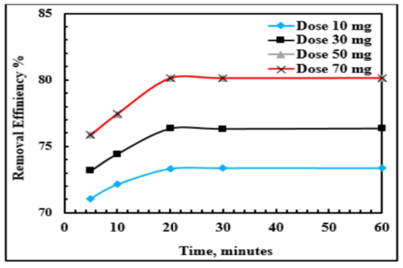
Figure 6. Effect of Contact Time on
Removal efficiency, Co=2mg/l, MFS
=3T, pH=7

3.2 Second Scheme: Effect of pH on Removal Efficiency
Many experiments are performed to find the best pH under various operating parameters and a contact time of 20 minutes. It is obvious that copper removal increased with the increase of pH up to 5, then after it decreases (Figure 7). Therefore, a pH of 5 is fixed for the next schemes. This trend agrees well with that of (Gupta et al, 2003; Shi et al, 2015; Fatemeh and Bahri, 2018; Chavan et al, 2019; Seif et al, 2019; Gautam et al, 2020; Mohib et al, 2020; Mohammed, 2024). The dominant species of copper is free Cu⁺², which is mainly involved in the adsorption process when the pH is smaller than 5. When pH is greater than 5, copper starts to form Cu(OH)_{2,} which is hardly adsorbed. Moreover, below a pH of 5, there is a decrease in positive surface charge that causes a decrease in the repulsive force between the nanoparticle surface and copper ions. For low pH, there are a lot of H⁺ that compete with cation ions (Shi et al, 2015). This competition will resist the reach of cation ions due to the repulsion force (Gupta et al, 2003). At higher pH, cation adsorption became favorable due to the reduction of hydrogen ions, providing more adsorption sites for binding cations with the adsorbent. The increase in pH will increase the negative surface charge where positive cation ions are adsorbed (Naidu et al, 1997). The highest copper removal was obtained for the initial copper concentration of 2 mg/l, Fe₂O₃ dose of 50 mg, and magnetic field strength of 3 Tesla was 82.36%.

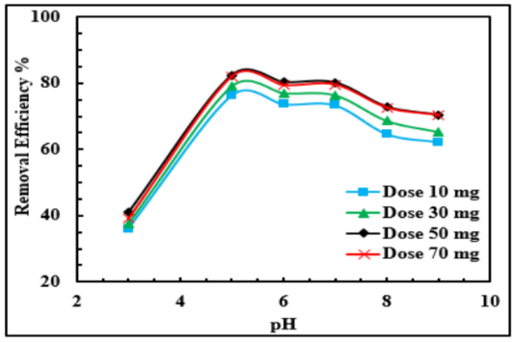

Figure 7. Effect of pH on Removal
Efficiency, Co=2mg/l, MFS =3T, CT=
20minutes

3.3 Third Scheme
3.3.1 Effect of Initial Copper Concentration on Removal Efficiency
Many experiments are performed to determine the effect of initial concentration (2-8 mg/l) on removal efficiency under MNPS dose of 10-70 mg/l, pH of 5, and MFS of 1.5-5.5 T. Figure 8 shows that copper removal is decreased with the increase of copper initial concentration. This trend is similar to that of (Abdel-Shafy et al, 1989; Barka et al, 2013; Ezeh et al, 2017; Fatemeh and Bahri, 2018; Gautam et al, 2018; Jain et al, 2018; Mohib et al, 2020; Abdel-Shafy et al, 2022; Amaibi et al, 2024). The poorer uptake of copper ions at higher initial concentrations has occurred as a result of the increase in the ratio of copper mass to the surface of the adsorption site with the increase of initial copper concentration. For a given Fe₂O₃ dose, the total number of adsorption sites is fixed while the adsorbate mass is increased with its initial concentration. This will lead to a decrease in copper removal. For a fixed adsorbent dose, the surface area and number of active adsorption sites are fixed. Increasing initial pollutant concentration means increasing the mass of the pollutant. Since each adsorbent can adsorb a given mass of the pollutant, the equilibrium concentration increases with the increase of the initial pollutant concentration. Increasing the dose will allow more pollutant mass to be adsorbed, which tends to reduce the effect of increasing the pollutant's initial concentration. For higher initial pollutant concentration, more ions are crowded on the adsorbent surface, resulting in faster occupation of the active sites (Mohib et al, 2020). Thus, higher pollutant mass (higher concentration) is left in the solution. It is suggested that the amount of metal ions suppresses the fixed number of available active sites by increasing pollutants (Abdel-Shafy et. al. 2022). The highest copper removal is obtained for the initial copper concentration of 2 mg/l, Fe₂O₃ dose of 50 mg, and magnetic field strength of 3 Tesla was 81.82%.
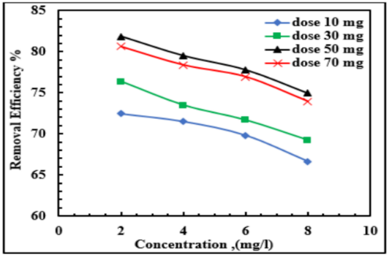

Figure 8. Effect of Initial Concentration
on Removal Efficiency, CT=20 minutes,
MFS =3T, pH=5

3.3.2 Effect of Fe₂O₃ Dose on Removal Efficiency
The effect of Fe₂O₃ dose on copper removal for copper initial concentration of 2 – 8 mg/l, magnetic field strength of 1.5-5.5 Tesla under contact time of 20 minutes, and pH of 5 is given in Figure 9. Figure 9 indicates that the copper removal efficiency usually improves when the adsorbent doses are increased. This behavior is consistent with that of (Han et al, 2011; Ramya et al, 2011; Jadidian et al, 2014; Shakoor and Nasar, 2016; Giannin et al, 2020; Abdulsalam et al. 2023; Abdullahi et al, 2023; Amaibi et al, 2024). This may occur because a higher dose of adsorbents provides greater adsorption sites. There is no further increase in absorption after 50 mg. The increase in dose will increase the available adsorption sites, leading to an increase in the adsorbed pollutant mass, giving an increase in the removal efficiency. There is an increase in the surface area of the adsorbent with the increase in dose. This increase in surface area will increase the available adsorption site (Gautam et al, 2020; Jannah et al, 2021; Mohamed and Marwa, 2024). The maximum percentage of copper removal is 82.35% at a 50 mg dose, and Co of 2 mg/l. This result also indicates that the equilibrium conditions are reached after a certain dose of the adsorbent.

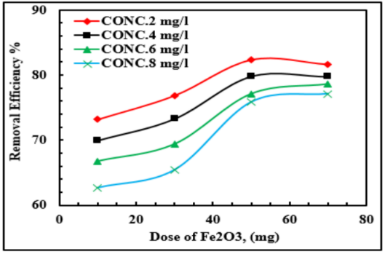

Figure 9. Effect of Fe₂O₃ Dose on
Removal Efficiency, CT=20 minutes,
MFS =3T, pH=5

3.3.3 Effect of Magnetic Field Strength on Removal Efficiency
The effect of magnetic field strength on copper removal for, Fe₂O₃ dose of 10-70 mg/l and copper initial concentration of 2 mg/l under contact time of 20 minutes and pH of 5 is shown in Figure 10. Figure 10 shows that copper removal is increased with the increase of magnet intensity up to 3 Tesla then after it levels out. A similar Trend is found by (Liu et al, 2008; Cheraghipour and Pakshir, 2021; Al-doury et al, 2025). The magnetic field strength affects the adsorption process as stated by (Olfat et al, 2012; Naef et al, 2021). Increasing magnet field strength up to 3 Tesla will increase the magnetism of copper thus increasing the attraction force. Although copper is a nonmagnetic material, it reacts to a certain extent with magnets. It seems that 3 Tesla is the magnetic field strength that gives a saturation magnetism (Chavan et al, 2019), therefore, there is no increase in the attraction force leading the removal efficiency to level out. Maximum copper removal is under the initial copper concentration of 2 mg/l, Fe₂O₃ dose of 50 mg, and magnetic field strength of 3 Tesla was 82.35%.

3.4 Fourth Scheme: Effect of Competing Ion on Removal of Copper
In this scheme, many experiments are performed to test the effect of competence on copper removal for copper initial concentration 2-8 mg/l under the best operating parameters obtained from the previous schemes namely: contact time 20 minutes, pH 5, Fe₂O₃ dose 50 mg/l, and magnet intensity 3 Tesla. The competing ions are Mn and Zn at a concentration of 2,4,6,8 mg/l for each. The results of this scheme are given in Figure 11. These data indicate that copper removal in the presence of competing ions is lower than that of the corresponding values for copper removal when it is alone. This trend agrees well with that of (Bouazza et al, 2018; Ayub et al, 2020; Amalia et al, 2021). This is because competing ions compete on the same available adsorption sites. Those having the greatest ionic potential (ratio of charge to ionic radius) or the most electronegative are removed first. If the adsorption sites are still under-saturated, ions with lower ionic potential or electronegative are removed in sequence. Since heavy metals have to compete for limited adsorption sites (Zhuowen et al, 2022), the coexistence of heavy metals causes a decrease in pollutant removal. The adsorption of Fe, Mn, Cu , and Zn is studied by Chang et al, (2024), and found that the presence of four ions will reduce the adsorbed amount of each ion. The values for the competing ions efficiency are 79.5%, 75.16%, 72.37%, and 69.61 for copper initial concentration of 2,4,6, and 8 mg/l respectively. The corresponding values for the non-competing situation are 82.35%, 77.25%, 74.53%, and 71.35%.

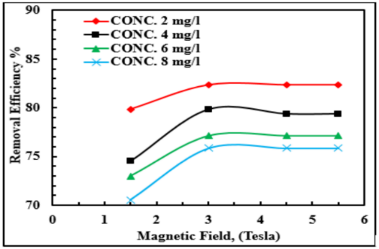

Figure 10. Effect of Magnetic Field on
Removal Efficiency, CT=20 minutes,
Dose=50 mg, pH=5

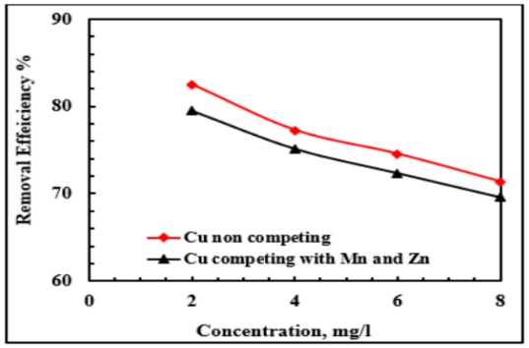

Figure 11. Effect of Competing on
Removal Efficiency, Dose=50mg,
pH=5, MFS=3T, CT=20 minutes

  - Regeneration
Regeneration and recycling of the adsorbent are essential from an economic point of view. Many experiments are performed for copper initial concentration of 2 mg/l under Fe₂O₃ dose of 50 mg/l, magnetic field strength of 3 Tesla, contact time of 20 minutes, and pH of 5. After finishing the experiment, the spent adsorbent is separated and regenerated as follows:
(1) The external magnet of 3 Tesla is attached at the bottom of the beaker.
(2) Remove all water from the beaker, keeping only the spent Fe₂O₃.
(3) Add 5 ml of 1% HCl and sonicate Fe₂O₃ for one hour.
(4) Reattach the magnet and remove HCl.
(5) Let the regenerated Fe₂O₃ dry for 24 hours under room temperature.
(6) Use the regenerated Fe₂O₃ in a new experiment
This process is repeated five times, and the results are given in Figure 12. This Figure indicates that copper removal has decreased successively from 82.35% in the first cycle to 60.57% in the fourth cycle and remains the same in the fifth cycle. This is because the adsorbed copper ions are transferred to the HCl solution easily. The present trend is similar to that found by (Fato et al, 2019). The adsorbent can be reused three cycles without a significant reduction in its performance (Suhyun et al, 2021). The adsorbent was regenerated and used for six cycles, maintaining 98 % removal efficiency of Cu⁺² after six consecutive cycles (Jinghan et al, 2025). Olivija et al (2019) found that 88% copper removal is obtained after four regeneration cycles. The adsorbent can be used three times without any reduction in adsorption capacity (Muradiye et al, 2023).

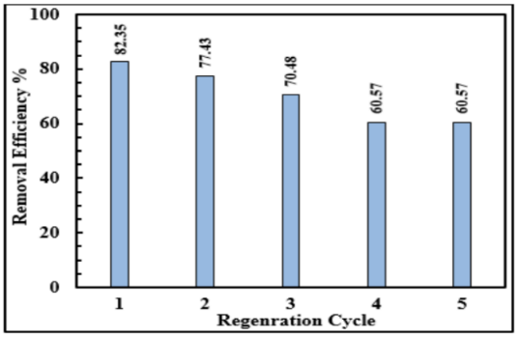

Figure 12. Effect of Regeneration
Cycle on Removal Efficiency

3.6 Adsorption Capacity
Many models are used to represent adsorption data mathematically, the most famous and applied models are the Freundlich and Langmuir models. These two models are used to represent the present work's experimental data. The correlation coefficient (R²) is a measure of the fitness of laboratory data to the values calculated by a model. The closer it is to 1, the more they are fitted and vice versa. R² ranges are 0.9906-0.9978 and 0.9987-0.9997 for the Freundlich and Langmuir models, respectively. This means that the present work data agrees better with the Langmuir model, thus, it is used to find the adsorption capacity. A sample of calculations for adsorption model constants is listed in Table 4. Figure 13 represents samples of data graphed according to the Langmuir model.

Table 4 Samples of Adsorption Constants
Co = 2 mg/l, CT = 20 min, pH = 5, MFS = 3 Tesla
Dose, mg/l |  | 10 | 30 | 50 | 70
TE, minutes |  | 20 | 20 | 20 | 20
CE, mg/l |  | 0.6 | 0.49 | 0.33 | 0.32
Langmuir constants | a | 45.45
Langmuir constants | b | -4.78
Langmuir constants | R² | 0.999
Freundlich constants | n | -1.95
Freundlich constants | k | 54
Freundlich constants | R² | 0.998

3.6.1 Effect of Contact Time on Adsorption Capacity
Figure 14 represents the effect of contact time on adsorption capacity under an initial concentration of 2 mg/l, Fe₂O₃ dose of 10 - 70 mg/l, pH 7, and magnetic field strength of 3 Tesla. It is clear that the adsorption capacity increases with the increase of contact time up to 20 minutes, and then after it levels out. As the time is increased, more pollutants will be
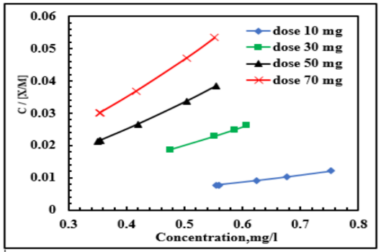

Figure 13. Relationship of C/[X/M]=
Ce/qe with Ce(Langmuir model), Co
=2mg/l, MFS=3T

adsorbed until an equilibrium is reached (Hashem et al, 2021). These results are consistent with the general trend obtained by (Xin et al, 2012; Jadidian et al, 2014; Li-Ting et al, 2020; Zhongbing et al, 2021; Amaibi et at, 2024). At the start, a lot of active sites are available, and the concentration of heavy metal ions is high. This will permit a high success rate for metal to reach adsorption sites, leading to a rapid increase in the adsorption rate in the early stage. However, as the number of adsorption sites decreases, the adsorption capacity is close to saturation. When the adsorption time is prolonged, the absolute adsorption capacity is not affected, and the adsorption curve is a horizontal line (Zhongbing et al, 2021).

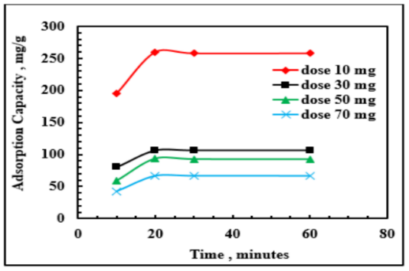

Figure 14. Effect of Contact Time on
Adsorption Capacity, Co=2mg/l,
MFS=3T, pH=7

3.6.2 Effect of pH on Adsorption Capacity
Figure 15 represents the effect of pH on the adsorption capacity of an initial concentration of 2 mg/l, Fe₂O₃ dose of (10-70) mg/L, contact time of 20 minutes, and magnetic field of 3 Tesla. The highest adsorption capacity occurred at pH =5 and decreased for further increase in pH. This is because copper is less soluble at low pH, i.e., it is of lower polarity. This will enhance its removal from the solution. At higher pH, copper forms soluble hydroxy complexes which are very hard to remove from solution (Ramya et al, 2011; Ponyadira et al, 2015). These results agree well with that of (Fatemeh and Bahri, 2018; Gautam et al, 2020; Mohib et al, 2020; Hashem et al, 2024). The effect of pH (3-5) on lead adsorption is investigated by Ponyadira et al, (2015) and found that pH of 5 gives maximum adsorption. They stated that with the increase in pH, more negatively charged surfaces became available, leading to a greater cation uptake. At low pH, more hydrogen ions are available, leading to competition between cations and hydrogen ions. This will increase the metal removal.

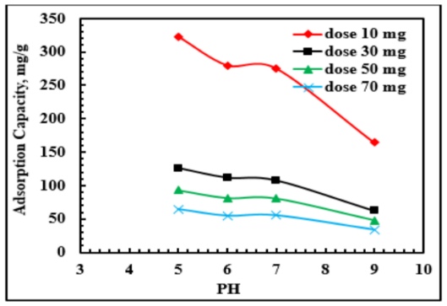

Figure 15. Effect of pH on Adsorption
Capacity, Co=2mg/l, MFS=3T, CT=
20minutes

3.6.3 Effect of Fe₂O₃ Dose on Adsorption Capacity
Figure 16 represents the effect of Fe₂O₃ dose on adsorption capacity for the copper concentration of 2-8 mg/l, the magnetic field strength of 3 Tesla, under contact time of 20 minutes, and pH 5. It is noted that the adsorption capacity is decreased with the increase of MNPS dose up to 30 mg/l, then after it tends to level out. These results agree well with those of (Kanoush, 2012; Padmavathy et al, 2016; Ezeh et al, 2017; Almomani et al, 2020; Hashem et al, 2021; Amaibi et al, 2024). This is because for constant pollutant concentration, increasing the dose (M) will tend to a reduction in the adsorbed mass per unit mass of adsorbent (X/M=qe). However, increasing the dose will give more adsorption sites that will accept more pollutants. It seems that beyond a certain dose, the effect of increasing M (that will increase X) has no further effect on adsorption capacity. The decrease in adsorption capacity takes place as the adsorbent dose increases because a higher dose provides more active adsorption sites (Ezeh et al, 2017). However, the increase in dose will reduce the adsorption capacity due to particle aggregation (Padmavathy et al, 2016).
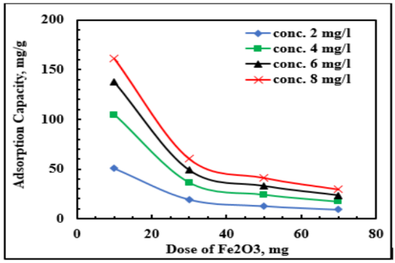

Figure 16. Effect of Fe₂O₃ Dose on
Adsorption Capacity, Co=2mg/l,
MFS=3T, pH=5

3.6.4 Effect of Magnetic Field Strength on Adsorption Capacity
Figure 17 represents the effect of magnetic field strength on adsorption capacity for initial copper concentration from 2-8 mg/l, MFS of 3 Tesla under contact time 20 minutes, and pH 5. It is noticed that there is a slight increase in adsorption capacity up to 3 T, then after that it levels out. This is because of two reasons. The first is the increase of magnetism with the increase of magnetic field strength. Although copper is a diamagnetic material, it is affected slightly by the magnetic field. The second reason is the fact that the magnetism of ferromagnetic material reached the saturation value with the increase of the external magnetic field. In the present work, it seems that 3 T is the saturation magnetic field strength. This agrees well with what was stated by Martínez-Arnáiz et al, (2011).
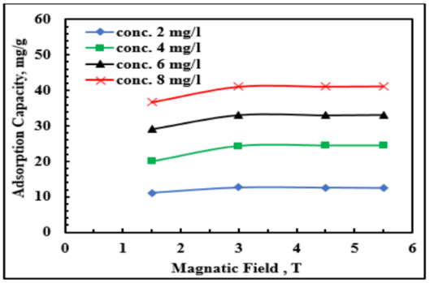

Figure 17. Effect of Magnetic Field
Strength on Adsorption Capacity,
Co=2mg/l, Dose=50mg, pH=5

3.6.5 Effect of Initial Copper Concentration on Adsorption Capacity
Figure 18. represents the effect of initial concentration on adsorption capacity for Fe₂O₃ dose of 10-70 mg/I, the magnetic field of 3 Tesla under contact time for 20 minute, and pH 5. The adsorption capacity is increased with the increase of copper initial concentration. This can be explained as follows: increasing the copper initial concentration will increase the driving force according to the following equation:

$\frac{dc}{dt}=K_{la}\left(C_{o}-C_{e}\right)$…………(4)

dc/dt: concentration change with time, mg/(l.sec).
Kla: mass transfer coefficient (m³/s).
Co: initial concentration (mg/l).
Ce: equilibrium concentration (mg/l).

Increasing the driving force will increase the mass of the adsorbed pollutant; thus, the term X/M will increase. Increasing X/M will reduce C/(X/M). Thus, according to the method of finding the adsorption capacity, the reciprocal of C/(X/M) will be increased, which means that the adsorption capacity is increased. However, increasing the driving force with the increase of initial concentration has the opposite effect on adsorption capacity. As the initial concentration increases, C/(X/M) will also increase. So, the reciprocal of C/(X/M) will be reduced, which means that the adsorption capacity is reduced. It seems that the net effect of the two opposite effects resulting from increasing the inlet concentration will give an increase in adsorption capacity. This trend agrees well with the result of (Nurulhuda et al, 2009; Abdelwahab and Amin, 2013; Padmavathy et al, 2016; Ezeh et al, 2017; Lallan et al, 2017; Al-Doury and Maadh, 2019; Amaibi et al, 2024; Chang et al, 2024). The increase of initial pollutant concentration will increase the driving force for adsorption. This will give an increase in the adsorbed mass of pollutant (X), hence increasing adsorption capacity (qe=X/M). It is mentioned by Al-Doury and Maadh, (2019) that the increase of initial pollutant concentration will act on two directions, each of them will increase the adsorption capacity. The increase in pollutant concentration will increase the driving force that will overcome the resistances to the mass transfer between the aqueous and the solid phases (Srivastava et al, 2006). The second reason is the increase of the term C/(qe) with the increase of pollutant concentration. The adsorption capacity is increased with the increase of pollutant concentration due to the increase in concentration gradient (Ezeh et al, 2017). This force is necessary to overcome the mass transfer resistance force between the solid and liquid phases. High concentration implies more metal ions fixed at the adsorbent surface and maximum utilization of active adsorbent sites (Barka et al, 2013).
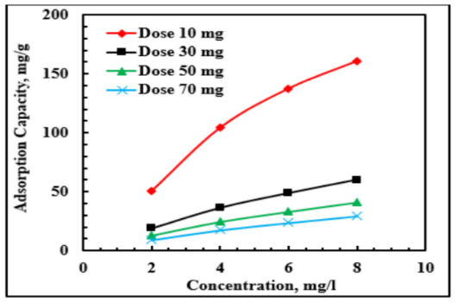

Figure 18. Effect of Cu Concentration
on Adsorption Capacity, MFS=3T,
pH=5

3.6.6 Effect of Competing on Absorption Capacity
The adsorption capacities for the competing experiments are found and graphed in Figure 19. The adsorption patterns under individual adsorption conditions are different from those under competitive adsorption conditions, as heavy metals rarely occur alone, and their interactions with each other as well as other components in natural environments are known to influence their transport between liquids and solutions. it is noted that the adsorption capacity of copper alone is higher than the adsorption capacity of copper in the presence of other competing metals in the same solution. This is because another metal competes with copper for the active sites of the adsorbent (Chang et al, 2024). These data agree well with that of (Zhuowen et al, 2022; Chang et al, 2024). The order for the competing ion adsorption capacity is {Copper-non competing (41..8, 33.4, 24.36, and 12.63 mg/g) for initial cu concentration of 2,4,6, and 8 mg/l, respectively}. The corresponding values for competing schemes are Copper (32.56, 25.17, 16.70, and 9.87 mg/g).
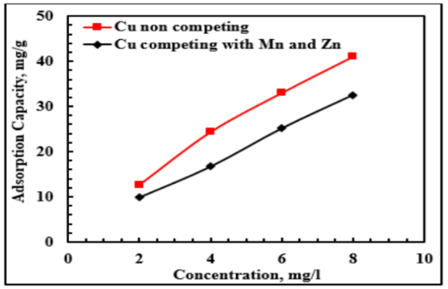

Figure19. Effect of Competing on
Adsorption Capacity, Co=2mg/l,
MFS=3T, pH=5, Dose =50mg

- Conclusions
Magnetic nanoparticles can effectively remove copper ions from the solution. The removal efficiency and adsorption capacity are affected by the operating parameters, which are pH, contact time, initial copper concentration, magnetic nanoparticle dose, and magnetic field strength. Experimental data fit the Langmuir model fairly. The competition of heavy metals reduces the efficiency of copper removal, as well as reducing the adsorption capacity. Moreover, the spent nanoparticle can be regenerated and reused.

List of abbreviations
a maximum adsorption capacity, mg/g
b Langmuir model constants, l/mg
C concentration, mg/l
Co initial metal concentration (mg/l)
Ce equilibrium concentration (mg/l).
CT contact time, minutes
dc/dt concentration change with time (m/(l/sec).
n Freundlich model constant, dimensionless.
K Freundlich constant, (mg/g)(l/mg)1/n
Kla mass transfer coefficient, m³/s.
M adsorbent mass, g
MFS magnetic field strength, Tesla
MNPS magnetic nanoparticles
X adsorbed mass, mg

Declarations
Availability of data and material ; https://data.mendeley.com/datasets/v7zp9sdr48/1

Disclaimer (Artificial intelligence)
Option 1:
Author(s) hereby declare that NO generative AI technologies such as Large Language Models (ChatGPT, COPILOT, etc.) and text-to-image generators have been used during the writing or editing of this manuscript.
Option 2:
Author(s) hereby declare that generative AI technologies such as Large Language Models, etc. have been used during the writing or editing of manuscripts. This explanation will include the name, version, model, and source of the generative AI technology and as well as all input prompts provided to the generative AI technology
Details of the AI usage are given below:
1.
2.
3.

References
Abdel-Shafy, H. I., El. Gamal, I. M., Abdel-Sabour, M. F., and Аbo-El-Wafa, O. 1989. Removal of Cadmium and Lead from Water by Activated Carbon. Environment Protection Engineering, 15 (1-2), pp 63-78.
Abdel-Shafy H. I., Mohamed H., Hussein M. A., Fatehy M. A. 2022. Removal of Cadmium, Nickel, and Zinc from aqueous solutions by activated carbon prepared from corncob - waste agricultural materials. Egypt. J. Chem. Vol. 65, No. 3 pp 677– 687.
Abdelwahab O. and Amin N. K. 2013. Adsorption of Phenol from Aqueous Solutions by Luffa Cylindricafibers: Kinetics, Isotherm and Thermodynamic Studies.2013, The Egyptian Journal of Aquatic Research Vol.39, Issue 4, pp 215-223.
Abdullahi, A., Yahya, S. I., Nura, A. Y., Kabiru, M. Y., Alhassan, M., Dallacoasta I. A., & Bello, A. 2023. Kinetic Studies of Emerging Contaminants Removal from Wastewater using Organo Modified Activated Carbon. International Journal of Innovation Science and Research Technology. Volume 8, Issue 10, ISSN: 2456-2165, DOI: //doi.org/10.5281/zenodo.10057110
Abdulsalam, A., Ibrahim, Y. S., Yaro, N. A., Olanrewaju, O. A., Alhassan, B., Iyayosa, D. A., & Lawal, K. 2023. Emerging Contaminants Removal from Wastewater Using Organo-Modified Bentonite Clay. Journal of Engineering Research and Reports, 25(10), pp121–144, https://doi.org/10.9734/jerr/2023/v25i101006
Abu Auwal, Jewel Hossen, and Md. Rakib-uzZaman. 2018. Removal of phenol from aqueous solution using Tamarind seed powder as adsorbent", IOSR Journal of Environmental Science, Toxicology and Food Technology (IOSR-JESTFT) e-ISSN: 2319-2402, olume 12, Issue 3 Ver. I, pp 41- 48.
Alasadi A., Khaili F., and Awwad A. 2019. Adsorption of Cu (II), Ni (II) and Zn (II) ions by nano kaolinite: thermodynamics and kinetics studies. Chemistry International, 5(4), pp258-265.‏
Al-Doury Muzher Mahdi Ibrahem and Maadh Hasan Alwan. 2019. phenol removal from synthetic wastewater using batch adsorption scheme. Tikrit Journal of Engineering Sciences 2019; 26(3): pp 31-36
Al-doury Muzher Mahdi Ibrahem, Nizar N. Ismaeal, and Mohammed Jameel Mahdi, 2025. Treatment Efficacy of Groundwater by Electromagnetic Polarization. International Journal of Environment and Climate Change Volume 15, Issue 1, Page pp 258-272,; Article no.IJECC.130033
Al-Jabri M. T. K., Geetha M. D., Al Abri M. 2018. Synthesis, characterization and application of magnetic nanoparticles in the removal of copper from aqueous solution. Applied Water Science 8:223
Almomani F., Bhosale R., Khraisheh M., and Almomani T. 2020. Heavy metal ions removal from industrial wastewater using magnetic nanoparticles (MNP). Applied Surface Science, 506, 144924.
Amaibi, P.M., Egong, J. F., and Iwe, C. R., and; Obunwo, C. C. 2024. Adsorption and kinetic studies for removal of fluoride in aqueous System by Activated Carbon Produced from lemon peels. J. Appl. Sci. Environ. Manage. Vol. 28 (5), pp 1413-1419.
Amalia Ekaputri Hidayat, Setyo Sarwanto Moersidik, Sandyanto Adityosulindro 2021. Adsorption and desorption of zinc and copper in acid mine drainage onto synthesized zeolite from coal fly ash. Journal of Physics: Conference Series 1811,012045
Anbalagan K., Magesh K. M., Sudarsan J. S., and Nithiyanantham S. 2021. Removal of heavy metal ions from industrial wastewater using magnetic nanoparticles. Journal of Eng. Research, Vol.10 No. (4A) pp. 59-71
Aya S. Mahmouda, Nadia A.Youssefa, Ahmed O. Abo El Nagab, M. M.Selim. 2019. Removal of copper ions from wastewater using magnetite loaded on active carbon (AC) and oxidized active carbon (OAC) support. J. Sci. Res. Sci., Vol.(36), pp 226-247.
Ayub S., Siddique A. A., Khursheed M. S., Zarei A., Alam I., Asgari E., and Changani F. 2020. Removal of heavy metals (Cr, Cu, and Zn) from electroplating wastewater by electrocoagulation and adsorption processes. Desalination Water Treat, 179(1), pp 263-271.
Barka, N., M. Abdennouri, M.E. Makhfouk, and S. Qouezal. 2013. “Biosorption Characteristics of Cadmium and Lead onto Eco-Friendly Dried Cactus (Opuntia ficusindica) Cladodes”. J. Environ. Chem. Eng. 1:144-9
Blöcher C., Dorda J., Mavrov V., Chmiel H., Lazaridis N. K., and Matis K. A. 2003. Hybrid flotation—membrane filtration process for the removal of heavy metal ions from wastewater. Water Research, 37(16), pp 4018-4026.
Bouazza D., Miloudi H., Adjdir M., Tayeb A., and Boos, A. 2018. Competitive adsorption of Cu (II) and Zn (II) on impregnated raw Algerian bentonite and efficiency of extraction. Applied Clay Science, 151, pp 118-123.
Buzea C., and Pacheco I. 2017. Nanomaterial and nanoparticle: origin and activity. In Nanoscience and Plant–Soil Systems, pp 71-112, Springer, Cham.
Chang Yin, Yongbo Zhang, Yongjiang Tao & Xueping Zhu 2024. Competitive adsorption behavior and adsorption mechanism of limestone and activated carbon in polymetallic acid mine water treatment. Scientific Reports, Vol.14, Article number: 23561.
Chavan V. D., Kothavale V. P., Sahoo S. C., Kollu P., Dongale T. D., Patil P. S., and Patil P. B. 2019. Adsorption and kinetic behavior of Cu (II) ions from aqueous solution on DMSA functionalized magnetic nanoparticles. Physica B: Condensed Matter, 571, pp 273-279.
Cheraghipour E., and Pakshir M. 2021. Environmentally friendly magnetic chitosan nano-biocomposite for Cu (II) ions adsorption and magnetic nano-fluid hyperthermia: CCD-RSM design. Journal of Environmental Chemical Engineering, 9(2), 104883.
Devasena S. S., Padmavathy P., Rani V., Ganesan P., Pereira J.J. 2024. A Review on Various Bio-Resources as a Tool to Reduce Water Pollution Via Eco-Friendly Adsorption Technology. Asian J. Biotechnol. Bioresour. Technol. [Internet]. 0(1):p p34-46. Available from: https://journalajb2t.com/index.php/AJB2T/article/view/196
Delasa A. A., Arash G., Davoud F. H., Fahimeh G.,Kiarash G., 2024.Copper Removal from Wastewater by Means of Magnetic Graphene Composite. Nanoscale and advanced materials, Vol. I, Issue 1, pp 49-60.
Ezeh K., I.C. Ogbu I.C., Akpomie K. G., Ojukwu N. C., and Ibe J. C. 2017. Utilizing the sorption capacity of local nigerian sawdust for attenuation of heavy metals from solution: isotherm, kinetic, and thermodynamic investigations. The Pacific Journal of Science and Technology. Volume 18. Number 1. (Spring), pp 251-264.
Fan F. L., Li H. W., Cheng N. W., Huang Q. G., Chen D. S., Wu X. L., and Qin Z. 2022. Selective adsorption and separation of Cu (II) from Zn solution by CU resin. Journal of Radioanalytical and Nuclear Chemistry, pp 1-8.
Fatemeh G., Bahri R. A. 2018. Adsorption of Cr(VI) from aqueous solution by adsorbent prepared from paper mill sludge: kinetics and thermodynamics studies. Adsorption Science & Technology 2018, Vol. 36(1–2), pp 149–169
Fatikow S., Eichhorn V., and Bartenwerfer M. 2012. Nanomaterials Enter the Silicon-Based CMOS Era: Nanorobotic Technologies for Nanoelectronic Devices. IEEE Nanotechnology Magazine, 6(1), pp 14-18.
Fato F. P., Li D. W., Zhao L. J., Qiu K., and Long Y. T. 2019. Simultaneous removal of multiple heavy metal ions from river water using ultrafine mesoporous magnetite nanoparticles. ACS omega, 4(4), pp 7543-7549.
Freundlich H. 1926. Adsorption in solution. Phys Chem 57:pp 384–410
Gautam A. K., Markandeya, Singh N. B., Shukla S. P., Mohan D., 2020. Lead Removal efficiency of various natural adsorbents (Moringa oleifera, Prosopis julifora, peanut shell) from textile wastewater. Research Article SN Applied Sciences 2:288.
Giannakis S., Lin K. Y. A., and Ghanbari F. 2021. A review of the recent advances in the treatment of industrial wastewater by Sulfate Radical-based Advanced Oxidation Processes (SR-AOPs). Chemical Engineering Journal, 406, 127083.
Giannin M. , Cosmin V., Simona P., Marius G., and Sorina B. 2020. Syringa vulgaris leaves powder a novel low-cost adsorbent for methylene blue removal: isotherms, kinetics, thermodynamic and optimization by taguchi method. doi: 10.1038/s41598-020-74819-x
Gonzalez-Munoz M. J., Rodríguez M. A., Luque S., and Álvarez J. R. 2006. Recovery of heavy metals from metal industry wastewaters by chemical precipitation and nanofiltra- tion. Desalination, 200(1-3), pp 742-744.‏
Gupta V.K., C.K. Jain, A. Imran, M. Sharma, and V.K. Saini. 2003. Removal of Cadmium and Nickel from wastewater using bagasse fly ash— a sugar industry waste. Water Research. 37: pp 4038-4044.
Han X, Wang W, Ma X. Adsorption Characteristics of methylene blue onto low cost biomass material lotus leaf. 2011.Chem. Eng. J. 2011;171: pp1–8
Hashem A., Aniago C. O., Afifi M. A. F., Abou-Okeil A., Samaha S. H. 2021. Synthesis of Super-Absorbent Poly (AN)-g-starch Composite Hydrogel and its Modelling for Aqueous Sorption of Cadmium Ions. Korean J. Chem. Eng., 38 (10), pp. 2157-2170
Hashem A., Chukwunonso O. A., Farag S., Fikry M., Aly A. A., Amr A. 2024. Evaluation of the adsorption capacity of surfactant-modified biomass in an aqueous acid blue 193 system. Waste Management Bulletin , Volume 2, Issue 1, pp 172-183.
Jadidian R., Parham H., Haghtalab S., and Asrarian R. 2014. Removal of copper from industrial water and wastewater using magnetic iron oxide nanoparticles modified with benzotriazole. Advanced Materials Research (Vol. 829, pp 742-746). Trans Tech Publications Ltd.
Jain M., Yadav M., Kohout T., Lahtinen M., Garg V. K., and Sillanpää M. 2018. Development of iron oxide/activated carbon nanoparticle composite for the removal of Cr (VI), Cu (II), and Cd (II) ions from aqueous solution. Water Resources and Industry, 20, pp 54-74.‏
Jannah M., Mulyati S., Rosnelly C. M., Muchtar S. 2021. The influences of operating conditions on the removal of Fe(II) in water by adsorption using bentonite as a low-cost adsorbent. 10th AIC 2020 IOP Conf. Series: Materials Science and Engineering 1087, 012055 IOP Publishing.
Jinghan R., Enjian S., Haiyan Wu, Yueping G. 2025. Highly selective and effective copper removal from wastewater by magnetic precipitation separation. Journal of Water Process Engineering Volume 69, 106700
Kanamarlapudi S. L. R. K., Chintalpudi V. K., and Muddada S. 2018. Application of biosorption for the removal of heavy metals from wastewater. Biosorption, 18(69), pp 70-116.‏
Kanoush A. A. 2012. Removing some heavy metals from liquid waste using granular activated carbon" Master's Thesis, Tikrit University, College of Engineering.
Kennedy LJ, Vijaya JJ, Kayalvizhi K and Sekaran G. 2007. Adsorption of phenol from aqueous solutions using mesoporous carbon prepared by two stage process. Chemical Engineering Journal, 132, pp 279 – 287.
Kumar S., Ahlawat W., Kumar R., and Dilbaghi E. 2015. Graphene, carbon nanotubes, zinc oxide, and gold as elite nanomaterials for the fabrication of biosensors for healthcare. Biosensors and Bioelectronics, 70, pp 498-503.
Lallan S.Y., Bijay K.M., and Arvind K. 2017. Batch and Column Studies for Phenol Removal from Aqueous Solutions using Laboratory-prepared Low-Cost Activated Carbon as an Adsorbent. Chemical Technology; an indian journal Vol. 12, issue 2. Pp 1- 32.
Langmuir I. 1918. Adsorption of gases on plane surfaces of glass, mica and platinum. J Am Chem Soc 40: pp1361–1403
Lim J. Y., Mubarak N. M., Abdullah E. C., Nizamuddin S., and Khalid M. 2018. Recent trends in the synthesis of graphene and graphene oxide-based nanomaterials for removal of heavy metals—A review. Journal of Industrial and Engineering Chemistry, 66, pp 29-44.
Li-Ting Z., Jiao G., Meng Li, Orphe B. T, Chao W., Chang-Guo Xue, Yin Liu, and Jian-Jun Li. 2020. Low-Cost magnetic adsorbent for efficient Cu(II) removal from water. Mater. Res. Express 7, 105503
Liu J. F., Zhao Z. S., and Jiang, G. B. 2008. Coating Fe₃O₄ magnetic nanoparticles with humic acid for highly efficient removal of heavy metals in water. Environmental science & technology, 42(18), pp6949-6954.
Martínez-Arnáiz R., López-Santiago J., Crespo-Chacón I., and Montes D. 2011. Effect of magnetic activity saturation in chromospheric flux–flux relationships. Monthly Notices of the Royal Astronomical Society, 414(3), pp 2629-2641.‏
Mohamed A. R. H. and Marwa A. A. 2024. Efficient and eco-friendly removal of heavy Metals from wastewater by low-cost adsorbents. Journal of Ecological Engineering 25(10), pp 111–118
Mohammed K. C. 2024. Removal of Pb(II) and Cu(II) fr al of Pb(II) and Cu(II) from water using silver nanoparticles prepared using extract plant (Albizia odoratissima). Al-Qadisiyah Journal of Pure Science , Volume 29 Number 1 Article 11
Mohib Ullah, Ruqia N., Muslim K., Waliullah K., Mohib S., Sahib G. A., Amir Z. 2020.The effective removal of heavy metals from water by activated carbon adsorbents of Albizia lebbeck and Melia azedarach seed shells. Soil and Water Research, 15, (1): pp 30–37
Muradiye Ş.,Muhammet A.,Yasin A., and Dilek Y., 2023. Removal of Ni(II), Cu(II), Pb(II), and Cd(II) from aqueous phases by silver nanoparticles and magnetic nanoparticles/nanocomposites. ACS Omega Vol 8/Issue 38, pp 34834-34843.
Naef A. A. Qasem, Ramy H. Mohammed, and Dahiru U. Lawal 2021. Removal of heavy metal ions from wastewater: a comprehensive and critical review. npj Clean Water volume 4, Article number: 36.
Naidu R., Kookana R.S., Sumner M.E., Harter R.D., Tiller K.G. 1997. Cadmium sorption and transport in variable charge soils: a review, J. Environ. Qual., 26, pp 602-617.
Namasivayam C., and Sangeetha D. 2006. Recycling of agricultural solid waste, coir pith: removal of anions, heavy metals, organics, and dyes from water by adsorption onto ZnCl₂ activated coir pith carbon. Journal of Hazardous Materials, 135(1-3), pp 449-452.
Nurulhuda Amri, Ridzuan Zakaria and Mohamad Zailani Abu Bakar 2009. Adsorption of Phenol Using Activated Carbon Adsorbent from Waste Tyres. 2009, Pertanika J. Sci. & Technol 17 (2), pp 371 – 380.
Olfat A. Fadali, Ebrahiem E. Ebrahiem, Mohamed S. Mahmoud, and Mohamed Obaid 2012. Contribution of Electromagnetic Field in Elimination of Heavy Metal from Industrial Wastewater. 6th International Conference on Chemical & Environmental Engineering 29 - 31 May, CEEA-2 1/12.
Olivija P., Matjaž F., Sašo G., Urban A., Irena B., and Lidija F. Z. 2019. Efficient copper removal from an aqueous anvironment using a novel and hybrid nanoadsorbent based on derived-polyethyleneimine linked to silica magnetic nanocomposites. Nanomaterials 9, 209; doi:10.3390/nano9020209
Padmavathy K. S. , G.Madhub , Haseena. P.V. 2016. A Study on Effects of pH, Adsorbent Dosage, Time, Initial Concentration and Adsorption Isotherm Study for the Removal of Hxavalent Chromium (Cr (VI)) from Wastewater by Magnetite Nanoparticles. International Conference on Emerging Trends in Engineering, Science and Technology (ICETEST - 2015) . Procedia Technology 24, pp 585 – 594.
Ponyadira Kabwadza-Corner, Erni Johan, Naoto Matsue, 2015. pH Dependence of Lead Adsorption on Zeolites. Journal of Environmental Protection > Vol.6 No.1.
Pumera M. 2011. Graphene-based nanomaterials for energy storage. Energy & Environmental Science, 4(3), pp 668-674.‏
Ramya R., Sankar P., Anbalagan S., and Sudha P. N. 2011. Adsorption of Cu (II) and Ni (II) ions from metal solution using crosslinked chitosan-g-acrylonitrile copolymer. International journal of environmental sciences, 1(6), pp 1323-1338.‏
Sajid H. G., Samia M. M., and Al-luaibi S. Sh., 2022. Heavy Metals Removal from Aqueous Solution Using (Cured Epoxy resin- lignin) Nanomagnetic Interpenetrating Polymer Network. J Nanostruct 12(1): pp 204-212.
Seif S., Marofi S., Mahdavi S. 2019. Removal of Cu2+ ion from aqueous solutions using MgO and montmorillonite nanoparticles, Environ. Earth Sci. 78 (13).
Sezgin N. 2018. Removal of copper from industrial wastewater using manganese ferrite nanoparticles: evaluation of equilibrium and kinetic model. Environmental Engineering & Management Journal (EEMJ), 17(9).‏
Shahmirzadi M. A. A., Hosseini S. S., Luo J., and Ortiz I. 2018. Significance, evolution, and recent advances in adsorption technology, materials, and processes for desalination, water softening, and salt removal. Journal of Environmental Management, 215, pp 324-344
Shakoor S, Nasar A. 2016. Removal of Methylene blue dye from artificially contaminated water using citrus limetta peel waste as a very low cost adsorbent. J. Taiwan Inst. Chem. Eng. 66: pp154–163.
Shi Z., Zou P., Guo M., Yao, S. 2015. Adsorption equilibrium and kinetics of Lead Ion onto synthetic ferrihydrites . ran. J. Chem. Chem. Eng. Vol. 34, No. 3.
Srivastava V. C., Swamy M. M., Mall I. D., Prasad B, and Mishra I. M.2006. Adsorptive Removal of Phenol by Bagasse Fly Ash and Activated Carbon: Equilibrium, Kinetics and Thermodynamics.Colloids and Surfaces, 272, pp 89 - 104.
Sudilovskiy P. S., Kagramanov G. G., Trushin A. M., and Kolesnikov V. A. 2007. Use of membranes for heavy metal cationic wastewater treatment: flotation and membrane filtration. Clean Technologies and Environmental Policy, 9(3), pp 189-198.
Suhyun L., Lakshmi P. L, Jae-Kyu Y., Yoon-Young C., Janardhan R. Koduru 2021. Potential electromagnetic column treatment of heavy metal contaminated water using porous Gd₂O₃-doped graphene oxide nanocomposite: Characterization and surface interaction mechanisms. Journal of Water Process EngineeringVolume 41,102083.
Tran T. K., Leu H. J., Chiu K. F., and Lin C. Y. 2017. Electrochemical Treatment of Heavy Metal‐containing Wastewater with the Removal of COD and Heavy Metal Ions. Journal of the Chinese Chemical Society, 64(5), pp 493-502.
Verbych S., Hilal N., Sorokin G., and Leaper M. 2005. Ion exchange extraction of heavy metal ions from wastewater. Separation science and technology, 39(9), pp 2031-2040.‏
Vunain E., Mishra A. K., and Mamba B. B. 2016. Dendrimers, mesoporous silicas and chitosan-based nanosorbents for the removal of heavy-metal ions: a review. International journal of biological macromolecules, 86, pp 570-586
Xin X., Wei Q., Yang J., Yan L., Feng R., Chen G., and Li H. 2012. Highly efficient removal of heavy metal ions by amine-functionalized mesoporous Fe₃O₄ nanoparticles. Chemical Engineering Journal, 184, pp132-140.
Zargoosh K., Abedini H., Abdolmaleki A., and Molavian M. R. 2013. Effective removal of heavy metal ions from industrial wastes using thiosalicylhydrazide-modified magnetic nano-particles. Industrial & engineering chemistry research, 52(42), pp14944-14954.
Zhongbing W., Wenbin Xu, Fanghui J., Zongwen Z., Kai Z., and Hui L. 2021. The selective adsorption performance and mechanism of multiwall magnetic carbon nanotubes for heavy metals in wastewater. Scientifc Reports,11:16878.
Zhuowen M., Ting X., Shuang H.,., Haimeng Ge.Wenting Mu, Zhongbing L. 2022. Effects of competitive adsorption with Ni(II) and Cu(II) on the adsorption of Cd(II) by modified biochar co-aged with acidic soil. Chemosphere Volume 293, 133621.

