**Effect of Storage on Value-Added Products Developed from Composite Flour of Acacia and Banana**

**Abstract**

This study evaluated the effect of storage on two value-added snack products i.e., biscuits and sev developed from composite flour made by blending Acacia nilotica pod flour and raw banana flour. The formulation aimed to combine the antioxidant and antimicrobial properties of Acacia with the palatability and nutritional richness of banana. Among different substitution levels, Type-I (20% composite flour) was the most acceptable based on sensory evaluation. These products were then assessed for lipase activity, peroxide value, and microbial count over a 30-day storage period. Type-I samples demonstrated significantly lower lipase activity (0.17–1.14 µmol/g for biscuits; 0.34–1.16 µmol/g for sev) and peroxide values (1.13–2.20 meq/kg for biscuits; 1.36–3.13 meq/kg for sev) compared to controls. Microbial counts remained within safe limits, with substantially lower growth in composite flour products. The findings indicate that this novel combination can improve the shelf life and safety of functional snack foods, highlighting its potential for health-focused food innovation and commercial application.

Key words: snack products, Flour, Storage, Value-added food, Biscuit, sev

1. **Introduction**

Traditional foods have a distinct texture and taste, making them an important part of people's diets across countries. Snack foods make up a large portion of traditional foods. According to Webster's New Ninth Collegiate Dictionary (1985), the noun "snack" (first used in 1757) refers to a "light meal, foods eaten between regular meals, food suitable for snacking" and the verb snack means "to eat a snack." According to Kulkarni (1992), snacks made from locally accessible raw ingredients evolved as a way to break up monotony in diets. Traditional Indian cuisine consists of cereal, lentils, and vegetables (Waghray and Gulla, 2010).

*Acacia nilotica* is also known as the Babul, Kikar, or Indian gum Arabic tree. It belongs to the Leguminosae-Mimosoideae family and can be found all throughout India. It is a significant multipurpose tree, with almost every part used to treat an ailment. Because of their potential benefits for a number of chronic illnesses, the scientific community and consumers have shown a strong interest in bioactive compounds such as antioxidants (Revathi *et al.,*2017). Synthetic antioxidants are often utilised in the food processing industry to extend product shelf life while also promoting them as healthy meals. However, high doses of these synthetic antioxidants have been demonstrated to be toxic rather than beneficial to health. Some are known to cause cancer and other negative health effects. These effects can be avoided by replacing them with natural antioxidants found in Acacia nilotica.Almost all of its ingredients are used in pharmaceuticals and have been found to have numerous health benefits, including anti-inflammatory, anti-diabetic, antihypertensive, and in vitro anticancer properties (Saggu *et al.,*2015; Majumder *et al.,*2021). Overall, *Acacia nilotica* pods could be a useful functional component due to their nutritional value, processing functionality, and potential health advantages. However, acacia pods are bitter, rendering them unsuitable for value addition. To boost Acacia nilotica's market potential in the food industry, it is necessary to find a suitable vehicle that can provide a food matrix to mask the bitterness of acacia while also possessing product development attributes.

Mature banana pulp is abundant in iron, potassium, and vitamin A, but low in protein and fat (Adeniji *et al.,* 2006). Ripe banana flour is perfect for food preparations that require great solubility, sweetness, and energy density. content. Zhang *et al.* (2005) and Mohapatra *et al.* (2010) investigated and described the physical properties of fresh bananas and their components, including banana starch. They are wealthy. They are rich in vitamin B6, fibre, vitamin C, magnesium, and potassium. Bananas are high in vitamins and minerals, with each large serving providing 123 I.U. of vitamin A. According to Vasudha and Misra (2013), bananas are a healthful fruit that can improve the taste of food.

Value-addition involves transforming a raw commodity into a high-quality finished product. Value-added refers to enhancing a commodity with time, place, and shape to cater to consumer preferences. Value-added means anticipating consumer needs, delivering them on time and in the right place (Parimita and Puneet, 2015). Value addition in food items leads to greater quality, safer, and more nutrient-dense goods that meet various requirements (Pant and Chinwan, 2014).

Despite the documented nutritional and medicinal properties of Acacia nilotica and banana, there is limited research on the practical application of their composite flour in the development of value-added functional foods, particularly in terms of evaluating storage stability parameters such as lipase activity, lipid oxidation, and microbial safety. Most existing studies focus on their biochemical profiles or isolated uses in traditional medicine, but their potential synergistic benefits when used as composite flour in processed snacks remains underexplored. Moreover, no comprehensive data is available on how such composite formulations behave over time in terms of shelf life and safety, which is crucial for industrial adoption. Therefore, this study aims to fill this gap by assessing the storage-related biochemical and microbial changes in products made from Acacia-banana composite flour, with the goal of validating their use in health-promoting, shelf-stable snack foods.

**2 Materials and Methods**

**2.1 Development of value-addedfood products**

Value-added food products were developed using composite flour formulations to enhance the nutritional profile, functionality, and market potential of the final products, such as biscuits and sev.

**2.1.1 Biscuit**

Value-added biscuits were made by replacing wheat flour partially with composite flour in various ratios. The control sample was 100 g of wheat flour, and the treatment formulas replaced 20 g (T-I), 30 g (T-II), and 40 g (T-III) of wheat flour with composite flour. All the preparations consisted of 40 g ghee, 60 g sugar, 40 mL milk, one teaspoon ammonium bicarbonate, and an amount of sodium bicarbonate equal to a pinch. Flours were first sieved for removing impurities. Ghee and sugar were creamed together, and then baking powder, sodium bicarbonate, ammonium bicarbonate, and respective flour mixtures were added. The batter was mixed well and milk was gradually added to create a soft dough. The dough was rolled into sheets of about ½ inch thickness and biscuit shapes were cut out. The biscuits were baked in the oven at 160°C until they turned light brown. **Plate 1: 30:70 Composite flour supplemented biscuits**

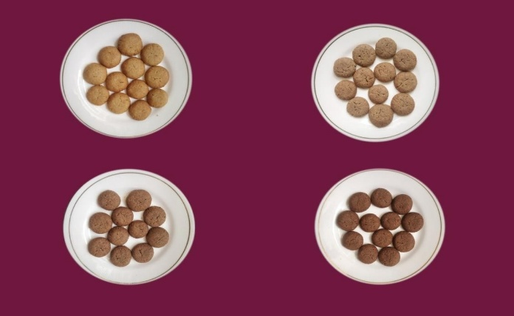

**Control**

**T-I**

**T-II**

**T-III**

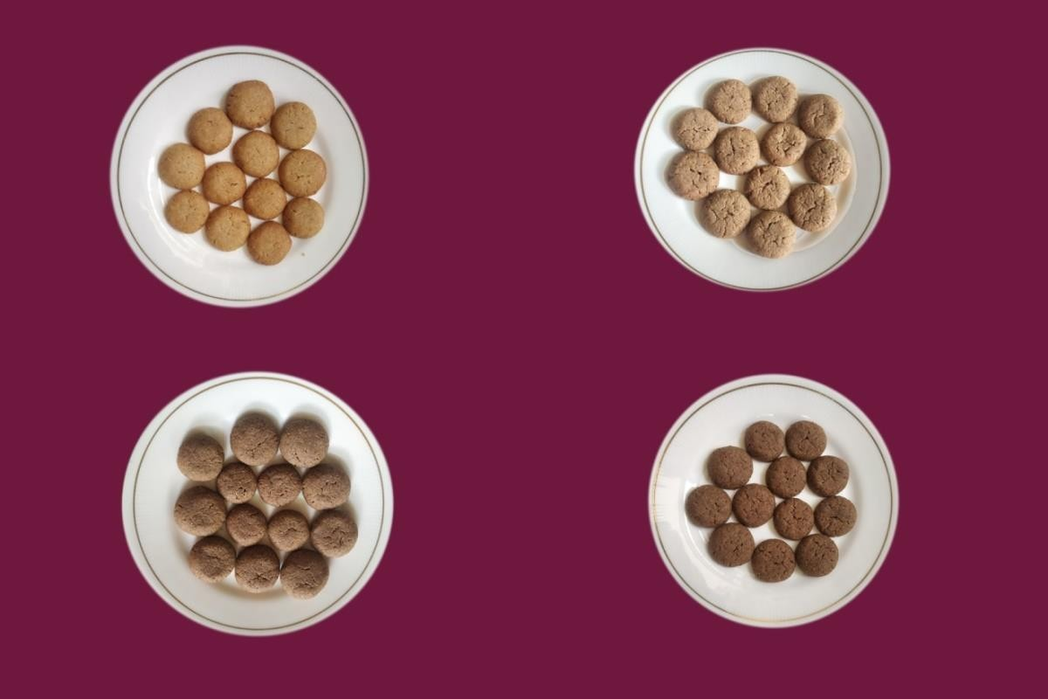

**Control**

**T-I**

**T-II**

**T-III**

**Plate 2: 50:50 Composite flour supplemented biscuits**

***2.1.2 Sev***

In order to assess the usability of composite flour in snack food, *sev* were made with the following Bengal gram-composite flour replacement ratios:

**Process:** A typical recipe consisted of Bengal gram flour, salt, spices (ajwain, turmeric, chili powder), and water. The mixture was kneaded to a semi-soft state to make the dough. The dough was processed through a *sev* press having a fine-holed plate, and extrudates were fried in refined vegetable oil at 170–180°C until golden brown. The fried foods were brought to room temperature and stored in food-grade polyethylene pouches for subsequent analysis.

Control: Bengal gram flour (100%)

Type-I: Composite flour: Bengal gram (20:80)

Type-II: Composite flour: Bengal gram (30:70)

Type-III: Composite flour: Bengal gram (40:60)

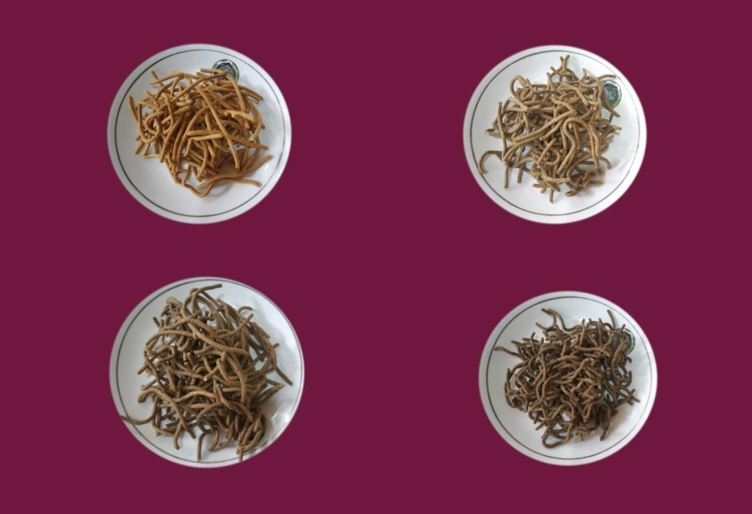

**Control**

**T-I**

**T-II**

**T-III**

**Plate 3: 30:70 Composite flour supplemented *sev***

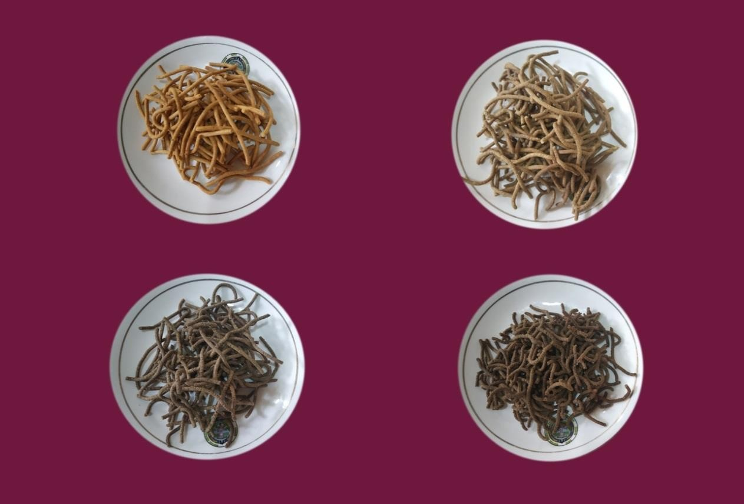

**Control**

**T-I**

**T-II**

**T-III**

**Plate 4: 50:50 Composite flour supplemented *sev***

**2.2 Lipase Activity**

Lipase activity was determined based on the titration of free fatty acids released from triacylglycerols, following the method of Verduin *et al*. (1973).

**2.2.1 Substrate Preparation:**

A 50 mM phosphate buffer (Na₂HPO₄/NaH₂PO₄, pH 7.0) was prepared. The substrate emulsion was made by homogenizing 40 g of sample with 60 mL of 5% gum Arabic solution. A total of 50 mL of this emulsion was mixed with 45 mL of the buffer solution.

**2.2.2 Enzymatic Activity Assay:**

To 9.5 mL of the prepared substrate, 0.5 mL of crude enzyme extract was added. The mixture was incubated at 28°C for 1 hour in a shaker. Free fatty acids released were titrated with 50 mM NaOH until the pH reached 9. One unit of lipase activity was defined as the amount of enzyme that releases 11 μmol of fatty acids per hour at 28°C.

**2.2.3 Total Microbial Count**

Total microbial burden was approximated on Plate Count Agar (PCA) medium made up of (g/L): peptone 5.0, yeast extract 2.5, dextrose 1.0, and agar 20.0 in 1000 mL distilled water. The medium was autoclaved at 121.6°C (15 psi) for 15 minutes, and glassware was sterilized using a hot air oven at 160°C for 2 hours (Clark, 1965).

For the purpose of analysis, 1 g of sample was homogenized in 9 mL of sterile distilled water to give a 10⁻¹ dilution. The serial dilutions (10⁻² and 10⁻³) were made likewise. From each of the dilutions (10⁻¹, 10⁻², 10⁻³), 1 mL was plated onto sterile Petri plates with PCA medium. The plates were incubated at 30 ± 2°C for 24–48 hours. Colony-forming units (cfu/g) were determined by the formula:

CFU/g = Number of colonies × dilution factor × 10

**2.3 Peroxide value**

Peroxide value of stored samples (0, 15, and 30 days) was measured in accordance with AOAC (2000). A 5 g sample was shaken with 30 mL acetic acid–chloroform (3:2, v/v) in a conical flask and swirled until dissolved. Then, 0.5 mL saturated potassium iodide was added and reaction mixture was left to react for 1 minute with shaking at intervals. Next, 30 mL distilled water was added, and the solution was titrated with 0.01 N sodium thiosulphate until the colorfaded. Following the addition of 0.05 mL starch solution as indicator, titration was continued until the blue color disappeared. A blank was run in a similar manner. The peroxide value was calculated in milliequivalents of peroxide per kilogram of sample (meq/kg).

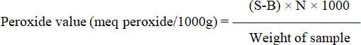

Where,

B = Volume (ml) of Na2S2O3 used for titration of blankS = Volume (ml) of Na2S2O3 used for titration of sampleN= Normalityof Na2S2O3solution

**2.4 Statistical analysis**

All experiments were conducted in triplicate and the results are presented as mean ± standard deviation (SD). The data were statistically analyzed using Analysis of Variance (ANOVA) and critical difference (CD) at p≤0.05 to determine significant differences between control and composite flour treatments across different storage periods. The statistical computations were performed using the OPSTAT software developed by CCS Haryana Agricultural University (Sheoran and Pannu, 1999). Differences among means were compared using the t-test wherever applicable. This approach authenticated the reliability and reproducibility of observed effects in lipase activity, peroxide value, and microbial count.

1. **Results**
   1. **Lipase Activity Trends**

The lipase activity trends were analyzed to evaluate the enzymatic potential related to lipid hydrolysis in the composite flour samples, providing insights into their stability, shelf life, and possible metabolic effects.

**3.1.1 Biscuit**

Thelipaseactivityofcontrolbiscuitsvariedfrom1.57to5.33µmol/gduring0to30daysofstorage.Intype-Ibiscuit thelipaseactivityfrom0to30thdayofstoragerangedfrom0.17to 1.14µmol/g.Type-Ibiscuithadminimumcontentoflipaseactivityascomparedtocontrol (Table 1).

***3.1.2 Sev***

Control *sev* lipase activity ranged from 1.37 to 4.67µmol/g during storage (0-30 days). Lipase activity in type-I biscuits ranged between 0.34 and 1.16 µmol/g from the first to 30th day of storage. Type-I *sev* had the lowest level of lipase activity when compared to the control (Table 1).

**Table 1: Lipase activity (µmol/g) of value-added product during storage**

|  |  |  |  |  |  |
| --- | --- | --- | --- | --- | --- |
| **StoragePeriod(day)** | **0** | **7** | **15** | **30** | **CD(p**≤**0.05)** |
| **Biscuit** | | | | | |
| ControlW.F(100%) | Nil | 1.57±0.07 | 3.27±0.08 | 5.33±0.12 | 0.39 |
| T-I | Nil | 0.17±0.04 | 0.53±0.20 | 1.14±0.01 | 0.45 |
| ***Sev*** | | | | | |
| ControlBGF(100%) | Nil | 1.37±0.12 | 3.22±0.04 | 4.67±0.07 | 0.23 |
| T-I | Nil | 0.34±0.16 | 0.84±0.05 | 1.16±0.024 | 0.45 |

* 1. **Peroxide value**

Peroxide value was measured to assess the extent of lipid oxidation in the samples, indicating the freshness and oxidative stability of the composite flour during storage.

**3.2.1 Biscuit**

Peroxide value content of control biscuits increased significantly (p≤0.05) during storage. Peroxide value of control ranged from 1.80 to 3.40 meq peroxide/1000g. In type-I biscuit peroxide value from 0 to 30th day of storage ranged from 1.13 to 2.20 meq peroxide/1000g. Type-I biscuit had minimum content of peroxide value as compared to control (Table 2)

***3.2.2 Sev***

Peroxide value of control *sev*ranged from 2.23 to 5.76 meq peroxide/1000g, respectively. Type-I *sev*showed significantly **(**p≤0.05) lower peroxide value 1.36 to 3.13 meq peroxide/1000g, throughout storage period as compared to control *sev*(Table 2).

**Table 2: Effect of storage period on peroxide value (meg peroxide/1000g) of stored value-added products**

|  |  |  |  |  |  |
| --- | --- | --- | --- | --- | --- |
| **StoragePeriod(day)** | **0** | **7** | **15** | **30** | **CD(p**≤**0.05)** |
| **Biscuit** | | | | | |
| ControlW.F(100%) | Nil | 1.80±0.05 | 2.63±0.08 | 3.40±0.32 | 0.75 |
| T-I | Nil | 1.13±0.03 | 1.72±0.05 | 2.20±0.05 | 0.22 |
| ***Sev*** | | | | | |
| ControlBGF(100%) | Nil | 2.23±0.08 | 3.93±0.08 | 5.76±0.06 | 0.35 |
| T-I | Nil | 1.36±0.12 | 2.13±0.14 | 3.13±0.26 | 0.60 |

* 1. **Total microbial count**

The total microbial count of the composite flour samples was assessed to determine the level of microbial contamination and to evaluate the microbiological safety and shelf life of the developed products. Results indicated the effectiveness of processing and storage conditions in controlling microbial growth.

**3.3.1 Biscuit**

The total microbial count of control biscuits increased significantly (p≤0.05) duringstorage.Totalmicrobialcountofcontrolbiscuitsvariedfrom3.20to5.86logcfu/gduring0to 30 days of storage. In type-I biscuit the total microbial count from 0 to 30th day of storageranged from nil to 1.36 log cfu/g. Type-I biscuit had minimum content of microbial count ascompared tocontrol (Table 3).

***3.3.2Sev***

The total microbial count of control *sev* varied from 3.13 to 5.70 log cfu/g during 0 to30 days of storage. Total microbial count of type-I *sev* ranged from nil to 1.23 log cfu/g,respectively. The total microbial count from 0 to 30th day of storage in Type-I *sev* hadminimumascompared to control (Table 3).

**Table 3. Microbialanalysis(logcfu/g)ofdevelopedvalue-addedproducts duringstorage**

|  |  |  |  |  |  |
| --- | --- | --- | --- | --- | --- |
| **StoragePeriod(day)** | **0** | **7** | **15** | **30** | **CD(p**≤**0.05)** |
| **Biscuit** | | | | | |
| ControlW.F(100%) | Nil | 3.20±0.00 | 3.56±0.03 | 5.86±0.57 | 1.34 |
| T-I | Nil | Nil | 0.50±0.20 | 1.36±0.33 | 0.81 |
| ***Sev*** | | | | | |
| ControlBGF(100%) | Nil | 3.13±0.03 | 3.63±0.14 | 5.70±0.11 | 0.51 |
| T-I | Nil | Nil | 0.66±0.12 | 1.23±0.08 | 0.76 |

**4 Discussion**

The most acceptable products (Type-I biscuits and *sev*) were used for shelf-life parameter evaluation with a storage period of 0 to 30 days.

**4.1 Lipase Activity**

Lipase activity for Type-I biscuits varied between 0.17 to 1.14 µmol/g, and for Type-I *sev*, it varied between 0.34 to 1.16 µmol/g during the storage period. The rise in lipase activity with time suggests the hydrolytic breakdown of lipids, which is a normal process during storage. Both Type-I biscuits and *sev*, however, showed considerably lower lipase activity than the control samples. This diminished activity can be linked to the occurrence of bioactive compounds in Acacia flour that are found to inactivate lipolytic enzymes.These results are in line with those of Hafez (2012), who observed reduced lipase activity in cakes fortified with herbal extracts, attributing this effect to the antioxidant constituents of the plant ingredients. Similarly, Oladosu et al. (2013) demonstrated the antimicrobial and enzyme-inhibiting properties of Acacia nilotica, which could explain the suppression of lipolytic activity. The lower enzyme activity in our composite flour products indicates slower lipid hydrolysis, which supports their suitability for longer shelf life.

**4.2 Peroxide Value**

The peroxide value, a measure of the primary lipid oxidation, rose considerably (p ≤ 0.05) in all products under storage. The peroxide value varied from 1.13 to 2.20 meq peroxide/1000 g in Type-I biscuits and from 1.36 to 3.13 meq peroxide/1000 g in Type-I *sev* from day 0 to day 30 of storage. Interestingly, the two products both contained much lower peroxide values than their respective controls, indicating increased oxidative stability. This is a result of the secondary metabolites present in Acacia flour, which are antioxidants and antibacterials.

Upadhyay *et al*. (2017) have also indicated that cookies made from herbal powders of plant-based materials and low in cost could serve as immune-stimulating functional foods. The antimicrobial property of Acacia nilotica was evidenced by Oladosu *et al*. (2013), who proved its efficacy against pathogenic microorganisms. Hafez (2012) has also noted that cakes fortified with sweet marjoram contained lower peroxide values upon storage than control, affirming the enhancing effect of natural antioxidants on product shelf life.

**4.3 Total Microbial Count**

The overall microbial population of biscuits and *sev* enhanced considerably (p ≤ 0.05) within the storage duration. Yet, microbial growth in Type-I biscuits and *sev* was still below the control level throughout 30 days. The microbial load was still below the safe consumption level for cookies of less than 1×10⁴ cfu/g, as suggested by Banusha and Vasantharuba (2014). This proves that the products were microbiologically safe for use even after storage for one month.

Similar results were obtained by Komal and Kaur (2019), who proved that the addition of banana blossom powder at 20% considerably enhanced the shelf life of bakery foods. This endorses the efficiency of adding functional plant food ingredients in order to promote microbial stability and increase the storage life of foods.

**5 Conclusion.**

The use of composite flour from Acacia and raw banana in biscuits and *sev* had a significant effect on the storage stability. Type-I products (substitution with 20% composite flour) had the best results with respect to lipase activity, peroxide value, and microbial count during 30 days of storage. These products had reduced lipid hydrolysis and oxidation and improved microbial stability than respective controls. This enhancement is due to the presence of bioactive components with antioxidant and antimicrobial activities in the composite flour. The research hence lays down that Acacia and banana composite flours can be efficiently used in the development of functional snacks with extended shelf life, providing both nutritional and preservative benefits. These results have significant implications for the food processing industry in manufacturing healthier, longer-life value-added foods.

Disclaimer (Artificial intelligence)

Option 1:

Author(s) hereby declare that NO generative AI technologies such as Large Language Models (ChatGPT, COPILOT, etc.) and text-to-image generators have been used during the writing or editing of this manuscript.

Option 2:

Author(s) hereby declare that generative AI technologies such as Large Language Models, etc. have been used during the writing or editing of manuscripts. This explanation will include the name, version, model, and source of the generative AI technology and as well as all input prompts provided to the generative AI technology

Details of the AI usage are given below:

1.

2.

3.

**6 References**

Adeniji, T. A., Sanni, L. O., Barimalaa, I. S., & Hart, A. D. (2006). Determination of micronutrients and colour variability among new plantain and banana hybrids flours. *World Journal. Chemistry*, *1*(1), 23-27.

AOAC. (2000) Official Methods of Analysis. 16th Ed. Association of Official Analytical chemists. Arlyngton, Virginia, USA.

Banusha, S. and Vasantharuba, S. (2014). Preparation of Wheat-Malted Flour Blend Biscuit and Evaluation of its Quality Characteristics. *American Eurasian Journal of Agricultural and Environmental Science*, 14(5): 459-463.

Clark, F. E. (1965). Agar‐plate method for total microbial count. *Methods of Soil Analysis: Part 2 Chemical and Microbiological Properties*, *9*, 1460-1466.

Hafez, A. A. (2012). Physico-chemical and sensory properties of cakes supplemented with different concentration of marjoram. *Australian Journal of Basic and Applied Sciences.* 6 (13): 463-470

Komal and Kaur P. (2019). Development of Value-Added Product and Evaluation of Banana Blossom Incorporated Nut Chocolate. *International Journal of Trend in Scientific Research and Development*, **3**(5): 1930-1931.

Kulkarni, A. P. (1992). Food quality control and processing. Eating on the run. *Food Laboratory News*, *8*(2), 10-13.

Majumder, D., Nath, P., Debnath, R., & Maiti, D. (2021). Understanding the complicated relationship between antioxidants and carcinogenesis. *Journal of Biochemical and Molecular Toxicology*, *35*(2), e22643.

Mohapatra, D., Mishra, S., & Sutar, N. (2010). Banana and its by-product utilisation: an overview.

Oladosu, P., Isu, N. R., Ibrahim, K., Okolo, P., & Oladepo, D. K. (2013). Time kill-kinetics antibacterial study of *Acacia* nilotica. *African Journal of Microbiology Res*, ***7***(46), 5248-5252.

Pant, S., &Chinwan, D. (2014). Value addition of food products. *Int. J. Eng. Sci. Res*, *4*(12), 946-949.

Parimita, E., & Puneet, E. (2015). Development of fruit bar by using apple and banana pulp supplemented with omega-3 fatty acid. *International Journal of Engineering Studies and Technical Approach*, *1*(2), 27-35.

Revathi, S., Govindarajan, R. K., Rameshkumar, N., Hakkim, F. L., Mohammed, A. B., Krishnan, M., & Kayalvizhi, N. (2017). Anti-cancer, anti-microbial and anti-oxidant properties of Acacia nilotica and their chemical profiling. *Biocatalysis and Agricultural Biotechnology*, *11*, 322-329.

Saggu, S., &Sundaravalli., A. (2016). Development and Evaluation of Value-Added Iron Rich Spirulina Millet Mix Flour. *International Journal of Science and Research,* 2319-7064.

Sheoran, O.P. & Pannu, R.S. (1999) Statistical Package for agricultural workers. “O.P. Stat” College of Agriculture, Kaul, CCS Haryana Agricultural University, Hisar. India.

Upadhyay, S., Khan, S., Tiwari, R., Kumar, S., Kohli, D. and Rautela, I. (2017). Nutritional and Sensory Evaluation of Herbal Cookies. *International Journal of Food Science and Nutrition*, **2**(6): 156-160.

Vasudha, S., & Mishra, H. N. (2013). Non dairy probiotic beverages. *International Food Research Journal*, *20*(1).

Verduin, P. A., Punt, J. M. H. M., & Kreutzer, H. H. (1973). Studies on the determination of lipase activity. *ClinicaChimica Acta*, *46*(1), 11-19.

Waghray, K., & Gulla, S. (2010). Butylated hydroxyanisole (BHA) to maximize the oxidative stability of snacks: A case study with *sev* and boondi. *Journal of Human Ecology*, *32*(2), 97-99.

Zhang, P., Whistler, R. L., BeMiller, J. N., & Hamaker, B. R. (2005). Banana starch: production, physicochemical properties, and digestibility—a review. Carbohydrate polymers, 59(4), 443- 458.