Original Research Article

Sensory Evaluation of millet-based Indian flatbreads

ABSTRACT

Aims: The present study investigates the sensory evaluation of millet-based Indian flatbreads.
Background: Millet-based flatbreads are lower in gluten content, making them suitable for individuals with gluten intolerance or celiac disease. The sensory properties of millet-based flatbreads are also noteworthy. Research indicates that the addition of millet flour can alter the texture and taste of traditional flatbreads, often resulting in a product that is both palatable and nutritious.
Methodology: The study was carried out at the Department of Foods and Nutrition, Post Graduate and Research Centre (PGRC), College of Community Science, and Professor Jayashankar Telangana Agricultural University, Rajendranagar, Hyderabad, Telangana, India, between January 2024 and August 2024. Flatbreads were developed using varying proportions of wheat flour, foxtail millet, and little millet (70:30, 60:40, 50:50, 40:60, and 30:70). The ingredients were mixed and kneaded for 15–20 minutes, followed by resting the dough for 60 minutes. Flatbreads were then rolled using a jowar roti machine, cooked on both sides on a heated tawa until done, and finally, sensory evaluation was conducted by a 9-point hedonic scale by semi-trained panels.
Results: Sensory evaluations of millet-based flatbreads reveal notable preferences, with MMT4(40% wheat and 60% foxtail) and MMTT1(70% wheat and 30% little millet) excelling in visual appeal, flavour, and overall acceptability. Lower-performing samples, like MMTT5(30% wheat and 70% little millet), indicate areas for improvement. Hence, MMT4 (40% wheat and 60% foxtail millet) and MMTT1(70% wheat and 30% little millet) are identified as the most preferred samples, compared with control sample MMT0(100% wheat), excelling in various sensory characteristics,
Conclusion: The findings demonstrate the potential of millet-based flatbreads as a nutritious and sustainable alternative to traditional varieties, with opportunities to optimise formulations for enhanced consumer appeal.

Keywords: Flatbread, Foxtail Millets, Wheat, Little Millets, Sensory evaluation

- INTRODUCTION
Flatbreads are among the oldest forms of bread known to humanity and can be prepared using flours from various raw materials. Their dough may vary in consistency, be either leavened or unleavened, and can be baked using a range of methods. Despite these differences, all flatbreads share a common feature: a relatively thin profile, typically only a few centimetres thick(Pasqualone, 2018). These breads were a staple at every meal in ancient times, often used as plates or as tools for scooping up stews and sauces (Mir et al.,2014). In regions like India and the Middle East, flatbreads hold deep cultural and culinary importance and have steadily gained popularity in Western countries due to their incredible versatility. They can serve as wraps (like tortillas), holders (like pita), or even as a hearty base for dishes (like pizza). People have been making flatbreads for over 6,000 years. The world’s oldest baker’s oven dates back to 4000 B.C. in Babylon, and Egyptians also baked flatbread around the same time, either in hot ashes or on heated stones. Nomadic herdsmen further developed this tradition by sun-baking dough on flat stones. The tandoor, a cylindrical clay oven, originated in Persia (modern-day Iran) and made its way to India through Afghanistan around 3000 B.C. Similar small mud ovens have also been discovered in the ancient cities of Harappa and Mohenjo-Daro. Across the globe, different cultures have developed unique flatbreads. For example, Injera from Ethiopia, Somalia, and Eritrea is a spongy, pancake-like bread made from teff flour and used as both a dish and a utensil. Khubz, popular in Morocco and the Arabian Peninsula, is a large flatbread traditionally baked by slapping the dough onto the walls of a “tannuur” oven. In Mali, a simple flatbread called Ngome is made with millet, water, and vegetable oil. In India, a rich variety of wheat-based flatbreads is central to traditional cuisine. These include chapati, puri, tandoori roti, parantha, naan, bhatura, kulcha, parotta, and khakra. Naan, often enriched with yoghurt and baked in a tandoor, is a common accompaniment to meals, with delicious varieties like Peshwari naan (stuffed with nuts and raisins), Keema naan (filled with minced meat), and Kashmiri naan. Chapati is a soft, unleavened bread made from whole wheat flour, while parathas are layered with ghee and pan-fried. Puri is deep-fried until puffed and golden, often filled with savoury or sweet fillings. Khakras are thin rotis roasted until crispy. Each flatbread tells a story, not just of culinary technique, but of culture, tradition, and human innovation across time..(Rehman et al.,2007; Parimala & Sudh 2013)
Wheat (Triticum spp.) is one of the most widely cultivated and consumed grains worldwide, serving as a staple food in many cultures. It is primarily valued for its high carbohydrate content and is a significant source of dietary fibre, vitamins, and minerals, particularly when whole grain forms are consumed (Tripathi & Singh, 2019; Rasika et al.,2024).
Millets, which include varieties like pearl millet (bajra), finger millet (ragi), and sorghum (jowar), have been cultivated in India for thousands of years and are recognized for their resilience in adverse climatic conditions and their nutritional benefits ( Debnath, 2023; Aringalayan et al., 2022). These grains are rich in essential nutrients, including proteins, dietary fibres, and minerals, making them an excellent alternative to wheat-based products, especially for populations facing malnutrition and dietary deficiencies (Anitha et al., 2022; Kumar et al., 2018; Saleh et al., 2013). The incorporation of millet flour into flatbreads enhances their nutritional profile. Studies have shown that substituting wheat flour with millet flour increases the content of protein, fibre, and essential minerals such as iron and zinc, while also reducing the glycaemic index of the resulting products (Omran & Mahgoub, 2022; Nagaraju et al., 2020). This is particularly beneficial for individuals with diabetes, as lower glycaemic index foods can help manage blood sugar levels (Sobhana et al., 2020). Furthermore, millet-based flatbreads are gluten-free, making them suitable for individuals with gluten intolerance or celiac disease (Kaur, 2024). The sensory properties of millet-based flatbreads are also noteworthy. Research indicates that the addition of millet flour can alter the texture and taste of traditional flatbreads, often resulting in a product that is both palatable and nutritious (Leven & Bilgicli, 2012; Mounika et al., 2020). The blending of millet with other flours, such as legumes or quinoa, has been explored further to enhance these flatbreads' nutritional quality and sensory appeal ( Singh et al.,2012; Yadav, 2023). Additionally, the use of traditional processing techniques, such as fermentation, can improve the digestibility and nutrient availability of millet, further contributing to its health benefits (Gowda et al., 2022). In terms of sustainability, millets are considered climate-smart crops due to their low input requirements and ability to thrive in poor soil conditions (Debnath, 2023). This makes them a viable option for smallholder farmers in India, promoting food security and economic stability (Ahmed, 2018). The United Nations has recognised the importance of millets by declaring 2023 as the International Year of Millets, emphasising their role in sustainable agriculture and nutrition (Maharajan, 2024). Millet-based Indian flatbreads are a staple food with deep cultural roots and a nutritionally rich and sustainable option that can contribute significantly to dietary diversity and health. Their incorporation into daily diets can help to address nutritional deficiencies and promote overall well-being, making them a valuable addition to contemporary food systems.

2. Materials and Methods
The study was conducted at the Department of Foods and Nutrition, Post Graduate and Research Centre (PGRC), College of Community Science, and Professor Jayashankar Telangana Agricultural University, Rajendranagar, Hyderabad (India).

2.1 Raw materials: All the required materials, like grains (wheat, foxtail, and little millet), were procured from the local market. The grains were cleaned and washed thoroughly, sun-dried until the moisture content was reduced to 11%, and then grains were milled. The prepared flours were stored in HDPE polyethene packaging material at room temperature for further research
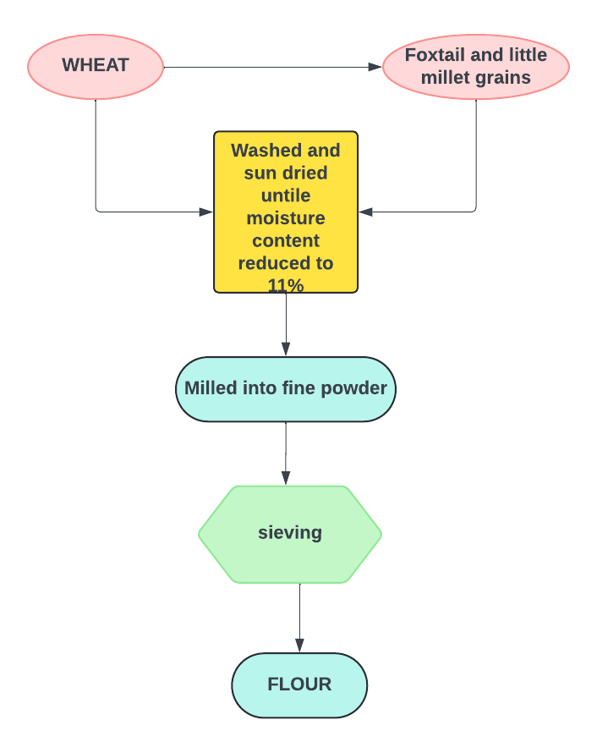

Figure 1. Flow diagram for the preparation of flour

2.2 Preparation of millet-based Indian flatbreads:
The flatbreads were prepared by measuring out different blends of wheat flour, foxtail millet, and little millet in specific ratios: 70:30, 60:40, 50:50, 40:60, and 30:70. These variations help to assess the amount of millet that affects the final quality of the flatbreads. Once measured, the flours are combined and kneaded into a smooth dough. This step takes about 15 to 20 minutes, giving the ingredients time to hydrate and the gluten in the wheat a chance to develop, which helps create a good texture. After kneading, the dough is left to rest for an hour. This resting period allows the dough to soften and become more pliable, making it easier to roll out and improving the final texture. The rested dough is then rolled out into thin discs using a jowar roti machine. The rolled flatbreads are cooked on a tawa. They’re cooked on both sides until done, developing a pleasant flavour and texture. Finally, the cooked flatbreads are tasted and evaluated based on sensory qualities like flavour, texture, aroma, appearance, and overall appeal. This step is essential for selecting the best acceptable proportion of flatbreads for further research study.

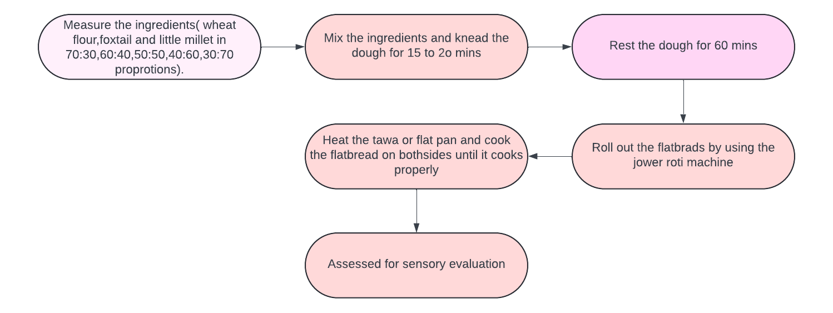
Figure 2. Flow diagram for the preparation of millet-based Indian flatbreads

2.3 Sensory evaluation: The millet-based Indian flat breads were assessed for Appearance, Colour, Flavour, Taste, Mouth feel, Texture, and Overall acceptability by a semi-trained panel of 15 members from PGRC (Post Graduate Research Centre), PJTAU (Professor Jayashankar Telangana Agricultural University) using 9-point hedonic scale, this scores were determined using a hedonic scale of 1 to 9, with 1 denoting an extreme dislike (very bad) and 9 denoting an extreme like (excellent) (Meilgaard, et al., 1999).

2.4 Statistical analysis: The results obtained were expressed as mean ± standard deviation of three determinations and were subjected to ANOVA. The significance was determined at (p ≤ 0.05).

3. results and discussion
3.1 Sensory evaluation
The sensory evaluation data for samples MMT0 to MMTT5 provides insights into various attributes such as appearance, colour, flavour, texture, taste, mouthfeel, and overall acceptability. Among the samples, MMT1 excelled with the highest scores in both appearance (9.00±0) and colour (9.00±0), highlighting its excellent visual appeal. MMT0 leads in flavour (8.267±0.79), while MMT4 stands out in terms of aftertaste (8.133±0.74) and overall acceptability (8.133±0.63), and MMTT1 performs well in overall acceptability (8.333±0.61), indicating the best acceptable samples among all. In contrast, lower-scoring samples include MMTT5, which receives the lowest ratings across most attributes, particularly in flavour (6.733±0.70) and overall acceptability (6.80±1.20). MMTT4 also shows lower ratings, especially in appearance and texture.. Similar results have been reported by Seleem and Omran 2014 in One Layer Flat Bread Supplemented with Beans and Sorghum. The mean scores for all attributes range from 7.53 to 7.85, reflecting moderate overall preferences among the samples. The standard error (SE) values, ranging from 0.069 to 0.075, indicate consistency in the ratings. The coefficient of variation (CV%) demonstrates moderate variability across attributes, with taste exhibiting he highest variability (11.01%). The critical difference (CD%) values suggest that a difference of approximately 0.51 to 0.60 between samples is statistically significant.

Table 1: Sensory evaluation of millet-based Indian flatbreads

Sample | Appearance | colour | Flavour | Texture | Taste | After test | Overall acceptability
MMT0 | 8.53^{b}±0.74 | 8.06^{b}±0.59 | 8.26ª±0.79 | 7.80^{b}±0.94 | 7.80^{d}±1.01 | 8.00^{b}±0.84 | 8.00^{c}±0.84
MMT1 | 9.00ª±0 | 9.00ª±0 | 7.93^{d}±0.79 | 7.73^{d}±1.03 | 8.13ª±0.83 | 8.00^{b}±1.13 | 7.80e±1.01
MMT2 | 7.53^{f}±0.83 | 7.26^{f}±1.16 | 7.26^{g}±0.88 | 7.33^{f}±1.04 | 7.13^{h}±0.91 | 7.33e±0.89 | 7.53±0.91
MMT3 | 7.60e±0.82 | 7.26^{f}±1.16 | 7.40^{f}±0.91 | 7.33^{f}±0.72 | 7.26^{g}±1.09 | 7.20^{f}±0.77 | 7.20^{f}±0.86
MMT4 | 8.06^{d}±0.70 | 7.60e±0.63 | 8.06^{b}±0.83 | 7.80^{c}±0.67 | 8.00^{c}±0.75 | 8.13ª±0.74 | 8.13^{b}±0.63
MMT5 | 7.40±1.05 | 7.60e±0.91 | 7.00^{i}±1.19 | 7.46e±0.833 | 7.40^{f}±0.98 | 7.46^{d}±1.12 | 7.60^{g}±0.91
MMTT1 | 8.40^{c}±0.73 | 8.06^{c}±0.79 | 8.00^{c}±0.65 | 8.13ª±0.83 | 8.06^{b}±0.88 | 8.00^{b}±0.75 | 8.33ª±0.61
MMTT2 | 8.06^{d}±0.70 | 8.00^{d}±0.65 | 7.73e±1.03 | 7.73^{d}±0.79 | 7.66e±0.89 | 7.86^{c}±0.91 | 7.86^{d}±0.74
MMTT3 | 7.40^{g}±0.73 | 7.13^{g}±0.99 | 7.20^{h}±0.67 | 7.26^{g}±0.70 | 7.26^{g}±0.96 | 7.00^{g}±1.06 | 7.06^{h}±0.88
MMTT4 | 7.00^{h}±1.06 | 6.80^{h}±0.94 | 7.26^{g}±0.88 | 6.86^{h}±0.83 | 7.13^{h}±1.06 | 6.93^{h}±0.79 | 6.86^{i}±0.63
MMTT5 | 6.86^{i}±1.18 | 6.73^{i}±1.22 | 6.73^{j}±0.70 | 6.80^{i}±1.20 | 7.06^{i}±0.88 | 6.86^{i}±0.99 | 6.80^{j}±1.20
Mean | 7.85 | 7.66 | 7.60 | 7.53 | 7.59 | 7.59 | 7.61
SE | 0.074 | 0.079 | 0.072 | 0.069 | 0.072 | 0.075 | 0.071
CV% | 9.15 | 9.99 | 10.62 | 9.84 | 11.01 | 10.81 | 9.56
CD% | 0.51 | 0.55 | 0.58 | 0.53 | 0.60 | 0.59 | 0.52
*Values are expressed as mean ± standard deviation of three determinations.
MMT0: Flatbreads with 100% Wheat flour
MMT1: Flatbreads with 70%Wheat+30%Foxtail millet
MMT2: Flatbreads With 60% Wheat+40% Foxtail millet
MMT3: Flatbreads with 50% wheat + 50% Foxtail Millet
MMT4: Flatbreads with 40% Wheat +60% Foxtail millet
MMT5: Flatbreads with 30%Wheat+70%Foxtail millet
MMTT1: Flatbreads with 70% wheat + 30% little millet
MMTT2: Flatbreads With 60%Wheat +40%Little millet
MMTT3: Flatbreads with 50% Wheat +50% Little Millet
MMTT4: Flatbreads with 40% Wheat +60% Little Millet
MMTT5: Flatbreads with 30% Wheat +70% Little Millet

The acceptability index score was calculated and presented in Figure 3. The highest acceptability index score for foxtail millet-based flatbreads was given to MMT4(88.57), followed by MMT1(87.41). The lowest score was seen in MMT3 and MMT4(81.38), and the highest acceptability index score for little millet-based flatbreads was given to MMTT1(90.57), followed by MMTT2(87.69), MMTT3(80.36), MMTT4(77.77), and the lowest score was observed in MMTT5(76.28). It was observed from Table 1 and Figure 3, that the foxtail-based flatbreads and the little millet-based flatbreads (except MMTT5) got significantly higher (p ≤ 0.05) scores for all parameters (appearance, colour, texture, flavour, taste, after test and overall acceptability) than the control sample. MMT4 and MMTT1 are identified as the most preferred samples, compared with control sample MMT0, excelling in various sensory characteristics, whereas MMTT5 and MMTT4 rank as the least favoured based on overall acceptability and other sensory attributes.

Figure 3: Acceptability index of foxtail and little millet-based flat breads
Note:MMT0 Control flatbreads
MMT0: Flatbreads with 100% Wheat flour
MMT1: Flatbreads with 70%Wheat+30%Foxtail millet | MMTT1: Flatbreads with 70% wheat + 30% little millet
MMT2: Flatbreads With 60% Wheat+40% Foxtail millet | MMTT2: Flatbreads With 60%Wheat +40%Little millet
MMT3: Flatbreads with 50% wheat + 50% Foxtail Millet | MMTT3: Flatbreads with 50% Wheat +50% Little Millet
MMT4: Flatbreads with 40% Wheat +60% Foxtail millet | MMTT4: Flatbreads with 40% Wheat +60% Little Millet
MMT5: Flatbreads with 30%Wheat+70%Foxtail millet | MMTT5: Flatbreads with 30% Wheat +70% Little Millet

4. Conclusion
The sensory evaluation of millet-based flatbreads highlights notable variations in semi-trained panel preferences across key sensory attributes. samples such as MMT4 and MMTT1 were the most flavoured, excelling in essential sensory qualities like visual appeal, flavour, and overall acceptability. in contrast, MMTT5 and MMTT4 received lower scores in attributes like flavour and texture, indicating areas where the formulations could be improved. these results demonstrate the potential of millet-based flatbreads as a nutritious and appealing alternative to traditional varieties, with opportunities for optimising sensory attributes to further enhance consumer satisfaction

DISCLAIMER (ARTIFICIAL INTELLIGENCE)
Author(s) hereby declare that NO generative AI technologies such as Large Language Models (Chatgpt, COPILOT, etc.) and text-to-image generators have been used during the writing or editing of this manuscript..

References
Ahmed, A. (2018). A comparative study on the consumption of millets in urban and rural areas. International Journal for Research in Applied Science and Engineering Technology, 6(5), 1959-1963. https://doi.org/10.22214/ijraset.2018.5319
Anitha, S., Givens, D., Subramaniam, K., Upadhyay, S., Kane‐Potaka, J., Vogtschmidt, Y., & Bhandari, R. (2022). Can feeding a millet-based diet improve the growth of children a systematic review and meta-analysis. Nutrients, 14(1), 225. https://doi.org/10.3390/nu14010225
Aringalayan, N., Singh, R., Mishra, S., Thangalakshmi, S., Kaur, B., Bajpai, V., … & Singh, A. (2022). Optimisation and characterisation of malted proso millet (Panicum miliaceum) based bread. Efood, 3(5). https://doi.org/10.1002/efd2.29
Debnath, S. (2023). Acceptance of millets in aspects of nutritional profiles, health and environmental benefits. International Journal of Ayurveda and Pharma Research, 71 75. https://doi.org/10.47070/ijapr.v11i9.2977
Gowda, N., Siliveru, K., Prasad, P., Bhatt, Y., Netravati, B., & Chennappa, G. (2022). Modern processing of Indian millets: a perspective on changes in nutritional properties. Foods, 11(4), 499. https://doi.org/10.3390/foods11040499
Kaur, C. (2024). Impact of non-thermal techniques on millets. Nutrition & Food Science, 54(2), 403-420. https://doi.org/10.1108/nfs-04-2023-0082
Kumar, A., Tomer, V., Kaur, A., Kumar, V., & Gupta, K. (2018). Millets: a solution to agrarian and nutritional challenges. Agriculture & Food Security, 7(1). https://doi.org/10.1186/s40066-018-0183-3
Levent, H., & Bilgiçli, N. (2012). Evaluation of physical, chemical and sensory properties of Turkish flat breads (bazlama and yufka) supplemented with lupin, buckwheat and oat flours. International Journal of Food Science and Nutrition Engineering, 2(5), 89-95.
Meilgaard M, Civille GV, Carr BT. Sensory Evaluation Techniques. Edn 3rd, CRC Press, Boca Raton, 1999.
Maharajan, T. (2024). Role of genome sequences of major and minor millets in strengthening food and nutritional security for future generations. Agriculture, 14(5), 670. https://doi.org/10.3390/agriculture14050670
Mounika, M., Hymavathi, T., Kuna, A., & Sreedhar, M. (2020). Development, physical and sensory evaluation of chapathi (indian flatbread) produced by utilizing minor millet, legumes, nutri-cereals and wheat flour. Current Journal of Applied Science and Technology, 68-76. https://doi.org/10.9734/cjast/2020/v39i1830773
Mir, S., Naik, H. , Shah, M. , Mir, M. , Wani, M. and Bhat, M. (2014) Indian Flat Breads: A Review. Food and Nutrition Sciences, 5, 549-561. doi: 10.4236/fns.2014.56065.
Nagaraju, R., Sobhana, P., Thappatla, D., Epparapalli, S., Kandlakunta, B., & Korrapati, D. (2020). Glycemic index and sensory evaluation of whole grain based multigrain indian breads (rotis). Preventive Nutrition and Food Science, 25(2), 194 202. https://doi.org/10.3746/pnf.2020.25.2.194
Omran, A. and Mahgoub, S. (2022). Quality evaluation of gluten-free flat bread prepared by using rice and millet flour. British Food Journal, 124(12), 4406-4419. https://doi.org/10.1108/bfj-11-2021-1215
Pasqualone A. Traditional flat breads spread from the Fertile Crescent: production process and history of baking systems. Journal Ethn Foods. 2018;5:18 9.
Parimala, K and ,Sudh,M.I.(2013). Wheat-Based Traditional Flat Breads of India. Critical reviews in food science and nutrition. 55. 10.1080/10408398.2011.647121.

Rasika A, Dr. S. M. Chavan, Dr. Jayant Ghatge, Sravya Gopi, Dr. K. Prathapan, P.(2024).Review Paper on Millet: Production, Nutrients, Processing, and Food Products for Health and Sustainability. International Journal of Environment Agriculture and Biotechnology(ISSN: 2456-1878).9(3), 088- 103.10.22161/ijeab.93.10.
Rehman, S., Paterson, A. and Piggot, J.R. (2007) Chapatti Quality from British Wheat Cultivar Flours. LWT-Food Science and Technology, 40, 775-784. http://dx.doi.org/10.1016/j.lwt.2006.04.009
Seleem, H.A. and Omran, A.A. (2014) Evaluation Quality of One Layer Flat Bread Supplemented with Beans and Sorghum Baked on Hot Metal Surface. http://dx.doi.org/10.4236/fns.2014.522238
Saleh, A., Zhang, Q., Chen, J., & Shen, Q. (2013). Millet grains: nutritional quality, processing, and potential health benefits. Comprehensive Reviews in Food Science and Food Safety, 12(3), 281-295. https://doi.org/10.1111/1541-4337.12012
Sobhana, P., Kandlakunta, B., Nagaraju, R., Thappatla, D., Epparapalli, S., Vemula, S and Korrapati, D. (2020). Human clinical trial to assess the effect of consumption of multigrain indian bread on glycemic regulation in type 2 diabetic participants. Journal of Food Biochemistry, 44(11). https://doi.org/10.1111/jfbc.13465
Singh KP, Mishra A, Mishra HN. Fuzzy analysis of sensory attributes of bread prepared from millet-based composite flours. LWT—Food Science and Technology. 2012;48:276– 82.
Tripathi, J. and Singh, J. (2019). Nutritional potential of malted nutri flour against conventional flours used in Indian food products. Journal of Applied and Natural Science, 11(3), 694-697. https://doi.org/10.31018/jans.v11i3.2150
Yadav, R. (2023). A review on yield gap analysis of millets in India. International Journal of Plant & Soil .https://doi.org/10.9734/ijpss/2023/v35i183462

