Traditional Knowledge and the Ethno-gastronomy of Indigenous Steamed Snack Foods in Northeast India: A Review of Culinary Practices and Cultural Significance

Abstract
Background:
India's vast cultural diversity, encompassing numerous civilizations, languages, climates, religions, and communities, has significantly contributed to the development of a rich and varied culinary heritage. North-East Indian cuisine, in particular, represents an exotic blend of traditional dishes influenced by regional practices and international interactions.
Aim: The current study attempts to record all the information obtained from the culture and knowledge of the several ethnic people and create a scientific systematic document on existing production process, quality and overall knowledge of snacks related to ethnic/religious beliefs of North-Eastern India.
Methods:
The study involves ethnographic and field-based data collection from selected North-Eastern states. Data were gathered via interviews, direct observation, and participatory methods involving traditional food artisans and community members. The collected data is analyzed to identify key practices, challenges, and potential areas for technological intervention. Comparative assessments of traditional and modern processing methods are also conducted to explore potential improvements
Results:
The findings reveal a wealth of indigenous knowledge surrounding snack preparation, though current practices face issues related to standardization, labour demand, and perishability. However, these products possess significant potential for value addition and commercialization if supported by scientific standardization, mechanization, and improved packaging techniques. Indigenous knowledge offers valuable insights into ingredient functionality and cultural relevance, which can guide process optimization.
Conclusion: Integrating traditional knowledge with scientific advancements can help standardize production, extend shelf life, and create market-ready products. This can promote entrepreneurship, generate rural employment, particularly for women, and preserve cultural food heritage by contributing to the socio-economic development of the region. The study emphasizes the need for scientific intervention in traditional snack production in North-East India to enhance quality, scale, and sustainability, while preserving cultural identity.
Keywords: local snacks, indigenous, north east, steamed, ethnic foods, traditional.
- Introduction
India is a multicultural nation that embraces many different languages, civilizations, climes, faiths, and groups. India is blessed with diverse cuisines that use a variety of ingredients and preparation techniques as a result of its diversity. The social and economic situations of the specific region and state can be greatly improved with the help of traditional wisdom. The eating patterns of people living in various parts of the country are vary incredibly, particularly in the hilly regions where people are practicing indigenous methods of preparing fermented foods and beverages based on easily accessible local raw materials (Pohsnem et al., 2023). North-East India also called the “Land of Seven Sisters”, represents both a geographic and political administrative division of the country. They are characterized by diverse population with different ethnic backgrounds. Indigenous and fermented foods are an intrinsic part of diet of these ethnic tribes. Northeast India accounts for over 8% of the country's total land area and has a population of around 40 million that is around 3.1% of India's entire population. Indigenous food has always been a diverse component of North Eastern culture. These eating habits are influenced by socio-economic level, religious significance, and cultural customs. It is widely accepted that these foods and drinks belong to hill communities since they feature essential components such as an exquisite texture, ethnic flavour, and nutritional content.
The residents in every country or culture consume LTFs (local-traditional foods) as part of their purpose-oriented (occasional, ritual, therapeutic, or refreshment) diet as they have a long history of preparation and consumption (Batu, 2018; Bhuiyan et al., 2022). McWilliams (2022) defined traditional food as “a coherent tradition of food preparation that rises from the daily lives and kitchens of a people over an extended period in a specific region of a country, or a specific country, and which, when localized, has notable distinctions from the cuisine of the country as a whole. Due to shifting consumption habits and lifestyles, traditional foods have been going extinct over the years (Basak et al., 2023). The market for industrially processed foods is expanding at a rapid pace, threatening the provision of traditional meals preferred by specific demographics. Food product development is continually driven by consumer tastes in both the domestic and international markets. (Byakika et al., 2019; Lücke and Zangerl, 2014; Panagou et al., 2013) In light of this, documentation and the generational flow of information are essential to the sustainable use and preservation of traditional foods.
Northeastern area of India (Fig. 1.) is incredibly distinctive in its geographic location, biodiversity, abundance of natural resources, multi-cultural tribal and non-tribal groups, and customs around the world. Table 1. shows the major tribal groups of North-east India.With its cultural and traditional variants, the NER (North-east region) of India is well-known for its numerous cuisine offerings, which include both vegetarian and non-vegetarian options. North-East India's several states each have their distinct cuisine culture. Some of these ethnic dishes include Pithas of Assam, Apong: a refreshing drink of Arunachal Pradesh, Kabok and Iromba of Manipur, Jadoh and Pukhlein of Meghalaya, sel roti, Zhero and Chang of Sikkim etc. (Kala, 2021). The preparation and processing of diverse ethnic dishes not only highlights the natives' creativity and treasures of their food culture heritage, but also their incremental learning to preserve the ecosystem and life as a whole. (Singh et al., 2007).
Snacking can be described as the problem-free consumption of easy-to-handle, miniature-portioned, hot or cold products in solid or liquid form which need little or no preparation and are intended to satisfy the occasional pangs of hunger. Indian traditional snacks have nutritional and commercial value. To produce this type of traditional food on a large scale, there is a need to incorporate modern techniques and research (Kumar et al., 2017). By producing such traditional snacks on a larger scale can contribute to the growth of the Indian economy. There is a lot of potential for innovation in the development of machines that can produce such products for hunger and nutrition management (Anadani et. al., 2020).
In view of the above importance, the current study attempts to record all the information obtained from the culture and knowledge of the several ethnic people and create a scientific systematic document on existing production process, quality and overall knowledge of snacks related to ethnic/religious beliefs of North-Eastern India as there is a threat to this knowledge with the changing of life style of the community and the emergence of various fast foods.
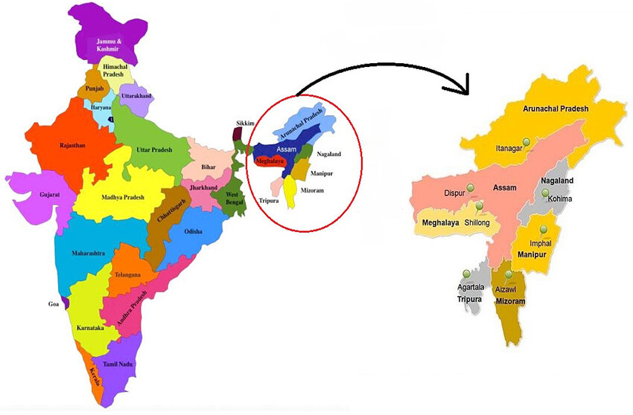
Fig 1. North eastern region of India (Source: Bhattacharya & Deka, 2023)

- Classification of snack foods
Snack foods can be categorized based on their ingredients, the technology or processing they undergo, their kind of consumption (e.g., RTE (Ready to Eat) or RTP (Ready to Prepare), or even their origin (or the region of popularity). According to Bawa & Sidhu (2003), snack products can be classified into various categories viz., warm snacks, cold snacks, milk and dairy products, bakery bars, savoury snacks, confections, extruded goods, and snacks made with nuts, meat, and legumes. Indigenous snacks of India are mostly steamed (momo, pittha) or deep fried (Gaja, Khaja, murukku etc.). In general, most of the Indian snacks are made using grains, sugar and are deep fried which leads to long storage life. Due to high perishability of steamed snack products viz., idli, momo, the shelf life is limited. These are mostly processed as premixes or in frozen form to increase their shelf life and availability. Moreover, steamed snack products in its frozen form necessitates need of refrigeration during storage. This study attempts to provide some insight into research gaps that can be taken up for future research in standardizing the production process of these indigenous steamed snacks of North East India for which very limited literature is available.
- Methodology
The study was conducted in CAEPHT, Ranipool, Sikkim where students from universities (ages 18 to 23) who come from all around the north-eastern states were selected. Also, the local people, including farmers, street vendors, college employees, and store owners were included as they are more cognizant of the regional cuisine culture and history. This investigation consisted of open-ended questions through an internet survey and an in-person interview. Data from several databases and search engines, such as ScienceDirect, Web of Science, Wiley Online Library, Springer, and Google Scholar, were thoroughly evaluated and synthesized for this review.
Table 1. Major tribes of North-eastern states of India
State | Major tribes
Arunachal Pradesh | Adi, Aka, Aptani, Bangani, Khamba, Khowa, Memba, Monpa, Miji, Hill Miri, Mishing Miri, Sherdukpen, Sulong, Singpho, Tagin, Tangsa, Wancho, Yobin, Zakhring and Galo.
Assam | Chakma, Dimasa, Garo, Hajong, Hmar, Khasi, Jaintia, Synteng, Pnar, War, Bhoi, Lyngngam, Kuki, Riang, Sairhem, Selnam, Singson, Haolai, Hengna, Hongsungh, Hrangkhwal, Raokhol, Tongbe, Khawathlang, Khothalong, Khawchung, Khelma, Kholhou, Kipgen, Kuki, Lengthang, Lhangum, Lhoujem, Lhouvum, Misao, Riaong, Sairhem, Selnam, Singsom, Sithou, Sukto, Thado, Thangngeu, Uibush Vaiphel, Lakher, Man, Mizo, Mikir, Naga Tribes, Pawi, Syntheng, Barmans in Cachar, Boro, Borokachari, Deori, Hajong, Kachari, Sonowal, Lalung, Mech, Miri and Rabha.
Manipur | Aimol, Anal, Angami, Chiru, Chethe, Gangte, Hmar, Kabui, Kacha Naga, Koirao, Koireng, Kom, Lamgang, Mao, Maram, Maring, Mizo, Monsang, Moyon, Paite, Purum, Ralte, Sema, Simte, Suhte, Tangkhul, Thadou, Vaiphui, Zou.
Meghalaya | Bhoi, Boro, Chakma, Dimasa, Garo, Hajong, Hmar, Jaintia, Karbi, Khasi, Koch, Kuki, Lakher, Lyngngam, Man, Mizo, Naga, Pawi, Pnar, Rabha, Synteng, and War.
Mizoram | Chakma, Dimasa Kachari, Garo, Hajong, Hmar, Khasi, Jaintia, War, Kuki, Lekher, Man, Karbi, Naga, and Pawi.
Nagaland | Lotha, Phom, Pochury, Rengma, Sumi, Sangtam, Yimchungru, Zeliang, Ngami, Ao, Chakhesang, Chang, Khemungan, Konyak, Lotha, Phom, Pochury, Rengma, Sangtam, Sema, Yimchunger and Zeliang. Adi, Aka, Dimasa, Galong, Garo, Khasi and Jaintia, Khowa, Kuki, Karbi, Mizo, Naga Ao, Angami, Chakhesang, Chang, Chiru, Khiemnungan, Konyak, Lotha, Makwari, Phom, Rengma, Sangtam, Sema, Tikhir, Yimchungree, Zeliang, Syntheng and Momba.
Sikkim | Lepcha, Bhutia, Sherpa, Tamang and Nepalese
Tripura | Tripuri, Jamatia, Bhil, Reang, Noatia, Bhutia, Chakma, Chaimal, Garo, Halam, Khasia, Kuki, Lepcha, Lushai Mag, Munda, Kaur, Orang, Santhal and Uchai
Source: Modified from Dutta & Dutta (2005) and Chakraborty et al. (2012)
- Steamed ethnic snacks of NE India
Steaming is a popular cooking method that involves using hot steam to cook food, typically without adding oil or fat. They are high in moisture soft and solid snack food. These snacks are lower in calories and fat compared to fried or baked alternatives. Steamed snacks can vary widely in flavour, texture, and ingredients depending on the region and culture they belong. Mostly, they are freshly made and sold in the market, whilst industrially produced versions use chemical preservatives to improve shelf life. Some of the popular steamed snacks of NER are discussed in further sections.
  - Winsii
Arunachal Pradesh's Tangsa tribe is the primary makers of the rice cake known as winsii (Fig. 2.). It is a rice cake prepared by boiling/steaming. The local rice called “Raico” is used in the preparation of this rice cake. First, the rice is soaked in water for at least 2-3 h and then processed into a fine flour after being shade/sun dried for 2 h. The rice flour is then combined with 80% water to create a paste. The paste is applied on the Nyiipshup jaq leaf (local name) in a thin layer. The meticulously packed leaf is steamed for 30 minutes while resting on top of a perforated steel utensil. One can serve this cake hot with soup, tea, or veggies. Winsii is mostly prepared for New Year's celebrations (Basaiawmoit et al., 2023).
Fig. 2. Winsii (Source: Basaiawmoit et al., 2023)

  - Sunga pitha/Chunga pitha
Sunga pitha (Fig. 3.) is a traditional treat that is mostly made during Magh Bihu, also known as the “Makar Shankranti festival”, which takes place in January. Because “sunga” in Assamese means bamboo tube and “pitha” means rice cake, the dish is known as Sunga pitha. These are typically made the night before Bihu, known as “Uruka”. Bamboo tubes and sticky rice, known as bora chawl in Assamese, are needed for its preparation. Additionally, certain hays, known as “Kher” in Assamese, are needed to burn the bamboo tubes because they facilitate slow burning, which is ideal for pitha preparation. The rice is initially steeped for 2-3 h before being partially packed in bamboo tubes. To prevent rice from leaking out of the bamboo tubes while they are cooking, the other half of the tube is filled with water, and the opening is sealed with hay or banana leaves. The bamboo tubes are crossed at both ends, and a long bamboo is positioned on both sides of the bamboo, which is set on a “Kher” (bed of hay). The tubes of rice-filled bamboo are then placed on the balanced bamboo at an angle. The rice within is then cooked through by slowly burning the hay. It is continuously turned while burning for around 40-45 minutes to ensure that all sides receive the same amount of heat for cooking. Following full cooking, the bamboo tubes are left in this position for roughly 10-12 h to allow them to cool. The rice cake is taken out after the bamboo tubes are divided into sections the following morning. It tastes finest when eaten with cream or curd and jaggery. In certain regions of Assam, rice flour that has been previously soaked, drained, and dried is used to make sunga pitha. They are then combined with water and jaggery, thoroughly churned, and then filled into bamboo tubes and put in the hay bed with the balanced bamboo in the previously mentioned inclined position. The rest of the cooking and burning process is same (Deka & Sit, 2022).
Fig. 3. Chunga/Sunga pitha (Source: https://bit.ly/4gsnwjz)

  - Tekeli pitha
Another name for tekeli pitha is keteli pitha. It is essentially a steam-cooked rice cake. Since the pitha is made on top of the kettle's lid covered in muslin cloth, it is known as “Tekeli pitha”. This can be a nutritious breakfast choice as well as a morning and evening snack. They are also made for numerous celebratory events, like Bihu. Ingredients needed for its creation include crushed sesame seeds (optional), jaggery (gur), grated coconut, and fragrant rice or any type of rice. First, the rice is soaked for 2-4 h. The excess water is then drained, and the rice is spread out on a bamboo “saloni”. To get rid of extra water, the rice is crushed into tiny particles and sieved to create a fine flour. Water is added to the kettle and heated until it boils. To ensure that the rice flour does not come out between the fingers when squeezed with the palm, some water is sprinkled on it to make it fairly wet. When the flour is ready, the muslin cloth is moistened and placed over the kettle's lid. On the wet muslin cloth that is placed over the lid, a handful of dampened rice powder is then placed. Next, one tablespoon or less of jaggery, one tablespoon of grated coconut, and half a tablespoon of roasted and powdered sesame seeds are added (optional). After that, the wet muslin cloth is laid over the next layer of soaked rice flour. The flour should not be pressed too hard could as it may be left undercooked or lead the cake to lose its fluff. As a result, the kettle's mouth is covered and left to wait for roughly 7-10 minutes. The pitha can then be obtained by carefully opening the lid (Deka & Sit, 2022). Fig. 4. shows the process flowchart for tekeli pitha preparation.

Fig. 4. Process flowchart for preparation of Tekeli pitha

  - Til pitha
One of the most significant pithas is Til pitha (Fig. 5.), an essential component of an Assamese Bihu platter. It is typically made for celebratory events like Bihu. The primary idea behind til pitha is a rice flour roll filled with gur (jaggery) and slightly roasted and powdered sesame seeds. Typically, bora chawl, or sticky rice, is used to make til pitha. After cleaning and washing, the rice is steeped for roughly 6-7 h and then it is dried in the shade for 30-60 minutes. It's important to take care that the rice doesn't get direct sunlight or fan exposure because this can fully dry it out. Following that, the rice is either pounded into tiny particles in a ural or in a dheki (wooden rice pounder) and then sieved. The rice flour is then kept compressed in a container with a damp cloth over it to retain the moisture. As a result, the rice flour is prepared for roll-making. Sesame seeds are soaked in water for approximately 3-4 h before being washed, strained, and dried in order to prepare the filling. After that, a nutty flavour is generated by roasting them in a hot pan. It is pounded into coarser particles and combined with chopped jaggery after chilling for a while. After heating the tawa, one tablespoon of rice flour is taken and spread out on it. Filling is added when the rice flour has partially baked, and the roll is then made. After that, it is left by the side of the tawa for 1-2 minutes to give the pitha some crunch. They can be consumed with tea as a snack (Deka & Sit, 2022).
Fig. 5. Til pitha (Source: https://bit.ly/4jML0me )

  - Entaap
Entaap, (Fig.6.) a type of rice cake, is one of the traditional snacks of Bodo tribe in Assam. Its primary ingredients are sesame seeds (15–20%) and black sticky rice, also referred to locally as “Maibra gwswm”. Regular rice can also be used instead of black rice. Some people also use 15–20% shredded coconut. The black sticky rice is first soaked in water for 2-3 h. Then, it is ground into a fine flour using wooden mortar and pestle. After being sprayed with water (5–10%), the rice flour is dried (boiled in an earthen kettle). Over the rice cake, sugar, shredded coconut, and ground sesame seeds are applied. It is then cooked for 2-3 minutes after being squeezed into a folded shape (Basaiawmoit et al., 2023).
Fig. 6. Entaap

  - Putharo
Is a traditionally dry cooked, oval or disc shaped snack prepared in a special earthen dish called “Saraw” in Khasi and “wieng” in Jaintia. Up until the production of rice paste, the initial preparation is the same as punei described in Section 5.11. In a cup, the paste is taken and poured on a previously burnt “saraw” (80-85 ℃) covered with a burnt saraw lid and baked on fire till the dough is raised. During the process, the “saraw” should be very hot. Putharo is typically round in shape having 9-10 cm diameter and 2-3 mm thickness. Served at weddings and other important occasions, Putharo is a common rice snack among Meghalaya's Khasi and Jaintia communities and is commonly available in the markets and is used as a special snack on occasions. (Umdor et al., 2016; Basaiawmoit et al., 2023). It is also consumed with pork-based dishes called dohjem. Fig.7. shows the process flowchart for putharo preparation.

Fig. 7. Process flowchart for the preparation of Putharo

  - Pusyep
The traditional steam-cooked snack known as Pusyep (Fig. 8.), from Meghalaya is a bowl-shaped snack that is made by continuously boiling water within a cylindrical tin or earthen dish with a hole in the lid (Fig. 9.). In this case, only non-sticky rice is used, and the sieved rice flour is moistened by sprinkling cold water and carefully mixed by hand to prevent making it sticky. The soaking, pounding, and sieving steps are similar to those used to prepare putharo. It is then let to ferment for at least 6 h. To separate the rice flour from any clumps, it is next sieved using a conventional bamboo sieve. For the required shape, a little amount (10–15 g) of moistened rice is placed within a kettle lid. Then, it is moved to a bowl that is roughly the same size as the cylindrical tin's mouth and covered with a muslin cloth. Any size can be used when steaming on the clay dish. The covered bowl's mouth is then set over the cylindrical tin or clay pot's hole, and the bowl is taken out to let the steam rise to the top of the formed rice paste. This rice cake is steam-cooked for 5-10 minutes, or until the steam seeps through the moistened rice paste. Pusyep is a typical tea-accompanied snack that is consumed at any time of day and is also prepared during local festivals and marriage ceremonies (Umdor et al., 2016; Basaiawmoit et al., 2023).
Fig. 8. Pusyep | Fig. 9. Earthern pot with a hole in a lid

  - Putyndong
Putyndong (Fig. 10.) is a rice cake that is unique to the Bhoi people of Ri-Bhoi district and is made by the Khasi tribe of Meghalaya. This rice cake is made in a bamboo pipe that is about 30 cm long and 8–10 cm in diameter. It is then burned in a flame, giving it a unique and pleasant aroma. Sticky black rice (20%) and mynri rice (80%) make up the majority of the rice flour used. First, a traditional bamboo sieve is used for sieving the rice after it has been pounded in a wooden mortar and pestle. To properly moisten and blend the rice cake, cold water is then sprinkled on top. Then, in order to avoid lumps, the damp rice flour is sieved once more. It is then taken, put inside a bamboo pipe that has just been cleaned, and sealed with two to three pieces of clean, Phrynium pubinerve (Fig. 11.), known locally as slamet, sealing the mouth. The packed bamboo tube is then positioned over the fire at an angle so that the flame can burn the entire bamboo surface (Fig. 12.) and rotated regularly at 5-10 minutes so that they burn from all sides. When the bamboo surface turns black and the rice within adheres to the bamboo wall, the rice snack, or putyndong is ready. After the bamboo has cooled from the fire, the burned part is cut into slices, and the snack is removed from the bamboo casing when it's time to serve. All of the locals enjoy putyndong, a kind of tea snack that can be eaten every-day and is also made on special occasions (Umdor et al., 2016; Basaiawmoit et al., 2023).
Fig. 10. Putyndong (Source: Umdor et al., 2016) | Fig. 11. Plant of Phrynium pubinerve
Fig. 12. Burning of bamboo pipe in fire (Source: Umdor et al., 2016)

  - Pumaloi
Is a traditionally steam cooked soft snack round in shape similarly prepared like Pusyep but it is considerably softer and smaller than pusyep because additional water is used to make the rice flour slightly sticky. Pumaloi is almost like idli (Bareh, 2007). In Jaintia, this snack is locally called “Tpulangdong” and is commonly taken as breakfast food with tea and also prepared during festivals (Umdor et al., 2016). Pumaloi is made from sticky rice flour either white sticky rice or black/purple sticky rice. It is typically cylindrical in shape (6-7 cm diameter and 2-3 cm thickness) which is steamed and enjoyed as a light snack or as an accompaniment to other dishes. A steamer is filled with water and then is boiled. A traditional bamboo steamer or any other steamer can be used. The rice that has been soaked overnight soaked is ground to a coarse powder and is mixed with a pinch of baking soda. Salt or sugar can be added as per the taste. Gradually, warm water is poured and is mixed continuously to form dough. Once the dough is ready, it is shaped into small cylinders using a cup or any container. Alternatively, one can form it into a long log shape and cut into desired pieces after steaming. The shaped dough is placed onto the steamer tray, ensuring they don’t touch each other and is covered with a lid and steamed for about 15-20 minutes, or until they are fully cooked. Once it is properly cooked, pumaloi is firm and has a slightly shiny appearance. Fig. 13. shows the process flowchart for pumaloi preparation.

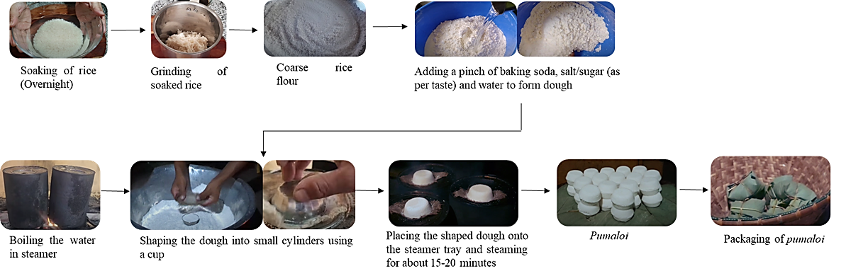
Fig. 13. Process flowchart for preparation of Pumaloi

  - Pulaiñ Saw
The Khasi tribe of Ri Bhoi is known to prepare native steamed cake called Pulaiñ Saw (Fig. 14.), which is nearly spherical in shape. The native cooking process is comparable to that of pumaloi, but two local rice varieties: the sticky red variety and the non-sticky white kind—are used, and sugar is added to make it sweeter. After soaking and draining the water, the rice is crushed separately. Separately, the rice flour is sieved, and then cold water is added and well combined without making it sticky. A muslin cloth is wrapped around the moist white rice, which is then placed on the mouth of a vessel that is nearly the same size as the bowl inverted. The moist white rice is filled nearly halfway of a large bowl, and then a thin layer of moist red rice is evenly spread over the white rice's surface. Water is continuously boiled over the fire inside the vessel. Steam travels through the muslin cloth to cook the cake, and it is fully cooked when the bottom of the bowl is hot. When the cake cools down, it is cut. Pulaiñ saw is a unique rice-based dish that is exclusively made for special events like weddings and festivals (Umdor et al., 2016).
Fig. 14. Pulaiñ saw (Source: Umdor et al., 2016)

  - Sakin gata
Sakin gata (Fig. 15.), also known as sticky white rice cake, is a favourite sweet rice cake among Meghalaya's Garo people. Sticky rice (Minil merong) and regular rice (Miari merong) are combined in a 3:1 ratio to make this. The rice is first soaked for 6 h. The following day, soaked rice is sun-dried for roughly 3 h and then pounded with a mortar and pestle. The next step is to sauté the sesame seeds for 2 minutes, or until they produce a fragrance and crackle. A finely coarse form is obtained by grinding the sesame seeds. After the rice is powdered, 50% ground sesame seeds and 5% sugar are added and mixed. After that, the mixture is put into an earthen pot with a few holes in the bottom. Banana leaves or fibre loofah are laid on top of the pot. To guarantee adequate steaming, a few slits are made in the layered loofah or banana leaf. The banana leaf or loofah is covered with a coating of powdered sticky rice mixture, followed by a small amount of black sesame powder. This procedure is carried out until the components are arranged in five layers. This earthen pot is placed on top of a hot, steaming vessel and left to steam for 30-40 minutes after layering is finished. To prevent steam from escaping, the earthen pot is tightly packed with fabric and topped with a lid. Sakin gata is mostly made for rituals like the Wangala festival and other ceremonies (Basaiawmoit et al., 2023).
Fig. 15. Sakin gata (Source: https://bit.ly/414228a)

  - Pudoh
Pudoh is a rectangular-shaped rice-based snack filled with chunks of pork fat (approximately 7-8 cm in length, 5-6 cm in breadth, and 2-3 cm in thickness). For the preparation of pudoh, normal rice and sticky rice (3:1) is soaked overnight. After soaking, the rice is ground into fine flour. A pinch of baking soda and warm water is added to the rice flour to make a dough. The pork fat is boiled and cut it into small pieces or chunks. Salt is added as per taste. The pork fat pieces are then stuffed into the rice dough and the mixture is shaped into a rectangle. Finally, the mixture is wrapped in a leaf of Phrynium capitatum (known as Sla met in Khasi and Bolgota in Garo) and steamed. Fig. 16. shows the process flowchart for pudoh preparation.
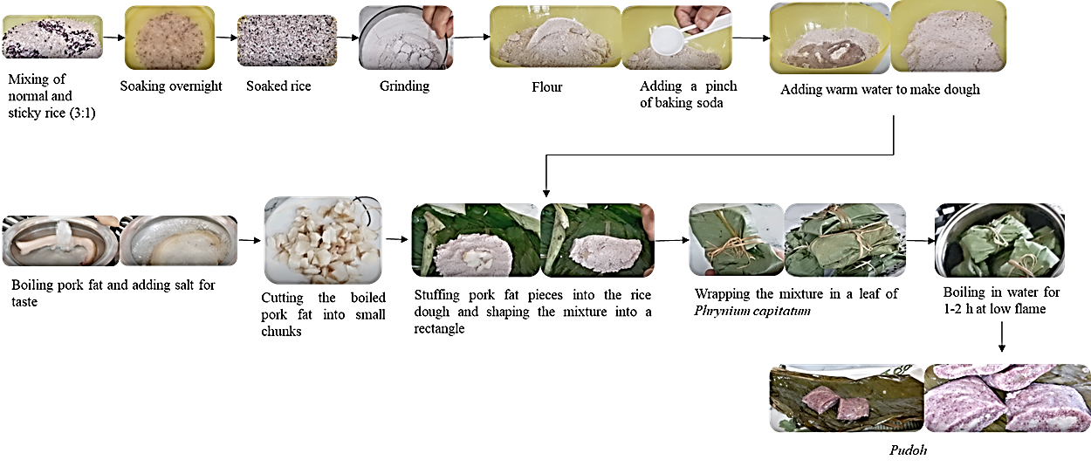
Fig.16. Process flowchart for preparation of Pudoh

  - Pu sla
Pu sla is traditional sweet snacks of Meghalaya, prepared using rice flour and jaggery. It is rectangular in shape with 9-10 cm length, 4-5 cm breadth and 2.5-3 cm height. For the preparation of pu sla, the rice is soaked for 5-6 h and then ground into fine flour. The jaggery syrup is prepared by adding water in a pan and letting it boil while stirring it continuously. Once the jaggery syrup is cooled, it is gradually added to the rice flour to make a dough. Then, a small amount of dough is taken and shaped into a rectangular form in a leaf of Phrynium capitatum and steamed for about 30 minutes using a steamer. Fig. 17. shows the process flowchart for preparation of pu sla.
Fig. 17. Process flowchart for preparation of Pu sla

  - Jashulia/ Japnah
Jashulia, also known as japnah is a steamed sticky rice, typically consumed by the different tribes of Meghalaya. Among Khasi and Jaintia tribe, these snacks are usually prepared using only sticky rice wrapped in a leaf of Phrynium capitatum which is then steamed, whereas, among Garo Communities, sticky rice is often layered with coconut and black sesame seeds wrapped in banana leaves and steamed in a regular steamer. For its preparation, the sticky rice is soaked overnight or at least for 8-10 h. Soaked rice can either be mixed with black sesame seeds and grated coconut or placed in layers (optional). Then the soaked rice is placed in a steamer for 20-30 minutes or till it is cooked properly. Finally, jashulia/japnah is wrapped in a leaf (Banana leaf or leaf of Phrynium capitatum). Fig. 18. shows the process flowchart for preparation of jashulia/japnah.
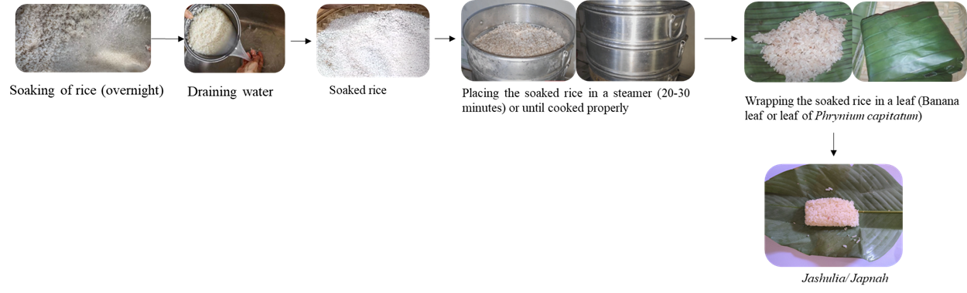
Fig. 18. Process flowchart for preparation of jashulia/japnah

  - Chhangban
Chhangban (Fig.20.) is a traditional steamed snack from Mizoram which is a sticky rice-based bread or cake. Various types of rice, including Tai Buhban, Zakeuva, Fazu, Buhtawi, and Kawnglawng, are utilized in its preparation. The rice is first soaked for an hour or overnight, followed by sun drying before being ground. The ground flour is then sieved and mixed with water to make a sticky ball. The balls are then wrapped in hnahthial (Phrynium capitatum) (Fig.19.) leaves and steamed in a big pot and consumed (Deka & Sit, 2022).
Fig. 19. Plant of Phrynium capitatum | Fig. 20. Chhangban

  - Awang Bangui
Traditionally, the Tripuri people in the state of Tripura make the rice cake known as Awang Bangui (Fig. 21.). This type of rice cake is made using two types of rice. 25% of Bengal Joha rice and 75% of Auwan/Guria Maira (local sticky rice) are obtained and combined. First, rice is left to soak in water for the entire night. Then, the soaked rice is left to dry for 2-3 h and then ground using wooden mortar and pestle to achieve a fine flour. Salt (1-2%), jaggery/sugar (5-6%), and 70% warm water (50 °C) are combined with the flour. 8–10% sesame seeds are used for flavour. Additionally, raisins are used, which must be soaked for at least 1 h. To create a thick paste, the cashews are chopped into small bits. After that, the mixture (about 200-250 g) is formed into a cone shape inside a banana leaf and fastened with a grass straw. Then, the leaf with rice mixture is placed in a pot of boiling water (80–90 °C) and boiled for 20–30 minutes. They can then be offered as dessert. Occasionally, rice is soaked, strained, and then combined with cashews, raisins, and ghee before being placed in a conical banana leaf and boiled (Deka & Sit, 2022; Basaiawmoita et al., 2023).
Fig. 21. Awang Bangui (Source: https://bit.ly/3WTBKCV)

Table.2. Ethnic snacks of North east India
Food product | Region | Major ingredient | Nature and use | Major consumers
Winsii | Arunachal Pradesh | Rice flour | Steamed snack | Tangsa
Sunga pitha | Assam | Rice based | Sweet, baked snack | Assamese
Tekeli pitha | Assam | Rice, jaggery, grated coconut | Sweet, steamed, snack | Assamese, Bodo
Til pitha | Assam | Rice flour, sesame seeds, jaggery | Sweet, baked snack | Assamese
Entaap | Assam | Sticky rice flour, sesame seeds | Sweet, steamed snack | Bodo
Putharo | Meghalaya | Rice flour | Savoury, steamed, snack | Khasi and Jaintia
Pusyep | Meghalaya | Rice flour | Savoury, steamed snack | Khasi and Jaintia
Putyndong | Meghalaya | Rice flour, sugar | Savoury, steamed snack | Khasi
Pumaloi | Meghalaya | Rice flour | Steam cooked, snack | Khasi and Jaintia
Pulaiñ saw | Meghalaya | White and red variety of rice | Steam cooked, snack | Khasi
Sakin gata | Meghalaya | Sticky rice flour, plain rice flour, sugar, sesame powder | Sweet, steamed snack | Garo
Pudoh | Meghalaya | Normal rice, sticky rice, pork fat, baking soda, salt | Steam cooked, snack | Garo and Khasi
Pu sla | Meghalaya | Rice flour, jaggery | Sweet, steamed snack | Garo, Khasi and Jaintia
Jashulia/ Japnah | Meghalaya | Sticky rice (either white/black/purple), black sesame seeds, coconut, salt/sugar | Steam cooked, snack | Garo, Khasi and Jaintia
Awang bangui | Tripura | Sticky rice flour, Bengal Joha rice flour, jaggery/sugar, salt, sesame seeds | Sweet, steamed snack | Tripuri

Conclusion
Traditional foods in India are evidence of to the wise use of resources in different regions, including coastal, plains, hilly, and desert regions. They are carefully processed to satisfy the palate and provide nutritional value. To make it more feasible and palatable, the developed knowledge must also be incorporated with scientific ideas. Traditional snacks are made with indigenous skills passed down through generations. These things serve as a source of money in addition to providing them nourishment and a portion of their meals and snacks. Standardization of the processing methods of these snacks is essential for improving its quality, shelf life, which in turn will lead to commercialization thereby elevating the social and economic status of the ethnic community. The present study presents a compilation of various ethnic steamed snacks of NE India as mentioned in Table 2, highlighting the ingredients, traditional process, and tools used for their preparation. This information can be used for standardization and mechanization of the indigenous snacks prevalent in NE India.
Consent for publication
All authors agree for this publication.
Availability of data or materials
The authors declare that there are no associated data or materials with this paper.
Competing interests
Authors have no conflict of interest to declare.
Funding
Not applicable.
Author Contributions
Apeksha: Conceptualization, methodology, visualization, investigation, writing – original draft
Dhamchoe Dolma Bhutia: Resources, reviewing, editing and writing
Sujata Jena: Conceptualization; project administration; supervision; writing-review and editing.
Acknowledgements
We gratefully acknowledge all those who helped us in many ways to accomplish data collection and analysis successfully.
Disclaimer (Artificial intelligence)
Author(s) hereby declares that NO generative AI technologies such as Large Language Models (ChatGPT, COPILOT, etc.) and text-to-image generators have been used during the writing or editing of this manuscript.
References
Anadani S V, Akbari S H , Kumar, N, Ravani, A, 2020; Processing and mechanization of Indian traditional food products. J. Pharmacogn. Phytochem. 9 (1) :2313-2315.
Bareh H M. Encyclopedia of North-East India, Meghalaya. 4 (97): New Delhi: Mittal Publications. 2007.
Basaiawmoit B, Mishra B K, Hati S. Rice cakes of North-East region of India: A systematic review. Indian J. Tradit. Knowl. 2023; 22 (1): 99-107.
Basak S, Chakraborty S, Singhal R S. Revisiting Indian traditional foods-A critical review of the engineering properties and process operations. Food Control. 2023;143: 109286.
Batu A. Konya (Turkey) gastronomy culture extending to Seljuk Empire. J. Ethn. Foods. 2018; 5: 184–193.
Bawa A S, Sidhu J S. Snack foods, in: Caballero, B., Trugo, L., Finglas, P. (2nd Ed.), Encyclopedia of Food Sciences and Nutrition, Oxford: Elsevier Science 2003; 5322–5332.
Bhattacharya B, Deka D C. Biochemical Indices and Consumption Pattern of Traditional Alcoholic Beverages by Tribal Communities of North-East India: A Review. Curr. Res. Nutr. Food Sci. 2023;11 (2):470-487.
Bhuiyan M H R, Hossain M A, Yeasmen N. Local-traditional foods of Bangladesh: A treasure to be preserved. Int. J. Gastron. Food Sci. 2022;30: 100602.
Byakika S, Mukisa I M, Byaruhanga Y B, Male D, Muyanja C. Influence of food safety knowledge, attitudes and practices of processors on microbiological quality of commercially produced traditional fermented cereal beverages, a case of Obushera in Kampala. Food Control. 2019; 100:212–219.
Chakraborty R, De B, Devanna N, Sen S. North-East India an ethnic storehouse of unexplored medicinal plants. J. Nat. Prod. Plant Resour. 2012;2 (1):143-152.
Deka P, Sit N. A review of the traditional cereal-based foods and beverages of north-east India. Int. J. Gastron. Food Sci. 2022;31: 100632.
Dutta B K, Dutta P K. Potential of ethnobotanical studies in North East India: An overview. Indian J. Tradit. Knowl. 2005;4 (1): 7-14.
Kala C P. Ethnic food knowledge of highland pastoral communities in the Himalayas and prospects for its sustainability. Int. J. Gastron. Food Sci. 2021;23: 100309.
Kumar N G, Rubesh V, Rakesh Kumar N, Venkat Prabhu R. Design of anarsa making machine. Int. J. Mech. Prod. Eng. Res. Dev. 2017;7 (2):121-126.
Lücke F K, Zangerl P. Food safety challenges associated with traditional foods in German-speaking regions. Food Control. 2014; 43: 217–230.
McWilliams B. "The American Food Revolutions: Cuisines in America.". http://www.eldrbarry.net/hatr/eldrcuis.html. 2022; Accessed 27/06/2024.
Panagou E Z , Nychas G J E, Sofos J N. Types of traditional Greek foods and their safety. Food Control. 2013;29 (1): 32-41.
Pohsnem J M, Ramakrishnan E, Parasar D P.Fermented food products in the Himalayan belt (North East India) and their health benefits. Int. J. Gastron. Food Sci. 2023; 31:100676.
Singh A, Singh R K , Sureja A K. Cultural significance and diversities of ethnic foods of Northeast India. Indian J. Tradit. Knowl. 2007; 6 (1): 79 - 94.
Umdor M, Kyndiah E, Mawlong H M L. Indigenous knowledge in preparing rice-based foods by the tribes of Meghalaya. Int. J. Innov. Res. Sci. Stud. 2016; 3: 234-241.

