FT-IR analysis of Ultrasonic-assisted extracts of total alkaloid and total phenolic compounds from Uvaria chamae (Annonaceae) root bark and its biological effects

Abstract
Background The concept of sustainable development is relevant nowadays, hence the use of extraction methods with a positive environmental impact or eco-friendly extraction technique to obtain the active ingredients of the plant.
Aims: Besides Fourier Transform Infrared (FTIR) spectroscopy analysis of U. chamae root bark extracts
This study investigates the antioxidant and antiplasmodial potential of various crude extracts from the root bark of Uvaria chamae P. Beauv (Annonaceae).
Methods: Two extraction techniques and different solvents were used. Ultrasonic-assisted extraction (UAE) and magnetic stirring extraction with ethanol and hydroethanolic solvent (30:70). The total alkaloid content (TAC) and total phenolic content (TPC) were quantified using the acid dye colorimetric method and the Folin-Ciocalteu method, respectively. The antioxidant activity was assessed using the DPPH (2,2-diphenyl-1-picrylhydrazyl) scavenging method and In vitro antiplasmodial activity was evaluated through the SYBR Green I-based fluorescence assay.
Results: Total Alkaloid Content (TAC) and Total Phenolic Compounds (TPC) with values of (1.5 ± 0.3) μgAE/g of extract and (11.6 ± 0.4) μgGAE/g of extract, respectively are obtained. IC50 values of antioxidant potential ranging from (0.075 ± 0.001 to 0.183 ± 0.003) mg mL⁻¹. IC50 values of antiplasmodial activity ranging from (9.84 ± SD to 28.69 ± SD) µg mL⁻¹. The extraction yield of 9.80% achieved with UAE demonstrated its superior efficiency compared to the conventional solvent extraction method, which yielded only 3.18%. Fourier Transform Infrared (FTIR) spectroscopy analysis of U. chamae root bark extracts identified the presence of active functional groups typically associated with alkaloids and polyphenols.
Conclusion: Obtained results using the green extraction method (UAE) confirming its suitability and efficiency for recovering secondary metabolites with antioxidant and antiplasmodial potential from U. chamae root bark. Hence this provides a strong database for pharmaceutical research and the galenic formulation of phytomedicines against oxidative stress with antimalarial properties
Keywords: Uvaria chamae, Ultrasonic assisted extraction, antiplasmodial activity, antioxidant activity.

Graphical abstract
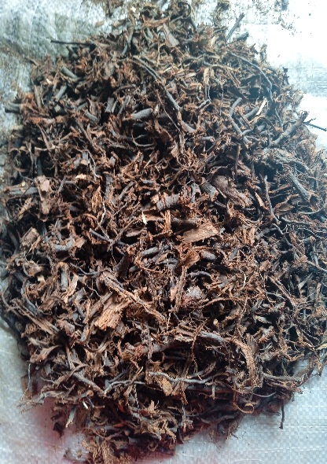
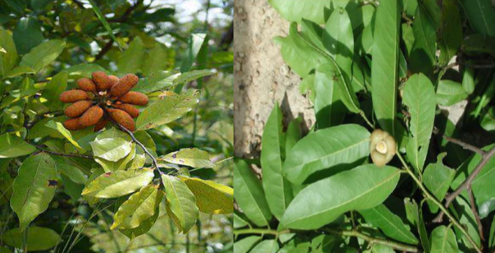
Dried U. chamae root bark

Plant materials
Fresh plant of U.chamae

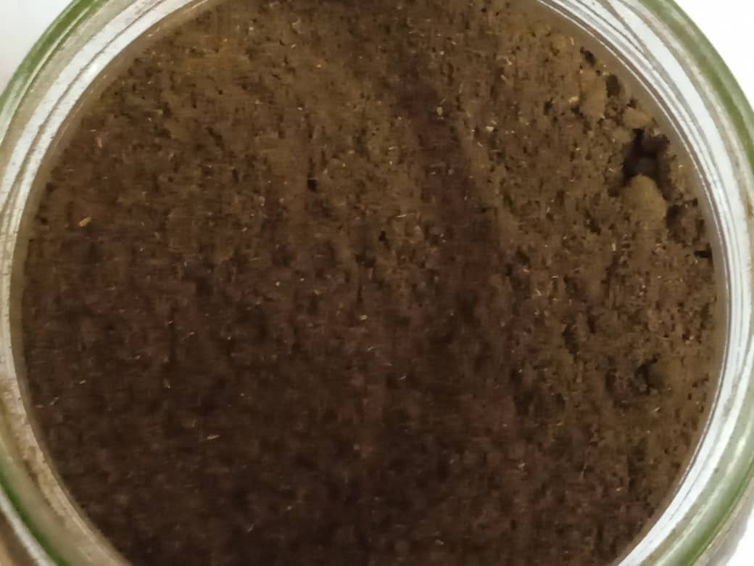
Dried powder of U. chamae root bark
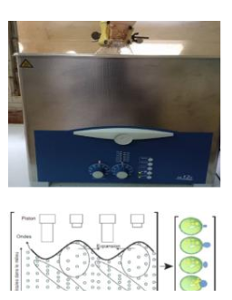

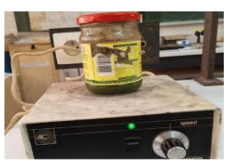
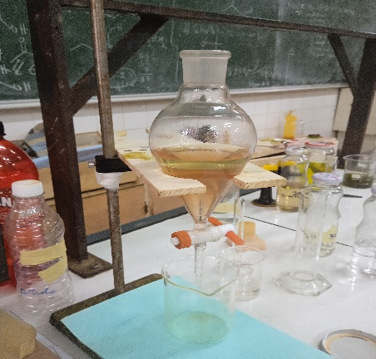
Different extraction methods

Magnetic stirring extraction
Alkaloid extraction
Ultrasonic-assisted extraction of alkaloid and phenolic compounds
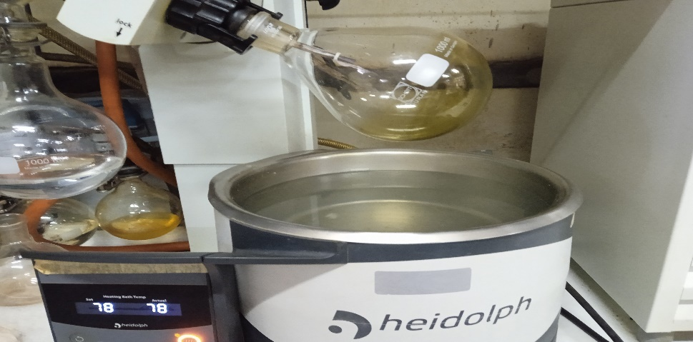

Rotary evaporator

,

Quantitative analysis and biological assessments
Extraction yields
Antioxidant assessment
Antiplasmodial assessment
Total alkaloid content
Total phenolic content

FTIR analysis
1. INTRODUCTION
Uvaria chamae is a medicinal plant belonging to the Annonaceae family. According to the botanical description, U. chamae is a shrub plant of the Cameroon, Ivorian, Benin, Senegal and Congo biodiversity used in traditional medicine. Commonly known as finger root or bush banana, this common name refers to the fruits growing in small bunches; the fruits are edible and widely eaten (Eyog et al., 2001). Malaria is an infectious disease caused by the parasite Plasmodium falciparum the most severe among the five existing species. It is the one that causes the highest number of deaths in Sub-Saharan Africa and is transmitted to humans through the bite of an infected female Anopheles mosquito (Batana et al., 2024). Dual therapy that destroys the parasite and counteracts redox imbalances generated during infection is necessary. Indeed, a clinical patient study demonstrated the beneficial antioxidant properties of N acetylcysteine given in combination with artesunate as a treatment for severe malaria (Fekam, 2003). Thus, the discovery of substances possessing two biological activities would constitute an important gain for the fight against malaria. In addition, Uvaria chamae is used for the treatment of countless pathologies such as hemorrhages, dysentery, wounds, sore throat, abdominal pain, fatigue, respiratory disorders and anemia (Adomou et al., 2012; Koné et al., 2013). The macerate of the leaves is also used in the form of a lotion against edema, and inflammation of the intraocular tissues of the deep layers of the eyeball. The roots are recommended against heart disease and nasal hemorrhage (Etukudo, 2003; Moses et al., 2013). Antioxidant properties have been reported by Kone et al in 2015 (Kone et al., 2015) and the anti-inflammatory effect of this extract would significantly inhibit carrageenan-induced rat paw edema (Bamba et al., 2021). More U. chamae is used throughout its range to treat fevers and has antibiotic properties.
The use of synthetic antioxidant molecules is nowadays called into question due to their countless harmful side effects on human health; hence the search for new sources of natural antioxidants from plants. Indeed, a large number of research works have shown a positive relationship between the phenolic content and the antioxidant capacity of the plant. Moreover, the regular consumption of antioxidant products is believed to prevent oxidative-stress events and oxidative-stress-related diseases (Bamba et al., 2019). Obtaining such compounds often requires many long and costly steps, such as extraction, isolation and identiﬁcation and those process result in thermal degradation of various bioactive constituents. In addition, loss of some compounds by degradation, low production efﬁciency, time- and energy-consuming procedures (prolonged heating and stirring, use of large volumes of solvent) may be encountered using these conventional solvent extraction methods. These shortcomings have led to the use of new sustainable ‘‘green and innovative’’ extraction techniques, which typically involve less time, solvent and energy, such as ultrasound-assisted processing, supercritical ﬂuid extraction, extrusion, microwave-assisted extraction, controlled pressure drop process, pulse-electromagnetic ﬁeld, high pressure, and subcritical water extraction (Virot et al., 2010).
In this context, the development of alternative extraction methods is one of the major challenges in technological innovation towards the direction of “Green chemistry” (Farid et al., 2016). Furthermore, In order to extract efficiently these bioactive secondary metabolites, the most appropriate method is needed. Hence, Ultrasound offers a net advantage in terms of productivity, yield and selectivity, with better processing time, enhanced quality, reduced chemical and physical hazards, and is environmentally friendly compared to the conventional method, such as conventional magnetic stirring. Ultrasonic-assisted extraction (UAE) has been utilized in several studies with the aim of enhancing the yields of bioactive compounds. Despite the biological and therapeutic virtues of this plant, little information on Ultrasonic-assisted extraction of the total alkaloid content (TAC), the total phenolic content (TPC), antioxidant and antiplasmodial activity investigations exist. However, to the best of our knowledge, so far there is no report about the effect of UAE on antioxidant and antiplasmodial activity for U. chamae root bark extracts obtained by magnetic stirring and Ultrasonic assisted extraction. Although there are reports of the use of U. chamae root bark to treat fevers/ malaria in Nigeria, Ghana…..etc (Ene et al., 2016; Obi et al., 2024), it seems that the antiplasmodial activity of U. chamae root bark extracts obtained by UAE has not been subjected to any scientific testing or study. Despite countless research on using UAE in extracting phenolic compounds from U. chamae, its total alkaloid content approach remains also unexplored.
2.
MATERIALS AND METHODS
2.1 Plant material and chemicals
The plant samples were harvested in the Far-north region in November 2022 and identified by Dr Fawa Guidawa, botanist and agro forester in the Department of Biological Sciences of the University. In addition, the samples were also authenticated by comparing them with the preserved specimens at the National Herbarium of Cameroon located near the University of Yaounde I. The samples were freed from extraneous materials, cut into smaller pieces, shade-dried at room temperature and powdered using an electrical blinder. A mass of 3 kg was obtained and stored at room temperature for further investigation.
2.1.2 Chemicals
All the chemical reagents used in this work such as ethyl acetate, ethanol, sulfuric acid, hydrochloric acid, glacial acetic acid, ammonium hydroxide, sodium carbonate, nitric acid, aluminium chloride, sodium sulfate anhydrous, petroleum ether, potassium iodine, mercury chloride, thiourea, gallic acid, Folin ciocalteu reagent, DPPH, atropine, Draggendorf reagent, Mayer’s reagent, butyl hydroxyl toluene and quinine were purchased from Sigma-Aldrich Chemical Co. (St. Louis, USA). All other chemicals and reagents were of analytical grade and used in their standard state without further treatment.
2.2 Methods
2.2.1 Ultrasonic-assisted extraction procedure.
UAE was performed in an ultrasonic apparatus (The Clifton Range Ultrasonic bath SW Series of Industrial Ultrasonic Baths, EMC Directive 2014/30/EU, BS24 9BL United Kingdom) with a working frequency ﬁxed at 38 kHz. For extraction, 10 g of the powder of U. chamae root bark was placed in a 250 mL amber glass bottle containing 100 mL of solvent (ethanol, ethanol: water 70:30 (v:v)), and distillate water). The suspension was exposed to acoustic waves under distinct setting parameters during 20 min of irradiation time. The temperature of 60˚C was maintained constant. After extraction, the vessel was allowed to cool down for 30 minutes, then the mixture was filtered using a Whatman filter paper and funnel to obtain extract. The ethanolic filtrate obtained was concentrated using a rotary evaporator (Heidolph Germany), under partial pressure to obtain the ethanol-free extract and the aqueous filtrate was lyophilized using a lyophilizer (Copfrance) Fig. 1 After this step, the different extracts were kept at 4°C for further investigations. Mechanical agitation extraction was performed as in previous work (Nana et al., 2024).
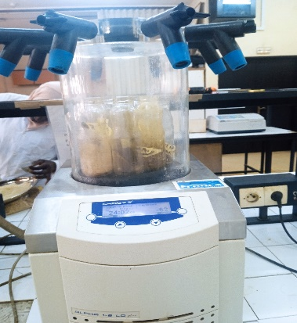

Fig. 1 Lyophilizer for aqueous
Fig. 1 Lyophilizer for aqueous extracts

2.2.2 Alkaloids conventional solvent extraction
The extraction of total alkaloids from U. chamae root bark, made by liquid-liquid extraction is based on the difference in the solubility of alkaloids in the acidic and alkaline medium in acidified water on the one hand and in an organic solvent on other hand (Djilani et al., 2006). Specifically, 10 g of powdered U. chamae root bark was wetted with 15 mL of the solution of ammonium hydroxide (NH₄OH 25% v/v) and macerated at room temperature. Extraction was performed with 300 mL of ethyl acetate for 72 h. The filtrate recovered after this maceration time was evaporated in a rotary evaporator under reduced pressure at 70˚C. The extract obtained after the concentration was dissolved in water and acidified with S₂O₄ to a pH of 3-4. Then, the aqueous solution obtained will be subject to different partitions. The first partition was carried out by adding, petroleum ether and diethyl ether to remove lipophilic, acidic and neutral material. After basifying the aqueous phase recovered to pH 9-10 with the solution of ammonium hydroxide (NH₄OH 25% v/v), the second partition during which the extraction with chloroform of the previous basified solution took place. This step was followed by a series of three washing with distilled water of the recovered organic phase to neutralize the pH, followed by drying by adding Na₂SO₄ and concentrated to dryness under reduced pressure to obtain crude total alkaloids
2.2.3 Ultrasonic-assisted extraction of total alkaloids
The same amounts of powdered root bark of U. chamae and solvent used for maceration extraction were used to make UAE. This extraction was carried out with a constant frequency of 38 kHz and a temperature of 30℃ for 2h30 min. Once filtered, the solution undergoes the same steps as those of the maceration extraction to obtain the total alkaloids (Yang et al., 2015). Fig. 2 illustrate the Clifton Range Ultrasonic bath used for the extraction process.
previous work (Nana et al., 2024).
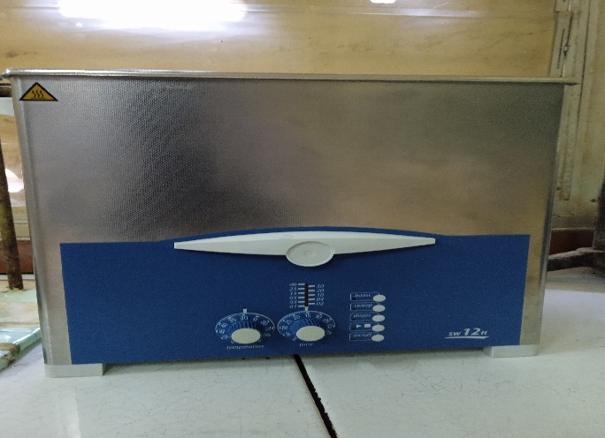
Fig.2 The Clifton Range Ultrasonic bath (SW series)
2.2.4. Qualitative secondary metabolites analysis
2.2.4.1 Fourier transformed infrared (FT-IR) spectroscopic analysis and Thin Layer Chromatography (TLC) of U. chamae crude extract
FT-IR spectroscopy is an analytical technique used to identify organic compounds by identifying the main functional groups in a sample using infrared light and hence chemical properties. FTIR spectroscopy is based on the principle according to which each function can be decomposed into a sum of sinusoidal functions, each of which is defined by two values: its frequency (wavelength) and its amplitude (Intensity) (Diabi et al, 2022). The alkaloidal extract obtained was subjected to FTIR analysis and vibration bands characteristic of alkaloids were recorded in the absorption range between 1000 and 3500 nm as illustrated in Figure 3 below. FT-IR analysis was performed using Perkin Elmer Spectrophotometer system, which was used to detect the characteristic peaks, types of chemical bonds and probable functional groups present in U. chamae sample. The peak values of the FT-IR were recorded and the analysis was repeated twice for the spectrum conﬁrmation. Precisely, extract fragments were further introduced in the inhibited medium. After the investigation, those fragments were mixed with KBr (potassium bromide) and subjected to infrared spectroscopy using (SHIMADZU Model FTIR-84008) to identify the functional group in the investigated extracts.
Still to verify the presence of alkaloids in the extracts, thin-layer chromatography was carried out according to the slightly modified method of Kurt (1971) as follows; After dissolution (10 mg mL⁻¹) of the extract and Atropine in 1 mL of methanol, 10 µL of each of the solutions are deposited 1 cm from the bottom edge on the baseline of the chromatographic silica gel plate of 0.2 mm layer Macherey-Nagel brand, previously activated in an oven at 110°C for 3 at 5 minutes using a micropipette. Each deposit was dried using a hair dryer, the plate was then immersed in the chromatographic tank containing the mobile phase system (methanol/chloroform/ammonia: 8/2/0.15 (V/V/V)). When the front of the solvent reaches 4 cm from the upper edge of the plate, the chromatograms are removed, dried and sprayed with Dragendorff’s reagent immediately, dark brown spots appeared on a yellow-orange background and the plate was read under a UV lamp at 254 meaning the presence of alkaloids (Kurt, 1971).
2.2.5. Quantitative secondary metabolites analysis
2.2.5.1 Determination of total phenolic content (TPC)
The amount of total polyphenolics of U. chamae root bark extracts was determined spectrophotometrically using the Folin-Ciocalteau assay according to the modified method of Singleton (Singleton et al., 1999). The Folin-Ciocalteu reagent (1/16) and aqueous Na₂CO₃ (20 g L⁻¹) were added to the mixture. The mixture was allowed to stand at 40°C for 20 min with intermittent shaking. The absorbance was measured at 760 nm on the Metertech Germany Spectrophotometer UV/vis sp 8001 using glass cuve against blank in the number one test tube. The TPC was assessed by plotting the gallic acid calibration curve and the results were expressed as gallic acid equivalent (GAE) per g of extract. The standard curve with reference substance of Gallic acid was Y =2.272x+0.1482 (R²= 0.9866), where Y is the absorbance and X is the concentration of Gallic acid. All the measurements were performed in triplicate and the total polyphenol content is calculated according to the formula below:
$$x=\frac{c.V}{m}$$
Extracts (0.1
With: 𝐗 the phenolic content;
C =𝐘, (𝐘=𝐚𝐱+𝐛); 𝐚 and 𝐛 are the coefficients of the linear calibration line and x corresponds to the optical densities read
m: The mass of the extract used, V: The volume of the extract used for the test.
2.2.5.2 Determination of total alkaloid content (TAC).
The acid dye colorimetric method is commonly used in the determination of the total alkaloid content. The amount of total alkaloid content from U. chamae root bark extracts was determined spectrophotometrically according to the modified method used by Shamsa (Shamsa et al., 2008). Precisely, the spectrophotometric method based on the reaction with bromocresol green (BCG) (69.8 µg/mL) was the one used for the determination of the total alkaloids content in U. chamae root bark and absorbance was measured at 420 nm. Atropine was used to establish the calibration curve and total alkaloid content is reported as atropine equivalent as mg g⁻¹. The standard curve is produced from a stock atropine solution of 10 mg/L with a range of concentrations from 0 to 1 mg mL⁻¹. The absorbance of the complex in chloroform was measured at 470 nm against blank prepared as above but without atropine using Metertech Germany Spectrophotometer UV/vis sp 8001.
2.2.5.3 Quantitative antioxidant test using DPPH radical-scavenging activity
The antioxidant capacity was measured according to the method used by Yang with some slide modifications (Yang et al., 2021). Precisely, a stock solution of 100 μg mL⁻¹ of each extract was prepared by diluting 0.5 mg in 5 mL of solvent. By different dilutions of the stock solution, a standard range of concentrations: 0.04, 0.08, 0.12, 0.16 and 0.2 mL mg⁻¹ were obtained. Butylated hydroxytoluene (BHT) was used as reference compound. For each concentration, assays were triplicated, the optical densities were measured using a Metertech Germany Spectrophotometer UV/vis sp 8001 at 517 nm and the antioxidant activities were evaluated using the following formula:
IP% = (A _{control-A sample})/A control) * 100,
Where initial A is the absorbance of the control reaction and A sample is the absorbance of the test extract or purified organic compound. The negative witness, a solution of DPPH at 10 % in the methanol and the positive witness, the Butylhydroxytoluene (BHT) solution were submitted to the same analysis and rigorously in the same conditions with the same concentration as the plants fractions.
2.2.5.4. In vitro antiplasmodial activity.
The SYBR Green I- Based Fluorescence Assay to Assess Cell Viability of Malaria is widely used to monitor drug susceptibility of malaria parasites.
2.2.5.4.1 Parasite maintenance
Plasmodium falciparum parasites obtained from BEI Resources (https://www.beiresources.org/) were maintained in culture as described by Trager and Jensen (1976) in fresh O-positive human red blood cells suspended at 4% (V/V) hematocrit in complete RPMI 1640 medium (500 mL RPMI 1640 (Sigma, Munich, Germany) supplemented with 25 mM HEPES, 10% Albumax II (Gibco, Waltham, MA, USA), 1X hypoxanthine (Gibco, Waltham, MA, USA) and 50 mg/mL gentamicin (Sigma–Aldrich, Munich, Germany) and incubated at 37°C in a humidified atmosphere of 5% CO₂. The medium was renewed daily to propagate the culture. Parasite growth was monitored by microscopic examination of Giemsa-stained thin blood smears under oil immersion.
2.2.5.4.2 Synchronization of P. falciparum asexual-blood stage culture
To obtain the ring stage of the parasite, the cultures were synchronized as previously described ((Lambros and Vanderberg, 1979). Briefly, the cultures with parasites mainly at the ring stage were treated with an equal volume of aqueous 5% D-sorbitol for 10 min. The treated cultures were centrifuged at 1,500 rpm for 5 min, and the pellets were further suspended in a complete medium. The synchronized culture was used at 2% parasitemia and 1% hematocrit for the antiplasmodial assay.
2.2.5.4.3 Determination of the antiplasmodial activity
The antiplasmodial activity of the samples was evaluated using the previously described SYBR Green I-based fluorescence method (Smilkstein et al., 2004). Briefly, 10 µL of each test substance was transferred to a 96-well assay plate in duplicate for final concentrations varying from 0.16 to 100 μg mL⁻¹. Artemisinin and chloroquine at 10 μM and 0.1% DMSO (v/v) were tested as positive (0% growth) and negative (100% growth) controls, respectively. Thereafter, 90 µL of parasitized red blood cells at 2% parasitemia and 1% hematocrit were dispensed into each well and incubated for 72 hours. Plates were directly checked for the presence of trophozoites to evaluate parasite growth. To this end, cells were lysed by performing freeze-thaw cycles, and 50 µL of the thawed culture in each well was gently mixed with 50 µl of SYBR Green I lysis buffer solution [0.2 μL of 10,000×SYBR Green I (Invitrogen) per mL of lysis buffer {Tris (20 mM; pH 7.5), EDTA (5 mM), saponin (0.008%; wt/v), and Triton X-100 (0.08%; v/v)}]. Plates were additionally incubated for 60 minutes in darkness at room temperature, and fluorescence was measured using a Tecan Infinite M200 plate reader (Tecan) at excitation and emission wavelengths of 485 and 530 nm, respectively. These data were normalized to percent control activity using Microsoft Excel software, and median inhibitory concentrations (IC₅₀) were calculated using Prism 5.0 software (GraphPad) with data fitted by nonlinear regression to the variable slope sigmoidal dose-response formula
y = 100/ [1+ 10(logIC₅₀-x)^{H}], where H is the Hill coefficient or slope factor (Rosenthal and Singh, 2001).
3. RESULTS
3.1 Extraction yields.
Table 1 below shows the U. chamae extracts obtained by Ultrasonic-assisted extraction and by mechanical agitation methods. Amongst different extractions methods and solvent used, the highest extraction yields were obtained using UAE with hydroethanolic solvent and maceration for alkaloids extract.
Table 1 Extraction yields of secondary metabolites from U. chamae root bark obtained from the two extraction techniques
Extraction methods | Solvent used | Crude extract yields (%) | Alkaloids extract yields (%)
UAE | EtOH/ H₂O (3:7) | 9.80 | 4.10
Maceration | EtOH/ H₂O (3:7) | 3.18 | 12.51

3.2 Qualitative evaluation assay of different extracts
3.2.1Thin-Layer Chromatography (TLC) of U. chamae of alkaloid crude extract
The appearance of brown-orange spots on a yellow-orange background having practically the same frontal ratio as that of the quinine used as standard is observed on the Thin-Layer Chromatography profile illustrated by the fig. 3.
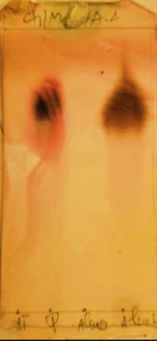
Quinine
Alkaloids
Fig. 3 Chromatography profile of total alkaloids from U. chamae root bark. (methanol/ chloroform/ ammonia: 8/2/0.15 (V/V/V))
3.2.2 FT-IR of Uvaria chamae extracts
The Fourier Transform Infra-Red (FT-IR) analysis was carried out on the three Uvaria chamae extracts to identify the different active functional groups, extract obtained by conventional solvent extraction (fig. 4), the two alkaloids extracts (fig. 5, and fig. 6) obtained by respectively conventional solvent assisted extraction and ultrasonic-assisted extraction.
F
E
D
C
B
A
Fig. 4 FT-IR Spectra of U. chamae hydroethanolic crude extract from conventional solvent extraction.
Table 2 FT-IR peak values and functional groups of conventional solvent extract of U. chamae
Peak values | Wavenumber(cm⁻¹) | Absorption | Chemical bonds | Funtional groups
A | 3262.72 | medium | O—H | O—H stretching/ group
B | 2082.83 | Very week | C≡C | C≡C stretching/alcohol
C | 1592.00 | strong | C═C | C═C stretching/aromatic group
D | 1386.98 | strong | C—H | C—H bending
E | 1253.18 | broad | C—O | stretching/alcohol group
F | 1066.08 | strong | C═C─ C—H | C—H bending/alkane group

J
K
I
H
G
F
E
D
C
 B
A
Fig. 5 FT-IR Spectra of U. chamae ethanol total alkaloid extract from conventional solvent extraction
Table 3 FT-IR peak values and functional groups of total alkaloids from conventional solvent extract of U. chamae
Peak values | Wavenumber(cm⁻¹) | Absorption | Chemical bonds | Funtional groups
A | 3485- 3272.55 | medium | N—H | N—H stretching/amine group
B | 3066.26-2927.06 | strong | O—H | O—H stretching/alcohol
C | 2854.34 | broad | O—H | O—H stretching/carboxylic acid group
D | 1719.70 | strong | C=O | C=O stretching/aldehyde group
E | 1600.41 | strong | C=O | C=O Carbonyl/unsaturated group
F | 1372.85-1489.97 | strong | C—H | C—H bending/alkane group
G | 1244.42-1270.84 | variable | C—H | C—H stretching/aromatic group
H | 1041.09-1205.62 | week | C—N | C—N stretching/amine group
I | 843.57-979.83 | strong | C—H | C—H bending/alkene group
J | 711.77-809.22 | variable | C—H | C—H bending/aromatic group
K | 601.08-697.73 | variable | C—H | C—H bending/aromatic group

A
H
G
F
E
D
C
B
Fig. 6 FT-IR Spectra of U. chamae ethanol total alkaloid extract from ultrasonic-assisted extraction
Table 4 FT-IR peak values and functional groups of total alkaloid extract from ultrasonic-assisted extraction of U. chamae
Peak values | Wavenumber(cm⁻¹) | Absorption | Chemical bonds | Funtional groups
A | 3371.66-3753.48 | broad | N—H | N—H stretching/amine group
B | 2923.59-3009.41 | strong | O—H | O—H stretching/ carboxylic acid
C | 2853.85 | strong | C—H | O—H stretching/ alkane
D | 1665.02-1742.78 | strong | C=O | C=O stretching/aryl ketone group
E | 1458.79 | strong | C—H | C—H bending/alkane
F | 1164.27 | week | C—N | C—N stretching/amine group
G | 953.69-1085.01 | week | C—N | C—N stretching/amine alkyl
H | 721.66-876.78 | strong | C—H | C—H bending/aromatic

3.3 Quantitative evaluation of different extracts
3.3.1 Total phenolic and total alkaloid content of U. chamae
Table 5 Total phenolic content of Uvaria chamae root bark obtained from the two extractions techniques and different solvent extraction
Extraction methods | Solvent used | Total phenolic content (mg GAE/g of Extract) | Regression equation of Gallic acid calibration curve | R²
UAE | EtOH | 10.1 ± 0.8 | Y = 2,272x + 0,1482 | 0.9866
UAE | EtOH/ H₂O (3:7) | 11.6 ± 0.4 | Y = 2,272x + 0,1482 | 0.9866
UAE | H₂O | 08.3 ± 0.3 | Y = 2,272x + 0,1482 | 0.9866
Maceration | EtOH | 08.1 ± 0,2 | Y = 2,272x + 0,1482 | 0.9866
Maceration | EtOH/ H₂O (3:7) | 10.4 ± 0.6 | Y = 2,272x + 0,1482 | 0.9866
Maceration | H₂O | 05.25 ± 0,07 | Y = 2,272x + 0,1482 | 0.9866

Table 6 Total alkaloid content of Uvaria chamae root bark obtained from the two extraction techniques
Extraction methods | Total alkaloid content (mg AE/g of Extract) | Regression equation of Atropine calibration curve | R²
UAE | 0.45 ± 0.04 | Y= 2.256x + 0.036 | 0.9940
Maceration | - ± 0.3 | Y= 2.256x + 0.036 | 0.9940

3.3.2 Antioxidant activity
Polyphenols make a major contribution to free radical scavenging capacities. From Table 4 below, it emerges that whatever the solvent used, the ultrasonic extraction technique presents better results.
Table 7 Antioxidant inhibitory activities of the standard, ethanol and aqueous extracts from the U. chamae root bark
Extraction sample | I% | IC50 (mg mL⁻¹) | R²
BHT/H₂O | 61,7± 8,8 | 0,015 ± 0,001 | 0,951
BHT/C₂H₅OH | 68,1 ± 9,7 | 0,089 ± 0,005⃰ | 0,950
Ethanolic (AM) | 60,4 ± 10,8 | 0,099 ± 0,004 | 0,952
Ethanolic (US) | 73,7 ± 13,8 | 0,075 ± 0,001⃰ | 0,951
Aqueous (AM) | 36,8 ± 17,4 | 0,183 ± 0,003 | 0,916
Aqueous (US) | 41,6± 11,6 | 0,158 ± 0,007 | 0,933

Figure 7 below shows the evolution of the reducing power of the extracts obtained by ultrasonic and magnetic stirring of the root barks of U chamae and the standard. It emerges that based on IC50, the reducing power of BHT is lower than that of the ethanolic extract from ultrasonic assisted extract (0,075 ± 0,001 mg mL⁻¹) but a bit higher than that from magnetic stirrer (0,099 ± 0,004 mg mL⁻¹) which is closer to BHT (0,089 ± 0,052 mg mL⁻¹).

CSEE
UAEE

Fig. 7 Inhibition percentage in function of the concentration and in function of the extraction method used of U. chamae extracts.
CSEE: Conventional solvent extraction extract
UAEE: Ultrasonic-assisted extraction extract.
3.3.3 In vitro antiplasmodial activity
The antiplasmodial investigation activity of the different extracts tested in vitro on P. falciparum is expressed with the values of the inhibitory concentrations 50 of each extract. It appears generally that the extracts obtained by ultrasonic-assisted extraction have better antiplasmodial activities as observed in Table 8 below.

Table 8 In vitro antiplasmodial activity on the chloroquine sensitive strain of multi-resistant strain of PfDd2 investigations
 | Antiplasmodial results on Plasmodium falciparum Dd2
 |  |  | IC50(µg mL⁻¹)
Extracts/compounds |  | Extraction Method used | IC₅₀ (1) | IC₅₀ (2) | Mean | SD
Total alkaloids |  | MS | 11,46 | 9,457 | 10,4585 | 1,0015
Total alkaloids |  | US | 9,844 | 6,685 | 8,2645 | 1,5795
Crude ethanolic extract |  | MS | 28,69 | 23,9 | 26,295 | 2,395
Crude aqueous extract |  | US | >100 | >100 | >100 | ND
Crude hydroethanolic extract |  | US | 95,28 | 94,25 | 94,765 | 0,515
Crude hydroethanolic extract |  | MS | >100 | >100 | >100 | ND
Crude ethanolic extract |  | US | 22,95 | 19,58 | 21,265 | 1,685
Crude aqueous extract |  | MS | >100 | >100 | >100 | ND
Artemisinine(µM) |  |  | 0,03328 | 0,03323 | 0,033255 | 2,5E-05
Chloroquine(µM) |  |  | 0,2787 | 0,2783 | 0,2785 | 0,0002
Artemisinine(µg/ml) |  |  |  |  | 0,00939 | 0,0007
Chloroquine(µg/ml) |  |  |  |  | 0,08908 | 0,00639

MS: Magnetic Stirring, US: Ultrasonic, ND: Not Detected
4 DISCUSSION
4.1 Extraction yields
Successful determination of biologically active compounds from plant material is largely dependent on the type of solvent used and the extraction method. (Sulaiman et al., 2014). Hence the comparative studies approach on the extraction yields obtained by the two extraction methods used are summarised in table 1 above. This table shows the U. chamae extracts obtained by Ultrasonic-assisted extraction and by mechanical agitation methods. The highest extraction yields were obtained using UAE with hydroethanolic extract at 9.80 % and aqueous extract at 3.18 %. This effectiveness of ultrasonic in accelerating extraction can be explained by the intensification of materials transfer using the mechanical effect of ultrasound which allows rapid exudation into the solvent until reaching an equilibrium where the stage is governed by diffusion (Chemat et al., 2017). However, the alkaloids extraction yield obtained by maceration was three times higher than ultrasonic-assisted extraction yield. According to the alkaloids extraction, the highest extraction yield (12.51 %) was achieved by mechanical agitation method extraction, compared to ultrasonic-assisted extraction with a lower extraction yield (4.10 %). This result is similar to the work carried out by Abu who obtained an extraction yield of 6.70 % using the maceration method and 3.80 % for UAE (Abu et al., 2018) ^{a,b} . In the conventional extraction method, the agitation movement increase energy which extracts alkaloids from plants materials. The extraction is assigned to the effect of the solvent and the process of agitation that takes place leading an increase of the temperature provoking the leaching of the plant material. With this green alternative extraction method, the processing time is reduced from hours to a few minutes when compared with conventional maceration.
4.2 Thin-Layer Chromatography (TLC) of U. chamae of alkaloid crude extract
After revelation with Dragendorff’s reagent and under UV lamp at 254 nm those appearances confirm the presence of alkaloids in the sample (fig. 3). The migrated extract shows the same chromatographic profile as the migrated standard. Many studies have shown the presence of alkaloids in different parts of the species U.chamae (Akibou et al., 2014; Bouaziz, 2014; Okwuosa et al., 2012).
4.3 FT-IR of Uvaria chamae extract
The three spectra are different according the extract obtention methods. But the two alkaloids spectra are a bit similar despite the functional groups present in one and not appearing in the other. The FTIR spectroscopic figures depict different characteristic peak values with various functional groups of compounds. Figures 4, 5 and 6 show numerous peaks thus reflecting the presence of mixed function compounds with various functional groups. The range of the peak numbers includes (3266 to 1066; 3472.55 to 601.08, and 3262.72 to 721.66) cm⁻¹. Similar observations were documented by Osasenaga in 2016 (Osasenaga et al., 2016). This proves that Uvaria Chamae is an active species that contains bioactive molecules with therapeutic active ingredients.
Fig.4. Different characteristic peak values with various functional groups of compound (s) in U. chamae conventional solvent extraction root bark extracts. Broad O—H stretching around 3272 cm⁻¹ depicts the presence of an alcohol functional group. This justiﬁes the presence of compound (s) with alcohol characteristics in U. chamae. A very week stretch around 2082 cm⁻¹ shows C≡C stretching depicts an alkyne functional group. The stretching and bending around 1598 cm⁻¹ and 1386 cm⁻¹ respectively reveal a sp² functionality which is indicative of the presence of unsaturated compounds with C═C bond in U.chamae. The stretch around 1253 and 1066 cm⁻¹ is indicative of the presence of a C—O in the crude extract. This carboxyde group stretch suggests the presence of alcohol, esters or cyclic esters (Seyhan, 1994). The peak values, transmittance, chemical bonds, functional groups and possible groups of compounds present in U.chamae root bark extracts are summarized in table 2 above.
Fig. 5 above another FT-IR corresponding to the spectra of U. chamae crude alkaloid extract from conventional solvent extraction. Different characteristic peak values with various functional groups of compound (s) in U. chamae conventional solvent extraction root bark extracts. Broad O—H stretching around (3485-3272.55) cm⁻¹ depicts the presence of an amine and amide functional groups. This justiﬁes the presence of compound (s) with amine and amide characteristics of the investigated extract. Moderate stretches around (3066.26-2927.06) cm⁻¹ show O—H stretching which respectively depict carboxylic acid functional groups. The stretching and bending around 2854.34 cm⁻¹ reveals the presence of the O—H stretching/carboxylic acid group. The stretch around (1719.70 to 1600.41) cm⁻¹ of a strong absorption band indicates the presence of C=O stretching/aldehyde group and C=O Carbonyl/unsaturated carbon group in the crude ultrasonic-assisted extraction extract (Seyhan, 1994). Table 3 above presents the rest of the description of the different functions present in the secondary metabolites contained in this extract. These functions therefore are responsible for the biological activities of U. chamae root bark.
Fig. 6 shows another FT-IR spectra corresponding to the spectra of U. chamae crude alkaloid extract from ultrasonic-assisted extract. Different characteristic peak values with various functional groups of compound (s) in U. chamae root bark UAE extracts. Broad O—H stretching around (3371.66-3753.48) cm−1 depicts the presence of amine and amide functional groups. This justiﬁes the presence of compound (s) with amine and amide characteristics of the investigated extract. Moderate stretches around (2923.59-3009.41) cm−1 show O—H stretching which respectively depict carboxylic acid functional groups. The stretching and bending around 2853.34 cm−1 reveals the presence of the O—H stretching/carboxylic acid group. The stretch around (1665.02-1742.78) cm⁻¹ of a strong absorption band indicates the presence of C=O stretching/aldehyde group and C=O Carbonyl/unsaturated carbon group in the crude ultrasonic-assisted extraction extract. 1458.79 cm⁻¹ depicts the presence of a bending C—H alkane group, 1164.27 cm⁻¹ reveals the presence of a C—N stretching/amine group (Seyhan, 1994). Table 4 above presents the rest of the description of the different functions present in the secondary metabolites contained in this extract. These functions therefore are responsible for the biological activities of U.chamae root bark UAE.
It is clear from the comparison of the two FTIR spectra of the alkaloid extract that the dominant alkaloid in both extracts is an alkaloid with an isoquinoline nucleus (Lebœuf et al., 1981). On the other hand, the alkaloid extracts obtained by ultrasonic-assisted extraction have more intense peaks than the alkaloid extract obtained by magnetic stirring which has a higher number of peaks; both are similar to the FTIR spectrum of isoquinoline according to the work of Lebœuf on the alkaloids of Annonaceae such as U.chamae
4.4 Quantitative evaluation of different extracts
The table 5 indicates the total phenolic content of Uvaria chamae root bark obtained from the two extraction techniques and different solvent extraction and the results in table 6 show the conventional maceration extraction process which gave the best total alkaloid content.
It emerges from the investigations carried out on the different extracts, the results of which are presented in the tables above, that the extracts obtained by ultrasound present the highest contents. The improvement of the ultrasonic extraction technique is assigned to the disruption of the cell walls leading to increased mass transfer of the cell content to the hydroethanolic solvent, caused by the bubbles smash produced by acoustic cavitation which accelerates the active secondary metabolites transfer (Nadia et al., 2019). A similar conclusion was observed with Shanmuganathan’s previous work in 2022 on the Selection and optimization of extraction techniques for the preparation of phenolic- and flavonoid-rich extract of leafy vegetables, grandis (Linn.) Voigt. In addition, Biesaga’s work in 2011 showed that the ultrasonic extraction technique has been considered as an alternative method than conventional method such as maceration extractions process (Biesaga’s et al., 2011; Shanmuganathan et al., 2022). According to the alkaloids extraction process, the poor result of UAE can be explained by the fact that ionic liquid is the suitable extraction solvent for Ultrasonic assisted extraction; but in this work, the solvent used was the same used in conventional technique extraction.
4.5 Antioxidant activity
Table 7 and fig. 7 above indicate the antioxidant inhibitory activities of the standard, ethanol and aqueous extracts from the U. chamae root bark and the evolution of the reducing power of the extracts obtained by ultrasound and magnetic stirring of the root barks of U chamae and the standard. It emerges from those representations that; on the one hand, the low IC50 values of the extracts indicates a strong antioxidant potential of the secondary metabolites and on the other hand, the correlation between the concentration of polyphenols and the antioxidant activity observed in U. chamae polyphenols makes them capable to scavenge free radicals such as hydroxyl radicals (OH•) superoxide anions (O^{2‾}) and peroxilipid radicals hence opposing the oxidation of macromolecules. Indeed, the antioxidant activity does not only depend on the concentration of phenolic compounds, but also on the nature and structure of the antioxidants present in the extract (Falleh et al., 2011). All the fractions are active but the ultrasonic-assisted extraction with ethanol solvent is the most active better than BHT taking as the standard suggesting that this strong antioxidant activity could be attributed to the phytochemicals present in the fraction. We can notice that the different extracts has a very low IC50 value meaning the very good antioxidant potential. This reflects the strong antioxidant capacity of the species U. chamae highlighted in several studies (Kabore et al., 2024; Okereke et al., 2023; Popoola et al., 2021; Thomas et al., 2018)
4.6 In vitro antiplasmodial activity
The results of in vitro antiplasmodial activity on the chloroquine-sensitive strain and the multi-resistant strain of PfDd2 are presented in table 8 above. According to the criterion for categorizing the antiplasmodial activity against the P. falciparum strain an active fraction of the standard values of inhibitory concentration 50 range from (5-50µg ml⁻¹) (Kumari et al., 2016). Hence, the two alkaloid extracts obtained by ultrasonic-assisted extraction, by magnetic stirring, and the crude extracts obtained by ultrasonic-assisted extraction, by magnetic stirring present a good activity. The hydroethanolic (30:70) extracts obtained by ultrasonic-assisted extraction, by magnetic stirring, and the aqueous extract obtained by ultrasonic-assisted extraction and by magnetic stirring are not active at all. Similarly, the work carried out by Okokon in 2006 on the root of U. chamae gives for the ethanolic extract obtained by a conventional extraction method an IC50 of 26, 60 mg mL⁻¹ (Okokon et al., 2006). In addition, Ene in 2016 worked on the leaves, stem barks and root of U. chamae and found an IC50 ranging from (1,73 ± 1,22 to 0,47 ± 0,02) mg mL⁻¹ for ethanolic root extracts (Ene et al., 2016). The present work reports an active antiplasmodial activity consistent with a previous report of active antimalarial activity in the work of Dougnon in 2022 on the different parts of U. chamae (Dougnon et al., 2022). Based on the results and the discussion above, it emerges that this study validates the traditional use and consumption of Uvaria chamae fruit and bark by local populations for its antioxidant properties and its potential to alleviate malaria symptoms. The Fourier Transform Infrared (FT-IR) spectra revealed the presence of various chemical functional groups in the secondary metabolites of U. chamae, which are likely responsible for its biological activities. The findings also highlight that extracts obtained through ultrasonic-assisted extraction (UAE) using a hydroethanolic solvent (30:70) demonstrated excellent extraction yields and strong antioxidant activity, as evidenced by the low IC50 values. Additionally, the total alkaloid content and ethanolic extract effectively inhibited the growth of Plasmodium falciparum, supported by the low IC50 values observed. Furthermore, UAE proved to be the most efficient extraction method, offering the highest yield, the shortest extraction time, and superior antioxidant and moderate antiplasmodial activities.
5. CONCLUSION
Based on those results, UAE emerges as the optimal extraction technique for U. chamae, with ethanol being the most effective solvent. To further enhance extraction efficiency, future studies will focus on optimizing the extraction technique, conducting kinetic analyses to understand the phenology associated with the mass transfer process, and isolating specific molecules. These steps will help elucidate the structure-activity relationship, identify the active compound(s), or determine whether the biological activity results from a synergistic effect among multiple components.
ABBREVIATION LIST
TAC | Total Alkaloid Content
TPC | Total Phenolic Content
AE | Atropine Equivalent
GAE | Gallic Acid Equivalent
SD | Standard Deviation
UAE | Ultrasonic-Assisted Extraction
FT-IR | Fourier-Transformed Infrared Spectroscopy
DPPH | 2,2-Diphenyl-1- Picryl Hydrazyl
NH4OH | Ammonium hydroxide
Na2SO4 | Sodium sulfate
KHZ | Kilo Herz
TLC | Thin-Layer Chromatography
KBr | Potassium Bromide
UV | Ultraviolet
Na2SO3 | Sodium sulfite
BCG | Bromocresol Green
BHT | Butylated Hydroxytoluene
RPMI | Roswell Park Memorial Institute
CO2 | Carbone dioxide
PH | Hydrogen Potentiel
EDTA | Ethylene diamine tetraacetic acid
IC50 | Inhibitory Concentration 50
CSEE | Conventional solvent extraction extract
UAEE | Ultrasonic-assisted extraction extract

DISCLAIMER (ARTIFICIAL INTELLIGENCE)
No generative AI technologies such as Large Language Models (ChatGPT, COPILOT, etc) and text-to-image generators have been used during writing or editing this manuscript.

REFERENCES
- Abu, T., Ajaiyeoba, E. O., Abiodun, O. O., and Ogbole, O. O. (2018) Antioxidant and anti-inflammatory intestinal effect of Uvaria chamae P. Beauv (Annonaceae) in acetic acid-induced acute colitis in rats. Book of Abstract. The Nigerian Society of Pharmacognosy 30th AGM/14th Scientific Conference, pp: 48.
- Abu, T., Rex-Ogbuku, E. M., and Idibiye, K. (2018) A review: secondary metabolites of Uvaria chamae P. Beauv. (Annonaceae) and their biological activities. International Journal of Agriculture Environment and.Food Sciences. 2, 177- 185. DOI:10.31015/JAEFS.18031
- Adomou, A. C., Yedomonhan, H, Djossa, B., Legba, S. I., Oumorou, M., and Akoegninou, A. (2012) Ethnobotanical study of medicinal plants sold in the Abomey-Calavi market in Benin. International Journal of Biological and Chemical Sciences. 6(2), 745-772. DOI: https://doi.org/10.4314/ijbcs.v6i2.18.
- Akibou, O. M., Agbangnan, P. D. C., Bossou, A., Koudoro, Y., Noudogbessi, J. P., Avlessi, F., and Sohounhloue, D. C. K. (2014) Chemical characterization and biological activities of extracts of three plants used in traditional medicine in Benin: Tectona grandis, Uvaria chameae and Justicia secunda. Asian Journal of Pharmaceutical Clinical Research. 7(5), 23-27.
- Bamba, B., Benie, C. K. D., Ouattara, A., Doukourou, D. N., Kamou, R. K., and Ouattara, K. (2021) Total phenolic contents, antioxidant activities of macerates and decoctions of the leaves of Uvaria chamae P. Beauv. (Annonaceae). International Journal of Biological and Chemical Sciences. 15(1), 54-67. DOI: 10.4314/ijbcs.v15i1.6
- Bamba, B., Golly, K. J., Ouattara, A., Kone, M., Doukourou, D. N., Benie, C. K. D., Kamou, R. K., and Ouattara, K. (2019) Anti-inflammatory activity of the aqueous macerate of leaves of Uvaria chamae (P. Beauv) (Annonaceae) on acute Edema of rat paw induced by carrageenan. International Journal of Pharmacognosy and Phytochemistry Research 11(2), 44-48. DOI: 10.25258/phyto.11.2.2.
- Batana, F. L. M., Ngouana, V., Kemgne, E. A. M., Kamdem, B. P., Nangap, M. J. T., Makemteu, R. K. J., Dize, D., Fokou, P. V. T., Tenkeu, A. C., Lunga, P. K., Teponno, R. B., Tapondjou, L. A., and Boyom, F. F. (2024). Antiplasmodial and Antioxidant Activity of Vernonia blumeoides, a Medicinal Plant Used in Cameroon to Treat Malaria. Medicines. DOI: 10.20944/preprints202411.2320.v1
- Biesaga, M. (2011). Influence of extraction methods on stability of flavonoids. Journal of Chromatography 1218(18), 2505-2512. https://doi.org/10.1016/j.chroma.2011.02.059
- Bouaziz, A. L. (2014). Identification of secondary plant metabolites that protect cone photoreceptors for the treatment of retinopathy pigmentosa. Sense organs. Doctoral thesis. Pierre and Marie Curie University – Paris 6. p 49, 139-148
- Boyom, F. F. (2003). Essential oils of Cameroonian Annonaceae: Chemical analysis, antioxidant and antiplasmodial activities. Doctoral thesis, University of Yaoundé I. 45-77.
- Chemat, F., Aissa, A., Boumechhour, A., Arous, O., and Ait-Amar, A. (2016). Extraction mechanism of ultrasound-assisted extraction and its effect on the yield and purity of artemisinin crystals from Artemesia annua L leaves. Ultrasonic Sonochemistry, 16: 1350-4177.
- Chemat F, Rombaut N, Sicaire AG, Meullemiestre A, Fabiano-Tixier AS and Abert‑Vian M (2017) Ultrasound assisted extraction of food and natural products. Mechanisms, techniques, combinations, protocols and applications. A review. Ultrasonic Sonochemistry 34: 540-560. https://doi.org/10.1016/j.ultsonch.2016.06.035
- Diabi, R., and Benhaddad, N. B. (2022). Effect of ultrasound-assisted extraction on the phenolic compound contents and bio-activity of haloxylon articulatum plant extracts. Université Frères Mentouri- Constantine 1 Master's thesis. pp: 83.
- Djilani, A., Legseir, B., Soulimani, R., Dicko, A. and Younos, C. (2006). New Extraction Technique for alkaloids. Journal of Brazielian Chemical Society 17(3), 518-520. https://doi.org/10.1590/S0103-50532006000300013
- Dougnon, V., Legba, B. B., Koudokpon, H., Klotoe, J.R., Bankole, H., and Dougnon, J. (2022). Bioactives and Pharmacology of Uvaria Chamae P. Beauv. Book: Bioactives and Pharmacology of Medicinal Plants edition 1st: eBook ISBN9781003281658 p
- Ene, A. C., Egbosi, N. C, Obika, C. J., Ibegbulem, C. O., Ujowundu, C. O., and Alisi, C. S. (2016). In vivo Antiplasmodial Activity of Ethanol and Aqueous Extracts of Uvaria chamae and Phyllantus amarus Plants. FUTO Journal series (FUTOJNLS) 2(2), 83 – 97.
- Etukudo, I. (2003). Ethnobotany, conventional and traditional uses of plants, (191p) Verdict Press Uyo Nigeria.
- Eyog, O. M., Adjanohoun, E., De Souza, E. S., Sinsin, B. (2001). Forest Genetic Resources Program in Africa South of the Sahara (SAFORGEN Program). ISBN: 978-92-9043-470-2, ISBN: 92-9043-470-
- Falleh, H., Ksouri, R., Chaieb, K., Karay-Bouaroui, N., Trabelsi, N., Boulaaba, M., and Abdelly, C. (2008). Phenolic composition of Cyinara Cardunculus L. Organs, and their biological activities. Comptes. Rendus. Biologies. 331, 372-379. DOI: 10.1016/j.crvi.2008.02.008
- Kabore, K., Crepin, D. I., Sama, H., Diao, M., Somda, M. K., and Dicko, M. H. (2024). Phenolic content, Antioxidant potential and antimicrobial activity of Uvaria chamae (Annonaceae) a food plant from Burkina Faso. Biochemistry Research International. (13), 1-8. DOI:10.1155/2024/1289859
- Kone, M., Ouattara, K., Gnahoue, G., Ouattara, A., and Coulibaly; A. (2013). Study Ethnopharmacological and Phytochemical Screening of Some Plants Involved in the Treatment of Abdominal Infections in The Department of Kouto (Côte d'Ivoire). Scholars Journal of Applied Medical Sciences. 1(2), 56-61. DOI: 10.36347/sjams.2013.v01i02.007
- Koné, M., Toure, A., Ouattara, K., and Coulibaly, A. (2015). Phytochemical Composition, Antioxydant and Antibacterial Activities of Root of Uvaria chamae P. Beauv. (Annonacea) Used in Treatment of Dysentery in North of Cote d’Ivoire. International Journal of Pharmacognosy and Phytochemistry Research. 7(6), 1047-1053.
- Kumari, S. D., Satish, P. V., Somaiah, K., Rekha, S. N., Brahmam, P., and Sunita, K. (2016). Anti-malaria activity of Poyalthia longifolia (False Ashoka) against chloroquine-sensitive Plasmodium falciparum 3D7. Journal of Medical and Surgical Practice. 4, 495-501.
- Kurt, R. (1971). Chromatographie sur couche mince. Gauthiers Villars, France
- Lambros, C., and Vanderberg, J. P. X. (2004). Synchronization of Plasmodium falciparum erythrocytic stages in culture. Journal of Parasitology. 65, 418–420.
- Leboeuf, M., Legueut, C., Desconclois, J. F., Forgacs, P., and Jacquemin, H. (1981). Alkaloids of the Annonaceae XXIX: Alkaloids of the Annona muricata L. Journal of Medicinal Plants Research. 42, 37 – 44.
- Moses, S. O., Olowu, R., Adewale, N. S. D., and William, N. S. (2013) 1-Nitro- 2-phenylethane dominates the chemical composition of the leaf essential oil of Uvaria chamae from Badagry, Nigeria. American Journal of Essential Oils. 1(1), 48-50. https://www.essencejournal.com/pdf/2013/vol1issue1/PartA/15-352.pdf
- Nadia, B. M., Lila, B. M., Khodir, M., Artur, M. S. S., Dairi, S. C. X., Sonia, O. B., and Susana, M. C. (2019). Optimization of Ultrasound-Assisted Extraction of Polyphenols from Myrtus communis L. Pericarp. Antioxidants 8, 205. https://doi.org/10.3390/antiox8070205
- Nana, O., Guidana, A., and Momeni, J. (2024). Optimization of Ultrasonic-Assisted Extraction of Total Flavonoids from Uvaria chamae Root Bark by Response Surface Methodology and Its Antioxidant Activity. European Modern Studies Journal 8 (5), DOI: 10.59573/emsj.8 (5).2024.17
- Obi, O. C., Sonibare, M. A., and Adebodun, S. A. (2024). Pharmacognostic standards for Uvaria Chamae P.Beauv Leaves (annonaceae). Nigerian Journal of Pharmaceutical Research 18 (2), 113-123. https://dx.doi.org/10.4314/njpr.v18i2.3
- Okereke, A., Sanni, O., and Okpuzor, J. (2023). Evaluation of Phytochemical Constituents of Fresh Roots Aqueous and Ethanolic Extracts of the Medicinal Plants of Uvaria chamae, Anthocleista djalonensis and Euadenia eminens. Journal of Applied Sciences and Environmental Management. 27(3), 543-548. DOI: 10.4314/jasem.v27i3.18
- Okokon, J. E., Ita, B. B. N., and Udokpoh, A. E. (2006). The in-vivo antimarial activities of Uvaria chamae and hippocratea. Africana. Annals of Tropical Medicine and Parasitology 100, 585-590. DOI: 10.1179/136485906X118512
- Okwuosa, O. M. T .B., Chukwura, E. I., Chukwuma, G. O., Okwuosa, C. N., Enweani, L. B., and Agbakoba, N. R. (2012). Phytochemical and antifungal activities of Uvaria chamae leaves and roots, Spondias mombin leaves and bark and Combretum racemosum leaves. African Journal of Medical Sciences. 41, 99-103.
- Osasenaga, I. M., Oluseyi, A. A., Regina, U. N., Samuel, O. O., and Opeyemi, F. (2016). FT-IR analysis of Sapium ellipticum (Hochst) pax ethanol leaf extract and its inhibitory effects on pancreatic α-amylase and intestinal α-glucosidase activities in vitro. Egyptian Journal of Basic and Applied Sciences. 3, 343–349. http://dx.doi.org/10.1016/j.ejbas.2016.09.003
- Popoola, T. D., Guetchueng, S. T., Ritchie, K. J., Awodele, O., Demster, N. M., Akinloye, O., S. D., Sarker, and Fatokun, A. A. (2021). Potent NrF2-inducing antioxidant and anti-inflammatory effects and identification of contituents validate the anti-cancer use of Uvaria chamae and Olax Subscorpioidea. BMC Complementary Alternative Medicine 21(1), 234. DOI:10.1186/s12906-021-03404-0
- Seyhan, E. (1994). Organic Chemistry structure and reactivity Third Edition P 381
- Shamsa, F., Monsef, H., Ghamooshi, R., and Verdian-rizi, M. (2008). Spectrophotometric determination of total alkaloids in some Iranian medicinal plants. Thai Journal of Pharmaceutical Sciences. 32(1), 17-20. https://doi.org/10.56808/3027-7922.2196
- Shanmuganathan, E., Arawwawala, L. D. A. M., Wasana, K. G. P., and Attanayake, A. P. (2022). Selection and optimisation of extraction technique for the preparation of phenolic- and flavonoid-rich extract of leafy vegetable, Coccinia grandis (Linn.) Voigt. International Food Research Journal. 29(5), 1032–1042. DOI: 10.47836/ifrj.29.5.06
- Singh, A., Rosenthal, P. J. (2001). Comparison of efficacies of cysteine protease inhibitors against five strains of Plasmodium falciparum. Antimicrobial Agents and Chemotherapy 45 (3), 949–951 doi.org/10.1128/AAC.45.3.949-951.2001
- Singleton, L. V., Orthofer, R., and Lamuela-Raventos, R. R. (1999). Analysis of total phenol and other oxidation substrates and antioxidants by mean of Folin-Ciocalteu reagent. Methods Enzymology 299, 152-178. https://doi.org/10.1016/S0076-6879(99)99017-1
- Smilkstein, M., Nongluk, S., Kelly, X. J., Wilairat, P. M., and Riscoe, M. (2004). Simple and Inexpensive Fluorescence-Based Technique for High-Throughput Antimalarial Drug Screening. Antimicrobial Agents Chemotherapy 48 (5), 1803-1806. DOI: 10.1128/AAC.48.5.1803-1806.2004
- Sulaiman, S. R., and Jigam A. A. (2014). In vivo antiplasmodial activity of the stem extracts of Balanites aegyptiaca (L) Delile. European Journal of Medicinal Plants 4(4), 490-502. DOI: 10.9734/EJMP/2014/3982
- Thomas, P. S., and Essien, E. E. (2018). Antiglycation, antioxidant and cytotoxic activities of Uvaria chamae root bark and essential oil composition. Natural Product Research. 34(6), 880-883. https://doi.org/10.1080/14786419.2018.1504048
- Virot, M., Tomao, V., Bourvelle, C. L., Renard,. C. M. C. G., and Chemat, F., (2010). Towards the industrial production of antioxidants from food processing by products with Ultrasound assisted extraction. Ultrasonic Sonochemistry 17(6), 1066-1074 http://dx.doi.org/10.1016/j.ultrasonch.2009.10.015
- Yang-yang, L., and Chang-jiang, L. (2015). Determination of Total Alkaloids in Different Parts of Actinidia arguta by Spectrophotography. International Journal of Biological and Chemical Sciences. 15(1), 54-67, Doi:10.2991/ MEBE-15.2015.31
- Yang-Yang L and Chang-Jiang L (2015) Extraction process Optimisation of total alkaloids from Actidia arguta. International conference Materials, Environmental and Biological engineering. DOI:10.2991/mebe-15.2015.32

