Original Research Article

SUSTAINABLE PURIFICATION OF WET-PROCESS PHOSPHORIC ACID FOR HIGH-PURITY FERTILIZER PRODUCTION

ABSTRACT

In this study, the desulfurization process of Kyzylkum wet-process phosphoric acid (16.51% P₂O₅; 1.00% F; 1.12% MgO; 0.054% CaO; 0.43% Al₂O₃; 0.28% Fe₂O₃; 2.99% SO₃;) was carried out using calcium carbonate. At the optimal precipitant norm (125%) the sulfate ion removal efficiency reached 85.66%. For deep purification of the wet-process phosphoric acid from impurities, it was treated with a threefold excess of a mixture containing 99.50% acetone and 99.00% ethanol. The resulting precipitates contained significant amounts of macronutrients - phosphorus, calcium, and magnesium oxides, which can be recommended for use as a phosphorus-calcium-magnesium (PCaMg) fertilizer. Organic solvents were recovered via vacuum evaporation, enabling multiple reuse cycles and reducing operational costs. Subsequently, ammoniation was conducted on the preliminary desulfated, purified, and evaporated phosphoric acid with the following composition (wt. %): 45.65% P₂O₅, 0.31% F, 0.54% MgO, 0.13% CaO, 0.05% Al₂O₃, 0.04% Fe₂O₃, 0.06% SO₃ and to a pH of 5.5 and 8.5 in order to obtain monoammonium phosphate (MAP) and diammonium phosphate (DAP), respectively. MAP contains 12.83% N and 61.10% P₂O₅, and DAP contains 19.26% N and 53.83% P₂O₅. Their salt composition was determined by X-ray and IR spectroscopic studies.

Keywords: calcium minerals, desulfurization, gypsum sludge, acetone, ethanol, purification, X-ray, IR spectroscopy.

- Introduction

Phosphoric acid is a versatile chemical compound with widespread applications across multiple industries, including pharmaceuticals, manufacturing, food processing, and as a cleaning agent. Additionally, it functions as a catalyst in various chemical reactions, such as dehydration, polymerization, and alkylation of hydrocarbons. In the food industry, orthophosphoric acid is designated as a food additive (E338) and is commonly used to regulate acidity in carbonated beverages, including popular soft drinks like Coca-Cola.
In Uzbekistan, JSC “Ammofos-Maxam” processes phosphate concentrate, which undergoes washing and calcination, with an average phosphorus pentoxide (P₂O₅) content of 26%. The company employs the dihydrate method to produce wet-process phosphoric acid (WPA), which typically contains 14-16% P₂O₅, along with impurities such as 0.3-0.8% MgO, 0.5-1.0% CaO, 0.5-1.0% Al₂O₃, 1.5-2.0% Fe₂O₃, and 2-3% SO₃. This WPA is further utilized in the synthesis of ammonium phosphate fertilizers. According to the technical specifications (TS 6.6-09:2008), the ammonium phosphate produced contains 46±1% available P₂O₅, 33-43% water-soluble P₂O₅ (P₂O_{5wat.}), 11±1% nitrogen (N), and up to 1.0% moisture (H₂O), with a minimum granule strength of 3.0 MPa. However, the product demonstrates incomplete water solubility, with the proportion of P₂O_{5wat.} to total P₂O₅ (P₂O_{5tot.}) being less than 80%. This limitation is primarily due to the presence of various non-reactive impurities in the WPA, which negatively impact the product's solubility and overall quality.
Thus, there is a critical need to refine WPA to produce high-quality ammonium phosphates that comply with international standards. This entails maximizing the content of P₂O_{5wat.} while minimizing impurities [1, 2]. Various methods for purifying WPA from impurities have been documented in the literature, including evaporation, precipitation, neutralization with ammonia, ion exchange, sorption using adsorbents, and extraction with organic solvents [3-9].
In industrial settings, WPA purification facilities that process phosphoric acid derived from the sulfuric acid decomposition of apatite concentrate have encountered challenges with the extractant tributyl phosphate (TBP). Over time, TBP becomes contaminated with organic compounds, including humic acids-complex nitrogen-containing, high-molecular-weight oxycarboxylic acids [10, 11]. This contamination degrades hydrodynamic conditions in pulsed columns, leading to reduced efficiency and operational issues such as column flooding. To address this, a patented method involves pre-washing TBP with a 10-15% alkali solution at 50°C before the extraction stage. This step not only minimizes extractant losses and improves hydrodynamic performance but also facilitates the recovery of sodium phosphate solutions. Despite these improvements, the industrial purification process using TBP requires additional steps to remove fluorine and residual TBP, typically achieved through concentration under conditions of intense heat and mass transfer [12-13].
However, the high cost of TBP renders the process economically challenging, particularly in regions like Uzbekistan, where TBP is not locally produced. Consequently, there is a need to explore more cost-effective and readily available organic extractants.
In this regard, acetic acid, acetone, and ethanol present promising alternatives. Acetic acid is produced at JSC “Navoiyazot” with an annual capacity of 25,000 tons, while acetone is also manufactured at the same facility. Ethanol, on the other hand, is widely produced by various enterprises across the country. These extractants are advantageous due to their ease of regeneration and ability to be reintroduced into the purification cycle, enabling multiple reuse cycles and enhancing the sustainability of the process.

- METHODS AND MATERIALS

In order to determine the optimal conditions for the purification of WPA from sulfate ions, laboratory experiments were conducted across a wide range of precipitant dosages (100-150% of the stoichiometric amount required to bind H₂SO₄ into CaSO₄). Shortly, the initial WPA was placed into a reactor equipped with a screw stirrer and heated in a water thermostat to 80°C. Then, the calculated amount of precipitant was gradually added. The duration of desulfation was 15 minutes. After this time, the reactor contents were left to settle for 30 minutes at 60-65°C. The suspension was then separated from the precipitate by filtration using a Büchner funnel and a Buchner flask, under a vacuum of 0.65 mm Hg, through a single layer of “white” filter paper. The precipitate was washed with water, followed by acetone, and then dried at 80°C.
To identify the optimal conditions for removing sulfate ions from WPA, a series of laboratory experiments were conducted. These experiments explored a wide range of precipitant dosages, varying from 100% to 150% of the stoichiometric amount required to convert sulfuric acid (H₂SO₄) into calcium sulfate (CaSO₄). The experimental procedure was as follows: the initial WPA sample was placed in a reactor equipped with a screw stirrer and heated to 80°C using a water thermostat. The predetermined amount of precipitant was then gradually introduced into the reactor. The desulfation process was carried out for 15 minutes under continuous stirring. After completion, the mixture was allowed to settle for 30 minutes at a temperature maintained between 60°C and 65°C. Following the settling period, the suspension was separated from the precipitate through filtration. This was achieved using a Büchner funnel and a Büchner flask under a vacuum pressure of 0.65 mm Hg. A single layer of "white" filter paper was used for the filtration process. The collected precipitate was subsequently washed with water, followed by acetone, to remove any residual impurities. Finally, the washed precipitate was dried at 80°C to obtain the final product.
The chemical composition of both the initial and desulfated WPA, as well as the precipitate obtained during the process, was meticulously analyzed using standardized methodologies referenced in [14]. To determine the concentrations of magnesium oxide (MgO) and calcium oxide (CaO), a volumetric complexometric titration method was employed. This involved titrating the samples with a 0.05 N solution of ethylenediaminetetraacetic acid (EDTA), using fluorexon and Eriochrome Black T as indicators to accurately identify the titration endpoints.
The phosphorus pentoxide content was quantified using a differential spectrophotometric method, a well-established technique for analyzing phosphate ores and phosphorus-containing fertilizers. Measurements were conducted using a UV-1900i spectrophotometer at a wavelength of 440 nm (λ = 440 nm), where the absorbance of the phosphovanadomolybdate complex was recorded to determine P₂O₅ concentration.
For the analysis of aluminum oxide (Al₂O₃) and iron oxide (Fe₂O₃), a complexometric approach was utilized, ensuring precise quantification of these metal oxides. Sulfate ions (SO₃) were measured gravimetrically by precipitating them as barium sulfate (BaSO₄), followed by careful weighing of the precipitate to determine sulfate content. Fluoride ions were analyzed potentiometrically using a fluoride-selective electrode, which provided high sensitivity and accuracy in detecting fluoride concentrations.
These analytical techniques were selected for their reliability and precision, enabling a comprehensive evaluation of the chemical composition of the WPA and its derivatives. The results of these analyses are critical for assessing the efficiency of the desulfation process and ensuring the quality of the final product, which is essential for its application in industrial contexts. By employing these methods, the study provides a robust foundation for optimizing the purification process and enhancing the overall quality of WPA.

- RESULTS AND DISCUSSION

Ethanol and acetone, with their relatively low boiling points of 78.39°C and 56.2°C, respectively, and acetic acid, with a higher boiling point of 118.2°C, present promising options for the purification of WPA. Their distinct physical properties, particularly their volatility, make them suitable for use in extraction and purification processes. To explore their effectiveness, mixtures of ethanol and acetone were prepared in varying mass ratios (C₂H₅OH:CH₃COCH₃), ranging from 1:0.35 to 1:3, and applied to the purification of desulfated WPA.
Table 1 provides data on the precipitation efficiency of various impurities from WPA using these solvent mixtures. The results indicate a clear trend: as the mass fraction of acetone in the mixture increases, the precipitation efficiency of impurities such as fluoride (F), magnesium oxide (MgO), calcium oxide (CaO), aluminum oxide (Al₂O₃), iron oxide (Fe₂O₃), and sulfate ions (SO₃) also increases. For example, at a C₂H₅OH:CH₃COCH₃ ratio of 1:0.33, the precipitation efficiencies for F, MgO, CaO, Al₂O₃, Fe₂O₃, and SO₃ were 58.22%, 46.24%, 92.27%, 94.58%, 92.17%, and 78.61%, respectively. When the ratio was adjusted to 1:3, these values increased significantly to 62.72%, 81.91%, 97.57%, 99.19%, 99.17%, and 94.97%, respectively.
However, this improvement in impurity removal is accompanied by an increase in phosphorus loss. Specifically, the loss of phosphorus (P₂O₅) in the form of precipitates rose from 11.06% at a 1:0.33 ratio to 13.86% at a 1:3 ratio. This trade-off between impurity removal efficiency and phosphorus retention highlights the need to carefully optimize the solvent mixture to achieve a balance between effective purification and minimal loss of valuable phosphorus content. These findings demonstrate the potential of ethanol-acetone mixtures for WPA purification while emphasizing the importance of further research to refine the process for industrial applications.
Table 1. The sedimentation coefficient of components from desulfurized wet- process phosphoric acid
Mass ratio  C₂H₅OH : CH₃COCH₃ | Sedimentation coefficient, wt. %.
Mass ratio  C₂H₅OH : CH₃COCH₃ | P₂О₅ | F | MgО | CаО | Аl₂О₃ | Fе₂О₃ | SО₃
1 : 0.33 | 11.06 | 58.22 | 46.24 | 92.27 | 94.58 | 92.17 | 78.61
1 : 0.5 | 11.10 | 61.30 | 50.97 | 92.49 | 95.82 | 93.47 | 83.13
1 : 1.26 | 12.34 | 61.53 | 65.99 | 94.84 | 97.69 | 98.68 | 92.65
1 : 2 | 12.39 | 62.27 | 79.18 | 95.57 | 98.81 | 98.70 | 93.74
1 : 3 | 13.86 | 62.72 | 81.91 | 97.57 | 99.19 | 99.17 | 94.97
The precipitates containing 29.54-33.19% P₂O₅, 9.17-9.52% F, 6.73-10.71% MgO, 12.00-12.74% CaO, 5.52-5.99% Al₂O₃, 3.69-3.90% Fe₂O₃ and 5.94-6.55% SO₃ (table 2) are citrate-soluble and are quite suitable as a slow-release fertilizer. They may be represented by salts such as (Ca,Mg)HPO₄, (Ca,Mg)SO₄, (Fe,Al)PO₄, and (Ca,Mg)SiF₆ in both crystalline and amorphous forms.
Table 2. Chemical composition of precipitates generated during the purification of desulfurized WPA
Mass ratio of  C₂H₅OH : CH₃COCH₃ | Content of components on a dry basis, wt. %.
Mass ratio of  C₂H₅OH : CH₃COCH₃ | P₂О₅ | F | MgО | CаО | Аl₂О₃ | Fе₂О₃ | SО₃
1 : 0.33 | 29.54 | 9.52 | 6.73 | 12.69 | 5.93 | 3.87 | 5.94
1 : 0.5 | 29.64 | 9.25 | 7.48 | 12.74 | 5.99 | 3.90 | 6.27
1 : 1.26 | 30.29 | 9.27 | 8.89 | 12.00 | 5.63 | 3.79 | 6.43
1 : 2 | 30.54 | 9.43 | 10.70 | 12.17 | 5.74 | 3.79 | 6.55
1 : 3 | 33.19 | 9.17 | 10.71 | 12.06 | 5.52 | 3.69 | 6.39
To achieve the regeneration and reuse of organic solvents in the purification process, a mixture of acetone, ethanol, and phosphoric acid was subjected to vacuum evaporation at 0.65 mm Hg. During this process, acetone was distilled first at 58°C, followed by ethanol at 80°C, and finally water. The distilled solvents were condensed and collected, allowing the recovered acetone and ethanol to be reintroduced into the purification cycle for subsequent use.
Table 3. Chemical composition of concentrated phosphoric acid following organic solvent re-extraction
Mass ratio of  C₂H₅OH : CH₃COCH₃ | Content of components, wt. %
Mass ratio of  C₂H₅OH : CH₃COCH₃ | P₂О₅ | F | MgО | CаО | Аl₂О₃ | Fе₂О₃ | SО₃
1 : 0.33 | 45.29 | 0.44 | 1.56 | 0.22 | 0.09 | 0.09 | 0.21
1 : 0.5 | 45.31 | 0.43 | 1.39 | 0.20 | 0.06 | 0.07 | 0.16
1 : 1.26 | 45.34 | 0.40 | 0.99 | 0.18 | 0.06 | 0.06 | 0.10
1 : 2 | 45.41 | 0.36 | 0.63 | 0.16 | 0.05 | 0.06 | 0.08
1 : 3 | 45.65 | 0.31 | 0.54 | 0.13 | 0.05 | 0.04 | 0.06
Table 3 presents the composition of purified phosphoric acid samples with a P₂O₅ concentration exceeding 45%, obtained after the re-extraction of acetone and ethanol through vacuum evaporation. The findings reveal that the distillation process not only separated the solvents but also induced additional precipitation of impurities, including phosphorus pentoxide. Despite this, the purified phosphoric acid exhibited a significant reduction in divalent and trivalent metals, as well as sulfate and fluoride ions, achieving a high level of purity suitable for industrial applications. This method highlights the effectiveness of solvent recovery and reuse in enhancing the efficiency and sustainability of phosphoric acid purification.
However, based on the fluoride content observed in the concentrated WPA, it is recommended to implement a desorption process using hot air, steam, or flue gases. While the purification process achieves significant removal of divalent and trivalent metals, as well as sulfate and fluoride ions, the residual fluoride levels in the concentrated WPA suggest the necessity of further treatment through desorption. This step ensures the reduction of fluoride to acceptable levels, enhancing the quality of the final product.
Despite this, the purified and concentrated phosphoric acid derived from stored WPA is highly suitable for the production of water-soluble phosphorus-based fertilizers, such as ammonium phosphates or liquid complex fertilizers. These fertilizers are particularly effective for use in drip irrigation systems, making them ideal for greenhouse farming and other precision agriculture applications. This approach not only optimizes the utilization of WPA but also supports sustainable agricultural practices.
Following the preliminary desulfation, purification, and evaporation of WPA with the composition (wt. %): 45.65% P₂O₅, 0.31% F, 0.54% MgO, 0.13% CaO, 0.05% Al₂O₃, 0.04% Fe₂O₃, and 0.06% SO₃, ammoniation was conducted to produce monoammonium phosphate (MAP) and diammonium phosphate (DAP). The ammoniation process was carried out at pH levels of 5.5 and 8.5 for MAP and DAP, respectively. To minimize ammonia loss, the reaction temperature was maintained below 70°C.
The resulting phosphate slurry was subsequently dried and granulated at 60°C. Granulation was achieved using a pelletizing method, which ensured the formation of uniform and stable granules suitable for use as high-quality phosphorus-based fertilizers. This process highlights the efficient conversion of purified WPA into valuable agricultural products, demonstrating the potential for optimizing fertilizer production while maintaining high standards of quality and performance.
Table 4 presents the composition and strength of MAP and DAP.
Table 4. Composition and properties of monoammonium phosphate (MAP) and diammonium phosphate (DAP) based on ammoniation of purified and concentrated phosphoric acid extract
Product | Content of components, wt. % |  |  |  |  |  |  |  | $$\frac{Р_{2}О_{5aqu.}}{Р_{2}О_{5total}}, \%$$ | Strength  МPа
Product | P₂О_{5total} | P₂О_{5water soluble.} | N_{total} | F | MgО | CаО | Аl₂О₃ | Fе₂О₃ | $$\frac{Р_{2}О_{5aqu.}}{Р_{2}О_{5total}}, \%$$ | Strength  МPа
MAP | 61.09 | 60.83 | 12.80 | 0.92 | 0.18 | 0.15 | 0.04 | 0.15 | 99.53 | 2.72
DAP | 53.85 | 53.66 | 20.08 | 0.81 | 0.16 | 0.12 | 0.04 | 0.17 | 99.65 | 2.99
The test results showed that the fertilizer granules completely dissolve in water. MAP contains (wt. %): P₂O₅ – 61.09; N – 12.80; F – no more than 1.0, MgO – 0.18; CaO – 0.15; Al₂O₃ – 0.04; Fe₂O₃ – 0.15; with a granule strength of 2.72 MPa. A product with such characteristics is in high demand. DAP contains 53.85% P₂O₅ and 20.08% N, with a granule strength of 2.99 MPa. It also contains 0.16% MgO; 0.16% CaO; 0.04% Al₂O₃; 0.17% Fe₂O₃ and no more than 1.0% F.
The crystalline composition of the ammonium phosphate samples was characterized using X-ray diffraction (XRD) analysis. The measurements were conducted using an XRD-6100 diffractometer (Shimadzu, Japan) equipped with CuKα radiation (β-filter, Ni) and operated at 30 mA and 30 kV. The detector was set to a scanning speed of 4 degrees per minute, covering an angular range of 4° to 80°. To ensure homogeneous sample exposure, a rotating sample holder was employed, operating at 30 rpm. The acquired diffraction patterns were analyzed and interpreted using the International Centre for Diffraction Data (ICDD) database [15], allowing for the identification of crystalline phases and detailed structural characterization of the ammonium phosphate samples. This approach provided accurate and comprehensive insights into the material's crystallographic properties, essential for understanding its chemical and physical behavior.
The XRD pattern of the MAP sample, as illustrated in Figure 1, exhibits distinct diffraction peaks at 1.33; 1.37; 1.47; 1.54; 1.60; 1.67; 1.77; 2.01; 2.65; 3.06; 3.37; 3.74; and 5.30 Å, which are characteristic of NH₄H₂PO₄). Additionally, the presence of bands at 3.21; 3.41; 4.12; 5.03; and 5.56 Å in the diffraction pattern suggests the formation of ammonium hydrogen phosphate (diammonium phosphate, (NH₄)₂HPO₄) within the product. These findings confirm the coexistence of both MAP and DAP phases, providing valuable insights into the crystalline structure and composition of the synthesized material.
Unlike the MAP sample, on the MAP streak diagram we observe a somewhat X-ray diffraction pattern (Figure 2). Here, the bands of ammonium hydrogen phosphate are evident, as indicated by the diffraction maxima at 1.68; 2.08; 2.30; 2.47; 2.55; 2.81; 3.06; 3.15, 3.23; 3.37; 3.78; 4.01; 4.14; 5.07; 5.34; 5.60 Å.
Therefore, phosphorus in the final products—ammonium phosphates—exists entirely in a water-soluble form. MAP primarily comprises NH₄H₂PO₄, with a minor presence of (NH₄)₂HPO₄. In contrast, DAP is predominantly composed of (NH₄)₂HPO₄, along with a partial inclusion of (NH₄)₃PO₄, as illustrated in Figure 3. The following compounds precipitate due to their low solubility: MgHPO₄ (3.06 Å), CaHPO₄ (3.38 Å), CaHPO₄·2H₂O (7.64; 4.286; 3.77; 3.06; 2.54; 1.90 Å), (Al,Fe)PO₄·2H₂O (4.87; 3.33; 2.68 Å), AlPO₄ (2.71 Å), (Fe,Mg)Al₂(PO₄)₂(OH)₂ (6.15; 2.27 Å), FePO₄ (8.63; 2.54 Å). Calcium is bound in the form of CaF₂ (3.16 Å) and CaSO₄·2H₂O (7.63; 4.29; 3.06; 2.87; 2.68 Å).

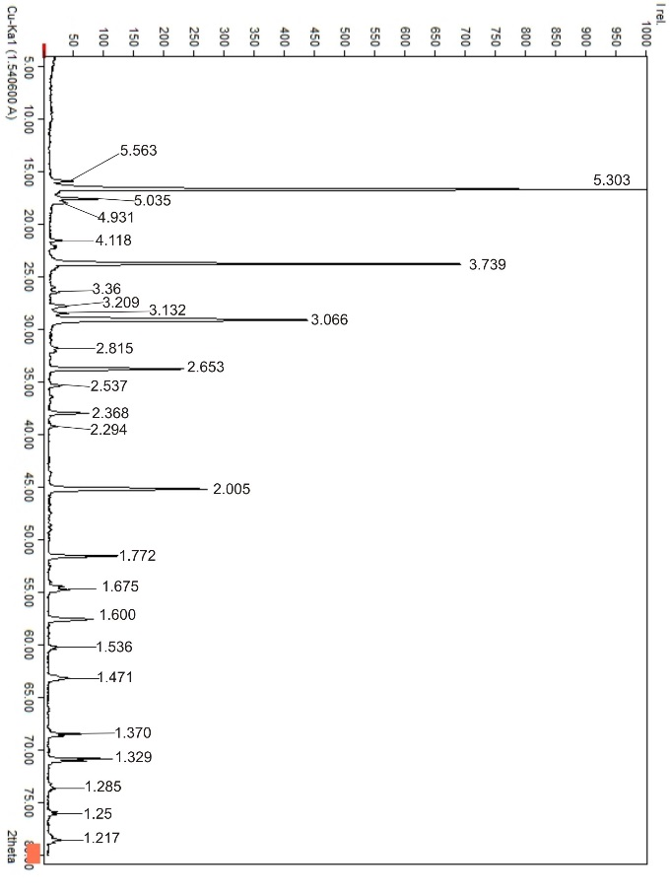
Fig. 1. X-ray diffraction pattern of the monoammonium phosphate sample
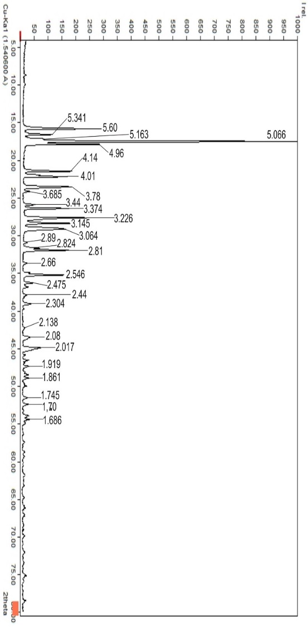
Fig. 2. X-ray diffraction pattern of the diammonium phosphate sample
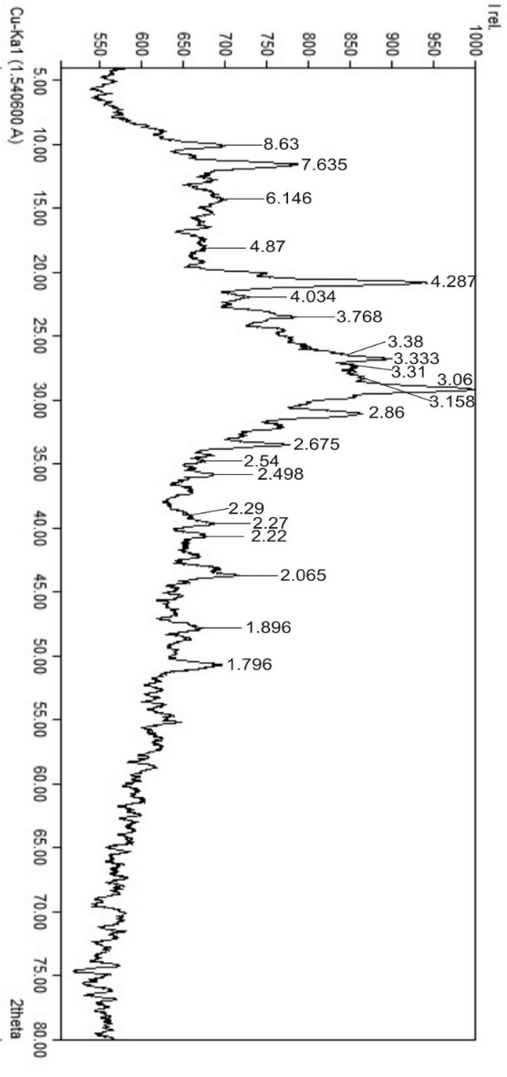
Fig. 3. X-ray diffraction pattern of the precipitate obtained when
H₃PO₄:(C₂H₅OH:CH₃COCH₃)=1:0.33, τ-30 minutes; t-25°C
The composition of the dried precipitate is as follows: 40.54% P₂O₅, 3.93% MgO, 8.49% CaO, 6.54% Al₂O₃, 4.92% Fe₂O₃ and 2.48% SO₃. It can be used as a concentrated phosphorus-containing fertilizer with prolonged action. At the same time, 10.43% of the phosphorus pentoxide from the total content in the initial acid is bound in the form of salts (see figure 3): MgHPO₄ (3.06 Å), CaHPO₄ (3.38 Å), CaHPO₄·2H₂O (7.64; 4.288; 3.77; 3.06; 2.54; 1.90 Å), FePO₄ (8.63; 2.54 Å), (Fe,Mg)Al₂(PO₄)₂(OH)₂ (6.15; 2.27 Å), AlPO₄ (2.71 Å). Due to their low solubility, these salts precipitate. Calcium binds in the form of CaF₂ (3.16 Å) and CaSO₄·2H₂O (7.63; 4.29; 3.06; 2.87; 2.675 Å).
Following the drying of these samples, infrared (IR) spectroscopic analyses were conducted. The analyses were carried out using a Perkin-Elmer FT-IR Spectrum 3 spectrophotometer, operating within a frequency range of 4000–400 cm⁻¹. The accuracy of the results obtained was ensured through verification against specific references [16, 17]. Figures 4–6 depict the outcomes of the IR spectroscopic analysis. At this location, we are discussing two important concepts: transmittance (% T) and wavenumber (cm⁻¹).
Figure 4 reveals the results of the IR spectroscopic analysis of the monoammonium phosphate sample the following vibrational frequencies were determined см⁻¹: 3029.23; 1439.85; 1403.74-(NH₄⁺), 1269.11-(C–O), 1053.60-(H₂PO₄⁻), 887.92-(-OH), as suggested by certain sources.
In Figure 5, the IR spectroscopic analysis of the diammonium phosphate sample the following vibrational frequencies were determined см⁻¹: 2798.98-(-OH), 1715.43 -(RR’N-COOR), 1453.57; 1403.51-(NH₄⁺), 1194.74-(C–O), 1046.62; 947.32 and 893.46- are indicative of the HPO₄²⁻ ion, as suggested by certain sources.
Moving to Figure 6, the IR spectroscopic analysis of the precipitate the following vibrational frequencies were determined см⁻¹: 3404.04-(-OH), 1645.01 -(C-N), 1088.10 (PO₄³⁻), as suggested by certain sources.
The production of high-concentration ammonium phosphates that comply with international standards as a phosphorus source requires the use of purified WPA free from sulfates and other impurities, as evidenced by the findings of this study. It has been established that for desulfurization of WPA, CaCO₃ is the preferred precipitant at a dosage of 125% of the stoichiometric amount, which results in a desulfurization efficiency of 85.65%. Along with gypsum, other impurities (MgO, CaO, Al₂O₃, Fe₂O₃ and F) are also removed. The gypsum precipitate, containing 15-19% P₂O₅, can be used as a slow-release phosphorus fertilizer.

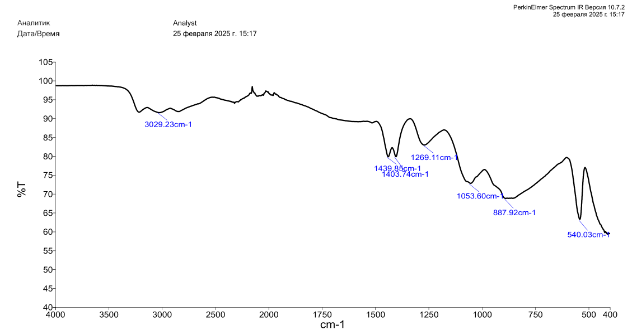
Fig. 4. IR spectroscopic analysis of the monoammonium phosphate sample at H₃PO₄:(C₂H₅OH:CH₃COCH₃)=1:0.33, τ-30 minutes; t-25°C
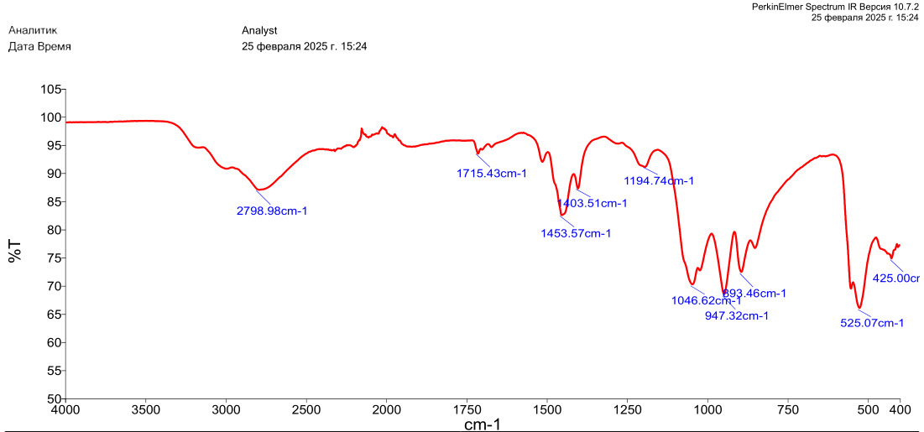
Fig. 5. IR spectroscopic analysis of the diammonium phosphate sample at H₃PO₄:(C₂H₅OH:CH₃COCH₃)=1:0.33, τ-30 minutes; t-25°C

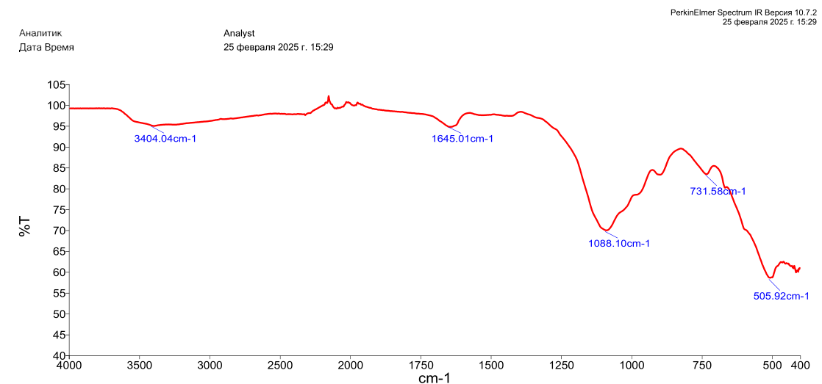
Fig. 6. IR spectroscopic analysis of the precipitate at
H₃PO₄:(C₂H₅OH:CH₃COCH₃)=1:0.33, τ-30 minutes; t-25°C
- CONCLUSION
The purified and concentrated WPA served as the foundational material for synthesizing high-quality phosphorus-based fertilizers. By adjusting the pH of the purified WPA to 5.5 and 8.5, monoammonium phosphate (MAP) and diammonium phosphate (DAP) were successfully produced, respectively. This purified and concentrated phosphoric acid, derived from processed WPA, is highly suitable for manufacturing water-soluble phosphorus-containing fertilizers, such as ammonium phosphates and liquid complex fertilizers. These fertilizers are particularly effective for use in drip irrigation systems, making them ideal for greenhouse agriculture, including applications in orchards, berry farms, vineyards, and other high-value crops. This approach ensures the production of efficient and environmentally friendly fertilizers that meet the demands of modern precision agriculture.

Disclaimer (Artificial intelligence)
Option 1:
Author(s) hereby declare that NO generative AI technologies such as Large Language Models (ChatGPT, COPILOT, etc.) and text-to-image generators have been used during the writing or editing of this manuscript.
Option 2:
Author(s) hereby declare that generative AI technologies such as Large Language Models, etc. have been used during the writing or editing of manuscripts. This explanation will include the name, version, model, and source of the generative AI technology and as well as all input prompts provided to the generative AI technology
Details of the AI usage are given below:
1. ChatGPT Plus for paraphrase and in order to be academic and clear.

REFERENCES
- Patent №2408530 Russian, MPK С01V 25/234. (2011). Method for purification of extraction phosphoric acid // L.V.Raksheeva, D.K.Klados, V.V.Kochetkova, T.I.Kuzmicheva, E.P.Zlobina, E.V.Bogach, P.V.Klassen. https://i.moscow/patents/ru2408530c1_20110110.
- Turdialiyeva, Sh.I., Alimov, U.K., Namazov, Sh.S., & Seytnazarov, А.R. (2018). Concentration of weak extraction phosphoric acid and its physico-chemical properties, Chemical industry 95.4: 171-178. https://doi.org/10.31489/2959-0663/4-24-4
- Zlobina, E.P., Bushuev, N.N., Petropavlovsky, I.A., Rakcheeva, L.В., & Kochetkov, S.P. (2002). Study of the process of purification of extraction phosphoric acid from sulfate ion with strontium carbonate, Chemical Technology, 12, 24-26. https://www.researchgate.net/publication/325570231_Issledovanie_processa_ocistki_ekstrakcionnoj_fosfornoj_kisloty_ot_sulfat-iona_karbonatom_stroncia
- Jurayev R.S., Eshkulov B.R., Kakhkhorov N.T. (2024). Production of Complex and Mixed Fertilizers by Acidic Processing of Phosphorites// Engineering Proceedings. 2024, 67(1), 59; https://doi.org/10.3390/engproc2024067059
- Karshiev B.N., Kaxarov E.M., Namazov Sh.S., Seytnazarov A.R. (2018). Purification of extraction phosphoric acid from washed, fired phosphoconcentrate using acetic acid // Universum: Technical Sciences: Electronic Scientific Journal. Moscow, 8(53). 20-27. http://7universum.com/ru/tech/archive/item/6265.
- Karshiev B., Seytnazarov A., Namazov Sh., Radzhabov R., Reymov A., Alimov U. (2020). Purification of wet process phosphoric acid using organic solvent // Journal of Critical Reviews. 7(17): 2913-2918. https://scispace.com/pdf/purification-of-wet-process-phosphoric-acid-by-3nurgmh6n7.pdf
- Karshiev B.N., Kaxarov E.M., Seytnazarov A.R., Namazov Sh.S. (2020). Obessulfachivanie i ochistka ekstraksionnoy fosfornoy kisloti s pomoshyu kalsievix mineralov i asetona // Chemical industry, Moscow. 97.3: 136-144. https://elibrary.ru/pdxnha
- Karshiev B.N., Seytnazarov A., Alimov U., Namazov Sh., Reymov А., Rasulov А. (2021). Purification of wet process phosphoric acid by desulfurization and ammonization // Issues of Chemistry and Chemical Technology, Ukraine.1, 24-34 ISSN 0321-4095. http://dx.doi.org/10.32434/0321-4095-2021-134-1-24-34
- Maftuna Akhtamova, Uktam Temirov, Navruzbek Khurramov, Azim Shukurov, Bekhzod Karshiev. (2023). Processing of phosphorites and additives with researching their thermodynamical properties // E3S Web of Conferences 434, 03016, https://doi.org/10.1051/e3sconf/202343403016.
- Lembpikov, V.M., Stepanov A.A., Konyaxina L.V., Volkova V.V. (2005). Influence of humic substances accumulated in the extractant on the purification of phosphoric acid by tp-n-butyl phosphate // // Chemical industry, Moscow., 7, 2-5. https://istina.fnkcrr.ru/publications/article/3280408/
- Patent R. N2128623, MPK6 S01V 25/234, S01V 25/46. (1999). Method for obtaining purified orthophosphoric acid / A.V.Grinevich, S.P.Kochetkov, Ye.P. Parfenov i dr. // N98109517/25; 10. https://findpatent.ru/patent/212/2128623.html
- Kochetkov S.P., Smirnov N.N., Ilin A.P. (2007). Concentration and purification of extraction phosphoric acid / GOUVPO Ivanovskiy State Chemical-Technological University. – Ivanovo, –304. http://main.isuct.ru/files/publ/PUBL_ALL/tnv/tnv30092008.pdf
- Ilkhom Е. Khoshimov, Shakhzoda I.Turdialieva, Atanazar R.Seytnazarov, Shafaat S. Namazov, Mohamed A.L. Rifky. (2024). Investigation of Vapor Pressure and Infrared Spectroscopic Analysis of Phosphoric Acid Extract Evaporation after Desulfation with SrCO₃. https://doi.org/10.31489/2959-0663/4-24-4. Eurasian Journal of Chemistry. vol 29. 4.
- Methods of analysis of phosphate raw materials, phosphate and complex fertilizers, feed phosphates. Vinnik M.M., Erbanova L.N., Zaysev P.M. and other. M. Moscow, Chemiya Publ., 1975. 218 https://www.twirpx.com/file/122270/
- Diffraction Data cards and Alphabetical and Group Numerical Index of X-Ray. International Centre for Diffraction Data, 2013. https://www.icdd.com/
- Sigma Aldrich. (Accessed 2024). IR Spectrum Table. [Online], Available at: https://www.sigmaaldrich.com/UZ/en/technical-documents/technical-article/analytical-chemistry/photometry-and-reflectometry/ir-spectrum-table.
- LibreTexts. (Accessed 2024). Infrared Spectroscopy Absorption Table.[Online], Available at: https://chem.libretexts.org/Ancillary_Materials/Reference/Reference_Tables/Spectroscopic_Reference_Tables/Infrared_Spectroscopy_Absorption_Table

