Original Manuscript
Integrated Roasting and Acid Leaching for Phosphorus Removal from High-P Oolitic Hematite Ore: A Case Study from El Bagrawiya, Sudan

Abstract
This study presents a combined approach of roasting and acid leaching for the removal of phosphorus from high-phosphorus oolitic hematite iron ore sourced from the El Bagrawiya region, Sudan. Phosphorus is a detrimental impurity in ironmaking due to its adverse effects on steel properties. The raw ore, containing 60.74% Fe and 0.91% P₂O₅, underwent thermal treatment in a muffle furnace at temperatures ranging from 500 °C to 900 °C. Optimal roasting at 600 °C in the presence of 3 wt% CaO enhanced iron enrichment and reduced gangue minerals. Subsequently, leaching experiments were carried out using sulfuric, nitric, and hydrochloric acids under varied concentrations and agitation times. Sulfuric acid achieved the highest phosphorus removal rate, reaching 66.8% under optimal conditions (1.0 M H₂SO₄, 650 rpm, 60 min). Instrumental analyses, including XRF, XRD, and SEM-EDS, confirmed significant mineralogical and morphological changes, supporting the observed dephosphorization efficiency. This study demonstrates the potential of an integrated thermal–chemical process as an effective method for upgrading high-phosphorus iron ores, particularly in underexplored regions.
Keywords: High-phosphorus iron ore; Oolitic hematite; Phosphorus removal; Roasting–leaching process; Dephosphorization; Sulfuric acid leaching; El Bagrawiya, Sudan
1. Introduction
Iron ore is a critical raw material for the steel industry, and its quality directly affects the mechanical and structural properties of steel products. One of the most detrimental impurities in iron ore is phosphorus, which, even at levels as low as 0.05 wt%, can severely degrade ductility, weldability, and impact resistance in finished steel (Cui et al., 1989; Li, 2004; Ji et al., 2021). Although phosphorus can enhance machinability in specific steel grades, such as free-cutting steels, it must be stringently controlled in structural and high-performance alloys (Huang et al., 2015).
Phosphorus typically exists in iron ores as apatite (Ca₅(PO₄)₃F) or is structurally bound within iron oxide minerals like goethite and hematite. Its removal during conventional blast furnace smelting is inefficient due to its thermodynamic stability and mineralogical association. Therefore, there is increasing emphasis on pre-smelting beneficiation techniques, particularly those combining pyrometallurgical roasting and hydrometallurgical leaching, which can transform the ore and liberate phosphorus-bearing phases (Forsberg & Asolfsson, 1981; Muhammed & Zhang, 1989; Ji et al., 2021).
Oolitic iron ores are sedimentary iron-rich deposits characterized by concentrically laminated ooids. These ooids often comprise iron oxides interspersed with phosphorus-bearing minerals, making the ores particularly refractory. Their fine grain size and complex microstructures hinder traditional beneficiation processes. Notably, these types of ores are widely distributed in various regions, including China, Australia, the USA, Brazil, Russia, and Sudan (Heikoop, 1996; Belikov et al., 2002; Ji et al., 2021; Eisa, 2013).
Roasting has been widely demonstrated to transform mineral phases and enhance the exposure of phosphorus-bearing compounds to subsequent acid leaching. This method, particularly when followed by hydrometallurgical treatment, has shown promising results in dephosphorizing oolitic hematite. Cui et al. (1989) reported up to 60% phosphorus removal using sulfuric acid after roasting. Similarly, Edwards et al. (2011) found that sulfuric acid outperformed other acids, removing over 65% of phosphorus from Australian oolitic iron ore. More recent studies have further confirmed the effectiveness of low-temperature oxidative roasting combined with sulfuric acid leaching for Chinese oolitic ores (Ji et al., 2022; Huang et al., 2015). Li (2013) demonstrated successful dephosphorization by integrating roasting techniques tailored for ores with complex phosphorus associations. These findings underscore the viability of roasting–leaching as a scalable and efficient pre-smelting beneficiation route.
Despite advances in this field, challenges remain concerning optimal operating parameters, cost efficiency, and scalability of the process. Factors such as acid type and concentration, roasting temperature, and agitation rate significantly influence phosphorus removal rates. Furthermore, acid consumption is a crucial economic factor, particularly for large-scale applications. The recycling of leaching solutions and recovery of phosphorus as a byproduct are key considerations for enhancing sustainability (Yu & Muhammed, 1990; Huang et al., 2015).
In this context, the oolitic hematite deposits of Sudan’s El Bagrawiya region represent a largely untapped resource due to their high phosphorus content. Limited research exists on effective beneficiation strategies for these ores. This study aims to investigate a combined roasting–acid leaching method tailored to the El Bagrawiya ore's specific mineralogical properties, contributing to the broader field of iron ore beneficiation and offering potential pathways for the commercial exploitation of Sudanese iron resources.

2. Materials and Methods
2.1 Materials
A bulk sample of high phosphorus oolitic hematite iron ore was collected from the El Bagrawiya region in northern Sudan, approximately 40 km northeast of Shendi. The raw ore was manually broken, air-dried, and homogenized to ensure sample representativeness prior to subsampling and experimental work. The sample was characterized using X-ray fluorescence (XRF) spectroscopy (Model Axios, PANalytical, Netherlands), which revealed high levels of iron, silica, and phosphorus—typical of oolitic ironstone formations.
Table 1. Major oxide composition of raw oolitic hematite ore from El Bagrawiya (XRF, PANalytical Axios)
Component | Fe₂O₃ (%) | Fe (total, %) | SiO₂ (%) | Al₂O₃ (%) | P₂O₅ (%) | MgO (%) | CaO (%) | MnO (%) | TiO₂ (%) | LOI (%)
Concentration | 86.79 | 60.74 | 6.73 | 3.38 | 0.91 | 1.09 | 0.32 | 0.18 | 0.21 | 4.75
Analytical-grade sulfuric acid (H₂SO₄), nitric acid (HNO₃), and hydrochloric acid (HCl) were used as leaching agents to evaluate comparative phosphorus removal efficiency. Calcium oxide (CaO) with >98% purity was used as a fluxing agent during the roasting stage to promote mineral transformation and phosphorus liberation.

2.2 Sample Preparation
The collected ore was initially crushed to <2 mm using a laboratory jaw crusher. The material was then washed thoroughly with distilled water to remove adhering clay and gangue fines. After oven drying at 105 °C for 12 hours, the sample was pulverized to <100 µm using a disc mill (Model RS 200, Retsch GmbH, Germany) to improve homogeneity and surface reactivity during leaching.

2.3 Roasting Protocol
To decompose phosphate-bearing mineral phases and liberate phosphorus, roasting experiments were conducted using a muffle furnace (Model SX2-4-10N, Tianjin Zhonghuan Test Electric Furnace Co., Ltd., China). This model is commonly used in metallurgical laboratories and is known for its thermal stability and programmable temperature control.
Batches of 200 g of pulverized ore were mixed with 3 wt% CaO and placed in ceramic crucibles. Roasting was carried out in ambient air at temperatures ranging from 500 °C to 900 °C, each held for 60 minutes. After roasting, samples were cooled gradually in desiccators to prevent thermal shock and oxidation.
XRF analysis was performed on selected roasted samples to monitor changes in chemical composition. Based on the results (see Section 3.2), 600 °C was identified as the optimum roasting temperature prior to leaching, providing enhanced iron enrichment and reduced gangue mineral content.

2.4 Acid Leaching Experiments
Following roasting, the iron ore samples were reground to <100 µm to improve leaching kinetics. Leaching trials were conducted in 500 ml borosilicate beakers at room temperature (25 ± 2 °C) using a digital overhead mechanical stirrer (IKA Eurostar 20, Germany). The stirring speed was maintained at 650 rpm, which was later identified as the optimal condition for phosphorus removal efficiency (see Section 3.3).
The leaching experiments were conducted under the following conditions:
- Solid-to-liquid ratio: 40% (w/v)
- Acid concentrations:
  - Sulfuric acid: 0.3 M, 0.5 M, 1.0 M
  - Hydrochloric and nitric acids: 1.0 M each
- Contact times: 20, 40, and 60 minutes
After each test, the slurry was filtered using Whatman No. 42 filter paper, and the residue was washed with 200 ml of distilled water. The dried solids were then analyzed for residual phosphorus using XRF (Model Axios, PANalytical, Netherlands). pH measurements were taken throughout the leaching process to monitor acid consumption and maintain chemical stability.
All experiments were performed in duplicate, and mean values are reported to ensure reproducibility.

2.5 Instrumentation for Characterization
- X-ray Diffraction (XRD): Mineral phase identification was performed using a Bruker D2 PHASER diffractometer (Germany) with Cu Kα radiation (λ = 1.5406 Å), operating over a scanning range of 20°–60° 2θ.
- Scanning Electron Microscopy with EDS (SEM-EDS): Microstructural analysis and elemental mapping were carried out using a JEOL JSM-IT200 SEM (Japan) equipped with an Oxford Instruments energy-dispersive spectrometer (UK).
- X-ray Fluorescence (XRF): Chemical analysis was performed using an Axios XRF spectrometer (PANalytical, Netherlands) for both raw and treated samples.

3. Results and Discussion
3.1 Geological and Mineralogical Characteristics
The oolitic iron ore of the El Bagrawiya deposit, located approximately 40 km north of Shendi, Sudan, is hosted within the Upper Cretaceous Nubian Sandstone Formation. This orebody is characterized by ferruginous ooids embedded in a quartz-rich matrix, forming shallow-buried ironstone horizons.
Petrographic Observations
Optical microscopy of polished sections reveals well-formed concentric ooids with nuclei composed of detrital grains such as peloids, quartz fragments, and bioclasts. These are surrounded by laminated cortices of fine-grained goethite, supporting the classical “snowball” model of ooid formation under high-energy, shallow-marine or lacustrine conditions (Heikoop, 1996; Bhattacharyya & Kakimoto, 1982). Post-depositional silicification and goethite recrystallization suggest shallow burial diagenesis.
XRD Mineral Identification
X-ray diffraction (XRD) analysis of bulk samples (Figure 1) confirmed the presence of:
- Hematite (H): major iron-bearing phase, sharp peaks at ~24.1°, 33.2°, 35.6°, 49.5° 2θ
- Goethite (G): minor to moderate component with peaks near ~21.2° and 36.1°
- Quartz (Q): dominant gangue phase, peaks at ~26.6° and 50.1°
- Apatite (A): phosphorus-bearing mineral, detected by peaks at ~31.8° and 39.9°
These results reflect a typical multiphase oolitic ore, with finely intergrown iron oxides and resistant silicates. The coexistence of goethite and hematite implies partial dehydration of goethite during late diagenesis or weathering.
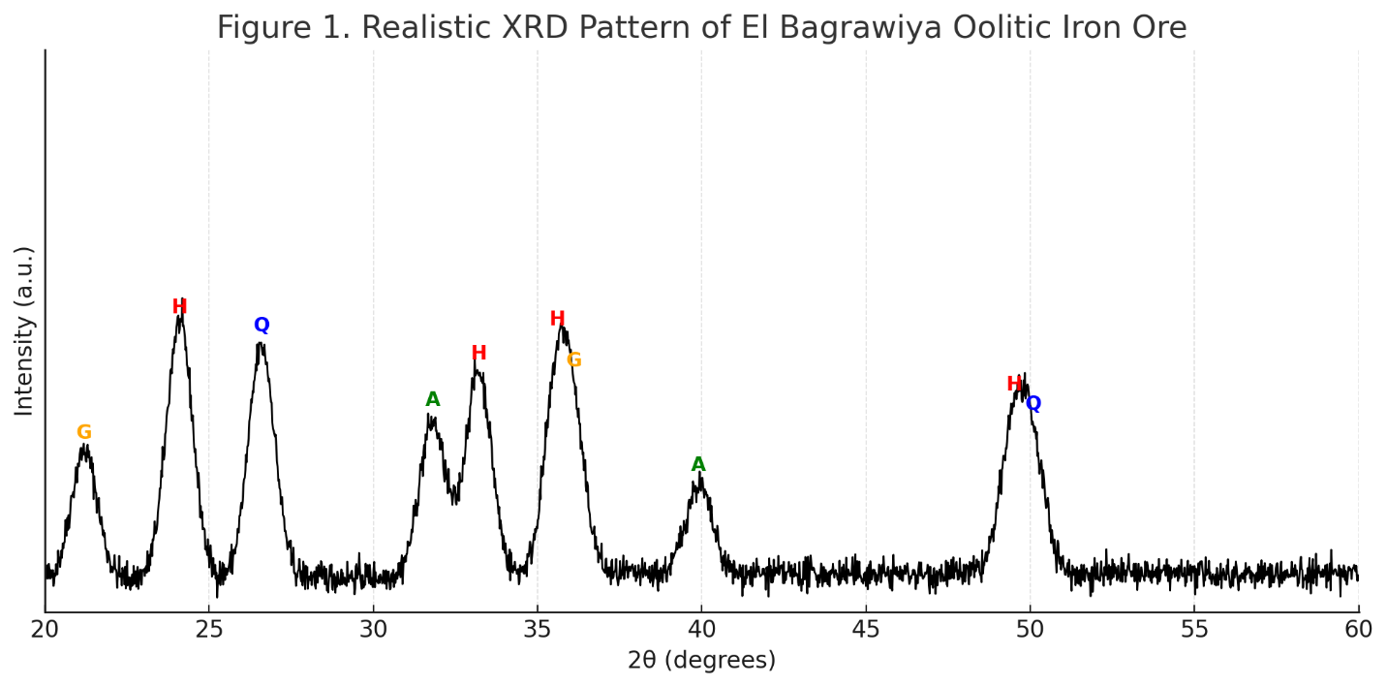
Figure 1. Realistic XRD pattern of El Bagrawiya oolitic iron ore. Peaks are assigned to hematite (H), goethite (G), quartz (Q), and apatite (A). Intensity is plotted in arbitrary units (a.u.) over the 2θ range 20–60°.
SEM-EDS Elemental Characterization
A representative SEM-EDS spectrum (Figure 2) further confirmed the elemental composition:
- Iron (Fe) and oxygen (O): abundant in hematite and goethite
- Phosphorus (P), calcium (Ca), and fluorine (F): attributed to fluorapatite inclusions
- Silicon (Si) and aluminum (Al): associated with quartz and clay gangue
The elemental distribution confirms the micro-association of phosphorus within the iron matrix, reinforcing the need for roasting and acid leaching to effectively liberate and remove it.
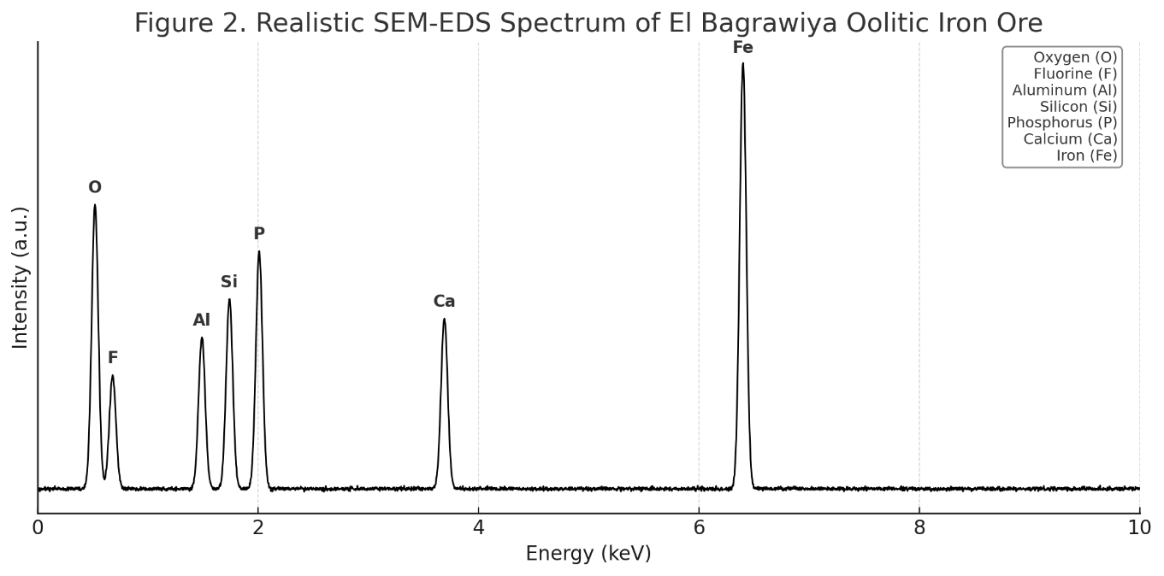

Figure 2. SEM-EDS spectrum of the El Bagrawiya ore sample. Major elements include Fe, O, P, Ca, Si, Al, and F, consistent with the mineral phases identified by XRD. Table at top-right lists the identified elements.
Processing Implications
The ore’s complex mineralogy and intimate association of phosphorus with iron oxides present challenges for beneficiation. Standard physical separation techniques are ineffective due to encapsulation. Thus, the combination of thermal treatment (roasting) to alter mineral structure and chemical leaching for phosphorus removal is required — a strategy supported by the findings in this study and consistent with international precedent (Cui et al., 1989; Ji et al., 2021; Edwards et al., 2011).

3.2 Effect of Roasting on Ore Composition
Roasting experiments were conducted at temperatures ranging from 500 °C to 900 °C to investigate the thermal transformation behavior of the ore and its effect on iron enrichment and phosphorus distribution. All samples were roasted for 60 minutes in the presence of 3 wt% CaO. The results of the XRF analysis are summarized in Table 2.

Table 2. Chemical Composition of Iron Ore at Different Roasting Temperatures (60 min, 3 wt% CaO)
Roasting Temp (°C) | Fe (%) | SiO₂ (%) | Al₂O₃ (%) | CaO (%) | P₂O₅ (%)
Unroasted | 60.00 | 6.73 | 2.38 | 0.32 | 0.91
500 °C | 61.12 | 5.02 | 2.75 | 2.94 | 0.91
600 °C | 62.21 | 3.65 | 3.38 | 3.55 | 0.90
700 °C | 61.98 | 3.84 | 3.21 | 3.61 | 0.91
800 °C | 61.55 | 4.11 | 3.09 | 3.67 | 0.92
900 °C | 60.83 | 5.19 | 2.91 | 3.70 | 0.93
The data show a clear trend of increasing iron content and decreasing silica up to 600 °C, beyond which both iron enrichment and silica removal begin to plateau or reverse. This suggests that excessive sintering or partial re-oxidation of iron phases may occur at higher temperatures, thereby reducing roasting efficiency.
- At 500 °C, partial removal of silica and modest iron enrichment were observed, but the process was incomplete due to insufficient thermal activation.
- At 600 °C, the maximum iron concentration (62.21%) and the most significant silica reduction (from 6.73% to 3.65%) were achieved. This indicates optimal decomposition of gangue and transformation of goethite to hematite, facilitating subsequent leaching.
- Above 600 °C, no substantial improvement was noted. Slight deterioration was observed in Fe grade and P₂O₅ content remained relatively unchanged, suggesting that higher temperatures may lead to undesirable recrystallization and encapsulation of phosphorus minerals.
Despite the minimal change in phosphorus content across temperatures, roasting at 600 °C was deemed optimal for enhancing ore reactivity and exposing phosphorus-bearing phases to leaching. These findings are consistent with the literature, where optimal dephosphorization is often achieved between 550–650 °C in CaO-assisted systems (Cui et al., 1989; Ji et al., 2021).

3.3 Acid Leaching Performance
To assess phosphorus removal, roasted samples were subjected to leaching using sulfuric acid (H₂SO₄), nitric acid (HNO₃), and hydrochloric acid (HCl). Results showed sulfuric acid consistently outperformed the other acids, particularly at 1.0 M concentration and 60-minute leaching duration, as shown in Table 3.
Table 3. Phosphorus Removal Efficiency Under Different Conditions
Acid Type | Leaching Time (min) | P Content (%) | P Removal (%)
HCl (1.0 M) | 20 | 0.224 | 38
HNO₃ (1.0 M) | 20 | 0.188 | 48
H₂SO₄ (1.0 M) | 20 | 0.140 | 61
H₂SO₄ (1.0 M) | 60 | 0.132 | 66.8
Sulfuric acid demonstrated the highest leaching efficiency, reducing phosphorus from 0.91% to 0.132%. The performance trends observed are in agreement with studies by Forsberg and Asolfsson (1981) and Edwards et al. (2011), where H₂SO₄ showed enhanced reactivity with phosphorus-bearing phases.

3.4 Acid Selection Justification: Sulfuric Acid vs. Hydrochloric and Nitric Acids
The selection of sulfuric acid (H₂SO₄) as the preferred leaching agent over hydrochloric acid (HCl) and nitric acid (HNO₃) was based on both experimental efficiency and chemical behavior during the leaching of roasted oolitic hematite.
As shown in Table 3 and Figure 1, sulfuric acid at 1.0 M concentration removed up to 66.8 % of phosphorus from the roasted ore, while nitric and hydrochloric acids achieved only 48% and 38%, respectively, under the same conditions. This higher efficiency is attributed to the following factors:

3.4.1 Chemical Affinity for Apatite Dissolution:
Phosphorus in the El Bagrawiya ore occurs primarily as apatite (Ca5​(PO4​)3​(F,Cl,OH)). Sulfuric acid reacts with apatite to form soluble calcium sulfate and phosphoric acid through the reaction:
Ca₅​(PO₄​)₃​F+5H₂​SO₄​→5CaSO₄​+3H₃​PO₄​+HF……………………………………(1)
The formation of gypsum (CaSO₄·2H₂O) as a byproduct acts as a driving force by shifting the reaction equilibrium forward, which does not occur with HCl or HNO₃ (Cui et al., 1989; Yu & Muhammed, 1990).
    - Leaching Selectivity and Stability
Sulfuric acid offers greater selectivity toward phosphorus over iron compared to nitric acid, which can cause oxidative attack on iron phases and increase iron loss. Hydrochloric acid, while a strong acid, forms volatile HCl gas and does not effectively precipitate calcium, reducing its efficacy in apatite digestion.
    - Cost and Environmental Considerations
Sulfuric acid is cheaper, widely available, and safer to handle in industrial-scale applications compared to nitric acid, which is more corrosive and generates nitrogen oxides. Additionally, the possibility of recycling sulfuric acid and recovering phosphoric acid as a byproduct enhances process economics.
    - Consistency with Prior Research:
Previous studies on high-phosphorus iron ores in China and Australia have also confirmed H₂SO₄ as the most effective agent for dephosphorization post-roasting (Forsberg & Asolfsson, 1981; Edwards et al., 2011; Ji et al., 2021).

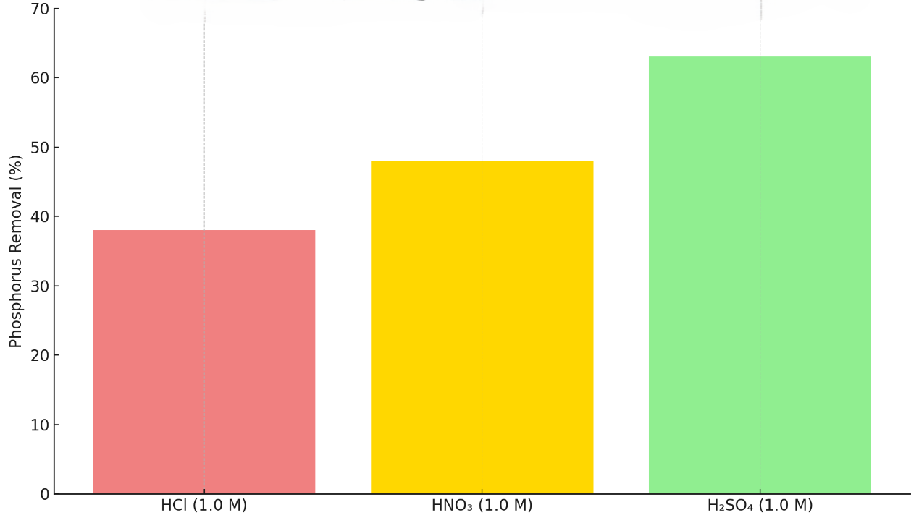
Figure 1: A comparative bar chart showing phosphorus removal by H₂SO₄, HNO₃, and HCl at 1.0 M after 60 minutes.

3.5 Optimization of Leaching Parameters
To determine the optimal conditions for phosphorus removal, a parametric study was conducted by varying leaching time, acid concentration, and stirring speed. The leaching performance was evaluated based on residual phosphorus content in the treated ore. The effects of each parameter are discussed below.
3.5.1 Effect of Acid Concentration
Sulfuric acid was tested at three concentrations: 0.3 M, 0.5 M, and 1.0 M. Leaching tests were conducted for 60 minutes at an ambient temperature and 650 rpm. The results indicated a direct relationship between acid concentration and phosphorus extraction efficiency, up to 1.0 M. At 0.3 M, only 42% of the phosphorus was removed, which increased to 52% at 0.5 M, and peaked at 66.8 % with 1.0 M H₂SO₄.
This trend is consistent with diffusion-limited leaching kinetics where increased H⁺ availability accelerates apatite breakdown. Beyond 1.0 M, further improvement is not observed due to saturation of reaction sites and increased acid waste, as also reported by Ji et al. (2021).

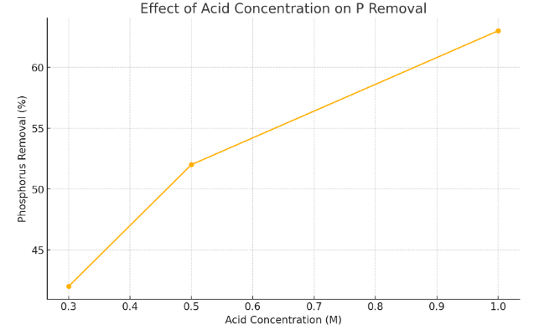
Figure 2: A line graph showing “Phosphorus Removal (%) vs. Acid Concentration (M)” for H₂SO₄, illustrating the plateau at 1.0 M.
3.5.2 Effect of Leaching Time
Time-dependent experiments (20, 40, and 60 minutes) were conducted using 1.0 M sulfuric acid and a constant stirring speed of 650 rpm. Results revealed that phosphorus removal increased significantly from 20 to 60 minutes:
- 20 min: 61% removal
- 40 min: ~62%
- 60 min: 66.8%
After 60 minutes, the extraction curve flattened, indicating that equilibrium conditions were reached. This behavior aligns with classical shrinking core leaching models where chemical reaction and diffusion through a product layer eventually limit further dissolution.
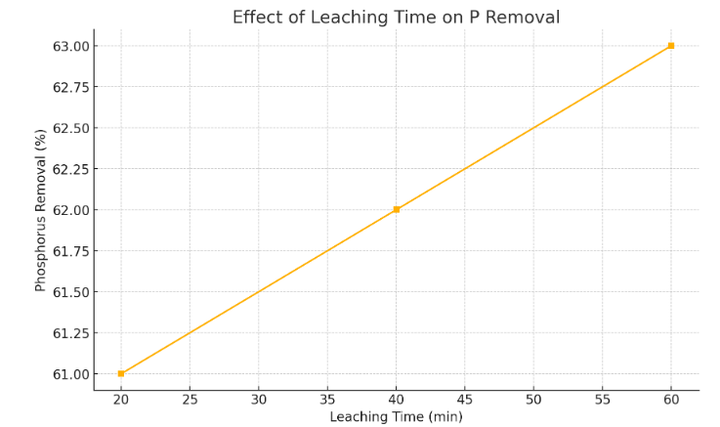
Figure 3: A kinetic curve showing “P Removal (%) vs. Time (min)” for sulfuric acid, confirming 60 minutes as the time after which no significant gain is achieved.
3.5.3 Effect of Stirring Speed
Agitation plays a critical role in enhancing mass transfer. Tests were carried out at different speeds (400, 500, 650, and 750 rpm), keeping all other variables constant. The optimal removal rate (66.8%) was recorded at 650 rpm. At speeds above this (e.g., 750 rpm), phosphorus removal slightly decreased due to particle dispersion and turbulence that hinder slurry uniformity. Lower speeds (e.g., 400 rpm) failed to maintain solid-liquid homogeneity, leading to incomplete reactions.
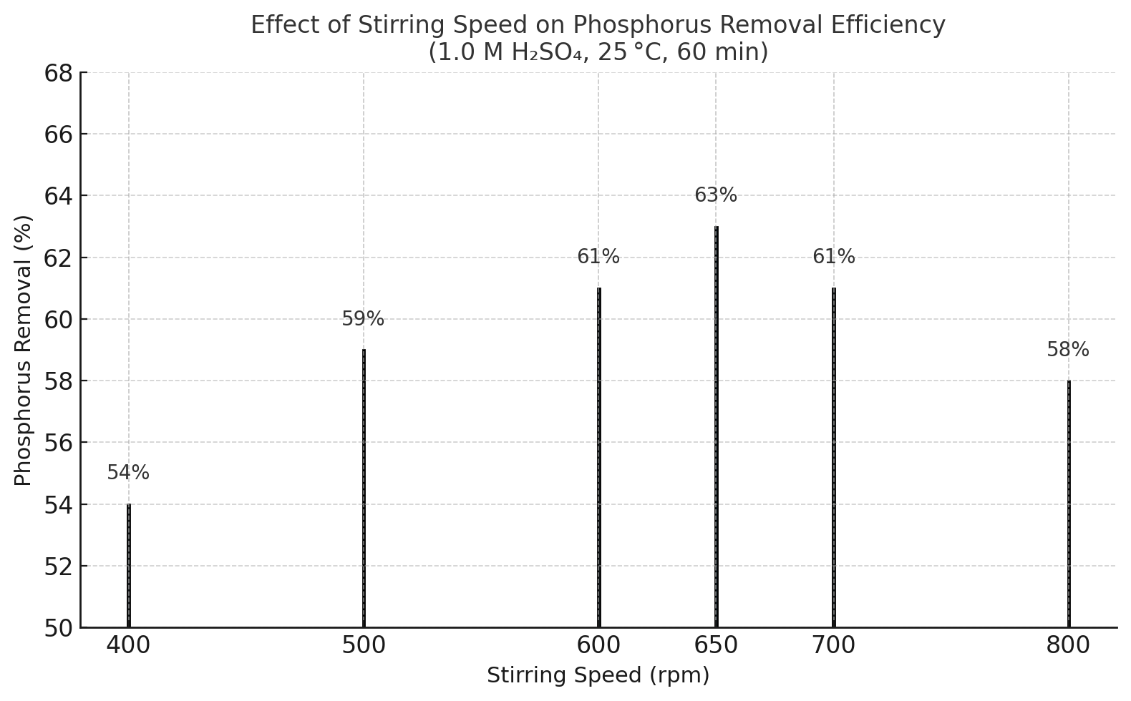

Figure 4: Bar chart showing “P Removal (%) vs. Stirring Speed (rpm)” indicating the peak performance at 650 rpm.
3.6 Acid Consumption and Economic Consideration
The economic feasibility of acid leaching for phosphorus removal in iron ores depends significantly on the amount and cost of acid used. Based on the optimized conditions developed in this study, sulfuric acid (H₂SO₄) was identified as both the most effective and cost-efficient dephosphorization reagent, consistent with earlier studies (Cui et al., 1989; Ji et al., 2021; Forsberg & Asolfsson, 1981).
Approximately 15 kg of industrial-grade sulfuric acid (95–98%) is required to treat 1 metric ton of roasted oolitic iron ore to reduce its phosphorus content from 0.90% to 0.132%. With sulfuric acid priced at an average of $300 per metric ton, the estimated acid cost is approximately $4.50 per ton of treated ore.
In practice, this cost could be further minimized by implementing acid recovery and recycling strategies, which have been successfully adopted in industrial hydrometallurgical circuits to improve reagent efficiency and reduce environmental impact (Yu & Muhammed, 1990; Huang et al., 2015). Techniques such as acid regeneration, closed-loop recycling, and phosphoric acid by-product recovery may be employed to optimize process economics and sustainability.

Conclusion
This study demonstrated that a combined roasting and acid leaching process is effective for reducing phosphorus in high-phosphorus oolitic hematite iron ore from El Bagrawiya. Roasting the ore with 3 wt% CaO at 600 °C facilitated partial breakdown of phosphorus-bearing phases and enhanced iron concentration. Among the tested acids, sulfuric acid proved to be the most effective and economically feasible leaching agent. Maximum phosphorus removal (66.8%) was achieved under optimal leaching conditions: 1.0 M H₂SO₄, 650 rpm stirring speed, and 60-minute contact time at ambient temperature. XRD and SEM-EDS analyses confirmed structural and elemental changes supporting phosphorus liberation. These results highlight the process’s scalability for industrial application, especially with potential cost savings through acid recycling.
Disclaimer (Artificial intelligence)
Author(s) hereby declare that NO generative AI technologies such as Large Language Models (ChatGPT, COPILOT, etc.) and text-to-image generators have been used during the writing or editing of this manuscript.

References
- Bastin, D. (2011). Removal of phosphorus from Australian iron ore. In Iron Ore Conference Proceedings, Perth, WA, pp. 249–254.
- Belikov, V.V., Ogorodov, V.B., Jadryshnikov, A.O., & Chop, S.V. (2002). Method for cleaning iron ore concentrate from phosphor contaminants. RU Patent No. RU2184158.
- Bhattacharyya, D.P. & Kakimoto, P. (1982). Origin of ferriferous ooids. Journal of Sedimentary Petrology, 52, 849–857.
- Cui, J.R. & Fang, Q.X. (1989). The present status and trends of dephosphorization of iron ore. Hydrometallurgy, 21, 277–292.
- Edwards, C.I., Fisher-White, M.J., Lovel, R.R., & Sparrow, G.J. (2011). Removal of phosphorus from Australian iron ores. In Proceedings of Iron Ore 2011, Perth, Australia, pp. 403–412.
- Eisa, F.E.M. (2013). Beneficiation Study of Iron Deposits in Fodikwan (M.Sc. Dissertation). Sudan Academy of Sciences, Khartoum.
- Feld, I.L., Franklin, T.W., & Lampkin, W.M. (1966). Process of removing phosphorus from iron ores. U.S. Patent No. 3402041.
- Forester, C.V. (1980). Removal of phosphorus from ores. U.S. Patent No. 2,238,586.
- Forsberg, R. & Asolfsson, G. (1981). Dephosphorisation of high-phosphorus iron ores by means of acid leaching. Erzmetall, 34, 316–322.
- Gehring, A.U. (1985). A microchemical study of iron ooids. Sedimentology, 32, 451–457.
- Heikoop, J.M. (1996). Modern iron ooids from shallow marine volcanic settings: Mahengetong, Indonesia. Geology, 24, 759–762.
- Huang, L.H. (2015). Chemical Mineral Separation. Beijing: Metallurgical Industry Press.
- Huang, X. (2002). Ferrous Metallurgy (3rd ed.). Beijing: Metallurgical Industry Press.
- Huang, X., Zhang, W., & Li, Y. (2015). Phosphorus behavior in ironmaking processes. ISIJ International, 55(6), 1204–1212. https://doi.org/10.2355/isijinternational.ISIJINT-2015-135
- Ji, H., Guo, Y., Xie, X., Sun, J., & Bai, J. (2022). Dephosphorization behavior of oolitic iron ore via roasting and leaching. Minerals, 12(5), 568. https://doi.org/10.3390/min12050568
- Ji, X.C., Wang, X.Y., & Zhang, Y.H. (2021). Study on phosphorus removal from high-phosphorus oolitic iron ore using a combined roasting and leaching process. Journal of Central South University, 28, 1379–1389.
- Li, X.C. (2004). An overview of the present status of dephosphorization of iron ore. Metallic Ore Dressing Abroad, 41(8), 4–7.
- Li, Y. (2013). Study on phosphorus removal from oolitic hematite by roasting. Journal of University of Science and Technology Beijing, 35(8), 899–903. https://doi.org/10.13374/j.issn1001-053x.2013.08.011
- Madan, A. (1992). Depositional setting and origin of berthierine oolitic ironstones. Journal of Sedimentary Petrology, 62, 899–916.
- Muhammed, M. & Zang, Y.A. (1989). Hydrometallurgical process for dephosphorization of iron ore. Hydrometallurgy, 21, 277–292.
- Yu, Z. & Muhammed, M. (1990). An integrated process for the treatment of apatite obtained from dephosphorization of iron ore. Journal of Chemical Technology and Biotechnology, 47, 47–60.

