ORIGINAL RESEARCH ARTICLE

Analytical approach and numerical simulation
using the Cast3M calculation code of the bending of beams made of compressed Iroko wood flour stabilized by recycled HDPE

.
ABSTRACT

The material covered in this study was developed in our previous studies. It is a composite of Iroko wood and high-density polyethylene. The objective is to find a way to predict the mechanical behavior during bending. Two studies were conducted: an analytical approach and a simulation using Cast3M. At the end, we compared the respective results. The analytical study confirmed the

simulation results. For example, for a 10% high-density polyethylene content, the respective values ​​for the analytical study and the simulation for the cantilever beam with a force applied to the free end are 1.65 x 10⁻⁵ and 1.66 x 10⁻⁵ degrees for rotation, respectively. For deflection, the respective values ​​are 2.2 x 10⁻⁶ and 2.1 x 10⁻⁶ m. In construction, this material can be used to make partitions with light loads.
Thus, we obtained a simulation method to predict the bending behavior of this material.

Keywords: Polyethylene, Iroko wood, deflexion, simulation, Cast3M

1.INTRODUCTION
The most common and critical simple stress in construction is bending (Shen et al., 2025; Tho et al., 2023; Ma et al., 2020; Shaat et al., 2020). Particular attention is paid to it. Therefore, in the study of mechanical behavior, particular importance is given to it, along with its various components. In this study, we developed wood-based briquettes using different proportions of high-density polyethylene (HDPE). This is a wood-polymer composite (WPC). We conducted two studies: the analytical approach and the simulation using Cast3M. The results of both cases are compared. The study focused on a beam loaded in its plane of symmetry. The specimen dimensions are LxHxW: 0.2x0.1x0.05 m3 (Figure 5). For both methods, the magnitudes increase as the percentage of high-density polyethylene (HDPE) increases. This is corroborated by the graphs. The example is given in Figures 8 and 12. They yield values ​​equal to 2.2 x 10⁻⁶ and 2.1 x 10⁻⁶ m for deflection, respectively. There is a clear agreement between the two studies. This material can be used to create lightweight partitions that delimit spaces without supporting significant loads.
We have therefore developed a simulation method to predict the mechanical behavior during bending.

2.Preliminary presentation of deformation in beam theory

For a better understanding of the context of this study, our illustration will focus on a straight beam loaded in its plane of symmetry and subjected to different stresses.

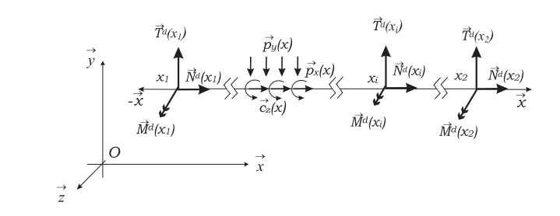

Figure 1: Straight beam loaded in its midplane with boundary conditions, distributed and concentrated loads

To size beams, it is generally necessary to resolve the internal equilibrium equation (1).

$N^{'}\left(x\right)+p_{x}\left(x\right)=0$ (1.1)
$T^{'}\left(x\right)+p_{y}\left(x\right)=0$ (1.2)
$M^{'}\left(x\right)+T\left(x\right)+c_{z}\left(x\right)=0$ (1.3)

The resolution of these differential equations involves the use, as appropriate, of boundary conditions, the behavior law and the boundary equilibrium conditions to finally obtain the displacements. This is how the stresses can be evaluated at any point of the beam from the internal forces found. And we will have:
$σ^{t}\left(x\right)=\frac{N(x)}{S(x)}$ (2.1)
$σ^{f}\left(x\right)=-\frac{M(x)}{I(x)}y$ (2.2)
$τ\left(x\right)=\frac{T(x)}{S(x)}$ (2.3)
In practice, the effect of shear in the beam resistance is generally neglected in the calculation of the deflection v(x) because it is very often an order of magnitude lower than the rotation term φ(x). In this context, by derivation of the last equilibrium equation, we obtain a differential equation in v(x) and M(x). This is the differential equation of the deformation at the abscissa x (eq.3):
$EIv^{''}\left(x\right)=M(x)$ (3)
The deflection is obtained by double integration, taking into account the boundary conditions.
The rotation of the section at a point with abscissa x is obtained by the first derivative of the deflection:
$φ(x)=v^{'}\left(x\right)$ (4)
The study focuses on the six samples, developed in our previous work, whose physical and mechanical properties to be used are given in Table 1(Ahmed D. et al. 10;3, 2024).

Table 1: physical and mechanical properties of the samples
 | Names of he samples
 | CBP10 | CBP20 | CBP30 | CBP40 | CBP50 | CBP60
%PEHD | 10 | 20 | 30 | 40 | 50 | 60
Density $ρ$(kg/m³) | 691.23 | 709.11 | 721.91 | 741.2 | 766.97 | 816.68
Young modulus E (MPa) | 2300 | 2125 | 2025 | 1900 | 1760 | 1770
Coefficient of Poisson ν | 0.33 | 0.33 | 0.33 | 0.33 | 0.33 | 0.33

All samples have in common the geometric properties summarized in Table 2.
Table 2 : Geometric properties
 | $I_{y}$ m⁴(10⁻⁵) | $I_{z}$ m⁴(10⁻⁵) | $I_{G}$ m⁴(10⁻⁷)
Values | 1.25 | 5 | 625

3.Methods
3.1Analytical study
A beam is subjected to simple bending when all the forces applied to it are perpendicular to the center line, and either located in the plane of symmetry, or distributed symmetrically about it; or concentrated at a point or distributed according to a law.
We propose to evaluate the rotations and deformations of the simple static bending of the beams covered by this two-dimensional study in three-dimensional space.

The various cases covered in this study are presented in Figure 2.

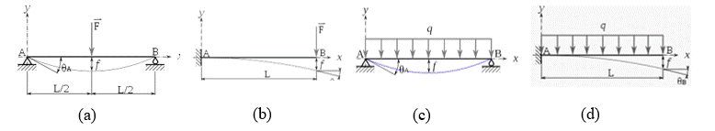
Figure 2: Diagrams of the different mechanisms of the study: (a) Three-point bending, (b) Console under point load at the end, (c) Bi-supported specimen under uniform load, (d) Console under uniform load

In the midplane, solving the previous equations (3; 4) allows us to find the deformation and rotation, taking into account the boundary conditions (Table 3).

Table 3: Types of connections used and boundary conditions

Connection | Degree of freedom | Efforts/Moments | Arrow | Rotation
Embedding | $\vec{u}=\vec{0}$ ; $\vec{θ}=\vec{0}$ | $\vec{R}≠\vec{0}$; $\vec{M}≠\vec{0}$ | 0 | 0
Single press | x$≠0$; y=0 ; z$≠0$ | N=T₃=0 ; T₂$≠0;$ $\vec{M}=\vec{0}$ | 0
Double press | x=$0$; y=0 ; z$=0$ | N$≠$0 ; T₃$≠$0 ; T₂$≠0;$ $\vec{M}=\vec{0}$ | 0

In this study, the beams are of rectangular sections. In this case, the neutral fiber passes through the center of gravity and varies there from the value –h/2 to the value h/2. (Figures 3, 4) [C25W/P442, Guide for Soil Thermal Resistivity Measurement, 1981 ; L. Chahwane, Université de Grenoble, France, 2011).

In the following, the point forces F and uniform forces q are respectively taken equal to 100 N and 50 N/m.
Figure 3: Geometric characteristics of the beam profile
Figure 4: Elements for reducing the internal force torsor
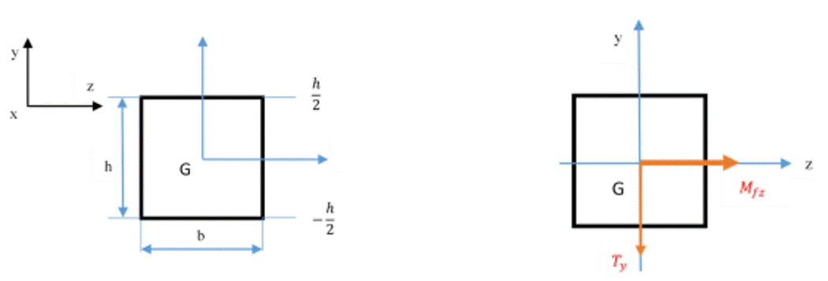

3-2- Cast3M simulations
Finite element modeling of the bending behavior of the CBPs was performed in Cast3M. All six types of CBPs were studied. Three-point bending tests, bending tests of a bi-supported beam with a centered point load, bending tests of a cantilever beam with concentrated force at the end, and bending tests of a fixed-free beam under uniform load were performed.
The specimens were modeled in a three-dimensional (3D) space as solid-type elements. They were considered deformable with dimensions Lxhxw=0.2x0.1x0.05 m3 (Figure 5).

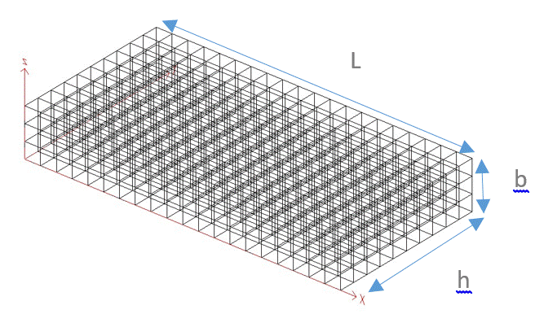
Figure 5: 3D mesh of specimens
The properties to be considered are density, Poisson's ratio, Young's modulus, and moments of inertia.
The study was conducted using an eight-node cubic element (CUB8) with six degrees of freedom in general static mode. The tests were simulated so as not to reach failure. In this simulation, we adopted the assumptions of continuum mechanics. The material is assumed to be homogeneous and linearly isotropic. The specimen deforms so that the small perturbation assumptions are verified.
At the end of these simulations, the deformation states were determined for each test case.
The corresponding graphs are constructed in comparison with the analytical values.

3. Results and Discussions
4.1. Analytical Study

Below are presented the results from the resolutions of the different system cases (Figures 6, 7, 8, 9).
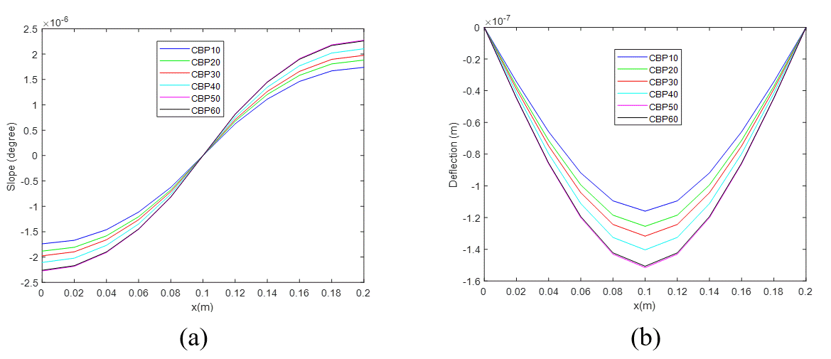
Figure 6: Analytical evolutions(a) of the rotation of the cross section, (b) of the deflection of the specimen in 3-point bending (Figure 2a)
Figure 6 shows the analytical evolutions of rotation (a) and deflection (b). The highest values ​​are located at the ends of the beam at the supports. Whereas for deflection, they are located in the middle. We will now consider the case shown in Figure 6(a). For all samples, rotation is zero in the middle and its value at the ends. For example, for CBP60, the maximum absolute value is 2.25.10⁻⁶ degrees. For each position, the value of the magnitude increases as the HDPE content increases.
For deflection, all values ​​are maximum in the middle and cancel out at both ends. For example, for CBP60, the value is 1.5.10⁻⁷ degrees. The deflection is zero at the supports.

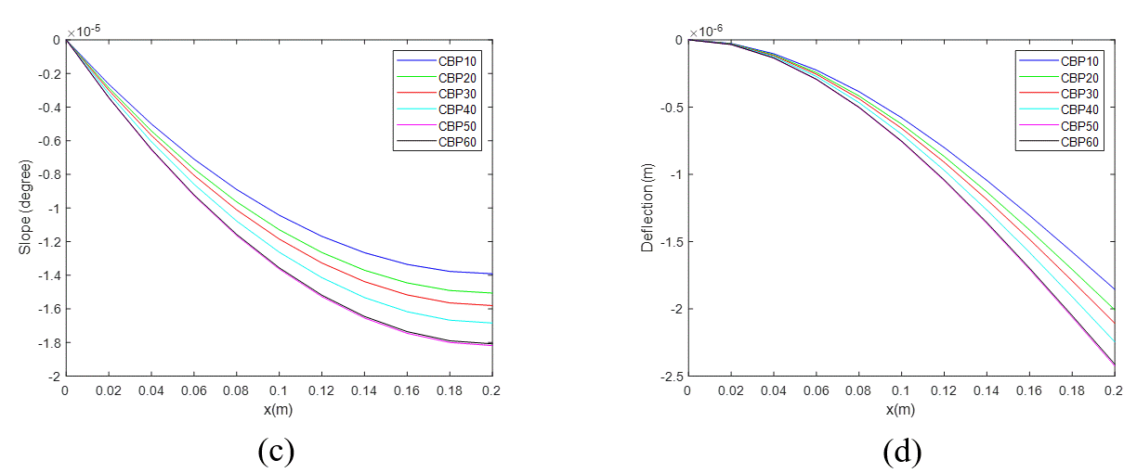
Figure 7: Analytical evolutions (c) of the rotation of the cross section, (d) of the deflection of the console specimen under point load at the other end (Figure 2b)
In Figure 7, we have the behavior of the console specimen under point loading at the end. For rotation, the absolute values ​​are between 0 and 1.82.10⁻⁵ and between 0 and 2.3.10⁻⁶. Figure 7.d shows us that the deflection evolves more quickly than the rotation. In all cases, the values ​​of CBP10 and CBP60 are respectively lower and higher. The deflection and rotation for CBP10 and CBP60 give identical behaviors with different values. The values ​​of the rotation of CBP60 are between [0; 1.7]10⁻⁵degree.
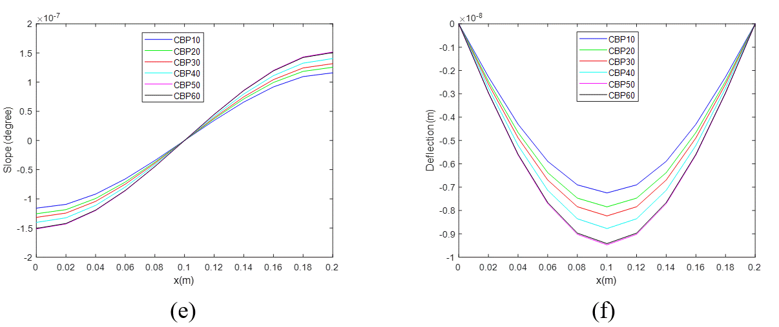
Figure 8: Analytical evolutions (e) of the rotation of the cross section, (f) of the deflection of the bi-supported specimen under uniform load(Figure 2c)
Figure 8 represents the analytical evolutions of the rotation of the cross section and the deflection of the bi-supported specimen under uniform load. We note that the two quantities have the same evolution as in Figure 6 except that the values ​​differ. For the deflection we have the same observation with different values ​​from Figure 6.
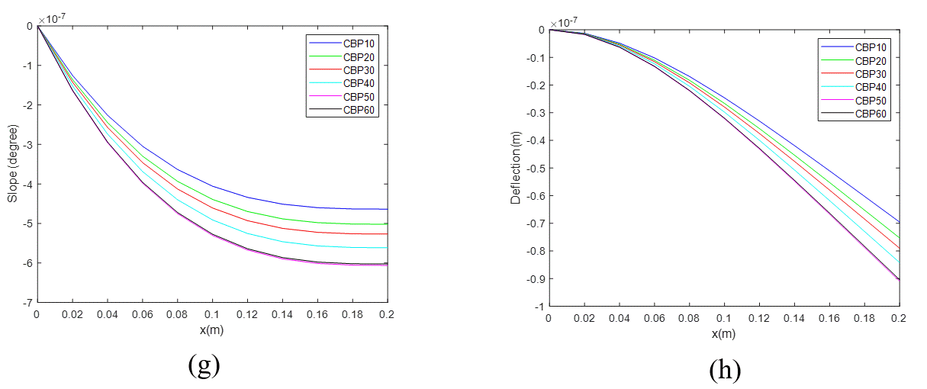
Figure 9: Analytical evolutions (g) of the rotation of the cross section, (h) of the deflection of the console specimen under uniform load (Figure 2d)
In Figure 9, there is a similarity between the evolutions as in the case of Figure 7. This is explained by the fact that the uniformly distributed load has a resultant that applies to the medium as in Figure 6. The graphs have the same similarities as Figure 7, for the same reason mentioned for Figure 8. However, the values ​​on the abscissa differ. For example, the defections of CBP60 and CBP10 are respectively: [0.9; 0]10⁻⁷ and [0; 0.65]10⁻⁷ m.

4-2-Numerical Simulations
For the simulation, we have presented the CBP10 case here. Like this case, the other cases yield similar results to the corresponding analytical cases
.
4-2-1- Specimens under three-point bending(Figure 10)
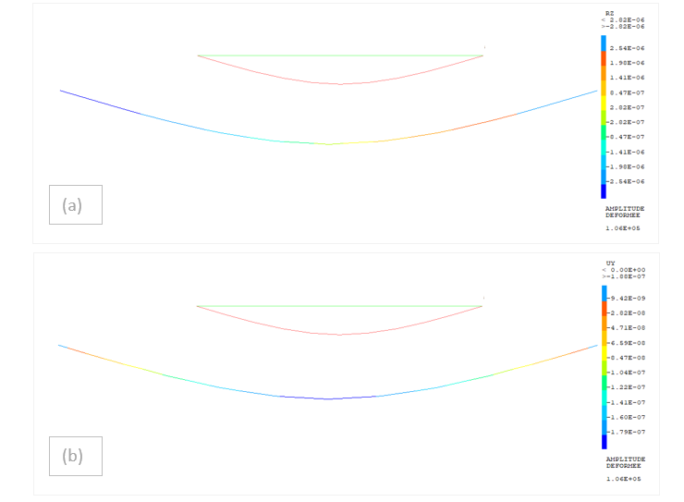
Figure 10: Simulations (a) of the rotation of the cross section, (b) of the deflection of the specimen in 3-point bending(Figure 2a)
Figure 10 shows the evolutions under Cast3M of the rotation (a) and the deflection (b). In both cases, the two quantities have the same appearance as in Figure 6. As in practice for a beam in three-point bending. The deflection values ​​are included in the interval: [9.42.10⁻⁹; 1.79.10⁻⁷]m.

4-2-2- Embedded specimens under concentrated load at the free end(Figure 11)

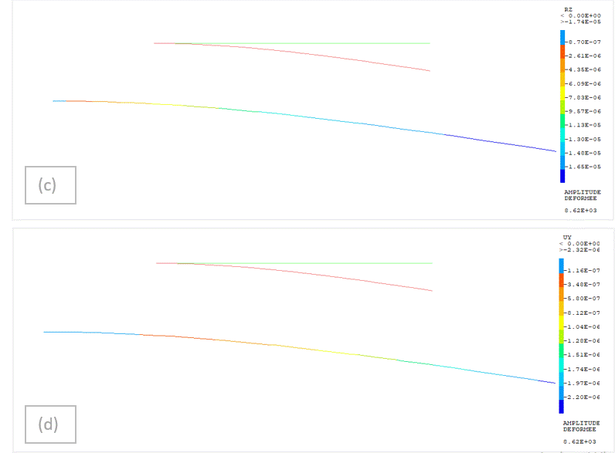

Figure 11: Simulations (c) of the rotation of the cross section, (d) of the deflection of the console specimen under point load at the other end(Figure 2b)
Figure 11 shows the simulations (c) of the rotation of the cross section, (d) of the deflection of the console specimen under point load at the other end. For the rotation, the values ​​are in the interval: [8.7.10⁻⁷; 1.65.10⁻⁵] degree. We have the same shape as in Figure 7.

4-2-3- Bi-supported specimens under uniform load over the entire length (Figure 12)
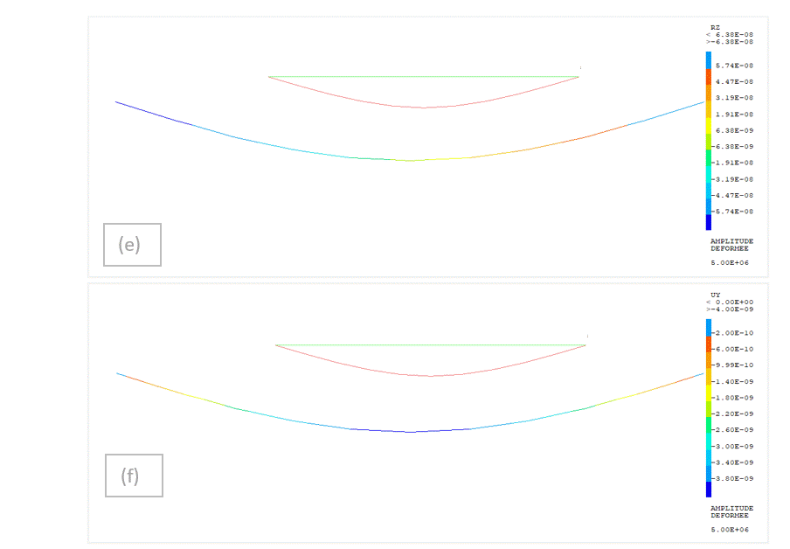
Figure 12: Simulations (e) of the rotation of the cross section, (f) of the deflection of the bi-supported specimen under uniform load(Figure 2c)
Figure 12 shows the evolutions under Cast3M of the rotation (a) and the deflection (b) of a bi-supported beam under uniform load. In both cases, the two quantities have the same appearance as in Figure 6. As in practice for a beam in three-point bending. The deflection values ​​are included in the interval: [9.42.10⁻⁹; 1.79.10⁻⁷] m

4-2-4- Embedded specimens under uniform load over the entire length
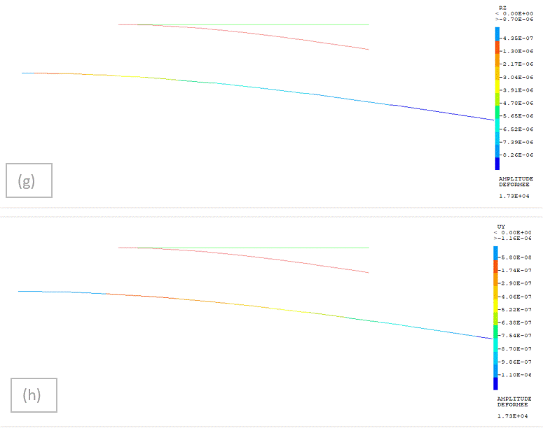
Figure 13: Simulations (g) of the rotation of the cross section, (h) of the deflection of the console specimen under uniform load (Figure 2d)
Figure 13: these are the simulations (c) of the rotation of the cross section, (d) of the deflection of the console specimen under uniformly distributed load. For the deflection, the values ​​are included in the interval: [5.10⁻⁸; 1.1.10⁻⁶] m. We have the same shape as in Figure 7.

4- COMPARATIVE STUDY
In the analytical study, for the beam subjected to three-point bending, we initially observe a symmetry of the values ​​consistent with the positioning of the action application points.
For both cases, as the HDPE content increases, the measured quantities increase. The maximum rotation and deflection values ​​are located at the ends and midpoints, respectively.
The same observations are made for the bi-supported specimen under uniform load, in terms of variations relative to the HDPE content.
For the Cast3M simulations, we note that each case exhibits the same characteristics as the corresponding analytical case. For comparison, we present the results for CBP10 for the analytical analysis and the Cast3M simulation in Table 4. It clearly demonstrates the agreement between the two methods.

Table 4: Analytical and Cast3M Rotation and Deflection Values ​​for CBP10
Analytical study
 | Figure 6 | Figure 7 | Figure 8 | Figure 9
Rotation | 2,83.10⁻⁶ | 1,65.10⁻⁵ | 5,74.10⁻⁷ | 9,27.10⁻⁷
Deflection | 1,79.10⁻⁷ | 2,2.10⁻⁶ | 3,82.10⁻⁸ | 1,1.10⁻⁷
Simulation ander Cast3M
 | Figure 10 | Figure 11 | Figure 12 | Figure 13
Rotation | 2,84.10⁻⁶ | -1,66.10⁻⁵ | -5,74.10⁻⁷ | -8,26.10⁻⁷
Deflection | -1,79.10⁻⁷ | -2,1.10⁻⁶ | -3,80.10⁻⁸ | -1,1.10⁻⁷

CONCLUSION
The aim of this work was to find a way to simulate the behavior of the composites we studied in bending, which remains the most common and destructive stress in construction. We studied the following cases: three-point bending, cantilever with counter-load at the end, bi-supported beam with uniform load along the length, and cantilever with uniform load along the entire length.
We conducted an analytical study followed by simulations using the Cast3M finite element analysis software. The first served as a reference to validate the second. The results obtained showed very good agreement between the two methods. This is corroborated by the graphs. The example is given in Figures 8 and 12. They yield values ​​equal to 2.2 x 10⁻⁶ and 2.1 x 10⁻⁶ m for deflection, respectively. There is a clear agreement between the two studies. We thus constructed a bending calculation model for wood-polymer composites. It will be useful in future work to predict the mechanical behavior of these materials.

AUTHOR'S CONTRIBUTION:
Ahmed Doumbia : writing manuscript, data collection, data analysis, and interpretation; Chardin Séri Séri and Seydou Traoré : data collection, reviewing and editing of the manuscript.

ACKNOWLEDGMENTS
We thank the Systems and Structures Modeling Department (DM2S) of the Nuclear Energy Directorate of the French Alternative Energies and Atomic Energy Commission (CEA) for providing the Cast3M software.

Definitions, Acronyms, Abbreviations
$S(x)$ : Cross section at abscissa x
$T^{d}(x_{1})$, $T^{d}(x_{i})$,$T^{d}(x_{2})$ : Shear forces at cross sections at abscissas $x_{1}, x_{i} and x_{2}$
$N^{d}(x_{1})$, $N^{d}(x_{i})$,$N^{d}(x_{2})$ : Normal forces at cross sections at abscissas $x_{1}, x_{i} and x_{2}$
$M^{d}(x_{1})$, $M^{d}(x_{i})$,$M^{d}(x_{2})$ : Bending moments at cross sections at the abscissas f$x_{1}, x_{i} et x_{2}$
$P_{y}(x)$, $P_{x}(x)$ : Uniform charges in the respective directions y and x at the abscissa x
$σ^{t}(x)$, $σ^{f}(x)$ : Normal stresses due to tension and bending in the cross section with abscissa x
$τ(x)$ : Tangential stress in the cross section of abscissa x
$I(x)$ : Moment of inertia at the abscissa x
$E$ : Longitudinal modulus of elasticity
$F$ : Point force
$C_{z}(x)$ : Torque in the z direction at the section with abscissa x
HDPE: high-density polyethylene
Disclaimer (Artificial intelligence)
Option 1:
Author(s) hereby declare that NO generative AI technologies such as Large Language Models (ChatGPT, COPILOT, etc.) and text-to-image generators have been used during the writing or editing of this manuscript.
Option 2:
Author(s) hereby declare that generative AI technologies such as Large Language Models, etc. have been used during the writing or editing of manuscripts. This explanation will include the name, version, model, and source of the generative AI technology and as well as all input prompts provided to the generative AI technology
Details of the AI usage are given below:
1.
2.
3.

REFERENCES

Ma, W. L., Jiang, Z. C., Lee, K. Y., & Li, X. F. (2020). A refined beam theory for bending and vibration of functionally graded tube-beams. Composite Structures, 236, 111878.

Shaat, M., Ghavanloo, E., & Emam, S. (2020). A micromorphic beam theory for beams with elongated microstructures. Scientific reports, 10(1), 7984.

Shen, J., Zhang, X., Wu, P., Yue, K., & Chen, J. (2025). Experimental and Finite Element Analysis of Bending Performance of Web-Embedded Double Inverted T-Shaped Steel–Concrete Composite Beams. Buildings, 15(5), 717.

Tho, N. C., Cong, P. H., Zenkour, A. M., Doan, D. H., & Van Minh, P. (2023). Finite element modeling of the bending and vibration behavior of three-layer composite plates with a crack in the core layer. Composite Structures, 305, 116529.

Ahmed Doumbia, Pierre Jean-Marie Richard Dablé, Analysis of the Mechanical Behavior of Bricks Based on Iroko Sawdust Stabilized Using Recovered High-Density Polyethylene Resin, Volume 10; Issie 3, 2024

C25W/P442, Guide for Soil Thermal Resistivity Measurement, PE-IEEE Power and Energy Sociaty, 1981.

L. Chahwane, Valorisation de l’inertie thermique pour la performance énergétique des bâtiments. Thèse de doctorat, Université de Grenoble, France, 2011.

