Characteristic and pattern of Aortic Stenosis: An observational study in a designated population of patients

ABSTRACT

Aim: The study aims to investigate the correlation between hemodynamic assessment in isolated Aortic stenosis (AS) and multivalvular disease.
Background: No one can deny the unpredictable progressive character of aortic stenosis. Aortic stenosis (AS) is a frequent valvular heart disease in the elderly, marked by narrowing of the aortic valve, leading to left ventricular hypertrophy and diastolic dysfunction. Calcification of the valve leaflets is the main pathological mechanism, often accompanied by lipid infiltration and fibrosis. AS has been asymptomatic for years, with symptoms like dyspnea, angina, and syncope signalling disease progression.
Methodology: This study retrospectively analyzed 100 adult patients with severe AS from July 2021 to October 2024. Echocardiography assessed AS severity via jet velocity, mean gradient, and aortic valve area (AVA). Data were analyzed using SPSS; t-tests and Chi-square tests compared clinical variables. The mean patient age was 57.26 years; 56.9% were male. Most had preserved left ventricular function and concentric hypertrophy. Severe AS was defined by AVA <1 cm², mean gradient >40 mmHg, and velocity >4 m/s.
Result: The findings showed that Males had a higher prevalence of pure AS; hemodynamic parameters were similar across sexes. Calcific AS is now recognized as an active inflammatory condition, not just degenerative. Echocardiography remains central in diagnosis and severity grading but CT and MRI can provide advanced structural insights but are not routinely used. Despite being asymptomatic initially.
Conclusion: AS progression varies, and untreated symptomatic patients face high mortality within 3 years so early detection and accurate grading are crucial for timely intervention.AS has poor outcomes post-symptom onset without intervention. So, valve replacement is indicated upon symptom development; management of asymptomatic patients remains complex.

Keywords: Aortic stenosis; multivalvular disease; AVA; hemodynamic valvular assessment

1. INTRODUCTION

Aortic stenosis (AS) is a common valvular heart disease in the elderly characterized by a narrowing of the aortic valve surface, responsible for remodelling and hypertrophy of the left ventricular that leads further away to diastolic dysfunction. It is a highly prevalent and clinically relevant cause of valvular heart disease worldwide, and, if left untreated, leads to substantial morbidity and mortality(Iung et al., 2003; Kuppusamy et al., 2025). “Described as a chronological reduction of the aortic valve, severe AS is defined by an effective orifice area (EOA) of less than 1.0 cm² and a mean transvalvular gradient of at least 40 mmHg” (Makkar et al., 2012). “Valve leaflet calcification is the main culprit lesion of AS. In addition to aortic valve calcification (AVC), lipid infiltration, aberrant extracellular matrix remodelling, and extensive valvular fibrosis may also contribute to the thickening and stiffening of aortic valve leaflets and thus to the development of AS. This valvular heart disease remains quiet for a while before the manifestations appear: dyspnea, chest pain, syncope. Understanding the geographical and temporal trends that are present in valve disease epidemiology is crucial for designing effective public health interventions for primary and secondary prevention. Global epidemiological data can be unreliable, as post-mortem analysis has revealed the true prevalence of valvular heart disease to be significantly greater than that which is clinically coded and reported” (Aluru et al., 2022; Coffey et al., 2017). The manifestation of symptoms signifies a pivotal stage in disease progression, thereby necessitating the reassessment and potential modification of therapeutic interventions. Those symptoms are the reflection of specific hemodynamic patterns that are well investigated by two-dimensional 2D and Doppler echocardiography. The objective of this study is to investigate the correlation between hemodynamic assessment in isolated Aortic stenosis (AS) and multivalvular disease.

2. material and method

Study design and population
Clinical and echocardiographic data of 100 adult patients who presented with severe aortic valve stenosis from July 2021 to October 2024 in a cardiac surgery department were analyzed retrospectively.
Patients in whom echocardiography with an assessment of the Aortic valve (AV) was indicated were considered eligible for the analysis. No additional tests, in particular no MSCT, were performed for the study. Exclusion criteria were: congenital heart disease except bicuspid aorta, previous aortic valve surgery and infective endocarditis.
All patients underwent routine transthoracic echocardiography.

Transthoracic echocardiography

Echocardiographic studies were performed using Vivid S70 (GE Vingmed Ultrasound, Horton, Norway; trans- ducer M5Sc-D, 1.4–4.6 MHz) and Philips EPIQ 7G (Philips Medical Systems, Andover, MA, USA; transducer X5-1, 1–5 MHz).
All echocardiographic studies were conducted by experienced clinicians. Image analysis and all measurements were carried out according to the current guidelines.

Classification and inclusion of patients

As recommended by current guidelines, the severity of AS was based on visual assessment and hemodynamic parameters: the peak jet velocity across the aortic valve, the mean transvalvular pressure gradient, and the effective aortic valve area by the continuity equation.
In the case of incongruent data in AVA, peak jet velocity and mean gradient, such as patients with low-flow, low-gradient AS, the results were labelled as inconsistent grading.

Visual assessment of aortic valve

Visual grading of AV morphology and degenerative changes was performed using two-dimensional images only. Degenerative changes of the AV were evaluated using four characteristics: echogenicity, thickening, localization of valve lesions, and mobility of AV leaflets.
Statistical analysis:
The collected data were entered using Word, graphs were created with Excel, and data processing and analysis were performed using SPSS software, version 26. Continuous variables were described using the mean ± standard deviation or the median and interquartile range, and compared using the Student's t-test. Categorical variables were described using frequencies and percentages, and compared using the Chi-square test.

3. results and discussion

100 Patients (mean age 57.26 ± 13.31 years, 56.9% men) were included in this study. Clinical and echocardiographic patient characteristics are summarized in Table 1. Patients with AS were older. Men had a higher prevalence of a pur AS compared to women.
Most of the patients diagnosed with isolated aortic stenosis had a normal left ventricular function. Hemodynamic parameters of AS were similar between female and male patients. In patients with severe AS, the average mean gradient was 51.79 ± 16.99 mmHg, the average peak aortic jet velocity was 4.51 ± 0.7 m/s and the average AVA was 1 cm², without a significant difference in these parameters between female and male patients (Table 1)

Parameter | Results |  | Groups by valvular desease |  |  | P value
 |  |  | Isolated AS |  | Multi valvular disease
Age >57 Y.O | 57.26+/-13.31 |  | 18 |  | 9 | 0.001
Sexe | 56.9% |  | 18 |  | 15 | 0.039
Hypertension | 13% |  | 03 |  | 04 | 0.469
Smoking | 20.7% |  | 03 |  | 08 | 0.391
Diabetes mellitus | 12.1% |  | 05 |  | 02 | 0.107
ACD | 13.8% |  | 05 |  | 03 | 0.233
CKD | 6.89% |  | 01 |  | 03 | 0.346
Echocardiography
LV EF <50% | 57.77%+/-9.84 | 2 |  | 9 |  | 0.064
Dilated LV | 20.7% |  | 1 |  | 11 | 0.006
Concentric hypertrophy of LV | 81% |  | 59 |  | 22 | 0.001
Aortic valve parameters
Bicuspid valve | 1.7% |  | 01 |  | 00 | 0.246
AVA <1 cm² | 79.3% |  | 21 |  | 25 | 0.443
Mean gradient >40 mmHg | 51.79+/-16.99 |  | 23 |  | 23 | 0.038
Peak velocity>4 m/s | 4.51+/0.7 |  | 23 |  | 24 | 0.064

Table 1: clinical and echocardiographic characteristics in both groups

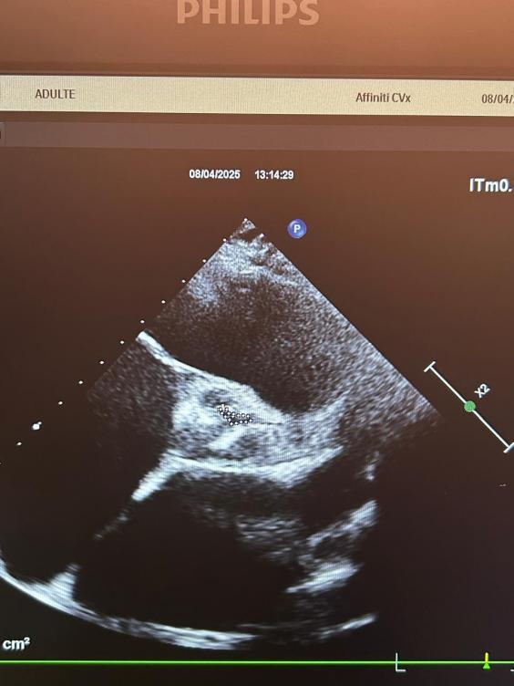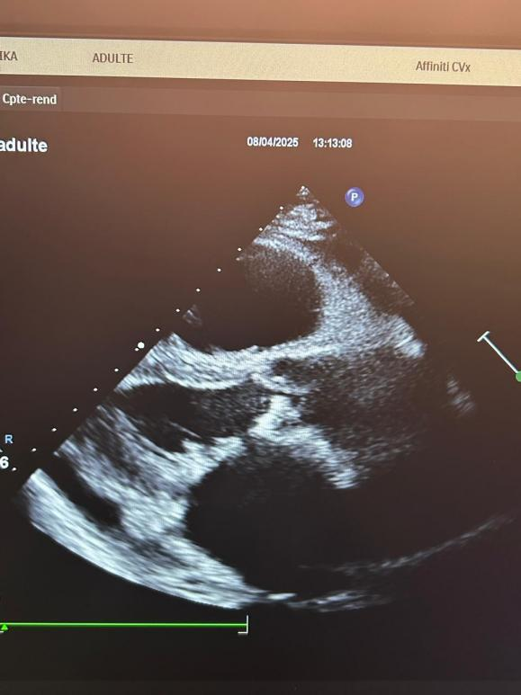

Figure 1: A parasternal short-axis view showing a heavily calcified aortic valve with features suggestive of severe aortic stenosis. Figure 2: A parasternal long-axis view showing a calcified aortic valve with restricted opening, leading to left ventricular hypertrophy.

Aortic stenosis is a critical condition caused by the narrowing of the aortic valve, responsible for reducing cardiac output and decreased functional capacity. It develops gradually so it is more seen with population ageing. “Aortic stenosis is asymptomatic for years, initial diagnosis of AS typically occurs during routine physical examination with the presence of a heart murmur, click, or other abnormal sounds, but undiagnosed patients may experience the onset of severe symptoms. This gradual development underlines the necessity of surveying such patients until the valve becomes severely narrowed so the symptoms start to appear: syncope; angina; heart failure signs” (1).
“Multiple etiologies can lead to aortic valvular stenosis principally aortic valve calcification, which is the main process leading to aortic stenosis and the degree of AVC-AS anatomic severity is closely related to AS haemodynamic severity as assessed using echocardiography”. (2)
“The native AV experiences a complex mechanical environment, including leaflet stretch, fluid shear stress, bending stresses, and pressure forces. The forces experienced by the leaflet vary spatially and temporally over the cardiac cycle and may be altered significantly because of disease. Calcific AS was initially believed to be a passive disease associated with the wear and tear of valve tissue due to ageing. However, multiple studies have shown that AV calcification is the result of active inflammatory processes, mediated by hemodynamic and genetic factors”. (3) In fact, “the disruption of the aortic valvular endothelium with endothelial dysfunction, lipid accumulation, and infiltration of lymphocytes and macrophages that release pro-inflammatory molecules; they recruit fibroblasts and activate osteoblasts, leading to valve fibrosis, progressive thickening, that, over time, evolves into severe valve calcification”.(4)
“Calcific aortic valve disease was long considered a degenerative and, therefore, permanent condition. Clinical and histological similarities with atherosclerosis have led to the hypothesis that statins may prevent AS progression. The Scottish Aortic Stenosis and Lipid Lowering Trial, Impact on Regression (SALTIRE), SEAS and Aortic Stenosis Progression Observation: Measuring Effects of Rosuvastatin (ASTRONOMER) trials assessed the effect of statins on progression of AS in asymptomatic patients and failed to demonstrate any effect. It has thus been suggested that any effect of statins may only be observable in the early phase in patients with mild AS or even in patients with aortic valve sclerosis” (5,6,7)
“Evaluation of aortic valve stenosis as based on data obtained from two-dimensional 2D and Doppler echocardiography plays a key role in the grading of aortic valve stenosis”. (8)
The first echocardiographic approach in the evaluation of AS begins with the characterization of aortic valve morphology by transthoracic parasternal long- and short-axis views, in order to identify the number, mobility, thickness, and calcification of the cusps and to evaluate the etiology;
AS haemodynamic severity is usually assessed using echocardiography based on mean gradient, peak velocity, and calculating the aortic valve area.
Current guidelines/recommendations define severe stenosis as an aortic valve area (AVA) <1 cm2 (or <0.6 cm2 adjusted for body surface area), mean pressure gradient (ΔPm) >40 mmHg, or peak flow velocity (Vmax) >4 m/s(9). If the left ventricular function is normal, “the three parameters should yield a consistent classification of a particular aortic stenosis as either mild; moderate or severe”. (10)
“Computed tomography (CT) provides the highest-resolution anatomic data of the AV in calcific AS. Additionally, CT provides the best assessment of calcification on the valve leaflets and annulus among all imaging modalities. Although cardiac CT was initially used to detect and quantify coronary artery calcification, its applicability to assess AVC was also demonstrated in early studies. Currently, multidetector CT scanners are most commonly used because of their lower cost and superior spatial and temporal resolution so they gained prominence recently in the treatment of AS with the use of transcatheter aortic valve replacements (TAVRs)”. (11,14).
“MRI has been used to a much lesser extent in the diagnosis of AS. The attractiveness of MRI lies in the avoidance of radiation exposure and in the ability to obtain both anatomic and hemodynamic measurements and full 3-dimensional information provided by the modality. On the other hand, the inherent disadvantages of MRI include the inability to accurately identify calcification, signal voids due to flow turbulence, lower spatial resolution in comparison with CT, imaging artefacts due to implanted medical devices, increased scan times, and higher costs”.(15,18).

“The progression of AS is variable between patients, with many being asymptomatic. However, studies have found that 75% of patients die within three years of symptom onset if no interventions are performed”. (19)
“In the management of patients with aortic valve stenosis, symptoms attributable to aortic stenosis (syncope, angina and dyspnoea) determine which patient should undergo valve replacement. On the other hand, decisions on the management of asymptomatic patients particularly with severe stenosis are more difficult and exact grading becomes more important. The risk of rapid progression of the disease, imminent heart failure and sudden death must be weighed against perioperative morbidity and mortality, valve deterioration and problems associated with possible long-term anticoagulation”. (20)

4. Conclusion

Aortic stenosis is a progressive and potentially life-threatening condition, often silent for years before the onset of symptoms. Its development, primarily driven by active calcific and inflammatory processes, highlights the complexity of the disease beyond simple degeneration. Early diagnosis through echocardiographic evaluation is essential for appropriate grading and timely intervention. As symptom onset marks a turning point with significantly increased mortality risk, close surveillance and individualized management strategies are critical, particularly in asymptomatic patients with severe stenosis.

Disclaimer (Artificial intelligence)
Option 1:
Author(s) hereby declare that NO generative AI technologies such as Large Language Models (ChatGPT, COPILOT, etc.) and text-to-image generators have been used during the writing or editing of this manuscript.
Option 2:
Author(s) hereby declare that generative AI technologies such as Large Language Models, etc. have been used during the writing or editing of manuscripts. This explanation will include the name, version, model, and source of the generative AI technology and as well as all input prompts provided to the generative AI technology
Details of the AI usage are given below:
1.
2.
3.

References

1. Soleimani, A., Maghsoodi, M., Bahrani, S. et al. Investigating the results of transcatheter aortic valve implantation (TAVI) in non-diabetic and diabetic patients: a systematic review and meta-analysis. BMC Cardiovasc Disord 25, 205 (2025). https://doi.org/10.1186/s12872-025-04646-3
2. Marie-Annick Clavel, David Messika-Zeitoun, Philippe Pibarot, Shivani R. Aggarwal, Joseph Malouf, Phillip A. Araoz, Hector I. Michelena, Caroline Cueff, Eric Larose, Romain Capoulade, Alec Vahanian, Maurice Enriquez-Sarano,The Complex Nature of Discordant Severe Calcified Aortic Valve Disease Grading: New Insights From Combined Doppler Echocardiographic and Computed Tomographic Study, Journal of the American College of Cardiology,Volume 62, Issue 24,2013
3. Neelakantan Saikrishnan, PhD, Gautam Kumar, MBBS, MRCP(UK), Fadi J. Sawaya, MD, StamatiosLerakis, MD, and Ajit P. Yoganathan, PhD, Accurate Assessment of Aortic Stenosis: A Review of Diagnostic Modalities and Hemodynamics, Circulation,Volume 129, Number 2
4. Sverdlov, A.L.; Ngo, D.T.; Chapman, M.J.; Ali, O.A.; Chirkov, Y.Y.; Horowitz, J.D. Pathogenesis of Aortic Stenosis: Not Just a Matter of Wear and Tear. Am. J. Cardiovasc. Dis. 2011, 1, 185–199.
5. Cowell SJ, Newby DE, Prescott RJ, et al. A randomized trial of intensive lipid-lowering therapy in calci c aortic stenosis. N Engl J Med 2005;352:
6. Rossebo AB, Pedersen TR, Boman K, et al. Intensive lipid lowering with simvastatin and ezetimibe in aortic stenosis. N Engl J Med 2008;359:1343–56.
7. Chan KL, Teo K, Dumesnil JG, et al. Effect of Lipid lowering with rosuvastatin on progression of aortic stenosis: results of the aortic stenosis progression observation: measuring effects of rosuvastatin (ASTRONOMER) trial. Circulation 2010;121: 306–14.
8. Baumgartner H, Falk V, Bax JJ, et al. 2017 ESC/EACTS Guidelines for the management of valvular heart disease. Eur Heart J. 2017;38:2739–2791. doi: 10.1093/eurheartj/ehx391
9. Jan Minners, Martin Allgeier, Christa Gohlke-Baerwolf, Rolf-Peter Kienzle, Franz-Josef Neumann, Nikolaus Jander, Inconsistencies of echocardiographic criteria for the grading of aortic valve stenosis, European Heart Journal, Volume 29, Issue 8, April 2008, Pages 1043–1048, https://doi.org/10.1093/eurheartj/ehm543
10. Gorlin R, Gorlin SG. Hydraulic formula for calculation of the area of the stenotic mitral valve, other cardiac valves, and central circu- latory shunts. I Am Heart J 1951;41:1 – 29
11. Agatston AS, Janowitz WR, Hildner FJ, Zusmer NR, Viamonte M, Detrano R. Quantification of coronary artery calcium using ultrafast computed tomography. J Am Coll Cardiol. 1990;15:827–832.
12. Mautner GC, Mautner SL, Froehlich J, Feuerstein IM, Proschan MA, Roberts WC, Doppman JL. Coronary artery calcification: assessment with electron beam CT and histomorphometric correlation. Radiology. 1994;192:619–623.
13. Woodring JH, West JW. CT of aortic and mitral valve calcification. J Ky Med Assoc. 1989;87:177–180.
14. Lippert JA, White CS, Mason AC, Plotnick GD. Calcification of aortic valve detected incidentally on CT scans: prevalence and clinical significance. AJR Am J Roentgenol. 1995;164:73–77.
15. John AS, Dill T, Brandt RR, Rau M, Ricken W, Bachmann G, Hamm CW. Magnetic resonance to assess the aortic valve area in aortic stenosis. J Am Coll Cardiol. 2003;42:519–526.
16. Kupfahl C, Honold M, Meinhardt G, Vogelsberg H, Wagner A, Mahrholdt H, Sechtem U. Evaluation of aortic stenosis by cardiovascular magnetic resonance imaging: comparison with established routine clinical techniques. Heart. 2004;90:893–901.
17. Schlosser T, Malyar N, Jochims M, Breuckmann F, Hunold P, Bruder O, Erbel R, Barkhausen J. Quantification of aortic valve stenosis in MRI-comparison of steady-state free precession and fast low-angle shot sequences. Eur Radiol. 2007;17:1284–1290.
18. Puymirat E, Chassaing S, Trinquart L, Barbey C, Chaudeurge A, Bar O, Blanchard D. Hakki’s formula for measurement of aortic valve area by magnetic resonance imaging. Am J Cardiol. 2010;106:249–254.
19. Carabello B.A., Paulus W.J. Aortic stenosis. Lancet. 2009;373:956–966. doi: 10.1016/S0140-6736(09)60211-7.
20. Lund O. Preoperative risk evaluation and stratification of long- term survival after valve replacement for aortic stenosis. Reasons for earlier operative intervention. Circulation 1990;82: 124 – 139..
21.Kuppusamy, P., Srinivasan, K. N., G, S., Rangan, S. S., Dhanasekaran, S., & Spandana, R. (2025). The Effect of TAVI on Left Atrial Function and Hemodynamics. Asian Journal of Cardiology Research, 8(1), 16–27. https://doi.org/10.9734/ajcr/2025/v8i1243
22.Iung, B., Baron, G., Butchart, E. G., Delahaye, F., Gohlke-Bärwolf, C., Levang, O. W., ... & Vahanian, A. (2003). A prospective survey of patients with valvular heart disease in Europe: The Euro Heart Survey on Valvular Heart Disease. European heart journal, 24(13), 1231-1243.
23.Makkar, R. R., Fontana, G. P., Jilaihawi, H., Kapadia, S., Pichard, A. D., Douglas, P. S., ... & Leon, M. B. (2012). Transcatheter aortic-valve replacement for inoperable severe aortic stenosis. New England Journal of Medicine, 366(18), 1696-1704.
24.Aluru, J. S., Barsouk, A., Saginala, K., Rawla, P., & Barsouk, A. (2022). Valvular heart disease epidemiology. Medical sciences, 10(2), 32.
25.Coffey, S., Harper, A. R., Cairns, B. J., Roberts, I. S., & Prendergast, B. D. (2017). Clinical information has low sensitivity for postmortem diagnosis of heart valve disease. Heart, 103(13), 1031-1035.

