**Epidemiology and left ventricular impact of secondary hypertension: A case series**

**ABSTRACT**

|  |
| --- |
| Secondary hypertension is defined as arterial hypertension due to an identifiable cause, and therefore can be cured when the underlying cause is treated. It is a rare entity, often underdiagnosed, with an overall prevalence estimated at 10% of hypertensive patients in literature. However, it is important to look for it given its reversible nature after treatment of the cause. This is a case series aiming to uncover this often heterogeneous entity by highlighting its epidemiological particularities and its impact on the left ventricle in our patient population and comparing its results with data in literature. The left ventricle is a primary target for hypertension end-organ damage. In addition to being a marker of hypertension, left ventricular hypertrophy (LVH) is a major independent risk factor for not only cardiovascular disease morbidity and mortality but also for all-cause mortality and neurological pathologies. Electrocardiogram and 2D transthoracic echocardiography are the primary diagnostic tools for the diagnosis and quantification of LVH. To identify the cause of hypertension in our patients, radiological examinations were used such as renal artery ultrasound, abdominal CT scan, and arteriography. Polysomnography was also used when obstructive sleep apnea was suspected. Routine blood tests were performed such as potassium level, as well as aldosterone level and plasma renin activity in case of suspected primary aldosteronism. In our case series, primary aldosteronism was the most frequent etiology of secondary hypertension representing 22.7% of the cases as well as renal artery stenosis. Primary aldosteronism, also known as Conn’s syndrome, is described in literature as the most common form of secondary hypertension. |

*Keywords: Secondary hypertension, arterial hypertension, left ventricular hypertrophy, primary aldosteronism, Conn’s syndrome, renal artery stenosis, Takayasu arteritis, pheochromocytoma.*

**1. INTRODUCTION**

“Most patients with hypertension (HTN) have essential or primary hypertension, where the exact cause remains unknown, while an estimated 10% have secondary hypertension (SH), with an identifiable cause (notably some studies indicate that the prevalence of secondary hypertension may be substantially higher, with modern systematic screening)” [1]. “The 2024 European Society of Cardiology (ESC) guidelines for the management of elevated blood pressure and hypertension recommend a comprehensive screening for the main causes of secondary hypertension in adults diagnosed with hypertension before the age of 40 years, except for obese young adults where it is recommended to start with an obstructive sleep apnea evaluation. They also recommend an appropriate screening for secondary hypertension in patients with hypertension presenting with suggestive signs, symptoms, or medical history of secondary hypertension” [2]. “Failure to recognise secondary causes can lead to resistant hypertension, cardiovascular complications or complications of the underlying condition” [3].

**2. MATERIAL AND METHODS**

We report a case series of patients who suffered from secondary hypertension. The patients were treated in the cardiology and vascular diseases department of the Mohammed VI University Hospital of Marrakesh. Clinical data about gender, age, anthropomorphic parameters and blood pressure measurement were recorded. Left ventricular hypertrophy was assessed with electrocardiogram (ECG) and 2D transthoracic echocardiography (TTE). Recorded radiological examinations were renal artery ultrasound, abdominal CT scan, and arteriography (performed for patients with renal artery stenosis). Polysomnography was also used when obstructive sleep apnea was suspected. Routine blood tests were performed such as potassium level, as well as aldosterone level and plasma renin activity in case of suspected primary aldosteronism.

**3. RESULTS**

There were 22 patients in our series, 10 were women (46%) and 12 were men (54%), with a sex ratio of 0.83. The mean age at diagnosis was 36 years, with extremes of 9 years and 72 years. Hypertension (HTN) affected 50% of our patients under the age of 40 years. It was discovered mainly by refractory headaches (32% of cases). In 22.7% of the patients, hypertension was discovered incidentally and during an assessment of resistant hypertension in 13.6% of cases. The disease was revealed by exercise dyspnea in 9%. Electrical left ventricular hypertrophy (LVH) was found in 50% of cases. This LVH was objectified by transthoracic echocardiography (TTE) in 41% of cases, with a female predominance (60% of women had LVH on TTE). Among patients who had electrical LVH, 64% had LVH in TTE, while in patients who did not have electrical LVH, 18% had LVH in TTE. The first etiology of secondary hypertension (SH) found in our series was primary aldosteronism (Conn's syndrome) and renal artery stenosis (mainly due to Takayasu arteritis) by a percentage of 22.7% each, followed by pheochromocytoma (13.6%) one of which was bilateral malignant. Coarctation of the aorta and somatotroph adenoma represented 14% of the causes each. Adrenal mass for which investigations are still in progress, represented 9% of cases. Obstructive sleep apnea was found in an elderly patient, and glomerular nephropathy was the etiology in one young patient. Hypertension was controlled in 80% of our patients whether by medical and/or interventional and/or surgical treatment.

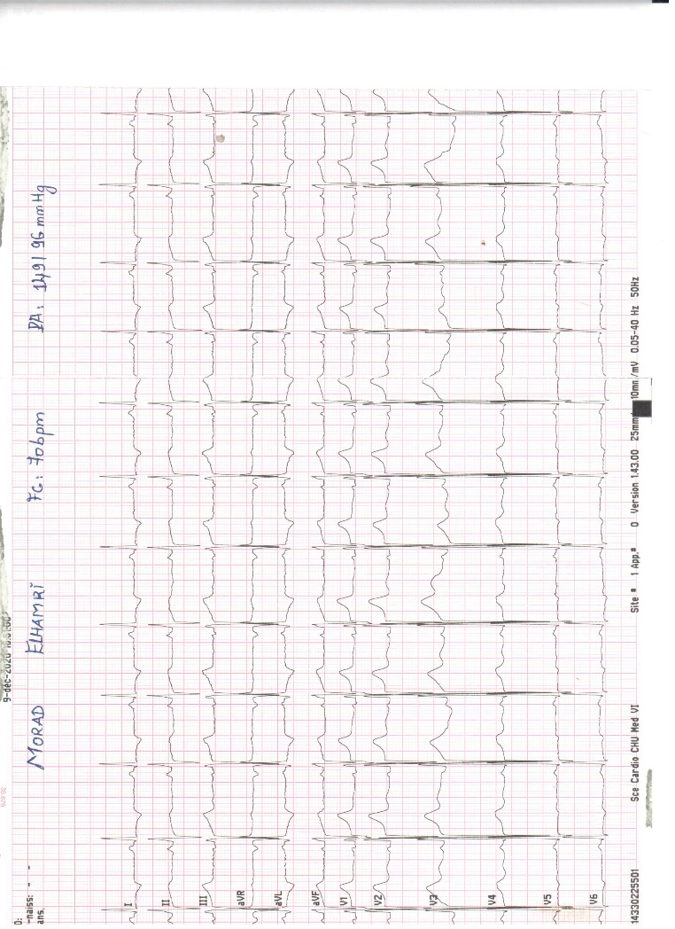

**Fig. 1: Example of electrocardiogram (ECG) showing a LVH in one of our patients.**

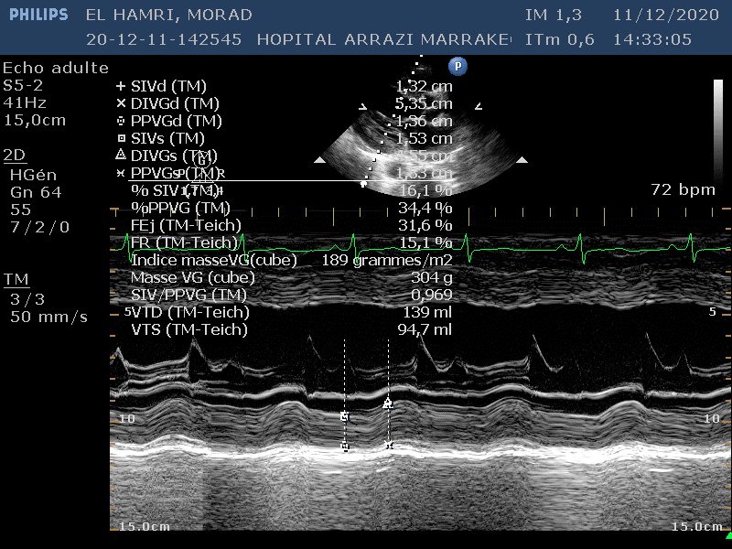

**Fig. 2. TTE image of LVH in TM mode in one of our patients.**

**Table 1: Clinical and paraclinical characteristics of our patients.**



|  |  |  |  |  |  |  |  |
| --- | --- | --- | --- | --- | --- | --- | --- |
| Patients | Male (M) / Female (F) | Age  (years) | Clinical presentation | Arterial blood pressure mmHg | LVH  in ECG | LVH  in TTE | Etiology |
| 1 | M | 15 | Acute pulmonary edema | 202/134 | No | No | Bilateral renal artery stenosis (Takayasu) |
| 2 | F | 12 | Headache | 162/95 | No | No | Bilateral renal artery stenosis (Takayasu) |
| 3 | F | 36 | Syncope + headache | 189/99 | Yes | Yes | Renal artery stenosis (Takayasu) |
| 4 | M | 24 | Incidental finding | 183/91 | Yes | Yes | Renal artery stenosis (Takayasu) |
| 5 | F | 22 | Headache | 180/130 | Yes | No | Renal artery stenosis |
| 6 | F | 42 | Exercise dyspnea + palpitations | 160/84 | Yes | No | Bilateral malignant pheochromocytoma |
| 7 | F | 34 | Headache + palpitations | 170/100 | No | No | Pheochromocytoma |
| 8 | F | 40 | Headache + Palpitations | 200/105 | No | No | Pheochromocytoma |
| 9 | F | 49 | Resistant HTN | 188/91 | No | No | Conn’s syndrome |
| 10 | F | 47 | Digestive symptoms | 160/95 | Yes | Yes | Conn’s syndrome |
| 11 | M | 57 | Transient ischemic attack | 200/110 | Yes | Yes | Conn’s syndrome |
| 12 | M | 32 | Incidental finding | 165/92 | No | No | Conn’s syndrome |
| 13 | F | 42 | Headache | 160/86 | Yes | No | Conn’s syndrome |
| 14 | F | 47 | Resistant HTN | 160/87 | Yes | Yes | Adrenal Mass |
| 15 | M | 28 | Incidental finding | 160/98 | No | Yes | Adrenal Mass |
| 16 | F | 9 | Hypertensive peak | 182/94 | Yes | No | Coarctation of the aorta |
|  |  |  |  |  |  |  |  |
| 17 | M | 53 | Incidental finding | 162/97 | No | Yes | Coarctation of the aorta |
| 18 | M | 21 | Dyspnea | 186/102 | Yes | Yes | Coarctation of the aorta |
| 19 | M | 51 | Acromegaloidism | 160/100 | No | No | Somatotroph adenoma |
| 20 | F | 35 | Acromegaloidism | 140/90 | No | No | Somatotroph adenoma |
| 21 | M | 24 | Headache | 200/120 | No | No | Glomerular nephropathy |
| 22 | M | 72 | Resistant HTN | 165/87 | Yes | Yes | Obstructive sleep apnea |

**Fig. 3. Incidence of clinical presentation of SH patients in our case series.**

**Fig. 4. Clinical manifestations of each etiology of SH.**

**4. DISCUSSION**

Secondary hypertension is more prevalent than previously thought. Depending on the definition used and the cohort studied, the prevalence of secondary hypertension is 10%–35% in all hypertensive patients [4,5]. Secondary forms of hypertension, when untreated, cause more cardiac damage than primary hypertension and are associated with greater cardiovascular risk [6]. “Left undiagnosed, secondary hypertension can lead to resistant hypertension, cardiovascular and renal complications, multiple specialist referrals and an unnecessary burden on the healthcare system” [3]. However, “once the secondary etiology is identified, the patient benefits profoundly from a potentially curative treatment that may lead to significant improvements in quality of life, morbidity, and mortality” [7].

Primary aldosteronism, also known as Conn’s syndrome [8], is a common cause, with a high prevalence of hyperaldosteronism (up to 12%) observed in patients with BP of >180/110 mmHg [9,10]. “Despite being widely recognised as the most common form of secondary hypertension, among the general hypertensive population the true prevalence of primary aldosteronism and its main subtypes, aldosterone-producing adenoma and bilateral adrenal hyperplasia, remains a matter of debate” [11]. In our series primary aldosteronism was the most frequent etiology of secondary hypertension representing 22.7% of the cases as well as renal artery stenosis. In literature, the most common causes of renal artery stenosis are atherosclerosis and fibromuscular dysplasia [6,12]. In our series, renal artery stenosis was mainly due to Takayasu arteritis.

“Takayasu arteritis (TA) is a rare type of vasculitis that affects mainly the aorta and its major branches” [13]. Arterial hypertension is the most common feature of the disease [14]. The diagnosis of TA was made based on the modified Ishikawa criteria [15] and the American College of Rheumatology criteria [16].

The left ventricle is a primary target for hypertension end-organ damage. In addition to being a marker of hypertension, left ventricular hypertrophy (LVH) is a major independent risk factor for not only cardiovascular disease (CVD) morbidity and mortality but also for all-cause mortality and neurological pathologies [12,17]. ECG and 2D transthoracic echocardiography (TTE) are the primary diagnostic tools for the diagnosis and quantification of LVH [12]. Despite the low sensitivity and specificity in diagnosing LVH, electrocardiographic LVH has a well-established prognostic value in cardiovascular diseases. In the ALLHAT (Antihypertensive and Lipid - Lowering Treatment to Prevent Heart Attack) study, baseline LVH was independently associated with increased CVD morbidity and all-cause mortality during a five-year follow-up among treated hypertensive participants [18,19].

**CONCLUSION**

SH is a rare entity that mainly affects young people under the age of 40 years. The main causes of SH are primary aldosteronism (Conn’s syndrome) and renal artery stenosis.

Since many studies showed an increased cardiorenal risk in patients with SH profiles, particularly those with primary aldosteronism, and since the prevalence of SH is increased in adults less than 40 years old, a thorough workup should be conducted in these patients to determine the most appropriate etiologic approach [20–22]. A detailed history, a meticulous cardiovascular examination and a simple exploration algorithm allow the identification of curable causes, thus avoiding complications and long-term medical therapy.

**ACKNOWLEDGMENTS**

We thank the internal medicine, endocrinology, nephrology, radiology and cardiovascular surgery departments for their participation and collaboration in diagnosing and treating these patients.

**Disclaimer (Artificial intelligence)**

Authors hereby declare that no generative AI technologies such as Large Language Models (ChatGPT, COPILOT, etc.) and text-to-image generators have been used during the writing or editing of this manuscript.

**REFERENCES**

1. Brown JM, Siddiqui M, Calhoun DA, Carey RM, Hopkins PN, Williams GH, et al. The Unrecognized Prevalence of Primary Aldosteronism. Ann Intern Med. 7 juill 2020;173(1):10‑20.

2. ESC Guidelines for the management of elevated blood pressure and hypertension. Link: https://www.escardio.org/Guidelines/Clinical-Practice-Guidelines/Elevated-Blood-Pressure-and-Hypertension

3. Puar THK, Mok Y, Debajyoti R, Khoo J, How CH, Ng AKH. Secondary hypertension in adults. Singapore Med J. mai 2016;57(5):228‑32.

4. Azizi M, Sapoval M, Gosse P, Monge M, Bobrie G, Delsart P, et al. Optimum and stepped care standardised antihypertensive treatment with or without renal denervation for resistant hypertension (DENERHTN): a multicentre, open-label, randomised controlled trial. The Lancet. 16 mai 2015;385(9981):1957‑65.

5. Käyser SC, Deinum J, Grauw WJ de, Schalk BW, Bor HJ, Lenders JW, et al. Prevalence of primary aldosteronism in primary care: a cross-sectional study. Br J Gen Pract. 1 févr 2018;68(667):e114‑22.

6. Januszewicz A, Mulatero P, Dobrowolski P, Monticone S, Van der NP, Sarafidis P, et al. Cardiac Phenotypes in Secondary Hypertension. JACC. 11 oct 2022;80(15):1480‑97.

7. Hirsch JS, Hong S. The Demystification of Secondary Hypertension: Diagnostic Strategies and Treatment Algorithms. Curr Treat Options Cardiovasc Med. 11 déc 2019;21(12):90.

8. Conn JW. Presidential address. I. Painting background. II. Primary aldosteronism, a new clinical syndrome. J Lab Clin Med. janv 1955;45(1):3‑17.

9. Douma S, Petidis K, Doumas M, Papaefthimiou P, Triantafyllou A, Kartali N, et al. Prevalence of primary hyperaldosteronism in resistant hypertension: a retrospective observational study. The Lancet. 7 juin 2008;371(9628):1921‑6.

10. Hyperaldosteronism Among Black and White Subjects With Resistant Hypertension | Hypertension. Link: https://www.ahajournals.org/doi/full/10.1161/01.HYP.0000040261.30455.B6

11. Monticone S, Burrello J, Tizzani D, Bertello C, Viola A, Buffolo F, et al. Prevalence and Clinical Manifestations of Primary Aldosteronism Encountered in Primary Care Practice. JACC. 11 avr 2017;69(14):1811‑20.

12. Van der Niepen P, Rossignol P, Lengelé JP, Berra E, Sarafidis P, Persu A. Renal Artery Stenosis in Patients with Resistant Hypertension: Stent It or Not? Curr Hypertens Rep. 1 févr 2017;19(1):5.

13. Oliveira PM, Fereira P, Murteira F, Rato IR, Barbedo M. Takayasu Arteritis as a Secondary Cause of Arterial Hypertension. Int J Cardiovasc Sci. 7 janv 2022;36:e20210040.

14. Sadurska E, Jawniak R, Majewski M, Czekajska-Chehab E. Takayasu arteritis as a cause of arterial hypertension. Case report and literature review. Eur J Pediatr. 1 mai 2012;171(5):863‑9.

15. Sharma BK, Jain S, Suri S, Numano F. Diagnostic criteria for Takayasu arteritis. Int J Cardiol. 1 août 1996;54:S127‑33.

16. The American College of Rheumatology 1990 criteria for the classification of takayasu arteritis - Arend - 1990 - Arthritis & Rheumatism - Wiley Online Library. Link: https://onlinelibrary.wiley.com/doi/abs/10.1002/art.1780330811

17. Yildiz M, Oktay AA, Stewart MH, Milani RV, Ventura HO, Lavie CJ. Left ventricular hypertrophy and hypertension. Prog Cardiovasc Dis. 1 janv 2020;63(1):10‑21.

18. Verdecchia P, Porcellati C, Reboldi G, Gattobigio R, Borgioni C, Pearson TA, et al. Left Ventricular Hypertrophy as an Independent Predictor of Acute Cerebrovascular Events in Essential Hypertension. Circulation. 23 oct 2001;104(17):2039‑44.

19. Electrocardiographic Left Ventricular Hypertrophy Predicts Cardiovascular Morbidity and Mortality in Hypertensive Patients: The ALLHAT Study | American Journal of Hypertension | Oxford Academic. Link: https://academic.oup.com/ajh/article-abstract/30/9/914/3739752

20. Noilhan C, Barigou M, Bieler L, Amar J, Chamontin B, Bouhanick B. Causes of secondary hypertension in the young population: A monocentric study. Ann Cardiol Angéiologie. 1 juin 2016;65(3):159‑64.

21. Yano Y, Stamler J, Garside DB, Daviglus ML, Franklin SS, Carnethon MR, et al. Isolated Systolic Hypertension in Young and Middle-Aged Adults and 31-Year Risk for Cardiovascular Mortality: The Chicago Heart Association Detection Project in Industry Study. J Am Coll Cardiol. 3 févr 2015;65(4):327‑35.

22. Milliez P, Girerd X, Plouin PF, Blacher J, Safar ME, Mourad JJ. Evidence for an increased rate of cardiovascular events in patients with primary aldosteronism. J Am Coll Cardiol. 19 avr 2005;45(8):1243‑8.