**A rare case of mistaken identity: mitral valve prolapse disguised as endocarditis in Systemic Sclerosis**

.

ABSTRACT

|  |
| --- |
| Systemic sclerosis (SSc) is a systemic disease involving collagen overproduction, microvascular damage, and immune activation.Organ involvement appears early, including Raynaud's phenomenon, lung fibrosis, renal crisis, and cardiac complications. Cardiac issues occur in 20–80% of patients, depending on the study. Mitral valve prolapse is seen in up to 60% of cases but is often asymptomatic and hemodynamically insignificant. Due to its rarity, valvular involvement is not a typical feature of SSc, making this case particularly noteworthy.  We report the case of a 61-year-old diabetic patient hospitalized for MRSA septicemia, complicated by meningitis and a corneal abscess. She was transferred to cardiology after transthoracic echocardiography suggested mitral valve vegetation. On admission, she was asymptomatic with right upper limb paresis and mucocutaneous signs suggestive of scleroderma.Echocardiography revealed a calcified mitral valve with suspected vegetation and transesophageal echocardiography showed P3 prolapse without mobile vegetations  Immunological tests confirmed systemic sclerosis,The patient was transferred to internal medicine for specialized management of systemic sclerosis.  Cardiac involvement in systemic sclerosis (SSc) is often silent and may be detected early through imaging modalities like echocardiography, ECG, CT, and MRI. Mitral valve prolapse occurs in about 20% of SSc-related valvular diseases, with unclear pathophysiology likely linked to inflammation and microvascular damage. Valvular involvement in SSc may resemble that in non-SSc patients, making diagnosis challenging. Echocardiography remains key for assessing valve structure, while cardiac CT and MRI offer complementary insights. In our case, mitral prolapse was confirmed only via transesophageal echocardiography, while initial suspicion of endocarditis was misleading due to infectious context and TTE findings. |

**Keywords**: Systemic sclerosis, mitral valve prolapsed, inflammatory damage, microvascular damage

**INTRODUCTION:**

Systemic sclerosis (SSc) is a systemic disease characterized by overproduction of collagen, microvascular disorders and immunological activation (1) In addition,the involvement of most organs occurs early in the disease duration, such as the Raynaud phenomenon, lung fibrosis, scleroderma renal crisis, and cardiac complications. (2) The latter are present in patients with SSc and range from 20–30% in a clinical study to 80% in an autopsy series. (2-3) Valve involvement is confined to the mitral valve, with a reported incidence of prolapse of60% even though it is often without hemodynamic consequences and asymptomatic.(4-5)

Because of the low prevalence of valvular involvement in SSc patients, it is not considered a typical manifestation (6) Hence the interest of this case presentation.

**CASE PRESENTATION :**

We report a case of a 61-year-old patient, with a history of diabetes mellitus discovered 5 years ago under insulin therapy with no endocrinological follow-up, she has been hospitalized in the infectious disease department for staphylococcus aeurus Meti R septicemia complicated by bacterial meningitis and a corneal abscess of the right eye, the patient was transferred to the cardiology department due to the suspicion of infective endocarditis after to the discovery in the transthoracic echocardiography of an image suggestive of vegetation, the examination on admission found an asymptomatic patient, without fever, the cardiovascular examination did not show any abnormality, the neurological examination found paresis of the right upper limb as a Sequela of her meningitis, the mucocutaneous examination found cardboard skin with limitation of oral opening and ulcerated lesions at the level of the pulps of both fingers hands, this aspect suggesting scleroderma which will push the investigations with the aim of confirming our clinical suspicion **(Figure 1 and 2)**

Furthermore, the electrocardiogram showed a sinus rhythm at 75 beat/minute with no rhythm or conduction abnormality.

Transthoracic echocardiography revealed a calcified mitral valve with an image raising suspicion of vegetation measuring 22 x 9mm located on the atrial side responsible for moderate to severe mitral insufficiency without stenosis, slightly calcified aortic valve without leak or stenosis, moreover biventricular function was preserved with an LVEF = 57%, the atria were not dilated, the systolic pulmonary pressure was estimated at 53 mmhg **(Figure 3 and 4 )**

Faced with diagnostic doubts, we were led to complete with a transesophageal echocardiography which had revealed a significant prolapse of the P3 segment of the mitral valve with a hyperechoic valve thinning at this level with moderate mitral insufficiency, with non-existence of a mobile element at its level, the slightly reworked aortic valve with a minimal central leak without a mobile element at its level, the interatrial septum was intact, without interatrial communication or PFO, left auricle had a preserved emptying speed, with no spontaneous contrast or thrombosis **(Figure 5).**

Concerning our clinical suspicion of scleroderma, we followed up the investigations with an immunological assessment with a positive level of Scl-70: DNA Topoisomerase I antibodies, a capillaroscopy which revealed a clear rarefaction of the capillary loops with megacapillaries on most of the fingers. This aspect suggested a severe sclerodermiform type distal vasculopathy. Being asymptomatic on the cardiac level, the patient was transferred to the internal medicine department where she was hospitalized for further treatment of her scleroderma.

Table 1: On the biological level

| **Blood cell count and Coagulation profile** | **fluid and electrolyte balance** | **Blood culture** | **Immunological assessment** |
| --- | --- | --- | --- |
| **Hb: 10,1 Hypochromic microcytic anemia WBC: 6500 PNN: 4110 Lc:1690 Plt: 541000 TP: 107% Fg:4,91** | **Na+:139 K+:4,7 Ca2+: Urea:0,22 Creat: 7,6 CRP:44**  **AST/ALT: 12/28** | **Four series were negatives after 72 hours** | **Scl-70: DNA Topoisomerase I antibodies (+)** |

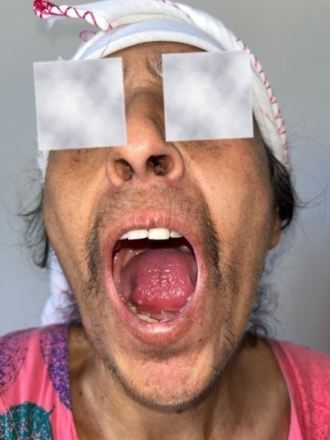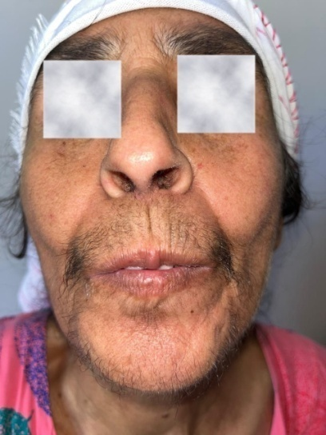Figure 1**:** cardboard skin with limitation of oral opening

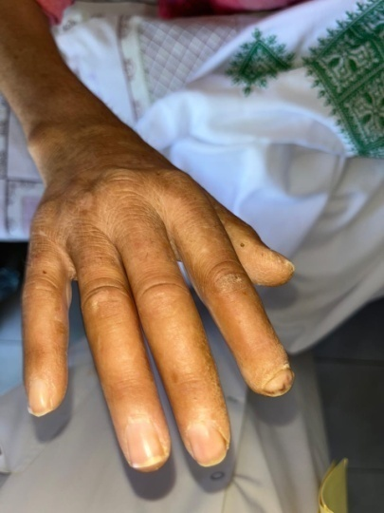

Figure 2: ulcerated lesions at the level of the pulps of both fingers hands

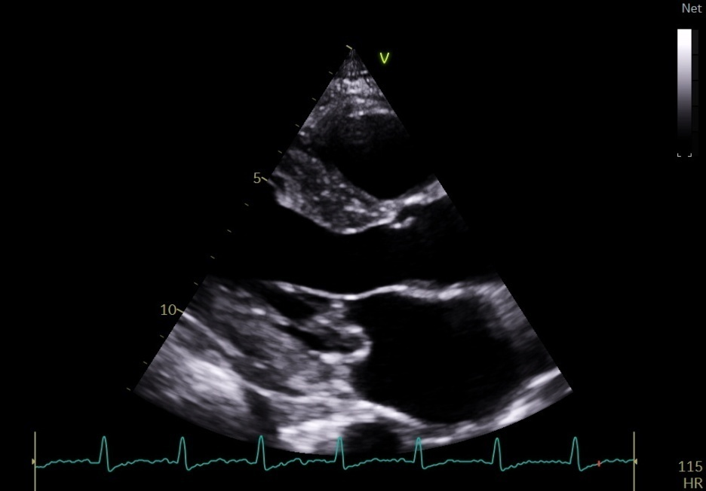  
Figure 3: suspicion of vegetation measuring 22 x 9mm located on the atrial side  
  
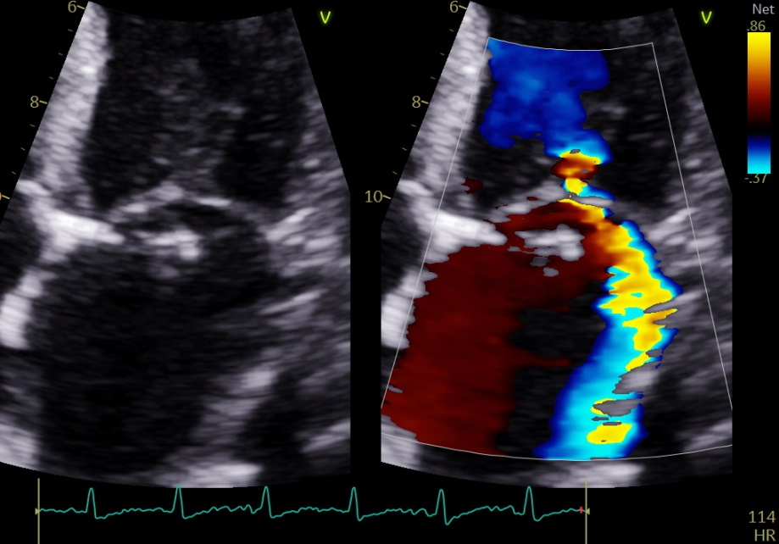

Figure 4: the suspected image (image on the left ) responsible for moderate to severe mitral insufficiency without stenosis (image on the right)

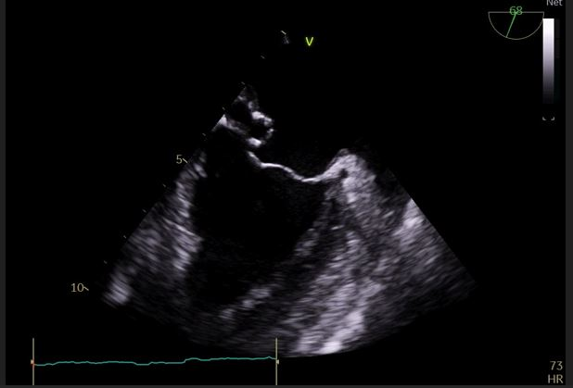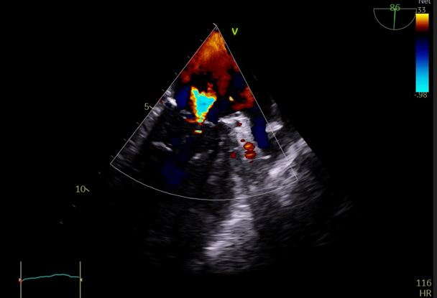  
Figure 5: Transesophageal echocardiography showing the mitral valve prolapsed (image on the left ) with a moderate mitral regurgitation ( image on the right ).

**DISCUSION:**

Cardiac involvement in SSc patients is often clinically occult. Demonstrated by echocardiography, electrocardiography (ECG), computed tomographic (CT), and magnetic resonance imaging, the existence of reversible functional and vasospastic abnormalities of the heart has been observed in SSc patients at an early stage (7) Mitral valve prolapse constitutes 20% of valvular diseases associated with SSc and has similar characteristics to those of patients without SSc. (8)

Our findings underscore the importance of comprehensive cardiovascular assessment in patients with suspected SSc, even when they are asymptomatic.

The mechanism of valvular diseases in SSc remains unknown. It has been reported that the underlying inflammatory burden, immune system activation, widespread microvascular and macrovascular damage, endothelial dysfunction, and fibroblast activity might play important roles in accelerating the progression in SSc (9) To date, echocardiography allows measurement of valvular dimensions and diagnosis of valvular involvement in SSc, while cardiac CT and CMR can also be considered (10)

Clinically, this case demonstrates how MVP in SSc may mimic infective endocarditis, leading to misdiagnosis and potentially inappropriate management. The echocardiographic appearance of leaflet thickening and prolapse, in conjunction with systemic inflammation and recent infection, can cloud clinical judgment—highlighting the need for careful differential diagnosis using advanced imaging like TEE.

In our case the diagnosis of mitral prolapse was only established after having performed the transesophageal echocardiography and the diagnosis of endocarditis was wrongly taken in the face of the suspicion of vegetation image on the transthoracic echocardiography and also added the infectious context which had made our reasoning lean towards infective endocarditis.

This case adds to the growing body of evidence suggesting that valvular abnormalities may be underrecognized manifestations of SSc, particularly in older patients with other comorbidities. Moreover, the co-occurrence of severe dermatological features and capillaroscopic abnormalities emphasizes the systemic nature of the disease and the value of a multidisciplinary approach.

This report also highlights important gaps in current knowledge. There is limited understanding of the exact pathophysiological mechanisms linking SSc to specific valvular lesions. Whether the observed mitral prolapse was directly caused by fibrotic involvement of the mitral apparatus, or was incidental and unrelated to SSc, remains uncertain. Larger prospective studies with advanced imaging and histopathological correlation are needed to delineate the true prevalence and clinical impact of valvular disease in SSc.

Limitations of this report include the inability to definitively rule out past silent endocarditis without histological confirmation, and the lack of longitudinal follow-up to evaluate the progression of valvular lesions over time. However, the integration of immunological markers, capillaroscopy, and multimodal cardiac imaging strengthens the diagnostic framework and adds clinical value to the case.

In summary, this case reinforces the necessity for high clinical suspicion and thorough cardiac evaluation in systemic sclerosis, even in the absence of cardiac symptoms. It also encourages the inclusion of MVP in the spectrum of cardiovascular manifestations of SSc, and advocates for greater awareness of autoimmune mimics of infective endocarditis.

**CONCLUSION:**

Systemic sclerosis (SSc) is a complex multisystem disease that demands comprehensive and careful management. Early recognition and treatment of cardiac complications are essential in slowing the progression of myocardial fibrosis, ischemia, and immuno-inflammatory injury—key contributors to mitral valve prolapse and other cardiac dysfunctions. These interventions can significantly enhance the quality of life and long-term outcomes for patients with SSc.  
Importantly, this case highlights the critical intersection between autoimmune disorders and cardiovascular health. It reinforces the need for heightened clinical vigilance and multidisciplinary collaboration in the early detection and management of cardiac involvement in SSc. These findings contribute to the broader field of cardiovascular research and autoimmune disease care by underscoring the value of proactive, targeted approaches to prevent irreversible organ damage.

**Consent**

As per international standard or university standard, patient(s) written consent has been collected and preserved by the author(s).

**abbreviations:**

SSc : systemic sclerosis

MRI: magnetic resonance imaging

MRSA: staphylococcus aeurusMeti R septicemia

LVEF: left ventricule ejection fraction

CT : computed tomographic

PFO: Patent Foramen Ovale

**Disclaimer (Artificial intelligence)**

Option 1:

Author(s) hereby declare that NO generative AI technologies such as Large Language Models (ChatGPT, COPILOT, etc.) and text-to-image generators have been used during the writing or editing of this manuscript.

Option 2:

Author(s) hereby declare that generative AI technologies such as Large Language Models, etc. have been used during the writing or editing of manuscripts. This explanation will include the name, version, model, and source of the generative AI technology and as well as all input prompts provided to the generative AI technology

Details of the AI usage are given below:

1.

2.

3.

**References:**

1 - Peltonen J, Kahari L, Uitto J, Jimenez SA. Increased expression of type VIcollagen genes in systemic sclerosis. Arthritis Rheum 1990; 33:1829–1835

2 - Champion HC. The heart in scleroderma. Rheum Dis Clin North Am2008;34:181–190. doi: 10.1016/j.rdc.2007.12.002

3 - Coghlan JG, Wolf M, Distler O, Denton CP, DoelbergM,Harutyunova S, et al. Incidence of pulmonary hypertension anddetermining factors in patients with systemic sclerosis. Eur Respir J2018;51:1701197. doi: 10.1183/13993003.01197-2017.

4 - Wranicz J, Zielinska M, Cygankiewicz I, Dziankowska-Bartkowiak B, SysaJedrzejowska A. Early cardiovascular involvement in patients with systemicsclerosis (SSc). Med Sci Monit 2002; 8:CR78–CR88.

5- Marasini B, Massarotti M, Cossutta R. Scleroderma heart disease. Int JImmunopatholPharmacol2005; 18:609–614.

6 - Bernelli C, Chieffo A, Giustino G, Montorfano M, Latib A, PanoulasVF, et al. Preliminary outcomes after transcatheter aortic valveimplantation in patients with systemic sclerosis.EuroIntervention2015;10:1464–1467. doi: 10.4244/eijv10i12a255.

7- Allanore Y, Meune C. Primary myocardial involvement in systemicsclerosis: evidence for a microvascular origin. Clin Exp Rheumatol2010;28:S48–S53.

8- Nie, L.-Y., Wang, X.-D., Zhang, T., & Xue, J. (2019). Cardiac complications in systemic sclerosis. Chinese Medical Journal, 1. doi:10.1097/cm9.0000000000000535

9- Bissell LA, Anderson M, Burgess M, Chakravarty K, Coghlan G,Dumitru RB, et al. Consensus best practice pathway of the UKSystemic Sclerosis Study group: management of cardiac disease insystemic sclerosis. Rheumatology (Oxford) 2017;56:912–921. doi:10.1093/rheumatology/kew488.

10- . Lambova S. Cardiac manifestations in systemic sclerosis. World JCardiol2014;6:993–1005. doi: 10.4330/wjc.v6.i9.993.