***Case report***

NSTEMI and Coronary Amyloid Infiltration: Challenges and Therapeutic Strategies – CHU Ibn Rochd, Casablanca

# Abstract

Acute coronary syndromes (ACS) are major cardiovascular emergencies requiring prompt and appropriate management to reduce complications and improve prognosis. We report an unusual case of high-risk non-ST-segment elevation myocardial infarction (NSTEMI) in a 63-year-old patient with hypertrophic cardiomyopathy (HCM) and coronary amyloid infiltration. Cardiac investigations revealed severe triple-vessel coronary artery disease with myocardial necrosis sequelae, leading to the recommendation for coronary artery bypass grafting (CABG). This rare association complicates management due to structural alterations from amyloid infiltration, increasing ischemic and arrhythmic risks. This case highlights the importance of a multidisciplinary approach and rigorous follow-up to adapt therapeutic strategies to complex clinical presentations.

# 1. Introduction

Acute coronary syndromes (ACS) are primarily the result of atherosclerotic plaque rupture, platelet activation, and intracoronary thrombosis, causing myocardial ischemia. However, atypical forms, especially those associated with infiltrative diseases like amyloidosis, present a diagnostic and therapeutic challenge. Cardiac amyloidosis is a rare infiltrative disease characterized by extracellular deposition of amyloid fibrils, which can lead to restrictive myocardial dysfunction and involvement of small coronary vessels. The association of hypertrophic cardiomyopathy (HCM) with amyloid coronary infiltration further complicates the clinical presentation, altering the ACS manifestation and influencing therapeutic decisions. We report here the case of a patient hospitalized for high-risk NSTEMI in whom cardiological exploration revealed severe coronary artery disease with amyloid infiltration, justifying the indication for coronary artery bypass grafting in a context of chronic atrial fibrillation and moderate heart failure.

# 2. Case Presentation

A 63-year-old male with a medical history of chronic atrial fibrillation on anticoagulants, moderate heart failure, type 2 diabetes, active smoking, and hypertrophic cardiomyopathy (HCM) was admitted for high-risk non-ST-segment elevation myocardial infarction (NSTEMI). On admission, he presented with angina and exertional dyspnea. His blood pressure was 130/77 mmHg and heart rate was 85 bpm, with no signs of acute decompensated heart failure. Electrocardiogram (ECG) showed atrial fibrillation with a ventricular rate of 85 bpm and repolarization abnormalities in the inferior territory. Transthoracic echocardiography revealed significant concentric left ventricular hypertrophy with preserved ejection fraction (LVEF at 55%). A global longitudinal strain suggestive of amyloidosis, showing a characteristic “apical sparing” pattern.

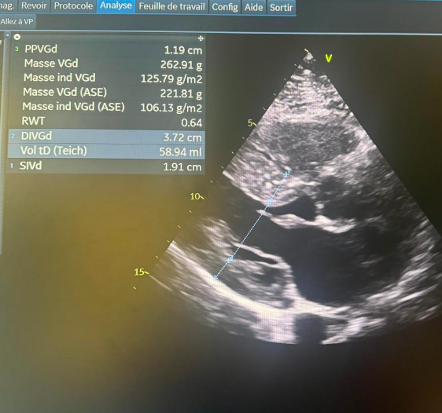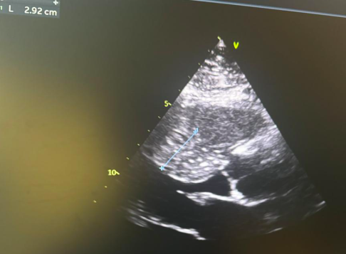

Figure 1: Significant concentric LVH, predominant at the septal level.

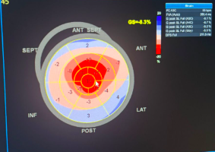

Figure 2 : Apical Sparing” Pattern on Longitudinal Strain Imaging Suggestive of Cardiac Amyloidosis

**Coronary angiography** revealed severe triple-vessel disease, with a mid-LAD (left anterior descending artery) occlusion involving an aneurysmal segment, a long and tight stenosis of the circumflex artery, and a chronic total occlusion of the right coronary artery with collateral network compensation. **Cardiac magnetic resonance imaging (MRI)** showed myocardial necrosis sequelae at the apex of the left ventricle (segment 17) and diffuse subendocardial late gadolinium enhancement, strongly suggestive of amyloid infiltration.

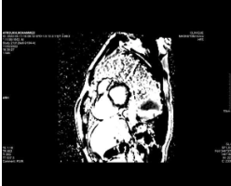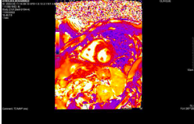

Figure 3 : Cardiac MRI findings in suspected cardiac amyloidosis(T2 Mapping showing myocardial edema and PSIR sequence demonstrating diffuse subendocardial gadolinium enhancement

**Laboratory tests** revealed:

* Serum sodium: 134 mmol/L
* Elevated troponin
* Serum potassium: 4.8 mmol/L
* Serum creatinine: 8.8 mg/L
* Estimated glomerular filtration rate (eGFR): 93 mL/min/1.73 m²
* C-reactive protein (CRP): 4 mg/L
* Hemoglobin: 12.6 g/dL

Serologic tests for HBV, HCV, HIV, and syphilis (TPHA/VDRL) were all negative.

**Management** included dual antiplatelet therapy (Plavix), beta-blockers (Cardensiel), calcium channel blockers (Vascor), and oral anticoagulation (Sintrom) with regular INR monitoring. Due to the complexity of the coronary lesions and the underlying infiltrative pathology, a multidisciplinary team decided on surgical coronary artery bypass grafting (CABG).

# 3. Discussion

The association between hypertrophic cardiomyopathy and acute coronary syndrome (ACS) is relatively rare, and its management becomes more complex when combined with amyloid infiltration of the coronary arteries. Cardiac amyloidosis, characterized by extracellular deposition of amyloid fibrils in the myocardium and coronary vessels, may provoke myocardial ischemia through microvascular impairment and increased myocardial stiffness. In this case, multimodal imaging demonstrated both major obstructive coronary lesions and diffuse amyloid infiltration, explaining the progression toward heart failure and chronic atrial fibrillation.

The presence of a chronic total occlusion of the right coronary artery, compensated by collateral circulation, reflects a silent evolution of the coronary pathology exacerbated by the amyloid context. Coronary artery bypass grafting was selected over angioplasty due to the inefficacy of stenting in infiltrated vessels, where structural distortion compromises long-term outcomes. Additionally, treatment planning had to consider elevated thromboembolic and hemorrhagic risks due to chronic atrial fibrillation and anticoagulation therapy. The prognosis remains guarded, with a heightened risk of progressing to advanced heart failure and ventricular arrhythmias. This case underscores the value of comprehensive imaging and multidisciplinary collaboration involving cardiologists, cardiac surgeons, and specialists in infiltrative diseases to tailor management strategies.

**The following three graphs illustrate:**

* **Evolution of left ventricular ejection fraction (LVEF) before and after management:** This curve shows a progressive decline in LVEF without intervention and stabilization following revascularization.
* **Incidence of post-ACS complications in patients receiving medical therapy alone versus revascularization:** It highlights an increased risk of complications in patients not undergoing revascularization compared to those receiving invasive treatment.
* **Survival curve based on management strategy:** This graph demonstrates improved long-term survival in patients who underwent revascularization.

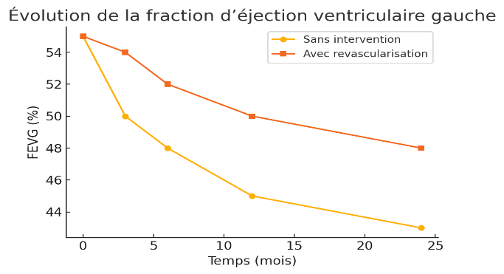

Figure 4: Evolution of Left Ventricular Ejection Fraction (LVEF) Before and After Management

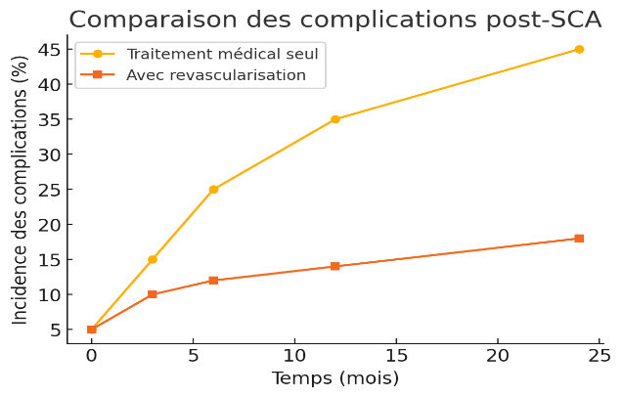

Figure 5 : Incidence of Post-ACS Complications – Medical Therapy vs. Revascularization

# C:\Users\hp\Downloads\output (7).png

Figure 6: Survival Curve Based on Treatment Strategy

# 4. Conclusion

This case underlines the diagnostic and therapeutic challenges encountered in acute coronary syndromes associated with cardiac amyloidosis.

The involvement of small coronary vessels and myocardial stiffening alters the classical ACS presentation and complicates diagnosis. Multimodal imaging plays a pivotal role in identifying both obstructive coronary lesions and infiltrative myocardial disease.

In such complex settings, surgical revascularization is often preferred over percutaneous techniques, given the limitations of stenting in amyloid-infiltrated vessels.

A multidisciplinary, personalized approach is essential to optimize management and improve long-term prognosis in this patient population.

Disclaimer (Artificial intelligence)

Option 1:

Author(s) hereby declare that NO generative AI technologies such as Large Language Models (ChatGPT, COPILOT, etc.) and text-to-image generators have been used during the writing or editing of this manuscript.

Option 2:

Author(s) hereby declare that generative AI technologies such as Large Language Models, etc. have been used during the writing or editing of manuscripts. This explanation will include the name, version, model, and source of the generative AI technology and as well as all input prompts provided to the generative AI technology

Details of the AI usage are given below:

1.

2.

3.

# 5. References

1. FERREIRA, Justine, RAY, Aurélie Avondo, IDOUZAL, Naïma, *et al.* Acute coronary syndrome in the elderly emergency department: diagnosis and management. *Soins. Gerontologie*, 2021, vol. 26, no 151, p. 19-23.
2. NGUYEN, Huan T. et NGUYEN, Chuyen TH. Cardiac amyloidosis mimicking acute coronary syndrome: a case report and literature review. *European Heart Journal-Case Reports*, 2020, vol. 4, no 6, p. 1-7.
3. STAMATELOPOULOS, Kimon, MUELLER-HENNESSEN, Matthias, GEORGIOPOULOS, Georgios, *et al.* Amyloid-β (1-40) and mortality in patients with non–ST-segment elevation acute coronary syndrome: a cohort study. *Annals of internal medicine*, 2018, vol. 168, no 12, p. 855-865.
4. GEORGE, Anish et MCCLEMENTS, Brian. Cardiac amyloidosis presenting as recurrent acute coronary syndrome with unobstructed coronary arteries: Case report. *Indian Heart Journal*, 2015, vol. 67, no 6, p. 570-573.
5. TEW, Yong Yong et SCOTT, Anne. Cardiac amyloidosis masquerading as acute coronary syndrome. *BMJ Case Reports CP*, 2021, vol. 14, no 2, p. e238499.
6. NGUYEN, Huan T. et NGUYEN, Chuyen TH. Cardiac amyloidosis mimicking acute coronary syndrome: a case report and literature review. *European Heart Journal-Case Reports*, 2020, vol. 4, no 6, p. 1-7.
7. JAISWAL, Vikash, AGRAWAL, Vibhor, KHULBE, Yashita, *et al.* Cardiac amyloidosis and aortic stenosis: a state-of-the-art review. *European Heart Journal Open*, 2023, vol. 3, no 6, p. oead106.
8. STAMATELOPOULOS, Kimon, MUELLER-HENNESSEN, Matthias, GEORGIOPOULOS, Georgios, *et al.* Amyloid-β (1-40) and mortality in patients with non–ST-segment elevation acute coronary syndrome: a cohort study. *Annals of internal medicine*, 2018, vol. 168, no 12, p. 855-865.
9. GAUTHIER, V., LAFRANCE, M., BARTHOULOT, M., *et al.* Long-term follow-up of incident acute coronary syndrome: results from the French MONICA registries over the 2009-2017 period. *European Journal of Preventive Cardiology*, 2022, vol. 29, no Supplement_1, p. zwac056. 316.
10. YACOB, O., BEYENE, S., MELAKU, G., *et al.* Patterns of coronary vascular involvement in patients with heart failure due to cardiac amyloidosis. *European Heart Journal*, 2020, vol. 41, no Supplement_2, p. ehaa946. 2455.
11. FRATICELLI, Laurie, KLEITZ, Olivier, CLAUSTRE, Clément, *et al.* Comparison of the pathways of care and life courses between first-time ST-elevation myocardial infarction (STEMI) and STEMI with prior MI: findings from the OSCAR registry. *BMJ open*, 2020, vol. 10, no 11, p. e038773.