**Duchenne Muscular Dystrophy: An Atypical Adult Presentation and Comprehensive Literature Review with Management Recommendations**

**Abstract**

**Background:** Duchenne Muscular Dystrophy (DMD), a severe X-linked recessive disorder caused by mutations in the *DMD* gene and subsequent dystrophin deficiency, leads to progressive muscle degeneration, loss of ambulation, and life-limiting cardiorespiratory failure. While classically presented in early childhood, significant advancements in multidisciplinary care have dramatically extended survival, transforming DMD into a chronic condition requiring lifelong management, including transition to adult care. Concurrently, the therapeutic landscape is evolving with the advent of mutation-targeted molecular therapies alongside established supportive care standards.

**Aim and Objectives:** This paper integrates the presentation of a rare case of DMD diagnosed in a 34-year-old male in Peshawar, Pakistan, with a comprehensive literature review. The objective is to synthesize current evidence-based knowledge regarding the etiology, diagnosis, prognostic factors, and multidisciplinary management of DMD across its full clinical spectrum. The review provides a framework for recognizing typical and atypical presentations, anticipating complications, implementing guideline-based care strategies, navigating transition issues, and understanding the potential and limitations of emerging therapies, with consideration for global perspectives and resource variability thereby highlighting current challenges and areas requiring further investigation.

**Methodology:** A case report methodology was employed, utilizing clinical records and diagnostic findings from the presented patient. This was combined with a comprehensive literature review synthesizing information from searches of biomedical databases (PubMed, Cochrane Library), key systematic reviews and meta-analyses, international care guidelines, patient registry data, and relevant primary research, focusing on evidence pertinent to the review's objectives.

**Synthesis & Conclusion:** DMD manifests a spectrum of severity influenced by genetic factors and potentially modulated by environmental and socioeconomic variables. Accurate diagnosis via genetic testing is paramount for appropriate management and therapy eligibility. While standardized multidisciplinary care has significantly improved outcomes, transforming DMD care necessitates addressing long-term adult needs and transition planning. Novel molecular therapies offer promise but face substantial challenges related to delivery, immunogenicity, safety, cost, and equitable global access. Optimizing outcomes requires integrating established comprehensive care standards with appropriate application of new diagnostic and therapeutic advances, tailored to individual patient needs across diverse global contexts. This review provides a synthesized overview to support clinicians in navigating the complexities of DMD diagnosis and lifelong management.

Keywords: Duchenne Muscular Dystrophy (DMD), Muscle degeneration, Loss of ambulation, Immunogenicity

**Introduction:**

Duchenne muscular dystrophy (DMD) stands as the most common inherited muscle disorder of childhood, an X-linked recessive condition stemming from mutations in the exceptionally large DMD gene located at chromosome Xp21.1 (1). These mutations preclude the synthesis of functional dystrophin, a 427-kDa cytoskeletal protein essential for myofiber stability and signaling (1). Dystrophin anchors the intracellular actin cytoskeleton to the sarcolemma and the extracellular matrix through the dystrophin-glycoprotein complex (DGC), a multi-protein assembly crucial for force transduction, membrane integrity, and potentially cell signaling (Figure 4) (1). Its absence leads to sarcolemmal instability, chronic muscle damage, inflammation, and progressive replacement of muscle by fibrotic and adipose tissue (Figure 1, Figure 2) (1). Affecting approximately 1 in 3,500 to 6,000 newborn boys worldwide(1, 2), DMD typically presents clinically before age five. Early signs include delayed motor milestones, difficulty running or climbing stairs, frequent falls, a characteristic waddling gait, and often pseudohypertrophy of the calves(1, 2). The Gowers' sign is a pathognomonic indicator of the proximal weakness (1). Key clinical features are summarized in Table 1. While primarily affecting males, female carriers can sometimes be symptomatic or develop cardiomyopathy (1, 3). The natural history involves relentless progression. Loss of independent ambulation (LOA) typically occurs between ages 8 and 12, although standardized care can significantly delay this milestone (Figure 7, Figure 8, Table 6) (1, 4). Predictors of earlier LOA include earlier symptom onset, lower baseline functional scores, specific genotypes, and potentially socioeconomic factors or ethnicity. Historically, survival was limited, but transformative advances in multidisciplinary care have dramatically increased life expectancy into the 30s and beyond, shifting DMD into the realm of chronic adult conditions requiring planned transitions of care. Despite progress, optimizing treatments to further delay cardiac involvement remains a key target to improve outcomes. Mortality often results from respiratory or cardiac failure(2, 4). DMD also commonly involves neurodevelopmental issues (2), and recent studies highlight unmet needs in psychosocial care.

**Table 1. Key Clinical Features of Duchenne Muscular Dystrophy(2)**

|  |
| --- |
| Predominantly proximal muscle weakness |
| Symmetrically involved muscles |
| Progressively increasing weakness |
| Exercise intolerance/Fatigue |
| Characteristic style of standing from sitting posture (Gower’s sign) |
| Occurrence with no prior family history (~1/3 cases due to *de novo* mutations) |
| Calf muscle hypertrophy (pseudohypertrophy) |
| Dystrophic facies (develops over time; less prominent early sign) |
| Contractures (e.g., Achilles tendon, hip flexors; develop over time) |
| Decreased muscle power |
| Muscle hypotonia (can be present early) |
| No sensory loss (sensation typically normal) |

Additional significant complications include progressive scoliosis, osteoporosis, dysphagia, and gastrointestinal dysmotility(2, 5). Lifelong, coordinated multidisciplinary management is essential(2, 5). Key interventions include physiotherapy, orthopedic management, glucocorticoid therapy, proactive cardiorespiratory care, nutritional support, and integrated psychosocial assistance(2, 5, 6). Non-pharmacological interventions like specific exercise regimens are also important adjuncts. Novel therapies targeting the genetic defect or downstream pathways are emerging, making precise genetic diagnosis critical (2, 7). Understanding the multifaceted burden of DMD globally, and its specific implications in diverse settings like Pakistan, is crucial for effective healthcare planning and patient support.

This literature review aims to synthesize the global understanding of DMD, covering its pathophysiology, epidemiology, diagnosis, prognostic factors, and evolving management strategies, while incorporating perspectives relevant to the burden in Pakistan, addressing:

1. Global and Pakistan-specific epidemiology, including influencing factors.
2. Quality of life considerations for patients and caregivers.
3. Current management strategies, including non-pharmacological approaches and transition planning, adherence factors, prognostic indicators, and recommendations.
4. The economic impact of DMD.

**Case Presentation**

A 34-year-old male presented to a hospital in Peshawar, Pakistan, reporting a multi-year history of gradually worsening muscle weakness. He noted increasing difficulty climbing stairs, rising from a seated position (requiring use of his hands on his legs – a positive Gower's sign), and experiencing frequent, unexplained falls. There was no significant family history of neuromuscular disorders. General physical and systemic examination revealed a well-nourished individual in no acute distress with normal cardiovascular, respiratory, and genitourinary systems, intact cranial nerves, and an unremarkable central nervous system. Locomotor examination had the following findings:

On locomotor examination, muscle tone was normal, and muscle power testing revealed normal strength (5/5) in bilateral proximal and distal upper limbs, significant symmetrical proximal weakness (3/5) in bilateral lower limbs particularly in pelvic and shoulder girdle muscles, reduced but stronger distal strength (4/5) bilaterally, and mild calf pseudohypertrophy; reflexes were present bilaterally at the knees, ankles, biceps, triceps, and brachioradialis, with downgoing plantar responses bilaterally.

Initial investigations revealed markedly elevated serum Creatine Kinase (CK) levels, consistently between 1500-2000 U/L (normal range typically < 200 U/L), indicating substantial ongoing muscle damage. Other laboratory results showed elevated serum aldolase (220 U/L) and lactate dehydrogenase (LDH) (860 U/L) levels in the presence of a normal C-reactive protein, elevated serum creatinine 1.8 mg/dL, elevated AST (350 U/L). Urinalysis revealed red-colored urine with a mild (1+) positive result for myoglobin, suggesting the presence of myoglobinuria. Electromyography (EMG) showed short-duration, low-amplitude polyphasic motor unit potentials, characteristic of a myopathic process. Magnetic Resonance Imaging (MRI) of the lower limbs demonstrated extensive fatty infiltration and replacement of muscle tissue, particularly evident in the calf muscles (**Figure 2**). A muscle biopsy was performed, and histopathology (**Figure 1**) revealed classic dystrophic features: marked variation in muscle fiber size, numerous centrally located nuclei, endomysial fibrosis, scattered necrotic and regenerating fibers, and significant adipose infiltration. Immunohistochemical staining confirmed the diagnosis of Duchenne Muscular Dystrophy, revealing **absent** dystrophin staining at the sarcolemma, despite the unusually late age of presentation and diagnosis. Recommended Genetic testing was not pursued owing to patient financial constraints.

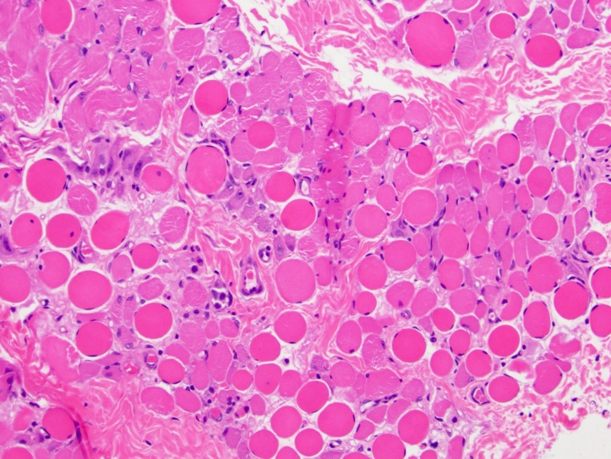

**Figure 1:** **Histological section of muscle biopsy.**

This figure presents a histological section of the muscle biopsy obtained in this case report. The analysis reveals key pathological features of dystrophinopathy, including rounded skeletal muscle fibers, significant variation in fiber diameter, increased central nucleation, evidence of myonecrosis, the presence of sterile inflammation, and developing perifascicular myofibrosis.

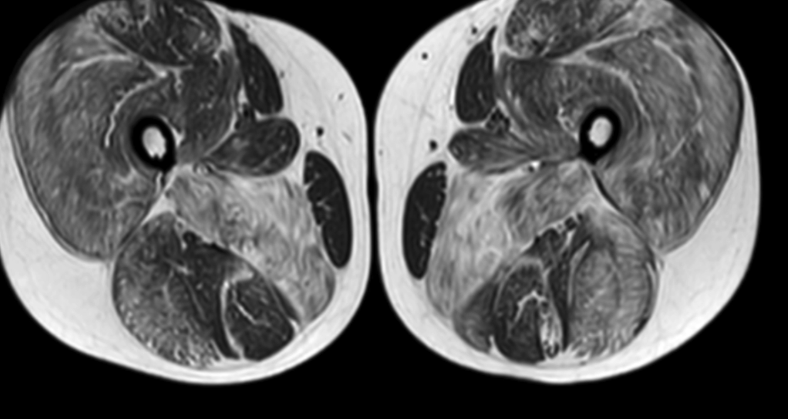

**Figure 2:** T 1 series of MRI showing fatty infiltration of calf muscles.

Following confirmation, the patient was referred for multidisciplinary management, including initiation of physiotherapy focusing on stretching and range of motion exercises, counseling regarding corticosteroid therapy options and potential benefits/risks at his age, and baseline cardiac and pulmonary function assessments with planned specialist surveillance.

**Literature Review: Global Perspectives on DMD with Pakistan Context**

**1. Etiology, Pathophysiology, and Genetics**

Duchenne Muscular Dystrophy (DMD) is an inherited X-linked recessive disorder caused by mutations in the DMD gene, located on chromosome Xp21(2). As the largest known human gene (spanning 2.4 Mb with 79 exons), it encodes the essential 427-kDa protein, dystrophin(1). Dystrophin is a crucial component of the Dystrophin-Glycoprotein Complex (DGC), a multi-protein assembly at the muscle cell membrane(1).The large 427-kDa dystrophin protein, encoded by the DMD gene, is comprised of several key functional regions critical for its role in muscle cells (Figure 3A). These include an N-terminal actin-binding domain (ABD1), a long central rod domain made of 24 spectrin-like repeats providing flexibility, a cysteine-rich domain containing the binding site for β-dystroglycan (part of the DGC), and a C-terminal domain that interacts with other complex proteins like syntrophins (1). DMD and BMD result from mutations, most often large deletions, within this gene (2). Figure 3B illustrates how such deletions can lead to various internally truncated, sometimes partially functional, dystrophin proteins (similar to those seen in milder Becker forms or used experimentally as mini/micro-dystrophin constructs). The specific domains lost or retained, along with the impact on the protein's reading frame, significantly determine the severity of the resulting muscular dystrophy(1, 2).

.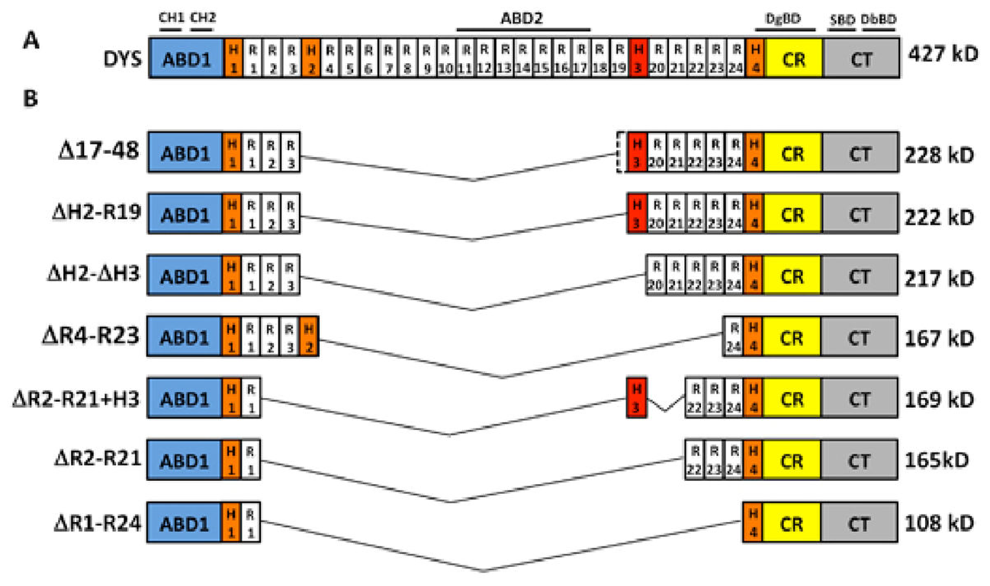

**Figure 3: Dystrophin functional domains and mini-/micro-dystrophin constructs(1).** (A) Dystrophin protein has four major functional domains. The N-terminal actin-binding domain (ABD1, shown in blue) contains two calponin-homology (CH) motifs. The central rod domain is composed of 24 spectrin-like repeats (R1-R24, shown in white) interrupted by the proline-rich hinges (H1–H4, shown in yellow). A second actin-binding domain (ABD2) spans R11–R17. The cysteine-rich domain (CR, shown in yellow) and part of H4 form the binding site for β-dystroglycan (DgBD). The C-terminus (CT, shown in grey) contains binding sites for syntrophins (SBD) and dystrobrevin (DbBD). (B) Domain structure of the internally-truncated dystrophin constructs discussed in the text. Note that exon 17–48 deletions (Δ17–48) retains a partial R19. The molecular weights are shown to the right of the constructs.

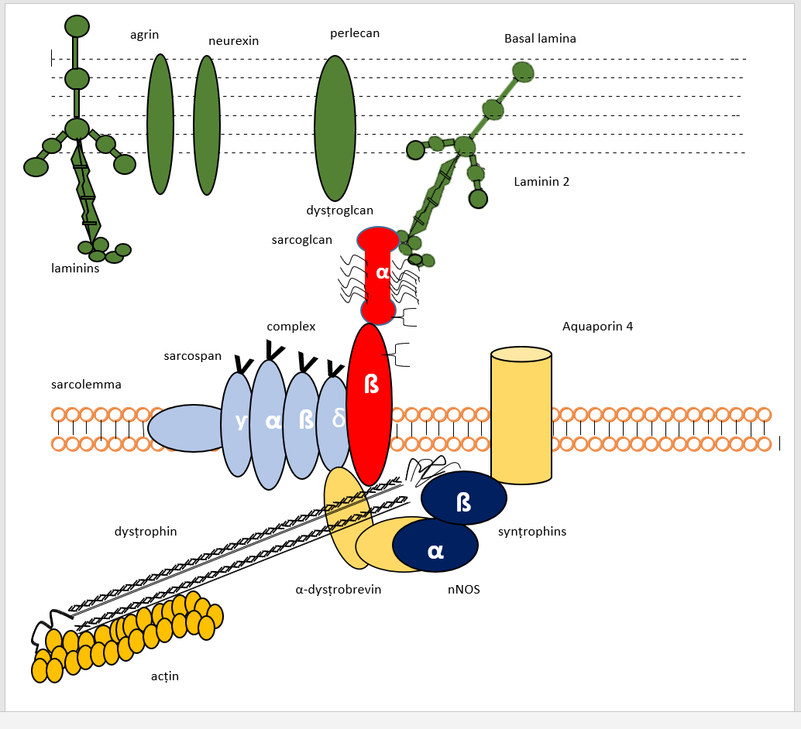

**Figure 4: Schematic representation of the dystrophin-glycoprotein complex (DGC) at the muscle cell membrane (sarcolemma), illustrating dystrophin's role in linking the intracellular** **actin cytoskeleton to the extracellular matrix(1, 8)**

The DGC physically links the internal actin cytoskeleton to transmembrane proteins (beta-dystroglycan, sarcoglycans, sarcospan) and subsequently to the extracellular matrix (via alpha-dystroglycan binding to laminin). This complex provides structural integrity, acting as a shock absorber during muscle contraction, and is also involved in organizing sarcolemmal signaling molecules(1, 8).

* **Pathophysiology:** In DMD, the absence or severe deficiency of functional dystrophin disrupts the DGC, compromising sarcolemmal stability and integrity. This leads to increased membrane fragility and susceptibility to micro-tears during muscle activity. The resulting cascade includes: excessive calcium influx triggering protease activation (calpains); mitochondrial dysfunction and oxidative stress; chronic inflammation; impaired muscle regeneration due to satellite cell exhaustion; and progressive replacement of contractile muscle tissue by fibrotic connective tissue (driven by pathways like TGF-beta) and fat. This pathology underlies the progressive muscle degeneration observed clinically and on investigations.(1)
* **Genetic Spectrum:** The range of *DMD* gene mutations causing DMD is vast and highly heterogeneous(9).
  + **Large Deletions:** These are the most frequent cause, accounting for **50-70%** of DMD mutations(9, 10). While various exons can be involved (e.g., examples like exons 3-19 and 42-60 mentioned), they often cluster in two main "hotspot" regions(11, 12). The major hotspot involves deletions spanning **exons 45-55** (representing up to 74% of deletions), removing a central part of the rod domain(11, 12). A second common hotspot involves deletions around **exons 3-19**, affecting the N-terminus(11, 12). Deletion breakpoints are widely distributed, but the most frequent starting points occur within **intron 44 (~20%), intron 47 (~10%), and intron 50 (~8%)(11)**.
  + **Small Mutations:** Accounting for **~20-25%** of cases(9), these include point mutations creating premature stop codons (**nonsense mutations**, ~40% of small mutations, often C>T transitions)(10, 13), small insertions or deletions causing **frameshift mutations** (~32%), (13, 14)and **splice site mutations** (~27%, usually affecting conserved AG/GT dinucleotides)(9, 13). Rare **missense mutations** make up ~1-2%(13).
  + **Large duplications**: Comprise ~7-15% of mutations(9, 10). Numerous distinct large duplications have been reported, showing great diversity(15). The most common single duplication involves exon 2(13). Many identified duplications appear to start within intron 1.
  + Other Rare Mutations: Include insertions, complex rearrangements, and deep intronic mutations causing aberrant splicing (pseudoexon inclusion)(10, 16).
  + **Inheritance:** Approximately two-thirds of mutations are inherited from a carrier mother, while about one-third arise as spontaneous de novo mutations in the affected individual (16, 17), reflecting the gene's large size and susceptibility to mutation(2, 9). Advanced genetic techniques like NGS are needed to fully characterize this spectrum (14-16).
* **Reading Frame Rule & Phenotype**: The "reading frame rule" generally correlates genotype with clinical severity (18, 19). Out-of-frame mutations (disrupting the triplet codon reading frame) typically lead to premature termination codons. The resulting mRNA transcript is often unstable and targeted for degradation by nonsense-mediated mRNA decay (NMD), or if translated, produces a severely truncated and non-functional protein that is rapidly degraded(18, 19). This results in little to no functional dystrophin (<5% of normal) and causes the severe DMD phenotype (19). In-frame mutations (preserving the reading frame) often allow the synthesis of an internally shortened but still partially functional dystrophin protein, leading to the milder Becker Muscular Dystrophy (BMD) phenotype(19).
* **Exceptions & Modifiers**: This rule holds true for approximately 85-92% of mutations(9, 19). Exceptions often involve mutations affecting functionally critical protein domains, regardless of frame (9). For example, deletions impacting the C-terminus and cysteine-rich domains (necessary for DGC binding and highly conserved evolutionarily) generally result in DMD, even if technically in-frame, emphasizing their functional importance (2, 9). Conversely, deletions in the more dispensable proximal rod domain may result in milder phenotypes (9, 13). Some reported exceptions include in-frame deletions starting at exon 3 (actin-binding domain) or in-frame duplications in the cysteine-rich domain causing severe phenotypes (20). A noteworthy finding was that phenotypic severity depends not just on the reading frame but crucially on the overall levels of functional dystrophin expression and which s pecific protein domains remain intact (21). The individual's genetic background, through modifier genes like SPP1 and LTBP4, also significantly influences disease progression and severity (13, 22).
* **Female Carriers:** While typically asymptomatic due to X-inactivation, some female carriers exhibit symptoms, ranging from myalgia and fatigue to significant muscle weakness or cardiomyopathy (9). The relationship between skewed X-inactivation and symptom manifestation is complex and not fully predictive; sufficient dystrophin levels in muscle tissue may be a key determinant (2, 9).
* **Tissue Involvement:** Dystrophin deficiency primarily affects skeletal muscle (causing progressive weakness) and cardiac muscle (leading to dilated cardiomyopathy, fibrosis, and arrhythmias)(2). Smooth muscle involvement can contribute to gastrointestinal issues. Critically, specific dystrophin isoforms (e.g., Dp140, Dp71) are normally expressed in the central nervous system(2, 23).Their absence or disruption in DMD is believed to underlie the increased prevalence of associated cognitive impairment (often mild, affecting verbal IQ more than performance IQ) and neurodevelopmental disorders such as ADHD, autism spectrum disorder, and learning disabilities(2, 23). This underscores DMD as a multi-system disorder with significant neurological implications beyond muscle pathology. Differences in skeletal versus cardiac muscle phenotypes might also arise from variations in mRNA processing or the functional importance of sp ecific dystrophin domains in each tissue.

**2. Epidemiology and Natural History**

Duchenne Muscular Dystrophy (DMD) is the most common inherited neuromuscular disorder present in childhood, occurring worldwide across diverse populations(24, 25). Most patients are diagnosed around 5 years of age, a time when their physical abilities diverge significantly from peers, muscle strength deteriorates, and characteristic signs become apparent(2).

* **Incidence and Prevalence:**
  + Global incidence is consistently estimated between 1 in 3,500 to 1 in 6,000 live male births(4, 26).
  + Prevalence (the number living with DMD at a given time) varies. Recent systematic reviews provide key pooled estimates for overall prevalence: approximately 7.1 cases per 100,000 males (95% CI: 5.0-10.1) and 2.8 cases per 100,000 in the general population (95% CI: 1.6-4.6)(26). Another review estimated DMD prevalence specifically at 4.8 cases per 100,000 people (95% CI: 3.6-6.3) (4). Some regional variations are noted, possibly higher in the Americas(26).
  + Birth prevalence is estimated considerably higher at approximately 19.8 cases per 100,000 live male births (95% CI: 16.6-23.6)(26). The difference likely reflects early mortality reducing the number counted in overall prevalence studies, especially in settings with limited access to advanced care(4, 26). Individual birth prevalence estimates from various studies contributing to this pooled figure are summarized in table 2.

**Table 2: Etimated Duchenne Muscular Dystrophy birth prevalence per 100,000 cases, along with 95% confidence interval(4, 26)**

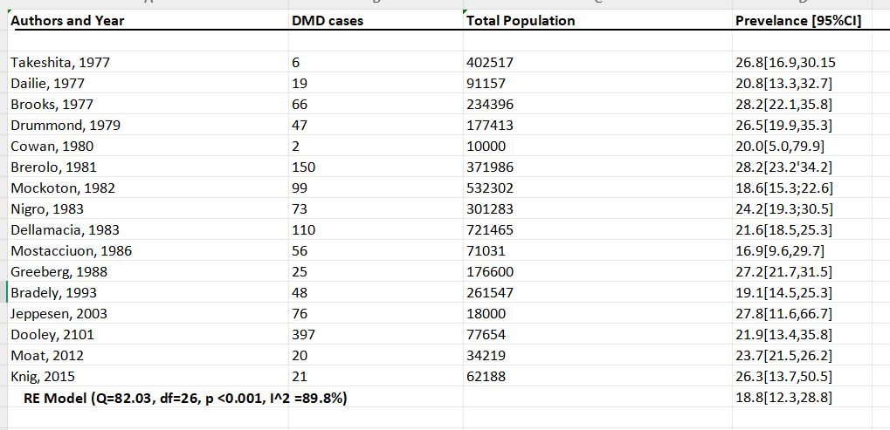

* + **Heterogeneity and Data Quality:**

Meta-analyses investigating the global prevalence of Duchenne Muscular Dystrophy (DMD) consistently report substantial heterogeneity among individual study estimates, as indicated by very high I² values (e.g., 98.5% for prevalence in males only and 87.4% for prevalence in males and females combined, p < 0.001 for both)(4, 26). Forest plot in Table 3 graphically illustrates the pooled estimates (diamond symbols) along with the prevalence estimates and confidence intervals from the individual studies, clearly depicting the significant inter-study variation for both males only and combined sexes(26). Further illustrating the meta-analysis results and the inter-study variation discussed, Table 4 presents summary tables from key publications providing prevalence data (for males only and combined sexes) alongside scatter plots visualizing aspects of this data(4, 26). Regarding birth prevalence estimates (Table 2), the meta-analysis indicated substantial heterogeneity between studies, with an I² statistic of 89.8% (p < 0.001) (Crisafulli et al., 2020). This significant variability is attributed to differences

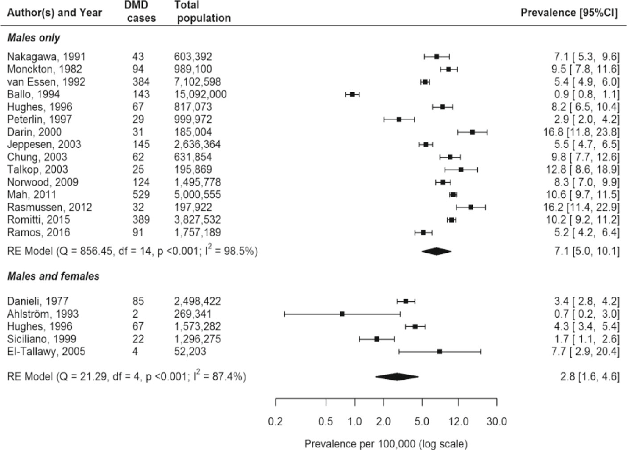across studies in their design, methods for case ascertainment (like clinical vs. genetic confirmation), data sources, time periods analyzed, and the quality of reporting(4, 26). Due to these heterogeneities, pooled figures must be interpreted cautiously(4, 26). Patient registries provide valuable demographic insights though potential participation biases should be considered.

**Table 3:** Forest Plot of DMD Prevalence Estimates(26).

It shows prevalence per 100,000 (log scale) with 95% confidence intervals for individual studies reporting on males only (top) and males and females combined (bottom), along with the overall pooled Random Effects (RE) Model estimates (diamonds)."

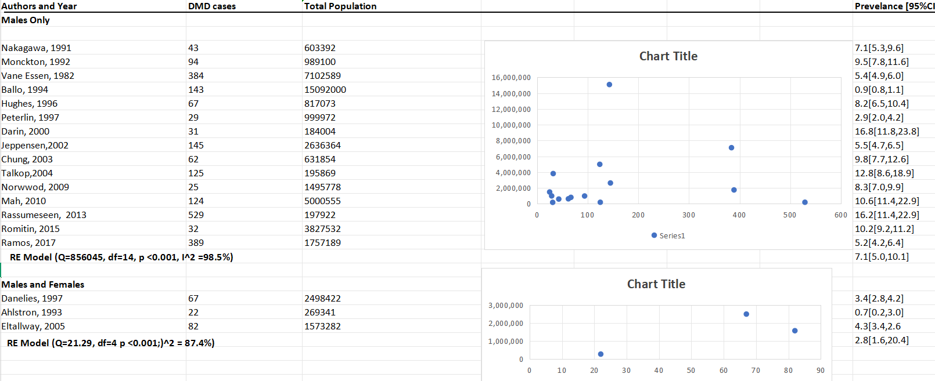

**Table 4:** **Prevalence Study Summary Plot/ Table (4, 26)**

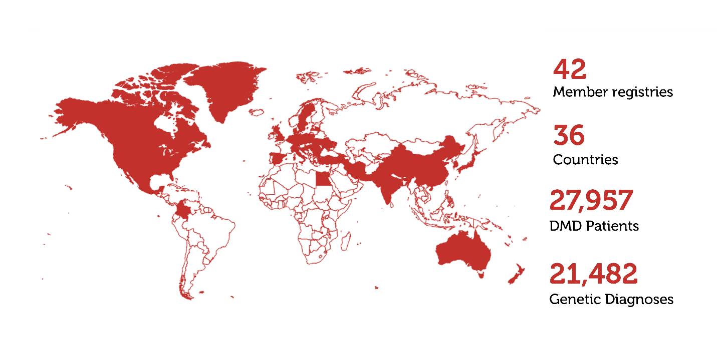

**Figure 5: Demographic View of the Registrants(27)**

**Table 5. Top 5 Countries in The Duchenne Registry**

|  |  |
| --- | --- |
| Top 5 Countries in The Duchenne Registry |  |
| United States | 3661 (67%) |
| India | 327 (6%) |
| Australia | 202 (4%) |
| Canada | 188 (3%) |
| United Kingdom | 141 (2%) |

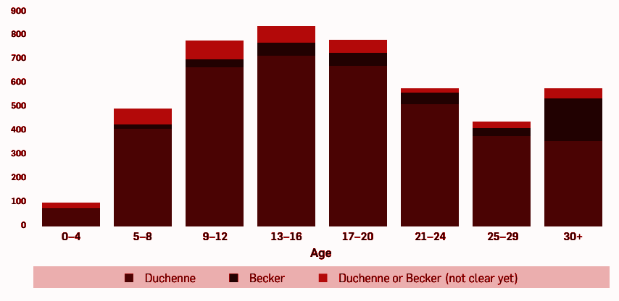

**Figure 6: Age Distribution of Duchenne Registry Participants by Diagnosis(28)**. Stacked bar chart showing the number of registrants within different age groups (x-axis), categorized by Duchenne, Becker, or unclear diagnosis. Note the predominance of Duchenne diagnoses in younger age groups (<21) and the relative increase in Becker diagnoses among older participants (21+).

* **Natural History and Progression:** Untreated DMD typically follows a predictable, though individually variable, course. After potentially subtle early motor delays, boys develop progressive proximal muscle weakness between ages 3-5, leading to difficulty running, jumping, climbing stairs, a characteristic waddling gait, and the Gowers' sign(1, 2). Muscle strength declines steadily, resulting in loss of independent ambulation (LOA), historically occurring around ages 8-12 years (1), necessitating wheelchair use before adolescence(1)(Figure 6).This rapid decline contrasts sharply with the much slower progression seen in Becker Muscular Dystrophy (BMD), where ambulation is often preserved for decades(1, 2)(Figure 7). Following LOA in DMD, weakness progresses to the upper limbs and trunk, and potentially life-limiting cardiorespiratory complications 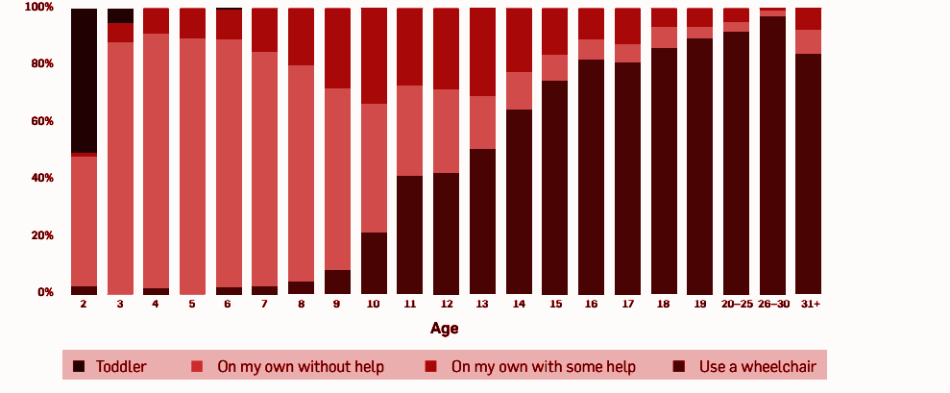emerge and worsen over time (1, 5).

**Figure 7: Current Ambulation of Duchenne Registrants (28)**

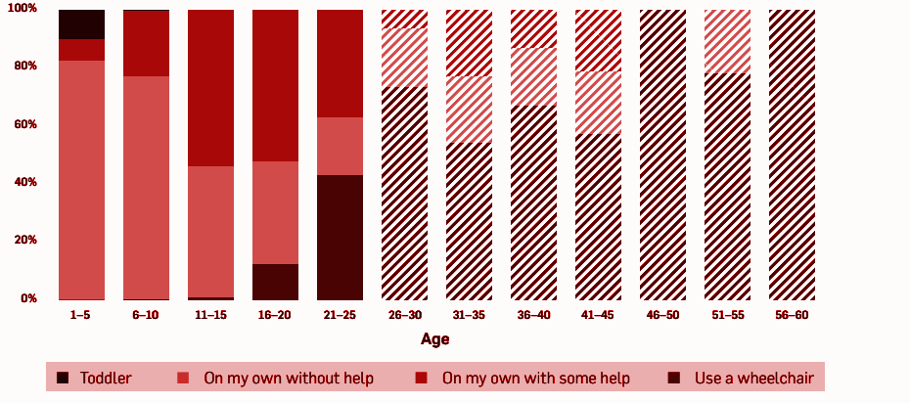

**Figure 8: Current Ambulation of Becker Registrants (28)**

**Predictors of Progression:** The rate of functional decline, especially the age at LOA, varies significantly. Key predictors identified include:

* **Glucocorticoid Therapy:** Consistent daily steroid use is the most significant factor known to delay LOA, typically by several years (pooled HR ~0.44)(29, 30) (Figure 10, Figure 11).
* **Baseline Motor Function:** Performance on tests like the 6-Minute Walk Test (6MWT) and North Star Ambulatory Assessment (NSAA) is highly predictive; lower scores/distances (e.g., 6MWT <330-350m) correlate with earlier LOA(29, 30).
* **Genotype:** Specific DMD mutations influence progression rates(29). Mutations amenable to skipping exons 8, 44, or 53, or large deletions like exons 3-7, tend to be associated with longer ambulation compared to distal mutations (intron 44 or downstream) or those amenable to exon 45 skipping(29).
* **Modifier Genes:** SNPs in genes like LTBP4 and SPP1 significantly modulate age at LOA, demonstrating the influence of genetic background(29).
* **Symptom Onset:** Earlier clinical onset generally predicts earlier LOA(29, 30).
* **Biomarkers:** Quantitative MRI assessing muscle fatty infiltration is emerging as a strong, non-invasive predictor of functional decline (29, 30)
* **Socioeconomic/Ethnic Factors:** Associations between lower SES, or specific ethnicities (e.g., South Asian in UK), and earlier LOA have been reported, possibly reflecting complex interactions involving care access, adherence, or genetics (31).

**Table 6: Key Predictors of Loss of Ambulation (LOA) in DMD(29, 30)**

|  |  |  |
| --- | --- | --- |
| Predictor Category | Factor Associated with Earlier LOA | Factor Associated with Later LOA / Prolonged Ambulation |
| Treatment | No glucocorticoid therapy | Consistent glucocorticoid therapy (Prednisone/Deflazacort) [HR ~0.44]; Longer duration (>1 yr post-LOA); Ataluren/Eteplirsen use (in some studies) |
| Baseline Function | Lower 6MWT distance (<330-350m); Lower NSAA score; Earlier onset of first signs/symptoms | Higher 6MWT distance (≥330-350m); Higher NSAA score |
| Genotype | Distal mutations (intron 44+); Deletions amenable to exon 45 skip; Deletion exons 49-50 | Proximal mutations (<intron 44); Deletion exons 3-7; Mutations amenable to exon 8, 44, or 53 skip |
| Modifier Genes (SNPs) | Specific variants in CD40, LTBP4, SPP1, TCTEX1D1 associated with LOA (specific alleles vary) | Specific variants in LTBP4, SPP1 associated with LOA (specific alleles vary) |
| Demographics/Other | Lower socioeconomic status / deprivation level; Specific race/ethnicity groups (e.g., South Asian in UK study | - |
| Biomarkers | Higher muscle fat fraction / specific patterns on MRI/MRS | Lower muscle fat fraction / specific patterns on MRI/MRS |

* **Survival and Mortality:** Comprehensive multidisciplinary care has dramatically improved survival(5, 6). Median life expectancy in patients receiving ventilatory support typically ranges from 21.0 to 39.6 years, compared to 14.4 to 27.0 years without it(32). A meta-analysis confirmed this trend, estimating median LE exceeding 28 years for those born after 1990 (32). Some reports suggest median survival improved to ~30 years, with 30% surviving beyond 30, linked particularly to nocturnal ventilation and spinal surgery(32). Key prognostic factors for survival are cardiac and pulmonary health(30, 33). Left ventricular dysfunction and severely reduced FVC (<1L) significantly increase mortality risk (30, 33), whereas ACE inhibitor use is associated with improved survival (33, 34). Cardiac or respiratory failure remain the primary causes of death (1, 32).
* **Pakistan Context:** While robust nationwide epidemiological data for Pakistan is lacking, clinical studies confirm the typical presentation of DMD features(figure 18)(35). 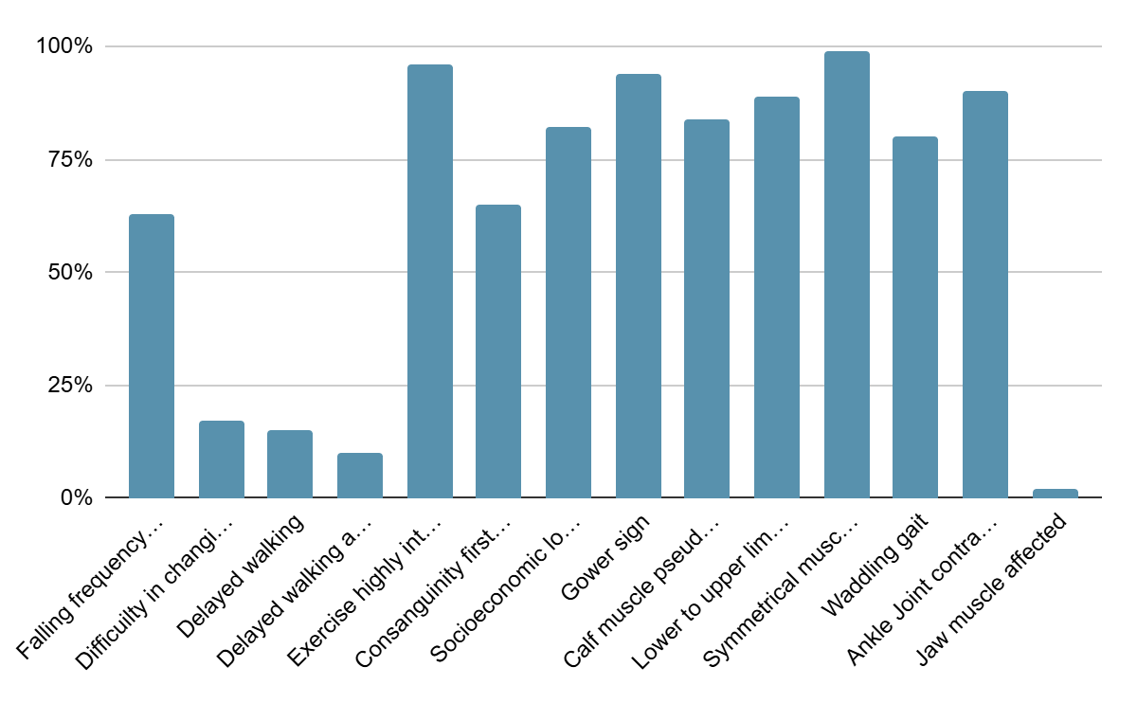

**Figure 9:** **Clinical Profile of Muscular Dystrophy Patients in a Pakistani Cohort (N=100)(35)**. Bar chart showing the percentage frequency of common signs (e.g., Gower sign, calf pseudohypertrophy), symptoms (e.g., falling frequency), developmental history, and associated factors (consanguinity, socioeconomic status) observed in 100 patients from Pakistan.

Genetic deletion patterns appear broadly comparable to other Asian populations(36). Global predictors (genotype, function, steroid use) are likely relevant (29, 30), but socioeconomic factors and ethnicity may be particularly important modifiers requiring local investigation to understand potential disparities(31). High consanguinity rates necessitate accessible genetic counseling services (35).

**3. Diagnosis and Investigations**

Prompt and accurate diagnosis of Duchenne Muscular Dystrophy (DMD) is paramount. It allows for the timely initiation of crucial multidisciplinary management strategies, facilitates appropriate genetic counseling for the family, and enables access to potential disease-modifying therapies, including participation in clinical trials. Despite increased awareness and improved diagnostic tools, significant diagnostic delays, often averaging 1-2 years from the initial parental concerns to confirmed diagnosis, regrettably persist globally. Minimizing this delay is a key goal in DMD care. The diagnostic process typically follows a stepwise algorithm based on clinical suspicion and confirmatory testing:

* **Diagnostic Algorithm:**

Prompt and accurate diagnosis of Duchenne Muscular Dystrophy (DMD) is paramount (Birnkrant et al., 2018). It allows for the timely initiation of crucial multidisciplinary management strategies, facilitates appropriate genetic counseling for the family, and enables access to potential disease-modifying therapies, including participation in clinical trials (Birnkrant et al., 2018). Despite increased awareness and improved diagnostic tools, significant diagnostic delays, often averaging 1-2 years from the initial parental concerns to confirmed diagnosis, regrettably persist globally (Birnkrant et al., 2018). Minimizing this delay is a key goal in DMD care (Birnkrant et al., 2018). The diagnostic process typically follows a stepwise algorithm based on clinical suspicion and confirmatory testing (Birnkrant et al., 2018):

**Diagnostic Algorithm:**

1. **Clinical Suspicion:** The process usually begins with recognizing characteristic signs and symptoms, particularly in young boys (2, 37). Key indicators include delayed motor milestones (especially walking), difficulty with activities like running, jumping, or climbing stairs, frequent falls, a notable waddling gait, and the presence of Gowers' sign (using hands to push off legs when rising from the floor)(2). Examination often reveals proximal muscle weakness (greater in legs than arms initially) and pseudohypertrophy (enlargement due to fibrofatty replacement, not muscle bulk) of the calf muscles (2). A summary of key features is found in Table 1. A family history of DMD/BMD may be present, but up to one-third of cases arise from de novo mutations with no prior family history(1).
2. **Serum Creatine Kinase (CK) Measurement:** If DMD is suspected clinically, the immediate next step is measuring serum CK levels (37). In DMD, CK levels are markedly elevated, typically exceeding 10 to 100 times (or even >200 times) the upper limit of normal, often reaching into the thousands or tens of thousands (U/L) (2). This extreme elevation is a sensitive hallmark of dystrophinopathy and is often present from birth or early infancy, significantly preceding the onset of obvious clinical weakness (2). Such high levels strongly suggest dystrophinopathy and warrant progression to genetic testing (2, 6).Mild to moderate CK elevation can be seen in other neuromuscular conditions, but the magnitude seen in DMD is distinctive(2).

**Genetic Testing (Definitive Diagnosis):** Molecular genetic testing of the DMD gene is the gold standard for confirming the diagnosis, determining the specific mutation type, differentiating DMD from the milder Becker Muscular Dystrophy (BMD based on the reading frame rule), and assessing eligibility for mutation-specific therapies(2, 37). The recommended approach is tiered:

1. **Deletion/Duplication Analysis:** Techniques like Multiplex Ligation-dependent Probe Amplification (MLPA) are typically performed first, as large deletions or duplications account for the majority (~70-80%) of DMD mutations(2, 37)
2. **Sequencing Analysis:** If deletion/duplication analysis is negative, sequencing of the entire DMD coding region and adjacent intronic regions (e.g., using Next Generation Sequencing - NGS) is performed(37, 38). This detects point mutations (nonsense, missense, splice site) and small insertions/deletions (indels) that account for the remaining ~20-30% of causative mutations (2). NGS offers comprehensive mutation identification (38). Understanding the specific mutation and its effect on the reading frame is crucial for prognosis and treatment planning (2, 37). Population studies show variations in the relative frequencies of specific deletion patterns.
3. **Long-Read Sequencing (LRS) for Complex Mutations:** While Next-Generation Sequencing (NGS) is effective for point mutations and small indels, advanced techniques like Long-Read Sequencing (LRS) are emerging as valuable tools for identifying complex structural variations in the DMD gene, such as large inversions, which may be missed by standard diagnostic methods like MLPA or even NGS (38).

**Muscle Biopsy:** Once the standard for diagnosis, muscle biopsy is now largely reserved for specific situations, such as when comprehensive genetic testing is negative or unavailable but clinical suspicion remains high (2, 37). If performed, the biopsy typically shows characteristic dystrophic features on histopathology: marked variation in muscle fiber size (including hypertrophic and atrophic fibers), fiber necrosis and regeneration (indicated by fibers with central nuclei), increased endomysial connective tissue (fibrosis), and fatty infiltration (figure 1)(1, 2). Importantly, immunohistochemical staining or Western blot analysis for the dystrophin protein can quantify its presence(2); in DMD, dystrophin is typically absent or severely reduced (<3-5% of normal levels), whereas in BMD it is usually present but often altered in size or reduced in amount(1, 2).

**Advances and Considerations:**

1. **Newborn Screening (NBS):** Driven by the potential benefit of initiating therapies earlier (including standard corticosteroids and emerging treatments), NBS for DMD is gaining significant interest(37). Pilot programs, such as a large-scale effort in New York State, have demonstrated the feasibility of using a two-tier approach: initial screening for elevated CK levels on standard dried blood spots, followed by confirmatory molecular genetic testing (often using comprehensive NGS panels) for those with positive screens (39). The goal is timely diagnosis before symptom onset, potentially improving long-term outcomes and reducing the "diagnostic odyssey" for families(37, 39). However, challenges remain regarding screening test sensitivity/specificity, cost-effectiveness, ensuring adequate follow-up diagnostic infrastructure and access to care, and addressing ethical considerations before widespread implementation(39).
2. **Biomarkers:** While CK is a sensitive marker of muscle damage, it doesn't correlate well with disease severity or progression, especially later on(2). Active research focuses on identifying and validating other blood, urine, or imaging biomarkers that could better reflect specific pathological processes (inflammation, fibrosis, muscle breakdown), track disease progression more accurately, predict treatment response, and potentially serve as surrogate endpoints in clinical trials(37). Candidates include specific microRNAs, muscle proteins (like myosin light chain), or markers of fibrosis/inflammation(1).
3. **Muscle Imaging:** Magnetic Resonance Imaging (MRI) has evolved beyond structural assessment. Quantitative MRI (qMRI) techniques, such as Dixon methods to calculate muscle Fat Fraction (FF), provide non-invasive measures of disease progression(40). Studies have shown that increasing muscle fat fraction, readily visualized on MRI(figure 2), strongly correlates with functional decline and predicts future loss of ambulation, making qMRI a valuable tool for monitoring disease status and potentially assessing therapeutic efficacy in clinical trials (40). Other MRI techniques (like T2 mapping) can provide insights into muscle inflammation or edema (40).

**Differential Diagnosis:** A thorough clinical evaluation, CK level, and particularly comprehensive genetic testing are essential to accurately differentiate DMD from these conditions(2, 37)

**Table 7: Differential Diagnosis of Duchenne Muscular Dystrophy(2)**

|  |  |
| --- | --- |
| **Becker muscular dystrophy** | Patients typically have higher concentrations of dystrophin protein. |
| **Congenital muscular dystrophy** | This consists of a group of inherited disorders associated with muscular dystrophy. The dystrophy is characterized by an increased severity at birth but has a benign nature throughout the life. There is a higher association with brain malformations. |
| [**Emery-Dreifuss Muscular Dystrophy**](https://emedicine.medscape.com/article/1178994-overview) | Muscle wasting disease characterized by early joint contractures, progressive muscle weakness, and cardiac problems. |
| **Limb girdle muscle dystrophy** | Primarily affects muscles of the hip and shoulder girdles |
| **Spinal muscle dystrophy** | Genetic condition causing muscle weakness and wasting due to the loss of motor neurons, which control muscle movement |
| **Myotonic Muscle dystrophy** | Causes progressive muscle weakness and wasting, often accompanied by difficulty relaxing muscles after contraction |
| **Oculopharyngeal Muscular dystrophy** | Genetic condition causing muscle weakness, primarily affecting the eyes and throat, leading to drooping eyelids (ptosis) and difficulty swallowing (dysphagia). |

**4. Management Strategies and Recommendations (Global Standard of Care)**

DMD management necessitates a proactive, lifelong, coordinated multidisciplinary approach, ideally delivered in specialized neuromuscular centers. International care considerations, significantly updated in 2018, provide a detailed, evidence-based framework aiming to anticipate complications, maintain function, optimize quality of life, and integrate new therapeutic advances(5, 6, 37). Key domains of management include:

* **Neuromuscular Management:**
  + **Glucocorticoids:** Represent the cornerstone pharmacological intervention to slow muscle degeneration (37). Daily regimens of Prednisone (0.75 mg/kg/day) or Deflazacort (0.9 mg/kg/day) are recommended, typically initiated around age 4-5 years or when motor skills plateau(37). Strong evidence substantiates that corticosteroid treatment significantly prolongs ambulation by 2 to 5 years, preserves muscle strength, improves pulmonary function by delaying the decline of Forced Vital Capacity (FVC), retards the onset and progression of scoliosis, and likely postpones the onset of cardiomyopathy (5, 30). This prolongation of ambulation is visually represented in Figure 10 and Figure 11(28). Figure 10 clearly illustrates this correlation, demonstrating a markedly slower decrease in the percentage of ambulatory patients within the steroid-treated group compared to the untreated cohort, particularly after the age of 7 within the Duchenne Registry(28). Moreover, comparative analysis of specific corticosteroids using registry data presented in Figure 11 indicates that while both prednisone and deflazacort are associated with improved outcomes relative to no treatment, deflazacort may be associated with slightly superior preservation of ambulation in later years within this cohort (28). Vamorolone (Agamree), a newer dissociative steroid, aims to retain efficacy with potentially fewer side effects, particularly concerning growth and bone health(41). Continued steroid use after losing ambulation remains beneficial, particularly for preserving pulmonary function and potentially delaying upper limb strength decline, though cardiac benefits are less consistently demonstrated in this phase(5).
* **Recommendation:** Initiate daily corticosteroids early (~age 4-5), following appropriate vaccinations (37). Discuss the choice between prednisone and deflazacort considering efficacy, side effect profiles, cost, and availability(37). Vigilant monitoring and proactive management of side effects (including weight gain management via nutrition counseling, monitoring linear growth, assessing bone health with annual DXA scans, monitoring blood pressure and glucose, regular eye exams for cataracts, and counseling on behavioral effects) are absolutely critical for long-term adherence and safety(5, 37).Discuss continued use after LOA individually, weighing pulmonary benefits against cumulative risks(5). Adrenal suppression must be anticipated and managed during illness or stress (37).

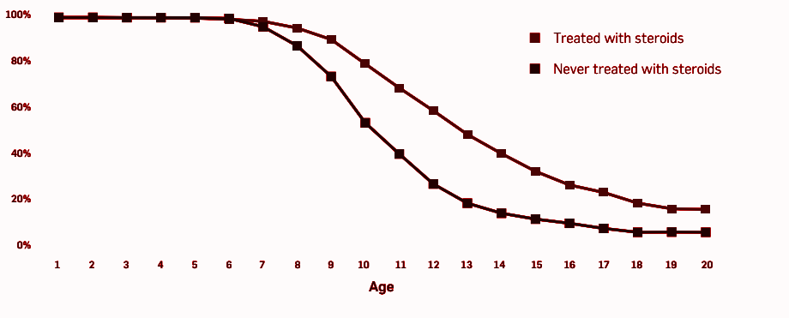

**Figure 10: Ambulatory Status of Duchenne Registry Participants by Age and Corticosteroid Use(28)**

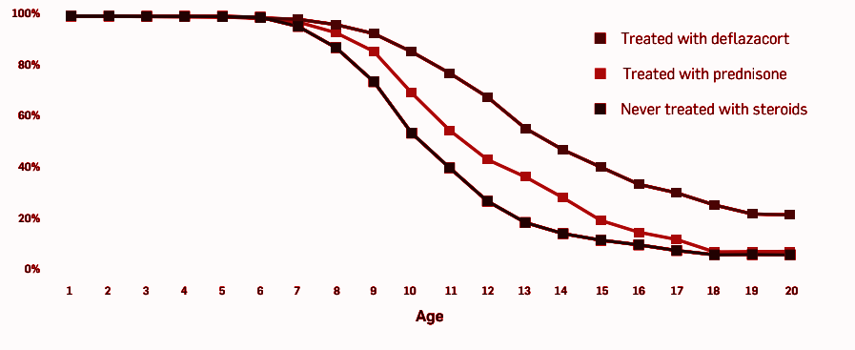

**Figure 11: Ambulatory Status of Duchenne Registry Participants by Age and Type of Corticosteroid Treatment(28)**

* + **Rehabilitation Therapy (Physical Therapy - PT / Occupational Therapy - OT):** Essential from diagnosis throughout life (Birnkrant et al. Part 1, 2018). Goals include preventing/managing contractures (especially ankles, hips, knees, elbows/wrists), maintaining muscle strength and function within safe limits, promoting mobility and independence through assistive devices, and adapting the environment (Birnkrant et al. Part 1, 2018). Regular passive stretching routines (Achilles, hamstrings, hip flexors, IT bands) are fundamental (Birnkrant et al. Part 1, 2018). Bracing, such as ankle-foot orthoses (AFOs) worn at night, helps manage ankle contractures (Birnkrant et al. Part 1, 2018). Wheelchair prescription (manual and powered) should be timely to maintain mobility and participation (Birnkrant et al. Part 1, 2018).**Evidence for Exercise:** While strenuous eccentric exercise should be avoided, gentle activity is encouraged to prevent disuse atrophy (Birnkrant et al. Part 1, 2018). Swimming and low-resistance cycling are often recommended (Birnkrant et al. Part 1, 2018). Recent evidence, though low-quality, suggests specific supervised exercise programs, including trunk-oriented strength training, may improve some aspects of upper limb function and balance without causing harm (Serrano-Pozuelo et al., 2024).**Recommendation:** Regular PT/OT assessments (at least 4-6 times/year) are needed to guide individualized stretching programs, monitor range of motion, assess equipment needs (braces, wheelchairs, adaptive equipment), and advise on safe, appropriate physical activity (Birnkrant et al. Part 1, 2018).

**Cardiovascular Management:**

* **Surveillance:** Cardiac involvement (primarily dilated cardiomyopathy, arrhythmias) is nearly universal with age(5).Regular surveillance is crucial, starting at diagnosis (5). This includes annual assessments with electrocardiogram (ECG) and echocardiogram from early childhood (e.g., by age 6 or at diagnosis) (5) Frequency may increase to biannually if abnormalities arise. Cardiac MRI with late gadolinium enhancement provides more sensitive detection of early fibrosis and dysfunction(5). Holter monitoring may be used if arrhythmias are suspected(5).
* **Prophylactic Treatment:** Early initiation of cardioprotective medications significantly improves outcomes(5, 34).
* **Recommendation:** Initiate Angiotensin-Converting Enzyme inhibitors (ACEi) or Angiotensin Receptor Blockers (ARBs) by approximately 10 years of age, or earlier if any signs of left ventricular dysfunction (e.g., LVEF <55% on echo) appear, even in asymptomatic patients(5). Consider adding a beta-blocker if LVEF remains <55% or declines despite ACEi/ARB therapy (5). Aldosterone antagonists (like Eplerenone) may be considered as add-on therapy in select cases with persistent dysfunction(5). Table 8 shows Data from the Duchenne Registry for participants born since 2000 that indicates the average age at commencement for major cardiac medication classes (28).

**Table 8: Total Number of current Heart medication by their age(28)**

|  |  |
| --- | --- |
| Medication Class | Average Age started |
| Beta Blockers | 10.4 |
| ACE Inhibitors | 9.3 |
| ARB | 9.5 |
| Diuretics | 11.1 |

* **Heart Failure Management:** Treat symptomatic heart failure according to standard cardiology guidelines, including diuretics and potentially other advanced therapies(5, 34). Optimizing cardiac care remains a key focus for extending survival(5).

**Respiratory Management:**

* **Surveillance:** Respiratory muscle weakness inevitably leads to restrictive lung disease and respiratory failure (5). Regular monitoring is essential (5). Pulmonary Function Tests (PFTs), including Forced Vital Capacity (FVC), Forced Expiratory Volume in 1 second (FEV1), Maximal Inspiratory/Expiratory Pressures (MIP/MEP), and Peak Cough Flow (PCF), should be performed at least annually starting when the child can reliably cooperate (usually age 5-6)(5). Monitor for signs/symptoms of nocturnal hypoventilation (headaches, fatigue, poor sleep)(5). Polysomnography (sleep study) is the gold standard for detecting sleep-disordered breathing (5).Severely reduced FVC (<1L) is a poor prognostic indicator(30).
* **Interventions:** Proactive airway clearance techniques (e.g., manual assisted cough, mechanical insufflation-exsufflation device) are crucial, especially during respiratory illnesses, once PCF declines (5). Routine immunizations (influenza, pneumococcal) are strongly recommended(5). Initiate Non-Invasive Ventilation (typically nocturnal Bilevel Positive Airway Pressure - BiPAP) when signs/symptoms of hypoventilation occur or when PFTs decline below specific thresholds (e.g., FVC <50% predicted, MIP <60 cmH2O, or specific blood gas abnormalities)(5).Timely NIV significantly improves survival and quality of life (5, 32). Consider tracheostomy with invasive ventilation if NIV is insufficient or not tolerated (5).Scoliosis surgery may help preserve pulmonary function in some cases(5).
* **Recommendation:** Annual PFTs/clinical assessment from age 5-6. Counsel on airway clearance/vaccinations. Monitor for sleep-disordered breathing. Initiate NIV based on established criteria (5).

**Orthopedic and Bone Health Management:**

* **Contracture/Scoliosis:** Manage lower limb contractures with stretching/bracing; consider surgical release if function is impaired (5). Monitor for scoliosis, especially after becoming non-ambulatory, via clinical exam and spinal X-rays (5). Surgical stabilization (spinal fusion) is recommended for progressive curves >20-30 degrees to improve seating/comfort and potentially aid respiratory function(5).
* **Bone Health:** Osteoporosis and fragility fractures are common, exacerbated by immobility and chronic steroid use (5).

**Table 9: Key Recommendations for Bone Health Management in DMD(5, 42)**

|  |  |
| --- | --- |
| Recommendation Area | Key Guideline Points |
| Monitoring | Monitor serum 25-hydroxyvitamin D levels annually; Maintain levels >20 ng/mL (preferably >30 ng/mL). Perform baseline DXA scan around time of steroid initiation or by age 6; repeat annually thereafter. Assess spine via lateral spine X-ray or DXA Vertebral Fracture Assessment (VFA) if back pain occurs or height loss noted. |
| Supplementation | Ensure adequate daily calcium intake (based on age). Supplement Vitamin D (e.g., 600-1000 IU daily, adjust based on levels) for all patients, especially on steroids. |
| Fracture Management | Optimize calcium/Vit D. Consult endocrinology/bone specialist. Consider intravenous bisphosphonate therapy (e.g., zoledronic acid, pamidronate) for clinically significant fractures (especially vertebral compression fractures) or significantly low bone density (Z-score <-2.0 with fracture history). Weigh benefits vs. risks of bisphosphonates. |
| General | Encourage weight-bearing activity as tolerated. Minimize fall risk. |

**Nutrition and GI Management:**

* Goal is to maintain optimal nutritional status, preventing both undernutrition and obesity (common with reduced mobility and steroids)(37).Monitor growth parameters. Assess swallowing function regularly, as dysphagia can develop, increasing aspiration risk(37). Manage constipation proactively (often related to decreased mobility and diet)(37). Gastrostomy tube placement may be necessary for safe and adequate nutrition/hydration if severe dysphagia or malnutrition develops (37).
  + **Recommendation:** Dietitian involvement for nutritional counseling, weight management, and supplement advice. Speech therapy evaluation for swallowing issues(37).

**Psychosocial and Neurodevelopmental Support:**

* DMD is associated with increased risk of learning disabilities, ADHD, ASD, anxiety, and depression(6).
  + **Recommendation:** Perform routine neurodevelopmental and psychosocial screening throughout life(6). Provide appropriate educational support and accommodations(6). Offer mental health support (counseling, therapy, medication if needed) for the patient and family to address coping, adaptation, behavioral challenges, and mental health conditions(6). Anticipatory guidance for key transitions (e.g., diagnosis, loss of ambulation, school changes, transition to adulthood) is crucial(6). Address the significant gap noted between mental health needs and service utilization (6)

**Transition of Care:**

* As survival extends into adulthood, planning the transition from pediatric to adult healthcare is vital (6). This complex process requires early initiation (early adolescence) and coordinated efforts involving the patient, family, pediatric team, and adult providers(6). Key elements include identifying knowledgeable adult providers (often challenging), ensuring comprehensive transfer of medical information, addressing psychosocial needs related to increasing independence and adult life, and supporting vocational/educational goals.
  + **Recommendation:** Implement structured transition policies within clinics, starting discussions early and empowering young adults to manage their care(6).

**Novel Therapies:** Aim to address the underlying genetic defect or downstream consequences(43). Require precise genetic diagnosis for eligibility (mutation-specific therapies)(43).

* **Exon Skipping:** Uses Antisense Oligonucleotides (ASOs) to modulate splicing and restore the dystrophin reading frame (Figure 12) (43). Approved drugs target specific exons (Eteplirsen-Ex51, Golodirsen/Viltolarsen-Ex53, Casimersen-Ex45)(43), benefiting distinct subsets of patients (Table 10). Some studies associate use with prolonged ambulation.

**Llimitations:****:** Mutation specificity, modest and variable dystrophin production/clinical benefit reported, inefficient delivery (especially to heart muscle), need for lifelong intravenous infusions, high cost, potential for side effects with modified chemistries or delivery systems(7, 43).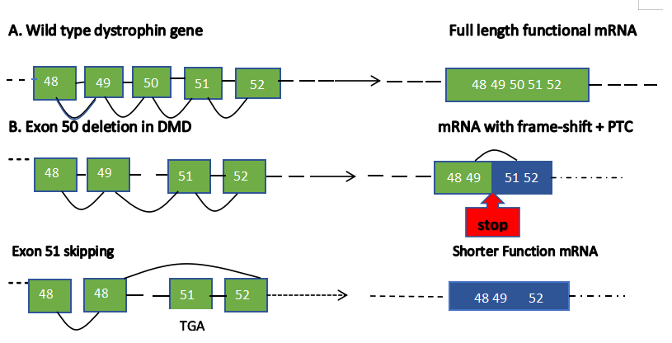

**Figure 12: Mechanism of Exon Skipping Therapy for DMD with Exon 50 Deletion(43).** (A) Normal splicing yields full-length functional mRNA. (B) Deletion of exon 50 results in exons 49 and 51 being joined out-of-frame, creating a premature termination codon (PTC) and non-functional dystrophin. (C) Antisense oligonucleotide-mediated skipping of exon 51 allows exons 49 and 52 to join in-frame, bypassing the PTC and yielding a shorter but potentially functional dystrophin protein.

**Table 10:** **Duchenne Registry Participants with Deletions Amenable to Specific Exon Skipping Therapies(28)**

|  |  |  |
| --- | --- | --- |
| Exon Skipping Therapy | Total Duchenne Registrants with Amenable Deletion | Expected Percentage |
| Exon 51 | 256(12%) | 14% |
| Exon 53 | 168(8%) | 10% |
| Exon 45 | 189(9%) | 9% |
| Exon 44 | 123(6%) | 7% |

* **Stop Codon Read-through:** Ataluren (Translarna) aims to enable ribosomal read-through of nonsense mutations (~10-15% of DMD) (Figure 13)(2, 43). Conditionally approved in some regions. Clinical efficacy results have been debated(7)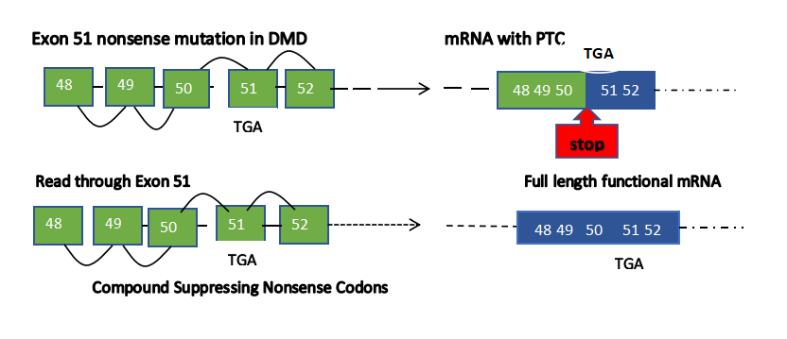

**Figure 13: Mechanism of Stop Codon Read-through Therapy(43).** (Top) A nonsense mutation (creating a premature termination codon, PTC) in the dystrophin gene leads to truncated, non-functional protein. (Bottom) Read-through therapies (e.g., Ataluren) enable the ribosome to bypass the PTC, allowing synthesis of full-length, functional dystrophin.

• **Gene Therapy (AAV-microdystrophin):** Delivers a shortened micro-dystrophin gene via AAV vector (7, 43). Delandistrogene moxeparvovec (Elevidys) received accelerated FDA approval for ambulatory children aged 4-5(44). **Limitations:** AAV packaging capacity limits transgene size (necessitating micro-dystrophin); significant proportion of patients ineligible due to pre-existing anti-AAV antibodies; potential for serious immune-mediated adverse events (requiring immunosuppression); uncertain long-term durability and safety; extremely high cost(7, 43).

• **Gene Editing (CRISPR/Cas9):** Aims for permanent correction of the DMD gene(45). Currently in preclinical/early clinical development (45). **Limitations:** Major challenges include safe and efficient in vivo delivery of editing components to muscle tissue systemically; high risk of off-target DNA alterations with potential long-term consequences; potential immunogenicity against Cas9 protein (45).

• **HDAC Inhibitors:** Givinostat (Duvyzat) targets downstream inflammation and fibrosis, approved regardless of mutation type based on slowing functional decline(46)

• **Outcome Measures for Trials:** Developing and validating sensitive outcome measures (functional scales like NSAA/PUL, timed tests like 6MWT/NSAA rise time, quantitative MRI, digital biomarkers like stride velocity) is essential for accurately assessing therapeutic efficacy in clinical trials (7, 37).

**Recommendation:** Accurate genetic diagnosis is paramount. Treatment decisions should integrate guideline-based standard care with consideration of novel therapies based on eligibility, potential benefits, significant limitations/risks, regulatory status, and access. Realistic expectations should be discussed. Participation in clinical trials or registries should be encouraged(6, 7, 37, 43). The lack of trial representation from diverse global populations needs addressing(47).

**Table 11: Comparison of Gene-Targeted Therapeutic Strategies for DMD(7, 43)**

|  |  |  |  |
| --- | --- | --- | --- |
| Feature | Antisense Oligonucleotide (AO) Exon Skipping | AAV-mediated Micro-dystrophin Gene Transfer | CRISPR/Cas9 Gene Editing |
| Mechanism | Modifies splicing of pre-mRNA to skip specific exons, restoring reading frame | Delivers a transgene encoding a shortened, functional micro-dystrophin protein via an AAV vector | Permanently modifies the DMD gene by deleting exons or correcting mutations via DNA repair mechanisms (NHEJ or HDR) |
| Target Mutations | Specific deletions/mutations amenable to skipping target exons (e.g., Exon 51, 53, 45) | Applicable regardless of specific mutation type (within approved age/patient groups) | Potentially applicable to various deletions, duplications, or point mutations depending on editing strategy |
| Outcome Goal | Production of internally truncated, partially functional dystrophin (BMD-like) | Production of functional micro-dystrophin protein | Production of near full-length or corrected dystrophin (potentially BMD-like or closer to wild-type) |
| Key Advantages | Established platform (multiple approved drugs), potential for personalization | Potential for long-term expression from single treatment, mutation-agnostic (micro-dystrophin) | Potential for permanent correction from single treatment, versatile editing capabilities |
| Major Limitations | Mutation-specific; variable efficacy; inefficient delivery (esp. heart); short half-life (requires repeat infusions); high cost; potential toxicity with modifications. | AAV packaging limits (requires micro-dystrophin); pre-existing anti-AAV immunity; potential immune response to capsid or transgene; delivery challenges; uncertain long-term durability; very high cost. | Delivery in vivo challenging; high risk of off-target DNA mutations; potential large genomic deletions; immunogenicity to Cas9 protein; ethical considerations; mostly preclinical/early clinical stage. |

**5. Quality of Life (QoL) and Socioeconomic Impact**

Duchenne Muscular Dystrophy profoundly impacts the Quality of Life (QoL) of affected individuals across multiple domains throughout their lifespan(6). The progressive muscle weakness leads to increasing physical limitations, loss of independence in activities of daily living (dressing, bathing, feeding), reduced mobility often necessitating wheelchair use from the early teens (Figure 7), and significant fatigue (6). These physical challenges frequently contribute to social isolation, reduced participation in school and community activities, and difficulties in forming peer relationships. The emotional burden is substantial, with higher rates of anxiety, depression, and behavioral issues reported compared to the general population, stemming from the stress of managing a chronic, progressive condition, physical limitations, and potential cognitive involvement(6, 48). A key finding is that recent studies highlights a concerning gap between the high prevalence of mental health concerns (including anger/aggression, attention disorders, anxiety/depression) among DMD patients and the actual utilization of psychosocial support services like counseling or therapy, suggesting a significant unmet need within standard care pathways(6).

Furthermore, the burden extends significantly to caregivers and families(49). Providing daily physical care for an individual with increasing dependence is demanding(49). Families often face substantial financial strain due to direct medical costs (specialist visits, therapies, medications, hospitalizations, assistive equipment, home modifications) and indirect costs, such as parents (often mothers) reducing work hours or leaving employment to provide care (49, 50). The emotional toll on caregivers is immense, encompassing chronic stress, anxiety about the future, grief, and potential social isolation(49, 51). Supporting caregiver well-being is increasingly recognized as crucial for the overall health of the patient and family resilience(49).

The overall economic impact of DMD on society and healthcare systems is considerable and increases markedly with disease progression as care needs intensify(50). Increased survival, while a positive outcome of improved care, also translates into longer periods requiring complex medical management, supportive therapies, and potentially expensive interventions (like spinal surgery, long-term ventilation, or novel molecular therapies), further escalating lifetime costs(50). Generating accurate epidemiological and economic data is therefore fundamental for public health planning and resource allocation(4, 26, 50).

**Pakistan Context:** While specific quantitative studies using standardized QoL instruments (like EQ-5D) or detailed economic burden analyses for DMD within Pakistan are limited in readily accessible international literature, the significant impact can be inferred. The clinical data available from a Pakistani cohort (Figure 9) demonstrates high frequencies of major functional limitations such as difficulty changing position, frequent falls, significant exercise intolerance, waddling gait, and eventual contractures(35). These physical impairments inevitably translate into substantial challenges in daily living, impacting independence, participation, and overall QoL for patients in Pakistan, similar to global experiences (6, 49).

Crucially, socioeconomic factors likely play a particularly significant role in amplifying the burden in this context. The notation of lower socioeconomic status being common in the studied Pakistani cohort (Figure 9) suggests that many families face considerable financial constraints(35). These constraints can severely limit access to timely diagnosis (especially expensive genetic testing), specialized multidisciplinary care (which may be geographically concentrated), consistent physiotherapy, necessary medications (including steroids or cardioprotective drugs), essential assistive devices (wheelchairs, ventilators), and environmental modifications needed to support function and participation(50). Furthermore, cultural perspectives on disability, health literacy levels, and the availability of social safety nets and community support services can influence coping strategies, care-seeking behavior, treatment adherence, and ultimately, both patient and caregiver QoL(49, 51). The findings from the UK study showing that socioeconomic deprivation and South Asian ethnicity were associated with earlier loss of ambulation (31) highlight the potential interplay of socioeconomic, cultural, and possibly genetic factors that warrant specific investigation within the diverse populations of Pakistan to understand and address local disparities in DMD outcomes and burden(31). Addressing these socioeconomic dimensions and improving access to basic supportive care and information are critical steps towards mitigating the QoL impact of DMD in Pakistan(49, 50).

**Methodology**

This paper integrates a clinical case report with a comprehensive literature review to provide a multifaceted perspective on Duchenne Muscular Dystrophy (DMD).

* **Case Report Component:** The methodology for the case report involved a retrospective review of a single patient presenting with an atypical adult onset of DMD symptoms at a hospital in Peshawar, Pakistan. Information was meticulously sourced through direct clinical observation during patient encounters and a detailed examination of the patient's existing medical records, including clinical notes, laboratory result (serum CK, Aldolase, LDH, CRP, myoglibinuria), electrodiagnostic findings (EMG), imaging report (**Figure 2**), and muscle biopsy histopathology report (**Figure 1**). Data regarding clinical presentation, diagnostic workup, final diagnosis confirmation process, and the initiated multidisciplinary management plan were extracted. This process adhered to institutional ethical guidelines and ensured patient confidentiality. The aim was specifically to document this rare presentation and highlight associated diagnostic considerations. Furthermore, this review critically evaluates the current state of knowledge to identify key research gaps and outline potential future directions in DMD diagnosis, management, and therapeutic development, which are explored within the Discussion section.
* **Comprehensive Literature Review Component:** A comprehensive literature review approach was employed to synthesize current knowledge and provide a broad overview of DMD, relevant to both the specific case presented and the broader clinical context, including global perspectives and specific considerations for Pakistan.
  + **Scope and Search Strategy:** The review aimed to cover key aspects including etiology, pathophysiology, genetics, epidemiology, diagnosis, clinical manifestations, established and emerging management strategies, quality of life impacts, and prognostic factors. Literature was identified through targeted searches of major biomedical databases, primarily **PubMed** and the **Cochrane Library**, using relevant keywords (e.g., "Duchenne muscular dystrophy," "dystrophinopathy," "adult onset muscular dystrophy," "DMD management," "DMD Pakistan," "exon skipping," "gene therapy DMD," "DMD prognosis") and appropriate **Medical Subject Headings (MeSH)** terms (such as **"Muscular Dystrophy, Duchenne," "Muscular Dystrophy, Becker," "Dystrophin," "Cardiomyopathy, Dilated,"** "Genetics, Medical," "Therapeutics," "Epidemiology"). Additional searches were performed as needed to explore specific topics identified during the review process.
  + **Source Selection and Synthesis:** Unlike a systematic review following strict inclusion/exclusion protocols for primary studies, this review prioritized the selection of key information based on relevance to the paper's aims and objectives. Emphasis was placed on integrating findings from recent, high-quality sources, including major **systematic reviews and meta-analyses**, international **consensus care guidelines** (particularly the 2018 update, foundational **basic science articles**, and relevant **clinical studies or reviews focusing on specific areas** like novel therapies or transition of care. Information from sources like the DMD World Registry was also considered for demographic or specific data points where appropriate. The synthesis involved qualitatively integrating the evidence gathered from these diverse sources to construct a comprehensive and coherent overview of the current understanding of DMD, addressing etiology, diagnosis, management standards, prognostic factors, emerging treatments, and contextual factors like the burden in Pakistan and challenges of atypical presentations. The focus was on presenting evidence-based information and current expert recommendations relevant to clinicians managing DMD. While formal quality scoring of each individual source was not performed as in a systematic review, the credibility and quality of sources (e.g., guidelines, meta-analyses vs. single studies or older reviews) were critically considered during information selection and synthesis.

### ****Table 12: Treatment Options for Duchenne Muscular Dystrophy (DMD):****

| **Treatment Type** | **Drug/Intervention** | **Mechanism/Goal** | **Comments** |
| --- | --- | --- | --- |
| **Conventional Therapies** |  |  |  |
| Corticosteroids | Prednisone, Deflazacort | Reduce inflammation and delay muscle degeneration | First-line standard care; long-term side effects (e.g., weight gain, osteoporosis) |
| Cardioprotective Agents | ACE inhibitors, Beta-blockers | Delay onset of cardiomyopathy | Used preventively, especially from adolescence onward |
| Respiratory Support | Non-invasive ventilation (BiPAP) | Assist breathing as muscles weaken | Improves survival and quality of life |
| Physical Therapy | Stretching, bracing | Prevent contractures and maintain mobility | Daily routine; key for joint health |
| Orthopedic Interventions | Surgery (e.g., tendon release) | Manage scoliosis and contractures | Individualized based on disease progression |

**Table 13: Advanced Drug Therapy in Duchenne Muscular Dystrophy (DMD)**

| **Drug Name** | **Drug Type/Mechanism** | **Target Mutation/Exon** | **Approval Status** | **Notes** |
| --- | --- | --- | --- | --- |
| **Eteplirsen** (Exondys 51) | Exon skipping (antisense oligonucleotide) | Exon 51 | FDA Approved | Enables production of truncated dystrophin protein |
| **Golodirsen** (Vyondys 53) | Exon skipping | Exon 53 | FDA Approved | Similar mechanism to Eteplirsen |
| **Viltolarsen** (Viltepso) | Exon skipping | Exon 53 | FDA Approved | Improved dystrophin levels in early trials |
| **Casimersen** (Amondys 45) | Exon skipping | Exon 45 | FDA Approved (2021) | For specific exon 45 deletion mutations |
| **Ataluren** (Translarna) | Stop codon read-through | Nonsense mutations | Conditional EU Approval | Not FDA-approved; allows translation through premature stop codon |
| **Delandistrogene moxeparvovec** (SRP-9001) | Gene therapy (micro-dystrophin) | All mutations (non-specific) | FDA Accelerated Approval (2023) | AAV vector delivery; used in younger DMD patients |
| **Idebenone** | Antioxidant/mitochondrial enhancer | All mutations (non-specific) | EMA Orphan Drug Designation | Slows respiratory decline; investigational use |
| **Pamrevlumab** | Anti-fibrotic (monoclonal antibody) | All genotypes | Phase 3 Trials (ongoing) | Targets connective tissue growth factor (CTGF) |
| **Givinostat** | Histone deacetylase (HDAC) inhibitor | All genotypes | Phase 3 Trials (ongoing) | May reduce inflammation and fibrosis |
| **Tamoxifen** | Selective estrogen receptor modulator (SERM) | All genotypes | Investigational | Anti-inflammatory & anti-fibrotic effects |

**Discussion**

The diagnosis of Duchenne Muscular Dystrophy in this 34-year-old highlights the clinical variability of dystrophinopathies (35). Unlike the classic childhood onset, this case demonstrates that DMD can present in adulthood due to delayed diagnosis or a milder initial course (35). This poses a diagnostic challenge, requiring clinicians to consider DMD/BMD in adults with progressive proximal weakness, elevated CK, and myopathic EMG/biopsy findings (Figure 1, Figure 2)(2, 37). Age alone is insufficient for exclusion, emphasizing the need to differentiate from other adult-onset myopathies (Table 7) (2). Definitive molecular diagnosis via DMD gene testing is important and gold standard for accurate classification, prognosis, genetic counseling, and determining eligibility for mutation-specific therapies (Table 10, Figure 12, Figure 13) (12, 37). Financial constraints hindering genetic testing in this case exemplify a real-world barrier to definitive diagnosis and access to modern therapies(50).

The significant increase in lifespan for individuals with DMD is largely due to the widespread adoption of standardized multidisciplinary care(5, 6, 32, 37). International guidelines, particularly the 2018 update, emphasize a proactive approach(5, 6, 37). Consistent glucocorticoid use alters disease progression (5, 30, 37), while proactive cardiac surveillance and early cardioprotective medications have greatly reduced cardiac mortality(5, 34). Similarly, vigilant respiratory monitoring and timely non-invasive ventilation have decreased respiratory failure(5, 32). This improved survival has shifted DMD care to extend into adulthood, requiring structured transition planning from pediatric to adult healthcare, starting in adolescence with close coordination between teams to address medical and evolving psychosocial, educational, and vocational needs(6). However, a lack of adult neuromuscular specialists often hinders this transition, indicating a need for systemic improvement(6)

Furthermore, understanding factors beyond the primary diagnosis that influence disease trajectory is increasingly important for personalized care. Prognostic factors are multifactorial (29, 30). While the specific DMD genotype clearly plays a role in determining the rate of progression (e.g., certain mutations predict longer ambulation than others), baseline functional performance (like 6MWT distance) is also a strong independent predictor of future decline(29, 30). The discovery and validation of modifier genes (e.g., LTBP4, SPP1) add another layer of complexity, confirming that an individual's broader genetic background significantly shapes their clinical course (29). This evolving understanding holds potential for more personalized prognostication and could inform stratification in future clinical trials(29, 30). The development of more sensitive outcome measures, including quantitative MRI to track muscle composition changes (Figure 2) (40) and digital biomarkers assessing real-world activity, further aids in monitoring progression and evaluating therapeutic responses more effectively than traditional timed function tests alone (7, 37, 40).

Despite these advancements in understanding and management, significant challenges and disparities persist globally. Implementing comprehensive multidisciplinary care consistently requires substantial resources and expertise, creating access barriers, particularly in lower-resource settings(5, 6, 37, 50). Studies explicitly show that socioeconomic status and ethnicity can correlate with outcomes like age at LOA, potentially mediated by differences in access to care, treatment adherence, or other sociocultural factors(31). These findings are highly relevant to the diverse context of Pakistan, where socioeconomic constraints noted in local cohorts (Figure 9) likely exacerbate care challenges(31, 35). Additionally, the crucial psychosocial dimension of DMD care remains globally under-addressed, with evidence indicating a significant gap between the high rates of mental health concerns among patients and the provision of necessary support services for both patients and their families (6, 49). Recognizing and integrating mental health and caregiver support is essential for truly holistic care(6, 49).

Novel therapies for DMD, including mutation-specific (exon skipping, stop-codon read-through, gene replacement) and mutation-agnostic (HDAC inhibition) approaches, offer diverse mechanisms but no current cure, facing significant hurdles(7, 43). Efficient and targeted delivery to all relevant muscle tissues remains a primary obstacle for ASOs, AAV vectors, and gene editing(7, 43). Immunogenicity is a major threat, with pre-existing anti-AAV antibodies excluding many from gene therapy trials, and immune responses potentially limiting efficacy and causing adverse events(7, 43). Ensuring long-term safety, particularly with CRISPR/Cas9 editing, and confirming the durability of therapeutic effects are critical(7, 45). A key challenge is the gap between biochemical correction and demonstrating robust, clinically meaningful functional improvement(43). The high cost of these therapies raises ethical concerns about equitable access(7, 43, 50), compounded by limited clinical trial representation from diverse populations, hindering data and future access(47).

Future research must prioritize overcoming these shared hurdles of delivery, immunity, safety, durability, cost, and equity. Potential directions include combination therapies, improved delivery vectors, genetically corrected stem cells, and novel biomarkers for better patient stratification and monitoring(7, 43). A non-invasive method using urine-derived cells (UDCs) reprogrammed into induced pluripotent stem cells (iPSCs) provides a valuable resource for in vitro disease modeling, drug screening, and research into cell-based therapies, particularly for diverse populations (52). Optimizing established supportive care remains vital for the potential success of novel therapies(5, 6, 37).

**Conclusion**

Duchenne Muscular Dystrophy (DMD), an X-linked genetic disorder due to DMD gene defects, is a complex, progressive multi-system condition requiring comprehensive, lifelong care(1, 2, 5, 6, 37). This review, prompted by an atypical adult case from Pakistan(35), emphasizes the clinical necessity of considering DMD in the differential diagnosis of myopathy across all ages, not just in children(2, 37). While presentation varies, definitive genetic testing is crucial for diagnosis(37). In the era of molecular medicine, precise genetic diagnosis is paramount for accurate classification, differentiating DMD from other myopathies, informed prognosis, effective family planning via carrier detection, and determining eligibility for increasing mutation-specific therapies (2, 12, 37).

DMD's natural history has been significantly altered by the successful implementation and refinement of multidisciplinary care (5, 6, 37). Proactive management, particularly of cardiorespiratory complications with early surveillance and interventions (ACE inhibitors, non-invasive ventilation)(5, 34), alongside consistent corticosteroid use to preserve muscle function and delay loss of ambulation(5, 30, 37), has significantly extended survival(32). Optimizing cardiac care remains crucial for longevity (5, 33, 34). This progress transforms DMD into a chronic adult condition (32). Modern comprehensive care must therefore address long-term complications, steroid side effects, structured transition planning from pediatric to adult care, and the often under-addressed psychosocial burden on patients and families (5, 6, 37). Furthermore, the growing understanding of prognostic factors—genotype, baseline function, and modifier genes—increasingly personalizes care expectations and management (29, 30), which should always include tailored rehabilitation exercise.

The field of DMD is at an exciting yet challenging point with novel molecular therapies targeting the root cause(7, 43). Strategies like mutation-specific exon skipping and stop-codon read-through, mutation-agnostic gene replacement, pathway modulators, and gene editing offer hope, but significant shared hurdles limit their widespread use and curative potential (7, 43). Substantial challenges persist in efficient systemic delivery, managing immune responses, ensuring long-term safety and durability, and navigating high costs (7, 43-45). Addressing these scientific, logistical, and economic barriers is essential. Critically, ensuring diverse global populations are included in clinical research and have eventual therapeutic access, overcoming the current concentration in high-income regions, is a fundamental ethical and scientific imperative for global impact (47).

Addressing the global DMD community's needs requires a continued, collaborative effort. This includes sustained basic research into dystrophin biology, pathogenesis, and genetic modifiers (1, 29). Simultaneously, ongoing optimization and equitable implementation of supportive care are crucial, especially addressing socioeconomic and ethnic disparities(5, 31, 50, 53). Improving global access to timely diagnostics, particularly genetic testing, and essential therapies remains a priority(37, 50). The therapeutic pipeline must focus on more effective, safer, durable, and accessible novel treatments, potentially through improved delivery, immune modulation, or combination approaches(7, 43). Refining clinical outcome measures, including digital biomarkers and imaging, is needed for better trial assessments and real-world monitoring (7, 40). Finally, strengthening global healthcare systems to provide consistent, integrated, high-quality multidisciplinary care—including vital psychosocial support—is fundamental(5, 6, 37, 49). Despite challenges, the synergy between advancing supportive care and innovative therapies offers substantial hope for continued improvements in longevity, function, and quality of life for individuals with DMD.

**Research Gaps and Future Directions:**

1. Diagnostics/Prognosis: Overcome financial/access barriers for genetic testing; validate prognostic factors (including modifier genes) and sensitive outcome measures (like qMRI, digital biomarkers); advance basic research and novel biomarker development.

2. Supportive Care/Management: Improve pediatric-to-adult care transition, addressing provider expertise gaps, and continue optimizing supportive care standards.

3. Novel Therapies: Address significant hurdles in delivery, immunogenicity, long-term safety/durability, and demonstrating clinical efficacy; future research must focus on improved strategies (combinations, vectors, stem cells) and overcoming accessibility/cost barriers.

4. Psychosocial Support: Bridge the significant gap in providing adequate mental health and caregiver support as part of integrated DMD care.

5. Global Equity/Access: Tackle resource limitations hindering global multidisciplinary care; investigate and mitigate socioeconomic/ethnic disparities impacting outcomes; address high therapy costs and inequitable clinical trial representation/access to diagnostics; strengthen healthcare systems worldwide.

**• Limitations**

This review, while comprehensive, faces certain limitations. The case report describes a single, atypical adult presentation, and its findings cannot be extrapolated to the broader, predominantly pediatric-onset DMD population. This literature review approach, while broad, lacks the methodology and formal quality appraisal of a full systematic review.The synthesized epidemiological data relies on studies noted for significant methodological heterogeneity, often medium-to-low reporting quality, and potential data source biases (e.g., ICD coding, registry participation), affecting the precision of prevalence estimates. Registry data (Figure 5, Table 5) may have participation and geographic biases. Evidence quality for certain interventions (e.g., non-pharmacological) is often low, and interpreting prognostic factors from observational data requires caution due to potential confounding variables and risk of bias in primary studies. Information on novel therapies evolves rapidly, and current approaches face significant inherent challenges including delivery, immunogenicity, long-term safety/durability, and cost. Finally, a scarcity of comprehensive, Pakistan-specific population data necessitates extrapolation from global findings and limited local studies (e.g Figure 9).

**Disclaimer (Artificial intelligence)**

Option 1:

Author(s) hereby declare that NO generative AI technologies such as Large Language Models (ChatGPT, COPILOT, etc.) and text-to-image generators have been used during the writing or editing of this manuscript.

Option 2:

Author(s) hereby declare that generative AI technologies such as Large Language Models, etc. have been used during the writing or editing of manuscripts. This explanation will include the name, version, model, and source of the generative AI technology and as well as all input prompts provided to the generative AI technology

Details of the AI usage are given below:

1.

2.

3.

**COMPETING INTERESTS DISCLAIMER:**

Authors have declared that they have no known competing financial interests OR non-financial interests OR personal relationships that could have appeared to influence the work reported in this paper.

**References:**

1. Gao QQ, McNally EM. The Dystrophin Complex: Structure, Function, and Implications for Therapy. Compr Physiol. 2015;5(3):1223-39.

2. Darras BTU, David K.; Ghosh, Partha S. Duchenne and Becker Muscular Dystrophy. In: Adam MPF, Jerry; Mirzaa, Ghayda M., editor. GeneReviews®. Seattle (WA): University of Washington, Seattle; 2023.

3. Lim KRQ, Sheri N, Nguyen Q, Yokota T. Cardiac Involvement in Dystrophin-Deficient Females: Current Understanding and Implications for the Treatment of Dystrophinopathies. Genes (Basel). 2020;11(7).

4. Salari N, Fatahi B, Valipour E, Kazeminia M, Fatahian R, Kiaei A, et al. Global prevalence of Duchenne and Becker muscular dystrophy: a systematic review and meta-analysis. J Orthop Surg Res. 2022;17(1):96.

5. Birnkrant DJ, Bushby K, Bann CM, Alman BA, Apkon SD, Blackwell A, et al. Diagnosis and management of Duchenne muscular dystrophy, part 2: respiratory, cardiac, bone health, and orthopaedic management. Lancet Neurol. 2018;17(4):347-61.

6. Birnkrant DJ, Bushby K, Bann CM, Apkon SD, Blackwell A, Colvin MK, et al. Diagnosis and management of Duchenne muscular dystrophy, part 3: primary care, emergency management, psychosocial care, and transitions of care across the lifespan. Lancet Neurol. 2018;17(5):445-55.

7. Chung Liang L, Sulaiman N, Yazid MD. A Decade of Progress in Gene Targeted Therapeutic Strategies in Duchenne Muscular Dystrophy: A Systematic Review. Front Bioeng Biotechnol. 2022;10:833833.

8. Sweeney HL, Barton ER. The dystrophin-associated glycoprotein complex: what parts can you do without? Proc Natl Acad Sci U S A. 2000;97(25):13464-6.

9. Juan-Mateu J, Gonzalez-Quereda L, Rodriguez MJ, Baena M, Verdura E, Nascimento A, et al. DMD Mutations in 576 Dystrophinopathy Families: A Step Forward in Genotype-Phenotype Correlations. PLoS One. 2015;10(8):e0135189.

10. Fortunato F, Tonelli L, Farne M, Selvatici R, Ferlini A. DMD deletions underlining mild dystrophinopathies: literature review highlights phenotype-related mutation clusters and provides insights about genetic mechanisms and prognosis. Front Neurol. 2023;14:1288721.

11. Geng C, Tong Y, Zhang S, Ling C, Wu X, Wang D, et al. Sequence and Structure Characteristics of 22 Deletion Breakpoints in Intron 44 of the DMD Gene Based on Long-Read Sequencing. Front Genet. 2021;12:638220.

12. Dr.Ihsan Ullah, Ali Abbas Khan, Javid Iqbal, Dr Sayed Ali, Samreen Kibria Siddiqui, Sameer Ali, & Hafsa Ihsan. (2024). COMPARISON OF AZITHROMYCIN AND AMOXICILLIN IN THE MANAGEMENT OF PEDIATRIC COMMUNITY-ACQUIRED PNEUMONIA. *Journal of Population Therapeutics and Clinical Pharmacology*, *31*(8), 3398-3404. <https://doi.org/10.53555/xy0qta76>

13. Flanigan KM, Dunn DM, von Niederhausern A, Soltanzadeh P, Gappmaier E, Howard MT, et al. Mutational spectrum of DMD mutations in dystrophinopathy patients: application of modern diagnostic techniques to a large cohort. Hum Mutat. 2009;30(12):1657-66.

14. Viggiano E, Picillo E, Passamano L, Onore ME, Piluso G, Scutifero M, et al. Spectrum of Genetic Variants in the Dystrophin Gene: A Single Centre Retrospective Analysis of 750 Duchenne and Becker Patients from Southern Italy. Genes (Basel). 2023;14(1).

15. Kong X, Zhong X, Liu L, Cui S, Yang Y, Kong L. Genetic analysis of 1051 Chinese families with Duchenne/Becker Muscular Dystrophy. BMC Med Genet. 2019;20(1):139.

16. Grimm T, Kress W, Meng G, Muller CR. Risk assessment and genetic counseling in families with Duchenne muscular dystrophy. Acta Myol. 2012;31(3):179-83.

17. Parent Project Muscular Dystrophy. Genetic Causes 2024 [Available from: <https://www.parentprojectmd.org/about-duchenne/what-is-duchenne/genetic-causes/>.

18. Aartsma-Rus A, Van Deutekom JC, Fokkema IF, Van Ommen GJ, Den Dunnen JT. Entries in the Leiden Duchenne muscular dystrophy mutation database: an overview of mutation types and paradoxical cases that confirm the reading-frame rule. Muscle Nerve. 2006;34(2):135-44.

19. Aartsma-Rus A, Ginjaar IB, Bushby K. The importance of genetic diagnosis for Duchenne muscular dystrophy. J Med Genet. 2016;53(3):145-51.

20. Ikram J, Jackson C, Ayad S. Anesthesia Management of Cold Agglutinin Disease in a

Pregnant Patient: A Case Report. Clin Case Rep. 2024 Dec;12(12):e9645..

21. Srinivasan A, Ikram J, Ayad S. Management of Placenta Previa in a Jehovah’s

Witness Patient. Clin Case Rep. 2024 Dec;12(12):e9706.

22. Kosac A, Pesovic J, Radenkovic L, Brkusanin M, Radovanovic N, Djurisic M, et al. LTBP4, SPP1, and CD40 Variants: Genetic Modifiers of Duchenne Muscular Dystrophy Analyzed in Serbian Patients. Genes (Basel). 2022;13(8).

23. Vaillend C, Aoki Y, Mercuri E, Hendriksen J, Tetorou K, Goyenvalle A, et al. Duchenne muscular dystrophy: recent insights in brain related comorbidities. Nat Commun. 2025;16(1):1298.

24. Paredes-Redondo A, Harley P, Maniati E, Ryan D, Louzada S, Meng J, et al. Optogenetic modeling of human neuromuscular circuits in Duchenne muscular dystrophy with CRISPR and pharmacological corrections. Sci Adv. 2021;7(37):eabi8787.

25. National Institute of Neurological Disorders and Stroke. Duchenne Muscular Dystrophy 2023 [updated March 16, 2023. Available from: <https://www.ninds.nih.gov/health-information/disorders/duchenne-muscular-dystrophy>.

26. Crisafulli S, Sultana J, Fontana A, Salvo F, Messina S, Trifiro G. Global epidemiology of Duchenne muscular dystrophy: an updated systematic review and meta-analysis. Orphanet J Rare Dis. 2020;15(1):141.

27. Zahid A, Ikram J. Comment on: Incident Heart Failure With Mildly Reduced Ejection

Fraction: Frequency, Characteristics, and Outcomes. Curr Probl Cardiol. 2023

Nov;48(11):101947..

28. <PPMD_15-Year-Registry-Report_2023.pdf>.

29. Landfeldt E, Aleman A, Abner S, Zhang R, Werner C, Tomazos I, et al. Predictors of Loss of Ambulation in Duchenne Muscular Dystrophy: A Systematic Review and Meta-Analysis. J Neuromuscul Dis. 2024;11(3):579-612.

30. Weber FJ, Latshang TD, Blum MR, Kohler M, Wertli MM. Prognostic factors, disease course, and treatment efficacy in Duchenne muscular dystrophy: A systematic review and meta-analysis. Muscle Nerve. 2022;66(4):462-70.

31. Hufton M, Roper H. Variations in Duchenne muscular dystrophy course in a multi-ethnic UK population: potential influence of socio-economic factors. Dev Med Child Neurol. 2017;59(8):837-42.

32. Broomfield J, Hill M, Guglieri M, Crowther M, Abrams K. Life Expectancy in Duchenne Muscular Dystrophy: Reproduced Individual Patient Data Meta-analysis. Neurology. 2021;97(23):e2304-e14.

33. Landfeldt E, Aleman A, Abner S, Zhang R, Werner C, Tomazos I, et al. Predictors of cardiac disease in duchenne muscular dystrophy: a systematic review and evidence grading. Orphanet J Rare Dis. 2024;19(1):359.

34. Bourke JP, Bueser T, Quinlivan R. Interventions for preventing and treating cardiac complications in Duchenne and Becker muscular dystrophy and X-linked dilated cardiomyopathy. Cochrane Database Syst Rev. 2018;10(10):CD009068.

35. Naseem DN, Mahmood DS, Hussain DA, Hussain DM, Munir MA, Latif MW, et al. Muscular Dystrophies; No More a Rarity. The Professional Medical Journal. 2016;23(09):1110-7.

36. Hassan MJ, Mahmood S, Ali G, Bibi N, Waheed I, Rafiq MA, et al. Intragenic deletions in the dystrophin gene in 211 Pakistani Duchenne muscular dystrophy patients. Pediatr Int. 2008;50(2):162-6.

37. Birnkrant DJ, Bushby K, Bann CM, Apkon SD, Blackwell A, Brumbaugh D, et al. Diagnosis and management of Duchenne muscular dystrophy, part 1: diagnosis, and neuromuscular, rehabilitation, endocrine, and gastrointestinal and nutritional management. Lancet Neurol. 2018;17(3):251-67.

38. Owusu R, Savarese M. Long-read sequencing improves diagnostic rate in neuromuscular disorders. Acta Myol. 2023;42(4):123-8.

39. Tavakoli NP, Gruber D, Armstrong N, Chung WK, Maloney B, Park S, et al. Newborn screening for Duchenne muscular dystrophy: A two-year pilot study. Ann Clin Transl Neurol. 2023;10(8):1383-96.

40. Burakiewicz J, Sinclair CDJ, Fischer D, Walter GA, Kan HE, Hollingsworth KG. Quantifying fat replacement of muscle by quantitative MRI in muscular dystrophy. J Neurol. 2017;264(10):2053-67.

41. Grounds MD, Lloyd EM. Considering the Promise of Vamorolone for Treating Duchenne Muscular Dystrophy. J Neuromuscul Dis. 2023;10(6):1013-30.

42. Haider, I., Ullah, H., Fatima, M., Karim, M. S., Haq, F. U., Majid, A., … Alam, F. (2023). Tissue characterization of benign cardiac tumors by cardiac magnetic resonance imaging, a review of core imaging protocol and benign cardiac tumors. *Frontiers in Cardiovascular Medicine*. Frontiers Media SA. https://doi.org/10.3389/fcvm.2023.1009411

43. Pichavant C, Aartsma-Rus A, Clemens PR, Davies KE, Dickson G, Takeda S, et al. Current status of pharmaceutical and genetic therapeutic approaches to treat DMD. Mol Ther. 2011;19(5):830-40.

44. Hoy SM. Delandistrogene Moxeparvovec: First Approval. Drugs. 2023;83(14):1323-9.

45. Min YL, Bassel-Duby R, Olson EN. CRISPR Correction of Duchenne Muscular Dystrophy. Annu Rev Med. 2019;70:239-55.

46. Salwa ., Pasha SFA, Wafeeqa Fatima W x, Srinivasamurthy SK. Gene Therapies for Spinal Muscular Atrophy and Duchenne Muscular Dystrophy: A Pathbreaking Moment in Therapeutics. J. Pharm. Res. Int. [Internet]. 2022 Nov. 19 [cited 2025 Apr. 14];34(53B):15-3. Available from: <https://journaljpri.com/index.php/JPRI/article/view/7229>.

47. Wijekoon N, Gonawala L, Ratnayake P, Sirisena D, Gunasekara H, Dissanayake A, et al. Gene therapy for selected neuromuscular and trinucleotide repeat disorders - An insight to subsume South Asia for multicenter clinical trials. IBRO Neurosci Rep. 2023;14:146-53.

48. Hellebrekers DMJ, Lionarons JM, Faber CG, Klinkenberg S, Vles JSH, Hendriksen JGM. Instruments for the Assessment of Behavioral and Psychosocial Functioning in Duchenne and Becker Muscular Dystrophy; a Systematic Review of the Literature. J Pediatr Psychol. 2019;44(10):1205-23.

49. Landfeldt E, Edstrom J, Buccella F, Kirschner J, Lochmuller H. Duchenne muscular dystrophy and caregiver burden: a systematic review. Dev Med Child Neurol. 2018;60(10):987-96.

50. Masud S, Aslam T, Kumar J, Ul Haq F, Kour J, Khan R. The Use of Tele-Education in Medicine, During and Beyond the COVID-19 Pandemic: A Commentary. *INQUIRY*. 2024;61. doi:[10.1177/00469580221148431](https://doi.org/10.1177/00469580221148431)

51. Porteous D, Davies B, English C, Atkinson J. An Integrative Review Exploring Psycho-Social Impacts and Therapeutic Interventions for Parent Caregivers of Young People Living with Duchenne's Muscular Dystrophy. Children (Basel). 2021;8(3).

52. Khan A, Ul Haq F, Wahab Q, et al. (February 24, 2025) Breaking Grounds: A Comprehensive Analysis of Cutting-Edge Treatments for Primary Biliary Cirrhosis/Primary Biliary Cholangitis With Futuristic Treatments. Cureus 17(2): e79582. doi:10.7759/cureus.79582.

53. Bushby K, Finkel R, Birnkrant DJ, Case LE, Clemens PR, Cripe L, et al. Diagnosis and management of Duchenne muscular dystrophy, part 1: diagnosis, and pharmacological and psychosocial management. Lancet Neurol. 2010;9(1):77-93.