**Occurrence of Protozoans on *Clarias gariepinus* at Omi Dam in Omi, Yagba West Local Government Area, Kogi State**

**Abstract**

35 million people in Nigeria and other Sub-Saharan African nations rely entirely or partially on fisheries and aquaculture as their primary source of income and food. This study was to determine the occurrence of protozoan on *Clarias gariepinus*. Total of 506 sample of both Adult and juvenile of *Clarias gariepinus* were purchased from Fishermen at Omi Dam in Omi from January–December, 2022. This study was done in both dry and rainy season, parasites species were looked out for in the gills, skin, operculum, muscle, liver, gut, intestine and stomach of *Clarias gariepinus*. Protozoans were isolated using a binocular lens to check for and subsequently followed by scraping of the protozoans and were isolated using forceps and subsequently viewed under a dissecting microscope and photomicrograph was used at x400 objectives. Identification was done using Parasitic Fauna of Fresh Water Fishes Ukrianian (S.S.R.). 102 fishes were infected with parasites and prevalence of 20.16% out of which is 38 protozoans. Six protozoan species were encountered during this study. *Ichthyophthirius multifilis* was most prevalent; *Trypanosoma cobitis* was also discovered during this study. Other protozoans include *Eimeria rivirei*, *Myxosoma branchialis*, *Myxidium oviforme* and *Chloromyxum mucronatum*). Parasites can cause weight loss, debilitation and mortality, eventually leading to low productivity. Fish farmers should be conscious of the effect of these fish parasites and put appropriate measures for the control such as monitoring fish health and water quality.

Keyword: Omi Dam, Protozoans, Fish, *Clarias gariepinus*

**Introduction**

Fish are coldblooded, bony, cartilaginous, jawless vertebrates that live in water. They have fins, permanent gills for breathing, and typically scales for stability and movement. The majority of the world was covered in water, and fish is a high-protein, flesh-based diet that humans eat. Fish typically contains lipids, vitamins, and minerals as well. Of all vertebrate species, fish make up 40% of the food chain. (4)

Over 35 million people in Nigeria and other Sub-Saharan African nations rely entirely or partially on fisheries and aquaculture as their primary source of income and food (7). Fish consumption and demand are closely related to its affordability and high protein content. Fish protozoans are significant to the aquatic ecosystem.

The important parasites of fish raised in intense culture are called protozoa. Myxozoans, microsporidians, ciliates, and flagellates are the main protozoan types that infect fish (27). Ciliates and flagellates, two distinct types of protozoans, mainly infect pond water fish and have a direct life cycle. However, because they are intracellular, microsporidians need host tissue in order to reproduce (7). By consuming spores from other contaminated fish or food sources, the fish contracted the infection (17). In order to support the parasite's proliferation (merogonous and sporogonous development), the parasite-carrying cells begin to enlarge (27; 3). The fish develops tumor-like lumps in a variety of tissues as a result of these sporozoites multiplying inside the cell (22). Multiple white nodules on the tissues and thickening of the gall bladder wall are among the clinical abnormalities brought on by these cancer-like growths (7). Haemopoietic cell microsporidian infection can cause acute anaemia (16). Numerous fish families, such as the Cyprinidae, Mugilidae, and Cichlidae, are infected by myxozoan parasites (7). It is known that more than 135 different species of myxozoans can infect fish in freshwater, brackish, and marine environments throughout Africa (23).

**Materials and method Study Area**

At Omi Dam, Omi in Kogi State, which is located between latitudes 8°34’ - 8°38’N on the equator and longitudes 6°37’ - 6°42’E of Greenwich Meridian, the study was conducted. The distance from Kwara state's capital, Ilorin, is roughly 146km. While actual construction on the Omi dam project began in 1983, the idea was first conceptualized in 1979. It entails building a 42-meter dam with a reservoir that can hold roughly 250 million cubic meters of water.

**Sample Collections**

Between January and December of 2022, fishermen used fishing nets to catch a total of 506 fish. The fish were then taken to the Federal University Lokoja laboratory and frozen in an icebox at 15°C to preserve them. N = N/1 + N (e)2 was the Yamane formula used to calculate sample size. Using a binocular hand lens, protozoa were searched for on their gills, skin, fins, and operculum. Once found, they were placed on a dissection board with their mouth, fins, and dorsal cavity securely fastened with entomological pins. Using surgical blades, the dorsal side was symmetrically opened to reveal the alimentary canal. For protozoan analysis, the gut, stomach, liver, heart, and gall bladder were carefully removed. Using forceps, the gonads were carefully removed and placed in a petridish containing 10% normal saline for 20 minutes. Using a dropper, the parasites that surfaced on the regular saline in the petri dish were removed and put under a microscope. (2). The parasitic fauna of freshwater fish Ukrianian (S.S.R.) was identified using a photomicrograph set at x400 objectives (18).

**Results & Discussion**

**Table 1: Overall Percentage of Infection**

No. of fish No. infectedNo. ofPrev. of Parasite recovered

Protozoans (%)

|  |  |  |  |  |
| --- | --- | --- | --- | --- |
| 506 | 102 | 38 | 20.16 |  |
|  |  |  |  |  |

**Table 2: Occurrence of Protozoan Species found in *Clarias gariepinus***

**Protozoans Total Count % Count Predilection Site**

*Ichthyophthirius multifilis* 18 47.3 skin, gills

*Trypanosoma cobitis*  5 13.2 blood

*Myxosoma branchialis* 5 13.2 gall bladder

*Myxidium oviforme* 4 10.5 gall bladder

*Eimeria rivirei* 3 7.9 intestine

*Chloromyxum mucronatum* 3 7.9 gall bladder

38 100

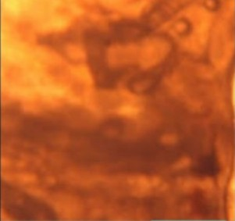

Mg X400

**Plate 1: *Ichthyophthirius multifilis***

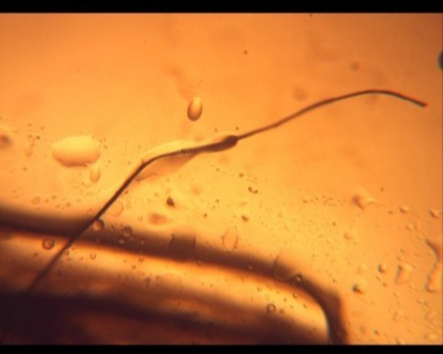

Mg X400

**Plate 2: *Trypanosoma cobitis***

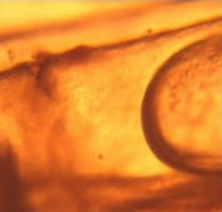

Mg X400

**Plate 3: *Myxosoma branchialis***

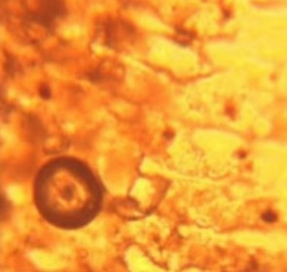

Mg X400

**Plate 4: *Myxidium oviforme***

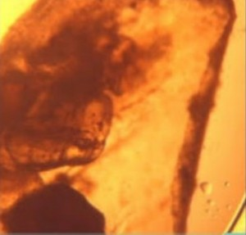

Mg X400

**Plate 5: *Eimeria rivirei***

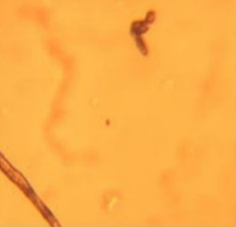

Mg X400

**Plate 6: *Chloromyxum mucronatum***

Six protozoan species—*Ichthyophthirius multifilis, Trypanosoma cobitis, Myxosoma branchialis, Myxidium oviforme, Eimeria rivirei,* and *Chloromyxum mucronatum*—were discovered over the course of the current investigation. *Ichthyophthirius multifilis* is the most common protozoan, whereas *Chloromyxum mucronatum* and *Eimeria rivirei* are the least common.

The results obtained from this investigation align with the research conducted by Omeji et al. (19), wherein *Ichthyophthirius multifilis* was identified as the primary parasite in *C. gariepinus* collected from both natural (River Benue) and cultured (pond) environments. According to (8), these protozoa can proliferate when the host fish is overloaded, which can lead to emaciation, weight loss, and mortality. Additionally, due of their innate feeding behaviour, they live in the intestine. The results were in conflict with the conclusions of the (1) research, which did not detect any *Ichthyophthirius multifilus* or cestodes.

Eimeria sp. (22.3%) was also found in fish intestines by (8); this species causes coccidiosis in fish and other animals. In their investigation, (8) found 5.3% of *Chloromyxum mucronatum* in fish intestines. In the current investigation, *Eimeria rivirei* and *Chloromyxum mucronatum* were also reported.

Fish gills and skin are made of epithelial tissues that are penetrated by many protozoa. The protozoan fish parasite *Ichthyophthirius multifilis*, sometimes known as "ich" or "white spot diseases," is arguably the most well-known.

According to (24), infection with *Ichthyophthirius multifilis* causes degradation of the epithelium and swelling of the gills. This could be explained by inflammatory processes that take place during this parasitic ciliate infection. Fish from the Great Kwa River in Calabar had protozoan infection in their stomachs and intestines, according to (6). (21); (11) report protozoan infections in fish gills, while (6) report protozoan cyst development. According to (5), *Trypanosoma* sp was found in the current investigation.

Interestingly, (14) described the first case of *Trypanosoma cobitis*, so this is the second record of that disease. Fish blood contains the hemoparasite *Trypanosoma cobitis*, which affects both freshwater and marine fish. Fish Additionally, (10), (13), (5), (25), and (26) reported finding parasitic trypanosomes in fish. It's important to remember that trypanosomiasis, which is primarily found in the wild, might weaken fish's immune systems.

Numerous parasite species can impact fish directly or indirectly, increasing their mortality rate. Fish infections are mostly caused by four primary types of parasites: nemathelminthes, acanthocephala, platyhelminthes (monogenean, digenean, cestodes), and protozoa (ciliates, flagellates, microsporidians, and myxozoans). Fish physiology contributes to the spread of deadly infections that cause large-scale deaths (15). The protozoa found were consistent with the findings of (12) and protozoan infection result in death, debilitation, and weight loss.

**Conclusion**

Protozoan acts as severe pathogen and makes fish more vulnerable to predator. This study provides information on the effect of protozoan on fish and its survival, fish act as hosts for numerous parasites; especially gastrointestinal (GI) helminths which are considered major fish parasites, causing intensive losses to the fish industry. Protozoans affect the diet, metabolism, and secretory functions of the digestive system, which causes severe damage to the nervous system and interrupts the normal reproduction of the fish. The parasitic threats are the major reason for the reduction in population.

**Disclaimer (Artificial intelligence)**

Option 1:

Author(s) hereby declare that NO generative AI technologies such as Large Language Models (ChatGPT, COPILOT, etc.) and text-to-image generators have been used during the writing or editing of this manuscript.

**References**

1. Adeogun, O.A, Oladosu, G.A, Akinwale, M.M.A, Okunade, O.A, Akintayo, I.A, Idika, N., Adeiga, A.A, Ezeugwu, S.M.C, Afocha, E.E, Peters, O.S. & Odusanya, A.F (2014). Identification, distribution, and prevalence of ectoparasites associated with cultured fish in Ogun State Nigeria. *Journal of Fisheries and Aquatic Science,* 9(5): 413-418
2. Adewole, S.O., Odeyemi, D.F., Fatunwase, O.P., Christopher, V.N., Omoyeni T.E. & Dada A.O. (2019). Parasites as Bioindicator for Health Status and Environmental quality of Freshwater Fish species in Ekiti State, Nigeria. *British Journal of Healthcare and Medical Research,* 6(2):1-7
3. Agboola, A.F., Omidiwura, R., Okiwelu, E.I. & Agbuza, S. (2021). Effects of dietary fish oil supplementation on performance, gut morphology, protozoan load and histopathological indices of broiler chickens. *Egyptian Poultry Science Journal*, 41: 249-263
4. Andronova, I.V. & Yakimovich, E.A. (2019). World fish market: Current trends, state and prospects. RUDN *Journal of Economics*, 27: 259-268
5. Biu, A.A., Diyawere, M.Y., Yakaka, W. & Joseph, E. (2014). Survey of Parasites infesting the Nile Tilapia *Oreochromis niloticus* Linnaeus 1758 From Lake Alau, Maiduguri Nigeria, *Nigerian Journal of fisheries and Aquaculture,* 2(2): 6 -12
6. Ekanem, A.P., Eyo, V.O. & Sampson, A.F. (2011). Parasites of landed fish from great Kwa River, Calabar Cross River State, Nigeria. *International Journal of Fisheries and Aquaculture*, 3(12):225-230
7. FAO (2015). FAOSTAT statistics database of the Food and Agricultural Organization of the United Nations (FAO). Rome, Italy. (http://faostat3.fao.org/〉
8. Gomes, G.B., Hutson K.S., Domingos, J.A., Chung, C., Hayward, S., Miller, T.L. & Jerry, D.R. (2017). Use of environmental DNA (eDNA) and water quality to predict protozoan parasites outbreaks in fish farms. *Aquaculture,* 479:467-473. doi.1016/j.aquaculture. 2017.06.017
9. Habib, S. (2007). Studies on the helminth parasites of a freshwater fish, Wallago attu. M.Sc. Thesis, Department of Zoology, Govt. College,Lahore, Pakistan. pp:35
10. Hassan, A.A., Akinsanya, B. & Adegbaju, W.A. (2007). Haemoparasites of *Clarias gariepinus* and *Synodontis clarias* from Lekki Lagoon, Lagos Nigeria. *J. American Sci*, 3: 61-67
11. Iyaji, F.O., Eyo, J.E., Falola, O.O. & Okpanachi, M.A. (2015).Parasites of *Synodontis sores* (Gunther 1866) Mockokidae Siluriformes in Rivers Niger and Benue at the Confluence area of Lokoja, Nigeria, *FUTA Journal of Research in Sciences,* (1):87-94.
12. Klinger, R.E. & Floyd, R.F. (2002). Introduction to fresh water fish parasite IR716. University of florida IFAS Extension.
13. Konas, E.,Genc E., Kaya, G. & Erol, C. (2010). Occurrence of *Trypanosoma* sp in wild African sharptooth catfish (*Clarias gariepinus* Burchell, 1822) in the River Asi (north-eastern Mediterranean), Turkey. *Turk J Zool*, 34:271-273
14. Letch, C.A. & Ball, S.J. (1979). Prevalence of *Trypanosoma cobitis* Mitrophanow, 1883 in fishes from the River Lee.*Parasitology,* 79:119-124
15. Lerssutthichawal, T., Manepitaksanti, W. & Puri, W. (2015). Monogeneans of potentially cultured Tilapias and first record of *Cichlidogyrus mbirizei* in Thailand. *Journal of Science and Technology,* 13:543-553
16. Maciel, P.O., Garcia, F., Chagas, E., Fujimoto, R.Y. & Tavares-Dia, M. (2018). Trichodinidae in commercial fish in South America. *Reviews in Fish Biology and Fisheries*, 28:33-56. doi:10.1007/s11160-017-9496-5
17. Manbe, M.Y., Adamu, M.K., Ismail, Abdulmar, M. & Kanki, H. (2020). Prevalence of protozoan parasites in some freshwater fishes of Dangana Lake Lapai, Niger State Nigeria*. Aquaculture*, 4: 6
18. Markevich, A.P. (1963). Parasitic fauna of freshwater fish of the Ukrainian SSR old bourne press. London EC4 388pp
19. Omeji, S., Solomon, S.G. & Idoge, E.S. (2013). A comparative study of the common protozoan parasites of *Clarias gariepinus* from the wild and cultured Environment in Benue State, Nigeria. *Journal of Agriculture and Veterinary Science*, 2(1):45-49
20. Omeji, S., Tiamiyu, L.O., Annune, P.A. & Solomon, S.G. (2014). Ecto and Intestinal parasites of *Malapterurus electricus* from Upper Benue River, *Journal of global Biosciences,* 3(6):895-903
21. Oniye, S.J., Adebote, D.A. & Ayanda, O.I. (2004). Helminth parasites of *Clarias gariepinus* in Zaria, Nigeria. *Journal of Aquatic Science*s, 19(2):71-76
22. Saha & Bandyopadhyay (2017). Seasonal incidence of protozoan parasitic infestation in ornamental fishes of West Bengal, India. *Journal of Parasitic Diseases*, 41:523-526. doi:10.1007/s12639-016-0823-7
23. Santos, M.A., Peixoto, J., Madi, R.R. & Esposito, T. (2018). Protozoan and metazoan parasites of juvenile tambaqui *Colossoma macropomum* farmed in the lower São Francisco, Brazil. *Acta of Fisheries and Aquatic Resources,* 6:29-34
24. Sigh, J., Lindenstrom, T. & Buchrnann, K. (2004). Expression of pro-inflamatory cytokines in rainbow trout (*Oncorhynchus mykiss*) during an infection with *Ichthyophthirius multifilis*. *Fish and Shellfish Immunology*, 17(1):75-86. doi:10.1016/j.fsi.2003.12.003
25. Smit, N.J., Davies, A.J. & Van As, J.G. (2000). A Trypanosome from the Silver Catfish (*Schilbe intermedius*) in the Okavango Delta, Botswana*. Bull. Eur. Assoc. Fish Pathol*., 20:116-119
26. Smit, N.J., Van As, J.G. & Davies, A.J. (2004). Fish trypanosomes from the Okavango Delta, Botswana. *Folia Parasitol*., 51:299-303. doi:10.14411/fp.2004.036
27. Wang, Q., Yu, Y., Zhang, X. & Xu, Z. (2019). Immune responses of fish to *Ichthyophthirius multifilis* (Ich): A model for understanding immunity against protozoan parasites. *Developmental & Comparative Immunology,* 93:93-102. doi:10:1016/j.dci.2018.12.008