A FUZZY COST OPTIMIZATION APPROACH IN SMART WASTE COLLECTION FM/FM/1 QUEUEING SYSTEM WITH HEXAGONAL NUMBERS

ABSTRACT:
This study presents a novel approach for managing parameter uncertainty in FM/FM/1 queueing systems through cost optimization using six-point hexagonal fuzzy numbers. By modeling arrival rates, service costs, and waiting costs as hexagonal fuzzy numbers, the proposed method offers a more precise and realistic representation of uncertainty compared to traditional fuzzy models. A unified framework is developed to determine optimal service rates and total costs in both crisp and fuzzy environments, with defuzzification performed via the signed distance method. To demonstrate the practical relevance, a case study on smart waste collection in urban infrastructure is explored. In this scenario, sensor-equipped garbage bins deployed across city zones monitor fill levels and generate service requests upon reaching capacity. The variability in waste accumulation and collection conditions is effectively captured using fuzzy parameters. Numerical and graphical analyses confirm the model’s ability to optimize operations under uncertainty, making it a valuable tool for sustainable and efficient urban service management.

KEY WORDS:
FM/FM/1 queueing system, Hexagonal fuzzy numbers, Crisp model, Fuzzy model, Signed distance Defuzzification method, Sensitivity analysis, Fuzzified optimal total cost.

INTRODUCTION
The foundational concept of fuzziness in decision-making was introduced by Bellman and Zadeh (1970), who explored fuzzy environments in management science, laying the groundwork for fuzzy logic in operational systems. Later, Zadeh (1978) expanded on this by formulating fuzzy sets as the basis for possibility theory. Klir and Yuan (1995) compiled these early advances into a comprehensive reference on fuzzy sets and logic, serving as a core text for fuzzy systems. Moving into applied queueing systems, Nathan and Kharoufeh (2006) studied unreliable servers in M/M/1 retrial queues, while Mishra and Shukla (2009) and Mishra and Yadav (2010) addressed cost and profit analysis in machine interference and clocked queuing networks respectively.
The decade saw a transition into fuzzy modeling, starting with Pardo and Fuente (2010) who applied fuzzy Markov decision processes to queuing systems. Around the same time, Ritha and Robert (2010) developed fuzzy queues with priority disciplines. Barak and Fallahnezhad (2012) provided a direct cost analysis of fuzzy queueing systems, bringing practical financial interpretation into fuzzy environments. Palpandi and Geetharamani (2013) utilized robust ranking techniques to evaluate bulk arrival queues with fuzzy parameters. The simulation aspect was advanced by Enrique and Enrique (2014) with models handling variable servers and rates. Shanmugasundaram et al. (2015) focused on single-server fuzzy queues, while Sundari and Palaniammal (2015) applied neural networks to M/M/1 simulations. Fathi-Vajargah and Ghasemalipour (2016) developed a simulation of random fuzzy multi-server queues.
Sharma (2016) and Singh et al. (2016) investigated optimal control and reneging in queueing models. Gou et al. (2017) introduced hesitant fuzzy linguistic entropy for decision-making in queuing. Kannadasan and Sathiyamoorthi (2018) analyzed M/M/1 queues with working vacations under fuzziness. Priya and Sudhesh (2018) provided transient analysis of discrete-time queues. Hidayah et al. (2019) compared traditional and fuzzy queuing models at airport counters. Prameela and Kumar (2019) addressed FM/FEk/1 queues using various fuzzy numbers. Chen et al. (2020) analyzed strategic customer behaviour in fuzzy queues, while Singh et al. (2020) optimized fuzzy Markovian queues. In recent years, Palaniammal and Pradeep (2024, 2025) have produced significant work on cost-benefit and state-dependent bulk queue analysis, and introduced trapezoidal and fuzzy approaches to M/M/1 cost optimization. Sutthibutr et al. (2025) extended fuzzy applications to supply chain production planning using fuzzy multi-criteria decision-making.
Markovian queues have been a major focus in queuing theory research. Researchers have found that fuzzy queuing models outperform crisp ones in Markovian queues due to their greater realism in real-world scenarios. For instance, it is more possibilistic than probabilistic to discuss the mean arrival rate, mean service rate, or both. However, we also concur that whereas arrivals and services at service stations are entirely probabilistic, their numerical formulations are possibilistic.
In addition, fuzzy queuing models have a wider variety of applications than crisp ones since they are more realistic. Queuing models may be divided into two categories. The first is referred to as descriptive and the second as normative. Normative queuing models are those that should be the best fit for the circumstances, whereas descriptive models are ones that actually occur in real-world settings. This model optimizes several queuing model characteristics, including arrival, service, number of servers, queue discipline and controls. Consequently, the descriptive model is a real-situation queuing model, whereas the normative model is an aspirational one. Queuing decision models, sometimes referred to as design and control models, represent the second category of queuing models.
This class of models makes an effort to determine the model's optimal parameters. Among control models, queuing models' service control is dependent on metrics like service rate, server count, queue discipline, or a mix of these. Changing the number of consumers coming, allocating arrivals to certain servers, or establishing tolls or other workable restrictions, such as structuring the physical area and working shift can also help manage arrivals. Recently, there has been a shift in the tendency toward optimizing the queuing model with unknown input data. The fuzzy paradigm is used to try to determine the model based on the input data's uncertainty. Several approaches have been developed to address the design and control models of queues, focusing on performance measures where cost coefficients, as well as arrival and service characteristics, are precisely known.
The structure of the paper is as follows:
In Section 2, Preliminaries and notations were given.
In Section 3, The model development and a real-time example were presented.
In Section 4, The methodological framework for the Hexagonal model was provided.
In Section 5, The novel contribution of the study was clearly explained.
In Section 6, A fuzzy mathematical formulation was developed for the Hexagonal model.
In Section 7, The hexagonal model was illustrated numerically and graphically.
In Section 8, A performance variability analysis was conducted for the Hexagonal model.
In Section 9, Conclusions along with numerical results were derived.

PRELIMINARIES AND NOTATIONS

The following preliminaries and notations are used in this paper:

Defnition 1. Crisp set: A precise, deterministic value with no ambiguity.
Defnition 2. Fuzzy set: A value represented by a membership function to capture uncertainty.

Defnition 3. Defuzzification: The process of converting a fuzzy number into a crisp value for decision-making.

Defnition 4. Signed Distance Method: A defuzzification technique that computes the weighted average of a fuzzy number’s α-cut bounds, emphasizing symmetry.

Defnition 5. Alpha Cut level: A confidence interval ${[x}_{low},x_{high}]$ derived from a fuzzy number
at $∈[0,1]$ .

Defnition 6. Performance analysis: Evaluating how changes in inputs Arrival rate, Service cost and Waiting cost affect outputs in Service rate and total cost in crisp and fuzzy.

NOTATIONS
$_\left(TC\right) =Optimal Total Cost (OTC),$
$$_k = Service cost per unit (SC),$$
$$_c = Waiting cost per unit (WC),$$
$$_λ = Arrival rate of customer (ARC),$$
$$_μ = Optimal Service rate (SR),$$
$$_μ^{*} = Fuzzified Optimal Service Rate (FOSR),$$
$$_k^{*} = Fuzzified Service cost per unit (FSC),$$
$${_c}^{*} = Fuzzified Waiting cost per unit (FWC),$$
$$_λ^{*} = Fuzzified Arrival Rate (FAR),$$
${_\left(TC\right)}^{*}=Fuzzified Optimal Total Cost (FOTC)$

- MODEL DEVELOPMENT AND REAL TIME EXAMPLE

Here, we examine FM/FM/1: FCFS / ∞ / ∞ both arrival and service follow the Poisson probability rule. The estimated numbers of clients in the line and the system’s projected waiting time, as well as the service utilization factor or busy period, are some of the queuing model's operational features and performance metrics. These operation characteristics are the focus of most articles, but there is a lack of study on the queuing system's optimal overall cost, especially in fuzzy environments. Two key expenses waiting costs and service costs that are in conflict with one another are the basis for the cost model of a queuing system. This suggests that waiting would become more expensive if the quality of service declined. The ideal total cost of the queuing system under discussion can be used to describe the cost model as a performance metric.

REAL TIME EXAMPLE
This case study investigates a novel and environmentally conscious application of the FM/FM/1 queueing model under fuzzy conditions in the context of smart waste collection in urban infrastructure. In a smart city setting, sensor-equipped garbage bins are strategically deployed across residential and commercial zones. These sensors continuously monitor fill levels and, upon reaching a threshold, transmit signals to the municipal system requesting garbage collection. To prevent issues such as bin overflow, foul odours and environmental degradation, garbage trucks are dispatched promptly based on these signals. This collection process can be effectively modelled as a queueing system, where incoming signals from bins represent customer arrivals and collection trucks act as servers. However, the exact rate at which bins reach capacity is uncertain due to various dynamic factors, including the type of area (residential or commercial), public events (festivals, holidays), and weather conditions that influence outdoor activity and waste generation.
To capture this imprecision, the arrival and service processes are modelled using hexagonal fuzzy numbers, which offer a flexible and realistic means of representing uncertainty compared to simpler triangular or trapezoidal fuzzy numbers. The FM/FM/1 queueing system incorporates fuzzy arrival rates ($_λ$) and fuzzy service rates ($_μ$), both expressed as hexagonal fuzzy numbers. These parameters are derived from real-time municipal data such as bin sensor readings, collection logs and zone-specific activity patterns.
For instance, a sample fuzzy arrival rate may be represented as
$Arrival rate \left(λ\right)=\left(19,21,23,25,27,29\right)$bins/hour,${Waiting cost (Cw}_{ })=\left(23,25,27,29,31,33\right)$bins/hour,
$Service cost \left(Cs\right)=\left(27,29,31,33,35,37\right)$trucks/hour.
With these fuzzy parameters, key performance measures such as the expected number of bins in the system To interpret these fuzzy measures for decision-making, defuzzification is carried out using the Signed Distance Method (SDM), which yields crisp estimates while retaining the embedded uncertainty.
Furthermore, a fuzzy total cost function is constructed to optimize the waste collection process. This function incorporates fuzzy waiting cost per bin per hour ​ and fuzzy service cost per truck per hour resulting in a total cost expression. The model is then applied to a numerical example with realistic input values, and results are analyzed across different fuzzy environments to demonstrate the sensitivity and adaptability of the system. Graphs and tables are used to illustrate performance trends and cost behaviour under varying degrees of uncertainty.

- METHODOLOGY FRAMEWORK FLOWCHART
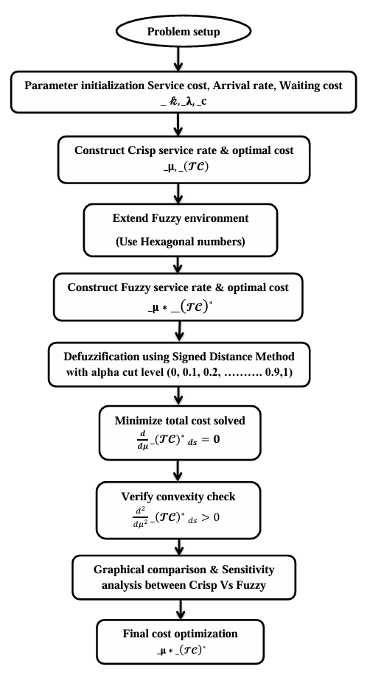
FIG 1: Flow chart showing study framework

- RESEARCH CONTRIBUTION
This study contributes to the field of queueing theory under uncertainty by developing a robust cost optimization framework for FM/FM/1 systems using hexagonal fuzzy numbers. It introduces both theoretical advancements and practical tools for decision-making in environments with uncertain or imprecise parameters.

Key contributions include:
- Introduction of Hexagonal Fuzzy Numbers: The paper pioneers the use of six-point hexagonal fuzzy numbers to model key queueing parameters arrival rate, service cost, and waiting cost providing a more realistic and flexible representation of uncertainty than traditional triangular or trapezoidal forms. This enhances applicability in complex real-world systems, such as smart city services.
- Fuzzy Cost Optimization Framework: A complete analytical formulation for determining the optimal service rate and total cost is developed for the FM/FM/1 model, first under crisp parameters and then extended to fuzzy settings using fuzzy arithmetic.
- Defuzzification via Signed Distance Method (SDM): The fuzzy optimal service rate and total cost are defuzzified using SDM, which maintains the central tendency and dispersion of hexagonal fuzzy numbers more effectively than centroid or max-membership methods ensuring clearer and more reliable decision-making outputs.
- Performance Analysis and Visualization: Sensitivity analysis identifies the most influential parameters, supporting system robustness assessments and resource prioritization. Comparative graphs including crisp vs. fuzzy outputs and α-cut based trends enhance interpretability and aid managerial insight.
- Case Study: Smart Waste Collection in Smart Cities: The proposed model is applied to a real-world case of smart waste management, where sensor-equipped bins transmit collection requests to a central system. The uncertainty in request arrivals, traffic conditions, and service costs is effectively handled using the fuzzy optimization model, enabling cost-efficient and environmentally responsive scheduling in urban infrastructure. This integrative approach bridges the gap between fuzzy theory and sustainable urban applications, offering a decision support tool that is both analytically sound and practically impactful.

6. FUZZY MATHEMATICAL FORMULATION
The cost model can be expressed as
$_\left(TC\right)=_k_μ+_c*_E(n^{*})$ (1)
$_\left(TC\right)=_k_μ+\frac{_c_λ}{_μ-_λ}$ ( 2 )
Where $_k$ = cost of service rate per unit time, $_c$ = cost of waiting customers per unit time
and $_E(n^{*})$= average number of customers in the system.
Total cost function is defined as
$_\left(TC\right)=_k_μ+\frac{_c_λ}{_μ-_λ}$ (3)
For minimum cost w.r.t to service , we have
$\frac{d}{dμ}\left[_\left(TC\right)\right]=\frac{d}{dμ}\left[_k_μ+\frac{_c_λ}{_μ-_λ}\right]=_k- \frac{_c_λ}{{\left(_μ-_λ\right)}^{2}}=0$ (4)

For minimum cost, we must have
$\frac{d^{2}}{dμ^{2}}\left[_\left(TC\right)\right]=\frac{2_c_λ}{{(_μ-_λ)}^{3}}>0$ (5)
Further we define a Hexagonal number $A^{*}=(a^{*},b^{*},c^{*},d^{*},e^{*},f^{*})$ with membership function
$μ_{A}(x)=\left\{\begin{matrix}0 x^{*}≤a^{*} \\ \begin{matrix}\frac{x^{*}-a^{*}}{b^{*}-a^{*}}, a^{*}<x^{*}≤b^{*} \\ \begin{matrix} 1 b^{*}<x^{*}≤d^{*} \\ \begin{matrix}\frac{f^{*}-x^{*}}{f^{*}-e^{*}}, d^{*}<x^{*}≤e^{*} \\ 0 x^{*}≥f^{*}\end{matrix}\end{matrix}\end{matrix}\end{matrix}\right\}$ (6)
Now we wish to fuzzify cost coefficients and arrival rates $_k,_c,_λ$ with the help of Hexagonal fuzzy numbers as $_k^{*},_c^{*},_λ^{*}$ respectively.
$_k^{*}=({_k}_{1}, _k_{2},{_k}_{3},{_k}_{4},{_k}_{5},{_k}_{6})$, $_c^{*}=({_c}_{1},{_c}_{2},{_c}_{3},{_c}_{4},{_c}_{5},{_c}_{6}),_λ^{*}=(_λ_{1},_λ_{2},_λ_{3},_λ_{4},_λ_{5},_λ_{6})$
${_\left(TC\right)}^{*} =_k^{*}{_μ}^{*}+\frac{_c^{*}{_λ}^{*}}{{_μ}^{*}-{_λ}^{*}}$ (7)
Which implies that
${_\left(TC\right)}^{*}=({_k}_{1}_μ, _k_{2}_μ,{_k}_{3}_μ,{_k}_{4}_μ,{_k}_{5}_μ,{_k}_{6}_μ)+$
$\left(\frac{c_λ_{1}}{-_λ_{1}},\frac{{_c}_{2}_λ_{2}}{-{_λ}_{2}},\frac{{_c}_{3}_λ_{3}}{-{_λ}_{3}},\frac{{_c}_{4}_λ_{4}}{-{_λ}_{4}},\frac{{_c}_{5}_λ_{5}}{-{_λ}_{5}},\frac{{_c}_{6}_λ_{6}}{_μ-_λ_{6}}\right)$ (8)
${ _\left(TC\right)}^{*} =\left(P,Q,R,S,T,U\right) where P={_k}_{1}_μ {_c}_{1}, Q={_k}_{2}_μ {_c}_{2}, R={_k}_{3}_μ {_c}_{3},$
$S={_k}_{4}_μ {_c}_{4},T={_k}_{5}_μ {_c}_{5} , U={_k}_{6}_μ- \frac{{_c}_{6}_λ_{6}}{_μ-{_λ}_{6}}$ (9)
Now we define
${{_\left(TC\right)}^{*}}_{ds}=\frac{1}{2}\left[\int_{0}^{1}{\left({_c}_{L}(ε)+{_c}_{R}(ε)\right)ε dε}\right]$ (10)
$\frac{d}{dμ}{{_\left(TC\right)}^{*}}_{ds}= \frac{1}{4}\left[\left({_k}_{1}+_k_{2}+{_k}_{3}+{_k}_{4}+{_k}_{5}\right)-\frac{{_c}_{5}_λ_{5}}{_μ-{_λ}_{5}}\right]$ (11)
For minimum$\frac{d}{dμ}{{_\left(TC\right)}^{*}}_{ds}=0$ with sufficient condition
$\frac{d^{2}}{{dμ}^{2}}{{_\left(TC\right)}^{*}}_{ds}= \frac{1}{2}\left(\frac{{_c}_{5}_λ_{5}}{{(__μ-{_λ}_{5})}^{3}}\right)>0$
which ultimately gives us $\left({_k}_{1}+_k_{2}+{_k}_{3}+{_k}_{4}+{_k}_{5}\right)*{\left(_μ-{_λ}_{5}\right)}^{3}-{_c}_{5}_λ_{5}=0$ (12)

NUMERICAL RESULTS AND GRAPHICAL ANALYSIS
  - RESULTS OBTAINED FOR CRISP AND FUZZY MODEL
This nonlinear equation is solved using the Signed Distance Defuzzification method with different alpha cut levels offers an efficient way to handle and understand fuzzy input parameters. The optimal service rate _µ and optimal total cost $_\left(TC\right)$ for the crisp model, as well as the fuzzy model's fuzzified optimal service rate _µ* and fuzzified optimal total cost ${_\left(TC\right)}^{*}$, have been computed numerically and graphically.
The results obtained for the crisp model are presented in Tables 1-3.
The results obtained for the fuzzy model are presented in Tables 4-6.

Table 1: Computation table for Service cost and Total Cost

 | $$_k$$ | $$_c$$ | _λ | _μ | $$_\left(TC\right)$$
Case 1 | 27 | 23 | 19 | 23.02 | 730.25
Case 1 | 29 | 23 | 19 | 22.88 | 776.15
Case 1 | 31 | 23 | 19 | 22.75 | 821.78
Case 1 | 33 | 23 | 19 | 22.64 | 867.17
Case 1 | 35 | 23 | 19 | 22.53 | 912.35
Case 1 | 37 | 23 | 19 | 22.44 | 957.31

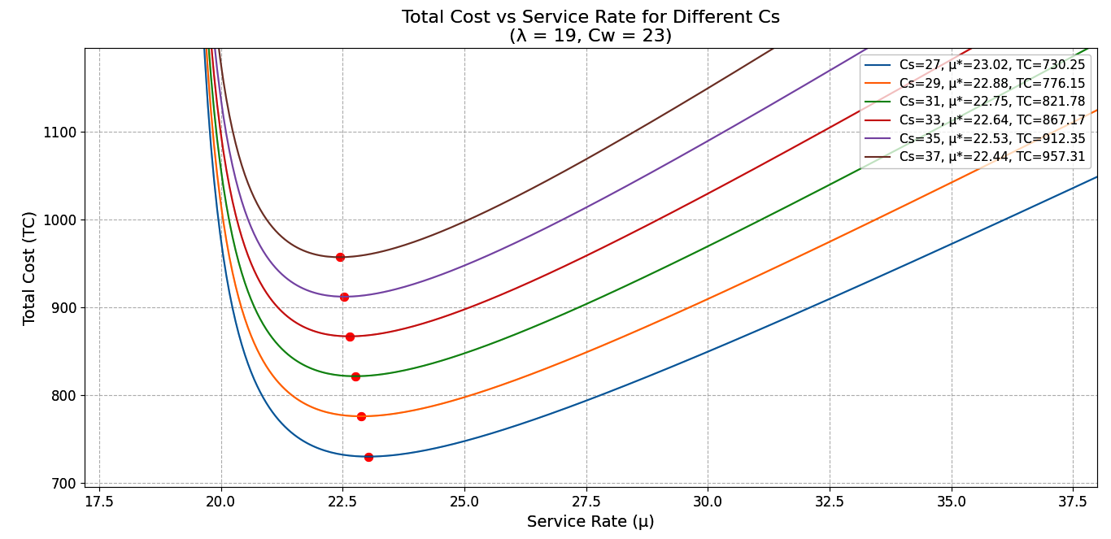
Fig 2 - Service cost Vs Total Cost

Table 2: Computation table for Waiting Cost and Total Cost

 | $$_c$$ | _$k$ | _λ | _μ | $$_\left(TC\right)$$
Case 2 | 23 | 27 | 19 | 23.02 | 730.25
Case 2 | 25 | 27 | 19 | 23.19 | 739.50
Case 2 | 27 | 27 | 19 | 23.36 | 748.38
Case 2 | 29 | 27 | 19 | 23.52 | 756.94
Case 2 | 31 | 27 | 19 | 23.67 | 765.21
Case 2 | 33 | 27 | 19 | 23.82 | 773.22

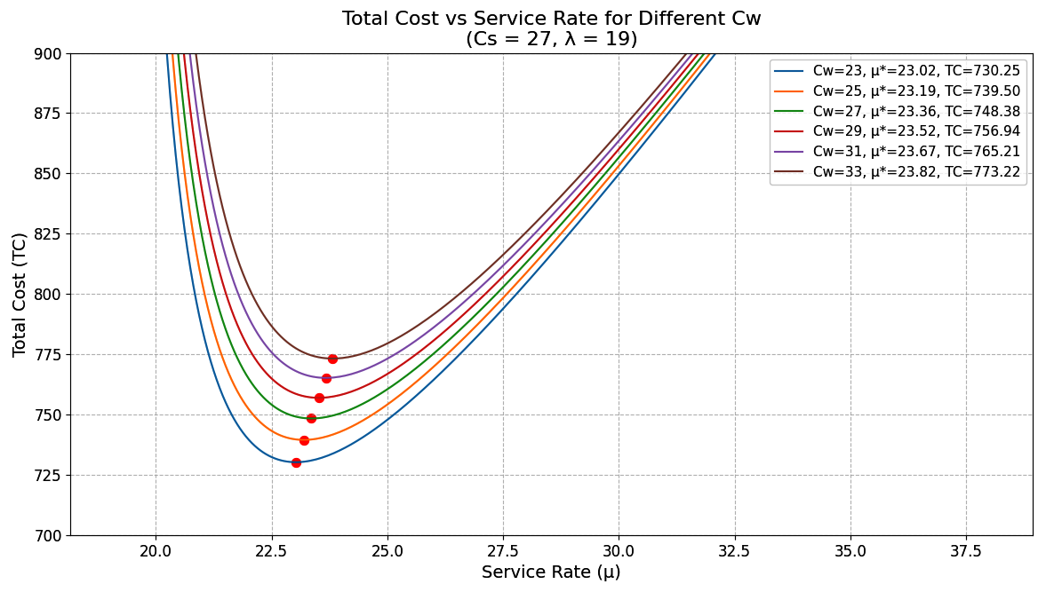
Fig 3 - Waiting Cost Vs Total Cost

Table 3: Computation table for Arrival rate and Total Cost

 | _λ | $$_c$$ | _$k$ | _ μ | $$_\left(TC\right)$$
Case 3 | 19 | 27 | 23 | 23.02 | 730.25
Case 3 | 21 | 27 | 23 | 25.23 | 795.39
Case 3 | 23 | 27 | 23 | 27.43 | 860.02
Case 3 | 25 | 27 | 23 | 29.61 | 924.20
Case 3 | 27 | 27 | 23 | 31.80 | 987.97
Case 3 | 29 | 27 | 23 | 33.97 | 1051.40

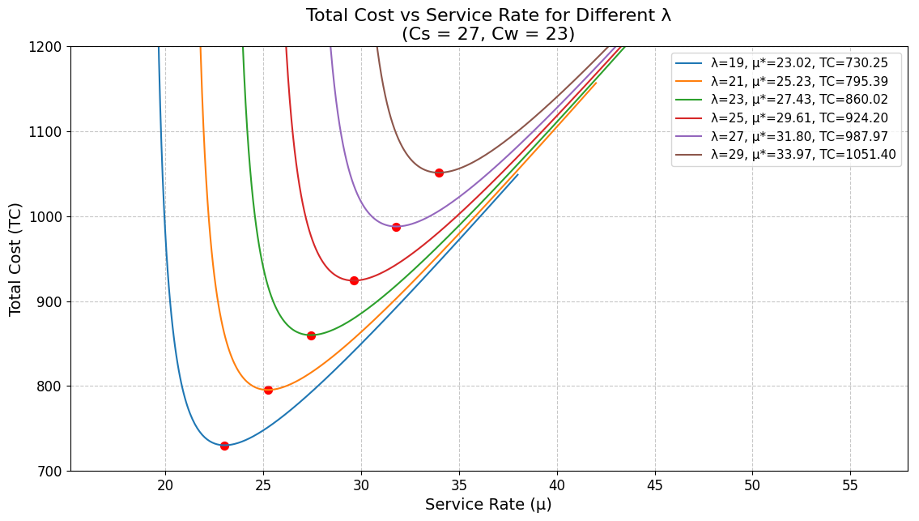

Fig 4 - Arrival rate Vs Total Cost

Table 4: Computation table for Fuzzified Service cost _$k$ * & Fuzzified Optimal Total Cost ${_\left(TC\right)}^{*}$

 | $_k$ * |  |  |  |  |  | _c* |  |  |  |  |  | _λ* |  |  |  |  |  | _μ* | $${_\left(TC\right)}^{*}$$
Case 4 | $${ _k}_{1}$$ | $${ _k}_{2}$$ | $${ _k}_{3}$$ | $${ _k}_{4}$$ | $${ _k}_{5}$$ | $${ _k}_{6}$$ | ${_c}_{1}$ | ${_c}_{2}$ | ${_c}_{3}$ | ${_c}_{4}$ | ${_c}_{5}$ | ${_c}_{6}$ | _λ1 | _λ2 | _λ3 | _λ4 | _λ5 | _λ6 | _μ* | $${_\left(TC\right)}^{*}$$
Case 4 | 22 | 24 | 26 | 28 | 30 | 32 | 18 | 20 | 22 | 24 | 26 | 28 | 14 | 16 | 18 | 20 | 22 | 24 | 23.02 | 663.86
Case 4 | 24 | 26 | 28 | 30 | 32 | 34 | 18 | 20 | 22 | 24 | 26 | 28 | 14 | 16 | 18 | 20 | 22 | 24 | 22.88 | 705.59
Case 4 | 26 | 28 | 30 | 32 | 34 | 36 | 18 | 20 | 22 | 24 | 26 | 28 | 14 | 16 | 18 | 20 | 22 | 24 | 22.75 | 747.08
Case 4 | 28 | 30 | 32 | 34 | 36 | 38 | 18 | 20 | 22 | 24 | 26 | 28 | 14 | 16 | 18 | 20 | 22 | 24 | 22.64 | 788.34
Case 4 | 30 | 32 | 34 | 36 | 38 | 40 | 18 | 20 | 22 | 24 | 26 | 28 | 14 | 16 | 18 | 20 | 22 | 24 | 22.53 | 829.41
Case 4 | 32 | 34 | 36 | 38 | 40 | 42 | 18 | 20 | 22 | 24 | 26 | 28 | 14 | 16 | 18 | 20 | 22 | 24 | 22.44 | 870.29

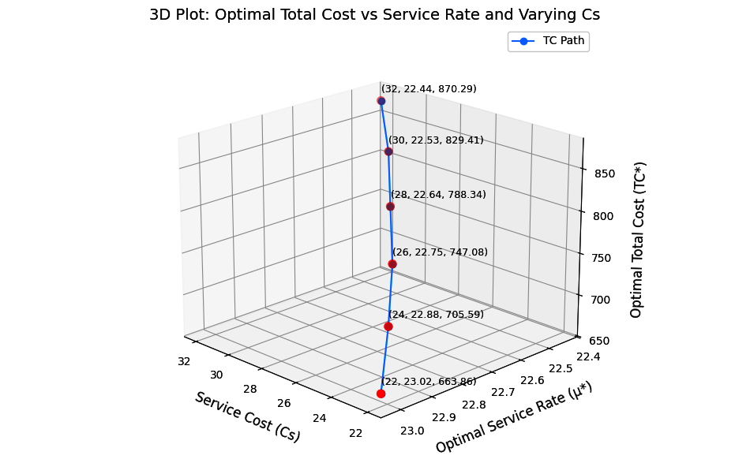
Fig 5 - Fuzzified Service cost Vs Fuzzified Optimal Total Cost

Table 5: Computation table for Fuzzified Waiting cost $_ c$ *& Fuzzified Optimal Total Cost ${_\left(TC\right)}^{*}$

 | ${_c}^{*}$ |  |  |  |  |  | ${_k}^{*}$ |  |  |  |  |  | _λ* |  |  |  |  |  | _μ* | $${_\left(TC\right)}^{*}$$
Case 5 | ${_c}_{1}$ | ${_c}_{2}$ | ${_c}_{3}$ | ${_c}_{4}$ | ${_c}_{5}$ | ${_c}_{6}$ | $${ _k}_{1}$$ | $${ _k}_{2}$$ | $${ _k}_{3}$$ | $${ _k}_{4}$$ | $${ _k}_{5}$$ | $${ _k}_{6}$$ | _λ1 | _λ2 | _λ3 | _λ4 | _λ5 | _λ6 | _μ* | $${_\left(TC\right)}^{*}$$
Case 5 | 18 | 20 | 22 | 24 | 26 | 28 | 22 | 24 | 26 | 28 | 30 | 32 | 14 | 16 | 18 | 20 | 22 | 24 | 23.02 | 663.86
Case 5 | 20 | 22 | 24 | 26 | 28 | 30 | 22 | 24 | 26 | 28 | 30 | 32 | 14 | 16 | 18 | 20 | 22 | 24 | 23.19 | 672.27
Case 5 | 22 | 24 | 26 | 28 | 30 | 32 | 22 | 24 | 26 | 28 | 30 | 32 | 14 | 16 | 18 | 20 | 22 | 24 | 23.36 | 680.35
Case 5 | 24 | 26 | 28 | 30 | 32 | 34 | 22 | 24 | 26 | 28 | 30 | 32 | 14 | 16 | 18 | 20 | 22 | 24 | 23.52 | 688.13
Case 5 | 26 | 28 | 30 | 32 | 34 | 36 | 22 | 24 | 26 | 28 | 30 | 32 | 14 | 16 | 18 | 20 | 22 | 24 | 23.67 | 695.65
Case 5 | 28 | 30 | 32 | 34 | 36 | 38 | 22 | 24 | 26 | 28 | 30 | 32 | 14 | 16 | 18 | 20 | 22 | 24 | 23.82 | 702.93

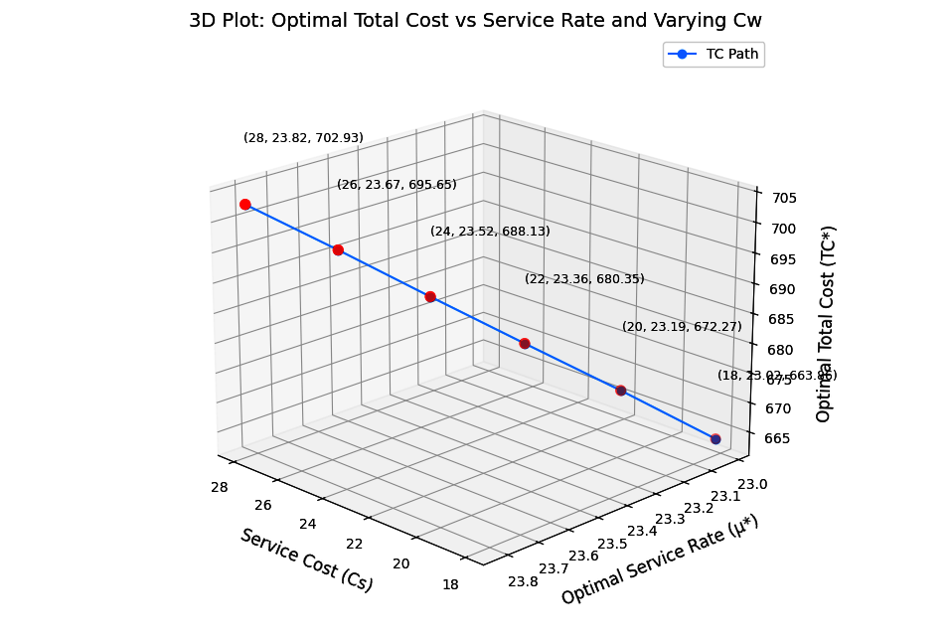
Fig 6 - Fuzzified Waiting cost Vs Fuzzified Optimal Total Cost

Table 6: Computation table for Fuzzified Arrival Rate _λ* & Fuzzified Optimal Total Cost ${_\left(TC\right)}^{*}$

 | _ λ * |  |  |  |  |  | $${_k}^{*}$$ |  |  |  |  |  | ${_c}^{*}$ |  |  |  |  |  | _μ* | $${_\left(TC\right)}^{*}$$
Case 6 | _λ1 | _λ2 | _λ3 | _λ4 | _λ5 | _λ6 | $${ _k}_{1}$$ | $${ _k}_{2}$$ | $${ _k}_{3}$$ | $${ _k}_{4}$$ | $${ _k}_{5}$$ | $${ _k}_{6}$$ | ${_c}_{1}$ | ${_c}_{2}$ | ${_c}_{3}$ | ${_c}_{4}$ | ${_c}_{5}$ | ${_c}_{6}$ | _μ* | $${_\left(TC\right)}^{*}$$
Case 6 | 14 | 16 | 18 | 20 | 22 | 24 | 22 | 24 | 26 | 28 | 30 | 32 | 18 | 20 | 22 | 24 | 26 | 28 | 23.02 | 663.86
Case 6 | 16 | 18 | 20 | 22 | 24 | 26 | 22 | 24 | 26 | 28 | 30 | 32 | 18 | 20 | 22 | 24 | 26 | 28 | 25.23 | 723.09
Case 6 | 18 | 20 | 22 | 24 | 26 | 28 | 22 | 24 | 26 | 28 | 30 | 32 | 18 | 20 | 22 | 24 | 26 | 28 | 27.43 | 781.84
Case 6 | 20 | 22 | 24 | 26 | 28 | 30 | 22 | 24 | 26 | 28 | 30 | 32 | 18 | 20 | 22 | 24 | 26 | 28 | 29.61 | 840.18
Case 6 | 22 | 24 | 26 | 28 | 30 | 32 | 22 | 24 | 26 | 28 | 30 | 32 | 18 | 20 | 22 | 24 | 26 | 28 | 31.80 | 898.16
Case 6 | 24 | 26 | 28 | 30 | 32 | 34 | 22 | 24 | 26 | 28 | 30 | 32 | 18 | 20 | 22 | 24 | 26 | 28 | 33.97 | 955.81

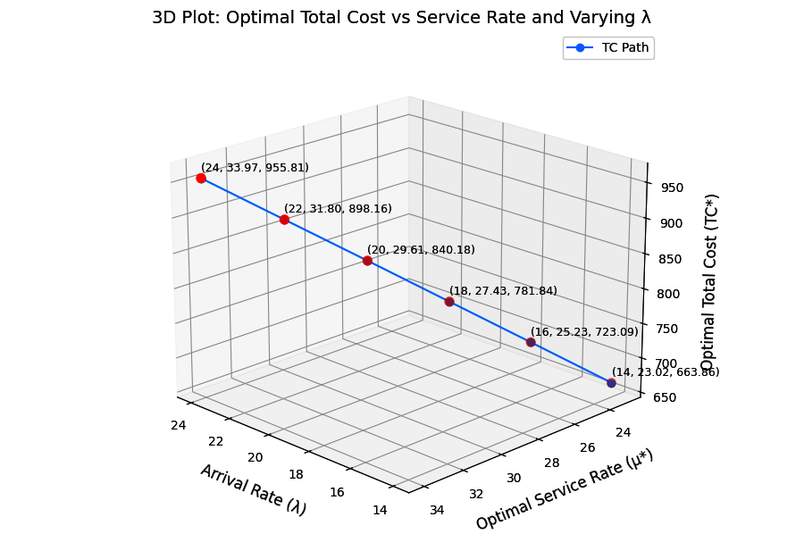
Fig 7 - Fuzzified Arrival Rate Vs Fuzzified Optimal Total Cost

Table 7: Comparison chart for Crisp value Vs Fuzzy value under $_k$ &_$k$ *

$_k$ &_$k$ * | _μ* | $$_\left(TC\right)$$ | $${_\left(TC\right)}^{*}$$
27 | 23.02 | 730.25 | 663.86
29 | 22.88 | 776.15 | 705.59
31 | 22.75 | 821.78 | 747.08
33 | 22.64 | 867.17 | 788.34
35 | 22.53 | 912.35 | 829.41
37 | 22.44 | 957.31 | 870.29

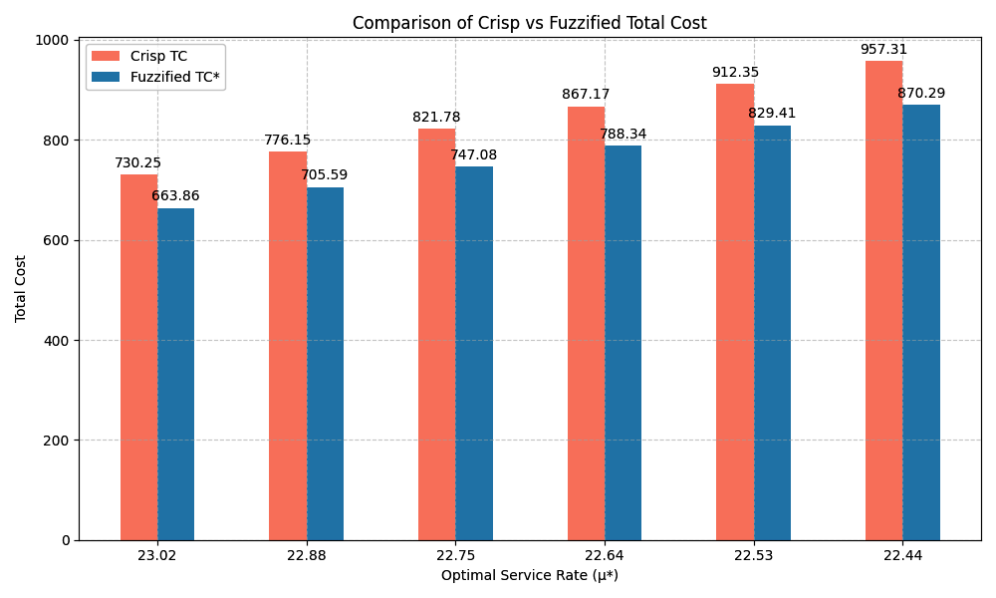
Fig 8 - Crisp value Vs Fuzzy value under Service cost

According to the analysis, both crisp and fuzzified total costs rise as the service cost rises.

Table 8: Comparison chart for Crisp value Vs Fuzzy value under $_c$ & ${_c}^{*}$

$_c$ & ${_c}^{*}$ | _μ* | $$_\left(TC\right)$$ | $${_\left(TC\right)}^{*}$$
23 | 23.02 | 730.25 | 663.86
25 | 23.19 | 739.50 | 672.27
27 | 23.36 | 748.38 | 680.35
29 | 23.52 | 756.94 | 688.13
31 | 23.67 | 765.21 | 695.65
33 | 23.82 | 773.22 | 702.93

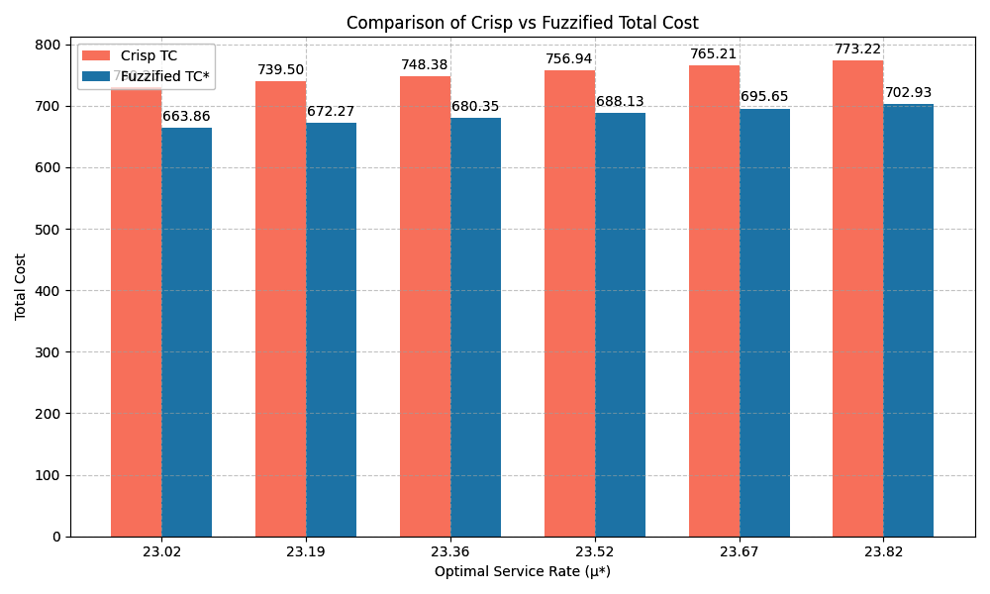
Fig 9 - Crisp value Vs Fuzzy value under Waiting cost
According to the analysis, both crisp and fuzzified total costs rise as the Waiting cost rises.
Table 9: Comparison chart for Crisp value Vs Fuzzy value under $_λ \&_λ^{*}$
$$_λ \&_λ^{*}$$ | _μ* | $$_\left(TC\right)$$ | $${_\left(TC\right)}^{*}$$
19 | 23.02 | 730.25 | 663.86
21 | 25.23 | 795.39 | 723.09
23 | 27.43 | 860.02 | 781.84
25 | 29.61 | 924.20 | 840.18
27 | 31.80 | 987.97 | 898.16
29 | 33.97 | 1051.40 | 955.81

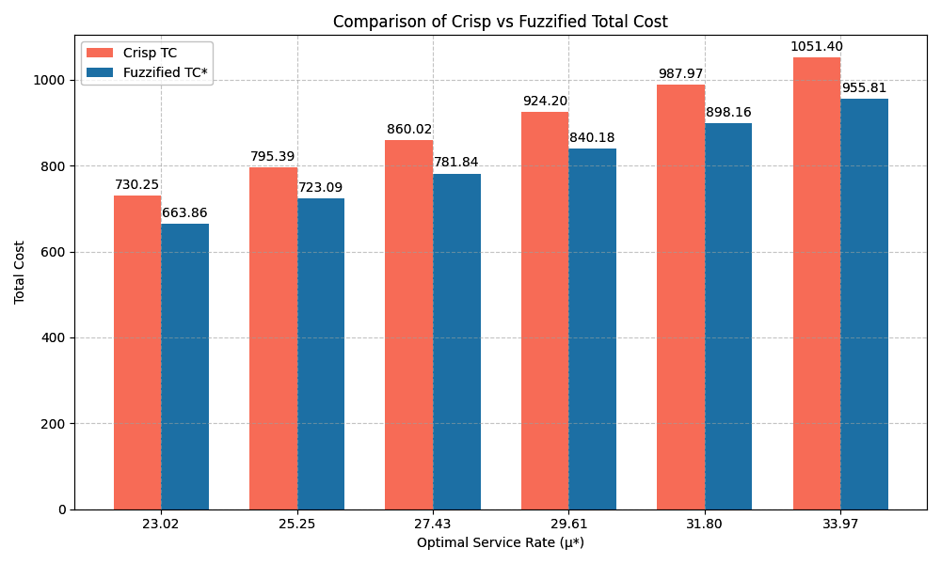
Fig 10 - Crisp value Vs Fuzzy value under arrival rate

According to the analysis, both crisp and fuzzified total costs rise as the arrival rate rises.
A Comparison between Pentagonal and Hexagonal Numbers under Service cost Vs Total cost
Table 10: Correlation between Service cost and TC (Crisp & Fuzzy)
Pentagonal approach
$_k$ /_$k$ * | $_\left(TC\right)$ (Crisp) | $_\left(TC\right)$* (Fuzzy)
28 | 791.86 | 719.87
30 | 840.00 | 763.64
32 | 887.87 | 807.16
34 | 935.50 | 850.45
36 | 982.91 | 893.55

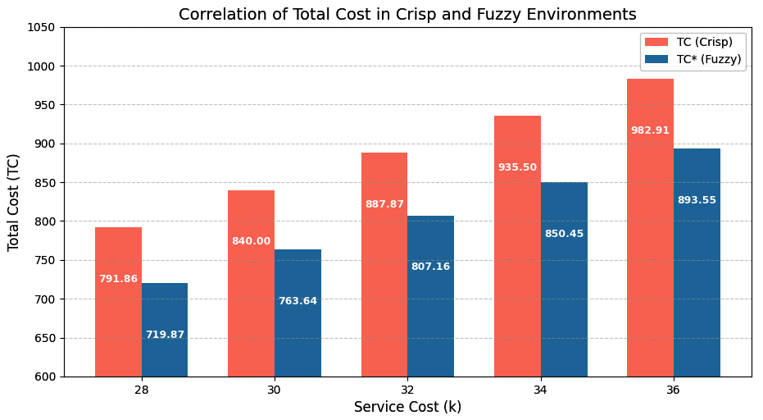
Fig 11 - Correlation between Service cost and Total cost – Pentagonal Approach

Table 11: Correlation between Service cost and Total Cost (Crisp & Fuzzy)
Hexaagonal approach
$_k$ /_$k$ * | $_\left(TC\right)$ (Crisp) | $_\left(TC\right)$* (Fuzzy)
27 | 730.25 | 663.86
29 | 776.15 | 705.59
31 | 821.78 | 747.08
33 | 867.17 | 788.34
35 | 912.35 | 829.41
37 | 957.31 | 870.29

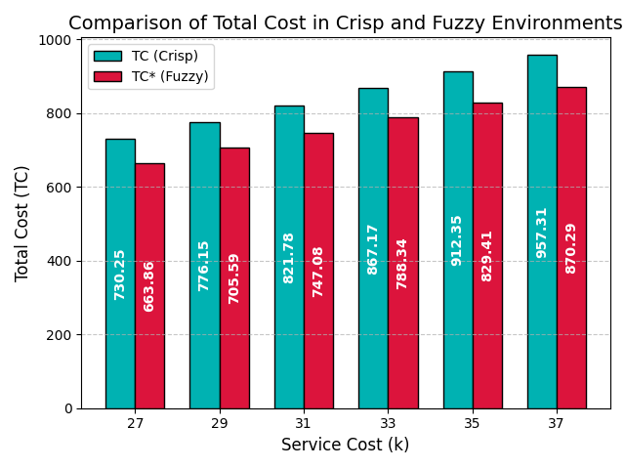
Fig 12 - Correlation between Service cost and Total cost – Hexagonal Approach

Performance Variability Analysis
A performance variability analysis is a comprehensive examination of the model's variation-propensity. Table 1 and Fig 2, Illustrates how the crisp model's overall ideal cost rises in tandem with the service cost per unit. It is noteworthy that the overall optimum cost of the model rises in tandem with increases in waiting costs and waiting times per unit in Table 2 and Fig 3. As shown in Table 3 and Fig. 4, the overall optimum cost of the model likewise rises anytime the customer arrival rate to the service channel does.

Table 4 and Fig 5, Illustrates that the overall optimal fuzzy cost of the fuzzy model under discussion rises in proportion to the increase in fuzzy service cost per unit. Table 5 and Fig 6 illustrates that when the fuzzy waiting cost per unit rises, the model's overall optimal fuzzy cost also rises. Finally, Table 6 and Fig 7 shows that if the fuzzy arrival rate of consumers to the service channel rises, the model's overall optimal fuzzy cost also rises. Table 7-9 and Fig 7-8, Illustrates that the Comparison between Crisp and Fuzzy in different Hexagonal parameters.

In Table 10-11 and Fig 9-12, shows a very essential metric for assessing the model's suitability for use is correlation. In both graphs, as the Service Cost increases, the Total Cost also increases steadily in both Crisp and Fuzzy scenarios. Across all data points, the Crisp total cost is consistently higher than the Fuzzy total cost. This reflects the cost-reducing nature of fuzziness, which accounts for uncertainty and reduces over estimation. Fuzzy logic reduces the estimated total cost compared to crisp methods.

Conclusion
In this case study, we investigated the application of a fuzzy FM/FM/1 queueing model to smart city waste management through sensor-equipped garbage bins. This study highlights how fuzzy hexagonal modeling enhances the robustness and realism of queue-based smart waste collection strategies. It provides valuable insights for city planners seeking to minimize environmental impact while handling unpredictability in urban waste generation and collection logistics. By incorporating uncertainty in the system parameters using fuzzy numbers, we were able to model real-world variability in waste generation and collection more realistically.
In the crisp environment, the system yielded a service cost of 27, a waiting cost of 23, an arrival rate of 19, and an optimal service rate of 23.02, resulting in a total cost (TC) of 730.25 units. In the fuzzy environment, using fuzzy numbers and defuzzification techniques, the service cost, waiting cost, and arrival rate were maintained at the same defuzzified values (27, 23, and 19 respectively), with the optimal service rate also computed as 23.02. However, the total cost (TC) was observed to reduce to 663.86 units. This significant reduction in total cost demonstrates the advantage of using a fuzzy modeling approach, which better captures the uncertainties inherent in real-world systems. Compared to the Pentagonal approach, the Hexagonal fuzzy number approach has higher cost optimization capabilities, offering greater sensitivity to unknown service parameters, better control over cost escalation, and lower overall expenses.Future research may expand this model to multi-server scenarios, priority-based waste types, or integrate real-time adaptive routing to further optimize collection efficiency.

Disclaimer (Artificial intelligence)
Author(s) hereby declare that NO generative AI technologies such as Large Language Models (ChatGPT, COPILOT, etc.) and text-to-image generators have been used during the writing or editing of this manuscript.
Disclosure of conflict of interest
All authors declare that they have no conflicts of interest.
Declaration of competing interest
The authors declare that they have no known competing financial interests or personal relationships that could have appeared to influence the work reported in this paper.

References
- Barak S. and M.S. Fallahnezhad (2012). Cost analysis of fuzzy queuing systems, International Journal of Applied Operational Research, 2(2), 25-36. https://ijorlu.liau.ac.ir/article-1-138
- Belloman R.E. and L.A. Zadeh (1970). Decision-making in a fuzzy environment, Manng. Sci., 17(4), 141-164. http://dx.doi.org/10.1287/mnsc.17.4.B141
- Chen Gang, Liu Zaiming and Zhang Jingchuan (2020). Analysis of strategic customer behavior in fuzzy queueig system. American institute of mathematical sciences, 16(1), 371-386. https://www.aimsciences.org/article/doi/10.3934/jimo.2018157
- Enrique, M. and H.R. Enrique (2014). Simulation of fuzzy queuing systems with a variable number of servers, arrival and service rates, IEEE Transactions on Fuzzy Systems, 22(4), 892- 903. t http://dx.doi.org/10.1109/TFUZZ.2013.2278407
- Fathi-Vajargah B. and Ghasemalipour (2016). Simulation of a random fuzzy queuing system with multiple servers. Journal of Contemporary Mathematical Analysis , 51(2), 103-110.
doi.10.3103/S1068362316020060
- Gou, X., Z. Xu and H. Liao (2017). Hesitant fuzzy linguistic entropy and cross-entropy measures and alternative queuing method for multiple criteria decision making. Information Sciences, 388, 225-246. http://dx.doi.org/10.1016/j.ins.2017.01.033
- Hidayah, M.Z.N., S.A. Nadirah, A.N Atikah, H.N. Su Ain Abu and A. Norani (2019). Comparison of queuing performance using queuing theory model and fuzzy queuing model at check-in counter in airport. Mathematics and Statistics,7(4A), 17-23. http://dx.doi.org/10.13189/ms.2019.070703
- Kannadasan, G. and N. Sathiyamoorthi (2018). The analysis of M/M/1 queue with working vacation in fuzzy environment. International Journal Applications and Applied Mathematics, 13(2), 566-577. https://digitalcommons.pvamu.edu/aam/vol13/iss2/1
- Klir G. and B. Yuan, Fuzzy Sets and Fuzzy Logic, vol. 4, Prentice Hall New Jersey, 1995. https://dl.acm.org/doi/book/10.5555/202684
- Mishra, S.S. and D.C Shukla (2009). A computational approach to the cost analysis of machine interference model. American Journal of Mathematical and Management Sciences, 29(1&2), 277-293. http://dx.doi.org/10.1080/01966324.2009.10737760
- Mishra, S.S. and D.K. Yadav (2010). Computational approach to cost and profit analysis of clocked queuing networks. Contemporary Engineering Sciences, 3(8), 365-370. http://dx.doi.org/10.61294/jiaps2024.2842
- Nathan P. Sherman and Jekrey P. Kharoufeh, An M/M/1 retrial queue with unreliable server, Operations Research Letters 34 (2006), 697- 705. http://dx.doi.org/10.1016/j.orl.2005.11.003
- Noppasorn Sutthibutr , Kunihiko Hiraishi, Navee Chiadamrong (2025), A fuzzy multi-criteria decision-making for optimizing supply chain aggregate production planning based on cost reduction and risk mitigation, Journal of Open Innovation:Technology, Market and complexity,Volume10,Issue4, http://dx.doi.org/10.1016/j.joitmc.2024.100377
- Palaniammal, S. and Pradeep, S. (2024) Cost benefit analysis for non-Markovian bulk queue with server failure’, Int. J. Mathematics in Operational Research, Vol. 28, No. 4, pp.455–474, http://dx.doi.org/10.1504/IJMOR.2024.140351
- Palaniammal, S. and Pradeep, S. (2024) A State Dependent Arrival Analysis In a Non-Markovian Bulk Queue with Server Failures , International Journal of Operational Research, 2024 Vol.53 No.3, pp.235 - 252, http://dx.doi.org/10.1504/IJOR.2023.10056844
- Palaniammal, S. and Pradeep, S. (2025) A Trapezoidal approach to cost optimization in M/M/1 queueing systems , International Journal of Science and Research Archive, 2025 Vol.15 No.1, pp.391-399, http://dx.doi.org/10.30574/IJSRA.2025.15.1.1014
- Palpandi, B. and G. Geetharamani (2013). Evaluation of performance measures of bulk arrival queue with fuzzy parameters using robust ranking technique. International Journal of Computational Engineering Research, 3(10), 55-57.
https://ijceronline.com/papers/G03101053057
- Pardo, M.J. and D. Fuente (2010). Fuzzy markovian decision processes, application to queuing systems, Computers & Mathematics with Applications, 60(9), 2526-2535. https://doi.org/10.1016/j.camwa.2010.08.004
- Prameela, K.U. and P. Kumar (2019). FM / FEk /1 Queuing model with erlang service under various types of fuzzy numbers. International Journal of Recent Technology and Engineering, 8(1), 2277-3878. https://www.ijrte.org/wp-content/uploads/papers/v8i1/A1085058119
- Priya, R.S. and R. Sudhesh (2018). Transient analysis of a discrete-time infinite server queue with system disaster, International Journal of Mathematics in Operational Research, 12(1), 91-101. http://dx.doi.org/10.1051/ro/2016008
- Ritha W and Lilly Robert (2010), Fuzzy queues with priority discipline, Applied Mathematical Sciences 12(4),5 75-582. https://www.m-hikari.com/ams/ams-2010/ams-9-12-2010/rithaAMS9-12-2010.
- Shanmugasundaram S, S. Thamotharan, M. Ragapriya, A Study on Single Server Fuzzy Queueing Model, International Journal of Latest Trends in Engineering and Technology, Volume 6 issue 1, September 2015, 162-169, https://www.ijltet.org/wp-content/uploads/2015/09/22
- Singh B B, S. Rawat, S.K. Yadav and S.S. Mishra (2020), Optimization of Markovian arrival and service Queuing model under Fuzziness, International Journal of Agricultural and Statistical Science, Vol 16,No 2, p 567-572, 2020. https://connectjournals.com/03899.2020.16.567
- Sharma, P. (2016). Optimal flow control of multi-server time sharing queuing network with priority. International Journal of Mathematics in Operational Research, 9(3), 363-374. http://dx.doi.org/10.1504/IJMOR.2016.078826

- Singh, C.J., M. Jain and B. Kumar (2016), Analysis of single server finite queuing model with reneging. International Journal of Mathematics in Operational Research, 9(1), 15-38. http://dx.doi.org/10.1504/IJMOR.2016.077558
- Sundari, M.S. and S. Palaniammal (2015), Simulation of M/ M/1 queuing system using ANN. Malaya Journal of Mathematik, S(1), 279-294. https://www.malayajournal.org/articles/paper26
- Zadeh, L.A. (1978). Fuzzy sets as a basis for a theory of possibility. Fuzzy Sets Syst, 1, 03-28. https://doi.org/10.1016/0165-0114(78)90029-5

