**Intraamniotic Methotrexate Administration for Unruptured Tubal Ectopic Gestation: A Case Report**

**ABSTRACT**

A case of unruptured right tubal ectopic gestation in a 28 year old Gravida 2 Para 0+1 who presented at 6 weeks 2 days gestation with an ultrasound report showing an unruptured right tubal ectopic gestation. The serum beta hcg was 22,824.97miu/ml and there was fetal cardiac activity. She initially had a single dose of intramuscular methotrexate administered but pregnancy still persisted. She then had methotrexate administered into the gestational sac under ultrasound guidance nine days later with complete resorption of the ectopic gestation and return of normal serum beta hcg values within two weeks. This case demonstrates that not all ectopic pregnancies must be managed surgically. It also shows the extent one might need to go in achieving success when one conservative method fails.

Keywords: Ectopic Gestation, cardiac activity, ectopic pregnancies, fertilized ovum

**INTRODUCTION.**

Ectopic pregnancy is the implantation of a fertilized ovum on any tissue other than the endometrium of the uterus1. The commonest site is the fallopian tube in over 90% of cases1,2. It can also occur in the ovary, cervix or abdominal cavity.

In Nigeria, 0.9%–4.38% of pregnancies are ectopic1, 1–2% of pregnancies worldwide, with case fatalities of 27.9/1000 and 37/1000 reported in Accra, Ghana, and Lagos, Nigeria, respectively3,4.

Among the factors predisposing to ectopic pregnancy, pelvic inflammatory disease is widely regarded as the single most important aetiologic factor. Other aetiological factors will include post-abortal sepsis, puerperal sepsis, appendicitis or endometriosis and the use of intra uterine contraceptive device (IUCD)2,3. Other risk factors include previous ectopic pregnancy, previous operation on the tube and developmental abnormalities of the tube and tumours that distort the tube as well as use of ovulation induction drugs.

The diagnosis requires a high index of suspicion. When ruptured, they often present classically with features of haemoperitoneum and cardiovascular collapse, while the diagnosis of unruptured tubal pregnancy could be difficult. Differentials would include acute pelvic inflammatory disease, ovarian torsion, incomplete abortion, endometriosis, a degenerating uterine fibroid, acute appendicitis and urinary tract infections. Serial assay of the human chorionic gonadotropin (hcG) β sub unit with transvaginal pelvic ultrasound greatly adds to diagnostic success5.

The treatment for a ruptured ectopic gestation is usually an emergency laparotomy and salpingectomy (which could be partial or total). Non-surgical management is indicated in unruptured cases. This entails the use of drugs such as methotrexate which could be administered parenterally or injected directly into the gestational sac either by ultrasound scan guidance or laparoscopically. In this case, methotrexate was initially administered intramuscular but failed to achieve resorption of the ectopic. She had another dose administered directly into the gestational sac under ultrasound guidance with successful termination of the pregnancy.

**CASE PRESENTATION**

A patient, 28 year old Gravida 2 Para 0+1 who presented at 6 weeks 2 days gestation with an ultrasound report showing an unruptured right tubal ectopic gestation. She had a history of mild lower abdominal pain and spotting per vaginam of a few days. There was no prior history of trauma, no associated fever nor any urinary tract symptoms. On examination she was afebrile, not pale (PCV – 34%) with a BP of 100/70mmHg. Abdominal examination was unremarkable. There was some cervical motion tenderness on pelvic examination. The serum beta hCG was 22,824.97miu/ml and there was fetal cardiac activity noted on ultrasound. She was keen to avoid surgery as her last pregnancy was a miscarriage with subsequent manual vacuum aspiration. She was counseled on the increased chances of treatment failure due to the high serum beta hCG value as well as the presence of fetal cardiac activity. She however insisted on trying the medical option. She had 85mg of methotrexate administered intramuscular (based on 50mg/m2) and was counseled to return immediately if she developed increased abdominal pain. A repeat serum beta hCG on day four was 21,639.13miu/ml. She had no complaints as the abdominal pain had subsided. However, her serum beta hCG on day seven rose to 28,706.38miu/ml with resurgence of the lower abdominal pain. A repeat pelvic ultrasound scan showed a right tubal ectopic gestation. The gestational sac diameter was 1.04 by 0.59cm and there was fetal cardiac activity. We then proceeded to administer 85mg of methotrexate directly into the gestational sac under transabdominal ultrasound guidance. We made use of a size 22 spinal needle. The procedure was well tolerated and she was place on prophylactic antibiotics. A repeat serum beta hCG on day four post-administration was 13,849.01IU/L which was a 52% reduction. Lower abdominal pain was absent and spotting per vaginam had decreased significantly. Serum beta hCG on day seven was 4,887.51IU/L and a repeat pelvic ultrasound scan showed no adnexal mass. Serum beta hCG returned to non-pregnant level six weeks later. She was counseled to avoid pregnancy for at least two months, and was placed on folic acid 5mg daily.

**DISCUSSION**

The incidence more than quadrupled between 1970 and 1987 (from 1 in 200 live births to 1 in 43).

Among the factors predisposing to ectopic pregnancy, pelvic inflammatory disease is widely regarded as the single most important aetiologic factor. Other aetiological factors will include post-abortal sepsis, puerperal sepsis, appendicitis or endometriosis and the use of intra uterine contraceptive device (IUCD)3,4. Other risk factors include previous ectopic pregnancy, previous operation on the tube and developmental abnormalities of the tube and tumours that distort the tube as well as use of ovulation induction drugs. In Mrs C.K, none of these were identified.

The diagnosis requires a high index of suspicion. When ruptured, they often present classically with features of haemoperitoneum and cardiovascular collapse. The diagnosis of unruptured tubal pregnancy could be difficult, however, advances in imaging modalities and urinary early pregnancy test kits have led to increased detection.

The management of a ruptured ectopic gestation is an emergency. Laparotomy and salpingectomy (which could be partial or total) should be performed. In an unruptured tubal ectopic gestation, there is still the temptation to carry out a salpingectomy either laparoscopically or via laparotomy, owing to the reduced risk of recurrence of an ectopic in that tube. However, expectant management and medical management are both viable options. Additionally, the inherent drawbacks of surgical treatment are anesthesia complications, secondary injuries and blood loss. In contrast, non-surgical management can avoid these problems. Some studies have shown success rates of those managed expectantly (50%-73%) and those with methotrexate (75%-90%)5,6.

Methotrexate is usually the drug of choice employed in the medical management of ectopic pregnancy. The drug acts as an anti-folic acid, anti-tumor agent and has been identified as an inhibitor of the JAK/STAT pathway7. Available regimens are single-dose (i.e., MTX 50 mg/m2 intramuscular injection), two doses (i.e., 50 mg/m2 injected on days 1 and 4), and multiple doses (i.e., 1 mg/kg intramuscular injection on days 1, 3, 5, ± 7). Contraindications to medical management with methotrexate include ruptured ectopic pregnancy, serum β-HCG level >5000 mIU/ml, gestational sac (>3.5 cm), embryonic cardiac activity present, hemodynamically unstable, sensitivity to MTX, active pulmonary disease, renal disease, chronic liver disease, preexisting blood dyscrasia, immunodeficiency, peptic ulcer disease, and free fluid more than 100 ml in the POD8,9. However, even in the presence of fetal cardiac activity, methotrexate can be injected into the gestational sac8,10. There are documented cases that show transvaginal ultrasound guided local and systemic methotrexate injection may be performed successfully for the cases of advanced gestational age with fetal cardiac activity and high serum β-hCG levels10,11,12,13. Mrs. C.K had a serum beta HCG level of 22,824.97miu/ml (>5000 mIU/ml) and there was fetal cardiac activity noted on ultrasound, however, she was haemodynamically stable. As expected, the intramuscular methotrexate that was administered initially failed. However, following injection of methotrexate into the gestational sac under ultrasound guidance, there was resolution.

Some studies have found that fertility was significantly higher after methotrexate than after surgical treatment11,14. Studies are on-going to see if new medications including letrozole and gefitinib (even if used in connection with methotrexate) may reduce the number of adverse events, increase effectiveness, and change the actual gold standard15.

**CONCLUSION**

Provided recommended criteria and follow-up are adhered to, non-surgical management has been shown to have comparative safety to traditional surgical management with acceptable efficacy and patient acceptability. A multidisciplinary approach, patient education, and close monitoring are essential for successful conservative management. This conservative management is cost-effective.

**Disclaimer (Artificial intelligence)**

**Option 1:**

**Author(s) hereby declare that NO generative AI technologies such as Large Language Models (ChatGPT, COPILOT, etc.) and text-to-image generators have been used during the writing or editing of this manuscript.**

**REFERENCES**

1. Odunvbun WO. Ectopic Pregnancy: A 5-year review of cases in a secondary health facility in Delta state, Nigeria. Port Harcourt Medical Journal. 2019 May 1;13(2):53-7.
2. Hendriks E, Rosenberg R, Prine L. Ectopic pregnancy: diagnosis and management. American family physician. 2020 May 15;101(10):599-606.
3. Sindiani AM, Alshdaifat E, Obeidat B, Obeidat R, Rawashdeh H, Yaseen H. The use of single dose methotrexate in the management of ectopic pregnancy and pregnancy of unknown location: 10 years’ experience in a tertiary center. International Journal of Women's Health. 2020 Dec 22:1233-9.
4. Odejinmi F, Huff KO, Oliver R. Individualisation of intervention for tubal ectopic pregnancy: historical perspectives and the modern evidence based management of ectopic pregnancy. European Journal of Obstetrics & Gynecology and Reproductive Biology. 2017 Mar 1;210:69-75.
5. Berry J, Davey M, Hon MS, Behrens R. A 5-year experience of the changing management of ectopic pregnancy. Journal of Obstetrics and Gynaecology. 2016 Jul 3;36(5):631-4.
6. Hawrylyshyn K, McLeod SL, Thomas J, Varner C. Methotrexate for the treatment of unruptured tubal ectopic pregnancy. Canadian Journal of Emergency Medicine. 2019 May;21(3):391-4.
7. Xiao C, Shi Q, Cheng Q, Xu J. Non-surgical management of tubal ectopic pregnancy: a systematic review and meta-analysis. Medicine. 2021 Dec 17;100(50):e27851.
8. Selvaraj Y. Conservative Management of Unruptured Ectopic Pregnancy—A Retrospective Study. Surgical Science. 2024 Oct 28;15(10):536-46.
9. Po L, Thomas J, Mills K, Zakhari A, Tulandi T, Shuman M, Page A. Guideline No. 414: management of pregnancy of unknown location and tubal and nontubal ectopic pregnancies. Journal of Obstetrics and Gynaecology Canada. 2021 May 1;43(5):614-30.
10. Ozcivit IB, Cepni I, Hamzaoglu K, Erenel H, Madazlı R. Conservative management of 11 weeks old cervical ectopic pregnancy with transvaginal ultrasound-guided combined methotrexate injection: Case Report and Literature Review. International Journal of Surgery Case Reports. 2020 Jan 1;67:215-8.
11. Hao HJ, Feng L, Dong LF, Zhang W, Zhao XL. Reproductive outcomes of ectopic pregnancy with conservative and surgical treatment: A systematic review and meta-analysis. Medicine. 2023 Apr 28;102(17):e33621.
12. Grigoriu C, Bohiltea RE, Mihai BM, Zugravu CA, Furtunescu F, Georgescu TA, Munteanu DI. Success rate of methotrexate in the conservative treatment of tubal ectopic pregnancies. Experimental and Therapeutic Medicine. 2022 Feb;23(2):150.
13. Nišević J, Vuković J, Milatović S, Đurđević S. Conservative approach in the management of ectopic pregnancy. Medicinski pregled. 2021;74(1-2):54-9.
14. Uludag SZ, Kutuk MS, Dolanbay M, Ozgun MT, Eliyeva G, Altun O. Conservative management of interstitial pregnancies: experience of a single centre. Journal of Obstetrics and Gynaecology. 2018 Aug 18;38(6):848-53.
15. Leziak M, Żak K, Frankowska K, Ziółkiewicz A, Perczyńska W, Abramiuk M, Tarkowski R, Kułak K. Future perspectives of ectopic pregnancy treatment—review of possible pharmacological methods. International Journal of Environmental Research and Public Health. 2022 Oct 31;19(21):14230.

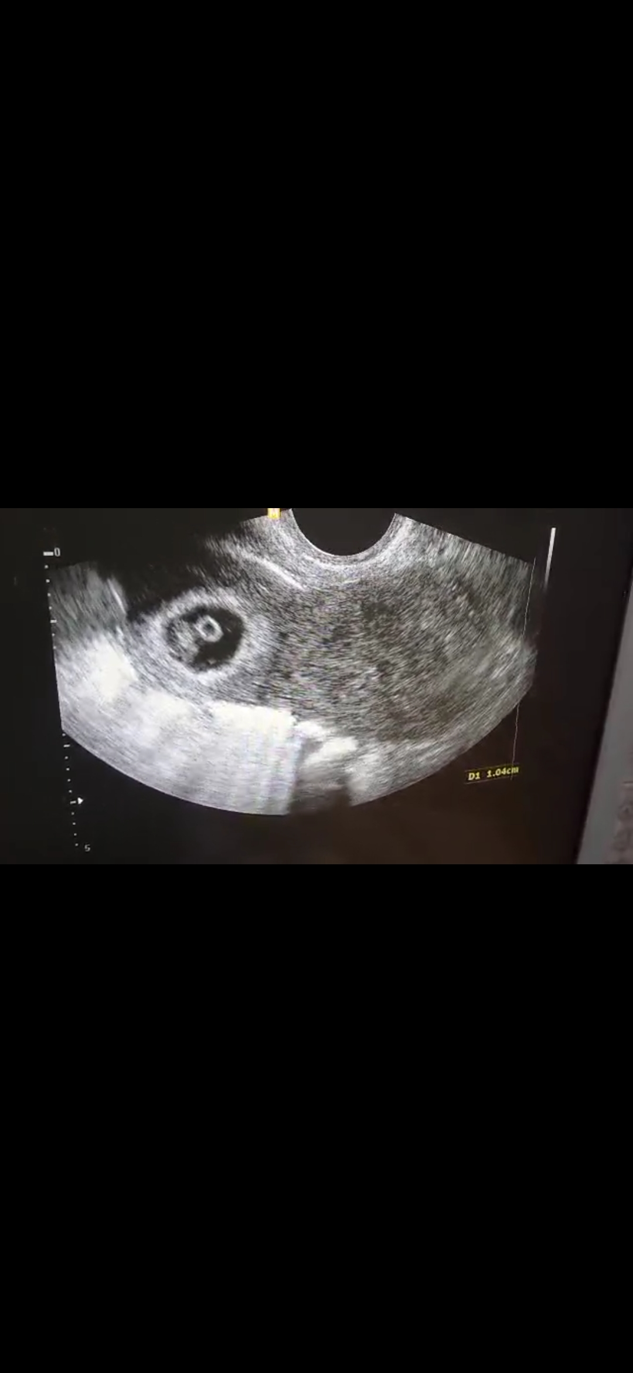

Fig 1: Tubal Ectopic at 6 Weeks

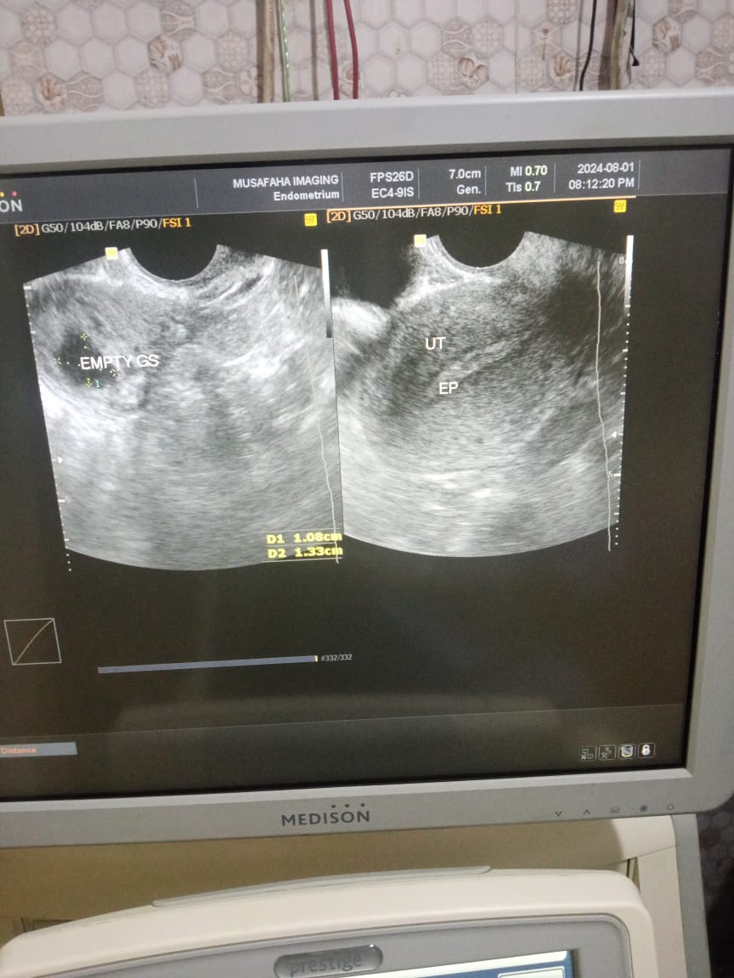

Fig 2: USS on day 7 after inraamniotic methotrexate showing an empty gestational sac

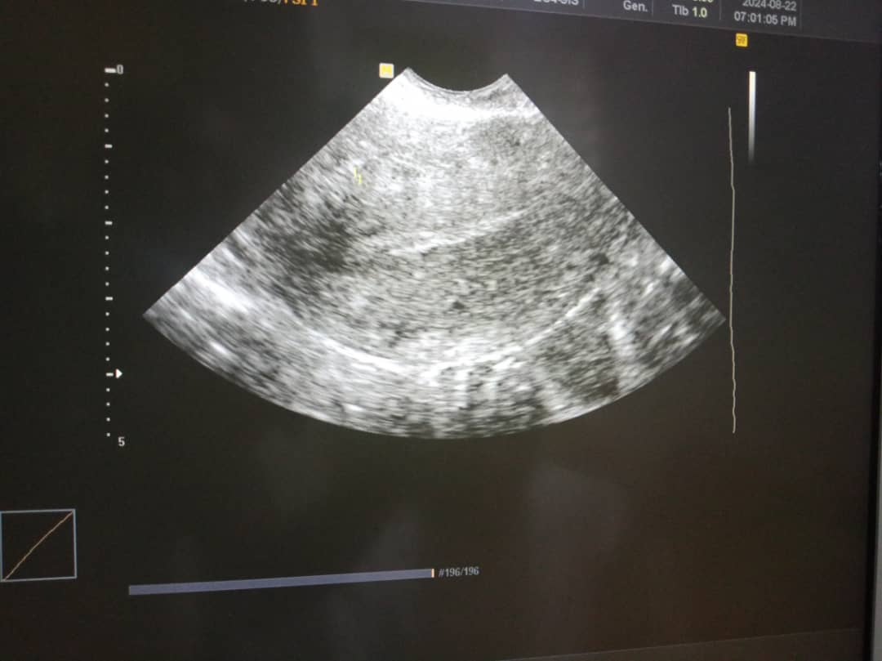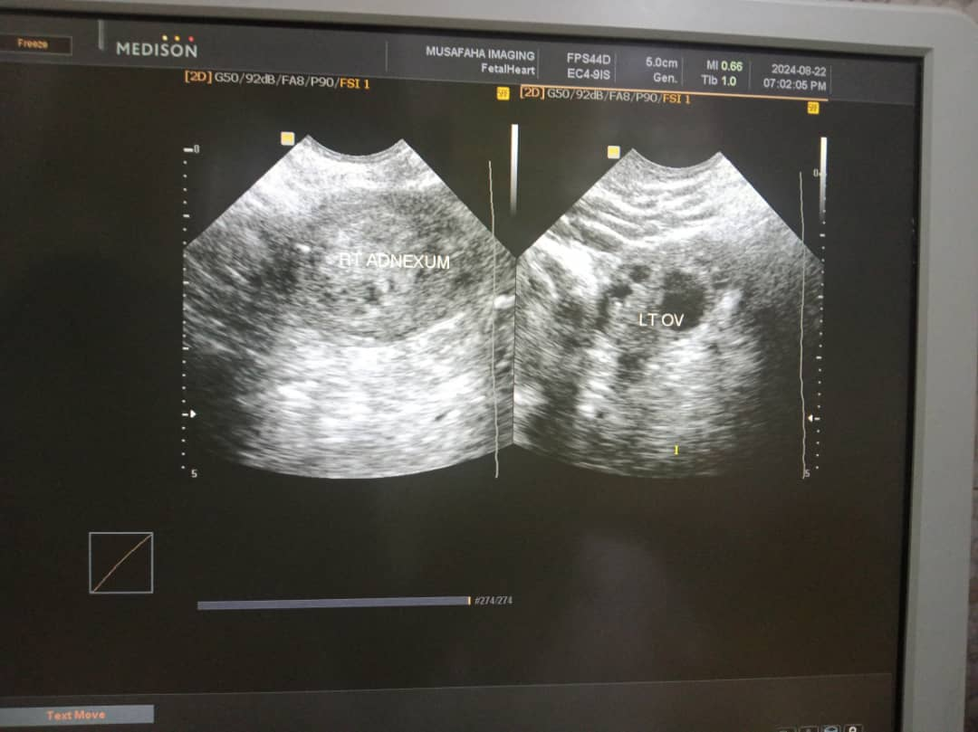

(A)

(B)

Fig 3(A,B): USS on day 28 showing empty uterus and adnexae