Evaluation of Abiotic Stress Tolerance and Compatibility of Native Isolates of Trichoderma spp. of Kasargod District, India

ABSTRACT

.
Aim: To evaluate the selected native isolates of Trichoderma spp. of Kasaragod district for abiotic stress tolerance and compatibility assessment with other biocontrol agents.
Study design: CRD
Place and Duration of Study: Department of Plant Pathology, College of Agriculture, Padannakkad, between November 2023 and November 2024.
Methodology: The selected Trichoderma isolates Tr-5, Tr-12, Tr-41, Tr-43 (Trichoderma asperellum) and Tr-40 (Trichoderma lixii) were subjected to various abiotic stresses, namely low (4°C, 10°C and 15°C) and high (30°C, 45°C and 55°C) temperatures, salinity (0.5M, 1.5M and 2.5 M NaCl) and drought (10%, 30% and 40% PEG). The PDA was embedded with different NaCl and PEG concentrations to test the salinity and drought tolerance. After 4 days of inoculation (DAI), radial growth of Trichoderma isolates in treatments and controls was recorded. The compatibility of these Trichoderma isolates was checked with the other bio-control agents viz., Pseudomonas fluorescens, Metarhizium anisopliae, Lecanicillium lecanii and Beauveria bassiana using the dual culture technique.
Results: In the temperature tolerance study, the selected isolates did not show any radial growth at 4°C, 10°C, 45°C, and 55°C.At 15°C, slight mycelial growth was observed, and the optimal range was found to be 30°C for good mycelial growth. The tolerance to salinity was up to 0.5M NaCl, but only in Tr-5 (0.83cm), Tr-12 (0.91), and Tr-40 (0.8) isolates; the mycelial growth was observed at 1.5M NaCl. At 10% PEG, the radial growth of isolates was on par with the control. Upon increasing concentration, radial growth of Trichoderma isolates was decreased/ absent along with sporulation. In the compatibility study, Trichoderma isolates were found to be compatible with P. fluorescens, M. anisopliae, L. lecanii and B. bassiana. But with fungal biocontrol agents, only Tr-40 showed incompatibility with M. anisopliae (66.67%), L. lecanii (33.58%), but was compatible with B. bassiana.
Conclusion: In this study, all five native Trichoderma isolates, Tr-5, Tr-12, Tr-40, Tr-41 and 43 showed high tolerance to abiotic stresses at an optimum range of temperature (30ºC), NaCl (0.5M), and PEG (10%). The isolates of Trichoderma spp. were compatible with bacterial and fungal bio-control agents except Tr-40.

Keywords: Trichoderma spp., Bio-control agents, soil borne pathogens, abiotic stresses

1. INTRODUCTION

The farmers of Kasaragod district mostly rely on vegetable crops, especially solanaceous crops (brinjal, tomato, chilli, amaranthus, etc.), which fulfil their basic style of food. Unfortunately, the crop is affected by numerous soil pathogens, which may seriously threaten the livelihood of farmers. By repeated application of the same chemical or unscientific use, most soil borne pathogens Pythium spp., Phytophthora spp., Rhizoctonia spp., Fusarium spp. have started developing resistance (Kim and Knudsen, 2013). An alternate method is to be put forth for this problem. A natural, ecological solution to the issues brought on by conventional chemical techniques of plant protection is biological control, which involves using particular microbes that obstruct plant diseases and pests. Among the biocontrol agents, Trichoderma is one of the agents that has an opportunistic effect on most soil-borne pathogens (Kucuk et al., 2017). The competitive saprophytic ability of Trichoderma spp. overwhelms pathogens for nutrients and space (Leo Daniel et al., 2011). These species of Trichoderma produce many enzymes and volatile substances to suppress the growth of the pathogen by the mechanism of mycoparasitism. Moreover, they have the potential to improve plant growth and their application results in sustainable agriculture. In this study, the native isolates of Trichoderma spp., which were already isolated and identified, were used to study their abiotic stress tolerance and check their compatibility with other biocontrol agents.

2. Materials and Methods
The Trichoderma isolates Tr-5, Tr-12, Tr-41, Tr-43 (T. asperellum) and Tr-40 (T. lixii), which were isolated from the soils of two different Agro-ecological units (11 and 15) of Kasargod district, were selected for the study of abiotic stress tolerance. The tolerance level of these isolates was compared with the KAU reference culture collected from the College of Agriculture, Padannakkad. These isolates were identified based on molecular characterization using ITS and RAPD primers.
In vitro evaluation of Trichoderma isolates to abiotic stress tolerance
Evaluation of temperature tolerance: Isolates were subjected to different temperatures (4⁰C,10⁰C, 15⁰C, 30⁰C,45⁰C and 55⁰C). A fungal disc measuring 5mm was placed in the center of a Petri plate containing PDA (potato dextrose agar) and kept in a BOD incubator, exposed to the required temperature with three replications per treatment. Four days later, observations on the radial growth, pattern of growth, colour and texture of the colony and number of days for sporulation were recorded.
Evaluation of salinity and drought tolerance: The salinity tolerance of these isolates was studied at three different concentrations, viz., 0.5M, 1.5M and 2.5 M of NaCl. The sodium chloride (NaCl) was embedded in the prepared and autoclaved PDA media, according to the concentration and plated in a Petri plate. After solidification, a 5mm fungal disc was placed at the center of each plate and incubated at room temperature (Zehra et al., 2017; Muthuvaduganathan et al., 2023). Polyethylene glycol (PEG 6000 Da) was used to check the tolerance level to drought, which will induce stress. This experiment was carried out with three different concentrations of PEG, viz., 10%, 30% and 40%. The prepared and autoclaved PDA media were embedded with varying concentrations of PEG and plated on a petri dish. Later, a 5mm fungal disc was placed at the center of the plate and incubated at room temperature. The control plates were also maintained for each experiment without adding NaCl and PEG. The observations were recorded as mentioned above.
Compatibility of Trichoderma isolates with other bio-control agents:
The compatibility of the Trichoderma isolates was checked with other popular bio-control agents. Cultures of bio-control agents viz., Pseudomonas fluorescens, Metarhizium anisopliae, Lecanicillium lecanii and Beauveria bassiana collected from the College of Agriculture, Padannakkad were used for this study.
Bacterial bio-control agent: The study examined the compatibility of Trichoderma isolates with P. fluorescens. The bacterial bio-control agent, Pseudomonas fluorescens, was streaked onto the King's B media. Later, 1 ml of bacterial suspension was prepared by inoculating a loopful of Pseudomonas fluorescens with 1 ml of sterile water. A 5mm fungal disc of Trichoderma isolates was placed in the center of the plate containing PDA, which was already seeded with 10µl of bacterial suspension and was further incubated at room temperature (Kumar et al., 2012). The control plate was maintained without inoculating P. fluorescens. The radial growth of Trichoderma spp. in the treatment and control plates was recorded.
Fungal bio-control agents: Compatibility was checked for these Trichoderma isolates with fungal biocontrol agents, viz., M. anisopliae, L. lecanii and B. bassiana, using the dual culture technique. A 5mm mycelial disc of the fungal biocontrol agent on one side and Trichoderma isolates on the other end of the petri plate using a cork borer. In each treatment, three replications were maintained. In the control plates, Trichoderma isolates alone were maintained. After 5 days of incubation, the radial growth of the Trichoderma was recorded and per cent compatibility was calculated.
The per cent compatibility was calculated using the following formula:
Per cent inhibition = [(C-T/C)] x 100, where C is the radial growth of Trichoderma spp. in the control plate, and T is the radial growth of Trichoderma spp. in the treatment plates
Per cent compatibility = 100 – per cent inhibition
Statistical analysis: The statistical analysis was done using the GRAPES software developed by Kerala Agricultural University.
3. results and discussion
The isolates of Trichoderma spp. have saprophytic ability and are thriving to withstand different abiotic stresses, such as temperatures, salinity, and drought. Low temperatures at 4ºC and 10ºC, none of these five native isolates of Trichoderma spp. and KAU isolate showed radial growth of mycelium, but at 15ºC, slight growth was observed (Fig.1). The average growth per day in Tr-40 was high (0.8cm) compared to other isolates, followed by Tr-41, Tr-12, Tr-43 and Tr-5, where the least growth was seen in the KAU isolate (0.3cm). A similar study by Duzniewska (2004) showed that mycelial growth and sporulation were inhibited at 5 to 15 ⁰C. The temperature, 30°C, is found to be the optimum temperature for the mycelial growth of the Trichoderma isolates (Fig.1).
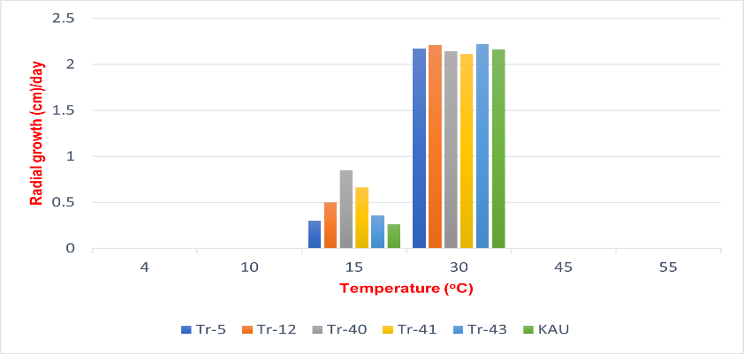
Figure 1. Tolerance of Trichoderma spp. to low (4ºC,10ºC and 15ºC) and high (30ºC, 45ºC and 55ºC) temperatures

A similar investigation was carried out by Singh and Kumar (2009) to determine the ideal temperature for the growth of Trichoderma spp. They discovered that most of the isolates of Trichoderma spp. thrived between 25°C and 30°C. According to Leo Daniel et al. (2011), at 30°C, T. viride performed good mycelial growth with 1.2x10⁸ cfu/g. The isolate of T. longibrachiatum exhibited good mycelial growth by showing a 70 mm colony diameter and sporulation at an optimum temperature of 30°C (Shahid et al., 2011). growth and sporulation of the fungus. Domingues et al. (2016) reported that Trichoderma isolates mycelial radial growth was not observed at 7ºC. At low temperature (15°C), the growth of the isolates of Trichoderma spp. was slow with detaining sporulation. However, between these temperatures, 25-35°C, two isolates, T. asperellum and T. hamatum, showed good growth and sporulation (Zehra et al., 2017). In this present study, at 30°C, the Trichoderma spp. showed good mycelial growth with regular margins and exhibited sporulation within 2 to 3 days.

Serial No. | Isolate | Colony characteristics
Serial No. | Isolate | 15ºC |  |  |  |  | 30ºC
Serial No. | Isolate | Radial growth (cm) | Pattern of growth | Colour of the colony | Texture of the colony | Number of days for sporulation | Radial growth (cm) | Pattern of growth | Colour of the colony | Texture of the colony | Number of days for sporulation
1 | Tr-5 | 0.30^{d} | Circular with irregular margin | Light white | Very light fluffy | 0 | 2.176^{bc} | Circular with regular margin | Greenish white | Medium fluffy | 2
2 | Tr-12 | 0.50^{c} | Circular with irregular margin | Light white | Very light fluffy | 0 | 2.218^{ab} | Circular with regular margin | Greenish white | Medium fluffy | 2
3 | Tr-40 | 0.85ª | Circular with irregular margin | Light white | Light fluffy | 0 | 2.142^{cd} | Circular with regular margin | Yellowish white | Medium fluffy | 3
4 | Tr-41 | 0.66^{b} | Circular with irregular margin | Light white | Light fluffy | 0 | 2.118^{d} | Circular with regular margin | Greenish white | Medium fluffy | 2
5 | Tr-43 | 0.36^{cd} | Circular with irregular margin | Light white | Very light fluffy | 0 | 2.224ª | Circular with regular margin | Greenish white | Medium fluffy | 2
6 | KAU | 0.26^{d} | Circular with irregular margin | Light white | Very light fluffy | 0 | 2.168^{c} | Circular with regular margin | Greenish white | Medium fluffy | 2
CD (0.05) |  | 0.07 |  |  |  |  | 0.04

Table 1. Evaluation of native isolates of Trichoderma spp. for temperature tolerance at 15ºC and 30ºC, P=0.05

The pattern of growth, texture and colour of the colony were mainly circular with regular margins, medium fluffy and greenish white at 30ºC (Table 1). However, in Tr-40, the colour of the colony is yellowish-white. Moreover, at 45ºC and 55ºC, no isolates showed growth. Similarly, Kucuk (2017) observed that Trichoderma spp. exhibited good mycelial growth at 30⁰C and even at the high-temperature stress (45ºC), the isolates T1, T3, T4, T15 and T17 proliferated the mycelial growth upon the stress. In the study of Sharma et al. (2020), Ta15 Trichoderma isolate showed average mycelial growth at 40ºC. In the present study, the time required for the sporulation was 2 Days after inoculation (DAI) in all native isolates of Trichoderma spp. except Tr-40, which took 3 days for sporulation. No sporulation was observed at 4ºC, 10ºC,15ºC,45ºC, and 55ºC in all the Trichoderma isolates.

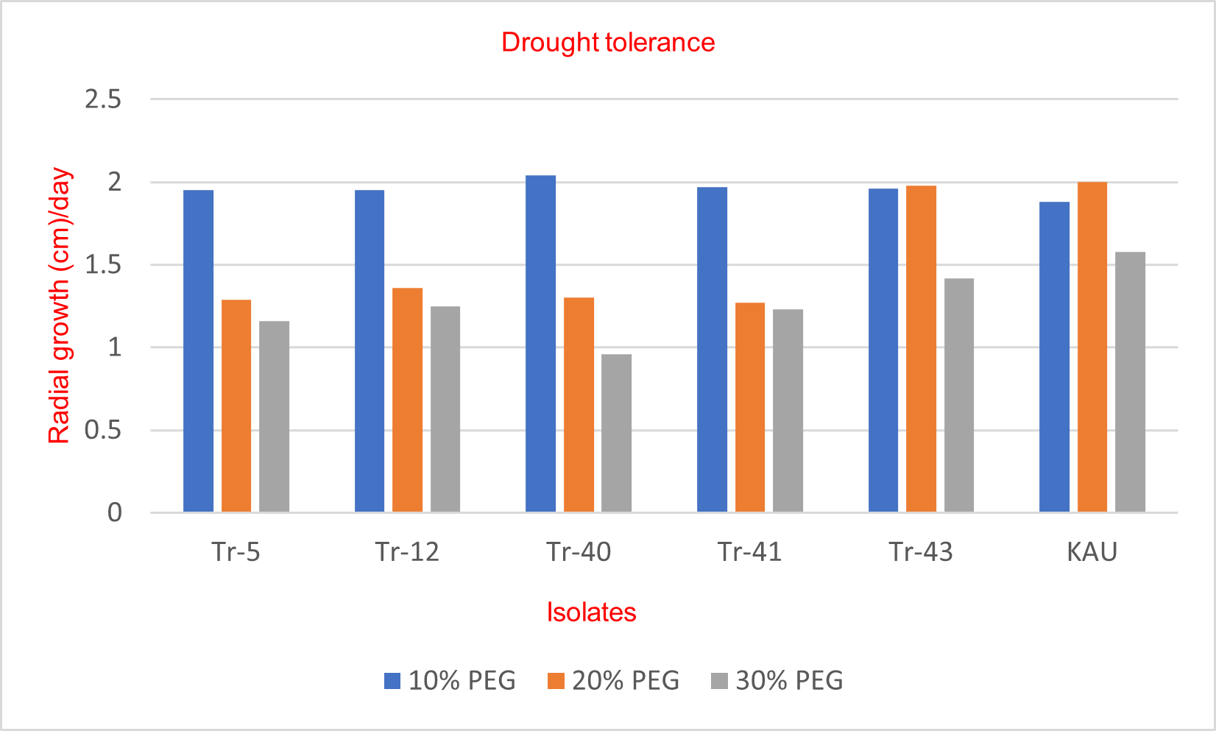
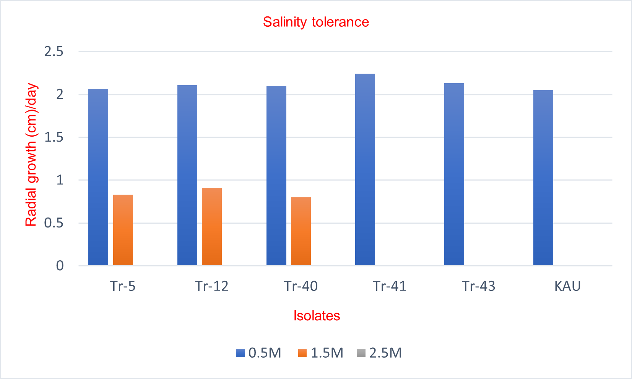
Fig. 2: Evaluation of Trichoderma spp. for the tolerance of salinity Fig. 3: Evaluation of Trichoderma spp. for the tolerance of drought
In the study for salinity tolerance, the isolates showed good growth at 0.5M concentration of NaCl, which was almost on par with the control plates. The growth of isolates was found to be reduced at a 1.5M concentration of NaCl (Fig. 3). At that concentration, three isolates (Tr-5, Tr-12, and Tr-40) showed slight growth and no growth was shown by isolates (Tr-41, Tr-43, and KAU), whereas at a concentration of 2.5M NaCl, mycelial growth was completely absent.

Table 2. Colony characteristics of Trichoderma spp. for salinity tolerance at 0.5M NaCl
Serial No. | Isolate | Colony characteristics
Serial No. | Isolate | 0.5 M NaCl
Serial No. | Isolate | Radial growth (cm)/day | Pattern of growth | Colour of the colony | Texture of the colony | Number of days for sporulation
1 | Tr-5 | 2.06^{b} | Circular with regular margin | Greenish white | Medium fluffy | 3
2 | Tr-12 | 2.11^{b} | Circular with regular margin | Greenish white | Medium fluffy | 3
3 | Tr-40 | 2.10^{b} | Circular with regular margin | Yellowish white | Medium fluffy | 3
4 | Tr-41 | 2.24ª | Circular with regular margin | Greenish white | Medium fluffy | 2
5 | Tr-43 | 2.13^{ab} | Circular with regular margin | Greenish white | Medium fluffy | 2
6 | KAU | 2.05^{b} | Circular with regular margin | Greenish white | Dense fluffy | 2
CD (0.05) |  | -

Table 3. Colony characteristics of Trichoderma spp. for salinity tolerance at 1.5 NaCl (P=0.05)
Serial No. | Isolate | Colony characteristics
Serial No. | Isolate | 1.5 M NaCl
Serial No. | Isolate | Radial growth (cm)/day | Pattern of growth | Colour of the colony | Texture of the colony | Number of days for sporulation
1 | Tr-5 | 0.83^{b} | Circular with irregular margin | Light white | Light fluffy | -
2 | Tr-12 | 0.91ª | Circular with irregular margin | Light white | Light fluffy | -
3 | Tr-40 | 0.80^{b} | Circular with irregular margin | Light yellow | Light fluffy | -
4 | Tr-41 | 0 | - | - | - | -
5 | Tr-43 | 0 | - | - | - | -
6 | KAU | 0 | - | - | - | -
CD (0.05) |  | 0.07

The pattern of growth, texture and colour of the colony were mainly circular with regular margins, medium fluffy and greenish white at 0.5 M NaCl, except in Tr-40 where the colour of the colony is yellowish-white (Table 2). The growth pattern was circular in three isolates, Tr-5, Tr-12, and Tr-40. No sporulation was observed at 1.5M concentration of NaCl (Table 3). The native isolates of Trichoderma sp. exhibited good mycelial growth at 70 mM NaCl, but at 350 mM, most of the isolates showed less mycelial growth (Kucuk., 2017). Under in vitro conditions T. harzianum (T103) isolate tolerated salinity at 1000 mM NaCl concentration with no sporulation (Mishra et al., 2016). In our study, the mycelial growth of Trichoderma spp. was highest at 0.5M NaCl and mycelial growth was utterly inhibited at 2.5M NaCl. At a concentration of 1.5M NaCl, the isolates Tr-5, Tr-12 and Tr-40 could exhibit slight mycelial growth.
For the study on drought tolerance, isolates of Trichoderma spp. were grown at three different concentrations of PEG, viz., 10%, 30%, and 40%. Efficient mycelial growth was observed in Tr-40 (2.04 cm) among all the Trichoderma spp. at 10% PEG concentration, which was almost on par with the control (Table 4). At the concentrations of 30% and 40% PEG, KAU culture showed 2.0 cm and 1.58 cm radial growth, respectively (Table 5 and Fig. 3).

Table 4. Colony characteristics of Trichoderma spp. for drought tolerance at 10% PEG
Serial No. | Isolate | Colony characteristics
Serial No. | Isolate | 10 % PEG
Serial No. | Isolate | Radial growth (cm)/day | Pattern of growth | Colour of the colony | Texture of the colony | No of days for sporulation
1 | Tr-5 | 1.95^{ab} | Circular with regular margin | Greenish white | Medium fluffy | 2
2 | Tr-12 | 1.95^{ab} | Circular with regular margin | Greenish white | Medium fluffy | 2
3 | Tr-40 | 2.04ª | Circular with regular margin | Yellowish white | Medium fluffy | 3
4 | Tr-41 | 1.97^{ab} | Circular with regular margin | Greenish white | Medium fluffy | 2
5 | Tr-43 | 1.96^{ab} | Circular with regular margin | Greenish white | Medium fluffy | 2
6 | KAU | 1.88^{b} | Circular with regular margin | Greenish white | Medium fluffy | 2
CD (0.05) |  | -

At 10% PEG concentration, the growth pattern was circular with a regular margin, and the texture was medium fluffy. However, at 30% and 40% PEG, the growth pattern was irregular, and the texture was feeble. The sporulation was not affected by 10% PEG, but at 30 % and 40% PEG, the density of the sporulation was affected, and the period was three days for sporulation. The isolates showed tolerance to drought at 10% PEG and 20% PEG were 99% and 94.3%, respectively, and later, there was a gradual decrease in the growth of the isolates upon an increase in the concentration of PEG. Sporulation was abundant at 10% PEG concentration (Leo Daniel et al., 2011). However, it became sparse at 25% and 30% PEG concentrations, and at 35% PEG concentration, no sporulation was observed.

Table 5. Colony characteristics of Trichoderma spp. for drought tolerance at 30% and 40% PEG
Serial No. | Isolate | Colony characteristics
Serial No. | Isolate | 30 % PEG |  |  |  |  | 40% PEG
Serial No. | Isolate | Radial growth (cm)/day | Pattern of growth | Colour of the colony | Texture of the colony | No. of days for sporulation | Radial growth (cm)/day | Pattern of growth | Colour of the colony | Texture of the colony | No of days for sporulation
1 | Tr-5 | 1.29^{bc} | Circular with irregular margin | Greenish white | Medium fluffy | 2 | 1.16^{cd} | Circular with irregular margin | Light greenish white | Light fluffy | 3
2 | Tr-12 | 1.36^{b} | Circular with irregular margin | Greenish white | Medium fluffy | 2 | 1.25^{bc} | Circular with irregular margin | Light greenish white | Light fluffy | 3
3 | Tr-40 | 1.3^{bc} | Circular with irregular margin | Yellowish white | Light fluffy | 4 | 0.96^{d} | Circular with irregular margin | Light yellowish white | Very light fluffy | 0
4 | Tr-41 | 1.27^{c} | Circular with irregular margin | Greenish white | Medium fluffy | 2 | 1.23^{bc} | Circular with irregular margin | Light greenish white | Light fluffy | 3
5 | Tr-43 | 1.98ª | Circular with irregular margin | Greenish white | Medium fluffy | 2 | 1.42^{ab} | Circular with irregular margin | Light greenish white | Light fluffy | 2
6 | KAU | 2.0ª | Circular with irregular margin | Greenish white | Medium fluffy | 2 | 1.58ª | Circular with irregular margin | Light greenish white | Light fluffy | 2
CD (0.05) |  | 0.07 |  |  |  |  | 0.24

In the same way, Kucuk et al. (2017) reported that at 10% PEG, all isolates showed mycelial growth and also noted that an increase in PEG concentrations can decline the growth. They also observed that only T13 (68%) and T10 (37%) were identified as the most drought-resistant isolates. In the current study, at 10% PEG, all five native isolates exhibited good mycelial growth and sporulation. It is also observed that the strength of the mycelium of these isolates became feeble upon increasing the concentration of PEG.

Compatibility of Trichoderma isolates with bio-control agents
The average radial growth of the isolates in the compatibility study of native isolates of Trichoderma spp. with P. fluorescens was 8.9cm in Tr-5, Tr-12, KAU culture, and 8.8cm in the isolates, Tr-40, Tr-41 and Tr-43. The compatibility percentage of Tr-5 and Tr-12 isolates with P. fluorescens was 99.3%, followed by the KAU culture (98.9%). Here the Trichoderma isolates did not affect the growth of the bacterial biocontrol agent and showed with homogenous growth hence these Trichoderma isolates were found to be compatible with P. fluorescens (Table 6 and Fig. 4). A similar study was carried out on the compatibility between microbial pesticides (T. viride and P. fluorescens) by Nandini (2018). In their study, the radial growth of T. viride was 6.24 cm, with recording 12.4 per cent inhibition. Seven days after inoculation, T. viride overgrew P. fluorescens in the culture plate, and it was concluded that T. viride and bacterial isolates were incompatible. Similarly, the bacterial biocontrol agent (PGPR strain), P. fluorescens, was reported to be compatible with T. harzianum (Th15 and Th16) due to the absence of an inhibition zone (Shobha, 2018).

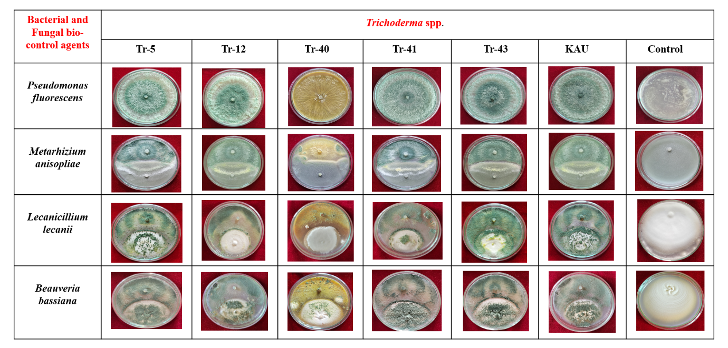
Figure 4. Compatibility of native isolates of Trichoderma spp. with bacterial and fungal biocontrol agents

Table 6. Compatibility of native isolates of Trichoderma spp. with P. fluorescens

Serial No. | Isolates | Average Radial growth of the isolates in the treatment plates (cm) | Per cent inhibition over control | Per cent  Compatibility  with P. fluorescens
1 | Tr-5 | 8.93ª | 0.7 | 99.3ª
2 | Tr-12 | 8.93ª | 0.7 | 99.3ª
3 | Tr-40 | 8.83ª | 1.8 | 98.2ª
4 | Tr-41 | 8.86ª | 1.5 | 98.5ª
5 | Tr-43 | 8.86ª | 1.5 | 98.5ª
6 | KAU | 8.9ª | 1.1 | 98.9ª
7 | Control | 9 | - | 0
 | SE(d) | 0.43 | - | 0.47
 | SE(m) | 0.30 | - | 0.33
 | CD (0.05) | - | - | -

Table 7. Compatibility of native isolates of Trichoderma spp. with M. anisopliae and L. lecanii
Serial No. | Isolate | Compatibility with M. anisopliae |  |  | Compatibility with L. lecanii
Serial No. | Isolate | Average Radial growth of the Trichoderma spp. in the treatment plate (cm) | Per cent inhibition over control plate | Per cent compatibility over M. anisopliae | Average Radial growth of the Trichoderma spp. in the treatment plate (cm) | Per cent inhibition over control plate | Per cent compatibility over L. lecanii
1 | Tr-5 | 5.3^{ab} | 18.46 | 81.54^{ab} | 6.66ª | 1.33 | 98.76ª
2 | Tr-12 | 5.36^{ab} | 17.43 | 82.56^{ab} | 6.56^{ab} | 2.81 | 97.27^{ab}
3 | Tr-40 | 4.33^{c} | 33.32 | 66.67^{c} | 2.26^{c} | 66.51 | 33.58^{c}
4 | Tr-41 | 5.2^{b} | 19.98 | 80.00^{b} | 6.46^{b} | 4.29 | 95.79^{b}
5 | Tr-43 | 5.23^{ab} | 17.94 | 82.05^{ab} | 6.63ª | 1.78 | 98.27ª
6 | KAU | 5.67ª | 12.81 | 84.90ª | 6.63ª | 1.78 | 98.26ª
 | control | 6.5 | 0 | 0 | 6.75 | - |  | 0
 | SE(d) | 0.12 | - | 1.91 | 0.07 | - |  | 1.10
 | SE(m) | 0.08 | - | 1.35 | 0.05 | - |  | 0.78
 | CD (0.05) | 0.25 | - | 4.18 | 1.55 | - |  | 2.40

The compatibility of isolates of Trichoderma spp. with other fungal bio-control agents, viz., M. anisopliae, L. lecanii and B. bassiana, was also checked. Here, the Trichoderma isolates have overgrown the cultures of M. anisopliae, L. lecanii and B. bassiana without interfering their growth and hence showed less per cent inhibition over the control (Table 7, 8 and Fig. 4). The isolate, Tr-40 (T. lixii), showed an antagonistic effect over the two fungal biocontrol agents M. anisopliae (33.32%) and L. lecanii (66.51%); hence, Tr-40 is not found to be compatible with these two fungal bioagents. But the Tr-40 (98.26%) isolates showed compatibility with B. bassiana (Table 8). A similar study was carried out by Sumalatha et al. (2017), in which they reported that T. viride showed the highest per cent inhibition over V. lecanii and were reported as incompatible. Upamanya et al. (2020) observed the compatibility of entomopathogens (B. bassiana and M. anisopliae) with the isolates of Trichoderma spp. viz., T. harzianum and T. asperellum.

Table 8. Compatibility of native isolates of Trichoderma spp. with B. bassiana
Serial. No. | Isolate | Average Radial growth of the Trichoderma spp. in the treatment plates (cm) | Per cent inhibition over control | Per cent compatibility with B. bassiana
1 | Tr-5 | 6.60ª | 2.22 | 97.77ª
2 | Tr-12 | 6.63ª | 1.78 | 98.26^{aa}
3 | Tr-40 | 6.63ª | 1.78 | 98.27ª
4 | Tr-41 | 6.63ª | 1.78 | 98.26ª
5 | Tr-43 | 6.56ª | 2.81 | 97.28ª
6 | KAU | 6.7ª | 0.74 | 99.25ª
 | Control | 6.75 | 0 | 0
 | SE(d) | 0.08 | - | 1.24
 | SE(m) | 0.05 | - | 0.87
 | CD (0.05) | - | - | -

4. Conclusion
In this study, all the five native isolates of Trichoderma spp. Tr-5, Tr-12, Tr-41, Tr-43 (T. asperellum) and Tr-40 (T. lixii) showed high tolerance to abiotic stresses at an optimum range of temperature (30ºC), NaCl (0.5M), and PEG (10%). The isolates of Trichoderma spp. were found to be compatible with fungal bio-control agents, viz., Metarhizium anisopliae, Lecanicillium lecanii and Beauveria bassiana and bacterial bio-control agent, Pseudomonas fluorescens. Only the Tr-40 isolate showed incompatibility with M. anisopliae, L. lecanii. Their ability to adapt to environments with various stress factors is a crucial evolutionary mechanism that enhances their effectiveness as biocontrol agents against plant pathogens. Further studies must be conducted to prove the biocontrol efficacy of these isolates to manage the soil borne pathogens under in vivo conditions.

Disclaimer (Artificial intelligence)
Option 1:
Author(s) hereby declare that NO generative AI technologies such as Large Language Models (ChatGPT, COPILOT, etc.) and text-to-image generators have been used during the writing or editing of this manuscript.
Option 2:
Author(s) hereby declare that generative AI technologies such as Large Language Models, etc. have been used during the writing or editing of manuscripts. This explanation will include the name, version, model, and source of the generative AI technology and as well as all input prompts provided to the generative AI technology
Details of the AI usage are given below:
1.
2.
3.

References

1. Domingues, M.V.P.F., Moura, K.E., Salomao, D., Elias, L.M. and Patricio, F.R.A. Effect of temperature on mycelial growth of Trichoderma, Sclerotinia minor and S. sclerotiorum, as well as on mycoparasitism. Summa phytopathologica, (2016);42(3): 222-227
2. Duzniewska, J. Effect of incubation temperature on development and biotic relations between Trichoderma spp. and pathogenic fungi. Acta Scientiarum Polonorum Agricultura, (2004);3(2): 257-262
3. Kim, T.G and Knudsen, G. Relationship between the biocontrol fungus Trichoderma harzianum and the phytopathogenic fungus Fusarium solani f.sp. pisi. Applied Soil Ecology, (2013); 68: 57-60
4. Kumar, R.M., Rao, M.S., Gavaskar, J. and Sowmya, D.S., Evaluation of compatibility and effect of Trichoderma harzianum and Pseudomonas fluorescens against the disease complex of tomato. International Journal of Innovative Horticulture, (2012);1(2):135-143
6. Kucuk, C., In vitro antagonistic activity against fusarium species of local Trichoderma spp. isolates J. Biol. Environ. Sci., (2017);11(32): 67-74
7. Leo Daniel, A. E., Praveen Kumar, G., Desai, S., & Mir Hassan, A. S. K. In vitro characterisation of Trichoderma viride for abiotic stress tolerance and field evaluation against root rot disease in Vigna mungo L. J Biofertil Biopestici, (2011);2(3):1-5. doi:10.4172/2155-6202.1000111
8. Muthuvaduganathan, N., Peter, A. J., Thirumalai, S., & Maiti, S. Isolation of Trichoderma spp. from arid and semi-arid conditions and screening for its in vitro bio-efficacy and abiotic stress tolerance J. Mycopathol. Res. (2023);61(2): 217-226 doi. 10.57023/JMycR.61.2.2023.217
9. Mishra, N., Khan, S.S. and Sundari, S.K., Native isolate of Trichoderma, a biocontrol agent with unique stress tolerance properties. World Journal of Microbiology and Biotechnology, (2016);32: 1-23.
10. Nandini, B., Compatibility and virulence studies of microbial pesticides commonly used in Telangana, j. of entomology and Zoology studies., (2019); 7(1): 244-249
11. Shahid, M., Singh, A., Srivastava, M., Mishra, R. P., & Biswas, S. K. Effect of temperature, pH and media for growth and sporulation of Trichoderma longibrachiatum and self-life study in carrier-based formulations. Annals of Plant Protection Sciences, (2011);19(1):147-149
12. Singh, O.P. and Kumar, S. Trichoderma spp. Growth as influenced by Temperatures. Annals of Plant Protection Sciences, (2009);17(1): 261p
13. Sumalatha, J., Rahman, S.J., Rahman, S.M.A.S. and Prasad, R.D. Compatibility of entomopathogenic fungi Verticillium lecanii with other biopesticides in laboratory conditions. The Pharma Innovation Journal, (2017);6(9):264-266.
14.Shobha, M.S., 2018. Effect of Endophytic and plant growth promoting rhizobacteria against foot rot disease of Piper nigrum L. International Journal of Environment, Agriculture and Biotechnology, (2018);3(6):268282p.
15. Sharma, M., Idong, S., Sharma, R., & Singh, P. Isolation and Evaluation of Temperature-Tolerant Trichoderma. International Journal of Current Microbiology and Applied Sciences, (2020);9(3):1164-1171.https://doi.org/10.20546/ijcmas.2020.903.136
16. Upamanya GK, Bhattacharyya A, Dutta P. Consortia of entomopathogenic fungi and bio-control agents improve the agroecological conditions for brinjal cultivation of Assam. 3 Biotech. (2020);10(10):450.
17. Zehra, A., Dubey, M. K., Meena, M., & Upadhyay, R. S. Effect of different environmental conditions on growth and sporulation of some Trichoderma species. Journal of Environmental Biology, (2017);38(2): 197.

