**Pure Verrucous Carcinoma of Penis : A rare case report**

**Abstract**

**Introduction :** Primary penile cancer is a rare pathology in daily practice. Verrucous carcinoma of the penis is exceptional, representing approximately 5% to 24% of all penile tumors. Diagnosis is often difficult and delayed. Early diagnosis and appropriate management can avoid aggressive and mutilating treatments and improve the prognosis.

**Case Study :** We report a case of verrucous carcinoma of the penis in a 70-year-old patient, circumcised during childhood, who progressed well after surgical treatment.

**Conclusion :** Early diagnosis of verrucous carcinoma allows for conservative treatment and improves the prognosis. Prevention can reduce the incidence of these tumors.

**Keywords:** Carcinoma, verrucous, penis, surgery.

**Introduction**

Penile verrucous carcinoma is a rare squamous cell carcinoma (SCC), representing 5% to 24% of all penile tumors. It is low-grade and well-differentiated, exhibiting slow-growing, warty growth and rare metastases (1). Traditional management has often relied on radical surgical approaches, including partial or total penectomy, which can have significant implications for urinary, sexual, and psychological function (2). In recent years, however, there has been a growing emphasis on organ-preserving surgical techniques aimed at maintaining genital function and aesthetic appearance while ensuring oncologic control (3).

**Case Report**

A 70-year-old man with no particular medical history, circumcised at the age of 3, presented with a penile tumor that had been developing for 2 years. It appeared spontaneously and progressed progressively. It was painless, without urinary signs such as dysuria or pollakiuria, and was in a feverish state and his general health was intact. Clinical examination revealed a painless, exophytic, "cauliflower"-shaped, budding tumor, 2 cm in diameter, with a whitish surface in places, located on the foreskin and connected to the glans without invading it. The tumor was movable. There were no other lesions on the penis (Figures 1, 2, 3).

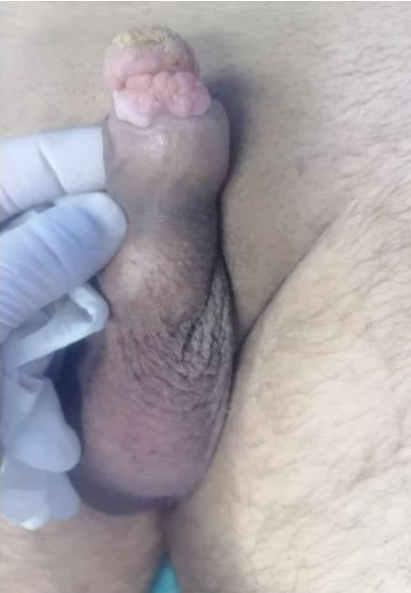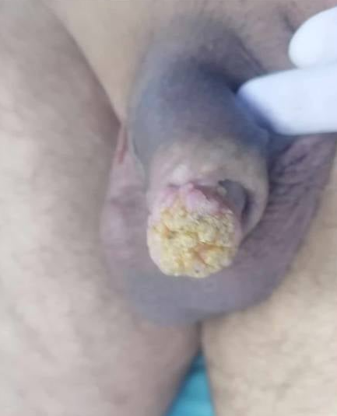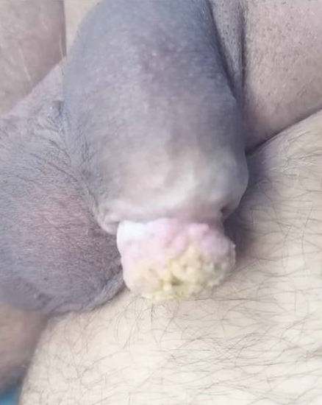

Figures 1, 2, 3 : Clinical appearance of the tumor

The lymph nodes were free. Serological tests for HIV, syphilis, and hepatitis B and C were negative.

Histological study of a deep biopsy showed a well-differentiated verrucous squamous cell carcinoma (Figure 4).

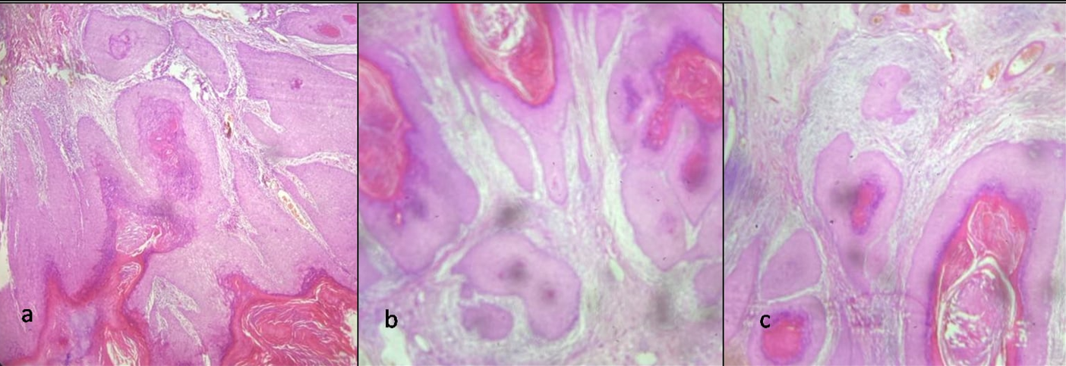

Figure 4 :

a. Keratinocyte proliferation with hyperkeratotic endo-exophytic architecture

b. Well-defined tumor clusters in the dermis composed of slightly atypical keratinocyte cells

c. Cell clusters centered by horny globes

Thoraco-abdomino-pelvic computed tomography (CT) showed no adenopathy or metastasis. The patient underwent tumor resection with a 5 mm resection margin (Figure 5, 6, 7).

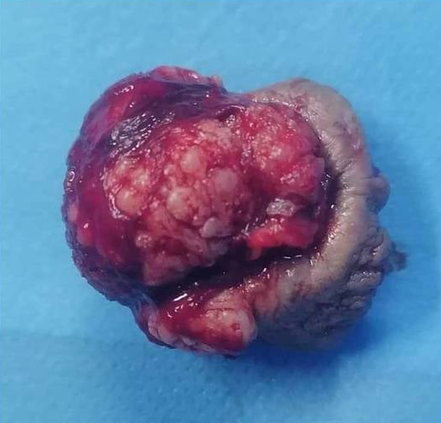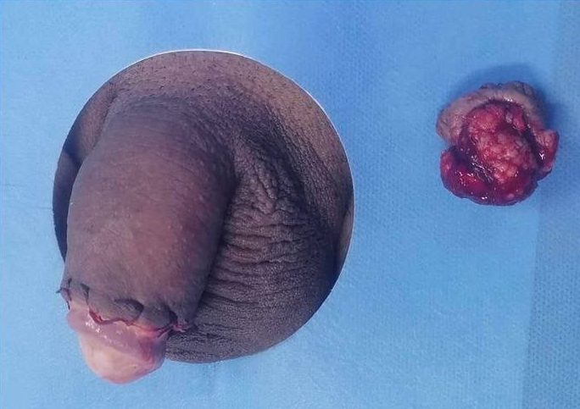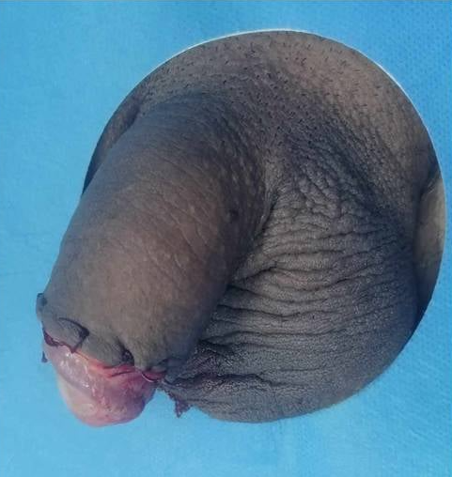

Figures 5, 6, 7 : Intraoperative appearance

The outcome was favorable with a follow-up of 12 months, without local recurrence (Figure 8, 9).

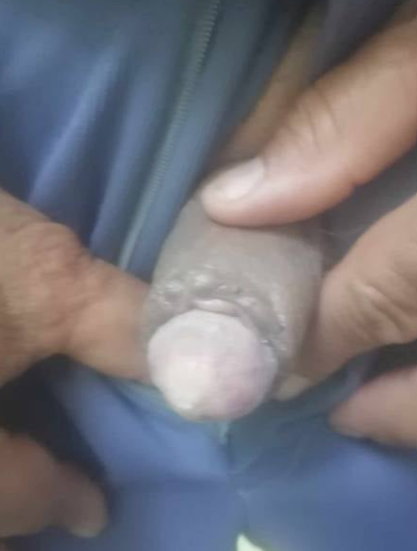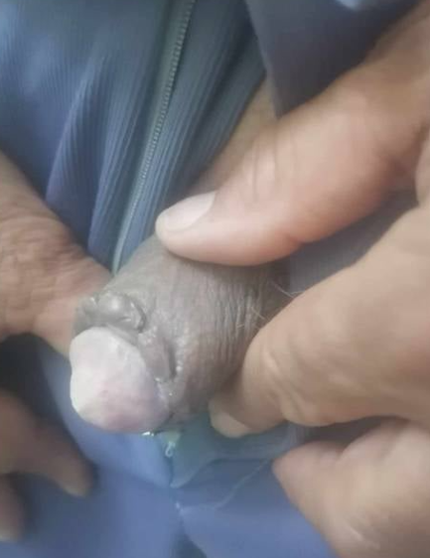

Figures 8 and 9 : Results at final follow-up

**Discussion**

Verrucous carcinoma is a well-differentiated, low-grade variant of squamous cell carcinoma, first described by Ackerman in 1948 in the context of the oral cavity. Although rare, it constitutes approximately 5% to 24% of all penile cancers and up to 20% of verruciform lesions affecting the penis (1). This neoplasm predominantly affects elderly, uncircumcised men. Its pathogenesis remains poorly understood, although several etiological factors have been implicated, including chronic inflammation, suboptimal genital hygiene, and infection with human papillomavirus (HPV).

The most frequent anatomical site is the glans penis. Phimosis and a redundant prepuce are recognized risk factors. Additional predisposing conditions include lichen sclerosus and pseudoepitheliomatous, keratotic, and micaceous balanitis. Histological changes such as squamous epithelial hyperplasia and marked hyperkeratosis are believed to contribute to tumorigenesis (4,5).

Clinically, the tumor typically presents as a slow-growing, exophytic mass with a papillomatous or verrucous surface. Despite their progressive local growth, these lesions are often asymptomatic and may extend proximally along the penile shaft. The classical clinical presentation includes a painless, slow-growing tumor with multiple papillary projections (6–8).

Histopathologically, verrucous carcinoma is characterized by a markedly well-differentiated squamous epithelium with both exophytic and endophytic growth patterns. Key microscopic features include hyperacanthosis, hyperkeratosis, and broad-based epithelial projections that push into the underlying stroma without true invasion. The epithelial papillae lack a fibrovascular core, and the nuclei are generally round with minimal cytologic atypia confined to the basal layer (9,10).

Verrucous carcinoma demonstrates local malignancy with negligible metastatic potential. Lymph node involvement is exceedingly rare (11). Although various non-surgical therapeutic approaches have been explored—including topical and systemic treatments—none have demonstrated superior efficacy compared to surgical excision, which remains the mainstay of management (12,13,14).

Historically, treatment protocols have favored aggressive surgery such as glansectomy or partial/total penectomy with wide margins (5–10 mm), even in cases of limited tumor burden (≤ 3 cm) (2,3). However, this strategy may be unnecessarily morbid for lesions with indolent biological behavior. In the case presented, the lesion was well-differentiated and exhibited a non-invasive course, suggesting a favorable prognosis with organ-preserving surgery.

We propose that, given its typically non-metastatic nature, penile verrucous carcinoma may be amenable to conservative surgical excision followed by vigilant clinical surveillance. Prophylactic inguinal lymphadenectomy is not routinely indicated in the absence of clinically or radiologically evident lymphadenopathy. In such cases, additional imaging (e.g., CT or ultrasound) may be deferred.

Although conservative management, including chemotherapy without surgery, has been described, local excision remains the standard. It is noteworthy that approximately one-third of cases have been reported to harbor foci of invasive squamous cell carcinoma, underscoring the importance of close follow-up and prompt reintervention in cases of recurrence (11).

Primary prevention strategies—including circumcision, HPV vaccination, and the management of premalignant penile lesions—may reduce disease incidence and improve long-term outcomes (6).

**Conclusion**

Verrucous carcinoma is a rare, slow-growing tumor with local malignancy, and recurrences are exceptional, requiring conservative surgical treatment : local excision with minimal surgical margins and regular follow-up improve the patient's functional, aesthetic, and psychosocial outcomes.

**References**

1. Chaux A., Velazquez E.F., Algaba F. Developments in the pathology of penile squamous cell carcinoma. Urology. 2010;76(2 Suppl 1):S7–S14.
2. [Dong In Jo](https://pubmed.ncbi.nlm.nih.gov/?term=%22Jo%20DI%22%5BAuthor%5D) , [Song Hyun Han](https://pubmed.ncbi.nlm.nih.gov/?term=%22Han%20SH%22%5BAuthor%5D) , [Soon Heum Kim](https://pubmed.ncbi.nlm.nih.gov/?term=%22Kim%20SH%22%5BAuthor%5D) , [Hye Young Kim](https://pubmed.ncbi.nlm.nih.gov/?term=%22Kim%20HY%22%5BAuthor%5D) , [Hong Chung](https://pubmed.ncbi.nlm.nih.gov/?term=%22Chung%20H%22%5BAuthor%5D) , [Hong Sup Kim](https://pubmed.ncbi.nlm.nih.gov/?term=%22Kim%20HS%22%5BAuthor%5D) .Optimal treatment for penile verrucous carcinoma: a systematic literature review. BMC Urol . 2021 Jan 29;21:13.
3. [Dong In Jo](https://pubmed.ncbi.nlm.nih.gov/?term=%22Jo%20DI%22%5BAuthor%5D) a, [Sang Kyu Choi](https://pubmed.ncbi.nlm.nih.gov/?term=%22Choi%20SK%22%5BAuthor%5D) a, [Soon Heum Kim](https://pubmed.ncbi.nlm.nih.gov/?term=%22Kim%20SH%22%5BAuthor%5D) a, [Cheol Keun Kim](https://pubmed.ncbi.nlm.nih.gov/?term=%22Kim%20CK%22%5BAuthor%5D) a, [Hong Chung](https://pubmed.ncbi.nlm.nih.gov/?term=%22Chung%20H%22%5BAuthor%5D) b, [Hong Sup Kim](https://pubmed.ncbi.nlm.nih.gov/?term=%22Kim%20HS%22%5BAuthor%5D) b. Local Excision for the Treatment of Penile Verrucous Carcinoma. Urol Case Rep . 2017 Apr 10;13:16–18.
4. Amicuzi U and call. [Exploring the Multifactorial Landscape of Penile Cancer: A Comprehensive Analysis of Risk Factors.](https://pubmed.ncbi.nlm.nih.gov/39202278/) Diagnostics (Basel). 2024 ; 16;14(16):1790.
5. Mannam G, Miller JW, Johnson JS, Gullapalli K, Fazili A, Spiess PE, Chahoud . [HPV and Penile Cancer: Epidemiology, Risk Factors, and Clinical Insights.](https://pubmed.ncbi.nlm.nih.gov/39339000/) J.Pathogens. 2024 ; 18; 13(9):809.
6. Li F., Xu Y., Wang H. Diagnosis and treatment of penile verrucous carcinoma. Oncol Lett. 2015;9(4):1687–1690.
7. Valentin Aebischer · Stephan Forchhammer. Verruköser exophytischer Tumor der Glans penis. Dermatologie 2023· 74:195–198.
8. Ali Beddouche1, Adil Kallat1. Carcinome verruqeux de la verge. Pan African Medical Journal. 2016; 24:188.
9. Agnes LESOURD. Anatomo-pathologie des tumeurs malignes du pénis. Progrès en Urologie (2005), 15 801-804.
10. [S Menon](https://pubmed.ncbi.nlm.nih.gov/?term=Menon+S&cauthor_id=36221864)and cal. WHO 2022 classification of penile and scrotal cancers: updates and evolution. Histopathology. 2023;82(4):508-520.
11. Shimizu A., Tamura A., Ishikawa O. Invasive squamous cell carcinoma arising from verrucous carcinoma. Recognition of verrucous carcinoma of skin as an in situ carcinoma. Eur J Dermatol. 2006;16(4):439–442.
12. Sheen M.C., Sheu H.M., Jang M.Y. Advanced penile verrucous carcinoma treated with intra-aortic infusion chemotherapy. J Urol. 2010;183(5):1830–1835.
13. He X, Zhang J, Tan L, Wang W, Song Y, Wang H, Zhang X, Kou H1, Lu Y. Treatment of verrucous carcinoma in penis with topical aminolevulinic acid photodynamic therapy: An effective and safe treatment method. Photodiagnosis Photodyn Ther. 2018;24:232–236.
14. Catarino R, Cardoso A, Ferreira C, Pereira D, Correia T, Cerqueira M, Reis FC, Correia-Pinto J, Crisóstomo R, Gama MJ, Prisco R. Glans Resurfacing in Carcinoma in situ of the Penis: A Case Report. J. Can. Tumor Int. [Internet]. 2020 Jan. 1 [cited 2025 May 10];9(4):1-5. Available from: https://journaljcti.com/index.php/JCTI/article/view/146