Managing Multiple Foreign Body Ingestion: A Clinical Case and Surgical Approach

Abstract:
A 23-year-old male with a history of alcoholism and psychotropic drug use was admitted after ingesting multiple foreign bodies, including batteries and glass shards, as part of a self-harm attempt. He presented with diffuse abdominal pain, primarily localized in the epigastric and periumbilical regions, accompanied by rectal bleeding. A CT scan revealed hyperdense foreign bodies located in the ileocecal region and colonic framework. An additional foreign body (a needle) was found intraoperatively in the extradigestive area. Given the associated risks, including chemical burns, intestinal perforations, and systemic toxicity, urgent surgical intervention was performed. A median laparotomy successfully removed multiple foreign bodies, and postoperative recovery was uneventful. This case underscores the importance of swift intervention and vigilant postoperative follow-up, including psychological evaluation, to prevent severe complications after the ingestion of foreign bodies.

Keywords:
Foreign body ingestion, Multiple foreign bodies, Chemical burns, Intestinal perforation, Systemic toxicity, Self-harm

Introduction:
Ingestion of multiple foreign bodies is a serious clinical issue, particularly among individuals with psychiatric disorders or tendencies toward self-harm. While the majority of foreign objects pass through the gastrointestinal tract without complications, certain materials, such as sharp objects and batteries, pose significant risks. These risks include intestinal perforation, chemical burns, and systemic toxicity, which can lead to potentially life-threatening complications if not addressed promptly (Pavlidis et al., 2008).
Batteries, commonly found in everyday items, are particularly hazardous when ingested. Their reactive contents can cause chemical burns to the gastrointestinal tract, leading to tissue necrosis, perforation, and systemic toxicity (Leinwand et al., 2016). Similarly, sharp foreign bodies, such as glass fragments, can puncture the bowel wall, resulting in peritonitis, internal bleeding, and sepsis if not treated in a timely manner (Tambakis et al., 2023).
In this report, we present the case of a 23-year-old male who ingested multiple foreign bodies, including batteries and glass fragments, in a self-harm attempt. The management and outcomes of this case highlight the importance of timely intervention in preventing severe complications from foreign body ingestion.

Case Report:
A 23-year-old male with a history of alcoholism and psychotropic drug use presented to the emergency department after ingesting multiple foreign bodies, including 11 batteries and several glass shards, in a self-harm attempt. The patient complained of diffuse abdominal pain, primarily localized to the epigastric and periumbilical regions, along with an episode of rectal bleeding. The abdominal pain was crampy and progressively worsening over the last few hours, with associated blood in the stool.
On physical examination, the patient appeared distressed but stable. The abdomen was tender to palpation, particularly in the epigastric and periumbilical areas. No peripheral edema was noted, and the rectal examination revealed no palpable masses or signs of infection. The patient was alert, oriented, and cooperative, but there was evidence of psychosocial distress consistent with his history of self-harm.
A CT scan of the abdomen was performed to assess the location and nature of the ingested foreign bodies. The scan revealed several hyperdense foreign bodies, including batteries and glass fragments, located in the ileocecal region, ascending colon, and rectum. No signs of pneumoperitoneum, peritoneal effusion, or intestinal perforation were observed.
Given the significant risks associated with the ingested foreign bodies, particularly the batteries, which can cause chemical burns and systemic toxicity (Leinwand et al., 2016), and the sharp glass fragments, which can result in gastrointestinal perforation (Demiroren, 2023), the decision was made for urgent surgical intervention.

Figure 1: CT Scan Image – A scan showing the location of the ingested foreign bodies, including batteries and glass fragments, in the ileocecal region and ascending colon.
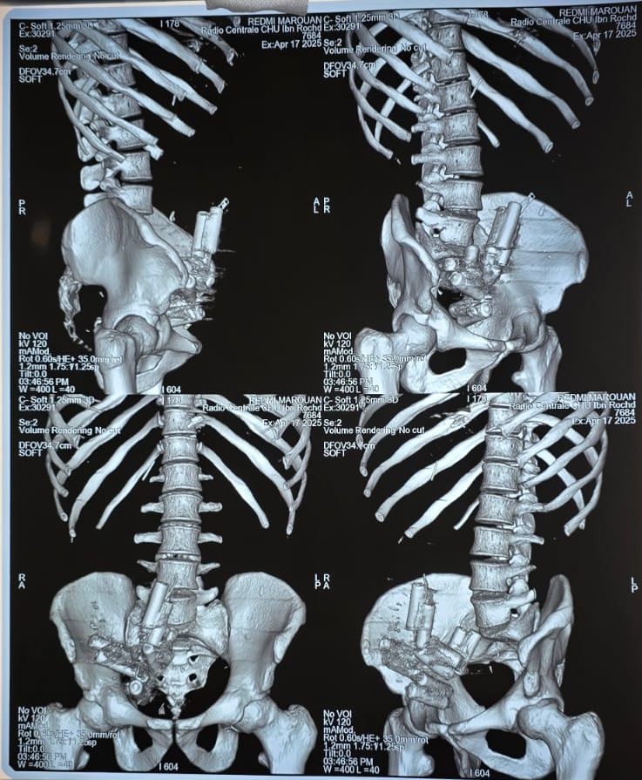
Figure 2: Removed Batteries and Glass Fragments – Image showing the batteries and glass shards that were successfully extracted during the median laparotomy.
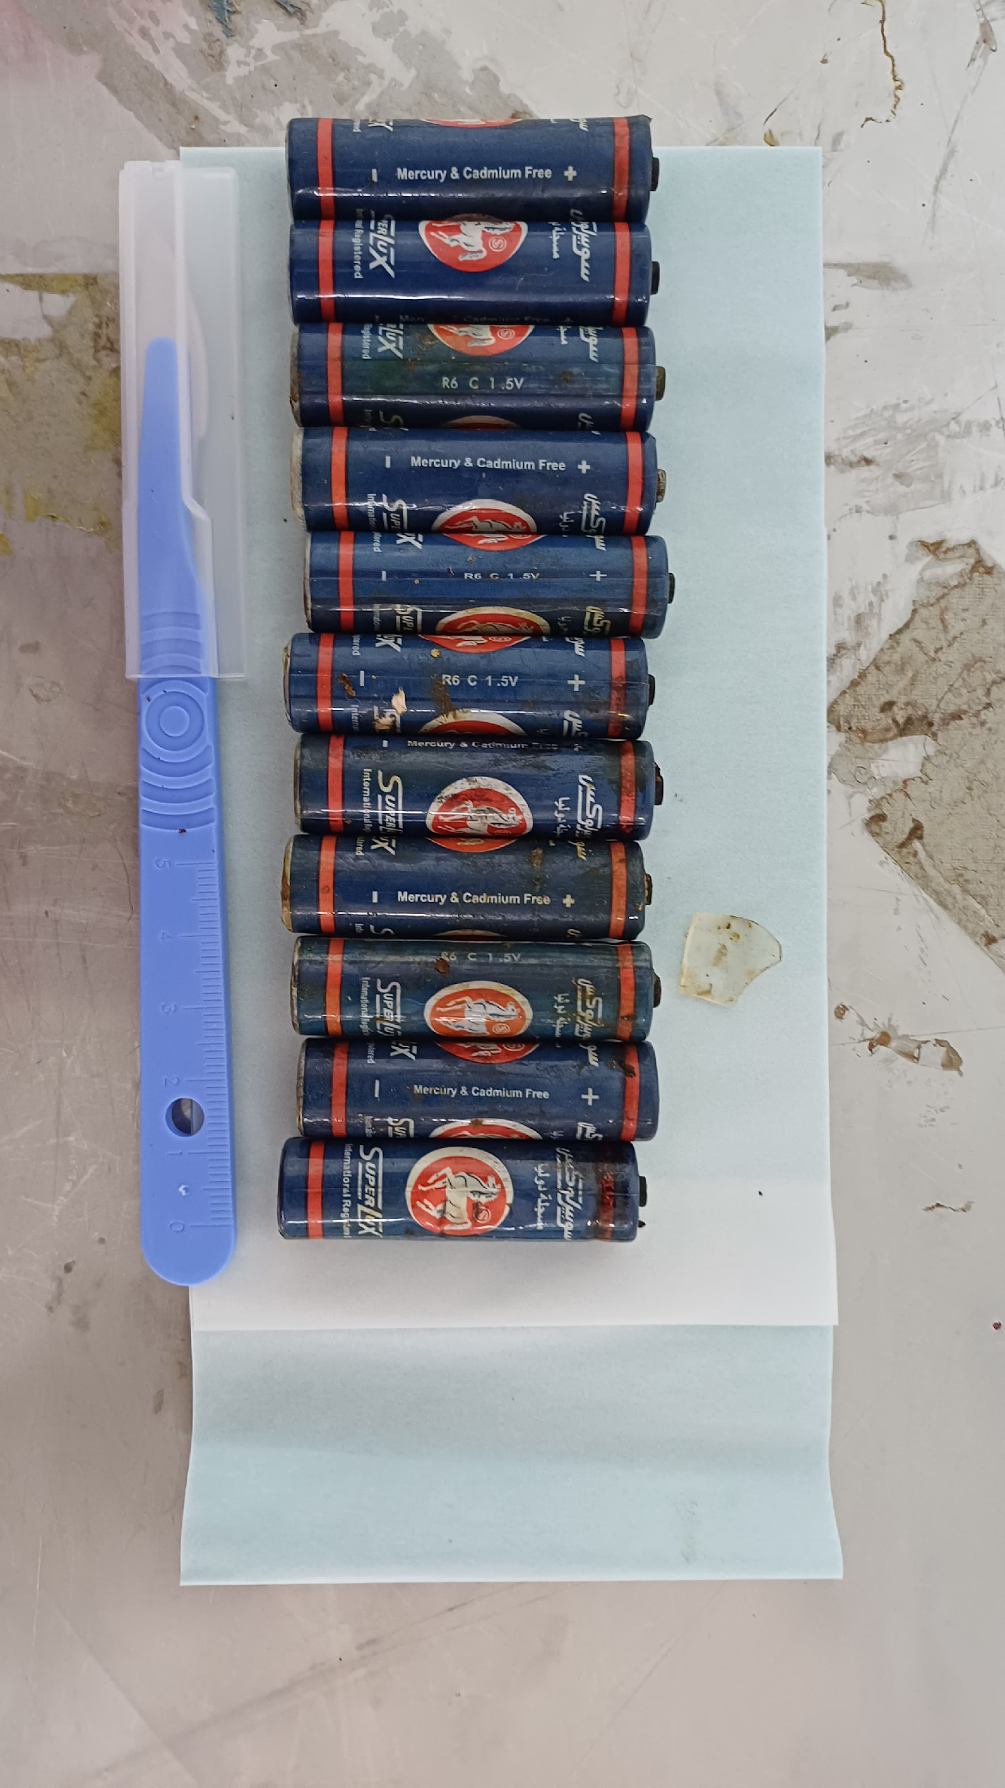
Figure 3: Needle Extracted in Extradigestive Area – Image showing the needle extracted from the extradigestive area during surgery, highlighting the presence of an additional foreign body not previously identified on imaging

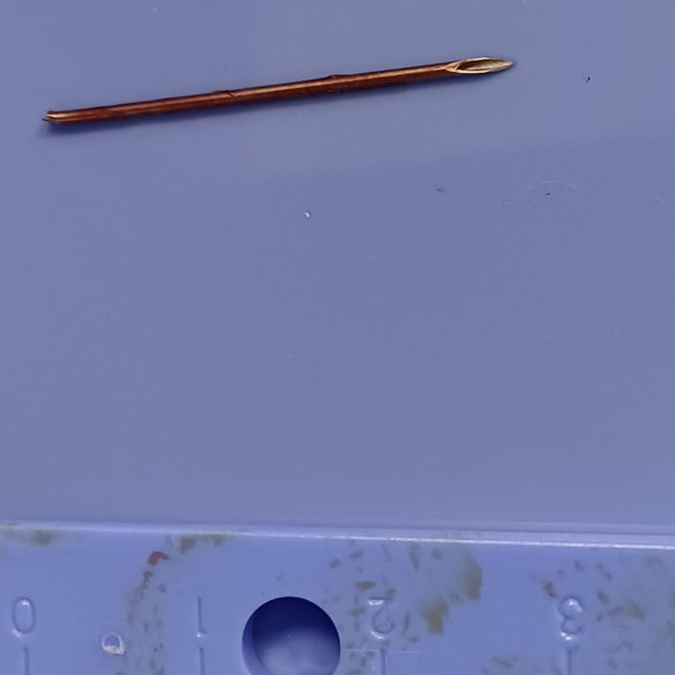

Discussion:
Foreign body ingestion is a common clinical issue, especially among pediatric and adult populations with underlying psychiatric conditions or a history of self-harm. While the majority of foreign bodies pass through the gastrointestinal tract without complications, certain objects can pose significant health risks, necessitating urgent intervention (Eisen et al., 2002).
The batteries ingested in this case were particularly dangerous due to their highly reactive chemical contents, which can cause chemical burns to the gastrointestinal tract (Leinwand et al., 2016). This can lead to mucosal necrosis, intestinal perforation, and systemic toxicity, which may manifest as electrolyte imbalances, cardiovascular instability, and neurological symptoms (Demiroren, 2023). The leakage of battery chemicals can exacerbate the situation, leading to systemic poisoning and widespread tissue damage. Early identification and removal of such foreign bodies are critical in preventing these serious outcomes.
Ingestion of sharp foreign bodies, such as glass fragments, presents another risk. These objects can puncture the bowel wall, resulting in gastrointestinal perforation, peritonitis, and sepsis if left untreated. Early detection and removal are essential to prevent these life-threatening complications (Tambakis et al., 2023).
The urgent laparotomy performed in this case allowed for the successful removal of all ingested foreign bodies. Although the patient’s recovery was uneventful, careful postoperative monitoring and follow-up imaging were necessary to ensure the complete removal of all objects and to detect any potential complications such as intestinal obstruction or infection.
Importantly, an additional needle was discovered in the extradigestive area during surgery, underscoring the limitations of imaging in fully assessing foreign body ingestion.
The role of psychosocial factors in this case is also significant. The patient’s history of self-harm highlights the complex relationship between physical health and mental health. Psychiatric evaluation and ongoing psychosocial support should be integrated into the management plan for patients presenting with self-harm behaviors to ensure comprehensive care (McMahon et al., 2025).
In addition to the immediate risks posed by foreign body ingestion, long-term effects such as psychological trauma and chronic gastrointestinal issues may persist. Continued monitoring and multidisciplinary management are essential for patients who present with similar clinical scenarios.

Conclusion:
This case underscores the significant risks associated with the ingestion of multiple foreign bodies, including batteries and sharp objects such as glass shards. The rapid decision to perform laparotomy was crucial in preventing chemical burns, intestinal perforation, and systemic toxicity. Early surgical intervention, followed by postoperative monitoring, is vital to ensuring a favorable outcome for patients who have ingested dangerous materials.
Furthermore, follow-up care, including imaging studies, psychiatric evaluation, and endoscopic assessments, is necessary to confirm the complete removal of foreign bodies and monitor for any complications such as intestinal obstruction or infection. This case highlights the need for a rapid, multidisciplinary approach to managing foreign body ingestion, particularly when hazardous materials are involved.

Consent:
As per international standard or university standard, patient(s) written consent has been collected and preserved by the author(s).
Ethical Approval:
This study has been approved by the Research Ethics Committee of the Department of General Surgery at IBN ROCHD University Hospital, Casablanca, Morocco. The principles of the Helsinki Declaration were followed.

Disclaimer (Artificial Intelligence): Option 1:
Author(s) hereby declare that NO generative AI technologies such as Large Language Models (ChatGPT, COPILOT, etc.) and text-to-image generators have been used during the writing or editing of this manuscript.

References:
- Pavlidis, T. E., Marakis, G. N., Triantafyllou, A., Psarras, K., Kontoulis, T. M., & Sakantamis, A. K. (2008). Management of ingested foreign bodies. How justifiable is a waiting policy? Surgical Laparoscopy, Endoscopy & Percutaneous Techniques, 18(3), 286-287. https://doi.org/10.1097/SLE.0b013e31816b78f5. PMID: 18574418
- Leinwand, K., Brumbaugh, D. E., & Kramer, R. E. (2016). Button battery ingestion in children: A paradigm for management of severe pediatric foreign body ingestions. Gastrointestinal Endoscopy Clinics of North America, 26(1), 99-118. https://doi.org/10.1016/j.giec.2015.08.003. PMID: 26616899; PMCID: PMC5425245
- Demiroren, K. (2023). Management of gastrointestinal foreign bodies with brief review of the guidelines. Pediatric Gastroenterology Hepatology & Nutrition, 26(1), 1-14. https://doi.org/10.5223/pghn.2023.26.1.1. Epub 2023 Jan 10. PMID: 36816435; PMCID: PMC9911172
- Eisen, G. M., Baron, T. H., Dominitz, J. A., Faigel, D. O., Goldstein, J. L., Johanson, J. F., Mallery, J. S., Raddawi, H. M., Vargo, J. J. 2nd, Waring, J. P., Fanelli, R. D., & Wheeler-Harbough, J.; American Society for Gastrointestinal Endoscopy. (2002). Guideline for the management of ingested foreign bodies. Gastrointestinal Endoscopy, 55(7), 802-806. https://doi.org/10.1016/s0016-5107(02)70407-0. PMID: 12024131
- McMahon, K., Conners, G. P., & Mohseni, M. (2025). Pediatric foreign body ingestion. In StatPearls [Internet]. Treasure Island (FL): StatPearls Publishing. Available from: https://www.ncbi.nlm.nih.gov/books/NBK430915/
- Tambakis, G., Schildkraut, T., Delaney, I., Gilmore, R., Loebenstein, M., Taylor, A., Holt, B., Tsoi, E. H., Cameron, G., Demediuk, B., Miller, A., Connell, W., Wright, E., Thompson, A., & Holmes, J. (2023). Management of foreign body ingestion in adults: Time to STOP and rethink endoscopy. Endoscopy International Open, 11(12), E1161-E1167. https://doi.org/10.1055/a-2201-6928. PMID: 38094028; PMCID: PMC10715904
- Altamimi, E., Yusef, D., & Rawabdeh, N. (2020). Endoscopic management of foreign body ingestion in children. Przegląd Gastroenterologiczny, 15(4), 349-353. https://doi.org/10.5114/pg.2020.101563. Epub 2020 Dec 10. PMID: 33777276; PMCID: PMC7988830

