Chilaiditi Syndrome and Antropyloric Stenosis: A Case Report

Abstract
Pneumoperitoneum is commonly associated with visceral perforations and often requires urgent surgical intervention. However, conditions such as Chilaiditi syndrome can mimic this alarming sign without actual perforation. This case report explores the coexistence of Chilaiditi syndrome and antropyloric stenosis, highlighting the diagnostic challenges and the need for accurate radiological assessment. Early differentiation between true and pseudo-pneumoperitoneum is crucial to avoid unnecessary surgeries. We also discuss the clinical management of patients presenting with overlapping gastrointestinal pathologies.
Keywords:
Chilaiditi syndrome, pneumoperitoneum, antropyloric stenosis, gastrointestinal obstruction, diagnostic imaging, surgical management.

Introduction
Pneumoperitoneum is the presence of free air within the peritoneal cavity and usually signifies a perforated abdominal viscus requiring emergency intervention. However, a rare condition called Chilaiditi syndrome, first described by Demetrius Chilaiditi in 1910, presents with similar radiologic signs but without actual perforation [2]. It involves the interposition of the colon—typically the transverse colon—between the liver and diaphragm. This anatomical variant may simulate subdiaphragmatic free air on imaging.
Chilaiditi syndrome is often asymptomatic but can complicate diagnosis when coexisting with other gastrointestinal pathologies such as antropyloric stenosis. Antropyloric stenosis, often secondary to chronic peptic ulcer disease, causes delayed gastric emptying and may present with recurrent vomiting and obstruction symptoms. Increased intra-abdominal pressure from vomiting, COPD, or abdominal adhesions may predispose patients to the development of Chilaiditi syndrome [4,5].
This case highlights the importance of recognizing this rare syndrome in patients presenting with gastrointestinal obstruction and radiographic signs of free air, and emphasizes the role of imaging in avoiding unnecessary surgery.

Case Presentation
Such association has been reported in other rare cases of partial colonic obstruction [7].
A 68-year-old male presented in September 2023 with symptoms of high intestinal obstruction. He had a medical history of COPD, chronic smoking, and a previously repaired ulcer perforation. In 2022, he was diagnosed with antropyloric stenosis.
Despite conservative management (bowel rest and nasogastric decompression), the patient experienced progressive abdominal pain, nausea, bilious vomiting, and cessation of bowel movements. Examination revealed a soft, non-tender abdomen, signs of dehydration, and a midline laparotomy scar. CT imaging showed extensive pneumoperitoneum without peritoneal effusion and demonstrated colonic interposition between the liver and diaphragm, consistent with Chilaiditi syndrome [6,7].
Due to persistent symptoms, exploratory laparotomy was performed. No perforation was found. A benign 2 cm bulbar stenosis was identified and an omega-loop gastrojejunostomy was performed to bypass the obstruction. The patient recovered well, with resumed bowel function and oral intake. He was discharged on postoperative day five.

.

Figures
Figure 1: CT scan showing pneumoperitoneum with suspected perforation, demonstrating the presence of Chilaiditi syndrome.
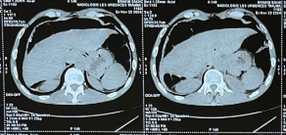

Figure 2 : CT scan image showing gastric stasis

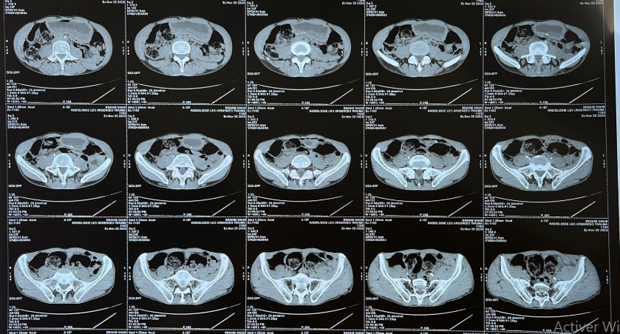

Figure 3: Stasis stomach and pyloric stenosis observed in the patient, highlighting key areas of concern
.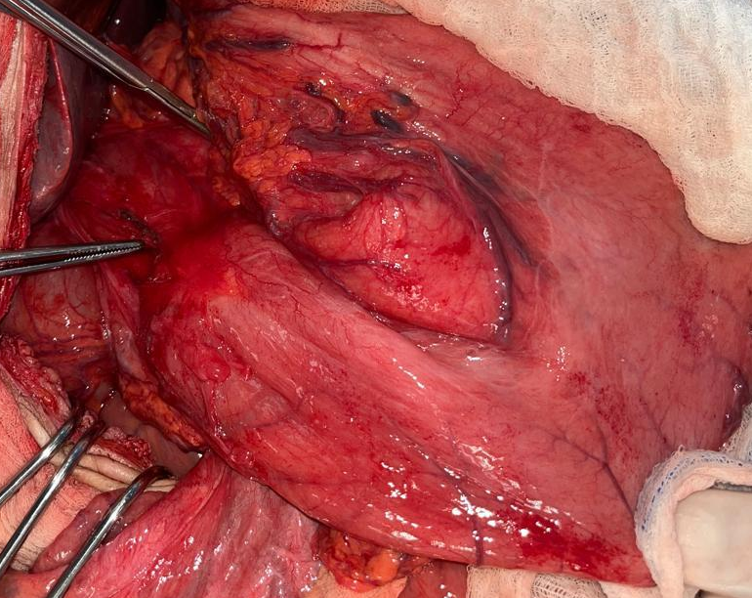

Figure 4: Pneumatosis of the colon, which mimics pneumoperitoneum, as seen in the patient's CT scan
.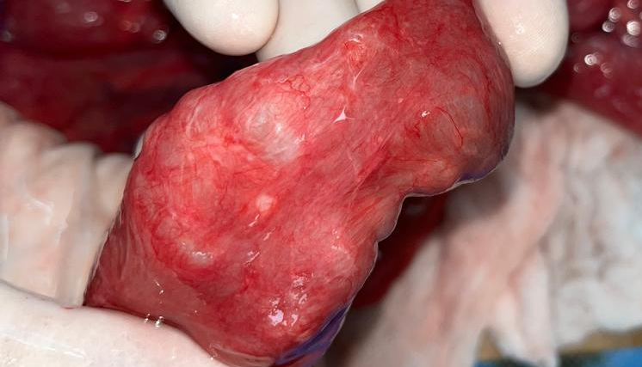

Discussion
Chilaiditi syndrome may present as an incidental radiologic finding or manifest with symptoms mimicking surgical emergencies [3]. It is essential to differentiate it from true pneumoperitoneum, which mandates emergent surgical intervention. Misdiagnosis may lead to unnecessary surgeries and patient morbidity [6].
Radiologic imaging is central to diagnosis. A plain X-ray may show air under the diaphragm, but absence of peritoneal signs and effusion should prompt consideration of Chilaiditi syndrome. A CT scan is the gold standard, confirming colonic interposition and ruling out perforation or peritonitis [6,8].
In this case, the patient’s history of antropyloric stenosis and COPD contributed to the pathophysiology. The term "false pneumoperitoneum" can be misleading; therefore, more precise terminology such as "radiological pneumoperitoneum without perforation" is preferable [9].
The surgical decision in this case was based on persistent obstructive symptoms despite radiologic findings. Although the stomach was not significantly distended, and perforation was ruled out, the pre-existing peptic stricture justified gastrojejunostomy. The need for vagotomy was not considered due to modern preference for acid suppression and the benign nature of the stenosis [10].
To prevent unnecessary interventions, a structured diagnostic approach should be adopted. CT imaging, serial examinations, and clinical correlation are vital. Awareness of this syndrome, especially in patients with COPD or abdominal surgery history, can significantly alter the management strategy [2,7].

Conclusion
This report underscores the diagnostic and therapeutic challenges when Chilaiditi syndrome coexists with antropyloric stenosis. Clinicians must be vigilant and consider benign etiologies of radiological free air. Appropriate diagnosis can prevent unnecessary surgical interventions and guide effective treatment strategies.

Provenance and Peer Review
Not commissioned, externally peer-reviewed.

Consent
As per international standard or university standard, patient(s) written consent has been collected and preserved by the author(s).

Ethical Approval
As per international standard or university standard written ethical approval has been collected and preserved by the author(s).

Conflicts of Interests
The authors have declared that no competing interests exist.

Source of Funding
None

References
- Adu Y, Nesiama EA, Siddiqui A, Prakash S, Obokhare I. Chilaiditi syndrome: a case report, literature review, and proposition of a novel management staging system. Cureus. 2023;15(10):e46688. doi:10.7759/cureus.46688. PMID: 37942369; PMCID: PMC10629610.
- Kumar A, Mehta D. Chilaiditi Syndrome. In: StatPearls. StatPearls Publishing, Treasure Island (FL); 2025. PMID: 32119452.
- Lin C, Yu J, Ou J, Lee Y, Huang M, Wu H. Chilaiditi syndrome: The pitfalls of diagnosis. Surg Sci. 2012;3(3):141–4.
- Kumar A, Mehta D. Chilaiditi syndrome [Updated 2023 Apr 10]. In: StatPearls [Internet]. Treasure Island (FL): StatPearls Publishing; 2025 Jan–. Available from: https://www.ncbi.nlm.nih.gov/books/NBK554565/
- Daly BD, Guthrie JA, Couse NF. Pneumoperitoneum without peritonitis. Postgrad Med J. 1991;67(793):999–1003. doi:10.1136/pgmj.67.793.999.
- Bourakkadi Idrissi M, Dkhissi Y. Pneumoperitoneum and Chilaiditi syndrome: navigating a diagnostic conundrum. J Surg Case Rep. 2024;2024(2):rjae056. doi:10.1093/jscr/rjae056.
- Basile EJ, Ahmed A, Rahman E, Rafa O, Frankini EL, Modica A. Chilaiditi syndrome presenting as partial colonic obstruction. Cureus. 2022;14(3):e22975. doi:10.7759/cureus.22975.
- Hisham AN, Gunn A, Jamil AA. Chilaiditi's syndrome presenting as acute abdomen. Med J Malaysia. 1995;50(3):281–3.
- Mansour KA, Hansen HA 2nd, Hersh T, Miller JI Jr, Hatcher CR Jr. Colon interposition for advanced nonmalignant esophageal stricture: experience with 40 patients. Ann Thorac Surg. 1981;32(6):584–91. doi:10.1016/s0003-4975(10)61803-6.
- Ajayi T, Moon G, Mony S. Chilaiditi's syndrome—an unusual cause of gastric outlet obstruction and constipation. Gastro Hep Adv. 2023;2(8):1026–1027. doi:10.1016/j.gastha.2023.08.001.

