Clinical Practice Article

A Centripetal Approach to Incisional Hernia Repair: Reflections from a Personal Surgical Evolution

Abstract:
This study presents a refined surgical technique for incisional hernia repair developed over three decades of experience. The “centripetal approach” involves a wide elliptical incision placed in healthy parietes, progressing inward to en-bloc remove attenuated tissues, followed by anatomical closure and mesh reinforcement. The approach minimizes dissection and bleeding while maximizing repair strength and postoperative outcomes. In cases where primary closure risks compartment syndrome, the sac is preserved and a dual mesh is overlaid to avoid direct visceral contact. This manuscript outlines patient characteristics, indications, dissection strategy, closure principles, and outcomes, supported by relevant literature.

Keywords: Incisional Hernia, Centripetal Approach, Mesh Repair, En-bloc Excision, Primary Closure, Dual Mesh, Component Separation Avoidance

Introduction:
Incisional hernias remain a common and often complex surgical challenge, especially in recurrent or large-volume cases. Despite various innovations, there is no universal consensus on the optimal repair technique [2,3]. Over the past thirty years, I have evolved a method I call the “centripetal approach,” marked by en-bloc excision of attenuated tissues and anatomical repair without component separation. This article aims to share the rationale, technique, and clinical outcomes associated with this method, and to demonstrate its applicability across a wide range of hernia types.

Methods:
This is a retrospective personal surgical review of patients with incisional hernias, including ventral and umbilical variants, repaired using the centripetal approach from 2010 to 2024 at a tertiary surgical oncology center. A total of 136 patients (age range: 28–84 years) underwent the procedure. Cases included multiple recurrent hernias, large-volume defects, and hernias following laparotomy, cholecystectomy, or oncological resections. All patients were followed for a minimum of 12 months postoperatively.

Surgical Technique:

- Incision and Exposure:
The centripetal approach begins with a wide elliptical incision made in healthy parietes, extending approximately 5–10 cm beyond the visible hernia defect [1,4]. The ellipse is designed in a 3:1 ratio—three units in length to one unit in breadth—to ensure optimal skin closure with minimal dog-earing and to achieve wide exposure of the surrounding healthy abdominal wall. The incision is either transverse or vertical, chosen on a case-by-case basis for optimal closure and exposure.

- Dissection and Tissue Handling:
Using energy devices such as ValleyLab diathermy, Ligasure Focus, and Ligasure Impact, dissection proceeds bloodlessly through subcutaneous fat and Scarpa’s fascia until the healthy parietes are reached [13,15]. Thereafter, the dissection proceeds medially toward the borders of the hernia defect and its ancillary extensions. If the defect is found to be amenable to anatomical closure, the dissection deepens circumferentially around the defect, incising the attenuated layers and opening the peritoneum. Adhesiolysis is performed meticulously, separating the adherent bowel or other viscera. The entire attenuated zone—comprising skin, subcutaneous fat, fascia, and sac—is excised en bloc. The fascial defect is then closed anatomically using loop Ethilon sutures, and reinforced with a self-adhering ProGrip onlay mesh placed with at least 5–10 cm overlap [4,6].
However, if the defect is too large to be closed primarily without risking compartment syndrome, the dissection is limited medially only to the borders of the defect. In such cases, the sac is preserved to act as a biological barrier. Superficial dissection is continued using energy devices to remove the overlying skin, subcutaneous fat, and attenuated fascia, while sparing the sac. A dual mesh is then placed as an inlay over the sac, which now lies between the mesh and abdominal viscera, minimizing direct contact and reducing the risk of fistula or adhesion formation. The dual mesh is sutured with continuous sutures to the borders of the defect as an onlay cover over the sac [9,10].

- Layered Closure:
The wound is closed in layers: Scarpa’s fascia, subcutaneous tissue, and inverted dermal sutures. A suction drain is placed over the mesh [12]. VAC dressings are used if early signs of seroma or infection arise postoperatively [13].Author contributions: All the authors contributed equally to the writing of the manuscript and approved the final version.

Results: Among the 136 patients, postoperative outcomes included:
- Mean hospital stay: 3.2 days
- Surgical site infection: 3.7%
- Seroma formation: 5.1%
- Hernia recurrence: 0%
- No patients required re-exploration
VAC dressings were required in 8 cases. No mesh-related complications were observed.

Discussion: The centripetal approach offers several advantages:
- Targeted dissection: Starting from healthy tissue and progressing medially to the defect margin minimizes unnecessary trauma, improves exposure, and ensures control over the operative field [5].
- En-bloc tissue removal: When feasible, the complete removal of compromised skin, subcutaneous fat, and fascial components decreases bacterial load, eliminates dead space, and exposes all minor or satellite defects [6].
- Anatomical closure without component separation: This method avoids extensive dissection and destabilization associated with component separation, thus minimizing infection and wound dehiscence [7].
- Use of preserved sac: In cases where closure would risk compartment syndrome, preserving the sac provides a natural buffer between dual mesh and viscera [10].
- Energy-assisted dissection: Advanced energy devices (Ligasure Focus for finer tissue planes and Ligasure Impact for deeper dissection) provide a bloodless field and minimize surgical morbidity [13].
- Postoperative reinforcement and wound care: Tension-free closure, layered approximation, and selective use of VAC dressing contribute to consistently favorable healing outcomes [14].
Causes of recurrence after mesh repair, as observed in literature and my personal practice, include:
- Inadequate mesh overlap (<5 cm beyond defect) [8]
- Missed fascial defects not included in the field of repair [4]
- Retention of attenuated tissues prone to failure [6]
This technique directly addresses each of these factors and enables surgeons to tailor the approach based on defect size and patient condition.

Conclusion: The centripetal approach to incisional hernia repair—beginning from healthy territory, minimizing dissection, ensuring wide exposure, and combining either primary closure or biologically buffered mesh reinforcement—has yielded excellent results in my practice. With no recurrence seen in a substantial cohort over more than a decade, I recommend this technique for surgeons managing complex, recurrent, or large-volume hernias.

Author Contribution: All the authors contributed equally to the writing of the manuscript and approved the final version.
Funding: None.
Conflict of interest: The authors declare no conflict of interest.
Ethical Approval:
As per international standards or university standards written ethical approval has been collected and preserved by the author(s).

References:
- Burger JW et al. Long-term follow-up of a randomized controlled trial of suture vs mesh repair of incisional hernia. Ann Surg. 2004.
- Muysoms FE et al. Classification of primary and incisional abdominal wall hernias. Hernia. 2009.
- Breuing K et al. Ventral hernia working group recommendations. Surgery. 2010.
- Holihan JL et al. Ventral hernia repair: A meta-analysis of randomized controlled trials. Ann Surg. 2017.
- Liang MK et al. Predicting hernia recurrence. Ann Surg. 2013.
- Deerenberg EB et al. A systematic review of the surgical treatment of large incisional hernia. Hernia. 2015.
- Novitsky YW et al. Transversus abdominis release: a novel approach. Ann Surg. 2012.
- Bittner R et al. Guidelines for laparoscopic treatment of ventral and incisional abdominal wall hernias. Surg Endosc. 2019.
- Bellows CF et al. The use of biologic versus synthetic mesh in ventral hernia repair. Ann Surg. 2013.
- Roth JS. Meshes for ventral hernia repair. Surg Clin North Am. 2013.
- LeBlanc KA. The critical technical aspects of laparoscopic ventral hernia repair. Am Surg. 2002.
- Köckerling F et al. Drain use in hernia surgery. Front Surg. 2018.
- Saettele TM et al. Complications in hernia repair with mesh: prevention and management. Surg Clin. 2020.
- Fischer JP et al. A 10-year review of surgical outcomes. J Am Coll Surg. 2014.
- Cavallaro G et al. Ventral hernia repair techniques: a comprehensive review. World J Clin Cases. 2023.

Figure 1.
Wide elliptical incision and centripetal dissection demonstrating en-bloc separation of skin, subcutaneous fat, fascia, and sac from the parietes. This intraoperative image highlights the hallmark of the centripetal approach—a wide local elliptical incision taken in healthy parietes, progressing inward, with the attenuated anterior abdominal wall tissues being carefully lifted as one composite layer.
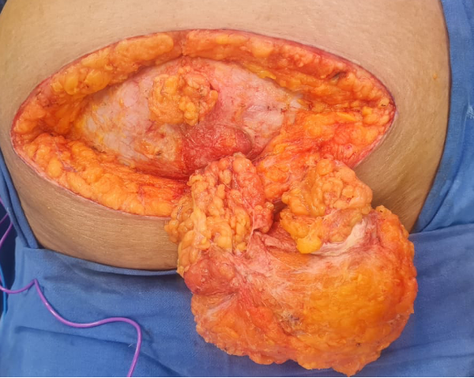

Figure 2.
Multiple discrete hernial defects with visible umbilicus, sac, and omentum after tissue separation. Following en-bloc excision of attenuated tissues, the anatomical extent of the hernia is clearly seen, with punctate and separated fascial defects, hernial sac, and omentum visualized distinctly.
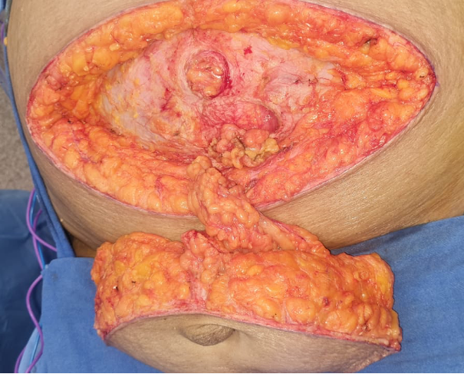

Figure 3.
Final mesh placement following anatomical closure of all defects. A self-adhering ProGrip mesh has been quilted in place, covering the entire repair site with at least 5–10 cm overlap. All defects have been primarily closed before mesh reinforcement.
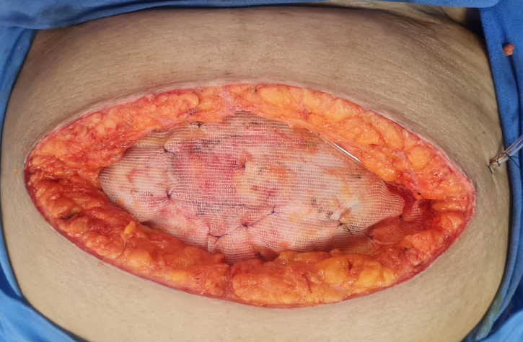

Figure 4.
Excised specimen demonstrating attenuated parietal tissues and omentum. This image shows the complete specimen removed en-bloc, including skin, fat, fascial elements, and adherent omentum, alongside a measurement scale to illustrate its size and extent.
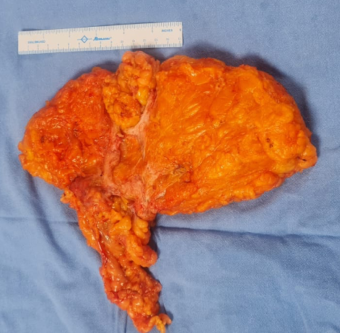
Figure 5.
Final layered closure of the incision after mesh placement. The surgical site following anatomical repair and mesh reinforcement shows a tension-free, multi-layered closure with approximation of Scarpa’s fascia, subcutaneous tissues, and inverted dermal sutures. The incision demonstrates a clean, well-aligned wound suitable for optimal healing.
