# Clinical Manifestations of Choledochal Cysts: Two Case Studies

Case report

**Abstract**

Choledochal cysts are congenital or acquired anomalies affecting the biliary system, characterized by dilation of the bile ducts. While the common bile duct (choledochus) is typically involved, both intrahepatic and extrahepatic bile ducts may also be affected.

The clinical presentation is often non-specific. Although the classical triad of abdominal pain, jaundice, and a palpable mass is well-known, it is observed in only about 10% of cases. Therefore, imaging studies are essential for accurate diagnosis and classification.

For adults with type I choledochal cysts, the treatment of choice is complete cyst excision followed by a Roux-en-Y hepaticojejunostomy. This surgical approach offers several advantages, including a reduced risk of anastomotic strictures, stone formation, cholangitis, and the development of malignancy within the cyst.

We report two adult female patients who were diagnosed using MRCP and subsequently underwent open Roux-en-Y hepaticojejunostomy.

# Key words

Choledochal cyst, hepatic-jejunostomy, cholangiocarcinoma, cholangitis

# Introduction

“Choledochal cysts are congenital anomalies of the bile ducts, characterized by abnormal and disproportionate cystic dilation of the biliary tract. The incidence varies geographically, ranging from 1 in 13,000 live births in Japan to approximately 1 in 200,000 in Western countries. Over 60% of cases are

diagnosed within the first year of life, while about 20% present in adulthood. The condition has a higher prevalence in females, with a female-to-male ratio of 4:1”. [1,2,3]

“The clinical presentation in adults is often non-specific. While the classical triad of jaundice, abdominal pain, and a palpable abdominal mass is well recognized, it is observed in a majority of adult cases”. [2,4]

“Diagnosis is primarily based on imaging studies. Commonly used modalities include ultrasonography, computed tomography (CT), magnetic resonance cholangiopancreatography (MRCP), endoscopic

retrograde cholangiopancreatography (ERCP), and endoscopic ultrasound”. [1,2]

The standard treatment involves complete cyst excision followed by a Roux-en-Y

hepaticojejunostomy. This surgical approach aims to restore normal bile drainage and minimize

complications such as cholangitis, stone formation, anastomotic strictures, and the risk of malignant transformation. [5,6,7]

# Case presentation

**Case I** A 25-year-old female was admitted to our center with complaints of abdominal pain and vomiting for three days. The pain was located in the epigastric region, colicky in nature, and continuous. It was associated with multiple episodes of non-bilious vomiting.

On physical examination, the patient was afebrile and non-icteric. A palpable lump was noted in the right hypochondrium. Laboratory investigations were within normal limits, and liver function tests did not show evidence of jaundice.

Magnetic Resonance Cholangiopancreatography (MRCP) revealed a Type I choledochal cyst measuring approximately 8 × 4 cm. There were no stones within the cyst or the gallbladder. The intrahepatic biliary radicles and pancreatic duct appeared normal, and the cyst was located completely above the duodenum (supra-duodenal). Based on imaging and clinical evaluation, a diagnosis of Type I choledochal cyst was confirmed.

Under general anesthesia, the patient underwent surgery through a standard Kocher’s incision with a slight extension into the epigastric region. Intraoperatively, a choledochal cyst of approximately 8 × 4 cm was identified. The cyst was transected proximally below the hepatic hilum, with a bulldog clamp applied to the proximal stump. The distal portion of the cyst was carefully dissected and transected posterior to the duodenum. Complete excision of the cyst, along with cholecystectomy, was performed.

Biliary reconstruction was achieved via a Roux-en-Y hepaticojejunostomy. A meticulous two-layer anastomosis was performed between the hepatic duct and the jejunum, with no evidence of bile leakage. The liver and pancreas appeared grossly normal.

The excised cyst was sent for histopathological examination. On gross inspection, no stones were found within the cyst, and microscopic analysis revealed no evidence of malignancy.

The postoperative course was uneventful. The patient was discharged on the 10th postoperative day. During one year of follow-up in the outpatient clinic, the patient remained asymptomatic, with no signs of stricture formation, jaundice, or malignancy. **(Fig 1-10)**

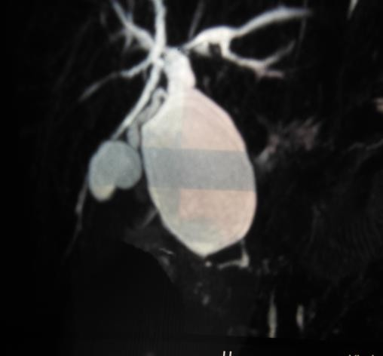

GB

CCs

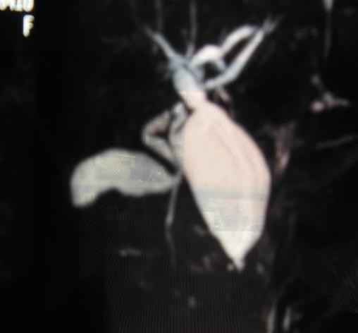

GB

CCs

**Fig-1 MRCP showing choledochal cyst with normal GB and intrahepatic biliary radicals**

**Fig-2 MRCP showing choledochal cyst with normal GB and intrahepatic biliary radicals**

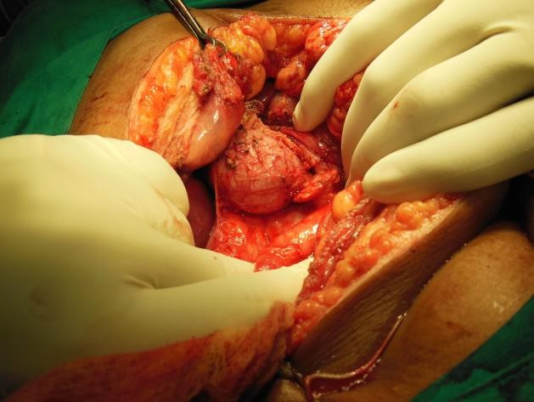

**Fig-3 Intraoperative photograph showing choledochal cyst measuring 8x4 cm**

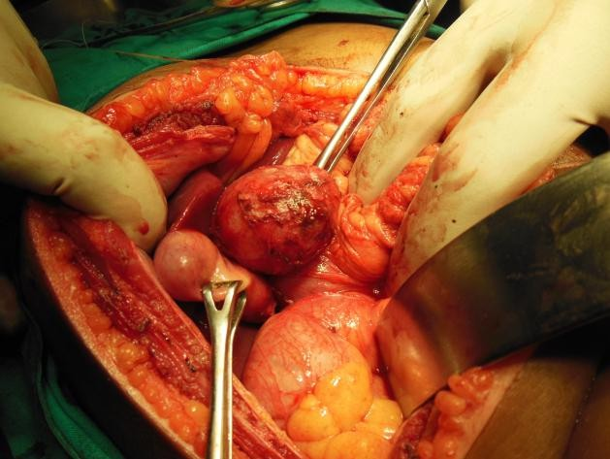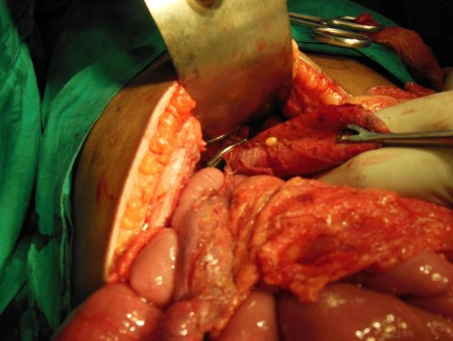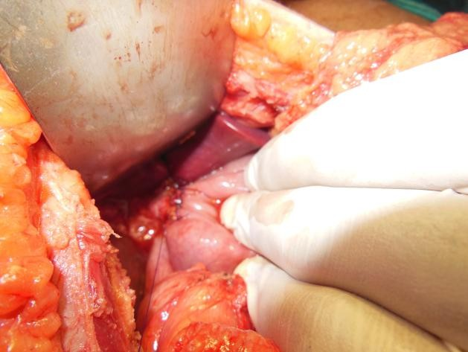

**Fig-4 Intraoperative photograph showing**

**Normal gall bladder with choledochal cyst**

**Fig-6 Intraoperative photograph showing application**

**of clamps proximal to choledochal cyst**

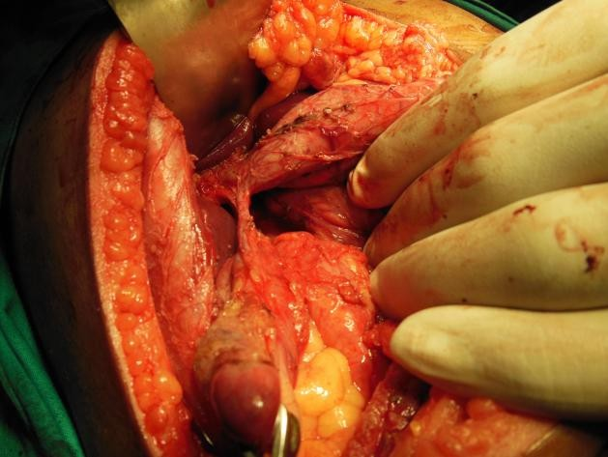

**Fig-5 Intraoperative photograph showing dissection of gall bladder and choledochal cyst**

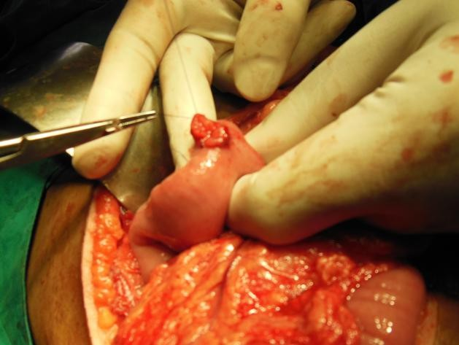

**Fig-7 Intraoperative photograph showing jejunostomy**

**Fig-8 Intraoperative photograph showing roux-en-Y hepaticojejunostomy**

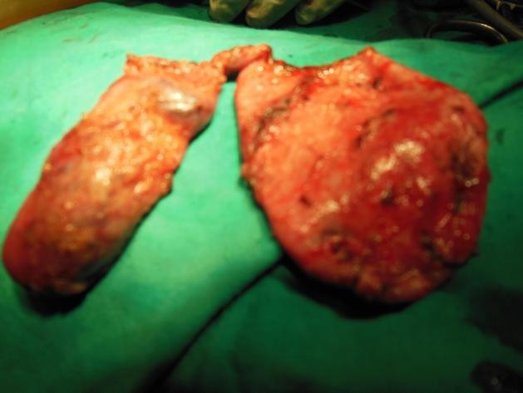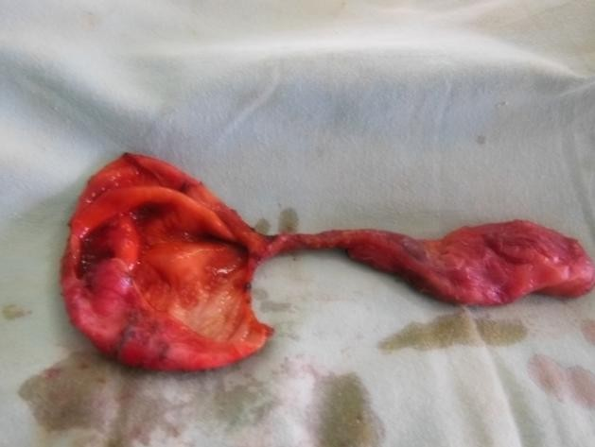

**Fig-9 Gross specimen of choledochal cyst measuring 8x4 cm and Gall bladder**

**Fig-10 After cutting the specimen, no stones inside the choledochal cyst and gall bladder**

# Case II

A 15-year-old girl was admitted to our center on 10/12/2017 with complaints of recurrent episodes of epigastric pain accompanied by vomiting for the past three months. On physical examination, she was non-icteric, and no significant abnormalities were found. Laboratory investigations were within normal

limits.

Ultrasound imaging revealed cystic dilatation of the extrahepatic common bile duct with a normal gallbladder. Further evaluation with Magnetic Resonance Cholangiopancreatography (MRCP) confirmed

a Type I choledochal cyst measuring approximately 10 × 4 cm. No stones were noted in the gallbladder or within the cyst. Based on Todani’s classification, a diagnosis of Type I choledochal cyst anomaly was established.

The patient underwent open surgery under general anesthesia via a right subcostal incision.

Dissection began at the gallbladder and extended along the extrahepatic bile duct. The distal end of the cyst, where it opened into the duodenum, was carefully isolated, clamped, transected, and transfixed. Following this, the posterior wall of the cyst was meticulously dissected away from the portal vein.

Dissection continued proximally up to the hepatic hilum. To achieve a wide and secure anastomosis, the dissection was extended further until the left hepatic duct was clearly visualized. The choledochal cyst was completely excised, and a Roux-en-Y hepaticojejunostomy was performed for biliary

reconstruction.

An intra-abdominal drain was placed in the Morrison's pouch and removed on the 7th postoperative day. The patient had an uneventful recovery and was discharged on the 10th postoperative day. She was followed up regularly for five years, during which she remained healthy with no evidence of biliary

stricture, pancreatitis, or other complications.

**Fig-11 MRCP showing choledochal cyst with normal GB and intrahepatic biliary radicals**

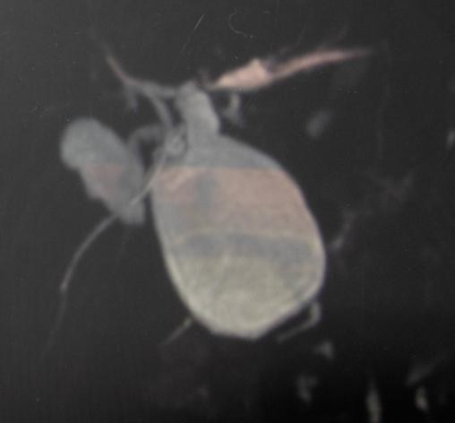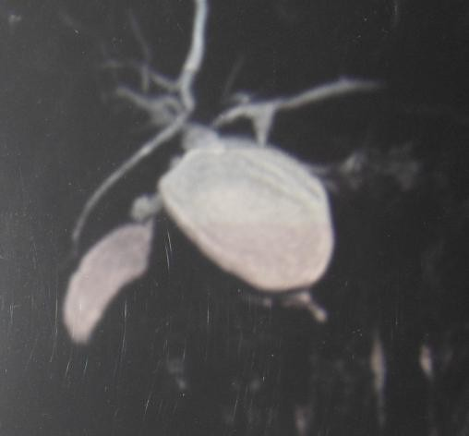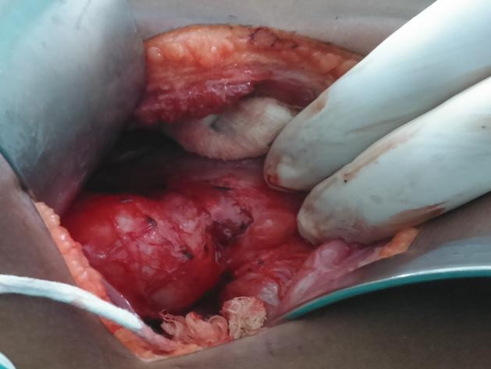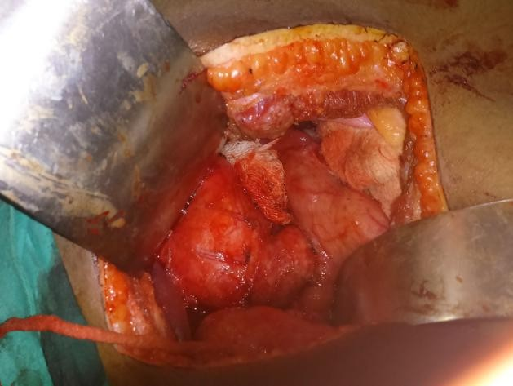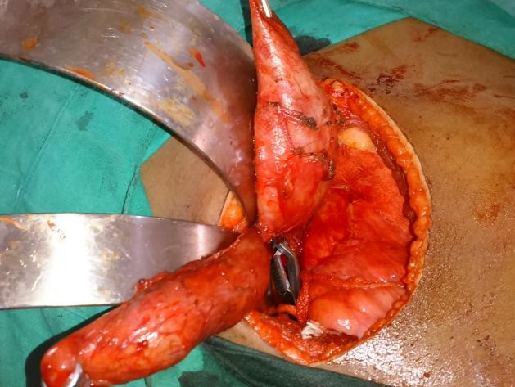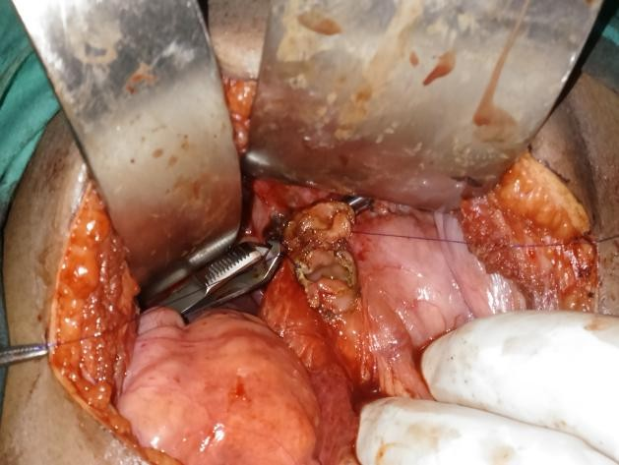

**Fig-12 MRCP showing choledochal cyst with normal GB and intrahepatic biliary radicals**

**Fig-13 Intraoperative photograph showing a choledochal cyst of size 10x 4 cm**

**Fig-14 Intraoperative photograph showing a choledochal cyst**

**Fig-15 Intraoperative photograph showing dissection of gall bladder and choledochal cyst**

**Fig-16 Intraoperative photograph showing bulldog’s clamp applied proximal hepatic duct**

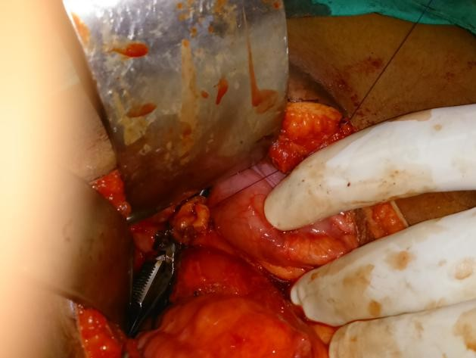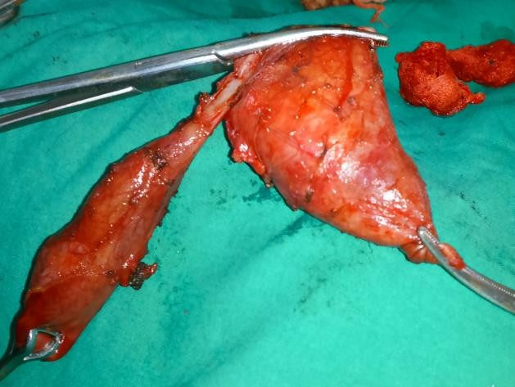

**Fig-17 Intraoperative photograph showing Roux-en-Y hepaticojejunostomy**

**Fig-18 Gross specimen of choledochal cyst measuring 10x4 cm and Gall bladder**

# Discussion

**Classification of Choledochal Cysts**

The first imaging-based classification system for choledochal cysts was proposed by Alonso-Lej et al. in 1959, and was later expanded by Todani et al. in 1977. The Todani classification, which is widely used today, categorizes choledochal cysts into five main types: [1,2,3]

1. Type I – Most common (50–80%)

Involves cystic or fusiform dilatation of the extrahepatic bile duct. It is further subdivided into:

* + Type IA – Cystic dilatation of the entire extrahepatic bile duct
  + Type IB – Segmental, focal dilatation of the extrahepatic bile duct
  + Type IC – Fusiform dilatation of the entire extrahepatic bile duct

1. Type II – Diverticulum Type (≈2%)

Represents a true diverticulum protruding from the common bile duct.

1. Type III – Choledochocele (1.4–4.5%)

Cystic dilatation of the distal common bile duct located within the duodenal wall (intraductal).

1. Type IV – Multiple Cysts (15–35%)
   * Type IVA – Multiple cysts involving both intrahepatic and extrahepatic bile ducts
   * Type IVB – Multiple cysts involving only the extrahepatic bile ducts
2. Type V – Caroli’s Disease (≈20%)

Involves single or multiple cystic dilatations of the intrahepatic bile ducts. It may be associated with congenital hepatic fibrosis and other ductal plate malformations. [1,2,3,4,5]

# Etio-pathophysiology

Several theories have been proposed to explain the development of choledochal cysts:

1. Long Common Channel Theory (Babbitt’s Theory)

This is the most widely accepted theory. It suggests that an anomalous pancreaticobiliary ductal union (APBDU) forms a long common channel, where the junction of the pancreatic duct and bile duct occurs away from the duodenum. This allows pancreatic enzymes to reflux into the bile duct, leading to chronic inflammation, weakening of the duct wall, ectasia, and eventual cyst formation. [1,2,3]

1. Distal Bile Duct Obstruction Theory

Proposes that mechanical or congenital obstruction at the distal bile duct leads to proximal dilation and cyst formation. [4,5,6]

1. Sphincter of Oddi Dysfunction

Abnormal motility or spasm of the sphincter of Oddi has been implicated in some cases, contributing to biliary stasis and cystic dilation. [7,8]

1. Neuromuscular Abnormalities (Kusunoki et al.)

Studies have shown reduced or absent ganglion cells in the narrowed portion of the common bile duct, leading to functional obstruction, similar to the pathophysiology seen in achalasia or Hirschsprung’s disease. [1,2,33]

1. Genetic and Familial Associations

Though rare, familial cases and associations with other congenital anomalies have been reported. [8,9,10]

# Management of Choledochal Cysts

The mainstay of treatment is surgical excision, aimed at preventing complications such as cholangitis, pancreatitis, stricture formation, and malignant transformation. Surgical approaches include:

# Open Surgery

* + The traditional method involves complete excision of the cyst and affected portion of the bile duct.
  + Biliary reconstruction is then performed via Roux-en-Y hepaticojejunostomy, which connects the hepatic duct to a limb of the jejunum in a Y-shaped configuration. This helps ensure smooth bile drainage while minimizing bile reflux and long-term complications. [1,2,3,10]

# Laparoscopic Surgery

* + First successfully performed in 1995, laparoscopic cyst excision with hepaticojejunostomy has become increasingly popular.
  + Advantages: Less postoperative pain, smaller scars, shorter hospital stays, and faster recovery. [2,3,4]

# Robotic Surgery

* + An emerging technique offering enhanced precision through 3D imaging, tremor filtration, and articulated instruments.
  + Advantages over traditional laparoscopy include better visualization and dexterity.
  + In 2006, Woo et al. reported the first robotic-assisted choledochal cyst excision in a 5-year-old patient.
  + In 2015, Kim et al. published the largest series to date, describing 36 pediatric cases treated successfully with robotic surgery. [5,6,7,11]

# Conclusion

Choledochal cysts are rare congenital anomalies characterized by cystic dilatation of the intrahepatic and/or extrahepatic bile ducts. Diagnosis is primarily achieved through imaging techniques such as

ultrasound, computed tomography (CT), and magnetic resonance cholangiopancreatography (MRCP).

Among these, MRCP is considered the gold standard due to its non-invasive nature and its ability to clearly visualize the biliary tree and pancreas, aiding in the diagnosis of choledochal cysts and any

associated anomalies. In adults, clinical presentation may include the classical triad of abdominal pain, jaundice, and a palpable right upper quadrant mass, although this is not seen in all cases.

The mainstay of treatment is surgical excision of the cyst, followed by Roux-en-Y hepaticojejunostomy

for biliary reconstruction. This procedure significantly reduces the risk of long-term complications such as anastomotic strictures, stone formation, cholangitis, and malignant transformation within the cyst.

**Ethical Approval:**

As per international standards or university standards written ethical approval has been collected and preserved by the author(s).

**Consent**

As per international standards or university standards, patient(s) written consent has been collected and preserved by the author(s).

Disclaimer (Artificial intelligence)

Option 1:

Author(s) hereby declare that NO generative AI technologies such as Large Language Models (ChatGPT, COPILOT, etc.) and text-to-image generators have been used during the writing or editing of this manuscript.

Option 2:

Author(s) hereby declare that generative AI technologies such as Large Language Models, etc. have been used during the writing or editing of manuscripts. This explanation will include the name, version, model, and source of the generative AI technology and as well as all input prompts provided to the generative AI technology

Details of the AI usage are given below:

1.

2.

3.

# References

1. Issa R, Hatoum S, Yazbeck N, Naffaa L. A Congenital Choledochal Cyst in an Adolescent: A Unique Case Report and the Role Liver-Specific Contrast Agents in the Diagnosis of

Challenging Cases. Cureus. 2022 Apr 22;14(4):e24384. doi: 10.7759/cureus.24384. PMID: 35619845; PMCID: PMC9126481.

1. Khandelwal C, Anand U, Kumar B, Priyadarshi RN. Diagnosis and management of choledochal cysts. Indian J Surg. 2012 Feb;74(1):29-34. doi: 10.1007/s12262-011-0388-1. Epub 2011 Dec 10. PMID: 23372304; PMCID: PMC3259169
2. Md. Sumon Rahman, Jesmin Rahman, A choledochal cyst in an 18-year-old girl with

diagnostic challenges, and outcome of surgery with a tailored procedure: A case report, International Journal of Surgery Case Reports, ISSN 2210-2612,

[https://doi.org/10.1016/j.ijscr.2023.108638.](https://doi.org/10.1016/j.ijscr.2023.108638)

1. Tariq WB, Twayana AR, Sunuwar N, Anjum A, Deo S, Rayamajhi S, Singh A. Case Report: A rare case of choledochal cyst. F1000Res. 2022 Aug 10;11:919. doi:

10.12688/f1000research.123930.1. PMID: 38725542; PMCID: PMC11079578.

1. Juwita Pratiwi, A 10-year-old Boy with Giant Choledochal Cyst: A Case Report. Arch Pediatr Gastr Hepatol Nutr [Internet]. 2022 May

<https://apghn.com/index.php/journal/article/view/9>

1. Badebarin D, Aslanabadi S, Teimouri-Dereshki A, et al. : Different clinical presentations of choledochal cyst among infants and older children: A 10-year retrospective

study. Medicine (Baltimore). 2017;96(17):e6679. 10.1097

1. Riris Juita Julianty, Yusri Dianne Jurnalis, Yorva Sayoet, Choledochal Cysts on 2 Years-Old Girl : A Case Report, International Journal of Clinical Pediatrics and Child Health, e-ISSN: 2656-2308 p-ISSN: 2656-2316
2. Rattan, K.N., Khurana, P., Budhiraja, S. et al. Choledochal cyst: A 10-year

experience. Indian J Pediatr 67, 657–659 (2000). <https://doi.org/10.1007/BF02762178>

1. Kim J, Ko D, Han JW, Kim HY. Case Report of Todani Type II Choledochal Cyst in a 13- Month-Old Female Patient. Adv Pediatr Surg. 2020

Jun;26(1):33- <https://doi.org/10.13029/aps.2020.26.1.33>

1. Wang XQ, Xu SJ, Wang Z, Xiao YH, Xu J, Wang ZD, Chen DX. Robotic-assisted surgery for pediatric choledochal cyst: Case report and literature review. World J Clin

Cases 2018; 6(7): 143-149

1. Bhattarai P, Timilsina B, Khanal P. Type IV-A choledochal cyst with choledocholithiasis in an adult female: A case report. Clin Case Rep. 2023; 11:e7992. doi:[10.1002/ccr3.7992](https://doi.org/10.1002/ccr3.7992)
2. Pandit N, Deo K, Yadav T N, et al. (November 10, 2020) Choledochal Cyst: A Retrospective Study of 30 Cases From Nepal. Cureus 12(11): e11414.

doi:10.7759/cureus.11414