*Case report*

Bilateral central retinal vein occlusion revealing malignant hypertension and terminal renal failure : a case report

ABSTRACT

|  |
| --- |
| **AIMS:** This case highlights the critical need for routine blood pressure monitoring, as unrecognized hypertension can lead to devastating complications. Early diagnosis and timely intervention are essential to prevent irreversible target organ damage and improve long-term cardiovascular and renal outcomes.  **Case report:** We present the case of a 35-year-old male who developed acute bilateral vision loss due to grade IV hypertensive retinopathy with bilateral central retinal vein occlusion. Further investigations revealed previously undiagnosed malignant arterial hypertension, complicated by end-stage renal disease and severe left ventricular hypertrophy. Despite prompt initiation of intensive antihypertensive therapy, renal function remained irreversibly impaired, necessitating kidney transplantation six months later. Over a one-year follow-up period, hypertensive retinopathy gradually resolved.  **Conclusion:** Malignant hypertension is a severe and life-threatening condition that can lead to multiorgan damage if left undiagnosed and untreated. |

1. INTRODUCTION

Central retinal vein occlusion (CRVO) is a common retinal vascular disorder typically associated with systemic vascular diseases and cardiovascular risk factors, with hypertension being the most significant. Although CRVO can occur at any age, it predominantly affects individuals over 50 years old, with only 10% of cases reported in patients under 40 [1]. The most frequently associated cardiovascular risk factors include hypertension, diabetes mellitus, ischemic heart disease, coagulation disorders, vasculitis, autoimmune diseases, malignancies, alcohol consumption, and oral contraceptive use [2]. The management of CRVO depends on the type and severity of the occlusion, regardless of its underlying etiology. We present a rare case of bilateral CRVO in a young male, incidentally, diagnosed along with hypertensive nephropathy.

2. CASE REPORT

We report the case of a 35-year-old male with no significant medical or surgical history, except for a COVID-19 infection from which he had fully recovered six months prior to admission. He presented to the emergency department, with a sudden and severe decrease in visual acuity, accompanied by intense headaches and profound fatigue.

At the time of admission, the patient was found to have previously undiagnosed severe hypertension, with a blood pressure of 210/110 mmHg, tachycardia at 136 pulse/mn associated to visual loss acuity at 04/10 for the right eye and 5/10 for the left one. Intraocular pressure was 15/16 mmhg and anterior ocular segment examination revealed no abnormalities. Funduscopy of both eyes showed characteristic central retinal vein occlusion signs such as significant venous dilatations associated to tortuosities, flame-shaped hemorrhages, exudates, cotton-wool spots of the four quadrants and diffuse macular edema with no papilledema (figure 1).

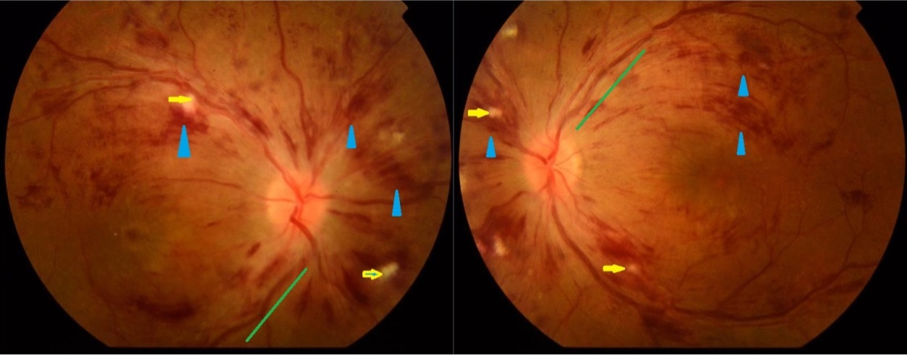

**Figure 1: figure showing characteristic central retinal vein occlusion signs: venous dilatations associated to tortuosities(green line) , flame-shaped hemorrhages(blue narrow), exudates, cotton-wool spots(yellow narrow) of the four quadrants and diffuse macular edema.**

Ophthalmological investigations included fluorescein angiography, which showed prolonged arm-retinal time, bilateral non-ischemic central retinal vein occlusion, multiple microaneurysms, engorged and tortuous veins with irregular filling pattern, multiple areas of blocked fluorescence and intravascular abnormalities (figure 2), and optical coherence tomography, which showed macular edema and the presence of subretinal fluid in the posterior pole (figure 3).

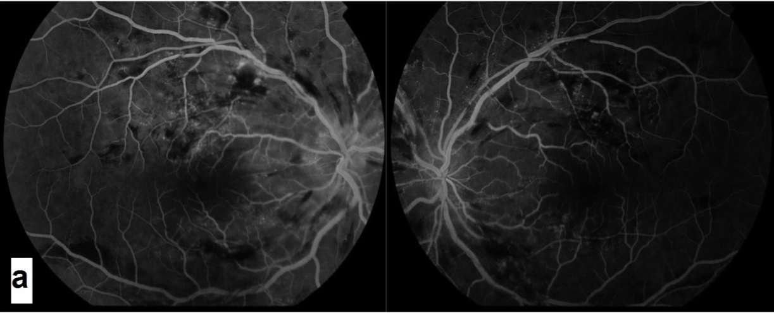

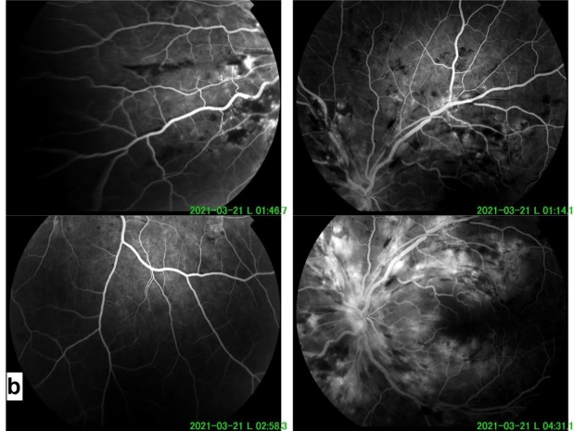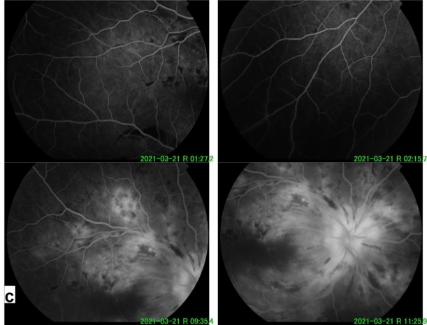

**Figure 2.(a-b-c): a-figure of fluorescein retinal angiography, showing prolonged arm-retinal time, multiple microaneurysms, engorged and tortuous veins with irregular filling pattern, multiple areas of blocked fluorescence and intravascular abnormalities. b- left eye. c- right eye.**

The first-line biological workup revealed an incidentally found severe end-stage renal failure with preserved diuresis. A uremic syndrome associated nausea, vomiting and a plasma urea at 2.26 g/L with serum creatinine at 1268 μmol/L (GFR at 4.1 ml/min MDRD) was also found, requiring emergency hemodialysis treatment. Glycemia level, lipid profile and sedimentation rate were in the normal range.

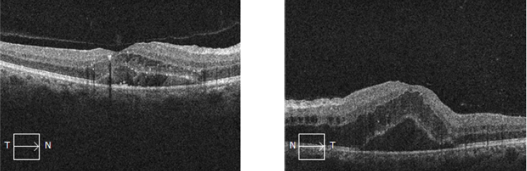

**Figure 3 : optical coherence tomography showing macular edema and the presence of subretinal fluid in the posterior pole (left eye).**

Severe arterial hypertension (Grade 3) had been validated by a 24-hour ABPM (arterial blood pressure monitoring), and a follow-up on the following days had confirmed terminal CKD. Cerebral and abdominal CT angiography found no cerebral process nor renal arteries/veins abnormalities. The diagnosis of malignant hypertension with damage to two target organs was therefore suspected.

The rest of the workup showed signs of chronic kidney disease, namely: hypocalcemia at 2.08 mmol/L, hyperphosphatemia at 2.12 mmol/L, secondary hyperparathyroidism at 122 ng/L (twice the normal value), and anemia (Hb at 10 g/dL), normochromic (MCHR 27.8), and normocytic (GMV 80.6).

As part of the etiological workup, abdominal ultrasound had shown poor cortico-medullary differentiation. No image of calculus or dilatation of the urine cavities was visualized. A cardiac echocardiography had detected a concentric left ventricular hypertrophy testifying to a chronic hypertension. EKG and carotid doppler ultrasound were normal. Serum proteins electrophoresis, immunological tests (ANA, native anti-DNA, anti-SSA/SSB, anti-MPO, anti-PR3, anti-MBG) and serologies (HBV, HCV, HIV, Syphilis) were negative. An endocrine workup was also requested but also came back strictly without abnormalities (cortisol cycle, methoxylated derivatives dosage, serum ACE level, adrenal CT).

Systemic diseases were ruled out by an internal medicine specialist. The patient underwent a complete evaluation for thrombophilia risk factors, including assessment for active protein C resistance, factor V Leiden mutation, deficiencies in protein C, protein S, and antithrombin, prothrombin gene mutation, as well as analysis of homocysteine levels, anticardiolipin antibodies, and lupus anticoagulant.

The evolution was marked by a normalization of the blood pressure after 01 month of bi-therapy treatment with both calcic inhibitor and conversion enzyme inhibitor. A gradual resolution of hypertensive retinopathy was observed, with a noticeable improvement in retinal findings. Central retinal vein occlusion (CRVO), initially present at admission, showed a significant reduction in severity, with marked and complete visual acuity recovery (figure 4). This positive response was attributed to both intravitreal injection of anti-VEGF and improvement in systemic hypertension. However, there was no significant improvement in renal function, with persistence of end-stage CKD, hence the initiation of chronic hemodialysis. The patient underwent successful kidney transplant 6 months later.

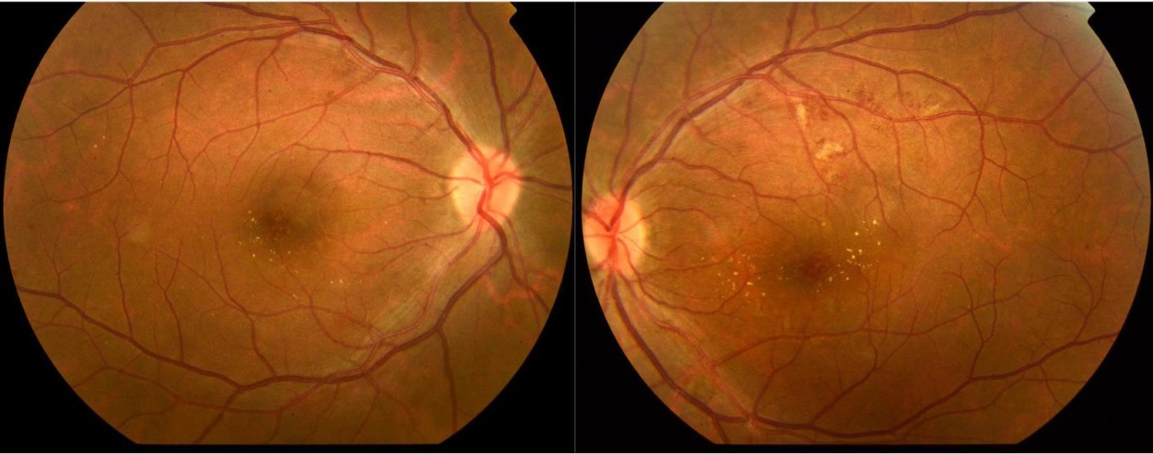

**Figure 4 : figure showing a significant reduction in severity of CRVO.**

3. discussion

The central retinal artery and vein are encased within a shared adventitial sheath as they traverse the lamina cribrosa, a confined space that predisposes the retinal veins to circulatory insufficiency. In the presence of hypertension and/or arteriosclerosis, the rigid arterial walls may compress the more pliable central retinal vein, resulting in hemodynamic disturbances and thrombus formation within the ocular fundus [3]. In this patient, we hypothesize that the bilateral central retinal vein occlusion (CRVO) was primarily caused by venous compression induced by hypertension. This mechanism likely led to impaired venous circulation and subsequent thrombus formation within the retinal veins.

The literature also includes reports of hyperviscosity-induced bilateral central retinal vein occlusion (CRVO) [4]. Similarly, a case of bilateral CRVO resulting from malignant hypertension has also been documented, akin to the condition observed in our patient [5].

Only few cases have been reported in the literature where bilateral central retinal vein occlusion (CRVO) was associated with hyperviscosity syndrome. In these instances, the underlying conditions were multiple myeloma and Waldenström's macroglobulinemia [6,7]. In contrast, our patient exhibited extremely high blood pressure, which likely caused the circulatory insufficiency in the retinal fundus[8]. The patient, a 36-year-old male, had no history of significant illness and no evidence of thrombophilia. Autoimmune or inflammatory diseases were excluded, with the diagnosis ultimately confirming malignant hypertension as the underlying cause[10-11].

Hypertension is a silent condition, often asymptomatic, which can progress undetected until it manifests through clinical signs such as ischemic heart disease, stroke, or, as seen in our case, visual impairment[11]. Structural damage related to hypertension typically remains unnoticed during routine clinical evaluations. It is essential for primary care physicians, including ophthalmologists, cardiologists, and nephrologists, to assess both typical and atypical risk factors for retinal vein occlusion in order to mitigate further ocular complications and prevent systemic repercussions. Preventing the long-term progression of hypertension requires a collaborative, multidisciplinary approach, emphasizing early intervention and comprehensive management [12].

.

4. Conclusion

This case underscores the critical association between malignant hypertension and its potential to cause severe ocular and renal complications, such as bilateral central retinal vein occlusion (CRVO) and end-stage renal failure. Despite the challenges of managing such a complex clinical presentation, early recognition and prompt antihypertensive therapy are essential to prevent irreversible target organ damage. In this case, while the hypertensive retinopathy gradually resolved over time, renal function did not recover, necessitating a kidney transplant. This highlights the importance of routine blood pressure monitoring, especially in young patients with no previous history of hypertension, to prevent the onset of catastrophic organ damage.

CONSENT

As per international standards or university standards, patient(s) written consent has been collected and preserved by the author(s).

ETHICAL APPROVAL

It is not applicable.

Disclaimer (Artificial intelligence)

Author(s) hereby declare that NO generative AI technologies such as Large Language Models (ChatGPT, COPILOT, etc.) and text-to-image generators have been used during the writing or editing of this manuscript.

References

[1] D. Prisco, R. Marcucci, L. Bertini, and A. M. Gori, ‘Cardiovascular and thrombophilic risk factors for central retinal vein occlusion’, Eur. J. Intern. Med., vol. 13, no. 3, pp. 163–169, May 2002, doi: 10.1016/S0953-6205(02)00025-0.

[2] D. Prisco and R. Marcucci, ‘Retinal vein thrombosis: risk factors, pathogenesis and therapeutic approach’, Pathophysiol. Haemost. Thromb., vol. 32, no. 5–6, pp. 308–311, 2002, doi: 10.1159/000073587.

[3] A. Sodi et al., ‘Atherosclerotic and Thrombophilic Risk Factors in Patients with Recurrent Central Retinal Vein Occlusion’, Eur. J. Ophthalmol., vol. 18, no. 2, pp. 233–238, Mar. 2008, doi: 10.1177/112067210801800211.

[4] J. M. Lahey, J. J. Kearney, and M. Tunc, ‘Hypercoagulable states and central retinal vein occlusion’, Curr. Opin. Pulm. Med., vol. 9, no. 5, p. 385, Sep. 2003.

[5] G. Cortina, J. Hofer, T. Giner, and T. Jungraithmayr, ‘Severe visual loss caused by unrecognized malignant hypertension in a 15‐year‐old girl’, Pediatr. Int., vol. 57, no. 2, Apr. 2015, doi: 10.1111/ped.12525.

[6] F. B. Aggio et al., ‘Bilateral Central Retinal Vein Occlusion Associated with Multiple Myeloma’, Ophthalmologica, vol. 218, no. 4, pp. 283–287, Jul. 2004, doi: 10.1159/000078622.

[7] P. Alexander, D. Flanagan, K. Rege, A. Foss, and M. Hingorani, ‘Bilateral simultaneous central retinal vein occlusion secondary to hyperviscosity in Waldenstrom’s macroglobulinaemia’, Eye, vol. 22, no. 8, pp. 1089–1092, Aug. 2008, doi: 10.1038/eye.2008.193.

[8] H. Koizumi, D. C. Ferrara, C. Bruè, and R. F. Spaide, ‘Central Retinal Vein Occlusion Case-Control Study’, Am. J. Ophthalmol., vol. 144, no. 6, pp. 858-863.e1, Dec. 2007, doi: 10.1016/j.ajo.2007.07.036.

[9] Hypertensive Retinopathy Classification, Adam H Rogers. Ophthalmology,

2nd edn. Yanoff & Duker, Mosby, St. Louis, MO,

2004; 852.

[10] Lekhra OP, Sawhney IMS, Gupta A, Varma S, Chopra JS.

Venous statis retinopathy in Waldenstrom’s Macroglobulinaemia. J Assoc Physicians India 1996; 44: 61–62.

[11] Avashia JH, Fath DF. Bilateral central retinal vein occlusion in Waldenstrom’s macroglobulinaemia. J Am Optom Assoc 1989; 60: 657–658.

[12] Nabet L, Dufier JL, Cornu P, Junghers P, Chauvin JC, de Monteynard MS et al. [Bilateral occlusion of the central vein of the retina disclosing Waldenstro¨m’s disease]. Bull Soc Ophthalmol Fr 1989; 89: 39–41.