Clinical Image

**Unexpected Corneal perforation after use of topical non-steroidal anti-inflammatory drugs**

**Abstract**

We report a case of 67-year-old with a type 2 diabetes on insulin therapy followed for moderete proliferative diabetic retinopathy undergoing pan-retinal photocoagulation ( PRP) who suffered from ocular redness and pain after the application of Non-steroidal anti-inflammatory drugs (indomethacine ) post-PRP. Slit lamp examination, a corneal perforation was noted on the inferotemporal side of the right eye, with iris that seals the perforation. We performed an anterior segment optical coherence tomography (OCT) of the right eye revealing corneal perforation with iris plugging the perforation and re-epithelialization of the defect.

**Keywords**: Optical coherence tomography, photocoagulation, corneal perforation, epithelial defects

**Introduction**

Corneal melt and perforation can arise from various etiologies, including the use of toxic topical drops, particularly topical non-steroidal anti-inflammatory drugs (NSAIDs). The literature has frequently documented the association between the use of topical NSAIDs and the subsequent development of corneal ulcers. More recently, reports have emerged linking the use of oral NSAIDs and colchicine to impaired corneal wound healing and corneal perforation (Aljehani et al., 2024).  NSAIDs are commonly used to manage both acute and chronic pain and inflammation. Topical NSAIDs have proven effective in relieving ocular inflammation following cataract surgery, argon laser trabeculoplasty, and in the treatment of cystoid macular edema [1]. With regard to corneal complications, topical NSAIDs have been reported to cause superficial punctate keratitis, sterile corneal infiltrates, and persistent epithelial defects. However, in general, these complications require frequent dosing and prolonged use (Mikropoulos et al., 2024).

Despite the increasing use of topical NSAIDs in post-operative care, corneal complications due to these drugs remain rare. However, reported adverse effects include superficial punctate keratitis, subepithelial and stromal infiltrates, immune rings, persistent epithelial defects, and corneal melt. These ophthalmic conditions can lead to corneal perforation and potential vision loss. Such complications are most commonly observed in patients with a previously compromised ocular surface, such as those with glaucoma, severe dry eye, or those who have undergone keratoplasty. [2] [3]

**Conclusion**

Awareness of these serious side effects, along with their risk factors and the importance of prompt intervention—such as discontinuing NSAIDs—are essential for preventing long-term damage.

References  :

1. Flach AJ. Corneal melts associated with topically applied nonsteroidal anti-inflammatory drugs. Trans Am Ophthalmol Soc. 2001;99:205‑12.

2. Lin JC, Rapuano CJ, Laibson PR, Eagle RC Jr, Cohen EJ. Corneal Melting Associated With Use of Topical Nonsteroidal Anti-inflammatory Drugs After Ocular Surgery. Archives of Ophthalmology. 1 août 2000;118(8):1129‑32.

3. Rigas B, Huang W, Honkanen R. NSAID-induced corneal melt: Clinical importance, pathogenesis, and risk mitigation. Survey of Ophthalmology. 1 janv 2020;65(1):1‑11.

4. Nicoară SD, Damian I. Controversy of indomethacin eye drops in the treatment of rheumatoid arthritis-induced corneal ulceration: a case report. J Med Case Reports. 4 mars 2021;15(1):116.

5. Aljehani, R., Almutlaq, M., Aldossari, S., & Al-Abduljabbar, K. (2024). Corneal Melt and Perforation Associated With Prolonged Oral Non-Steroidal Anti-Inflammatory Drug (NSAID) Use: A Case Report. *Cureus*, *16*(5).

6. Mikropoulos, D. G., Kymionis, G. D., Chatzea, M. S., Xanthopoulou, K., Ageladarakis, P. K., Voudouragkaki, I. C., & Konstas, A. G. (2024). Acute Corneal Melting Induced by the Concomitant Use of a Non-steroidal Anti-inflammatory Agent with an Antiseptic Eye Drop. *Ophthalmology and Therapy*, *13*(2), 645-649.

Figures :

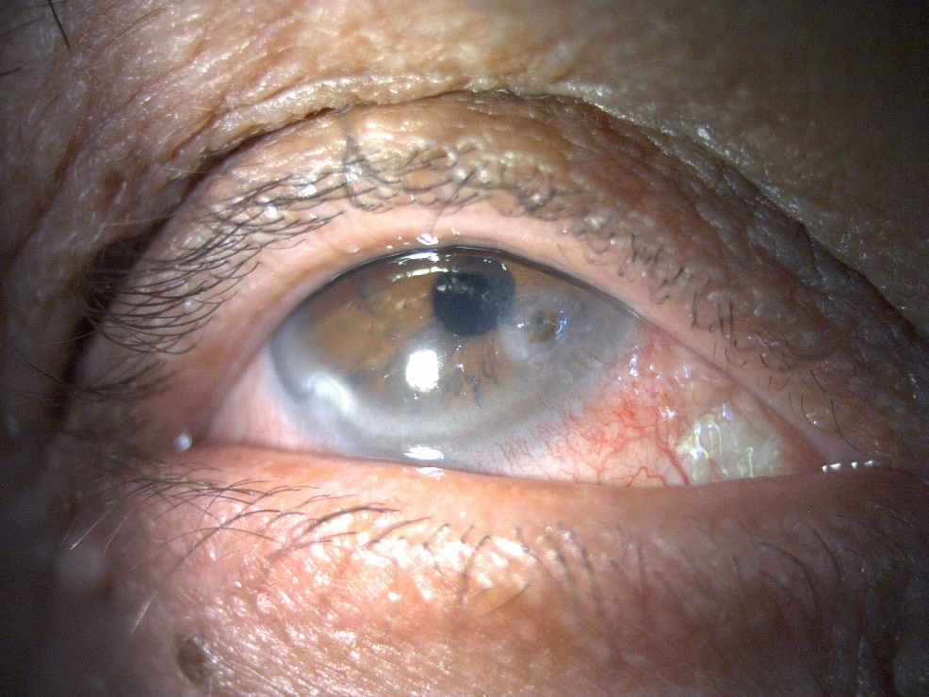 (a)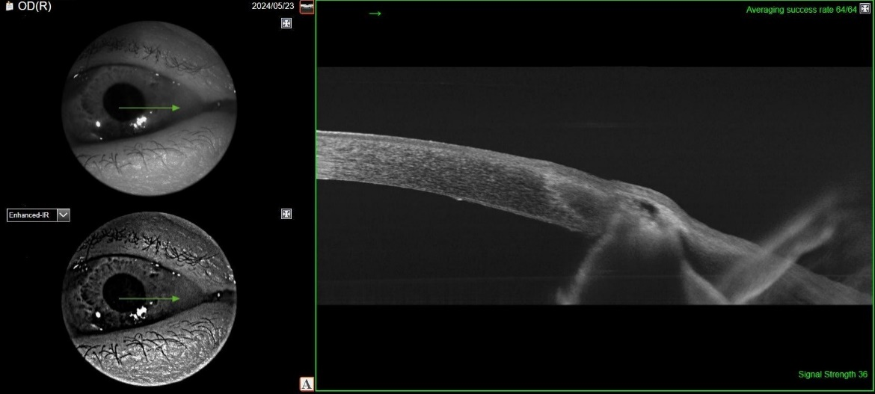 (b)

Figure 1 (a,b) : Corneal perforation sealed by iris at slit lamp and re-epithelialization of the defect at the OCT