***Case report***

**Refractory autoimmune thrombocytopenic purpura and renal transplantation: a success story**

**Abstract**

Immune thrombocytopenic purpura (ITP) is an exceptional autoimmune hematological abnormality in renal transplantation, marked by isolated thrombocytopenia and a high hemorrhagic risk [1].

We report in the form of a clinical case, A 24-year-old man with no notable medical history was managed in 2013 for chronic kidney failure of unknown cause, requiring long-term hemodialysis. In 2014, an isolated thrombocytopenia was incidentally found, fluctuating between 23,000 and 45,000/ μL. The etiological workup (infectious, immunological, myelogram) came back normal, arguing for a diagnosis of primary ITP.

At the time of diagnosis of immune thrombocytopenia, the patient was started on oral corticosteroids (1 mg/kg/day). However, the treatment was not effective in maintaining an adequate platelet count. A transient response was observed only at high doses, and any attempt to reduce the dose resulted in a rapid decline in platelet levels. This lack of sustained response and steroid dependence led to the introduction of eltrombopag (50 mg/day), which resulted in a rapid and marked increase in platelet count."

Eltrombopag was later discontinued as the patient remained asymptomatic despite persistent thrombocytopenia, without any bleeding or thrombotic events. Several years later, when a kidney transplant was planned with his HLA semi-identical father as a living donor, eltrombopag was reintroduced. Once again, it led to a rapid increase in platelet count within eight days, allowing the transplantation to be performed safely and without complication.

Transplantation was performed under thymoglobulin induction, followed by maintenance with tacrolimus, mycophenolate mofetil and prednisone. Treatment with eltrombopag was maintained for three weeks postoperatively. Graft function was stable (creatinine 14 mg/L) and platelets remained within normal limits.

Key words: renal transplantation, immune thrombocytopenic purpura, eltrombopag

**Introduction**

ITP is an autoimmune disorder marked by accentuated platelet destruction and sufficient production by the bone marrow, associated with isolated thrombocytopenia (platelet count 150,000/μL) [1]. The diagnosis is made by ruling out other causes. The occurrence of thrombocytopenia in patients with chronic end-stage renal disease (ESRD) is rare, as are data on renal transplantation in this context [2,3].

The major clinical issues are the risk of intraoperative bleeding, poor response to first-line treatment (corticosteroids), and uncertainty about the interaction of ITP treatment with post-transplant immunosuppression [4]. We report here a case of successful renal transplantation in a patient with ITP refractory to corticosteroids, with satisfactory control by eltrombopag.

**Clinical observation**

A 24-year-old man was diagnosed with end-stage renal disease (ESRD) of undetermined etiology in 2013, requiring hemodialysis. His disease history dates back to 2014 with the onset of peripheral thrombocytopenia.

A comprehensive diagnostic workup was performed, including peripheral blood smear, liver and thyroid function tests, coagulation studies, serum protein electrophoresis, viral serologies (hepatitis B, hepatitis C, HIV), and immunological screening (ANA, anti-dsDNA, antiphospholipid antibodies). Bone marrow aspiration and biopsy (myelogram and bone marrow biopsy) showed a hypercellular marrow with abundant megakaryocytes and macrophages, without signs of dysplasia, infiltration, or fibrosis. Heparin-induced thrombocytopenia was excluded, as dialysis protocols included biocompatible membranes, and no heparin exposure was documented. In 2014, when the patient first presented with thrombocytopenia (approximately 23,000/μL), corticosteroid therapy was initiated, as it is considered first-line treatment for immune thrombocytopenia. A dose of 1 mg/kg/day was administered over several months. However, only a modest increase in platelet count was achieved, and the response was not considered sufficient. As there was no significant clinical improvement, corticosteroids were eventually discontinued. Despite persistent thrombocytopenia, the patient remained asymptomatic and experienced no bleeding complications.

In 2019, the patient became a candidate for kidney transplantation. Given the limited availability and high cost of intravenous immunoglobulin (IVIg) therapy, as well as the significant hemorrhagic and infectious risks associated with splenectomy, eltrombopag was initiated as a second-line treatment. The drug led to a significant increase in platelet count. However, the treatment was discontinued by the patient due to its high cost and lack of consistent availability in pharmacies.

In 2023, the patient was referred to our center for kidney transplantation with his HLA semi-identical father as a living donor. A complete pre-transplant evaluation was performed and found to be satisfactory, making the patient eligible for the transplant. Given the long interval since the initial corticosteroid treatment in 2014, a re-challenge with corticosteroids was attempted to reassess potential responsiveness. However, no improvement in platelet count was observed, confirming corticosteroid resistance.

He was subsequently treated with eltrombopag, a thrombopoietin receptor agonist, at a daily dose of 50 mg, leading to normalization of the platelet count (260,000/µL). After eight days of therapy, the patient underwent renal transplantation. Eltrombopag was reintroduced post-transplant, given its favorable safety profile compared to splenectomy—which entails significant infectious and hemorrhagic risks—and the high cost of intravenous immunoglobulin (IVIg), which remained a limiting factor

Induction immunosuppression was initiated with thymoglobulin at 1.25 mg/kg on day 0, and subsequent doses were adjusted based on peripheral lymphocyte counts.

Maintenance immunosuppression consisted of:

* Corticosteroids
* Mycophenolate mofetil (MMF) at 2 g/day,
* Tacrolimus (Prograf®) at 0.1 mg/kg/day, divided into two doses administered 12 hours apart at consistent times.

Tacrolimus dosing was adjusted based on trough levels (T0):

* Between 7–10 ng/mL during the first month post-transplant (M0–M1),

Then maintained between 3–7 ng/mL from the third month (M3) onward.

The peri- and post-transplant period was uneventful, with good graft function and a final creatinine level of 14mg/l.

Treatment with eltrombopag was continued for 3 weeks post-transplant with normal platelet count.

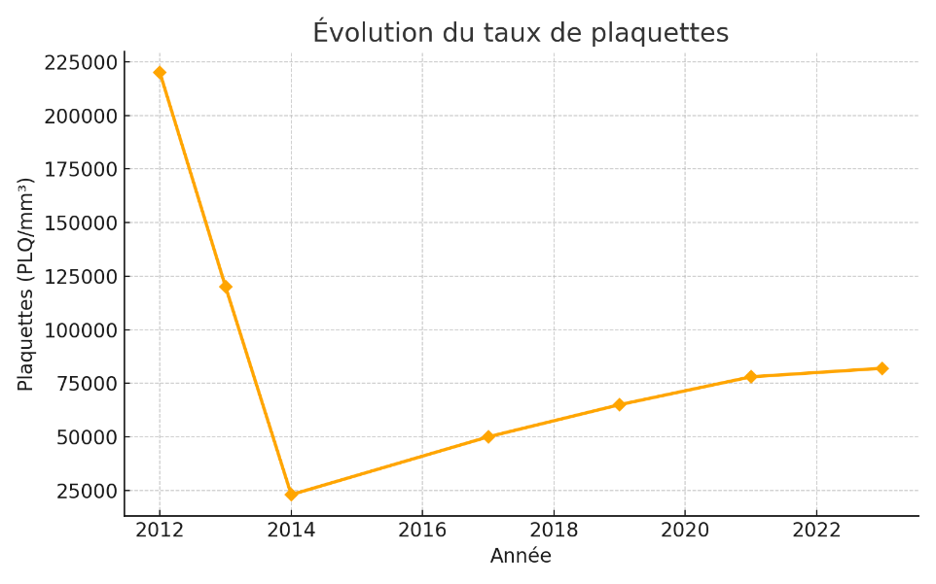

**Figure 1: Platelet count trends**

**Discussion**

ITP is characterized by isolated thrombocytopenia due to immune-mediated platelet destruction, with preserved or increased megakaryopoiesis on bone marrow examination [1,2]. The diagnosis is clinical and relies on excluding secondary causes of thrombocytopenia. First-line therapy typically consists of corticosteroids; however, up to 30% of patients fail to respond or relapse after tapering [5].

Second-line options include intravenous immunoglobulins (IVIG), splenectomy, rituximab, and thrombopoietin receptor agonists (TPO-RAs) such as eltrombopag [5,6]. Eltrombopag is an oral non-peptide TPO-RA that acts by stimulating megakaryocyte proliferation and differentiation. It has been shown to increase platelet counts in patients with chronic ITP who are refractory to first-line therapies [6]. Common adverse effects include hepatotoxicity, thrombosis, and, rarely, marrow fibrosis [10].

In patients with ESRD, thrombocytopenia is rare and may result from uremic platelet dysfunction, infections, or bone marrow suppression [3]. In our case, a comprehensive workup excluded these secondary causes, supporting a diagnosis of primary ITP.

Our patient initially received corticosteroid therapy in accordance with standard recommendations, but the treatment was ineffective. Eltrombopag was introduced due to the persistent thrombocytopenia and the imminent need for transplantation. The drug led to a rapid and sustained increase in platelet counts without adverse effects, making it a valuable bridging therapy during the pre- and perioperative period.

Kidney transplantation in patients with active thrombocytopenia presents distinct challenges, including:

The risk of intraoperative and postoperative bleeding,

Thrombotic complications in the event of abrupt platelet elevation.

The combination of eltrombopag, a non-peptide thrombopoietin receptor agonist, with tacrolimus, a calcineurin inhibitor commonly used in post-transplant immunosuppression, raises important pharmacokinetic and pharmacodynamic considerations that warrant close monitoring.

From a pharmacokinetic perspective, the two agents are metabolized via distinct hepatic pathways: eltrombopag primarily via UGT1A1, CYP1A2, and the transporters BCRP and OATP1B1, while tacrolimus is predominantly metabolized by CYP3A4/5. Therefore, no major direct enzymatic interaction is expected. However, eltrombopag is a BCRP inhibitor, which may increase the plasma concentrations of co-administered drugs eliminated through this pathway, although this interaction has not been conclusively demonstrated with tacrolimus.

From a pharmacodynamic standpoint, there is a potential cumulative hepatotoxicity, as both agents may induce elevated liver transaminases. Additionally, eltrombopag increases platelet counts, which, in the context of tacrolimus-induced hypertension or endothelial dysfunction, could theoretically amplify the risk of thromboembolic events. While no direct interaction has been clearly established, these combined effects justify joint monitoring of liver function, blood pressure, and platelet counts during co-administration (12).

Despite these risks, few case reports in the literature have described the successful use of eltrombopag in renal transplant candidates [4,7,9,10]. Agarwal et al. [9], for example, reported successful transplantation in a patient with corticosteroid- and IVIG-refractory ITP managed with eltrombopag. Other reports described favorable outcomes with eltrombopag in combination with IVIG [10].

In our case, eltrombopag monotherapy resulted in rapid platelet recovery, allowed transplantation without the need for transfusion or IVIG, and was well tolerated. Regular monitoring of tacrolimus levels helped prevent potential drug–drug interactions, and no hepatotoxicity or thrombosis was observed.

This case supports the idea that eltrombopag can be an effective and safe second-line therapy in the context of renal transplantation for patients with steroid-refractory ITP. However, careful patient selection, close hematological monitoring, and interdisciplinary coordination remain essential.

Further multicenter studies are necessary to establish standardized guidelines for the management of ITP in renal transplant candidates.

**Conclusion,**

This case calls into question the possibility of renal transplantation in a patient with steroid-refractory ITP, and proves the value of a combination based on eltrombopag for rapid control of thrombocytopenia without delaying transplantation or the occurrence of adverse events. This experience serves as a reminder of the importance of an individualised therapeutic strategy and of networking between haematologists and nephrologists.

Author(s) hereby declare that NO generative AI technologies such as Large Language Models (ChatGPT, COPILOT, etc.) and text-to-image generators have been used during the writing or editing of this manuscript.

References

1. Provan D, Arnold DM, Bussel JB, et al. Updated international consensus report on the investigation and management of primary immune thrombocytopenia. Blood Adv. 2019;3(22):3780–817.

2. Bussel JB, Cheng G, Saleh MN, et al. Eltrombopag for the treatment of chronic idiopathic thrombocytopenic purpura. N Engl J Med. 2007;357(22):2237–47.

3. Ghanima W, Godeau B, Cines DB, Bussel JB. How I treat immune thrombocytopenia: the choice between splenectomy or a medical therapy as a second-line treatment. Blood. 2012;120(5):960–9.

4. Kawaguchi T, Terasako K, Matsushita K, et al. Successful kidney transplantation in a patient with idiopathic thrombocytopenic purpura treated with eltrombopag. Clin Transplant. 2020;34(1):e13754.

5. Lesage C, Choukroun G, Frimat L, et al. Thrombopénie immunologique chez l’insuffisant rénal chronique. Néphrol Thérap. 2007;3(1):20–5.

6. Kuter DJ. The biology of thrombopoietin and thrombopoietin receptor agonists. Int J Hematol. 2013;98(1):10–23.

7. Nagai M, Hirakata H, Nakamoto H, et al. Kidney transplantation in a patient with chronic idiopathic thrombocytopenic purpura treated successfully with rituximab. Transpl Int. 2006;19(1):77–80.

8. McCrae KR. Thrombocytopenia in renal disease: pathogenesis and management. Hematol Oncol Clin North Am. 2012;26(6):1353–68.

9.Agarwal S, Beniwal P, Agarwal D, Rathore V. Renal Transplant in a Patient with Idiopathic Thrombocytopenic Purpura Refractory to Steroid and Intravenous Immunoglobulin. Indian J Transplant. 2019 Jul-Sep;13(3):228-230. doi:10.4103/ijot.ijot_11_19

10.Behera MR, Rao S, Mahapatra A, Mishra SS, Mishra J. Eltrombopag as a Safe Option for Pretransplant Optimization in a Patient with Chronic Immune Thrombocytopenic Purpura. Cureus. 2024 Feb;16(2):e54042. doi:10.7759/cureus.54042

11. Ebbo M, Récepteur de la thrombopoïétine agonistes et purpura thrombopénique immunologique de l' adulte : où en sommes-nous 10 ans après ? Rev Med Interne. 2021;42(1):38–45.

12. Martynova A, Chiu V, Mert M, Hermel DJ, Weitz IC. Effectiveness and safety of tacrolimus with or without eltrombopag, as a part of immunosuppressive treatment of aplastic anemia in adults: a retrospective case series. Ann Hematol. 2021 Apr;100(4):1019–1026. [PMCID: PMC7960622](https://www.ncbi.nlm.nih.gov/pmc/articles/PMC7960622/)