**Impact of the hepcidin assay on anaemia management in haemodialysis patients**

**Abstract**

Hepcidin is a hormone that plays a crucial role in maintaining iron balance by inhibiting iron absorption in the intestine and preventing iron release from storage cells like macrophages and hepatocytes. In patients with chronic kidney disease undergoing hemodialysis, elevated hepcidin levels are often observed and contribute to anemia by reducing the availability of iron needed for red blood cell production.  
This study aimed to assess the impact of measuring hepcidin levels on anemia management in hemodialysis patients. Conducted at the IBN Rochd Center in Casablanca, it involved 35 stable adult patients who had been on hemodialysis three times a week for at least six months. Blood samples were tested for hemoglobin, ferritin, transferrin saturation, C-reactive protein (CRP), and hepcidin levels using the ELISA method.  
The results revealed that the average hepcidin level was 23.7 ng/mL. Significant positive correlations were found between hepcidin and both CRP (r = 0.56, p < 0.001) and ferritin (r = 0.41, p = 0.018) through Pearson correlation analysis, highlighting a strong connection between inflammation and iron regulation.

Among the participants, 53% were receiving erythropoiesis-stimulating agents (ESAs). Those who responded to ESA therapy had notably lower hepcidin levels (mean 19.15 ng/mL) compared to non-ESA users (mean 35.53 ng/mL), with a statistically significant difference (p = 0.0068).

Although patients receiving injectable iron exhibited higher hepcidin levels (mean 28.10 ng/mL), this difference was not statistically significant.

These findings suggest that measuring hepcidin levels could serve as a valuable tool in optimizing anemia treatment in hemodialysis patients, promoting more personalized and effective use of ESAs and iron therapy

Keywords: hepcidin, hemodialysis, Anaemia**,** haemodynamic, asthenia

**Introduction**

Anaemia is a major issue in haemodialysis patients due to its various repercussions, including haemodynamic changes and asthenia. The cause of anaemia in ESRD is multifaceted, . It is mainly due to deficiencies in iron or vitamins, particularly iron . This deficiency is often exacerbated by chronic inflammation and oxidative stress, leading to impaired absorption mediated by hepcidin. Other contributing factors include decreased production of erythropoietin (EPO), a reduction in the lifespan of red blood cells (making them more fragile), systemic inflammation, various comorbidities such as cardiovascular diseases, poor nutritional intake or absorption of essential vitamins and minerals, and chronic blood loss, especially related to dialysis or gastrointestinal bleeding

Hepcidin, a polypeptide produced by the liver and activated by excess iron and inflammatory cytokines, inhibits iron absorption in macrophages and intestinal cells by binding to ferroprotein. Binding of hepcidin to ferroprotein causes internalisation and lysosomal breakdown of the ferroprotein, preventing iron release from macrophages and reducing intestinal iron absorption.

Hepcidin synthesis is increased in CKD patients due to an inflammatory condition caused by high uremic toxin production and retention, as well as exposure to catheters, dialysis membranes, and fluids. This increase in circulating hepcidin is critical for the irregular availability and delivery of iron for erythropoiesis. (4)

Hepcidin levels in CKD patients are markedly elevated, up to ninefold in MH patients (1). The rise could be due to impaired renal clearance, infrequent dialysis elimination, chronic inflammation, or, paradoxically, parenteral iron delivery.

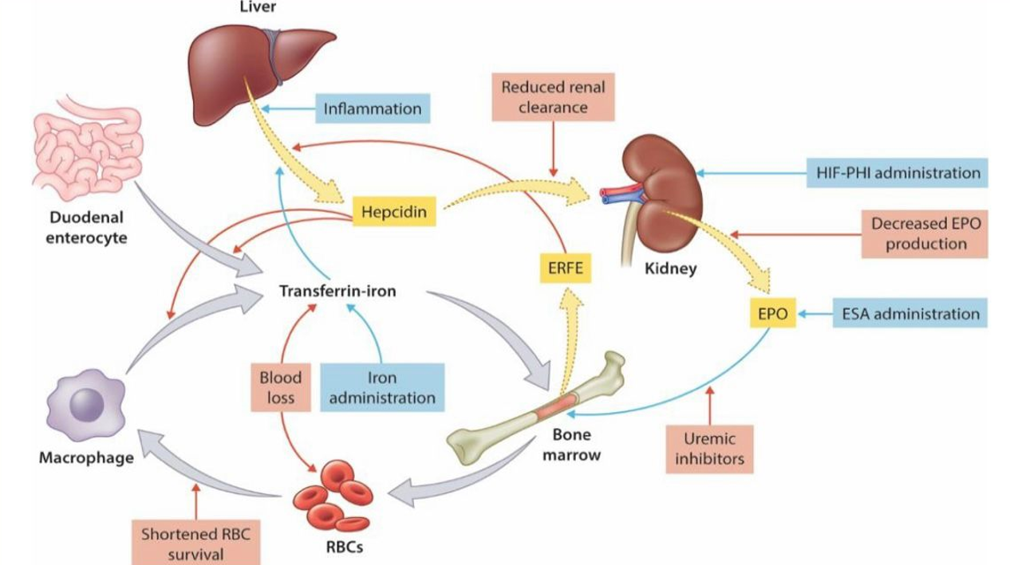

**Image 1: Increased Hepcidin synthesis in CKD patients**

**Materials and methods**

This study aimed to assess the impact of hepcidin measurement on anemia management in hemodialysis patients. Blood samples were collected before hemodialysis sessions. Hemoglobin, ferritin, CRP, and transferrin saturation (CST) were measured using standard laboratory procedures. Hepcidin levels were determined using the ELISA technique in a specialized laboratory in France, ensuring precise and consistent results.

For correlation analyses between hepcidin and other parameters (CRP, ferritin, CST), Pearson’s correlation coefficient (r) was calculated, and the statistical significance was evaluated. A p-value < 0.05 was considered statistically significant.

**Results**

This study involved 35 hemodialysis patients.

The mean age of our patients was 40 +/- 11.3 years.

Mean hemoglobin level was 8.24 g/dl.

|  |  |
| --- | --- |
| Parameter | Value |
| Number of patients | 35 |
| Mean age | 40 ± 11,3 yeras |
| Sex (% males) | 60% |

**Table 1: Demographics of patients included in the study**

|  |  |
| --- | --- |
| Parameter | Value |
| Hemoglobin | 8,24g/dl |
| Ferritin | 124ng/ml |
| CRP | 23ng/ml |
| Hepcidin | 24,45ng/ml |
| transferrin saturation (TSAT) | 20% |

**Table 2: Mean levels of Hemoglobin, Ferritin, CRP, Hepcidin and transferrin saturation**

* Hepcidin and CRP: r = 0.62, p < 0.001 (strong positive correlation)
* Hepcidin and ferritin: r = 0.41, p = 0.014 (moderate positive correlation)
* Hepcidin and transferrin saturation (TSAT): r = -0.35, p = 0.036 (moderate negative correlation)

Graph 1: Statistical correlations between CRP and hepcidin levels

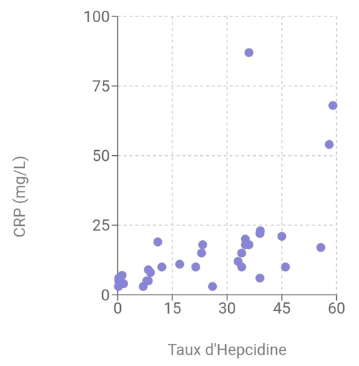

Treatment with Erythropoietin Stimulating Agents (ESAs) :

1. With EPO treatment and no response: 31.43% (mean hepcidin level 37.37)
2. With EPO treatment and response: 42.86% (mean hepcidin level 7.27)
3. Without treatment: 25.71% (mean hepcidin level 33.26)

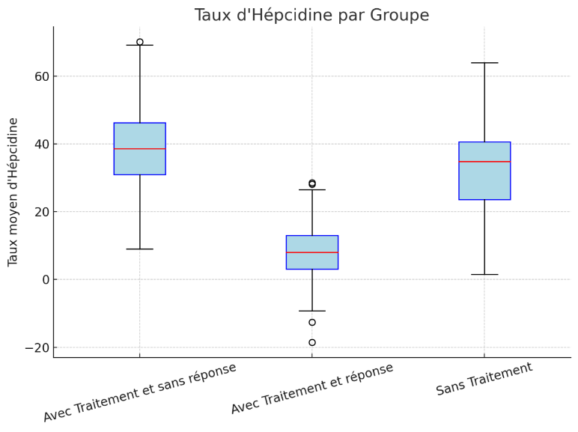

Figure 1: Box plot showing hepcidin levels( ng/l) for the three groups:

Dialysis patients were divided into three subgroups (responders and non-responders and those receiving no EPO treatment). Non-responders who did not show an increase in Hb of 2 g/dL within 2 months of EPO treatment despite dose escalation.

Statistically significant difference (p = 0.0068)

Treatment with injectable iron

* + - 19% of patients received injectable iron
    - Mean hepcidin level: 28.10 ng/ml (higher than patients without injectable iron)

**Discussion**

Anemia is a major complication for patients on hemodialysis, seriously affecting their quality of life and life expectancy. It stems from multiple factors, including a reduced production of natural erythropoietin, true or functional iron deficiency, and the chronic inflammation seen in end-stage renal disease [1,9]. Hepcidin, the key regulator of iron metabolism, plays a central role here by limiting both intestinal iron absorption and the release of stored iron by degrading ferroportin [3,4].

In chronic hemodialysis patients, inflammation is nearly constant. This is fueled by repeated exposure to dialysis membranes, the buildup of uremic toxins, and the use of central venous catheters — all of which keep the immune system in a state of continual activation, triggering the release of inflammatory molecules like IL-6 [4,5]. This persistent inflammation leads to an overproduction of hepcidin by the liver, explaining the high hepcidin levels we found in our study and that others have reported [5,7]. In this setting, measuring hepcidin provides a clearer picture of functional iron availability than just relying on traditional markers like ferritin or transferrin saturation coefficient (TSC).

We found a positive link between hepcidin and ferritin (r = 0.41, p = 0.018), which was expected. Ferritin, while a classic indicator of iron stores, also behaves as an acute-phase protein that rises in inflammatory conditions [5,7]. In hemodialysis patients, high ferritin levels often reflect not an excess of usable iron, but an ongoing inflammatory state that traps iron away from the red blood cell production process. Hepcidin is the mediator behind this disconnect between stored and usable iron. This finding shows that relying on ferritin alone to assess iron status is misleading in inflammatory conditions and supports measuring hepcidin levels alongside.

The connection between hepcidin and TSC is also worth highlighting. TSC measures how much transferrin is bound to iron in the blood and is supposed to reflect immediately available iron. However, in an inflamed state with high hepcidin, even if ferritin is high and TSC is low, iron remains trapped inside macrophages and unavailable for making hemoglobin . Understanding this is crucial: a low TSC doesn’t necessarily mean there’s an iron shortage—it might indicate a functional iron block caused by hepcidin’s inhibition of ferroportin. Iron is there, but inaccessible, locked away in cells. Recent studies back up our findings that in dialysis patients, high hepcidin levels correspond to low TSC without a true iron deficiency [8].

Looking at erythropoietin-stimulating agents (ESA), our study showed that patients who responded to ESA therapy had much lower hepcidin levels than non-responders. This fits with biological understanding: ESA boosts red blood cell production, which increases iron demand and lowers hepcidin to help release more iron [2,9]. But when inflammation is strong, hepcidin blocks iron release, making ESA less effective even at higher doses. This functional ESA resistance is now recognized as a major hurdle in treating anemia in chronic kidney disease [9]. Although our sample size was small, our findings line up with other studies linking high hepcidin to ESA treatment failure.

Finally, we need to point out the paradoxical effect of injectable iron on hepcidin. In our study, patients receiving intravenous iron had higher hepcidin levels compared to those who did not. This is explained by the liver’s natural response: when iron stores rise sharply, it triggers more hepcidin production [5]. This secondary hepcidin spike can block further iron absorption and worsen functional iron deficiency. Therefore, it’s essential to monitor hepcidin dynamically to better manage intravenous iron therapy, avoiding iron overload that could have harmful long-term effects [10].

Hepcidin deregulation—arising from genetic mutations, ineffective erythropoiesis, or inflammatory states—plays a pivotal role in the pathophysiology of various iron metabolism disorders, including refractory iron-deficiency anemia, inflammatory anemia, iron overload syndromes, and hereditary hemochromatosis. The measurement of hepcidin has thus emerged as a critical diagnostic and prognostic tool, enabling the differentiation between different types of anemia and guiding more targeted therapeutic strategies (11)

**Conclusion**

Hepcidin appears to be a viable biomarker for determining anaemia treatment methods in haemodialysis patients. This work sets the path for future research targeted at developing therapy protocols based on hepcidin levels to improve patients' quality of life.

Despite the reduced sample size due to the unavailability of hepcidin testing in local laboratories, our study highlights the essential role of hepcidin quantification in evaluating functional iron availability. The necessity of sending samples abroad for analysis imposed logistical constraints, yet the results strongly support the integration of hepcidin measurement into clinical practice for more accurate diagnosis and management of iron-related disorder

This study helps doctors find better ways to treat anaemia in people on dialysis by using a blood test called hepcidin. By checking hepcidin levels, doctors can choose the right treatment, avoid giving too much or too little iron or medicine, and help patients feel better. This means fewer hospital visits, better health, and lower medical costs. In the long run, it can improve the lives of many patients and make healthcare more effective.

**Ethical Approval:**

As per international standards or university standards written ethical approval has been collected and preserved by the author(s).

**Consent**

As per international standards or university standards, patient(s) written consent has been collected and preserved by the author(s).

**Disclaimer (Artificial intelligence)**

The author(s) declare that the manuscript was written and edited without the use of generative AI technologies. AI assistance was used only to translate the article from French to English.

# References

# 1 Sany, Dawlat1; Elsawy, Abd Elbasat1; Elshahawy, Yasser125(5):p 967-973, September 2014. | DOI: 10.4103/1319-2442.139868 Hepcidin and the Regulation of Iron Homeostasis in Patients on Maintenance Hemodialysis

# 2 McCarthy, J. et al. (2015). Efficacy of Erythropoiesis-Stimulating Agents in Patients with Chronic Kidney Disease. Journal of Nephrology.

# 3 Kautz, L., et al. (2014). Hepcidin Regulation and Iron Metabolism in Chronic Kidney Disease. Blood.

# 4 Serum Hepcidin Levels in Patients with End-Stage Renal Disease on Hemodialysis Rubab, Zille; Amin, Huma; Abbas, Khizer; Hussain, Shabbir; Ullah, Muhammad Ikram; Mohsin, Shahida Saudi Journal of Kidney Diseases and Transplantation 26(1):p 19-25, January-February 2015.

# 5 Weiss, G. et al. (2019). The role of hepcidin in iron metabolism in patients with chronic kidney disease. Kidney International

# 6 Elgamasy MM, Omar AAA, A. Hodeib H, T. Gabr M. Evaluation of Nutritional Status of Haemodialysis Patients Using Malnutrition Inflammation Score. J. Adv. Med. Med. Res. [Internet]. 2022 Feb. 16 [cited 2025 Apr. 15];34(2):40-52. Available from: <https://journaljammr.com/index.php/JAMMR/article/view/4352>

# 7. Matsuoka, T., Abe, M., & Kobayashi, H. (2024). Iron metabolism and inflammatory mediators in patients with renal dysfunction. *International Journal of Molecular Sciences, 25*(7), 3745. <https://doi.org/10.3390/ijms25073745>

# 8. Gao, Zhaoli MDa .The association of hepcidin, reticulocyte hemoglobin equivalent and anemia-related indicators on anemia in chronic kidney disease

# Medicine 102(17):p e33558, April 28, 2023.

# 9. Erythropoietin-Stimulating Agent Hyporesponsiveness in Patients Living with Chronic Kidney Disease Henry H.L. Wu a, b Rajkumar Chinnadurai b, c aDepartment of Renal Medicine, Lancashire Teaching Hospitals NHS Foundation Trust, Preston, UK; bFaculty of Biology, Medicine and Health, The University of Manchester, Manchester, UK; cDepartment of Renal Medicine, Northern Care Alliance NHS Foundation Trust, Salford, UK 2022

# 10. [KDIGO 2025 Clinical Practice Guideline for Anemia in CKD (PDF)](https://kdigo.org/wp-content/uploads/2024/11/KDIGO-2025-Anemia-in-CKD-Guideline_Public-Review-Draft_Nov42024.pdf)