***Short communication***

**Impact of the hepcidin assay on anaemia management in haemodialysis patients**

**Abstract**

Hepcidin is a hormone that plays a key role in regulating iron balance by blocking iron absorption in the intestine and preventing iron release from storage cells such as macrophages and hepatocytes. In patients with chronic kidney disease undergoing hemodialysis, elevated hepcidin levels are commonly observed and contribute to anemia by limiting iron availability for red blood cell production.

This study aimed to examine the impact of measuring hepcidin levels on the management of anemia in hemodialysis patients. Conducted at the IBN Rochd Center in Casablanca, the study included 35 stable adult patients who had been receiving hemodialysis three times per week for at least six months. Blood samples were analyzed for hemoglobin, ferritin, C-reactive protein (CRP), and hepcidin levels using the ELISA method.

The results showed that the average hepcidin level was 23.7 ng/mL, with significant positive correlations found between hepcidin and both CRP (p < 0.001) and ferritin (p < 0.02), indicating a strong link between inflammation and iron regulation. Among the participants, 53% were receiving erythropoiesis-stimulating agents (ESAs), and those who responded to ESA therapy had significantly lower hepcidin levels (mean 19.15 ng/mL) compared to non-ESA users (mean 35.53 ng/mL), with a statistically significant difference (p = 0.0068). Although patients on injectable iron showed higher hepcidin levels (mean 28.10 ng/mL), this difference was not statistically significant.

These findings suggest that measuring hepcidin levels could be a useful tool in optimizing anemia treatment in hemodialysis patients, enabling more personalized and effective use of ESAs and iron therapy

Keywords: hepcidin, hemodialysis

**Introduction**

Anaemia is a major issue in haemodialysis patients due to its various repercussions, including haemodynamic changes and asthenia. The cause of anaemia in ESRD is multifaceted, with main processes including relative erythropoietin (EPO) deficit, shortened erythrocyte lifespan, and iron deficiency and maldistribution.

Hepcidin, a polypeptide produced by the liver and activated by excess iron and inflammatory cytokines, inhibits iron absorption in macrophages and intestinal cells by binding to ferroprotein. Binding of hepcidin to ferroprotein causes internalisation and lysosomal breakdown of the ferroprotein, preventing iron release from macrophages and reducing intestinal iron absorption.

Hepcidin synthesis is increased in CKD patients due to an inflammatory condition caused by high uremic toxin production and retention, as well as exposure to catheters, dialysis membranes, and fluids. This increase in circulating hepcidin is critical for the irregular availability and delivery of iron for erythropoiesis. (4)

Hepcidin levels in CKD patients are markedly elevated, up to ninefold in MH patients (1). The rise could be due to impaired renal clearance, infrequent dialysis elimination, chronic inflammation, or, paradoxically, parenteral iron delivery.

**Materials and methods**

This study intends to evaluate the impact of the hepcidin assay on the management of anaemia in haemodialysis patients. MHD patients' blood samples were collected at the commencement of the HD session. Hb, ferritin, and CRP levels were determined using normal laboratory procedures. Samples for serum hepcidin analysis were carefully dispatched to a facility in France in the form of refrigerated serum, where they were tested using the ELISA method to assure accurate and consistent results.

To analyse the correlation between different parameters, we will use the Mann-Whitney U test. This test is appropriate because we are comparing two independent groups on a continuous variable (hepcidin level).

**-** Significance level: p < 0.05

**Results**

This study involved 35 hemodialysis patients.

The mean age of our patients was 40 +/- 11.3 years.

Mean hemoglobin level was 8.24 g/dl.

Ferritin levels ranged from 6 to 281 ng/ml, with an average of 124ng/ml.

|  |  |
| --- | --- |
| Parameter | Value |
| Number of patients | 35 |
| Mean age | 40 ± 11,3 yeras |
| Sex (% males) | 60% |

**Table 1: Demographics of patients included in the study**

|  |  |
| --- | --- |
| Parameter | Value |
| Hemoglobin | 8,24g/dl |
| Ferritin | 124ng/ml |
| CRP | 23ng/ml |
| Hepcidin | 24,45ng/ml |

**Table 2: Mean levels of Hemoglobin, Ferritin, CRP and Hepcidin**

- Mean hemoglobin level was 8.24g/dl.

- Ferritin levels are highly variable, ranging from 6 to 281 ng/mL, with an average of 124 ng/mL (Hepcidin and ferritin: significant positive correlation (p < 0.02)).

- Hepcidin levels: Hepcidin mean: 24.45 ng/mL Hepcidin standard deviation: 18.42 ng/mL

Graph 1: Statistical correlations between CRP and hepcidin levels

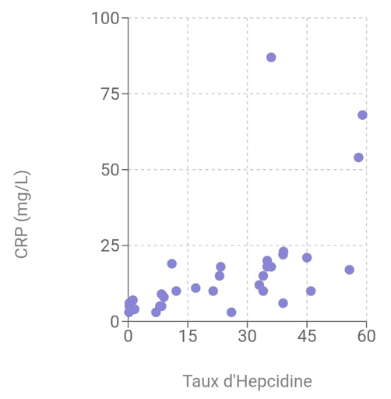

Treatment with Erythropoietin Stimulating Agents (ESAs) :

1. With EPO treatment and no response: 31.43% (mean hepcidin level 37.37)
2. With EPO treatment and response: 42.86% (mean hepcidin level 7.27)
3. Without treatment: 25.71% (mean hepcidin level 33.26)

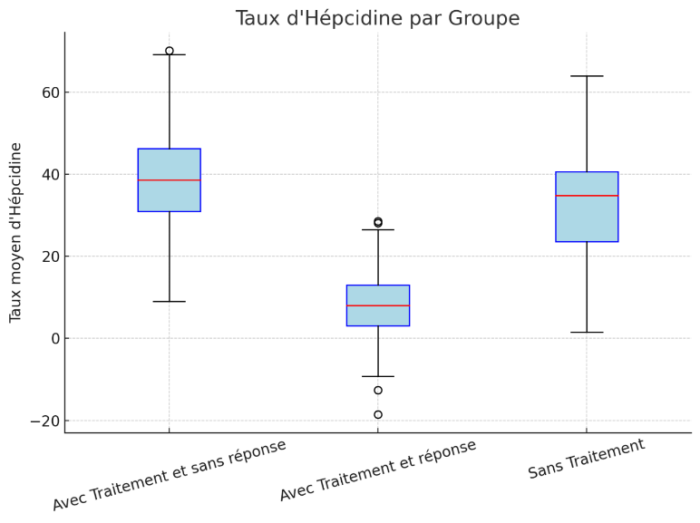

Figure 1: Box plot showing hepcidin levels( ng/l) for the three groups:

Dialysis patients were divided into three subgroups (responders and non-responders and those receiving no EPO treatment). Non-responders who did not show an increase in Hb of 2 g/dL within 2 months of EPO treatment despite dose escalation.

Statistically significant difference (p = 0.0068)

Treatment with injectable iron

* + - 19% of patients received injectable iron
    - Mean hepcidin level: 28.10 ng/ml (higher than patients without injectable iron)

**Discussion**

Increased hepcidin in response to inflammation worsens anaemia by reducing iron uptake (1). Our findings indicate that increasing hepcidin levels are related with higher ferritin levels, emphasising the role of inflammation in iron control.(6)

In this investigation, CRP and serum hepcidin were found to be substantially associated. This positive link was expected given that inflammation has been shown to enhance hepcidin production. Our findings are consistent with those of earlier research on renal failure patients that have found a link between hepcidin levels and CRP.(3)

Impact of Erythropoietin Stimulating Agents (ESAs)

ESAs, specifically Darbepoetin α, have been proven to effectively reduce hepcidin levels. In keeping with McCarthy et al.'s (2015) (2) findings, our ESA-treated patients had considerably reduced hepcidin levels, indicating better anaemia management. While serum hepcidin levels were significantly greater in non-EPO and EPO-resistant patients than in responders.

A recent study indicated that hepcidin levels are regarded as a stronger predictor of response to EPO. In CKD, increased inflammation and probably impaired hepcidin clearance might cause elevated serum hepcidin levels, iron-restricted erythropoiesis, and EPO resistance (2).

Treatment with injectable iron

Paradoxically, those who received injectable iron had higher hepcidin levels. This occurrence, as discovered by Weiss et al. (2019), emphasises the importance of an individualised approach to anaemia care.(5)

**Conclusion**

Hepcidin appears to be a viable biomarker for determining anaemia treatment methods in haemodialysis patients. This work sets the path for future research targeted at developing therapy protocols based on hepcidin levels to improve patients' quality of life.

This study helps doctors find better ways to treat anaemia in people on dialysis by using a blood test called hepcidin. By checking hepcidin levels, doctors can choose the right treatment, avoid giving too much or too little iron or medicine, and help patients feel better. This means fewer hospital visits, better health, and lower medical costs. In the long run, it can improve the lives of many patients and make healthcare more effective.

**COMPETING INTERESTS DISCLAIMER:**

Authors have declared that they have no known competing financial interests OR non-financial interests OR personal relationships that could have appeared to influence the work reported in this paper.

Author(s) hereby declare that NO generative AI technologies such as Large Language Models (ChatGPT, COPILOT, etc.) and text-to-image generators have been used during the writing or editing of this manuscript.

# References

# 1 Sany, Dawlat1; Elsawy, Abd Elbasat1; Elshahawy, Yasser125(5):p 967-973, September 2014. | DOI: 10.4103/1319-2442.139868 Hepcidin and the Regulation of Iron Homeostasis in Patients on Maintenance Hemodialysis

# 2 McCarthy, J. et al. (2015). Efficacy of Erythropoiesis-Stimulating Agents in Patients with Chronic Kidney Disease. Journal of Nephrology.

# 3 Kautz, L., et al. (2014). Hepcidin Regulation and Iron Metabolism in Chronic Kidney Disease. Blood.

# 4 Serum Hepcidin Levels in Patients with End-Stage Renal Disease on Hemodialysis Rubab, Zille; Amin, Huma; Abbas, Khizer; Hussain, Shabbir; Ullah, Muhammad Ikram; Mohsin, Shahida Saudi Journal of Kidney Diseases and Transplantation 26(1):p 19-25, January-February 2015.

# 5 Weiss, G. et al. (2019). The role of hepcidin in iron metabolism in patients with chronic kidney disease. Kidney International

# 6 Elgamasy MM, Omar AAA, A. Hodeib H, T. Gabr M. Evaluation of Nutritional Status of Haemodialysis Patients Using Malnutrition Inflammation Score. J. Adv. Med. Med. Res. [Internet]. 2022 Feb. 16 [cited 2025 Apr. 15];34(2):40-52. Available from: <https://journaljammr.com/index.php/JAMMR/article/view/4352>