**Review Article**

**An Overview of Transdermal Patches: Opportunities and Obstacles in Modern Drug Delivery**

**ABSTRACT**

Transdermal patches are a novel drug delivery system intended to deliver medication across the skin for systemic absorption. Transdermal patches have several benefits, including controlled and sustained release of the drug, improved patient compliance, and avoidance of first-pass metabolism, which is typical with oral administration. The patch is usually made up of a backing layer, a drug reservoir or matrix, and an adhesive layer that provides attachment to the skin. Release of the drug is achieved through the layers of the skin by diffusion, with formulation and skin properties dictating the rate of delivery.

Transdermal patches have been applied in many therapeutic categories, such as pain (e.g., fentanyl patches), hormone replacement (e.g., estrogen patches), and smoking cessation. Designing efficient transdermal systems relies on the optimization of drug properties, enhancement of skin permeability, and the choice of suitable materials for the patch. While transdermal drug delivery has many advantages, problems like skin irritation, restricted drug choice, and patient variability remain. Nevertheless, continued developments in formulation technologies and materials are enhancing the efficacy, safety, and suitability of transdermal patches as a promising alternative for sustained drug delivery and enhanced therapeutic effects.

**Keywords:** Transdermal patches, Injury, TDDS, Drug delivery patches, First pass metabolism, Skin irritation.

**1. INTRODUCTION**

The study of Transdermal Drug Delivery Systems is essential for advancing pharmaceutical sciences and improving patient care. By enabling controlled and sustained drug release, these systems offer a non-invasive alternative to traditional administration methods, enhancing therapeutic effectiveness while minimizing side effects. Their significance extends to treating chronic conditions where steady drug absorption is critical, making them invaluable for disease management. This manuscript contributes to the scientific community by exploring innovative approaches, optimizing formulations, and addressing challenges in transdermal drug delivery.

Transdermal delivery offers numerous advantages over conventional routes, such as oral or injectable systems, including avoidance of first-pass metabolism, improved patient compliance, sustained and controlled release of therapeutic agents, and minimized fluctuations in plasma drug concentrations. By facilitating a consistent and prolonged release of medication, TDDS can enhance therapeutic efficacy and reduce the frequency of administration, which is especially beneficial for chronic conditions requiring long-term treatment. Additionally, TDDS can minimize systemic side effects and improve the pharmacokinetic and pharmacodynamic profiles of drugs. However, challenges such as limited permeability of certain drug molecules, potential skin irritation, and variability in absorption due to skin conditions or environmental factors must also be addressed. This review aims to equip clinicians, pharmacists, and healthcare providers with a thorough understanding of the mechanisms, advantages, limitations, and recent advancements in TDDS, thereby supporting its optimal application in clinical practice.

An advanced drug delivery method, transdermal patches let therapeutic agents be systematically absorbed through the skin under control. Significant advantages including better patient compliance, continuous drug release, and avoidance of first-pass metabolism in the liver make this approach an alternative to conventional oral or injectable medications. Transdermal drug delivery mostly works by the active pharmaceutical ingredient (API) diffusing through the layers of the skin to enter the bloodstream [1].  
Usually consisting of several layers—a backing layer, a drug reservoir or matrix, and an adhesive layer guaranteeing strong skin attachment—these patches These patches' clever engineering and materials allow for exact control of drug delivery rate, so providing .In pain management (such as fentanyl patches), hormone replacement therapy (e.g., estrogen patches), smoking cessation, and even the management of chronic diseases like diabetes and hypertension, transdermal patches find application in many therapeutic domains. Notwithstanding their many benefits, problems including skin irritation, few drug candidates, and fluctuation in skin permeability still exist. Technical developments and continuous research help to solve these problems, so enhancing the accessibility, efficacy, and safety of transdermal drug delivery systems. Transdermal patches have been extensively used in many therapeutic domains, including pain management (e.g., fentanyl patches), hormone replacement therapy (e.g., estrogen patches), and smoking cessation (e.g., nicotine patches). Moreover, these patches provide consistency in drug delivery and convenience, which qualifies them for long-term therapies. To increase the efficacy and safety of this delivery system even more, though, issues including skin irritation, limited drug compatibility, and inter-patient variability in skin absorption must be resolved.  
To increase the spectrum of drugs that can be efficiently administered via this path, research is still mostly on refining patch materials, skin penetration enhancers, and drug formulations. Transdermal patches have great promise as a non-invasive, patient-friendly solution for a range of therapeutic requirements as technology develops [2].

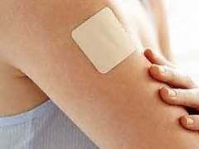

**Fig.1: Transdermal patch apply over skin**

A transdermal patch is a little, sticker-like tool used to administer medication into the body by sticking to skin. Its several layers cooperate to gently release the medication across the skin. The top layer is a protective one that shields the patch from damage and dirt. Below that, either mixed into the sticky section or housed in a little compartment, is the medicine. Sometimes the adhesive layer, the sticky component, contains medicine and helps the patch stay on the skin. Like on a standard sticker, there is a thin plastic cover you peel off before using the patch. Once the patch covers dry, clean skin. The medication then travels through the skin and into the blood, where it may be able to treat such conditions as pain, motion sickness, or addiction to nicotine. The technique does not require swallowing tablets and may provide a continuous flow of medication for hours or days. It is an easy, painless way to administer medicine without injecting it or taking it in the form of a tablet [3].

A transdermal drug delivery system, possibly of active passive design, is a system that offers an alternative method for the administration of medication. Such systems enable pharmaceuticals to be delivered through the skin barrier. In theory, transdermal patches operate very simply. A drug is placed in an are actively high dosage on the interior of a patch, which is worn on the skin for a protracted duration. By a diffusion process, the drug diffuses into the bloodstream directly from the skin. As there is concentrated drug on the patch and little concentration in the blood, the drug will continue to diffuse into the blood for a long duration of time, keeping the constant drug concentration in the blood flow. Transdermal preparation keeps the drug level within the therapeutic window for extended periods of time without allowing drug levels to drop below the minimum effective concentration or go above the maximum effective concentration. The proof of percutaneous drug absorption is established by quantifiable blood drug levels, demonstrable excretion of the drug and its metabolites in urine and by clinical response of the patient to the drug therapy that has been given. The best-selling transdermal patch in the United States is the nicotine patch, which releases nicotine in therapeutic amounts to aid in tobacco smoking cessation. Two opioid analgesics used to deliver round-the-clock relief from severe pain are commonly prescribed as patches: Fentanyl (sold under the brand name Duragesic) and Buprenorphine (sold under the brand name Bu Trans). Nitroglycerin patches are occasionally prescribed for the management of angina in the form of sublingual tablets [4].

**2. TRANSDERMAL ROUTE AND DRUG DELIVERY PROSPECTS**

A medicated patch is put on the skin to introduce drugs into the body. The process is referred to as the transdermal route of drug delivery. The patch continuously releases the medication, and the drug travels through the various layers of the skin to the bloodstream. This allows the medicine to function within the body without having to be administered orally or via injection. The skin is a barrier, so only specific kinds of drugs that can penetrate it are appropriate for this technique. Transdermal patches are useful because they deliver a constant amount of medicine over time, minimize side effects, and are convenient to use [5].Typical drugs used in patches are painkillers, smoking cessation, hormone replacement, and motion sickness. The route of drug delivery in transdermal patches is non-invasive and bypasses the digestive system, so the drug is not metabolized in the stomach or liver. This can increase the effectiveness of the treatment. Transdermal patches are generally a convenient and easy method of administering medicine via the skin in a slow and controlled fashion [6].

**2.1 Anatomy of skin:**

The structure of human skin (Fig.2) can be categorized into four main layers

1. The epidermis

2. The viable epidermis

3. Anon-viable epidermis (Stratum corneum)

4. The over lying dermis

5. The inner most subcutaneous fat layer (Hypodermis) [6]

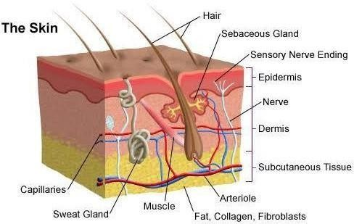

## Fig.2: Schematic Representation of Skin

## 2.1.1 The Epidermis

The epidermis is a renewing, stratified squamous epithelium covering the whole outer surface of the body and constituted primarily of two elements: the living or viable cells of the malpighian layer (collectively referred to as viable epidermis) and dead cells of the stratum corneum, commonly known as the horny layer. The viable epidermis itself is further divided into four layers as shown in Fig. 3.

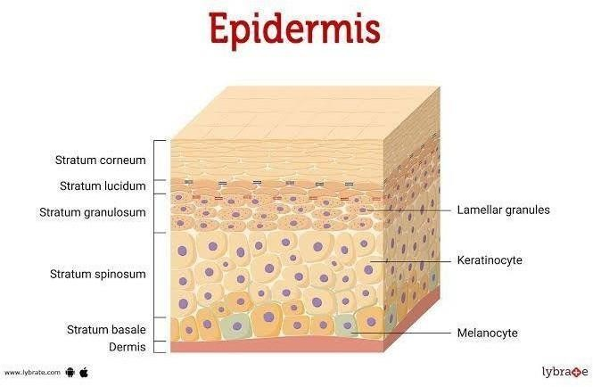

## Fig. 3: Schematic Representation Of Anatomy Of Epidermis

## 2.1.2 Stratum corneum

The stratum corneum is the outermost layer of the skin, and it is the first line of defense of our body's largest organ. This particular layer is part of the epidermis, which is the outermost layer that does a number of important things. The structure of this layer consists mainly of dead skin cells, which are no longer alive but are still very important to the health of the skin. These cells have a flat and hard structure, mainly because they are packed with a fibrous protein called keratin, which is a major component of their strength and protective properties [7]. The main function of the stratum corneum is to protect our body from harmful germs, possibly damaging chemicals, and excessive water loss, thereby keeping us hydrated. It functions very much like a strong shield that protects the skin from the outside world. With time, the old cells that live in this protective layer slowly shed away, giving way to new fresh cells that move from the deeper layers of the skin below. This ongoing process is necessary, as this layer is very important in keeping our skin safe, intact, and healthy [8].

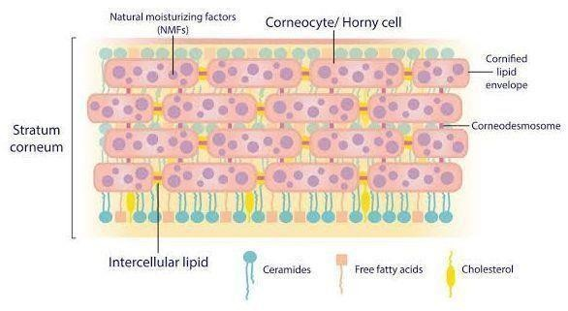

## Fig.4: Schematic Representation Of Structure Of Stratum Corneum

## 2.1.3 Viable epidermis

The viable epidermis is a living and essential component of the epidermis, situated directly beneath the outermost layer, consisting of dead cells referred to as the stratum corneum. This essential layer consists of a number of living strata of cells that are accountable for the processes of skin growth and self-repair. Other than the role they play in growth and repair, these living cells are also crucially involved in the formation of new skin, the protection from infection, and the control of moisture, keeping the skin strong and resistant. In contrast to the stratum corneum, consisting solely of non-living cells, the viable epidermis does consist of actively functioning cells; however, the fact must be pointed out that this layer does not have any blood vessels. The viable epidermis, therefore, plays a crucial and essential role in our overall skin health and protective processes [9].

## 2.1.4 Dermis

Dermis is the middle layer of the skin that is just underneath the epidermis. The dermis is the active part of our skin. The layer is alive and contains very essential things such as blood vessels, nerves, sweat glands, and hair roots. The dermis makes us sense touch, pain, and heat. It makes our skin firm and elastic as it contains collagen and elastin fibers. The dermis is what heals cuts and wounds if we get one. It is very essential in maintaining our skin healthy, well-nourished, and well-connected to the rest of the body [10].

## 2.1.5 Hypodermis

The hypodermis is the lower skin layer, or the subcutaneous layer. It lies beneath the dermis and consists of fat and connective tissue. The layer acts as a cushion, which keeps our bones and muscles safe from bumps and injuries. The hypodermis fat heats the body and stores energy. It holds the skin in place against the muscles beneath and gives the skin a soft and flexible texture. Thus, the hypodermis is extremely important in protection, warmth, and support [11].

**3. PERCUTANEOUS ABSORPTION**

Percutaneous absorption refers to the way a medication passes through the skin and into the bloodstream. Transdermal patches take advantage of this process to deliver medications directly into the body. When you apply a patch to your skin, the medication slowly migrates through the outer skin layers—the stratum corneum (the dead outer layer), then the viable epidermis, and then the dermis, where blood vessels are present. From there, the medication is absorbed into the bloodstream and begins to take effect.[12]

This specific method is also proven to be very effective because it delivers a consistent and controlled amount of medication that can last for hours or even possibly even days at a time. With this method, individuals are actually able to bypass many problems that they might encounter, such as the hassle of forgetting to take their prescribed medication pills or the discomfort of painful injections. Transdermal patches are used routinely for the delivery of a variety of drugs, such as those like nicotine, which is actually used for helping individuals in their smoking cessation, as well as painkillers and those used in hormone therapy. In addition, these patches are made to be very easy to use, painless, and proven to be safe for most individuals, thus an extremely comfortable and desirable method for many individuals in need of treatment [12].

**4. ROUTES OF DRUG PENETRATION THROUGH SKIN**

In transdermal patches, the drug diffuses into the body through three significant routes: the transcellular route, in which the drug simply passes through the skin cells; the intercellular route, in which the drug passes between the cells of the outer skin layer; and the appendageal route, in which the drug passes through sweat glands and hair follicles. Of the three, the intercellular route is most prevalent. Through all three, the drug is able to pass through to the dermis, in which it flows into the blood vessels and then spreads throughout the body. This is used to slowly and continuously dispense medication without the injections or pills [13].

1 Intact Horny Layer, 2 Hair Follicles and 3 Eccrine Sweat Glands

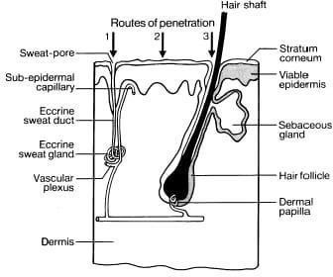

**Fig.5: Possible Macro-routes For Drug Penetration**

**5. BASIC PRINCIPLE OF TRANSDERMAL PERMEATION**

The transdermal permeation theory is to deliver a drug into the bloodstream via the skin instead of injecting it or taking it in the form of tablets. The drug is typically applied to the skin via a transdermal patch, which releases the drug slowly over a long period of time. The drug first has to permeate through the stratum corneum, the tough outer skin that keeps things out. Then it moves through the epidermis and dermis, where it reaches blood vessels and enters the bloodstream. To work effectively, the drug should be small, lipid-soluble, and stable in skin environments. This kind of treatment is ideal for drugs that must be delivered slowly over a long period of time, such as painkillers, nicotine, or hormone replacement therapy. Transdermal permeation bypasses the digestive system, bypasses the breakdown of the drug in the stomach or liver, and provides a safe, convenient, and painless method of taking medication [14].

## 6. FACTOR SAFFECTING TRANSDERMAL PERMEATION [15]

**6.1 Skin Thickness**

The skin shows an impressive variation in thickness based on the given area of the body. For example, the thinner regions, like the thin skin covering the inside of the wrist or the tender area behind the ear, allow for a better absorption of drugs than the much thicker regions, like the thick skin on the palm of the hand or the sole of the foot.

**6.2 Status of Stratum Corneum**

The outer layer of skin is the body's main barrier. When such a barrier is dehydrated, damaged, or well-hydrated, drug absorption is greatly influenced. In particular, when the skin is well-hydrated, it allows much better penetration of substances through it.

**6.3 Drug Concentration**

A higher concentration of the drug in the patch significantly improves the quantity of the drug that actually passes through the skin. This is due to the fact that a higher concentration gradient is established, permitting more efficient transdermal delivery of the drug.

**6.4 Drug Molecular Weight**

These small molecules also travel through the skin much more rapidly than their bulky counterparts. For maximum permeability and absorption into the skin, the molecular weight of such a substance should preferably be less than 500 Daltons.

**6.5 Lipid Solubility**

Lipid-soluble, or lipophilic, drugs are also more capable of penetrating the fatty layers of the skin.

**6.6 Water Solubility**

There must be a proper balance between water solubility and fat solubility to be maximally efficient. If there is too much water solubility or too great a degree of fat solubility in drugs, they might not be able to cross biological membranes.

**6.7 Skin Hydration**

Hydrated skin allows for increased drug absorption. For this reason, certain transdermal patches include moisturizing ingredients intended to soften the skin's surface.

**6.8 The age of the individual.**

Young skin can absorb drugs and medicines more readily than older skin, a circumstance that is chiefly brought about by the existence of thinner layers within the skin framework and a very higher skin rate of metabolism characteristic of childhood.

**6.9 Skin Temperature**

Increased skin temperature can enhance blood flow and drug penetration, leading to enhanced permeation. That is why patches are more effective in hot temperatures.

**6.10 The flow of blood towards the skin surface**

Regions of the body that possess rich blood supply significantly enhance the absorption and delivery of the drug into the blood stream, leading to better delivery of the drug.

**6.11 The use of Penetration Enhancers**

There are patches which employ chemical enhancers that can temporarily soften or open up the different layers of the skin. This process finally makes it easier for the drug that is present in the patch to penetrate these layers of the skin effectively.

# 7. TYPES OF TRANSDERMAL PATCH

**7.1 Matrix system:** In matrix-type patches, the drug is simply placed directly into a polymer matrix, which is the substance that the patch itself is composed of. When the patch is applied to the skin, the drug gradually seeps out of the matrix and into the different layers of the skin. This specific type of patch does not contain a reservoir or membrane, which in turn makes the production process simpler and less expensive. It also offers greater comfort and flexibility to the user as well as reducing the chances of any leakage taking place. But the rate at which the drug is released may be less accurately controlled than that of reservoir patches, and the rate of release may decrease over time. A typical example of this type of patch is the nicotine patch, which is widely used by smokers attempting to quit smoking [16].

**7.2 Reservoir system:** The reservoir-type transdermal patch contains the drug in a distinct compartment, typically in the form of a liquid or gel. This compartment is contained between a backing layer and a release-rate-controlling membrane. The drug is released in a controlled constant rate through the membrane and is absorbed in the skin. This type of design enables a constant amount of medicine to remain in the body for an extended period of time. It is suitable for drugs that must release slowly over an extended period of time. This patch is more complex in design and, when damaged, can leak, which is dangerous. Examples are nitroglycerin and fentanyl patches for heart disease and pain [17].

**7.3 Micro-Reservoir System:** The micro reservoir patch is a blend of matrix and reservoir systems. In this system, the drug is placed in many tiny gel-like reservoirs that are evenly spread within a polymer matrix. These tiny drug reservoirs regulate the drug release rate as well as making the patch soft and comfortable like a matrix system. This patch is more advanced and works well with skin, so it can be used with sensitive skin or long-term use. It is more difficult to produce, and the cost is a bit more. Micro reservoir patches are used in certain hormone treatments and advanced pain relief treatments.

**7.4 Adhesive Dispersion-Type Patch:** The medication is incorporated directly into the adhesive layer of the adhesive dispersion-type patch. That is, the adhesive plays a two-fold role: it keeps the patch in place and releases the medication. Because of this, the patch is thin, easy to place, and has close contact with the skin, which can make it easier to get absorbed faster. It is applicable to drugs that work in small quantities because the quantity of medication that can be incorporated into the adhesive is restricted. Its limitation is that sometimes it irritates the skin. These patches are widely used in hormone therapy and motion sickness [18].

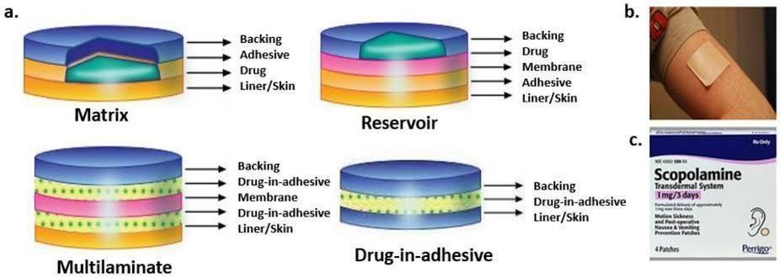

## Fig .6: Types of Transdermal Patch

## 8. METHODS FOR THE PREPARATION Of TRANSDERMAL DRUG DELIVERY SYSTEM [19]

**8.1 Solvent Casting Method**

This is a common way to make patches. Here, the drug is mixed into a liquid that also has a polymer, a plasticizer, and other ingredients. This liquid is then poured onto a flat surface, like a piece of glass or a Teflon sheet. After pouring, the liquid evaporates under controlled conditions, leaving behind a thin, flexible film. Once it's dry, the film is cut to the right size and given a backing layer and a liner to help with application. This method creates even patches and helps control how thick the film is and how much drug it contains.

**8.2 Hot-Melt Extrusion Method**

This method doesn’t use any liquid solvents and is good for drugs and polymers that can handle high heat. The drug is mixed with polymers and melted together in a machine called a hot-melt extruder. The hot mix is then made into a thin film, cooled down, and cut into patches. It's a great way to blend the drug and polymer without using harmful substances, making it gentle on the environment and good for ongoing production.

**8.3 Direct Compression Method**

This method involves mixing the drug with dry ingredients like polymers, fillers, and binders. This dry mix is then pressed by a machine into a thin sheet or film. The sheet is then given a backing and sticky layers to make a complete patch. This method is fast, cost-effective, and doesn't need heat or liquids, which is useful for drugs that can't stand heat or moisture.

**8.4 Membrane-Controlled Reservoir System**

Here, the drug is turned into a gel or liquid and stored in a reservoir. The reservoir sits between a backing layer and a membrane that controls the release of the drug. The reservoir is sealed to prevent leaks. This setup ensures a steady release of the drug over time, making it suitable for long-term treatments that need stable blood levels, like hormone or pain relief patches.

**8.5 Matrix Dispersion Method**

In this method, the drug is directly mixed with a polymer to form a solid or semi-solid structure called a matrix. This matrix is spread onto a backing layer and allowed to dry. Once the film forms, it's covered with an adhesive and liner. The drug is evenly spread in the matrix, and when the patch is used, it slowly passes through the skin. This straightforward method doesn’t require a special reservoir or membrane.

**8.6 Adhesive Dispersion Method**

In this approach, the drug is mixed into a pressure-sensitive adhesive that serves as both the drug holder and the sticky part that attaches to the skin. This mixture is spread on a backing layer and dried to create the patch. It's a popular method due to its simplicity and effectiveness in ensuring close contact with the skin for better absorption. It tends to be used for drugs that are needed in low doses.

**8.7 Micro reservoir System**

This hybrid system combines the benefits of reservoir and matrix patches. It creates tiny droplets of the drug within a gel, embedded into a polymer matrix. This allows for precise control of drug release over a longer period. The droplets are stable and evenly spread across the patch, offering both flexibility and controlled release. This system is perfect for drugs that need extended release and steady blood levels.

**8.8 Multilaminate Film Method**

In this technique, multiple film layers are made separately, with each layer doing a different job, like a drug layer, a sticky layer, or a barrier layer. These layers are then joined together to form one patch with controlled drug release. The multilayer design allows for adjusting drug release, protecting the drug from outside exposure, and improving the patch’s strength and flexibility.

**8.9 Electro spraying Technique**

This method is used to create super-thin films or particles. The drug-polymer mixture is charged and sprayed in a high-voltage electric field onto a surface to form a thin film. Electro spraying forms small structures and increases the surface area, helping the drug release better. Although it's more complex, it's helpful for modern patches that need to act quickly or enhance absorption.

**8.10 Supercritical Fluid Method**

This innovative approach uses supercritical fluids like supercritical CO₂ to create films that go on the skin. These fluids work as solvents under high pressure and temperature, dissolving the drug and polymers. Then, when the pressure lowers, the fluid disappears, leaving a thin film filled with the drug. This method is environmentally friendly, doesn’t leave harmful residues behind, and achieves uniform, stable drug films, making it suitable for sensitive drugs and advanced skin patch systems [20].

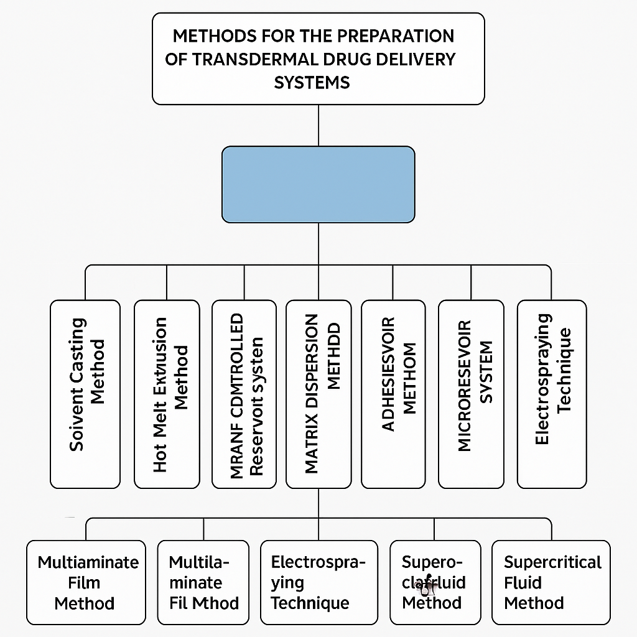

**Fig.7: Flow chart of method for preparation of transdermal patches**

Recent advancements in transdermal patch technology have significantly improved drug delivery efficiency and patient compliance. Innovations such as electroporation, which uses high-voltage pulses to enhance skin permeability, and nanotechnology, which enables precise drug targeting, are transforming the field. Additionally, smart materials and microfabrication techniques are being integrated into patch designs to optimize drug absorption and minimize variability in therapeutic effects. These advancements address challenges like skin barrier limitations and inconsistent drug absorption, making transdermal patches more effective for modern drug delivery.

**Table 1. Commonly Used Drugs in Transdermal Patches and Their Therapeutic Applications**

|  |  |  |  |
| --- | --- | --- | --- |
| Drug | Therapeutic Use | Brand/Example | Reference |
| Nitroglycerin | Angina pectoris | Nitro-Dur, Transderm-Nitro | [21] |
| Fentanyl | Chronic pain | Duragesic | [22] |
| Scopolamine | Motion sickness | Transderm Scop | [23] |
| Nicotine | Smoking cessation | Nicoderm CQ, Habitrol | [24] |
| Estradiol | Hormone replacement therapy | Climara, Vivelle-Dot | [25] |
| Clonidine | Hypertension | Catapres-TTS | [26] |
| Lidocaine | Localized pain relief | Lidoderm | [27] |
| Buprenorphine | Pain and opioid dependence | Butrans | [28] |
| Rivastigmine | Alzheimer’s disease | Exelon | [29] |
| Testosterone | Testosterone deficiency | Androderm | [30] |

**9.CONCLUSION**

Transdermal patches have transformed the delivery of medicine into the body. These patches are easy to use and do not involve injections or swallowing pills. Unlike taking a pill or getting an injection, the patches work by allowing the medicine to pass directly through the skin, bypassing the stomach. This means the body absorbs the medicine better and there are fewer side effects. They are especially useful for people who need regular medication or have trouble swallowing pills.

A major benefit of these patches is that they release medicine slowly over time, which helps maintain the right level of medicine in the body. This results in fewer doses being necessary. The simple application and removal of the patches make them suitable for elderly, young, and long-term patients alike.

Scientists carefully select drugs for these patches. Ideal drugs are usually small, dissolve in fats, and are very potent. Ongoing research continues to expand the range of medicines that can be delivered this way, using advancements like microneedles and other innovative methods to enhance skin absorption.

There are several types of transdermal patches, such as reservoir, matrix, adhesive dispersion, and microreservoir types. Each type uses a different technique for releasing medicine. The creation of these patches involves various methods like solvent casting and hot-melt extrusion, aiming to make them effective and safe for patients.

While these patches offer many benefits, there are some limitations. They can sometimes cause skin irritation and can only hold a limited amount of medicine. They are also suitable only for certain types of drugs that can pass through the skin easily. However, the advantages often outweigh these downsides, and ongoing innovations are helping to overcome these barriers, leading to a promising future for transdermal patches in medicine.

In conclusion, transdermal patches are an effective and user-friendly method of delivering drugs. They offer sustained release of medicine, reduce side effects, and help ensure patients follow their treatment plans. With continuous research and improvement, these patches have the potential to expand treatment options, refine drug formulations, and ultimately enhance patient care for various medical conditions.

1. **REFERENCES**
2. Phatale V, Vaiphei KK, Jha S, Patil D, Agrawal M, Alexander A. Overcoming skin barriers through advanced transdermal drug delivery approaches. Journal of controlled release. 2022 Nov 1;351:361-80.
3. Shah SW, Li X, Yuan H, Shen H, Quan S, Pan G, Ishfaq M, Shah AU, Xie H, Shao J. Innovative transdermal drug delivery systems: Benefits, challenges, and emerging application. BMEMat. 2025:e70001.
4. Ubhe TS, Gedam P. A brief overview on tablet and it’s types. Journal of Advancement in Pharmacology. 2020;1(1):21-31.
5. Boden WE, Padala SK, Cabral KP, Buschmann IR, Sidhu MS. Role of short-acting nitroglycerin in the management of ischemic heart disease. Drug Design, Development and Therapy. 2015 Aug 19:4793-805.
6. Al Hanbali OA, Khan HM, Sarfraz M, Arafat M, Ijaz S, Hameed A. Transdermal patches: Design and current approaches to painless drug delivery. Acta Pharmaceutica. 2019 Jun 30;69(2):197-215.
7. Wong WF, Ang KP, Sethi G, Looi CY. Recent advancement of medical patch for transdermal drug delivery. Medicina. 2023 Apr 17;59(4):778.
8. Zhang W, Fan Y. Structure of keratin. Fibrous Proteins: Design, Synthesis, and Assembly. 2021:41-53.
9. Flanagan M. Wound healing and skin integrity: principles and practice. John Wiley & Sons; 2013 Feb 26.
10. Al‐Dhubaibi MS, Mohammed GF, Bahaj SS, AbdElneam AI, Al‐Dhubaibi AM, Atef LM. The Role of Keratinocytes in Skin Health and Disease. Dermatological Reviews. 2025 Apr;6(2):e70028.
11. Denworth L. Friendship: The evolution, biology and extraordinary power of life’s fundamental bond. Bloomsbury Publishing; 2020 Mar 19.
12. Edwards S. The skin. Essential Pathophysiology For Nursing And Healthcare Students. 2014 Sep 1:431.
13. Nalamachu S, Gudin J. Characteristics of analgesic patch formulations. Journal of Pain Research. 2020 Sep 22:2343-54.
14. Workman B. Safe injection techniques. Primary Health Care. 2000 Jul 1;10(6).
15. Hedaya MA. Routes of Drug Administration. InPharmaceutics 2024 Jan 1 (pp. 537-554). Academic Press.
16. Pleuvry BJ. Factors affecting drug absorption and distribution. Anaesthesia & Intensive Care Medicine. 2005 Apr 1;6(4):135-8.
17. Imperial Cancer Research Fund General Practice Research Group. Effectiveness of a nicotine patch in helping people stop smoking: results of a randomised trial in general practice. BMJ: British Medical Journal. 1993 May 15:1304-8.
18. Mathews L, Roy A. Management of pain using transdermal patches-a review. MANAGEMENT. 2016;9(6):32.
19. Nachum Z, Shupak A, Gordon CR. Transdermal scopolamine for prevention of motion sickness: clinical pharmacokinetics and therapeutic applications. Clinical pharmacokinetics. 2006 Jun;45:543-66.
20. Arunachalam A, Karthikeyan M, Kumar DV, Prathap M, Sethuraman S, Ashutoshkumar S, Manidipa S. Transdermal drug delivery system: a review. Journal of Current Pharma Research. 2010 Oct 1;1(1):70.
21. Yilmaz EG, Ece E, Erdem Ö, Eş I, Inci F. A sustainable solution to skin diseases: ecofriendly transdermal patches. Pharmaceutics. 2023 Feb 8;15(2):579.
22. Gandhi MA, Patel BK. Transdermal drug delivery system: A review. Pharm Innov J. 2016;5(3):349–57.
23. Paudel KS, Milewski M, Swadley CL, Brogden NK, Ghosh P, Stinchcomb AL. Challenges and opportunities in dermal/transdermal delivery. Ther Deliv. 2010;1(1):109–31.
24. Prausnitz MR, Langer R. Transdermal drug delivery. Nat Biotechnol. 2008;26(11):1261–8.
25. Guy RH. Transdermal drug delivery. In: Kydonieus A, editor. Treatise on Controlled Drug Delivery. Marcel Dekker; 1992. p. 423–46.
26. Margetts L, Sawyer R. Transdermal drug delivery: principles and opioid therapy. Contin Educ Anaesth Crit Care Pain. 2007;7(5):171–6.
27. Prajapati ST, Patel CG, Patel CN. Transdermal drug delivery system: a review. Asian J Pharm Clin Res. 2011;4(1):70–4.
28. Raza K, Singh B, Lohan S, Sharma G, Negi P, Yadav N, Katare OP. Nano-lipo-carriers for transdermal drug delivery–clinical implications. Ther Deliv. 2013;4(9):1091–110.
29. Barry BW. Novel mechanisms and devices to enable successful transdermal drug delivery. Eur J Pharm Sci. 2001;14(2):101–14.
30. Lane ME. Skin penetration enhancers. Int J Pharm. 2013;447(1-2):12–21.
31. Benson HAE. Transdermal drug delivery: penetration enhancement techniques. Curr Drug Deliv. 2005;2(1):23–33.