Original Research Article

Phytotoxicity of Untreated Desiccated Industry Wastewater on the Germination of Vigna radiata (mung beans) and Root Growth of Allium cepa (onion bulb)

.
ABSTRACT

Aims: The experiment was done to assess the phytotoxicity of untreated desiccated coconut industry wastewater on the germination (DCIWw) of Vigna radiata (mung beans) and the root development of Allium cepa (onion bulb).
Study design: The researchers employed a laboratory experimental design, as the necessary data had to be obtained through experimentation in the Science/Biology laboratory
Place and Duration of Study: The study was conducted in Region XI, Philippines, between May 2024 and April 2025.
Methodology: The study employed Analysis of Variance (ANOVA) to determine the significant differences in the germination rate of Vigna radiata (mung beans) and root length of Allium cepa (onion bulb) among the various concentrations of DCIWw.
Results: The findings revealed that the highest mean germination rate occurred at 0% concentration of DCWw, while no germination was observed at 100% concentration. Conversely, the highest mean root length was recorded at 0% concentration, and the lowest at 100% concentration of DCWw. Further, a considerable was found in the germination rate of Vigna radiata (mung beans) and the root length of Allium cepa (onion bulbs), with p-values of .00
Conclusion: In conclusion, DCIWw was found to be phytotoxic to Vigna radiata (mung beans) and allium cepa (onion bulb) as the amount of concentration elevated. Furthermore, the results of this research may provide a foundation for enhancing agricultural and environmental awareness, since DCIWw presents a potential risk to soil fertility and crop productivity owing to its phytotoxic characteristics. In addition, a strict regulatory framework may be enforced by relevant authorities to ensure the proper treatment and discharge of industrial wastewater. Finally, future researchers may explore the potential of DCIWw as natural herbicide, given its ability to inhibit plant germination and root development.

Keywords: Phytotoxicity, Germination Rate, Root Length, Desiccated, Wastewater

1. INTRODUCTION

Germination is a process by which a new beginning will emerge, that small seeds have the potential to grow and develop into a new plant. However, certain factors like organic wastewater from diverse sources of factories try to hinder the germination rate and root length of certain plants. In the study Unnao district of Pradish India pertaining to Tannery Wastewater Impact, despite treatment, the wastewater had high levels of contaminants such as total dissolved solids (TDS), biological oxygen demand (BOD), and chemical oxygen demand (COD). Residual organic contaminants, such as benzoic acid and dibutyl phthalate, were discovered using gas chromatography-mass spectrometry (GC-MS). Phytotoxicity tests found that the wastewater decreased seed germination in Vigna radiata and root growth in Allium cepa, indicating a negative impact on plant development (Yadav et al., 2019).

Similar study has shown that there are serious environmental dangers associated with inappropriate disposal of waste coconut water from the Copra industry, including ground water pollution and soil damage. This due to the result from high amounts of organic matter, which increases biological oxygen demand (BOD) and chemical oxygen demand (COD) in receiving water bodies. This can lead to oxygen deprivation, which harm aquatic life and disrupt ecosystem (Pawels, R., & Sreedharan, S. (2021).

Several treatments were found effective in managing the coconut waste water. In the study of Radityo et al (2023) Wastewater from nata de coco manufacturing, a byproduct of coconut processing, was treated with anaerobic bio-filters made of wasp nest medium. The best treatment period was discovered to be 48 hours, with decreases of 53.24% in biochemical oxygen demand (BOD), 30.37% in COD, and 46.15% in pH levels. In similar studies, the use of coconut by-products, including shells, husks, and coir, as efficient bio adsorbents for eliminating contaminants from wastewater is highlighted in a thorough review conducted by researchers. These materials can be structurally altered to improve their effectiveness in treating pollutants like organic chemicals and heavy metals because of their abundance and advantageous adsorption qualities (James and Yadav, 2021). Further, ​the manufacturing and use of biochar made from coconut-based materials for CO2 capture and wastewater treatment are covered in another study. Through pore-filling processes, the research highlights the low cost and great efficacy of these adsorbents in eliminating a variety of contaminants, such as phenolic chemicals and pesticides (Khan et al., 2023).

However, despite some are treated still toxicity exist. A study conducted that both treated and untreated pharmaceutical industry effluent were evaluated for genotoxicity and phytotoxicity revealed that both untreated and treated wastewaters contained high amounts of pollutants beyond allowable limits, according to physicochemical tests. Significant suppression of Vigna radiata seed germination was shown by toxicological investigations, with decreases of up to 70% and 50% at 50% concentrations of untreated and treated wastewater, respectively. Allium cepa root cells also showed genotoxic effects, such as increased chromosomal abnormalities and lower mitotic indices (Jyoti, Soni, & Chandra, 2024).

While specific studies on desiccated coconut wastewater are limited in the Philippine settings and of the Local setting. This prompted the researcher to invistigate thouroghly on a topic for there were no such studies that dealt on phytotoxicity of desiccated coconut Industry wastewater on the germination of vigna radiata (mung beans) and root growth of allium cepa (onion bulb). Further, as some research findings may suggest that industrial effluents, which concentration is higher can hamper the rate of germination of and root growth of Vigna radiata, applying the concept of desiccated coconut industry wastewater in the locality, is the main reason that the researcher urgently pursue the study to find out if the said the phytotoxicity of Desiccated Coconut Wastewater in various concentration can affect the Germination rate of Allium Ceppa and Mungo beans of Allium Ceppa and Root length of Allium Ceppa.

Research Objectives
The study aims to determine the phytotoxicity of treated desiccated coconut industry wastewater in the germination of Vigna radiate (mung beans) and allium cepa (Onion Bulb).
Specifically, this study answered the following objectives:
- To determine germination rate of Vigna radiata among the different concentration of desiccated coconut industry wastewater?
  - O%
  - 10%
  - 25%
  - 50%
  - 75%
  - 100%
- To ascertain the root length of allium cepa among the different concentration of desiccated coconut industry wastewater?
  - 0%
  - 10%
  - 25%
  - 50%
  - 75%
  - 100%
- To find out the significant difference on the germination rate of Vigna radiate (Mung beans) among the different concentration of untreated desiccated coconut factory wastewater?
- To evaluate the significant difference on the root length of Allium cepa (Onion bulb) among the different concentration of untreated desiccated coconut factory wastewater?
Hypothesis
- There is no significant difference of the germination rate of Vigna radiate (Mung beans) among the different concentration of desiccated coconut industry wastewater.
- There is no significant difference on the root length rate of allium cepa among the different concentration of desiccated coconut industry wastewater.
Theoretical Foundation
This study is anchored on “Allelopathy Theory” of Rice (1984) as it gives emphasis on the interactions as to how neighboring organism being affected in terms of growth and development with the exposure chemical substances in the environment. This theory also describes the role of biochemicals or Allelochemicals in inhibition and stimulation of plant development. In the context of the study, the DCIWW may contain Allelochemicals that impede the germination and root growth of vigna radiata and allium ceppa.
In addition, it can also be rooted to Dose-Response Relationship Theory (Toxicology Principle) in which A key idea in toxicology. This explains how a substance's impact on an organism varies with its dosage or concentration. This hypothesis looks at how different compounds affect biological systems to assess how harmful they are, including chemicals found in industrial effluent (Hayes, 2007). In the framework of the study, the concentration of DCIWW varied from 0%, 25%, 50%, 75% and 100% to evaluate effectively its effect in the growth and development of Vigna radiate (Mung beans) and Allium cepa (Onion bulb).

2. material and methods

Presented in this part are the materials used in the experiment, data collection, procedure (Germination test, Roth length test and proper disposal) and data analysis

2.1 Data Collection

During the study, the researcher made sure that all the right steps were taken to collect the data. First, the researcher wrote a letter to the management of the selected corporation, requesting permission to obtain the study sample. Once the request was granted, the researcher, with the assistance of personnel managing the wastewater plant, proceeded with sample collection.

Moreover, the coconut wastewater was collected at the sewage tank of a desiccated coconut industry waste located in Davao Region, Philippines. A 3.5 litter sample of wastewater was collected in a clean container. After collection, the sample was stored at the Science laboratory at room temperature and sealed tightly overnight.

2.2 Materials

The materials used in the study included 60 Petri dish, 1 graduated cylinder, 30 plastic cups (6 ounce), 3.5 liter of coconut industry wastewater, 600 viable mungo beans, 30 onion bulb and 1 caliper.

2.3 Procedure

The research’s procedures encompass Germination Test, Root Lenth Test and Disposal.

2.3.1 Germination Test

The germination test method was adapted and modified from the research journal of Haq et al. (2019). In this method, Vigna radiata (mung beans) were prepared, ensuring that they had zero germination upon purchase from the market. The seeds were first soaked in tap water to select viable ones. A total of 600 Vigna radiata seeds, 60 Petri dishes and 6 plastic clean containers were prepared in the laboratory for different solution concentration. Each set of petri dishes represented one treatment group or concentration. Each Petri dish held 10 Vigna radiata seeds, and the treatments were repeated ten times for each concentration, including the control. Distilled water was utilized as a control.

Each group represents different concentration (0 %, 10%, 25%, 50%, 75% & 100%). On the first day, 10 ml of the respective solution was added to each treatment, followed by 3ml daily for next the six days. The germination of each seed in each replicate was monitored daily, and final results were recorded on the seventh day.

Moreover, the germination percentage was calculated using the method described Mim et al. (2025), as follows:

Germination % (GP) = (Number of germinated seeds (G) / Total Number of sown seeds (N)) X 100. Where, ‘GP’ is the germination percentage, ‘G’ for germinated seeds and ‘N’ for the number of seeds used for germination.

2.3.1 Root Length Test

The root length test was adapted and modified from Haq et al (2016). In this method, Allium cepa (onion bulb) were purchased from the market, ensuring they were healthy and uniform in size. A total of 30 onion bulbs, 30 plastic cups and 6 clean plastic containers were prepared for the 6 groups, each representing a different wastewater solution concentration (0 %, 10%, 25%, 50%, 75% & 100%). Distilled water was used as control.

The experiment included five duplicates of each concentration group. The onion bulbs were placed in 6- ounce plastic cups filled with 100ml respective solution, using of toothpick to suspend. Following a week (7 days), the researcher measured the root length of onion bulbs grown in each concentration. Lastly, the root length of every onion bulb was precisely measured using a caliper.

2.3.3 Disposal

The researcher ensured that all waste generated from the experiment was properly managed to prevent the spread of contamination. First, a pit was excavated near the experimentation area, and the researcher waited for an appropriate time to ensure that no one would be exposed to the strong odor of waste coconut water. Second, all the plastic cups and other waste materials were collected in the sack, securely tied, and placed in the designated dump area for collection garbage were placed in the sack and tighten with tie box and placed in the dump area for collection of Solid Waste Management personnel.

2.4 Data analysis

Mean. This will be used to determine the germination rate of Vigna radiate and root length of Allium cepa (Onion bulb) across the different concentration of untreated desiccated coconut factory wastewater.

Analysis of Variance (ANNOVA). This will be applied to evaluate the groups that were exposed to desiccated coconut industry wastewater at concentrations of 0%, 10%, 25%, 50%, 75%, and 100%.

Post-hoc Analysis. This will be used to identify where significant difference occur. Tukey’s HSD was used to determine whether concentrations of untreated desiccated coconut manufacturing effluent differed substantially from one other. The test evaluates every conceivable pair of means.
3. results

The findings, interpretation, and analysis are presented in this section. The tables are organized in the following order: germination rate, analysis of variance (ANOVA), and post-hoc analysis of vigna radiata (mung beans). Following this, the root length rate, analysis of variance (ANOVA), and post-hoc analysis of allium cepa (onion bulb) were conducted.

Table 1
Germination rate of Vigna radiata (mung beans) on different concentration of desiccated coconut industry wastewater
Concentration | N | Mean | SD
0% | 10 | 78.00 | 10.33
10% | 10 | 74.00 | 8.43
25% | 10 | 70.00 | 12.47
50% | 10 | 11.00 | 5.68
75% | 10 | 6.00 | 6.99
100% | 10 | 0.00 | 0.00
Total | 60 | 37.50 | 33.48
__________________________________________________________________________________________________

As displayed in Table 1, regarding the germination rate of Vigna radiata, the (0%) concentration had the highest mean germination rate, with an average of 78.00, followed by (10%) with a mean of 74.00, (25%) with a mean of 70.00, (50%) with a mean of 11.000, (75%) with a mean of 6.00 and finally (100%) concentration, no germination was observed.

Table 2
Analysis of variance (ANOVA) of the germination rate of Vigna radiata (mung beans) among the different concentration
 | Sum of Squares | df | Mean Square | F | Sig.
Between Groups | 70968.3 | 5 | 14193.7 | 205.48 | 0.00
Within Groups | 3730 | 54 | 69.07
Total | 74698.3 | 59
The ANOVA test was used to calculate and interpret the significant difference in the germination rate across various concentrations of desiccated coconut industry wastewater, as illustrated in Table 2. As you can observed in the table, the F-value is 205.485 with a p-value of .000, indicating the rejection of the null hypothesis and implies a significant difference across concentration.

Table 3
Post hoc analysis on the multiple comparison of germination rate among different concentration of desiccated coconut industry wastewater
(I) Concentration | (J) Concentration | Mean Difference (I-J) | Std. Error | Sig. | 95% Confidence Interval
 |  |  |  |  | Lower Bound | Upper Bound
0% | 10% | 4.00000 | 3.71683 | .889 | -6.9813 | 14.9813
0% | 25% | 8.00000 | 3.71683 | .277 | -2.9813 | 18.9813
0% | 50% | 67.00000* | 3.71683 | .000 | 56.0187 | 77.9813
0% | 75% | 72.00000* | 3.71683 | .000 | 61.0187 | 82.9813
0% | 100% | 78.00000* | 3.71683 | .000 | 67.0187 | 88.9813
10% | 0% | -4.00000 | 3.71683 | .889 | -14.9813 | 6.9813
10% | 25% | 4.00000 | 3.71683 | .889 | -6.9813 | 14.9813
10% | 50% | 63.00000* | 3.71683 | .000 | 52.0187 | 73.9813
10% | 75% | 68.00000* | 3.71683 | .000 | 57.0187 | 78.9813
10% | 100% | 74.00000* | 3.71683 | .000 | 63.0187 | 84.9813
25% | 0% | -8.00000 | 3.71683 | .277 | -18.9813 | 2.9813
25% | 10% | -4.00000 | 3.71683 | .889 | -14.9813 | 6.9813
25% | 50% | 59.00000* | 3.71683 | .000 | 48.0187 | 69.9813
25% | 75% | 64.00000* | 3.71683 | .000 | 53.0187 | 74.9813
25% | 100% | 70.00000* | 3.71683 | .000 | 59.0187 | 80.9813
50% | 0% | -67.00000* | 3.71683 | .000 | -77.9813 | -56.0187
50% | 10% | -63.00000* | 3.71683 | .000 | -73.9813 | -52.0187
50% | 25% | -59.00000* | 3.71683 | .000 | -69.9813 | -48.0187
50% | 75% | 5.00000 | 3.71683 | .759 | -5.9813 | 15.9813
50% | 100% | 11.00000* | 3.71683 | .049 | .0187 | 21.9813
75% | 0% | -72.00000* | 3.71683 | .000 | -82.9813 | -61.0187
75% | 10% | -68.00000* | 3.71683 | .000 | -78.9813 | -57.0187
75% | 25% | -64.00000* | 3.71683 | .000 | -74.9813 | -53.0187
75% | 50% | -5.00000 | 3.71683 | .759 | -15.9813 | 5.9813
75% | 100% | 6.00000 | 3.71683 | .593 | -4.9813 | 16.9813
100% | 0% | -78.00000* | 3.71683 | .000 | -88.9813 | -67.0187
100% | 10% | -74.00000* | 3.71683 | .000 | -84.9813 | -63.0187
100% | 25% | -70.00000* | 3.71683 | .000 | -80.9813 | -59.0187
100% | 50% | -11.00000* | 3.71683 | .049 | -21.9813 | -.0187
100% | 75% | -6.00000 | 3.71683 | .593 | -16.9813 | 4.9813
*. The mean difference is significant at the 0.05 level.

Table 3 presented the post-hoc analysis (Tukey’s HSD) test, which was conducted to determine the specific differences in germination rates of Vigna Radiata (mung beans) among the various concentrations of desiccated coconut industry wastewater. Depicted on the table, 0% concentration exhibited the highest germination rate, and significant differences were observed when compared to concentrations of 50%, 75%, and 100%, which had the p value of .000. Further, the 10% and 25% concentration did not show significant differences as compared to each other, suggesting the lower level of contamination may still allow for similar germination rates.

Table 4

Root length of Allium ceppa (onion bulb) on the different concentration of desiccated coconut industry wastewater.
Concentration | N | Mean (mm) | SD
0% | 5 | 38.2000 | 25.781777
10% | 5 | 2.40000 | .534772
25% | 5 | 1.2000 | 1.30384
50% | 5 | 1.0000 | 1.00000
75% | 5 | 1.4000 | 1.34164
100% | 5 | 1.0000 | 1.00000
Total | 30 | 7.5333 | 16.94969
__________________________________________________________________________________________________
Shown in Table 4 is the descriptive result of the Root length of Allium ceppa (onion bulb) at different concentration of desiccated coconut industry waste water. The result indicate that the 0% concentration has the highest mean root length of 38.2000 which a standard deviation of 25.781777. In contrast, the root lengths observed at 10%, 25%, 50%, 75% and 100% concentrations are comperable to each other, showing a significant reduction in gorwth compared to the 0% (control).

Table 5
Analysis of variance (ANOVA) of the root length of allium cepa (onion bulb) among the different concentration.
Sum of Squares | df | Mean Square | F | Sig.
5649.467 | 5 | 1129.893 | 10.111 | .000
2682.000 | 24 | 111.750
8331.467 | 29

Table 5 illustrates the Analysis of Variance (ANOVA) of the root length of Allium cepa (onion bulb) at various concentrations. The F-value of 10.111 and a p value of.000 in the ANOVA results indicate a significant effect of wastewater concentration on root length, thereby rejecting the null hypothesis.

Table 6
Post hoc analysis on the multiple comparison of root growth rate among different concentration of desiccated coconut industry wastewater
(I) Concentration | (J) Concentration | Mean Difference (I-J) | Std. Error | Sig. | 95% Confidence Interval
 |  |  |  |  | Lower Bound | Upper Bound
0% | 10% | 35.80000* | 6.68581 | .000 | 15.1279 | 56.4721
0% | 25% | 37.00000* | 6.68581 | .000 | 16.3279 | 57.6721
0% | 50% | 37.20000* | 6.68581 | .000 | 16.5279 | 57.8721
0% | 75% | 36.80000* | 6.68581 | .000 | 16.1279 | 57.4721
0% | 100% | 37.20000* | 6.68581 | .000 | 16.5279 | 57.8721
10% | 0% | -35.80000* | 6.68581 | .000 | -56.4721 | -15.1279
10% | 25% | 1.20000 | 6.68581 | 1.000 | -19.4721 | 21.8721
10% | 50% | 1.40000 | 6.68581 | 1.000 | -19.2721 | 22.0721
10% | 75% | 1.00000 | 6.68581 | 1.000 | -19.6721 | 21.6721
10% | 100% | 1.40000 | 6.68581 | 1.000 | -19.2721 | 22.0721
25% | 0% | -37.00000* | 6.68581 | .000 | -57.6721 | -16.3279
25% | 10% | -1.20000 | 6.68581 | 1.000 | -21.8721 | 19.4721
25% | 50% | .20000 | 6.68581 | 1.000 | -20.4721 | 20.8721
25% | 75% | -.20000 | 6.68581 | 1.000 | -20.8721 | 20.4721
25% | 100% | .20000 | 6.68581 | 1.000 | -20.4721 | 20.8721
50% | 0% | -37.20000* | 6.68581 | .000 | -57.8721 | -16.5279
50% | 10% | -1.40000 | 6.68581 | 1.000 | -22.0721 | 19.2721
50% | 25% | -.20000 | 6.68581 | 1.000 | -20.8721 | 20.4721
50% | 75% | -.40000 | 6.68581 | 1.000 | -21.0721 | 20.2721
50% | 100% | .00000 | 6.68581 | 1.000 | -20.6721 | 20.6721
75% | 0% | -36.80000* | 6.68581 | .000 | -57.4721 | -16.1279
75% | 10% | -1.00000 | 6.68581 | 1.000 | -21.6721 | 19.6721
75% | 25% | .20000 | 6.68581 | 1.000 | -20.4721 | 20.8721
75% | 50% | .40000 | 6.68581 | 1.000 | -20.2721 | 21.0721
75% | 100% | .40000 | 6.68581 | 1.000 | -20.2721 | 21.0721
100% | 0% | -37.20000* | 6.68581 | .000 | -57.8721 | -16.5279
100% | 10% | -1.40000 | 6.68581 | 1.000 | -22.0721 | 19.2721
100% | 25% | -.20000 | 6.68581 | 1.000 | -20.8721 | 20.4721
100% | 50% | .00000 | 6.68581 | 1.000 | -20.6721 | 20.6721
100% | 75% | -.40000 | 6.68581 | 1.000 | -21.0721 | 20.2721
*The mean difference is significant at the 0.05 level.

Table 6 presented a post hoc multiple comparison study of root lenght growth across various concentration (0%, 10, 25%, 50%, 75% and 100%) of DCIWW. The most significant mean differences were seen between the 0% concentration and the treatments of 10%, 50%, 75%, and 100%, with values spanning from 35.4000. The differences were statistically significant with p < 0.05. Likewise, assessements of higher concentration levels that above a certain threshold, augmenting wastewater concetration had no further impact on root lenght. Consequenty, the roots will fail to develop.

3. DISCUSSIONS

The result of the study demonstrates a substantial impact of Desiccated Coconut Industry Wastewater on the germination rate of Vigna radiata (mung beans) and root length of Allium cepa (onion bulb). The results suggest that a substantial reduction in root length and germination rate is observed as the concentration of wastewater increases. The mung bean germination is completely inhibited at a 100% concentration, while onion bulbs exhibit a noteworthy reduction in root length. Further, the ANOVA findings indicates that Vigna radiata and Allium cepa among various concentration of DCIWW is statistically significant. This implies that germination rates across various wastewater concentrations are statistically significant as well as reinforce substantial adverse effect of wastewater concentration on root development of Allium Cepa.

These findings are substantiated by numerous studies. In the research investigation of Jyoti et al. (2024) revealed that the existence of organic waste products and heavy metals in natural rubber wastewater was assessed for its phytotoxicity using Vigna radiata and Allium cepa. The results indicated that elevated concentrations of wastewater resulted in reduced germination rates and root elongation in both species, highlighting the adverse effects of wastewater contaminants on plant growth. The evidence is back up by research investigation conducted by Zhu et al. (2024) on the wastewater accumulated substantial concentrations of organic contaminants and heavy metals, resulting in detrimental impacts on seed germination, root elongation, and chromosomal integrity in the experimental plants. Elevated quantities of the wastewater led to decreased germination rates and root lengths, with a rise in chromosomal abnormalities, signifying its potential environmental risks. The findings highlight the need of appropriate treatment and disposal of natural rubber manufacturing wastewater to alleviate its harmful impacts on plant life and environmental health.

Moreover, comparable investigations were conducted to investigate the genotoxic and toxic effects of pulp and paper mill effluent on Vigna radiata and Allium cepa. The research revealed a substantial decrease in the length of the root and the germination of seeds in Vigna radiata as the concentration of effluent increased. In Allium cepa, root development inhibition was much greater at 75% and 100% effluent concentrations, with a steady decline in the mitotic at higher concentrations, suggesting cytotoxic effects (Haq et al., 2016). Furthermore, research conducted by Haq and Kalamnhad (2021) evaluates the toxicity of petroleum refinery effluent on Vigna radiata and Allium cepa. The findings indicated that untreated wastewater significantly impeded seed gemination in Vigna radiata and decreased root length in Allium cepa. Moreover, many chromosomal abnormalities were detected in onion root tip cells, indicating genotoxic consequences.

This research can possess multitude of implications in the field of agriculture and environmental policy making. The DCIWW can be threat to soil fertility and crop productivity and eventually will lead to deterioration of crop yield if not manage the source of waste. Meanwhile, the said wastewater can lead to risk of crop contamination as the uptake of toxic elements from effluent by crops could result in food safety concerns, rendering the crops unfit for human and animal sustenance, as well as detrimental to plant life and environmental health. On the other hand, this research can be a basis for formulation of stricter industry regulations. The formulation of environmental policies that enforce stricter requirements for effluent discharge from coconut processing industries could be facilitated by these findings. Finally, future researchers may use the result of this findings as their basis for potential herbicidal properties of DCIWW for it can hinder the germination and the development of root.

There were a number of limitations on this study. First, because the study only collected samples from one coconut business, the sample collection did not accurately reflect the Davao Region as a whole. Second, multiple organic wastewater types that might affect Vigna radiata germination and Allium cepa root development rate were not investigated by the researcher. The inability to clearly see digital picture of Allium cepa root growth for only the 0% concentration shown notable development and the rest were just minimal growth. Furthermore, the differences in root growth across concentrations were not distinctly observable, as the floating coagulated effluent closely resembled the roots in color, which may have led to misidentification. Moreover, the researcher did not test for heavy metals because it was outside the scope of the study's objective. However, this research could serve as a baseline for future investigations on potential harm. Finally, the researcher did not obtain an authenticity certificate from a plant taxonomy specialist for recognizing Vigna radiata (mung beans) and Allium cepa (onion bulbs), as both plant species are well-known and freely available.

4 cONCLUSIONS

The germination rate of Vigna radiata (mung bean) gradually decreases as the amounts of desiccated industry wastewater (DCIWw) increases with complete inhibition of 100%

The root length of Allium cepa (onion bulb) marked a reduction of root length as the concentration of desiccated industry wastewater (DCIWw) progress.

There is a significant difference on the Germination rate of Vigna radiata across various concentration desiccated industry wastewater (DCIWw).

There is significant difference on the Root length of Allium cepa throughout the different concentrations of desiccated industry wastewater (DCIWw).

Consent (where ever applicable)

Not Applicable

Ethical approval (where ever applicable)

not applicable

Disclaimer (Artificial intelligence)
Option 1:
Author(s) hereby declare that NO generative AI technologies such as Large Language Models (ChatGPT, COPILOT, etc.) and text-to-image generators have been used during the writing or editing of this manuscript.
Option 2:
Author(s) hereby declare that generative AI technologies such as Large Language Models, etc. have been used during the writing or editing of manuscripts. This explanation will include the name, version, model, and source of the generative AI technology and as well as all input prompts provided to the generative AI technology
Details of the AI usage are given below:
1.
2.
3.

References

Haq, A., Muhammad, Z., Badshah, L., Burni, T., & Ullah, I. (2019). Allelopathic effect of
Eucalyptus camaldulensis L. on seed germination and seedling growth of mungbean Vigna radiata (L.) Wilczek. Pakistan Journal of Weed Science Research, 25(3), 251.

Haq, F., Ullah, F., Ahmad, S., & Alam, M. (2016). Cytotoxic and genotoxic effects of tannery
wastewater on onion (Allium cepa L.). Chemosphere, 169, 265–271.

Haq, I., & Kalamdhad, A. S. (2021). Phytotoxicity and cyto-genotoxicity evaluation of organic
and inorganic pollutants containing petroleum refinery wastewater using plant bioassay. Environmental Technology & Innovation, 23, 101651.

Haq, I., Kumari, V., Kumar, S., Raj, A., Lohani, M., & Bhargava, R. N. (2016). Evaluation of the phytotoxic and genotoxic potential of pulp and paper mill effluent using Vigna radiata and Allium cepa. Advances in Biology, 2016(1), 8065736.

Hayes, A. W. (2007). Principles and methods of toxicology (5th ed.). CRC Press.

James, A., & Yadav, D. (2021). Valorization of coconut waste for facile treatment of contaminated water: A comprehensivereview (2010–2021). Environmental Technology Innovation, 24, 102075.

Jyoti, K., Soni, K., & Chandra, R. (2024). Phytotoxicity and genotoxicity assessment of organicand inorganic contaminants detected in pharmaceutical industrial wastewaters using Vigna radiata and Allium cepa. Journal of Experimental Biology and Agricultural Sciences, 12(1), 76–92.https://doi.org/10.18006/2024.12(1).76.92

Khan, M. H., Akash, N. M., Akter, S., Rukh, M., Nzediegwu, C., & Islam, M. S. (2023). Acomprehensive review of coconut-based porous materials for wastewater treatment and CO₂ capture. Journal of Environmental Management, 338, 117825.

Mim, Asmaul & Rashid, Md & Turjo, Ahnaf & Sikdar, Md & Rahman, Md. (2025). Impact of different seed priming techniques on germination, growth, and yield of mung bean (Vigna radiata L.). 10.21203/rs.3.rs-6221817/v1.

Pawels, R., & Sreedharan, S. (n.d.). Sustainable treatment of waste coconut water from copraindustry using microbial desalination cell (MDC). [Unpublished manuscript].

Radityo, M., Pratiwi, Y., & Hastutiningrum, S. (2023). The treatment of nata de coco processing wastewater using anaerobic bio-filter. International Journal of Environmental Science and Development, 14(2), 106–110.https://doi.org/10.18178/ijesd.2023.14.2.1421

Rice, E. L. (1984). Allelopathy. Academic Press.

Yadav, A., Raj, A., Purchase, D., Ferreira, L. F. R., Saratale, G. D., & Bharagava, R. N. (2019). Phytotoxicity, cytotoxicity, and genotoxicity evaluation of organic and inorganicpollutants rich tannery wastewater from a Common Effluent Treatment Plant (CETP) in Unnao district, India using Vigna radiata and Allium cepa. Chemosphere, 224, 324–332.https://doi.org/10.1016/j.chemosphere.2019.02.124

Zhu, D., Ge, C., Sun, Y., Yu, H., Wang, J., & Sun, H. (2024). Identification of organic pollutants and heavy metals in natural rubber wastewater and evaluation its phytotoxicity and cytogenotoxicity. Chemosphere, 349, 140503.

APPENDIX
‘

different concentration of DCWw on the germination of vigna radiata (mung bean)

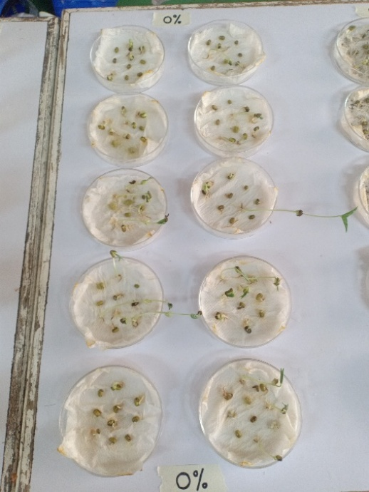
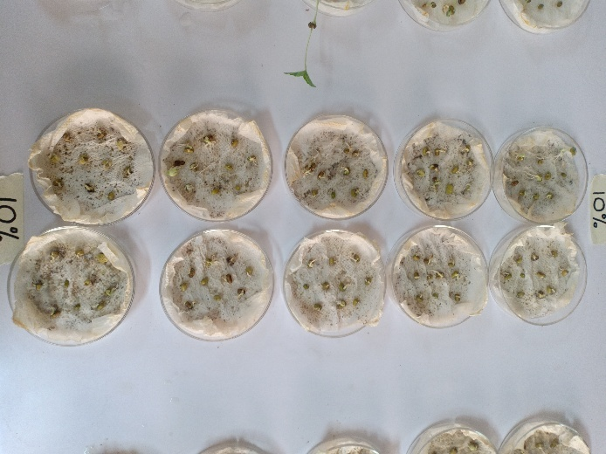

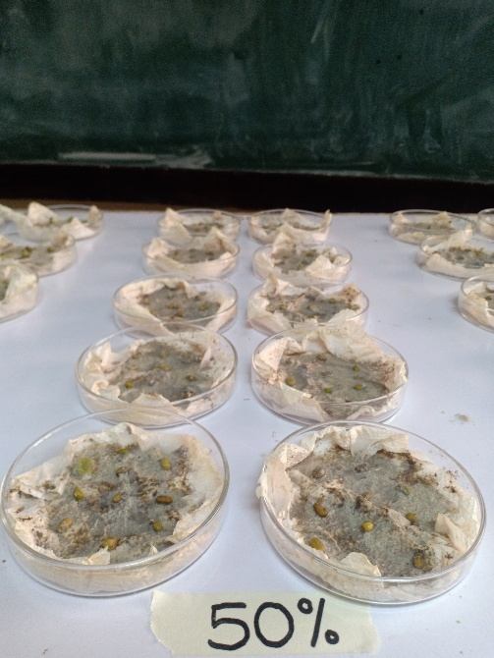
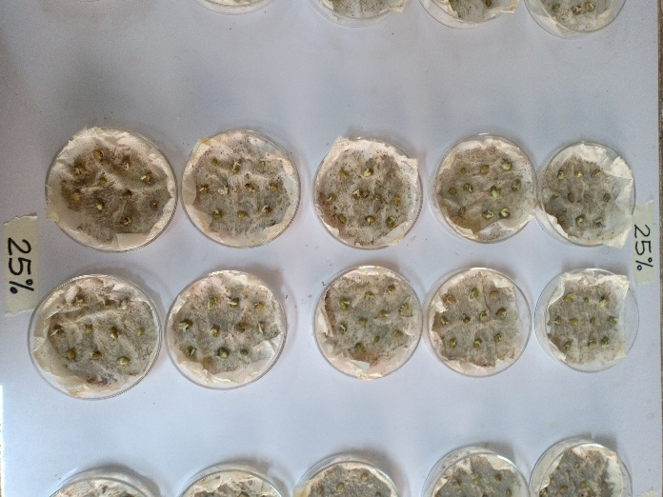

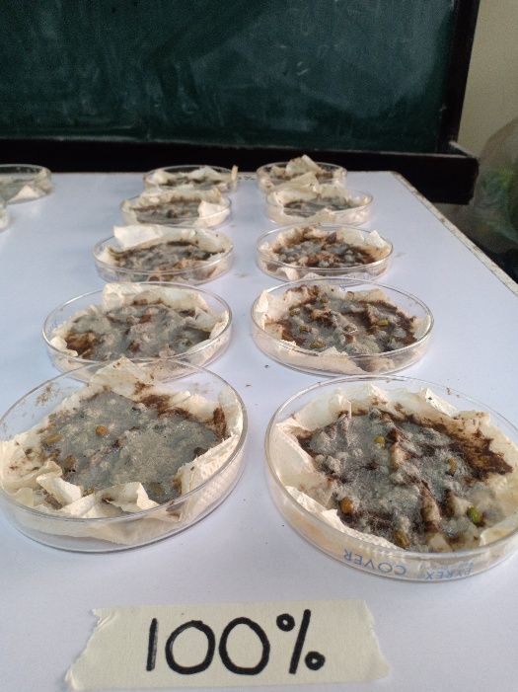
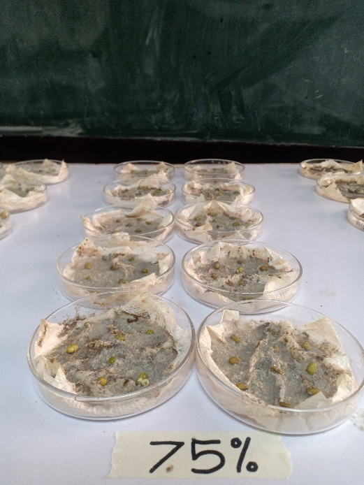

DIFFERENT CONCENTRATION OF DCWW ON ALLIUM CEPA (ONION BULB)

