Original Research Article

Spatial Distribution and Diversity of Adiantum capillus-veneris L. and Diplazium esculentum (Retz.) Sw. in Cross River National Park, Erokut Camp, Akamkpa

ABSTRACT
Ferns play a crucial role in tropical forests by offering various ecosystem services; however, the spatial distribution and diversity of Adiantum capillus-veneris L. and Diplazium esculentum (Retz.) Sw has not been recorded in Erokut Camp of Cross River National Park. For this study, ten plots were established, each measuring 10 × 10 m². The research utilized a non-random preferential sampling approach, where all fern species found within each plot were collected, identified, and documented. The collected ferns were identified using taxonomic literature, available materials, and consultation with experts in the field of Taxonomy, while the conservation status of each identified fern species was evaluated based on the recent IUCN 2023 Red List. Voucher specimens were stored in the Herbarium of the University of Cross River State (UNICROSS) in Calabar. The individuals of both species were mapped using a Global Positioning System (GPS) device. Location and attribute queries were produced using the map and coordinates from the study area to verify the accuracy of the data gathered. In total, two hundred and thirty-four (234) individuals of the two species were surveyed in the area, with A. capillus-veneris exhibiting a higher number of individuals compared to D. esculentum. A. capillus-veneris was found to have a Shannon value of 2.149 and an evenness of 0.959, whereas D. esculentum recorded a Shannon value of 2.182 and an evenness of 0.886, respectively. This study has demonstrated the use of GIS-based mapping in representing species locations, which supports conservation and resource management strategies.

Keywords: Ecosystem, Ferns, Forest, mapping, Spatial

1. INTRODUCTION
Ferns are vascular plants that do not produce seeds, with their body structures characterized by roots, stems, fronds, and pinnae. Their lack of flowers, seeds, and fruits (Cryptogamic) distinguishes them from higher plants (Egbe et al., 2025a; Bassey et al., 2024; Asikiye et al., 2023). Ferns may be perennial, annual, terrestrial, aquatic, or epiphytic. They represent one of the most significant and plentiful plant groups that play a crucial role in the natural habitats and flora of tropical forests (Egbe et al., 2025b; Hemp, 2002). The diversity, abundance, and distribution of ferns in tropical regions, including Nigeria, can be attributed to factors such as seasonal changes, soil quality, habitat type, elevation, rainfall, temperature, and human activities (Bassey et al., 2023; Akomolafe and Sulaimon, 2018). Globally, there are approximately 11,916 taxa belonging to 337 genera, 51 families, 14 orders, and two classes of ferns, with around 2,865 species being epiphytic (PPG-I, 2016). The richness of species is a key metric of community and regional diversity and is the basis for many ecological models that analyze the number of species recorded in various samples (Edwin-Wosu et al., 2024; Bassey et al., 2023).
Mapping species across both temporal and spatial gradients is essential for comprehending speciation, potential threats, survivorship, dispersal patterns, and the availability and use of resource materials. It has also been utilized in predictive modeling to forecast species declines and increases (Marjorie et al., 2025; Egbe and Edoki, 2019). The application of species mapping is widespread in forestry practices, as the conservation of young plants and the harvesting of mature timber depend, in part, on precise knowledge of species location and their abundance (Egbe and Edoki, 2019). Despite its significant role in conservation forestry and as a modulator of climate change, a vast majority of phyto-diversity data in Africa, along with most developed countries, lacks components related to distribution and abundance in the context of spatial orientation. This has complicated the mobilization of phyto-diversity data and, more crucially, the assessment of the scale of threats.
Erokut Camp is a segment of the Oban Division within the Cross River National Park (CRNP). It hosts a variety of flora, including ferns. Adiantum capillus-veneris L. is classified in the family Pteridaceae, while Diplazium esculentum (Retz.) Sw. falls under the Athyriaceae family. Although the distribution of these species is recognized as valuable (Egbe et al., 2025a) in Central and Northern Cross River State due to their nutritional and medicinal properties, it is essential to map and protect them, especially since they are not easily found within the study area. Cross River National Park’s Erokut Camp, however, lacks documented information on the taxonomy, ecology, and distribution of these species compared to higher plants, which underscores the necessity of this study.

2. MATERIALS AND METHODS
2.1 Study area
The study was carried out in the core forest area in Erokut Camp of the Cross River National Park (CRNP) Oban Division, Akamkpa Local Government Area (LGA). Akamkpa LGA is situated in the Southern part of Cross River State with approximately 5,003 Square Kilometers and 1000m above sea level. Akamkpa is bounded to the west and south by Odukpani and Akpabuyo LGAs, Biase and Yakurr to the north and west, Ikom and Etung LGAs to the north, and Republic of Cameroon to the west. The vegetation ranges from mangrove swamps, through rainforest, to derived savannah, and montane parkland. Just as its rocks are diverse, so also are the mineral resource potentials of Akamkpa with abundant limestone deposits. Figure 1 present study area.

2.2 Sampling design and techniques
Ten (10 × 10 m²) plots were established in the core forest zone taking into considerations edge effect. A non-random preferential sampling method was adopted as used by Egbe et al. (2025a) where all ferns encountered in each plot were collected, identified, and documented where necessary. Collected ferns were identified using taxonomic flora, literatures (Reference Field Guide by Edwin-Wosu, 2019; Introductory Pteridology by Bassey, 2013 and POWO, 2023) and experts in the field of Taxonomy, while conservation status of each identified fern species was assessed from recent IUCN 2023 red list website (www.iucnredlist.org). Voucher specimens were deposited in the Herbarium of University of Cross River State (UNICROSS), Calabar. Geographical coordinates of each sampled plot were obtained using a Global Positioning System (GPS) device.

2.3 Data analysis
Species diversity was determined using Shannon-Wiener index. All data were analyzed using Paleontological Statistics (PAST) software. While use of GIS tools in mapping and analysis of individuals of the two fern species in each sampled plot as used by Egbe and Edoki (2019) and Muhammad et al. (2014) was adopted for the study.

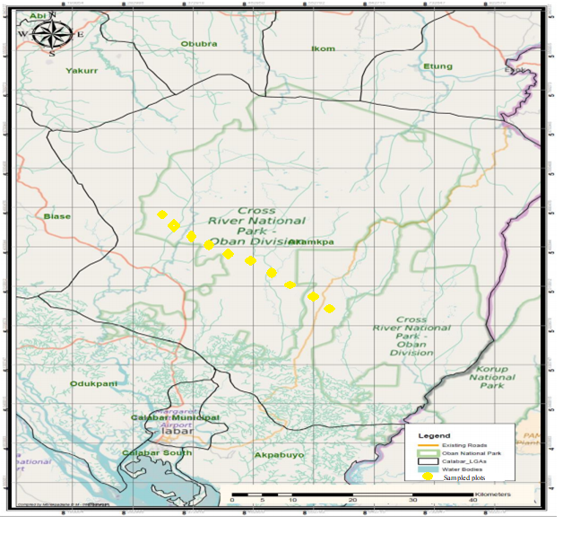

Figure 1: Map of study area
Source: Cross River Geographic Information System (CRS-GIS)

3. RESULTS AND DISCUSSION
A total of two hundred thirty-four (234) individuals from the two species were collected in the study area. Adiantum capillus-veneris L. accounted for 176 individuals, while Diplazium esculentum (Retz.) Sw had 58 individuals. Figure 2 illustrates the distribution map of the two fern species. This map was generated by dividing the area into grids, with each grid line (longitude or latitude) directly associated with the location of the respective species using GIS software (ArcGIS View 3.2a), enabling easy identification of each plant species' position on the map. This method provides a convenient approach for assessing, retrieving, and updating information regarding the fern species. As a result, the management of these fern species has been streamlined. Egbe and Edoki (2019) noted that using intended or actual species distribution maps is essential for various aspects of environmental research, conservation planning, and resource management. The identified taxa were visually represented on a map to illustrate their current locations within the park. The studies conducted by Baldeck et al. (2015) and Gaia et al. (2014) demonstrated the use of distribution maps to aid in the protection and management of individual species. Therefore, the combined application of mapping techniques and maps for multiple species allows park management to identify regions of biodiversity hotspots, areas with unique species groups, and sensitive regions that harbor at-risk species.
In this research, Adiantum capillus-veneris demonstrated the highest diversity values and abundance when compared to Diplazium esculentum (see Table 1). The elevated diversity values and the number of individuals found in the sampled area of the park suggest a rich and varied flora, highlighting the need for mapping the plant resources in the region. According to Egbe and Edoki (2019) and Allen et al. (2009), the notable diversity and abundance may stem from the region's capacity to sustain various plant and animal species. As a result, the distribution map that was generated indicated a significant random distribution component within the park. This aligns with the findings of Lynch and Fagan (2009), who noted that the random distribution and high numbers of these two fern species could be attributed to the dispersal of their spores by wind and water. Maxwel (2002) emphasized that conducting an inventory of species present is the essential first step in managing the plant resources of any park or landscape, in order to understand the different species that exist, where they are located, and to identify any species with declining populations. This inventory was completed for the selected fern species.
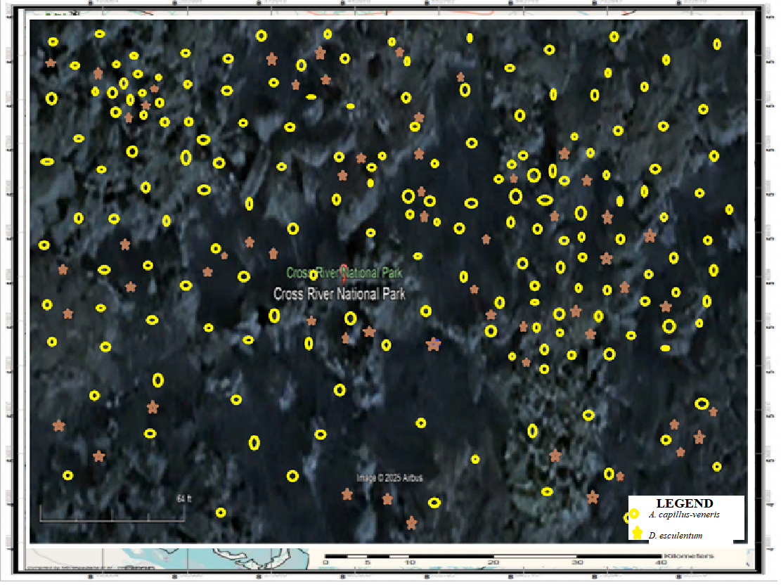

Figure 2: Species distribution
Table 1: Special diversity index
Variable | Adiantum capillus-veneris L. | Diplazium esculentum (Retz.) Sw.
Individuals | 176 | 58
Shannon | 2.149 | 2.182
Evenness | 0.959 | 0.886

4.0 CONCLUSION
The research successfully recorded the spatial distribution and diversity of Adiantum capillus-veneris and Diplazium esculentum within the study location, underscoring the dominance of A. capillus-veneris in terms of population. The application of GIS-based mapping was effective in illustrating the locations of species and aids in conservation and resource management decisions. The diversity patterns and distribution observed are consistent with earlier studies on the ecological behavior of ferns, highlighting the significance of such surveys for the management and protection of plant biodiversity in park ecosystems.

ACKNOWLEDGEMNT
We sincerely, acknowledge TETFUND, University of Cross River State (UNICROSS) and Nigerian Conservation Foundation (NCF) for sponsoring this research. We are indeed, grateful.

DISCLAIMER (ARTIFICIAL INTELLIGENCE)
Author (s) hereby declare that NO generative AI technologies such as Large Language Models (ChatGPT, COPILOT, etc.) and text-to-image generators have been used during the writing or editing of this manuscript.

COMPETING INTERESTS
Authors have declared that no competing interests exist.

REFERENCES
Akomolafe, G. F. & Sulaimon, A. (2018).Taxonomic survey of occurrence, diversity and ethnobotany of Pteridophytes in some parts of Nasarawa State, Nigeria. Fern Gazette, 20 (7): 269 - 279.

Allen, J. A., Brown, C. S. &Stohlgren, T. J. (2009). Non-native plant invasions of the United States National Parks. Biological invasions, 11(10), 2195-2207.

Asikiye, I., Blessing, O. G. & Mercy, G. A. (2023). Checklist of pteridophytes in Rivers State University, Rivers State, Nigeria. International Journal of Advanced Academic Research, 9 (6): 455-466

Azila, J.J., Papi, D.Y., Umaru, A.A., Mbah, J.J., Bassey, E.A. & Shoyemi, O.A.O. (2021). Diversity and Distribution of Ferns Species in Shere Hills of Jos North L.G.A Plateau State, Nigeria. The International Journal of Engineering and Science (IJES), 10 (7 Ser II): 10-15
Baldeck, C. A., Asner, G. P., Martin, R. E., Anderson, C. B., Knapp, D. E. and Kellner J. R. (2015). Operational Tree Species Mapping in a Diverse Tropical Forest with Airborne Imaging Spectroscopy. PLoS One 10 (7): e0118403

Bassey, M. E., Anwana, E. D., Mbong, E. O. & Umoh, O. T. (2023). Diversity and distribution of vascular cryptogams in relation to elevation gradient in Osomba range of the Cross River National Park, Cross River State, Nigeria. World Journal of Applied Science and Technology, 15 (1): 26 – 32
Bassey, M. E., Anwana, E. D., Umoh, O. T. & Mbong, E. O. (2024). Pteridophytes and lycophytes from Osomba Hills, Cross River National Park, Nigeria. Ceylon Journal of Science, 53 (2): 219-229
Chioma, N. L., Ishoro, A.P., Aja, E.E., Thomas, O. & Egbe, A. E (2021).Diversity of Epiphytic ferns in the cross river national park, Akamkpa, Nigeria as indicators of forest disturbance. Scientific Reports in Life Sciences, 3(1): 32-51.

Edwin-Wosu, N. L., Omara-Achong, T. E., Edward, P. O. & Okeke, N. P. (2024). Geospatial Trend of Phytodistribution Pattern of Cryptogamic Ferns in a Rainforest Vegetation. Trends Applied Science Research, 19 (1): 1-19
Edwin-Wosu, N. L. (2019). Cryptogamic Gallery: A Reference Field Guide, The Ferns and Fern Allies of Nigeria: A.T., Owolabi and A.B. Nwauzoma, 187 Pp. ACOTEC Technologies, Port Harcourt. Pp 14-17
Edwin-Wosu, N.L., Anekwe, C. C. & Okeke, N.P. (2022). Geospatial Ecological Distribution of Cryptogamic Flora in Swamp Forest Riparian Vegetation in parts of Rivers State, Nigeria. Ethiopian Journal of Environmental Studies & Management, 15(1): 111 – 124
Egbe, A. E. &Edoki, E. I. (2019). Spatial and Temporal Distribution of Diospyros Mespiliformis and Pycnanthus angolensis in Cross River National Park (Oban Division), Nigeria. International Journal of Engineering Applied Sciences and Technology, 4 (6): 234-239.

Festus, A. G., Zakaria, R., Rusly, R. & Bernard, O. (2024). Ferns richness along environmental gradients in a tropical forest ecosystem. Scientific Reports in Life Sciences, 5(2): 92-106.
Gaia, V. L., Jonathan, C. C., Qi, C., Jeremy, A. L., David, A. C., Leila, G., Fabio, D. F., Franco, M. & Riccardo, V. (2014). Biodiversity mapping in a tropical West African forest with airborne hyperspectral data. PloS One, 9(6), 91-97

Gbenga, F. A., Rusly, R., Zakaria, R. & Fatai, A. O. (2022). Patterns of ferns community assemblages in some Malaysian and Nigerian tropical forests. Ecology and Evolution, 12: e8961. https://doi. org/10.1002/ece3.8961

Hemp, A. (2002). Ecology of the pteridophytes on the southern slopes of Mt. Kilimanjaro I. Altitudinal distribution. Plant Ecology, 159: 211-239
Lynch, H. J. & Fagan, W. F. (2009). Survivorship curves and their impact on the estimation of maximum population growth rates. Ecology, 90, 1116-1124

Marjorie, D. A, Sirilak, R., Boniface, K. N., Sedricke, L & Harald, S. (2025). Spatial diversity and distribution of fern and lycophyte species in karst and non-karst landscapes towards conservation needs. Frontiers in Plant Science, 16: 1-12
Maxwell, B. D. (2002). "Inventory" Invasive Plant Management: Center for Invasive Plant Mnagement. Bozeman, MT. Montana state university. 239pp

Muhammad, M., Abdulhameed, A. & Abdullahi, M. B. (2014). Mapping of exotic plant species in Yankari Game Reserve using GIS tools. International Journal of Applied Biological Research, 6(1), 141-14

Nigerian Meteorological Agency {NIMET} (2018). Agrometeorological. Bulletin, 36 (3): 21-31

Nwosu, M. O. (2002). Ethnobotanical Studies on Some Pteridophytes of Southern Nigeria. Economic Botany, 56(3): 255-259

Plant of the World Online [POWO] (2023). Plants of the world Online powo.science. kew.org DOA 23/12/24. Retrieved from http://www. plantsoftheworldonline.org/.

PPG I. (2022). A community-derived classification for ferns and lycophytes. Taxon, 71(3), 512-538.

Pteridophyte Phylogeny Group I (PPG I). (2016). A community-derived classification for extant lycophytes and ferns. Journal of Systematics and Evolution, 54 (6): 563–603

Shoyemi-Obawanle, J. J., Azila, D. Y., Papi, A.A., Umaru, Mbah, J.J., Bassey, E.A. &Shoyemi-Obawanle, A.O. (2022). "Diversity and Distribution of Ferns Species in Shere Hills of Jos North L.G.A Plateau State, Nigeria." The International Journal of Engineering and Science (IJES), 10(07): 10-15.

