Explainable AI for Livestock Disease Detection: An Integrated ML/DL Framework
Abstract: Livestock diseases lead to significant economic loss and threaten food security. With the increasing demand for dairy and meat products, maintaining animal health has become a critical global priority. Although farmers and agricultural workers often lack deep technical understanding of data processing, modern AI and ML technologies are now central to early disease detection in livestock. Interpretable Machine Learning (IML) and Explainable AI (XAI) provide opportunities to build trust by making model predictions transparent and understandable. This article explores XAI and IML approaches for health monitoring in farm animals, offering insights into early symptom recognition through sensor data and image analysis. XAI integrates CNN-based visual diagnostics and real-time sensor stream interpretation, while IML utilizes SHAP (SHapley Additive exPlanations) and LIME (Local Interpretable Model-agnostic Explanations) for symptom pattern explanation and decision support. Experimental results using publicly available datasets of livestock behavior and visual symptom records demonstrate that XAI/IML-based systems provide farmers and veterinarians with clear, actionable insights to enhance livestock welfare and productivity.

Keywords: Explainable AI, IML, livestock, disease detection, SHAP, LIME, CNN, animal health, farmers, prediction, sensor data

INTRODUCTION
In the ever-evolving landscape of agriculture, the integration of technology has been instrumental in addressing the challenges of feeding a growing global population while ensuring sustainability and animal welfare. One such groundbreaking advancement is the application of Artificial Intelligence (AI) in livestock health monitoring. This research paper delves into the transformative potential of AI in revolutionizing the way we monitor and manage the health of livestock, ultimately enhancing agricultural productivity and sustainability.

Livestock health is paramount for the agricultural sector, not only for ensuring the well-being of animals but also for optimizing production efficiency. Traditionally, monitoring the health of livestock has been a labor-intensive and time consuming process, often relying on manual observations by veterinarians or farmers. However, with the advent of AI technologies, particularly machine learning algorithms and data analytics, a paradigm shift is underway [1].

AI-powered livestock health monitoring systems leverage various data sources such as sensors, wearables, and imaging technologies to continuously gather and analyze vast amounts of data in real-time. These data sources provide valuable insights into the physiological parameters, behavior patterns, and even emotional states of animals. By harnessing the power of AI, this data can be processed, interpreted, and acted upon swiftly, enabling early detection of health issues, proactive disease management, and precise interventions.

The implications of AI-enhanced livestock health monitoring are far-reaching. Improved detection of health anomalies allows for timely intervention, reducing the risk of disease outbreaks and minimizing economic losses for farmers. Moreover, by optimizing feeding regimes, identifying stressors, and enhancing environmental conditions based on AI-driven insights, the overall welfare and comfort of livestock can be significantly enhanced.

Furthermore, the integration of AI in livestock health monitoring aligns with broader efforts towards sustainable agriculture. By minimizing the use of antibiotics and other pharmaceuticals through targeted interventions, AI technologies contribute to mitigating the environmental impact of livestock farming while safeguarding animal welfare. Additionally, the optimization of resource allocation and management facilitated by AI-driven systems promotes efficient use of feed, water, and energy, thereby reducing the ecological footprint of livestock production [2].

However, the adoption of AI-enhanced livestock health monitoring is not without its challenges. Issues such as data privacy, algorithm bias, and the need for infrastructure investment pose significant hurdles. Moreover, ensuring accessibility and affordability for small-scale farmers and addressing concerns regarding job displacement in traditional veterinary roles require careful consideration.

Nevertheless, the potential benefits outweigh the challenges, making AI-driven livestock disease detection a promising frontier in agricultural innovation. As research in this field continues to advance, collaborations between technologists, agricultural experts, and policymakers are essential to harnessing the full potential of AI for sustainable and resilient livestock production systems.

In this paper, we will explore the current state of AI applications in livestock health monitoring, examine case studies highlighting successful implementations, discuss the challenges and opportunities ahead, and propose recommendations for realizing the transformative impact of AI in fostering healthier, more sustainable livestock farming practices.

BACKGROUND
AI-enhanced livestock health monitoring systems have the potential to revolutionize animal farming practices by providing real-time insights into livestock well-being. However, there are several existing problems that need to be addressed to fully realize their benefits. Livestock health monitoring poses a complex challenge, encompassing issues from early disease detection to merging modern technology with traditional farming methods. A key obstacle is promptly identifying health problems, as subtle symptoms may be overlooked until they worsen [3].
Furthermore, monitoring large herds or flocks presents logistical challenges due to the scale of livestock operations. The data influx from modern monitoring systems adds another layer of complexity, necessitating a strong data management system for accuracy and reliability [4]. However, the cost of implementing such systems can be a barrier for many farmers, especially those with smaller operations. Additionally, integrating new technologies with current practices requires not only financial investment but also education and training. Ethical concerns about data privacy and animal welfare further complicate the development and implementation of monitoring solutions. Ultimately, addressing these challenges requires collaboration among veterinarians, technologists, policymakers, and farmers to create comprehensive solutions that support animal health and sustainable agriculture.

- METHODOLOGY

Farmers are the people who will register and upload data on their cattle/livestock and can check the disease their animals are having [5].
Convolutional Neural Networks (CNNs) are a type of artificial neural network inspired by the visual cortex of the human brain. They have been highly successful in various tasks related to image recognition, classification, segmentation, and more.

CNNs are trained using large datasets of labeled images through a process called backpropagation. During training, the network learns to adjust its parameters (weights and biases) to minimize the difference between predicted and actual labels using optimization algorithms such as gradient descent.

Random Forest is a supervised learning algorithm used for both classification and regression tasks. It belongs to the ensemble learning family, which combines multiple individual models to improve overall performance.

Decision Trees: The base learner used in Random Forest is typically a decision tree. Decision trees recursively split the input space based on features to create a tree-like structure for making predictions. Randomization: Random Forest introduces randomness in two main ways. Random selection of data points: Each tree is trained on a random subset of the training data, sampled with replacement (bootstrap sampling). Random selection of features: At each split in a decision tree, only a random subset of features is considered, reducing the correlation between trees.

To train a Random Forest model, multiple decision trees are constructed based on bootstrap samples and feature subsets. Each decision tree is grown until some stopping criteria are met (e.g., maximum depth reached, minimum number of samples in leaf nodes). The randomness introduced during training helps to decorrelate the individual trees and reduce overfitting.

During prediction, each tree in the forest independently makes a prediction based on the input features. For regression tasks, the final prediction is typically the average of the predictions from all trees. For classification tasks, the final prediction can be determined by majority voting among the trees.
- The user has to register and log in to website to upload data about his cattle.
- For prediction the user has to enter animal name, age, temperature, weight, symptoms to find about the disease.
- For visual prediction the user has to take a picture of the animal and upload so that the disease can be predicted.
- User data is stored in mysql server and can be used for later purposes.
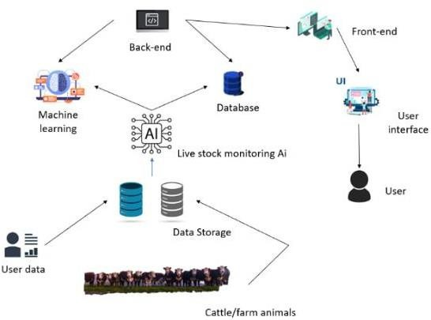

Figure 1. the architecture of the Know your Kattle website for livestock health management

The implementation of the Know your Kattle for livestock health monitoring involves several steps, including designing the user interface, developing the backend functionality. The following sections discuss the implementation details for each component of the architecture and the difficulties that may arise during the implementation process [7].

Know your Kattle is an HTML and CSS based cattle management tool. Its frontend has login and dashboard pages for users to access accounts and upload data. Development on the backend is done using Python, Anaconda, and Mysql. With CNN training pictures, machine learning algorithms forecast diseases depending on age, temperature, weight, and symptoms [8].

IMPLMENTATION

The AI-driven livestock health monitoring system gathers and processes a varied dataset of cattle from different areas, visualizes it using plots or charts, offers optional preprocessing tasks, securely stores notebooks, and uses version control to guarantee analysis reproducibility.

Two algorithms in the system train different datasets. Important for livestock health monitoring systems, the image dataset classifies images and detects objects using Convolutional Neural Network (CNN). Probably including structured data, the information dataset handles structured data with Random Forest Classifier (RFC). Versatile and strong, RFCs can build many decision trees and combine forecasts for precise classifications or predictions [5].

Effectively analyze the diverse features present in the information dataset, allowing for precise predictions regarding livestock health conditions or disease occurrences. Through the synergistic combination of these algorithms tailored to their respective datasets, the project aims to develop a comprehensive livestock health monitoring system capable of accurately predicting diseases and anomalies in real-time, thereby facilitating timely intervention and improved animal welfare [6].

The outcomes of putting the suggested system into practice are shown in this section. A number of factors, including efficiency, implementation, and registration, were considered when designing the framework. The system completed each step successfully .
Providing farmers with real-time health updates and disease forecasts, AI models have been created for livestock health monitoring and disease prediction. Using a trained Convolutional Neural Network (CNN) algorithm, farmers can find patterns, anomalies, and possible diseases by means of tailored accounts, input images or information about their livestock. Farmers can also enter manual data like temperature readings, heart rates, or behavioral observations; a trained Random Forest Classifier (RFC) algorithm processes this information.

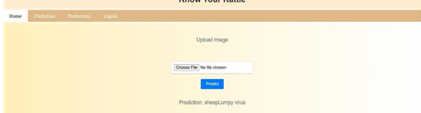
Figure 1: user uploads Image for Prediction

Farmers use the AI model to forecast probable illnesses or health problems in their livestock. It analyzes visual data by identifying patterns and anomalies using a Convolutional Neural Network (CNN) model. This information is interpreted by the Random Forest Classifier (RFC) model, which forecasts the most likely illness or condition. The model makes well-informed predictions and offers precise insights into the health status of livestock by using structured data to find patterns and correlations linked to a variety of diseases. This cutting-edge machine learning algorithm helps to enhance farm management techniques and animal welfare.
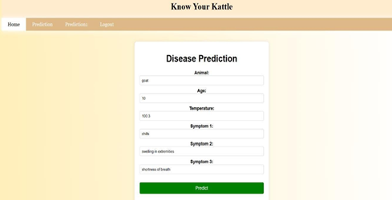

Figure 2: Disease prediction where user enter symptoms
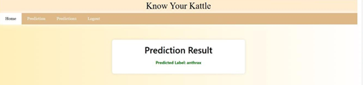

Figure 3: Symptom Result Page

CONCLUSION

The article covers AI-based health forecasting, which uses real-world data, enhanced user interfaces, and anonymized patient data for precise predictions. Included are wearables, family history, genetics, mental health, hydration levels, food consumption, and other characteristics. Forecasts are enhanced by means of Auto ML and Transfer Learning. User interfaces comprise health chatbots, dynamic health panels, voice interaction, instinctual apps, and personalized recommendations. The system follows international privacy laws, Federated learning, explainable artificial intelligence, and healthcare integration. It links to electronic health records to improve clinical decisions.

REFERENCES
[1]. Nikhil Khande, Sanmay Avhad, Maahi Khemchandani (2023). Cattle health monitoring systems are designed to monitor the health of individual cattle and quickly diagnose and treat sick cattle.
[2]. Xue Han, Zihuai Lin, Cameron Clark, Branka Vucetic (2022). AI Based Digital Twin Model for Cattle Caring.
[3]. Lijuan Liu, Yanping Wang, Wanle Chi (2020). Image Recognition Technology Based on Machine Learning.
[4]. Youngjoon Cho, Jongwon Kim (2023). AI- Based Intelligent Monitoring System for Estrus Prediction in the Livestock Industry
[5]. Karthik Darvesh, N. Khande, S. Avhad, M.Khemchandani(2023). IOT and AI based smart cattle health monitoring.
[6]. K.M.L. Pathak (2023). Indian Journal of Animal Research
[7]. Jehangir Arshad, Talha Ahmad Siddiqui, M. Ismail Sheikh, M. Sadeed Waseem, M. Abu Bakar Nawaz, Elsayed Tag Eldin, Ateeq Ur Rehman (July,2023). Deployment of an intelligent and secure cattle health monitoring system.
[8].https://en.wikipedia.org/wiki/Artificial_intelligence

[9]. https://www.geeksforgeeks.org/introduction-convolution- neural-network.

- https://ieeexplore.ieee.org/document/9430113
- https://en.wikipedia.org/wiki/Machine_learning
- https://www.cdc.gov/prions/bse/index.html
- https://www.daera-ni.gov.uk/topics/animal-health-and-welfare/animal-diseases/diseases-affect-sheep
- https://farmer.gov.in/disease.aspx
- https://agritech.tnau.ac.in/animal_husbandry/ani_goat_d%20mgt%20&%20v%20schedule.html
- https://www.nj.gov/agriculture/divisions/ah/diseases/diseaseworksheets.html
- https://en.wikipedia.org/wiki/Artificial_intelligence
- https://www.sciencedirect.com/science/article/abs/pii/B9780323851176000078

