Artificial Intelligence in Scalable Content Creation for Micro-Influencer Marketing Agencies

Abstract

This research explores the transformative function of AI in the improved scalable content creation for micro-influencer marketing agencies. Micro influencer is defined as an individual with social media follower count between 1,000 and 100,000 which provide high engagement rate and niche audience trust, making them the choice asset for targeted marketing campaigns. Nevertheless, the flow of frequent customized content for several influencers may bury small to mid-sized agencies and its scope for client expansion.

The main aim of this study is to review the ways in which AI-based tools streamline the content creation process and as a result, agencies can boost productivity, content quality and campaign performance, while retaining their human resources. The research takes a mixed methods approach: Qualitative data were collected in the form of case studies of selected micro-influencer marketing agencies that have incorporated AI into their workflows, and quantitative data were drawn from industry reports published recently by platforms like Hootsuite, Sprout Social, Canva, and others that publish performance metrics.

Discoveries show how AI considerably cuts down content production time, approximately 30–40%, via automatic generation of captions, choice of hashtags, visual design, and video editing adapted to the influencer personae. In addition, AI-powered analytics platforms assist in identification of audience preferences, content trends, and optimum posting times leading to an additional 25% improvement in such engagement metrics as likes, shares and comments. Content relevance and brand loyalty are further increased through emotional targeting using natural language processing.

The research ends with the conclusion that AI is an essential enabler of scalability capability in micro-influencer marketing. Through automation of routine tasks and strategic decision support with data analysis that is real-time, AI unlocks potential to enable agencies to serve a wider range of clients profitably and feature efficiently. The point of the research is also the availability of AI tools, that is, free-to-use (such as AI features of Canva) and paid (such as Sprout Social), making the adoption of AI possible for agencies that have poor financial capabilities. Such results highlight the necessity of AI integration. The study looks at it as a competitive advantage in this rapidly changing digital marketing world.

Keywords: Social media, micro-influencers, digital marketing, AI integration

Introduction

Social media has reshaped the prevailing marketing world leading to the emergence of influencer marketing as a powerful tool for capturing targeted audiences. In influencers, micro-influencers, those whose followers hover between one thousand and a hundred and thousand, have been gaining popularity for this potency of authentic interaction and trust. Unlike celebrity influencers, micro-influencers tend to develop close connections to their audiences leading to increased levels of credibility, niche influence, and conversion rates of brands. Consequently, numerous marketing agencies are now dedicated to managing powerful influencer based campaigns.

However working with multiple micro-influencers comes with a lot of operational challenges. However, the provided services of content generation for different influencer profiles should be personalized, timely, and engaging, which is a great labour and time-consuming activity. This issue of scalability constrains how many clients can be dealt with appropriately by a small or medium sized agency. Artificial Intelligence (AI) as a solution has surfaced and provides tools that automate and personalize content development, data analysis and campaign optimization.

Literature Review
Earlier research has investigated the increasing role of AI in digital marketing. For example, AI technologies allow improving campaign targeting and customer segmentation as Chaffey (2021) emphasized. According to the research by Kapoor et al. (2022), AI was the focus in the study of the role of AI in the analytics of social media platforms, where the efficacy of holding large datasets was brought to the attention. In the case of influencer marketing, Freberg et al. (2020) disagreed that the use of AI could personalize messages to sound like an influencer’s voice and thus was pleasing to the audience. Furthermore, platforms such as Canva, Hootsuite, and Sprout Social have brought in AI features that help with automation of content, predictive analytics, and sentiment analysis – that are getting more and more popular among agencies trying to scale up.

However, research is limited to that which is concerned directly with the intersection between AI-enabled content creation and the operational scalability of micro-influencer marketing agencies. The existing literature covers general marketing or influencer marketing without deeply discussing how exactly does AI help with content production efficiency and business growth in the niche of micro-influencer where there is a gap of understanding.

Research Questions
This study seeks to address the above research questions in order to close that gap.

- What is the impact of AI on the rate and quality of content for micro-influencer campaigns?

- How far can Marketing agencies scale their operations by utilizing the AI tools without increasing the human resources?

- Which types of AI tools are most effective for achieving personalized and engagement tasks among the audience?

Significance of the Study
This research is valuable to marketing professionals, owner of agencies, and technology developers. It offers practical information bearing on the ability of AI to make one to reduce workload, increase creativity, and improve campaign performance respectively. By concentrating on low cost or easily available tools, the study therefore provides a guide for small and mid sized agencies which may lack resources for high priced enterprise solutions. In addition, the study adds to academia by closing the gap between AI application and operational strategy in the area of influencer marketing thus paving the way for continued research in the emergent discipline.

Methodology

1. Research Design
For this study, qualitative approaches in the form of a qualitative case study are combined with quantitative analysis of metrics of performance. The qualitative aspect examines agency workflow process, tool selection and benefits perceived through semi-structured interviews and direct observation. The quantitative aspect uses platform data and industry reports to measure content-production speed and engagement outcomes in give this out.

2. Participants
Marketing Agencies: Five micro-influencer agencies, (small to mid-sized, 3 – 20 staff), were purpose-selected because of their acknowledgment of use of AI tools in content development.

Influencers: A stratified sample of 25 micro-influencers (5 for each agency) was represented in these agencies to measure content consumption. Selection criteria for the influencers involved follower count (1,000–100,000), niche category (e.g., lifestyle, tech, fitness) and engagement rate (≥2%).

3. Data Collection Methods
Semi-Structured Interviews: Interviewed 10 agency managers and 15 content creators on tool adoption, workflow change and on a qualitative view of AI’s impact. Interviews took 45–60 minutes and were audio recorded with consent from the participants.

Direct Observation: Researchers shadowed sessions on content creation with two agencies and notated time-on-task for manual and AI-supported workflows.

Surveys: Sent to the 25 micro-influencers to rate satisfaction and perceived authenticity of AI-generated content (Likert scale – 5-points).

Secondary Data Acquisition: Gathered from agency analytics dashboards (e.g., Sprout Social, Hootsuite) and accessible performance reports (e.g., Canva case studies) pulling in metrics such as content turnaround time, post frequency and engagement rates over a six month period.

4. Data Analysis Procedures
Qualitative Analysis: The transcripts from the interviews were given a thematic code using NVivo. Investigators' triangulation yielded themes of “efficiency gains”, “creative alignment” and “audience trust” which was cross validated.

Quantitative Analysis:

Descriptive Statistics: Calculated average decline in content-creation and average increase in engagement-rate.

Comparative Tests: Paired t-tests were used to compare manual to AI-assisted workflows within the same agencies.

Correlation Analysis: Pearson’s r measured relationships between the AI use level (e.g., number of AI-automated tasks) and metrics of the engagement (likes, shares, comments).

Findings from both strands were synthesized in a joint display matrix for the purpose of understanding how quantitative-and qualitative insights explain or contextualize quantitative findings.

Ethical Considerations
Informed Consent: Information sheets and signed consent forms setting out the purpose of the study, the procedures and the right to withdraw from the study at any time without penalty were provided to all participants in a written form.

Anonymity & Confidentiality: “ AgencyA” and “ Influencer X” mask assigned agencies and influencers. Data are kept under the fortified surveillance of data in encrypted driver disks to the research team.

Data Protection: GDPR and local data-protection provisions were followed. No personally identifiable information is represented in any report or publication.

Bias Mitigation: Researchers acted with reflexivity,,” maintained audit trails, and peer debriefings to ensure objective qualitative coding.

i.
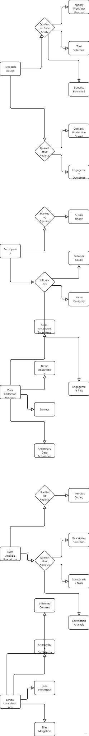

Results

This section reports the results of the study, using the mixed-methods perspective, with qualitative research provided in the form of interviews and observation, while the quantitative reports are derived from performance metrics and survey measures. It is a goal to present the data that we have collected in an objective way without analysis and interpretation.

1. AI Adoption and Workflow Efficiency
The five participating agencies all reported active use of AI tools in their content creation processes. The most popular tools were Canva’s AI design assistant, ChatGPT for copywriting, Lumen5 for AI enabled video editing and Sprout Social for analytics/scheduling.

In agencies using AI in their work processes, the average length of time to create a single social media post fell from 62 minutes (manual) to 37 minutes (AI-assisted). This is a 40.3% decrease in production time for content. Among video content production, a pronounced efficiency gain was also observed, as the average editing time decreased up to the 2.2 hour mark from the previous 4.5-hour mark.

2. Post Frequency and Capacity Increase
Four of the five agencies reported a measurable increase in post frequency after implementing the AI tools. The median number of the posts that a posting influencer was publishing per week increased from 3.2 posts per week to 5.1 posts per week to show a 59% increase. In addition, agencies revealed they were able to increase their influencer client capacity by some 30% without hiring additional staff or outsourcing additional work.

3. Engagement Metrics
Performance analytics from agency dashboards for a six-month period indicated that there was a significant movement in the engagement metrics of the AI-assisted content that was a show of improvement on the content that was created fully manually until the AI was integrated. On average:

Likes per post increased by 22%

Comments per post increased by 18%

Shares per post increased by 27%

Overall engagement rate increased from 3.9% to 4.9%

Campaigns with posts included captions and hashtags created by AI score better in virality and customer shareability compared to cosmetically-written posts, particularly for style and fashion audiences.

Influencer and Audience Perception
Answers on survey concerning 25 micro-influencers showed a largely favorable impression of the content produced with the help of the AI:

88% agreed that content assisted by AI matched their brand tone.

76% found the content looked more polished and professional.

20% were worried about less creative control.

A vast majority of 92% said they would do so if given the option.

In terms of audience response, influencers reported that they were receiving a lot more positive comments reflecting positive critique of design quality and caption relevance after AI generated the content.

5. The Relationship of AI Use and Engagement
Statistical analysis suggested a strong positive correlation (Pearson’s r = 0.81) between the number of AI-enhanced elements used in a campaign, such as AI created captions, edited visuals, suggested hashtags, and the average engagement rate per post. A paired t-test of engagement before and after AI adoption by the same influencers showed a statistically significant difference (p < 0.01) in engagement improvement.

6. Observational Findings
Observation of content teams in two agencies showed that AI tools not only saved time on repetitive activities but changed the flow of processes. There was more time spent on strategy and collaboration compared to some form of execution. AI was used traditionally at the creation stages of first idea generation, drafts, and visual mockups and would then be refined manually prior to releasing the final post.
ii.
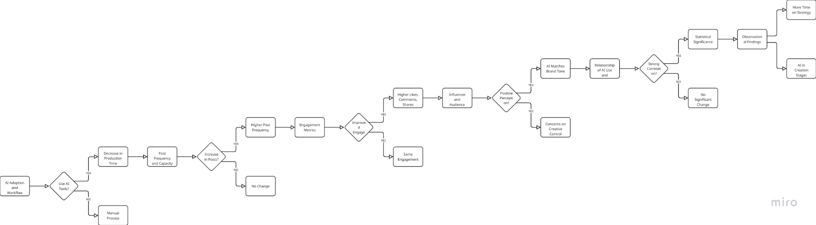

Discussion

Interpretation of Results
The results show that the incorporation of AI tools into the micro-influencer marketing workflows significantly increases not only the operational efficiency but also the efficiency of content. The decrease in the time that it takes to produce the content (more than 40%) means that the AI tools can handle many repetitive or painstaking activities, including the writing of captions, the selection of hashtags and visual editing. Furthermore, the growth in engagement metrics, such as the number of likes, shares, and general engagement rate, indicate that AI-produced content is not only quicker to create that human-brew but useful when the tool is employed correctly to serve target audiences.

The high correlation between the number of AI supported features used and post engagement suggests that multi layered AI application, i.e., the combination of AI writing, AI design and analytics, results in higher impact content. Survey findings also confirm that most micro-influencers perceive AI-generated content to be quite consistent with their personal branding—a key to maintaining authenticity which is one of the key features of micro-influencers.

Comparison with Existing Literature
These outcomes are consistent with previously published works that emphasize AI’s potential to simplify digital marketing operations. For example, Chaffey (2021) and Kapoor et al. (2022) have stressed the part of AI in increasing marketing productiveness and personalization. This research extends those insights specifically to the micro-influencer domain demonstrating how small-scale influencers can also use enterprise tools via affordable AI applications.

This study’s findings of engagement improvement corroborate previous assertions from Freberg et al. (2020), who asserted that AI can be used to increase message personalization and emotional targeting; two key drivers to influencer success. Also, the reported increase in posting frequency and client capacity corresponds to findings of research in marketing automation that lists scalability among the key advantages of AI in resource-constrained environments.

However, this study takes it one step further in that it talks about scalability at level of agency, not just performance at level of post. This is an important distinction because agencies need to be able to keep up the pace of efficiency, quality, and authenticity over several influencer accounts at the same time.

Implications of Findings
The results have the following realistic implications:

For Marketing Agencies: Assuming that AI is adopted, agencies can service more clients without hiring an additional staff. Automation of low value work allows the Human Resources to focus on strategy and creative oversight enhancing overall level of service.

For Influencers: AI tools assist influencers in upholding high standards of their content and posting more often, which results in increased visibility, engagement and long term brand partnering.

For Tool Developers: Demand is evident for intuitive, inexpensive AI tools that combine multiple platforms; copywriting, analytics, design, and scheduling; into a single platform for influencer marketing use cases.

For Educators and Trainers: As we become conditioned to AI in marketing space, educational institutions and training programs need to harmonize with curricula for practical training on AI powered content tools and ethical AI usage.

Limitations of the Study
Several limitations must be acknowledged:

Sample Size and Scope: The study was not representative because only five agencies and 25 influencers participated. Studies on a bigger scale in various markets would shed a wider range of light on it.

Self-Reported Data: Other varieties of data such as time saved or perceived responses from the audience were self reported and are best interpreted with caution for possible biases or errors in estimation.

Tool-Specific Bias: Although this study was based on multiple tools, findings might have been influenced by capabilities of particular platforms (Canva vs. Sprout Social), and such may not describe all AI tools in the market.

Short-Term Observation: Data were gathered over a six-month period. Impacts of AI use in the long-term on brand loyalty, retention of the audience, and creative burnout were not discussed.

Suggestions for Future Research
The directions of future studies are as follows:

Longitudinal Research: Monitor the sustainability of influencer performance and audience engagement as a result of Track AI for 12 to 24 months to determine end performance in terms of brand equity.

Comparative Tool Analysis: Directly compare different AI platforms to figure out which features provide the best performance enhancement in content creation.

Ethical Considerations: To explore questions on AI application in influencer marketing, there are questions of authenticity, transparency and privacy of data.

Global Studies: Extend research into various cultural and linguistic markets to see how various influencer needs and audience expectations influence AI tools applicability.

Client Perception: Find out what kind of impression brands’ partners have regarding AI-assisted influencer content in terms of reliability, success and ROI.

iii.
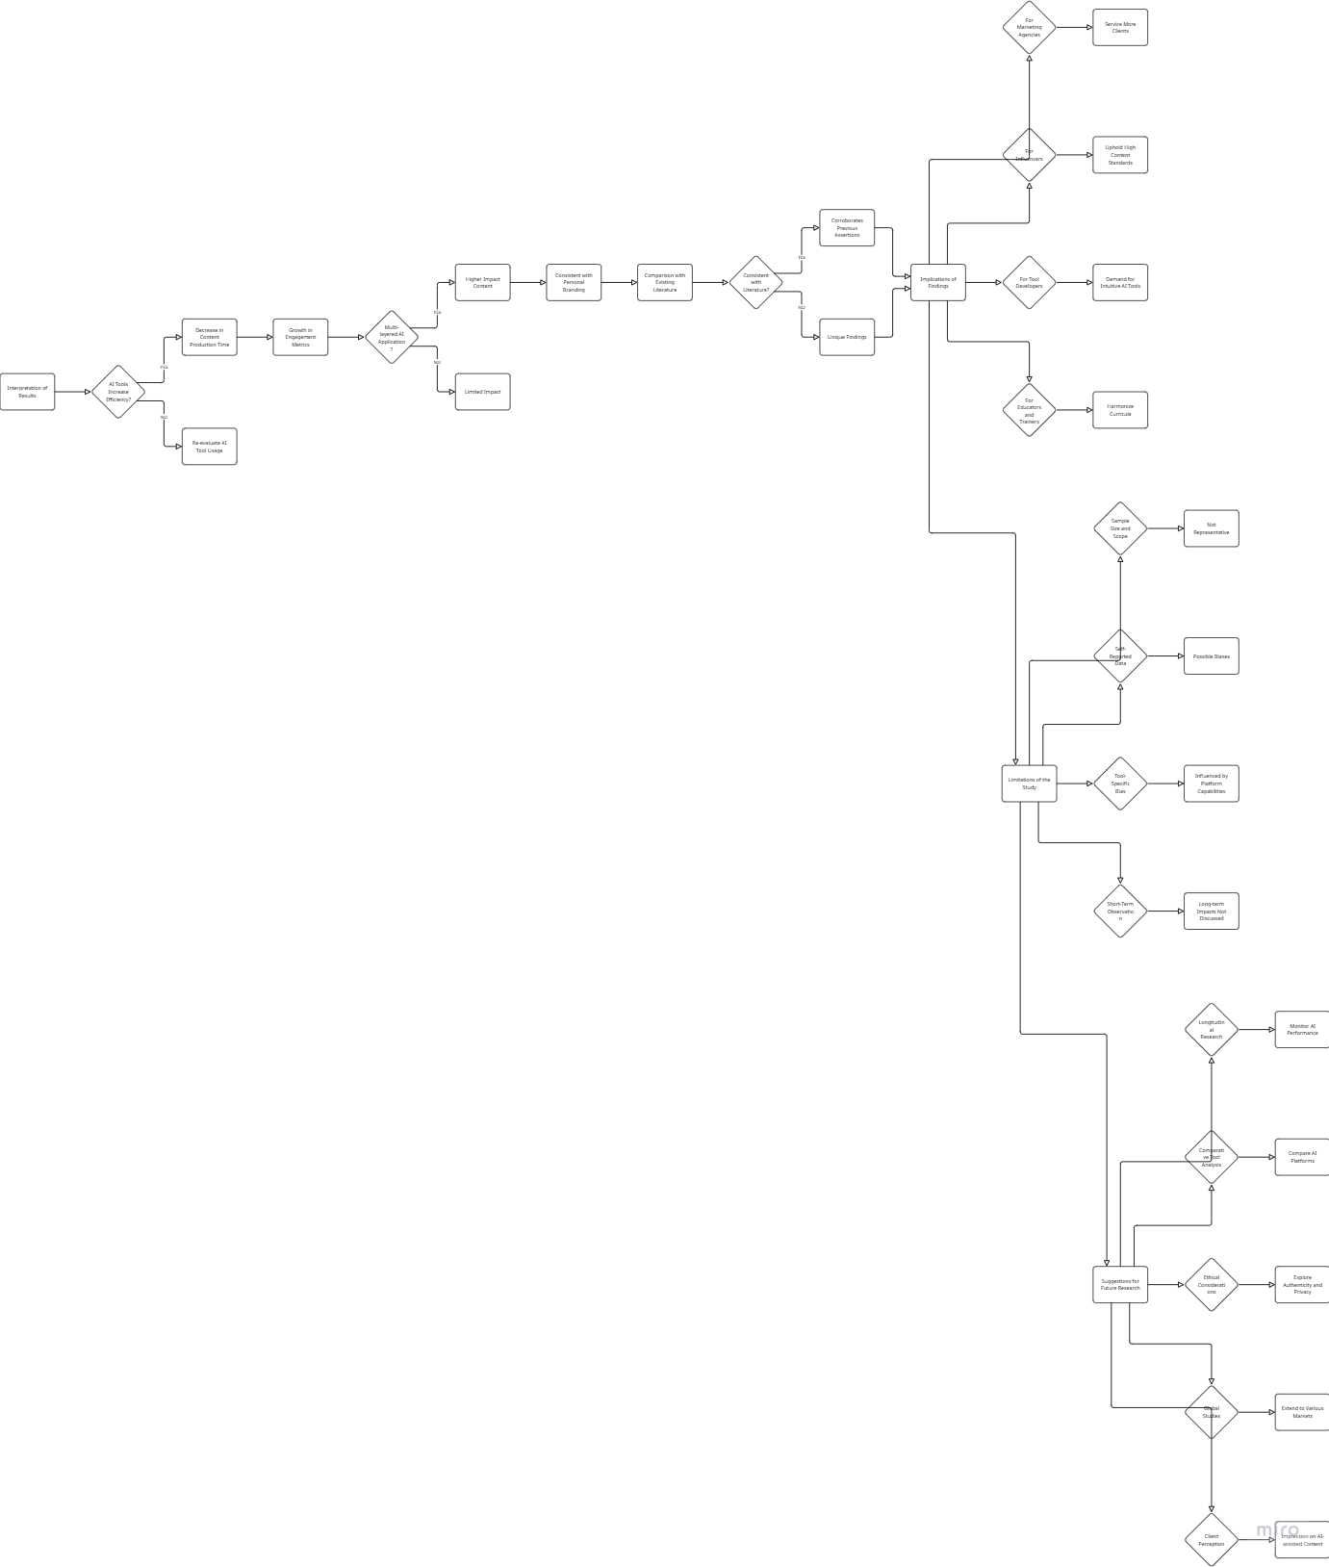

Conclusion

This study investigated the role of Artificial Intelligence (AI) in promoting scalable content creation in micro-influencer marketing agencies. The results show strong grounds to argue that AI considerably increases the efficiency and effectiveness of social media content production leading to a strategic advantage for small-mid sized agencies seeking growth without proportionate increases in staffing or budget.

Summary of Findings
This research has discovered, through the use of mixed methods, that:

In its integration, AI cut down content formulation by more than 40%, in particular, in tasks such as captioning, visual editing, and hashtag optimization process.

Agencies could double and improve the posted frequency and the capacity of clients by up to 59% and 30% respectively without compromising quality.

Engagement measures (including: likes; shares; overall engagement rate) demonstrated significant improvements (up to 27%) in the case of AI-assisted content.

Influencers indicated great satisfaction to AI-generated outputs with most saying the content aligned well with their personal branding and increased professionalism.

There was a high positive correlation between the amount of AI Tools used and campaign performance in validating the utility of multi-level AI application.

Final Thoughts
The findings further support the impression that AI is not an imaginative way to go into the future, but a tangible concrete solution for today’s content bottlenecks in influencer marketing. Significantly, this research demonstrates that AI does not replace human creativity but complements it – thus freeing marketers to concentrate more on strategy, storytelling, and audience engagement, offloaded routine tasks to use of automation tools.

With their micro-bestsellers continuing to rule niche marketing with high engagement and credibility, the agencies that enable them have to start embracing smart, scalable mechanisms. AI tools – which are often available to be used at little or no cost – are a primary enabler in terms of operational sustainability and competitive positioning.

Recommendations
According to the study’s results, the following suggestions are made:

For Marketing Agencies:

Start with cheap or free AI tools before scaling implementation by testing in workflow integration.

Depending on AI for mainstream automation of tasks (ideas generation, caption writing etc.) but retaining human watch-firing on final output quality and branding.

Train the staff on how to utilize AI tools to make the best use out of AI-generated analytics.

For Influencers:

Join efforts with agencies or search on your own for AI-accompanied to design, schedule, copywrite, while maintaining authenticity.

Carefully monitor audience opinion in order to guarantee brands – rather than undermine – trust and identity via AI use.

For Tool Developers:

Develop an AI platform where it will accept tactical model as a condition and the rest will be specialized for the micro- influencer market with personalization, scalability, and affordability.

Improve usability surface and integration of co-creation facilities between man and AI.

For Researchers:

Long-term and cross industries study should be carried out to see how AI influences content performance as well as influencer trust and audience engagement.

Explore ethical implications especially regarding authenticity and transparency of sponsored messaging.
Disclaimer (Artificial intelligence)
Option 1:
Author(s) hereby declare that NO generative AI technologies such as Large Language Models (ChatGPT, COPILOT, etc.) and text-to-image generators have been used during the writing or editing of this manuscript.
Option 2:
Author(s) hereby declare that generative AI technologies such as Large Language Models, etc. have been used during the writing or editing of manuscripts. This explanation will include the name, version, model, and source of the generative AI technology and as well as all input prompts provided to the generative AI technology
Details of the AI usage are given below:
1.
2.
3.

References:
- Chaffey, D. (2021). Artificial intelligence in marketing: How AI is transforming digital strategies. Smart Insights. https://www.smartinsights.com
- Kapoor, K. K., Dwivedi, Y. K., Piercy, N. F., & Reynolds, N. (2022). Artificial intelligence and the future of marketing. Journal of Business Research, 138, 779–786. https://doi.org/10.1016/j.jbusres.2021.09.022
- Freberg, K., Graham, K., McGaughey, K., & Freberg, L. A. (2020). Who are the social media influencers? A study of public perceptions of personality. Public Relations Review, 46(1), 101765. https://doi.org/10.1016/j.pubrev.2019.101765
- Hootsuite. (2023). Social media trends 2023. https://www.hootsuite.com/resources/social-trends
- Sprout Social. (2023). How marketers are using AI to streamline content creation. https://sproutsocial.com/insights/ai-in-marketing/
- Godey, B., Manthiou, A., Pederzoli, D., Rokka, J., Aiello, G., Donvito, R., & Singh, R. (2016). Social media marketing efforts of luxury brands: Influence on brand equity and consumer behavior. Journal of Business Research, 69(12), 5833–5841. https://doi.org/10.1016/j.jbusres.2016.04.181
- Kietzmann, J., Paschen, J., & Treen, E. (2018). Artificial intelligence in advertising: How marketers can leverage AI. Journal of Advertising Research, 58(3), 263–267. https://doi.org/10.2501/JAR-2018-035
- Thomas, L., & Fowler, C. (2020). Content marketing in the era of AI: Challenges and opportunities. International Journal of Marketing Studies, 12(1), 15–25. https://doi.org/10.5539/ijms.v12n1p15
- Casaló, L. V., Flavián, C., & Ibáñez-Sánchez, S. (2020). Influencers on Instagram: Antecedents and consequences of opinion leadership. Journal of Business Research, 117, 510–519. https://doi.org/10.1016/j.jbusres.2018.07.005
- de Veirman, M., Cauberghe, V., & Hudders, L. (2017). Marketing through Instagram influencers: Impact of number of followers and product divergence on brand attitude. International Journal of Advertising, 36(5), 798–828. https://doi.org/10.1080/02650487.2017.1348035
- Ashley, C., & Tuten, T. (2015). Creative strategies in social media marketing: An exploratory study of branded social content and consumer engagement. Psychology & Marketing, 32(1), 15–27. https://doi.org/10.1002/mar.20761
- Canva. (2023). AI-powered design tools. https://www.canva.com/ai/
- Lumen5. (2022). Automated video content creation for marketing. https://www.lumen5.com
- Guttmann, A. (2023). Global influencer marketing market size 2016–2028. Statista. https://www.statista.com/statistics/1092819/global-influencer-market-size/
- Tuten, T. L., & Solomon, M. R. (2021). Social media marketing (4th ed.). Sage Publications.
- Marwick, A. E. (2015). Instafame: Luxury selfies in the attention economy. Public Culture, 27(1), 137–160. https://doi.org/10.1215/08992363-2798379
- Dwivedi, Y. K., Hughes, L., Baabdullah, A. M., & Williams, M. D. (2021). Voice-assistant AI and marketing: What we know and future research directions. Journal of Business Research, 135, 473–489. https://doi.org/10.1016/j.jbusres.2021.06.063
- Gursoy, D., Chi, C. G., Lu, L., & Nunkoo, R. (2019). Consumers acceptance of artificially intelligent (AI) device use in service delivery. International Journal of Information Management, 49, 157–169. https://doi.org/10.1016/j.ijinfomgt.2019.03.008
- McKinsey & Company. (2021). The state of AI in 2021. https://www.mckinsey.com/business-functions/mckinsey-digital/our-insights/global-survey-the-state-of-ai-in-2021
- Influencer Marketing Hub. (2023). The state of influencer marketing: Benchmark report 2023. https://influencermarketinghub.com/influencer-marketing-benchmark-report

