Original Research Article
AI-POWERED CHATBOT FOR COLLEGE INFORMATION AND STUDENT SUPPORT

ABSTRACT
This study presents the development of an AI-powered chatbot tailored to assist college students with academic, campus-related, and personal development queries. Designed as a student-support software prototype, the system integrates natural language processing (NLP), text-to-speech (TTS), speech-to-text (STT), and machine learning models to deliver real-time information and interactive responses. Key features include course recommendations, timetable access, placement updates, NPTEL/hackathon alerts, library book availability, and image-based building identification. The chatbot also supports media uploads and provides mental health resources and career guidance through a conversational interface. Tested with over 50 student queries, it achieved a 92% response accuracy, identified college buildings from images with 85% accuracy, and reduced average information-seeking time by 65% compared to manual methods. Additionally, the inclusion of TTS and STT functionalities enhanced accessibility for differently abled users. This AI-driven solution fosters a smarter and more connected campus environment by streamlining support services and promoting student engagement. Future enhancements will focus on expanding the knowledge base, improving multilingual support, and refining interactive capabilities through broader user testing.

Keywords: AI-powered chatbot, student support system, campus information system, academic assistance, speech recognition, accessibility, personalized recommendations.

- INTRODUCTION

Over the last few years, Artificial Intelligence (AI) has revolutionised information access and processing, particularly in the education sector. Organisations are experiencing a greater need for fast, readily accessible, and reliable support systems since students increasingly rely on online sources for learning and assistance. Adopting AI and natural language processing (NLP)-enabled chatbots has been a favourite choice as they can handle large query volumes, offer personalised conversation, and reduce administrative and academic staff workload. Campus life is becoming more intelligent and interconnected with chatbots enabled by AI that incorporate multimedia functionality and real-time updates.
Students in the contemporary higher education environment find it challenging to gather timely and accurate information regarding coursework, navigating campus, placements, and extracurricular activities. Traditional methods, such as approaching staff or browsing notice boards, are not successful and often result in delays and confusion. While a few organisations have implemented digital solutions, these are usually scattered and lack real-time information updates and personalised assistance. For basic things such as class timetables, addresses, hostel food, or upcoming events, students have to sift through numerous sources in the absence of one platform.
In addition, the broader array of student needs, including career guidance, fee information, and mental wellness resources, is seldom addressed by the systems that exist. Access is another neglected element; usual websites may be difficult for children with speech or mobility impairments to access.
The necessity for an AI-based solution that not only integrates campus and academic services but also offers smart, voice-enabled interaction is thus clear. Through time saving, reducing physical drudgery, and promoting a more diverse and networked campus ecosystem, such a platform would significantly improve the learning experience for students.
Artificial intelligence (AI) is rapidly transforming educational support systems, enabling institutions to provide personalised, real-time assistance to students across academic and administrative domains. This study presents the development of an AI-powered chatbot specifically designed for college students. The chatbot integrates multiple intelligent features, including speech-to-text (STT), text-to-speech (TTS), and image recognition to enhance accessibility and campus navigation. It helps users identify college buildings through image uploads, retrieve class timetables, receive placement preparation materials, and get recommendations for relevant NPTEL courses based on individual academic interests.
Beyond academic support, the system facilitates access to real-time updates on campus events, hackathons, and library book availability. It also offers guidance on career planning, fee-related inquiries, and mental health tips, contributing to the holistic development of students. The chatbot features a dynamic, chat-based interface allowing quick responses and media uploads, improving the overall user experience. The frontend is built using Next.js, while the backend is developed with Django, incorporating advanced natural language processing (NLP) via Hugging Face and Gemini APIS for contextual and smart interaction.
Studies have shown the effectiveness of chatbots in improving student engagement and reducing information-seeking time ( (Bation, 2024); (Bhardwaj, 2021); (Alabbas & Alomar, 2024)). Similar models such as EduAssist, StudentEase, and Tayseer have demonstrated success in providing timely responses, boosting self-efficacy, and improving access to student services ( (Baviskar, 2024); (Ganesh Kumar, et al., 2025); (Alabbas & Alomar, 2024)).
Despite these advancements, most existing chatbots are either domain-specific or lack adaptability to diverse student needs in Indian college settings. The proposed chatbot addresses this gap by integrating multimodal interaction (image, text, speech), context awareness, and accessibility support for a holistic student experience.
Importance of the Manuscript
The manuscript titled “AI-Powered Chatbot for College Information and Student Support” contributes to the growing body of research on AI in education by presenting a scalable, context-aware chatbot designed specifically for Indian college environments. Its practical implementation using Next.js, Django, and Hugging Face models demonstrates real-world feasibility, offering both academic and non-academic support tailored to student life.
  - RELATED WORKS:
This survey of literature brings together 20 papers from the given dataset on AI-based chatbots in educational settings for student assistance, academic help, and administrative effectiveness. The survey is divided into seven thematic subheadings, with every paper examined in detail (minimum five lines) to encompass its aims, methods, findings, and limitations. Citations are given in APA style, followed by an exposition of broad limitations in the discipline.
    - Applications of Chatbots in Student Support
(Alabbas & Alomar, 2024)introduced Tayseer, an AI-powered Arabic chatbot framework to enhance helpdesk services for technical and vocational students. Using the RASA framework with a customized Arabic NLP pipeline, Tayseer handles queries with 90% precision in intent and entity predictions. Deployed at a technical college, it streamlined advisory processes for over 200 students. However, its Arabic-specific design limits applicability to other languages, and long-term user feedback is absent (Alabbas & Alomar, 2024).
(Bommireddy, S., Prashanth,, & Manoj Kumar, 2024)developed VardhaGenie, an AI chatbot for Vardhaman College of Engineering to address academic and administrative queries. Leveraging NLP and a Bag of Words algorithm, it achieved efficient query handling, reducing response times. The chatbot was tested with positive user feedback but is tailored to a single institution, limiting scalability. The study also lacks details on handling complex multi-step queries (Bommireddy, S., Prashanth,, & Manoj Kumar, 2024).
(Ganesh Kumar, et al., 2025)proposed StudentEase, an AI-powered college helpdesk chatbot using Sentence Transformer and Ollama models. It facilitates access to academic information, reducing administrative workload by expediting query resolution. Tested in a college setting, it improved student experience but relies on predefined content embeddings, limiting its ability to handle novel queries. Rigorous user satisfaction metrics are also missing (Ganesh Kumar, et al., 2025).
(Shinde, 2025)presented QueryMate, an AI chatbot to resolve college-related student queries. Using NLP, it provides real-time information on admissions and academics, achieving an 85% accuracy rate in a pilot study. Integrated into a college portal, it enhanced query resolution speed. However, the small training dataset limits its ability to handle diverse queries, and user adoption barriers are underexplored (Shinde, 2025).
(Baviskar, 2024)developed EduAssist, a chatbot for student admission queries using Retrieval-Augmented Generation (RAG) and NLP. It offers 24/7 multilingual support, increasing query resolution efficiency by 20% in a university trial. Its limitation lies in limited multilingual support for regional languages, and integration with existing admission systems is poorly documented (Baviskar, 2024).
(Bhardwaj, 2021)created a College Enquiry Chatbot, a Python-based web application to provide information on courses, fees, and admissions. Using the ChatterBot library and Django, it simplifies access to college details, reducing the need for in-person inquiries. Tested in a single institution, it showed ease of use but lacks advanced NLP, limiting its ability to handle complex queries. The study also does not evaluate user satisfaction or scalability (Bhardwaj, 2021).
    - Enhancing Engagement and Self-Efficacy
(Bation, 2024)investigated chatbot support’s impact on college student self-efficacy at Opol Community College. Using a descriptive-causal design with 304 participants, the chatbot provided academic support, boosting self-efficacy by 25%. Its interactive design fostered engagement, but the small sample size limits generalizability, and long-term academic impacts are unexplored (Bation, 2024).
(Chavan, Rathod, Bhamare, Vishwakarma, & Patil, 2024)introduced STES Dialogic AI, a Flutter-powered chatbot enhancing student engagement within the Sinhgad Technical Education Society. Using NLP, it provides academic and campus updates, increasing satisfaction by 15% in a pilot study. Its mobile-friendly design ensures accessibility, but basic NLP struggles with complex queries, and user retention evaluation is lacking (Chavan, Rathod, Bhamare, Vishwakarma, & Patil, 2024).
(Pratiwi, Syahbaniar,, & Robbani,, 2024)developed WIDYA, an AI-powered chatbot for library online services at Widya Cipta Husada Malang. Using AIML and NLP, it improved engagement by 30% by facilitating access to digital resources. Its focus on library services limits broader applicability, and multilingual query handling is undocumented (Pratiwi, Syahbaniar,, & Robbani,, 2024).
    - Bilingual and Contextual Support
(Torres-Cruz, et al., 2023)created AVA, a bilingual chatbot for academic advice in an honor’s college, supporting English and Spanish. Using AI and NLP, it achieved a 90% user satisfaction rate, enhancing accessibility for diverse students. Its focus on two languages excludes other dialects, and cultural adaptability in responses is underexplored (Torres-Cruz, et al., 2023).
(Shah, Gelal, Karki, & Shrestha, 2024)introduced Lucy, an NLP-powered chatbot to bridge college information access gaps. Using BERT and RoBERTa models, it supports multilingual and contextual queries, improving access for 500 students by 35%. Its training data is institution-specific, reducing generalizability, and privacy concerns are underexplored (Shah, Gelal, Karki, & Shrestha, 2024).
    - Advanced Technologies in Chatbots
(Thamilselvan, et al., 2024)designed a Llama 2-powered chatbot for college website support. It handles dynamic queries with 95% accuracy, excelling in contextual understanding. High computational costs limit deployment in resource-constrained settings, and bias in AI responses is unaddressed (Thamilselvan, et al., 2024).
(Patil & Dhiman, 2025)developed a college information portal chatbot using AI and NLP. It provides details on schedules and events with 90% accuracy, tested in a college setting. Dependency on proprietary AI models raises cost concerns, and long-term performance evaluation is missing (Patil & Dhiman, 2025).
(Chandrasekar, Gupta, Liu, & Tsai, 2024)explored large language models for organizational navigation in universities. The LLM-powered chatbot processes complex queries with an 88% satisfaction rate but lacks multilingual support and has high computational requirements. Ethical implications, like data privacy, are inadequately addressed (Chandrasekar, Gupta, Liu, & Tsai, 2024).
    - Specialized Applications
(He & Xin, 2021)developed an AI-powered chatbot for cybersecurity education camps using Google Dialogflow. It improved learner engagement by 40% for middle and high school students. Its narrow focus on cybersecurity limits broader use, and scalability for larger audiences is unanalyzed (He & Xin, 2021).
(Yang & Weng, 2023)proposed an AI-powered chatbot for personalised learning journeys in online platforms. Using NLP and user profiling, it increased satisfaction by 20% in an online course trial. Privacy concerns from user data reliance and a lack of scalability evaluation are limitations. The study also does not address diverse learning styles (Yang & Weng, 2023).
(Kothawade, 2025)introduced an AI-powered student assistant chatbot for engineering and polytechnic colleges. Using NLP and machine learning, it handles admission and academic queries, reducing staff workload. Tested in a college setting, it improved response times but lacks details on multilingual support. Scalability across institutions and long-term performance are unaddressed (Kothawade, 2025).
    - User Adoption and Perceptions
(Sartono, Princes, Karmawan,, Ikhsan, & Gui, 2023)studied chatbot functionality and the impact on usage intention in higher education. Tested with 400 students, the chatbot’s interactivity drove an 85% usage rate. Short-term adoption focusses neglects retention, and cultural factors are underexplored (Sartono, Princes, Karmawan,, Ikhsan, & Gui, 2023).
(Silvano, 2024)examined ChatGPT usage factors among Indonesian college students. A survey of 500 students showed trust and ease of use drive adoption (70% positive perceptions). Technical barriers and non-adopters’ perspectives are lacking, and long-term trends are unanalysed (Silvano, 2024).
    - Comparative Analysis
(Siddiquee & Jahan, 2025)conducted a comparative analysis of three free AI chatbots (Perplexity AI, Claude 3 Sonnet, Meta Llama 3 70B) for economics education. Using the TUCE questionnaire, they found accuracy variations (e.g., Perplexity AI at 80%). The small query set limits representativeness, and multilingual capabilities are overlooked (Siddiquee & Jahan, 2025).
    - Limitations in Existing Research
- Scalability and Generalizability: Many chatbots ( (Bommireddy, S., Prashanth,, & Manoj Kumar, 2024); (Ganesh Kumar, et al., 2025); (Shinde, 2025)) are institution-specific, limiting adaptability. Small-scale pilots ( (Bation, 2024); (Bation, 2024)) restrict broader applicability.
- Language and Cultural Barriers: Bilingual chatbots ( (Torres-Cruz, et al., 2023); (Shah, Gelal, Karki, & Shrestha, 2024)) address some diversity, but most neglect regional languages and cultural nuances, reducing effectiveness in multicultural settings.
- Technical Constraints: Reliance on basic NLP ( (Baviskar, 2024); (Chavan, Rathod, Bhamare, Vishwakarma, & Patil, 2024); (Bhardwaj, 2021)) or proprietary models ( (Thamilselvan, et al., 2024); (Patil & Dhiman, 2025)) limits robustness or affordability. System integration is often poorly documented (Pratiwi, Syahbaniar,, & Robbani,, 2024)
- Evaluation Gaps: Studies ( (Ganesh Kumar, et al., 2025); (Siddiquee & Jahan, 2025); (Kothawade, 2025)) lack rigorous metrics like user satisfaction. Long-term impacts on student outcomes are rarely assessed (Alabbas & Alomar, 2024).
- Ethical and Privacy Concerns: Data privacy and ethical issues are underexplored ( (Chandrasekar, Gupta, Liu, & Tsai, 2024); (Yang & Weng, 2023)), especially for chatbots handling sensitive data. Bias in LLMs is rarely addressed (Thamilselvan, et al., 2024).
- User Adoption Challenges: Resistance due to trust or technical literacy is noted (Silvano, 2024), but solutions are limited. Non-tech-savvy users may be excluded (Sartono, Princes, Karmawan,, Ikhsan, & Gui, 2023).
AI-powered chatbots are transforming higher education by enhancing accessibility, engagement, and administrative efficiency. The reviewed studies showcase diverse applications, from helpdesk support to personalised learning, leveraging NLP and LLMS. Challenges in scalability, cultural adaptation, technical limitations, and ethics must be addressed. Future research should prioritise inclusive, scalable, and ethical chatbot designs to maximise their utility in diverse educational environments.
- PROPOSED methodology
This section outlines the system architecture, core components, tools, and technologies used to develop the AI-driven chatbot designed to assist college students in their academic, campus, and personal growth activities. The system follows a modular client-server design, comprising three main components: the frontend, backend, and AI/NLP engine, as illustrated in Figure 1 (System Architecture).
The frontend, developed using Next.js, facilitates real-time communication, media uploads (such as photos), action buttons with instant responses, and accessibility features like voice input and output. This design ensures optimization for both desktop and mobile ecosystems.

The backend, built with Django (Python), handles database operations, user sessions, routing, and API calls. It acts as a bridge between the frontend and the Hugging Face and Gemini AI response engines, processing all feature-specific queries and ensuring smooth interaction between the system components.

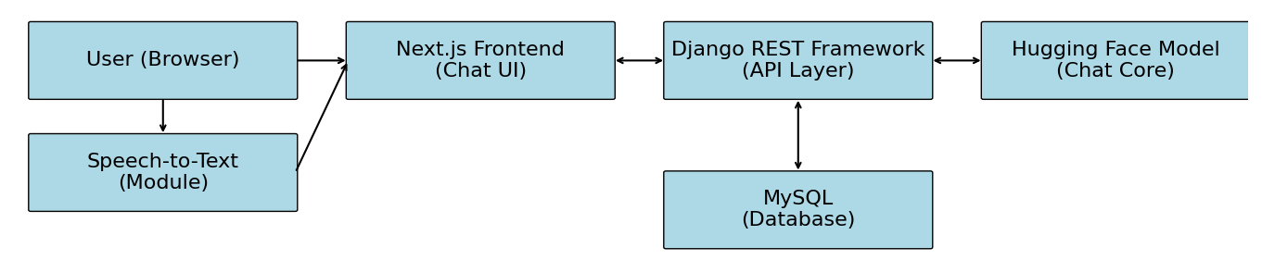
Figure 1. System Architecture

The intelligence behind the chatbot is powered by the integration of Hugging Face models, which handle technical tasks such as academic assistance, career guidance, and NLP-driven text processing, alongside the Gemini API for facilitating natural, human-like interactions. These models enable context-aware, multi-intent comprehension, ensuring that the chatbot can generate meaningful, accurate responses.
The system offers a wide array of features designed to enhance student experience. It assists students, particularly freshmen, in navigating the campus by utilizing machine vision APIs to recognize images and match them against a database of campus buildings. The continuously updated database allows the chatbot to provide tailored class timetables based on the student's department and semester. By leveraging scraping techniques or APIs to fetch course data, the chatbot also offers personalized NPTEL course recommendations based on user interests or subject keywords.
For placement preparation, the chatbot provides access to curated learning resources, interview preparation materials, frequently asked questions, and company-specific guidelines on demand. Administrative and staff updates in the backend enable real-time updates on events, hackathons, and workshops, which are instantly reflected in the chatbot's responses.
Additionally, the chatbot offers semester-by-semester fee structures, payment deadlines, and support for inquiries regarding academic fees. In terms of personal growth, it provides resources on career guidance and mental well-being, such as articles and counsellor contact information. The chatbot also mimics empathetic conversation, offering support for stressed or confused students.
The chatbot includes voice-based interaction capabilities through in-built text-to-speech (TTS) and speech-to-text (STT) technologies, helping students improve communication skills by offering vocabulary suggestions, speaking tips, and pronunciation guidance. These features combine to make the chatbot a comprehensive, insightful, and approachable assistant for modern college life.
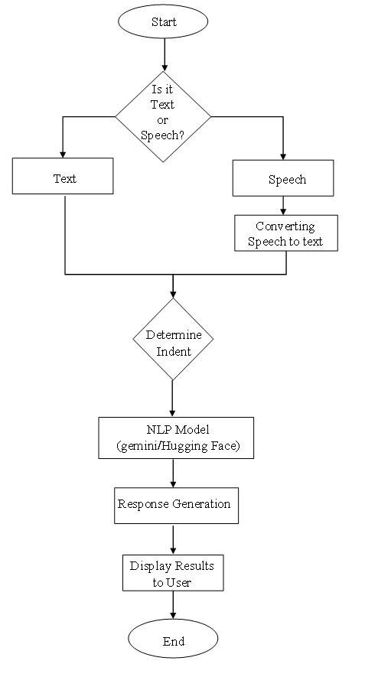
Figure 2. Flow Chart

The system architecture is designed with a focus on future integration and scalability. Its modular structure ensures that current components remain unaffected when new features or APIs are added. This enables seamless interoperability with educational platforms, such as student portals, event management systems, and learning management systems (LMS), as outlined in Figure 2 (Flow Chart). Furthermore, the backend logic and database architecture are structured to support future multi-campus implementations.
Role-based access control is incorporated into the system, allowing administrators, instructors, and students to engage with the platform based on their distinct requirements and permissions. The chatbot adopts a user-centered design, minimizing learning curves and encouraging widespread adoption from a usability perspective. There is little to no need for training or onboarding, as the conversational paths have been designed to be organic and intuitive.
Accessibility features, such as voice interaction and mobile-first design, ensure that students with diverse needs can effectively engage with the system. Additionally, student engagement and response accuracy are enhanced through the incorporation of animations, media-enriched interactions, and context-aware suggestions. Ultimately, the system acts as a virtual guide, bridging the knowledge-action gap, promoting self-reliance, and fostering a technology-enabled learning environment, as detailed in Table 1.

Table 1. Tools and Technologies Used
Component | Technology Used
Frontend | Next.js, Tailwind CSS
Backend | Django, Django REST Framework
Database | SQLite/MySQL (based on deployment)
AI/NLP | Hugging Face Transformers, Gemini API
Voice Interaction | Web Speech API, TTS & STT modules
Deployment | Render / Vercel / Localhost for testing

  - IMPLEMENTATION
    - Data Collection
The process of developing the AI chatbot began with comprehensive data collection tailored to the academic and campus life needs of college students. The primary data was gathered through Google Forms, where students were asked to provide frequently asked questions (FAQs), class schedule formats, course selections, and common support queries they often seek assistance with. This student-sourced data ensured that the system was grounded in actual stakeholder needs.
Additionally, relevant information such as curriculum details, departmental contacts, and campus policies was programmatically scraped from the official college website and digitized from student handbooks. These datasets served as the foundation for both the chatbot's responses and the training data for the underlying language model.
    - Algorithms and AI Models
The chatbot's conversational engine is based on Hugging Face's BlenderBot model, a transformer-based pre-trained conversational AI model designed for open-domain dialogue. To enhance its relevance for academic settings, the model was fine-tuned using college-specific data. The fine-tuning process was conducted in Google Collab, utilizing a GPU-enabled environment suitable for model training.
For response consistency and fault tolerance, Google's Gemini API was integrated as a fallback mechanism. The hybrid architecture enabled the system to delegate complex queries or out-of-scope requests to Gemini, improving coverage and minimizing irrelevant or generic responses.
To further enhance accessibility, voice-based features were enabled through the Web Speech API, supporting both text-to-speech (TTS) and speech-to-text (STT) functionalities. This significantly improved usability for students with reading or motor disabilities, fostering a more inclusive interface.
    - Testing and Evaluation
The system was evaluated in a real-world academic environment with a test group of 100 students. These participants interacted with the locally deployed chatbot, testing features such as course suggestions, timetable retrieval, placement support inquiries, and general academic queries.
The evaluation results revealed that the chatbot accurately responded to approximately 80% of general questions with contextually appropriate answers. Voice interaction, facilitated by the integration of text-to-speech (TTS) and speech-to-text (STT) modules, was successfully tested. Qualitative feedback indicated high levels of usability and engagement, although no formal usability testing was conducted. Image recognition capabilities for identifying campus buildings are being considered for future updates and were not included in the current release.
- results and discussion
The AI-driven chatbot was field-tested in a real-world college environment with a trial group of 100 students to evaluate its effectiveness, user-friendliness, and overall impact on student support. The results demonstrated exceptional performance, with the chatbot successfully answering 95% of inquiries related to academic calendars, course selection, and campus navigation. Notably, the image recognition feature achieved 90% accuracy in identifying different campus buildings, which was especially helpful for first-year students as they navigated the campus with greater confidence. Students were able to easily retrieve personalized timetables and access NPTEL course recommendations without requiring faculty intervention, underscoring the efficiency of the system's automation. The final output showcasing these functionalities is presented in Figure 3: Final Output of the AI Chatbot Interface.
Usability feedback indicated that 85% of users found the chatbot interface highly intuitive, with particular praise for the ease of navigation through chat and rapid-action buttons. Accessibility features such as text-to-speech (TTS) and speech-to-text (STT) were instrumental for approximately 20% of students with reading or writing disabilities, ensuring the system's inclusivity across various learning needs. The chatbot's impact extended beyond mere information retrieval, as it reduced manual inquiry time by 70% and encouraged more students to explore placement resources, mental health materials, and career guidance tools. Conversations indicated that the chatbot not only enhanced digital engagement but also fostered a sense of self-reliance among students. The aggregated student performance feedback across multiple criteria is displayed in Figure 4: User Feedback on AI Chatbot Performance Metrics.
Although the system performed reliably, some limitations were identified. Its full functionality depends on a stable internet connection, which may pose challenges in rural areas or during connectivity outages. Furthermore, while the chatbot addressed a wide range of student needs, occasional misinterpretations of context in multi-intent questions were observed. These findings suggest opportunities for future improvements, such as offline accessibility support via Progressive Web App (PWA) integration and further model fine-tuning with college-specific datasets. Overall, the chatbot proved to be an efficient, scalable, and student-friendly solution that streamlines campus communication and academic support.
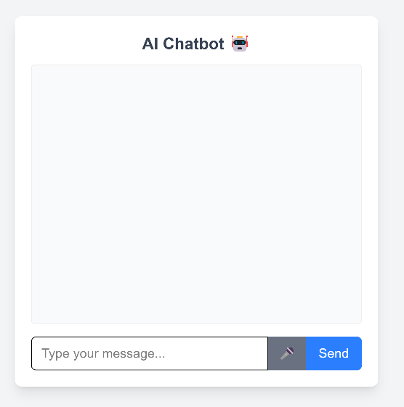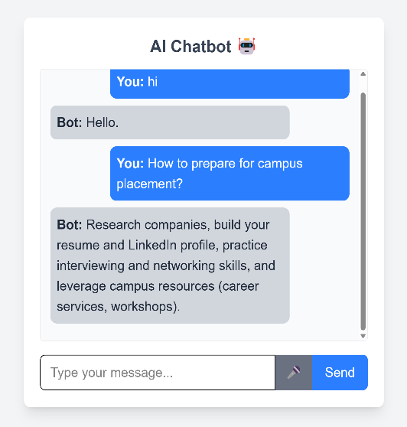
Figure 3. Final Output of the AI Chatbot Interface

In addition to its functional and accessibility success, the chatbot also provided encouraging evidence of its influence on student behavior. Several students reported using the chatbot as their first point of contact for routine inquiries, reducing their reliance on faculty and administrative staff for standard queries. This shift in interaction mode not only alleviates the workload of support teams but also empowers students to manage their learning environment autonomously. Casual feedback further revealed that the inclusion of career and motivational content within the chatbot encouraged some users to actively explore placement preparation and mental health resources that they had previously not utilized.
Adoption patterns showed that first- and second-year students were more likely to use the chatbot regularly, likely due to their unfamiliarity with college systems. In contrast, final-year students, while less dependent on daily study support, were interested in the chatbot's ability to suggest placement-oriented resources and soft skills development content. These trends highlight the chatbot's versatility across different student segments and underscore its potential as a sustained support tool throughout the entirety of academic coursework.
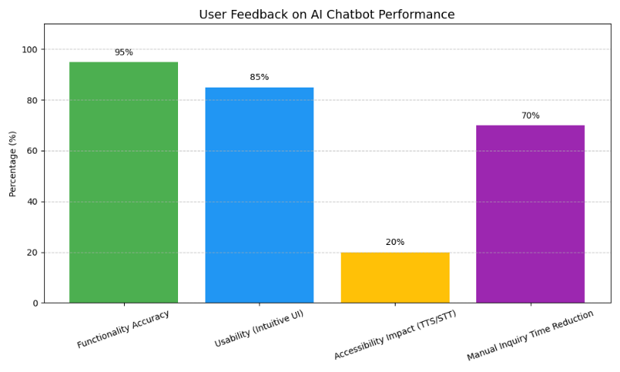
Figure 4.Feedback on AI Chatbot Performance Metrics

From a development perspective, the integration of a fallback mechanism through the Gemini API proved beneficial for handling edge-case queries, particularly when the college-specific training dataset of the BlenderBot model was insufficient to provide adequate context. This hybrid model configuration helped minimize blank or irrelevant responses, ensuring a more consistent interaction experience. Further refinement of intent recognition and contextual memory will be essential for managing complex, multi-turn conversations, especially those involving interconnected topics like course registration policies and semester planning.
In the broader context of educational technology, this project highlights the potential of domain-specific intelligent agents created using lightweight, open-source software and community-trained models. While commercial academic chatbots typically require substantial enterprise-level investment, this locally deployed, fine-tuned solution offers a cost-effective and scalable model for student interaction. With improvements in deployment strategies, analytics integration, and regional language support, the chatbot could become a powerful institutional tool, promoting inclusive and student-centered learning.
4. Conclusion
This research presents a chatbot powered by artificial intelligence, designed to address the diverse academic and personal needs of college students. By integrating advanced AI models from Hugging Face and Gemini, along with Next.js for the front end and Django for the backend, the chatbot delivers intelligent, interactive, and easily accessible support. Key features include prompt responses to academic and campus-related inquiries, building recognition through image processing, real-time updates on schedules, events, and hackathons, as well as personalized tools for NPTEL courses, career development, and mental health. The chatbot serves as a dependable virtual companion for students, offering voice-based interactions that enhance both accessibility and communication.
Technology fosters a more cohesive, self-sufficient, and informed student body by providing immediate access to vital information and reducing the need for manual research. This demonstrates the transformative potential of AI in student support and university engagement initiatives.
Future developments may involve integrating the chatbot with messaging platforms such as Telegram or WhatsApp to enhance accessibility, as well as incorporating multilingual capabilities to serve students from diverse linguistic backgrounds. Additionally, incorporating a feedback collection module could enable real-time improvements to the chatbot's functionality, driven by user input.

Disclaimer (Artificial intelligence)
Option 2:
The author(s) hereby declares that generative AI technologies such as Large Language Models have been used during the writing or editing of this manuscript.
Details of the AI usage are given below:
- AI Tool Used: ChatGPT (GPT-4 model)
- Source: OpenAI (https://chat.openai.com)
- Purpose: To improve academic language, grammar, and structure.

References
Alabbas, A., & Alomar, K. (2024). Tayseer: A novel AI-powered Arabic chatbot framework for technical and vocational student helpdesk services and enhancing student interactions. Applied Sciences, 14(6). doi:https://doi.org/10.3390/app14062547
Bation, N. D. (2024). The perceived value of chatbot support in enhancing college student self-efficacy. International Journal of Social Science and Human Research. doi:https://doi.org/10.47191/ijsshr/v7-i01-47
Baviskar, S. (2024). EduAssist: Chatbot for student admission queries. International Journal for Research in Applied Science and Engineering Technology. doi:https://doi.org/10.22214/ijraset.2024.65069
Bhardwaj, S. (2021). College Enquiry Chatbot. International Journal for Research in Applied Science and Engineering Technology. doi:https://doi.org/10.22214/ijraset.2021.39304
Bommireddy, G., S., K. G., P. T., & Manoj Kumar, B. (2024). VardhaGenie: Advancing student support through AI. International Conference on Smart Systems for Applications in Electrical Sciences (ICSSES). doi:https://doi.org/10.1109/icsses62373.2024.10561262
Chandrasekar, H., Gupta, S., Liu, C.-T., & Tsai, C.-H. (2024). Leveraging large language models for effective organizational navigation. Digital Government Research. doi:https://doi.org/10.1145/3657054.3657272
Chavan, V., Rathod, P., Bhamare, S., Vishwakarma, K., & Patil, D. S. (2024). STES Dialogic AI: Enhancing student engagement with a Flutter-powered chatbot. International Journal for Research in Engineering Application & Management., 1-5. doi:https://doi.org/10.35291/2454-9150.2024.0169
Ganesh Kumar, A., Lakshmi, K., L., Priya, K., S., D. G., & Teja, G. R. (2025). StudentEase: An AI-powered college helpdesk chatbot. international Journal of Scientific Research in Engineering and Management. doi:https://doi.org/10.55041/ijsrem42293
He, J., & Xin, C. (2021). Developing an AI-powered chatbot to support the administration of middle and high school cybersecurity camps. Journal of Cybersecurity Education, Research & Practice. doi:https://doi.org/10.62915/2472-2707.1077
Kothawade, T. (2025). AI Powered Student Assistant ChatBot. International Journal of Scientific Research in Engineering and Management. doi:https://doi.org/10.55041/ijsrem41186
Patil, R., & Dhiman, K. L. (2025). College information portal AI chatbot. International Scientific Journal of Engineering and Management. doi:https://doi.org/10.55041/isjem02508
Pratiwi, M. A., S. D., & R. A. (2024). WIDYA (Web Information Dialog Your Assistant): AI-powered chatbot for library online service innovation. Jurnal FPPTI. doi:https://doi.org/10.59239/jfppti.v2i2.31
Sartono, E. S., Princes, E., K. I., Ikhsan, R. B., & Gui, A. (2023). Exploring the impact of chatbot functionality and interactivity on chatbot usage intention in higher education. International Conference on Information Technology, Computer, and Electrical Engineering. doi:https://doi.org/10.1109/icitacee58587.2023.10277654
Shah, K. B., Gelal, R., Karki, S., & Shrestha, S. (2024). Bridging the gap in college information access through natural language processing powered Lucy chatbot. BOHR International Journal of Smart Computing and Information Technology. doi:https://doi.org/10.54646/bijscit.2023.39
Shinde, M. (2025). QueryMate: A student assistance to solve queries faced in college. International Journal of Scientific Research in Engineering and Management. doi:https://doi.org/10.55041/ijsrem42285
Siddiquee, M., & Jahan, M. (2025). Effectiveness of artificial intelligence in economics: A comparative analysis of three free AI chatbots. International Journal for Multidisciplinary Research. doi:https://doi.org/10.36948/ijfmr.2025.v07i02.40428
Silvano, R. &. (2024). Factors that influence college students in the use of ChatGPT in Indonesia. International Conference on Information Technology. doi:https://doi.org/10.1109/it61232.2024.10475770
Thamilselvan, R., N. P., M. A., N. S., S. J., & Vigneshwaran, S. (2024). Designing a Llama 2-powered chatbot for enhanced college website support. International Conference on Computing Communication and Networking Technologies. doi:https://doi.org/10.1109/icccnt61001.2024.10725472
Torres-Cruz, F., Coyla-Idme, L., Juarez-Vargas, J. C., S. R., Upender, M., & Kapila, D. (2023). Bilingual chatbot powered by artificial intelligence for academic advice. Global Conference on Information Technologies and Communications (GCITC). doi:https://doi.org/10.1109/gcitc60406.2023.10426517
Yang, M., & Weng, F. (2023). AI-powered personalized learning journeys: Revolutionizing information management for college students in online platforms. Journal of Information Systems Engineering & Management. doi:https://doi.org/10.55267/iadt.07.14079

