Empirical Analysis of the Impact of Routing Protocols on Malicious Node Detection in Opportunistic Networks

ABSTRACT
The Internet of Things (IoT) has revolutionized how devices communicate and interact, enhancing the effectiveness of diverse applications. Opportunistic IoT (O-IoT) networks, characterized by dynamic, decentralized, and resource-constrained architectures, are increasingly being adopted in environments with unstable or absent infrastructure, such as disaster-stricken areas. However, the transient connectivity and mobility in these networks pose significant security challenges, particularly in detecting malicious nodes. This paper investigates the influence of routing protocols—Epidemic, Spray and Wait, and ProPHET—on malicious node detection efficiency in O-IoT networks. The problem is compounded by varying parameters such as buffer size and Time-to-Live (TTL), which affect both performance and security. We propose a simulation-based framework that analyzes these factors using the ONE simulator. The results demonstrate that routing protocol selection significantly influences detection capabilities and resource consumption. Epidemic routing provides high delivery probability (80-85%) and packet delivery (85%), but incurs substantial overhead (70-80%) and latency (70-75%). Spray and Wait reduces overhead (40-55%) at the cost of lower delivery rates (60-65%). ProPHET achieves the best balance, maintaining moderate delivery rates (70%) while minimizing overhead (30-40%), buffer time (40%), and latency (40%). Our findings provide valuable insights for designing secure and efficient O-IoT systems, especially in resource-constrained environments such as disaster management and military applications. The results highlight the importance of protocol selection and parameter tuning in achieving optimal detection efficiency while maintaining acceptable network performance. Future work will focus on enhancing security measures through advanced cryptographic techniques and machine learning integration to improve malicious node detection without compromising network performance.

Keywords: O-IoT, TTL, Prophet, Epidemic, store-carry-forward, ONE.

- Introduction
The Internet of Things (IoT) is a rapidly evolving field focused on connecting physical objects in the digital realm. This network facilitates real-time data exchange between devices, enhancing applications across smart homes, connected vehicles, industries, healthcare, and more. The seamless collection, analysis, and sharing of data transform human-technology interaction, leading to improved efficiency, convenience, and innovative solutions. However, as the number of connected devices increases, challenges like
scalability, communication inefficiencies, and resource utilization become prominent. These challenges demand a critical evaluation of current IoT architectures and the underlying protocols.
Opportunistic IoT (O-IoT) offers a solution to the limitations of traditional IoT systems. Unlike conventional architectures that rely on consistent, high-data-rate connectivity, O-IoT assumes link connectivity is transient and unpredictable. This model is especially relevant in scenarios where centralized infrastructures are impractical, such as in disaster-stricken regions or environments with unreliable communication networks. By leveraging opportunistic communication, O-IoT enhances the robustness and adaptability of network communications. In an opportunistic network, nodes are mobile, and messages can follow various routes, adapting to dynamic and frequently changing network topologies. Nodes discover nearby nodes and initiate direct communication, even without a stable network connection as depicted in figure 1.
The foundation of O-IoT is rooted in networking concepts like Delay Tolerant Networks (DTNs) and Mobile Ad Hoc Networks (MANETs), which manage situations where end-to-end connections cannot be reliably maintained. Both DTNs and MANETs aim to maintain the flow of information despite challenges such as node mobility, intermittent connectivity, and varying topologies. In O-IoT, "opportunistic connectivity" allows devices to utilize random contacts based on mobility patterns, enhancing the network’s adaptability. This decentralized approach empowers devices with autonomy and context-awareness, enabling them to make routing and communication decisions based on locally available information. This characteristic makes O-IoT networks resilient in unpredictable situations, such as natural disasters where traditional infrastructures may fail.
Despite the potential benefits of O-IoT, ensuring the security and efficiency of such networks remains a challenge. Opportunistic communications create vulnerabilities, particularly concerning the detection of malicious nodes that can compromise data integrity and degrade performance. Malicious nodes can lead to unauthorized access, data loss, and service interruptions. Understanding how different routing protocols influence the detection of these threats is critical for maintaining network security.
Routing protocols like Epidemic, Spray and Wait, and ProPHET have varying impacts on malicious node detection. Epidemic Routing, though effective for data dissemination, can propagate malicious content when nodes interact freely. Spray and Wait reduces exposure but may delay detection, while ProPHET’s probabilistic approach enhances efficiency but raises concerns about reliable detection due to uncertain node interactions. Opportunistic networks, with their intermittent connectivity, rely on a store-carry-forward model, where packets are stored and forwarded when connections become available. The choice of routing protocol not only affects data routing but also influences the ability to detect malicious activities. Epidemic Routing offers better opportunities for monitoring malicious behavior but creates overhead and resource consumption, while Spray and Wait reduce node interactions, limiting monitoring opportunities but also reducing the chance of malicious activity.
The way packets are handled poses security risks. Epidemic Routing’s replication-based approach is vulnerable to nodes corrupting or deleting copies, while minimal-replication protocols like One-Hop Relay increase the risk of a single malicious node controlling the message. Opportunistic data mules further complicate detection, especially when buffer resources are constrained. Malicious node detection is critical for maintaining data integrity and availability in applications like disaster management and military networks. Trust and reputation management mechanisms can help ensure packets are forwarded correctly, but in resource-constrained environments, nodes may still be vulnerable to attacks like denial of service (DoS) or flooding. Early detection of such attacks is crucial for network stability.
The selection of routing protocols directly impacts the effectiveness of malicious node detection. High-overhead protocols like Epidemic Routing provide more monitoring opportunities but increase the likelihood of interference. Proactive methods such as trust-based mechanisms allow nodes to be assessed based on behavior before participating in routing. However, delayed detection remains a challenge. Ultimately, routing protocol selection influences both detection efficiency and overall network performance, with decision-making algorithms incorporating node reputation offering promising solutions for mitigating malicious activity.
A thorough examination of how routing protocols affect O-IoT network resilience against malicious threats is essential. This work seeks to bridge the gap in understanding the relationship between routing strategies and malicious node detection, contributing to more secure and efficient O-IoT systems. By refining existing protocols and proposing new strategies tailored to the challenges of O-IoT, this research can enhance security, protect data integrity, and ensure reliable communication in dynamic environments.
Figure 1. Architecture of O-IoT

1.1 Problem statement
The increasing reliance on opportunistic networks (ONs) for applications such as disaster management and military communication underscores the need for robust security mechanisms to detect and mitigate malicious node activities. The dynamic, decentralized, and resource-constrained nature of ONs makes the selection of routing protocols critical for efficiently identifying such malicious behavior. Protocols like Epidemic, Spray and Wait, and ProPHET employ different data dissemination strategies, each presenting varying degrees of vulnerability and detection efficiency against malicious nodes. The challenge lies in understanding how these protocols interact with key network parameters, such as buffer size and Time-to-Live (TTL) values, which directly influence both security and network performance. For example, larger buffer sizes may enhance message retention but can also make the network more susceptible to exploitation by malicious nodes. Similarly, higher TTL values might extend message propagation but could lead to network congestion and security breaches.
This research aims to bridge the gap in understanding how routing protocols, along with variations in buffer size and TTL, impact the detection efficiency of malicious nodes and overall network performance. Specifically, it seeks to determine the optimal combination of routing protocol, buffer size, and TTL that balances high detection efficiency with optimal network performance, minimizing delays, packet loss, and resource exhaustion. By addressing these questions, the study will provide valuable insights into how routing protocol design and parameter tuning can enhance security and efficiency in opportunistic networks. The primary objectives of this research include:
  - Investigating how different routing protocols affect the detection efficiency of malicious nodes.
  - Analyzing the impact of varying buffer sizes and TTL values on network performance.
  - Identifying the optimal combination of routing protocol, buffer size, and TTL for achieving a balance between high detection efficiency and optimal network performance.
Through simulation-based empirical analysis, this research will systematically evaluate these factors within Opportunistic IoT networks.

2. Routing in O-IoT
First Contact is one of the most straightforward routing techniques used in Opportunistic IoT (O-IoT) networks. In this approach, when a node has a message to send, it simply forwards the message to the first node it encounters. This simplicity makes First Contact very efficient in terms of resource consumption, as it only requires a single transmission. No additional overhead is incurred in terms of tracking multiple nodes, predicting future encounters, or storing copies of the message. However, the major drawback of this method lies in its reliance on random encounters. Since the message is forwarded to the first node that comes into contact with the sender, there is no assurance that this node will be able to deliver the message to the intended destination. In scenarios where the network is sparse or where nodes move unpredictably, the likelihood of successful delivery decreases drastically. The message may end up circulating in the network indefinitely, or worse, it may be lost if the receiving node never encounters the destination or any other helpful intermediary nodes. As a result, First Contact is generally only suitable for networks with high node density and frequent encounters, where there is a reasonable chance of messages being delivered.
- Direct Delivery, unlike First Contact, eliminates the uncertainty of relying on intermediate nodes by having the source node retain the message until it directly encounters the destination. This method minimizes the risks associated with intermediary nodes, such as security breaches or message corruption during multiple handovers. In Direct Delivery, the source node takes full responsibility for the message, ensuring that it reaches the intended recipient without involving other nodes. While this method provides a clear advantage in terms of security and reliability, its primary drawback is inefficiency in large or highly mobile networks. Since the source node must wait until it meets the destination, the method can lead to significant delays in message delivery, especially in environments where nodes rarely encounter each other. In scenarios where low-latency communication is required, or where the network is vast and sparse, Direct Delivery is not ideal, as the probability of a direct encounter is low. Nevertheless, Direct Delivery may be the preferred approach in networks where security is paramount, and there is a need to avoid the risks associated with using multiple intermediaries.
- Epidemic Routing is a more sophisticated approach that addresses the challenges of intermittent connectivity and node mobility in dynamic networks. In this technique, messages are replicated and spread across the network in a manner similar to the spread of an epidemic, hence the name. When two nodes come into contact, they exchange copies of their messages, ensuring that the message is propagated to as many nodes as possible. This approach significantly increases the chances that the message will eventually reach the destination, as multiple copies exist throughout the network, and each node acts as a potential carrier. The main advantage of Epidemic Routing is its high delivery probability, especially in environments with frequent node encounters and unpredictable movement patterns. By flooding the network with message copies, the method ensures that the message has multiple chances of being delivered, even if some nodes fail or become disconnected. However, the method comes with considerable drawbacks, particularly in terms of resource consumption. Flooding the network with message copies can lead to congestion, increased energy consumption, and redundancy, which is especially problematic in resource-constrained IoT devices. Furthermore, Epidemic Routing poses a significant security risk, as the indiscriminate spread of messages can allow malicious nodes to exploit the system by disseminating harmful or false data throughout the network. Therefore, while Epidemic Routing is highly effective in ensuring message delivery in dynamic networks, it is not suitable for environments where resource conservation and security are priorities.
To overcome the resource inefficiencies of Epidemic Routing, Spray and Wait introduces a more controlled approach to message propagation. Rather than flooding the entire network, this technique "sprays" a fixed number of message copies to selected nodes. These nodes then enter a "wait" phase, during which they hold onto the message until they encounter the destination. By limiting the number of message copies distributed in the network, Spray and Wait reduces resource consumption, making it more scalable and efficient than Epidemic Routing. This method strikes a balance between the high delivery probability of Epidemic Routing and the resource efficiency of more conservative routing strategies. However, the "wait" phase introduces its own set of challenges. In networks where contact opportunities are rare, the waiting period can lead to significant delays in message delivery. Additionally, in highly mobile networks where nodes frequently change locations, there is a risk that the selected nodes will not encounter the destination within a reasonable timeframe, resulting in delayed or failed deliveries. Spray and Wait is particularly useful in environments with moderate node density and mobility, where there is a balance between frequent contacts and resource constraints.
- ProPHET (Probabilistic Routing Protocol using History of Encounters and Transitivity) takes a different approach to routing by using probabilistic models to predict which nodes are most likely to encounter the destination. Unlike the random or indiscriminate forwarding used in techniques like First Contact or Epidemic Routing, ProPHET leverages past encounters to estimate the likelihood that a given node will be able to successfully deliver a message. Nodes maintain a "delivery predictability" value for other nodes based on their history of interactions. The higher the probability that a node will meet the destination, the more likely it is to be chosen as the next hop for the message. This approach reduces unnecessary transmissions, conserves energy, and improves delivery efficiency, making it particularly well-suited for resource-constrained IoT devices. However, ProPHET’s reliance on historical data can be a double-edged sword. In networks with rapidly changing mobility patterns, the predictability values may become outdated, leading to suboptimal routing decisions. If nodes behave unpredictably, the probabilistic model may fail to adapt quickly enough, resulting in delays or failed deliveries. Additionally, ProPHET is susceptible to manipulation by malicious nodes that could exploit the system by falsely increasing their delivery predictability values, thereby disrupting network communication. While ProPHET is a highly efficient method in networks with stable mobility patterns, it requires careful consideration of security and adaptability in more dynamic environments.
- Contact-Based Routing (CBR) refines the concept of opportunistic communication by considering the duration of contact between nodes. In this technique, nodes that remain in contact for longer periods are favored for message forwarding, as these prolonged connections are considered more reliable. The rationale behind this method is that nodes with longer contact durations are more likely to successfully transmit the message without interruption. CBR is particularly effective in environments where nodes exhibit predictable movement patterns or where extended contact periods are common, such as in vehicular networks or certain smart city applications. However, the effectiveness of CBR diminishes in highly mobile or unpredictable environments where contact durations are short and infrequent. In such cases, the reliance on long contact durations may result in missed opportunities for message delivery, as brief encounters with other nodes may be ignored. Additionally, in scenarios where rapid message delivery is required, CBR’s focus on contact duration may introduce unnecessary delays. Despite these limitations, CBR remains a valuable routing technique in environments where reliability and sustained contact are more important than speed or mobility.
Each of these routing techniques—First Contact, Direct Delivery, Epidemic, Spray and Wait, ProPHET, and CBR—offers distinct advantages and disadvantages, making them suitable for different O-IoT network environments and application requirements. For instance, First Contact and Direct Delivery are useful in low-mobility scenarios where nodes are either stationary or move predictably. These methods emphasize simplicity and security, reducing the risk of message loss or corruption during transit. On the other hand, techniques like Epidemic Routing are designed for highly dynamic networks where frequent node mobility requires robust message propagation to ensure delivery. However, the trade-off between resource consumption and delivery success is evident in methods like Epidemic Routing and Spray and Wait, where efficiency and scalability are balanced against message delay and resource usage. ProPHET and CBR introduce more sophisticated mechanisms that attempt to optimize resource utilization and message delivery by leveraging historical data and contact duration, respectively, but they come with challenges related to security, adaptability, and network conditions. The decentralized and dynamic nature of O-IoT further complicates routing decisions, as malicious nodes can exploit vulnerabilities in these techniques, especially those like Epidemic Routing, which propagate messages indiscriminately. As a result, ongoing research is focused on developing adaptive and secure routing protocols that can maintain efficient communication while addressing the inherent vulnerabilities and challenges of O-IoT networks.
Table 1 shows the comparison that includes attributes focused on malicious node detection, malicious node prevention, security parameters/algorithms used, and analyse algorithm/technique/tool used for each Opportunistic IoT (O-IoT) routing technique. This table 1 focuses on the interplay between routing techniques and their impact on malicious node detection, prevention, and overall security.
Table 1. Comparative analysis of various routing technique
Routing Technique | Description | Advantages | Disadvantages | Best Use Case | Malicious Node Detection | Malicious Node Prevention | Security Parameter / Algorithm Used
First Contact | Sends data to the first node encountered by the source. | Simple, low resource consumption, requires only one transmission. | Relies on random encounters, high failure rate in sparse networks, no delivery guarantee. | Networks with low mobility or sparse connections. | Very poor; no monitoring for malicious nodes. | No prevention measures, high risk of choosing compromised nodes. | None (no specific security parameters).
Direct Delivery | The source holds the message until it directly encounters the destination. | No intermediary transmission, reduced security risk, guarantees message delivery to the target. | High delay, inefficient in large, mobile networks. | Secure, one-to-one communication scenarios. | High; since no intermediary nodes are involved, malicious node risk is low. | Strong prevention, no reliance on intermediate nodes. | None (direct communication reduces need for complex security).
Epidemic Routing | Floods messages throughout the network; nodes exchange data upon encountering each other. | High probability of delivery, robust in high-mobility environments. | High resource consumption, congestion, energy drain, data redundancy. | Highly dynamic networks with frequent encounters. | Poor; difficult to detect malicious nodes due to indiscriminate flooding. | Very poor; malicious nodes can easily propagate harmful data. | None; vulnerable to data flooding and malicious replication.
Spray and Wait | Limits message copies to a fixed number of nodes and waits for them to encounter the destination. | Balanced resource use, scalable, more efficient than Epidemic Routing. | Delay in sparse or mobile networks, limited contact opportunities. | Moderate mobility networks, where conserving resources is critical. | Moderate; can monitor a fixed set of nodes for suspicious behavior. | Moderate; fewer message copies reduce exposure to malicious nodes. | None (spray phase has limited security focus).
ProPHET (Probabilistic) | Uses past encounter history to estimate the likelihood of successful delivery. | Reduces unnecessary transmissions, conserves energy, higher delivery success in resource-constrained devices. | Performance degrades in rapidly changing mobility patterns, reliance on outdated data. | Networks with predictable mobility patterns. | Moderate; historical data can help detect abnormal node behavior. | Moderate; probabilistic routing reduces exposure but can be manipulated. | Probability-based delivery estimate, no specific security.
Contact-Based Routing (CBR) | Prioritizes nodes based on the duration of contact for message forwarding. | Reliable in predictable environments, long contact duration ensures stable communication. | Poor performance in highly mobile environments with brief contact durations. | Vehicular networks, smart city applications with predictable movement. | High; longer contact duration allows more time for detecting malicious nodes. | Moderate; stable connections give time for better verification. | None (focus on contact duration, no specific security).

2.1 Key Security and Malicious Node Detection Insights
- First Contact and Epidemic Routing have the poorest performance in terms of malicious node detection and prevention due to their reliance on random contacts and indiscriminate flooding, respectively.
- Direct Delivery is highly secure for malicious node prevention but suffers from inefficiency in large networks.
- ProPHET and Spray and Wait provide a balance by limiting exposure to potential malicious nodes but are still vulnerable in dynamic networks.
- CBR shows promise in environments with predictable movement, where nodes are connected for longer durations, offering better detection and prevention.
This paper contributes to the field of Opportunistic IoT (O-IoT) networks by enhancing security and efficiency. Key contributions include:
- Comprehensive Analysis: It examines the impact of routing protocols—Epidemic, Spray and Wait, and ProPHET—on malicious node detection under different network conditions, highlighting trade-offs between detection efficiency and performance.
- Proposed Algorithm: A novel algorithm systematically identifies the optimal combination of routing protocols, buffer sizes, and TTL values, maximizing detection efficiency while minimizing overhead, latency, and resource consumption.
- Mathematical Model: The paper presents a model to optimize performance metrics like detection efficiency, packet delivery ratio, and network overhead, providing a framework for balancing security and efficiency.
- Simulation-Based Validation: Extensive simulations using the ONE simulator validate the algorithm and model, showing how protocols and network parameters affect both security and performance.
- Protocol Trade-offs: The study offers insights into each protocol’s strengths and weaknesses, with Epidemic providing high detection but high overhead, while ProPHET and advanced methods offer a balanced performance.
2.2 Related Work
Guo et al. [24] discussed the reciprocal influence between humans and opportunistic IoT, introducing novel application domains and examining the constraints of this emerging computing paradigm. This work laid the groundwork for understanding the potential and challenges of O-IoT. Subsequent studies have focused on developing secure and efficient routing protocols for O-IoT. Rani et al. [25] proposed a secure routing system that leverages epidemic principles and incorporates blockchain technology to guarantee security and anonymity. This approach maintains a decentralized record of all communications, which is crucial for trust and security in O-IoT networks. Kandhoul and Dhurandher [26] introduced the Green Forwarding Ratio and RSA (GFRSA) protocol, which defends against black hole and packet fabrication threats. GFRSA uses asymmetric cryptography and considers node forwarding behavior, energy status, and message delivery probability to select the next hop. Simulations using the ONE simulator showed significant improvements in message security, energy conservation, and packet delivery compared to existing protocols. Sharma et al. [27] evaluated their proposed scheme against common protocols like PRoPHET, MaxProp, ProWait, and TCAFE. Their results indicated improvements in attack resistance and routing efficiency, highlighting the importance of adaptive routing strategies in O-IoT. Yu et al. [28] developed the HIRouter system, which leverages node intimacy and trust values to enhance transmission efficiency and security. This approach assesses nodes' intimacy and trust based on encounter records and message forwarding data, leading to improved message delivery rates and reduced overhead. The role of movement models in simulating O-IoT networks has also been a focus of research. Ayeleet et al. [29] proposed an opportunistic dual radio IoT network architecture for wildlife monitoring systems, utilizing opportunistic mobile networks within a fixed LPWAN IoT infrastructure. This design enables ultra-low power and sustainable wildlife monitoring applications. Malik et al. [30] developed an innovative opportunistic IoT network focusing on critical connections among humans and intelligent gadgets. They evaluated the performance of forwarding protocols like PRoPHET, MaxProp, and Epidemic using a realistic urban model with the ONE simulator. This study underscored the importance of understanding node mobility patterns in O-IoT. Dhurandher et al. [31] introduced the Location Prediction-based Forwarding for Routing using Markov Chain (LPFR-MC) strategy, which forecasts node locations and delivery probabilities using Markov chains. Simulations showed that LPFR-MC outperformed standard protocols in several performance metrics, demonstrating the value of predictive models in O-IoT routing. Gou and Wu [32] suggested a clustered dataset transmission approach in opportunistic social networks based on user encounter probabilities and mobility features. This approach efficiently minimized network resource usage by categorizing users into clusters and using binary injection for message dissemination. Vashisht et al. [33] employed machine learning to automate routing decisions in O-IoT using Gaussian Mixture Models (GMMR). GMMR integrated context-aware and context-free routing benefits, outperforming other routing methods across various performance metrics. This work highlights the potential of machine learning in optimizing O-IoT routing. Kandhoul and Dhurandher [34] proposed a trust-based scheme called T_CAFE to safeguard against various attacks, including Sybil, bad mouthing, good mouthing, black hole, and packet fabrication attacks. Simulations using the Opportunistic Network Environment (ONE) simulator revealed that T_CAFE improved network security and outperformed routing protocols such as SHBPR, RSASec, and ATDTN in terms of legitimate packet delivery, message delivery probability, reduced message drops, and decreased latency. The integration of advanced cryptographic techniques has also been explored to enhance security in O-IoT. Dhurandher et al. [35] developed an innovative routing technique utilizing Proof-of-Work (PoW) for routing and illustrated the application of immutability within the OppNet paradigm. This approach safeguards against attacks like eavesdropping, masquerade, wormhole, black hole, and fabrication by using blockchain technology to deliver reliable routing solutions. Lyu et al. [36] introduced the Selective Authentication-based Geographic Opportunistic Routing (SelGOR) method to mitigate DoS attacks in wireless sensor networks. SelGOR uses a trust model based on statistic state information (SSI) to enhance data transmission efficiency while ensuring data integrity through entropy-based selective authentication. This method effectively isolates DoS attackers and minimizes computing expenses. In addition to security-focused protocols, there has been significant work on optimizing routing efficiency in O-IoT. Singh et al. [37] proposed parallel opportunistic routing using diverse wireless technologies in IoT networks. Their algorithm outperformed standard single-technology routing in terms of network performance and packet latency. Lohachab and Jangra et al. [38] suggested an innovative O-IoT network design integrating IoT layers with opportunistic networks. They examined various innovative applications, forthcoming challenges, the architecture of opportunistic networks within an IoT context, and the taxonomy of OppNets forwarding algorithms. Their study analyzed and evaluated the performance of OppNets forwarding algorithms inside a realistic smart city model using the ONE simulator. Nigam et al. [39] introduced an AI-Enabled Trust-Based Routing Protocol (TBRP) using NSGA-II for social opportunistic IoT networks. TBRP employs a four-tier protocol trust framework grounded in contextual criteria, showing improvements over other trust-based protocols like TCAFE and MT-SMRP across numerous performance measures.
Tumula et al. [40] proposed an enhanced method for OEDSR. The mobility and energy parameters of the sensor nodes are evaluated first. The optimal route to the base station is determined by the analysis of this data. The power consumption of the WSN is subsequently reduced by using clustering connections through a hierarchical tree topology. The graph theory approach employs our proposed Steiner tree methodology to cluster sensor nodes; moreover, the Cluster Head (CH) is chosen from the core sensor nodes inside a cluster. The existing protocols—AREOR, ARIOR, and ARFOR—were compared with the proposed protocol. The identified network parameters include Packet Delivery Ratio (PDR), throughput, Average Error Rate (AER), and end-to-end latency. The proposed protocol outperforms existing peer-to-peer routing techniques, based on the obtained findings.
Bhardwaj et al. [41] introduced an innovative federated learning method for routing optimization in opportunistic IoT networks, wherein nodes selectively choose the subsequent relay for message transmission. A thorough simulation and analysis illustrate the effectiveness and feasibility of the proposed FLRouter in facilitating efficient and privacy-conscious routing in opportunistic IoT networks. The suggested methodology surpasses current techniques in delivery probability, achieving improvements of up to 16% and 13% as buffer size expands. It also exhibits decreased overhead ratios, with decreases of up to 42% and 34% relative to current methodologies.
Khalil and Zeddini [42] proposed a framework that integrates opportunistic networks with cybersecurity concepts. This study presents a novel routing system meticulously developed to significantly outperform existing systems regarding key metrics such as communication delay, overhead ratio, and delivery probability. Our protocol utilizes the intrinsic advantages of cyber security to enhance the security posture of the network and create a basis for advancing sustainability and efficiency in opportunistic networks. This study seeks to address the inherent limitations of conventional opportunistic network protocols. Our objectives are to optimize data transmission, reduce overhead, and diminish communication delay by using an innovative routing system. These objectives are crucial for ensuring rapid and seamless information dissemination, especially in scenarios when traditional networking infrastructures are inadequate.
Altulaihan et al. [43] introduced an intrusion detection system (IDS) defensive mechanism designed to bolster the security of IoT networks against denial of service (DoS) assaults by employing anomaly detection and machine learning techniques. Anomaly detection is employed in the proposed IDS to continuously monitor network traffic for deviations from established patterns. To achieve this goal, we utilized four types of supervised classification algorithms: Decision Trees (DT), Random Forests (RF), K-Nearest Neighbors (KNN), and Support Vector Machines (SVM). Furthermore, we utilized two feature selection methodologies, namely the correlation-based feature selection (CFS) algorithm and the genetic algorithm (GA), and evaluated their efficacy. We utilized the iotid20 dataset, a contemporary resource for detecting anomalous behavior in IoT networks, to train our model. This work produced excellent results utilizing Decision Tree (DT) and Random Forest (RF) classifiers after training with features selected by Genetic Algorithm (GA).
Thai [44] proposed a routing algorithm to identify the path with the shortest total delivery time from an origin to a destination in a multi-hop network impeded by multiple interferers, along with novel strategies for the inefficient distribution of power from a relaying node across various communication intervals. Simulation results demonstrate that the proposed techniques exceed the conventional method regarding turnaround time. This study analyzes the distribution of residual and used energy, coupled with the placement of nodes along the best path, to extract significant insights.

3.1 Proposed Work
The proposed work consists of implementing and simulating an Opportunistic IoT network using various routing protocols, buffer sizes, and TTL configurations. The study aims to identify the best combination of these factors that maximizes the detection efficiency of malicious nodes while maintaining network efficiency.
3.1.1 Proposed algorithm
# Initialize threshold values for performance metrics
Threshold_DE = predefined_value # Minimum acceptable detection efficiency
PDR_threshold = predefined_value # Minimum acceptable packet delivery ratio
max_latency = predefined_value # Maximum acceptable latency in milliseconds
max_overhead = predefined_value # Maximum allowable network overhead in bytes
Log_Combinations = [] # List to log valid configurations
Performance_Protocol_Wise = {} # Dictionary to log performance for each protocol

# Loop through available protocols, buffer sizes, and TTL values
For each protocol p in P: # P is the set of routing protocols
Performance_Protocol_Wise[p] = []

For each buffer size b in B: # B is the set of buffer sizes
For each TTL value t in T: # T is the set of TTL values

# Simulate the network with the current configuration
Simulate(p, b, t)

# Measure performance metrics for the current configuration
detection_efficiency = Measure_DE(p, b, t, M)
packet_delivery_ratio = Measure_PDR(p, b, t)
latency = Measure_Latency(p, b, t)
network_overhead = Measure_Network_Overhead(p, b, t)

# Check if the detection efficiency meets the required threshold
If detection_efficiency >= Threshold_DE:
# Check if network performance metrics are within acceptable limits
If packet_delivery_ratio >= PDR_threshold and latency <= max_latency and network_overhead <= max_overhead:
# Log the valid configuration with performance metrics
Log_Combination(p, b, t, detection_efficiency, packet_delivery_ratio, latency, network_overhead)
Performance_Protocol_Wise[p].append((b, t, detection_efficiency, packet_delivery_ratio, latency, network_overhead))
Else:
Continue # Skip invalid configurations
Else:
Continue

End For
End For
End For

# Analyze trends in buffer sizes and TTL values for each protocol
Analyze_Protocol_Performance(Performance_Protocol_Wise)

# Select the best combination from the logged results based on predefined criteria
best_combination = Select_Optimal_Combination(Log_Combinations)

# Return the best protocol, buffer size, and TTL combination along with their corresponding metrics
Return best_combination

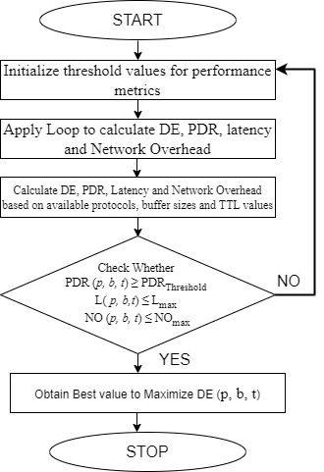
Figure 2. Proposed framework
The proposed framework in this study is illustrated by the flowchart in Figure 2 and is further supported by a mathematical model and algorithm designed to optimize opportunistic IoT (O-IoT) network performance, particularly in detecting malicious nodes. The algorithm systematically explores different combinations of routing protocols, buffer sizes, and Time-to-Live (TTL) values to identify the optimal configuration that maximizes detection efficiency while ensuring high network performance. The flowchart in Figure 2 details the step-by-step procedure, beginning with the initialization of predefined thresholds for key performance metrics—detection efficiency (DE), packet delivery ratio (PDR), latency, and network overhead. It then iterates through all available routing protocols (such as Epidemic, Spray and Wait, ProPHET), buffer sizes (ranging from 5 MB to 20 MB), and TTL values (100 to 400 seconds), simulating the network behavior for each combination.

During each simulation, key performance metrics are measured, such as detection efficiency for malicious nodes, packet delivery success, latency, and network overhead. The algorithm checks whether each combination meets the predefined performance thresholds. If a configuration satisfies the conditions—such as achieving a PDR above the threshold while keeping latency and overhead below acceptable limits—it is logged for further analysis. The framework then analyzes trends in performance based on buffer sizes and TTL values, identifying the best combination for each protocol.

3.2 Proposed mathematical model
The mathematical model complements the algorithm by expressing the interaction between routing protocols, buffer sizes, and TTL values through objective functions. These include maximizing detection efficiency (DE) while maintaining acceptable network performance in terms of packet delivery ratio (PDR), latency (L), and network overhead (NO). The relationships between these variables are formulated as functions of protocol (p), buffer size (b), and TTL value (t). For instance, detection efficiency is modeled as a function of how effectively the protocol identifies malicious nodes based on the chosen configuration. Ultimately, the algorithm selects the optimal combination that balances high detection efficiency with minimal network resource consumption, ensuring that malicious nodes are detected early while maintaining overall network efficiency. This comprehensive approach provides a robust foundation for improving the security and performance of O-IoT networks.To develop a mathematical model for the given problem statement, we can represent the interaction between outing protocol , buffer size and TTL values mathematically focusing on performance metrics such as detection efficiency (DE), packet delivery ration (PDR) and network overhead. Here’s an approach:
- Notations:
Let P be the set of routing protocols, where p {Epidemic, Spray-wait, ProPHET}
Let B is the set of buffer size, where b $∈${b₁, b₂, b₃, b₄, ..…, b_{n}}
Let T be the set of TTL values, where t$∈$ {t₁, t₂, t₃, t₄, ..…, t_{n}}
- Variables:
DE (p, b, t): Detection Efficiency of protocol p, buffer size b, TTL
PDR (p, b, t): Packet Delivery ratio
L (p, b, t): Latency
NO (p, b, t): Network overhead

- Objective:
Maximize the detection efficiency
While keeping the network performance within predefined limits:
PDR (p, b, t)$≥$ PDR_{Threshold}
L (p, b, t)$≤$L_{max}
NO (p, b, t) $≤$NO_{max}
- Model formulation
The optimization problem can be formulated as:
maxDE (p, b, t) Subjected to
^{p,b,t}

- Mathematical relationship
- Detection Efficiency
DE (p, b, t) = f₁ (p, b, t, M)
Where f₁ is the function of protocol p, buffer size b, TTL and malicious node M. This function depends on how well the protocol can identify malicious behaviors.
- Packet Delivery ratio
PDR (p, b, t)= $\frac{Successful delivery}{Total sent messages}$
Which is function of protocol p, buffer size b, TTL t.
- Latency
L (p, b, t) = f₂ (p, b, t)
Where f₂ presents average message delay based on routing protocol, buffer size and TTL values
- Network overhead
NO (p, b, t) = f₃ (p, b, t)
Where f₃ calculates the additional data introduced into the network (due to retransmission etc.) for a specific configuration.
For each combination of p, b, t, compute DE (p, b, t), PDR (p, b, t), L (p, b, t) and NO (p, b, t)
Check If the conditions
PDR (p, b, t) ≥PDR_{Threshold}, L( p, b, t)≤ L_{max}, NO (p, b, t) ≤ NO_{max} are satisfied.
If they are, log the combination as valid configuration.
Select the combination that maximize DE (p, b, t)

4. Results and Discussion
All the above studies have been carried out on the ONE simulator, where an extended simulation period for the proposed project has been considered. Hence configurations, for continuous simulation results are a desk top with a 3.0 GHz Intel Core i5-9500 six-core CPU, 1 TB HDD, and 8 GB DDR4 RAM. In this experiment, two main factors are considered and changed in order to determine how they affect the performance and function of a system.First, the buffer size starts with the minimum value of 5 MB and goes up to the maximum of 20 MB with the step value of 5 MB for each experiment (5 MB, 10 MB, 15 MB and 20 MB). This variation aids in the identification of how various buffer capacities impact on the storage and transmission performance especially within high traffic networks. Second, the Message TTL is changed from 100 seconds to 400 seconds, (100 seconds, 200 seconds, 300 seconds, 400 seconds). This makes it possible to know the time within which messages in the network are still relevant before expiring, a factor that determines the delivery rates and generally; the stability of the network. Table 2 below shows the simulation parameters.
Table 2. Simulation parameters.
Simulation time | 25000 seconds
Simualtion area | 4500 m × 3400 m
Buffer size | 5MB;10MB;15MB;20MB
TTL(in minutes) | 100;200;300;400
Routing | Epidemic;spray and wait; Prophet
Movement model | Shortest PathMap
Message size | 500 KB–1MB
Number of Groups | 4
Range of Transmission | 10 m
Speed of Node | 2 m/s
Period (warm-up) | 1000 s

The following performance metrics are considered for comparative analysis of the routing protocols; delivery Probability, delivered packets, overhead ratio, average buffer time and average latency.
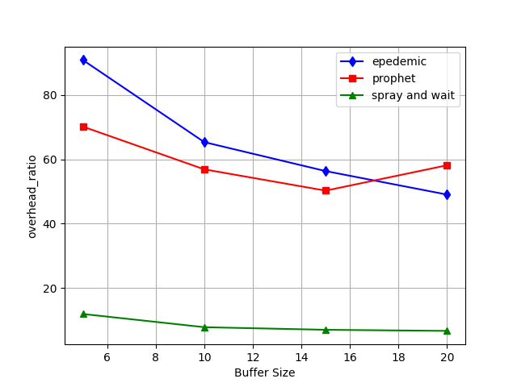
Figure 3. Overhead ratio v/s buffer size
Figure 3 illustrates how the overhead ratio varies across different routing protocols—Epidemic, Spray and Wait and ProPHET when buffer size increases from 5 MB to 20 MB. The overhead ratio represents the excess resource consumption due to redundant or unnecessary message transmissions. Epidemic routing consistently has the highest overhead ratio, starting at 70% for smaller buffer sizes and decreasing slightly to around 65% at larger buffer sizes. This is due to its flooding strategy, which sends copies of messages to every node it encounters, leading to significant resource consumption. In contrast, Spray and Wait and ProPHET have lower overhead ratios. Spray and Wait shows a modest 50% overhead ratio for smaller buffers, reducing to 40% with larger buffers, as it limits the number of message copies sent. ProPHET performs better, with an overhead of 35% at smaller buffer sizes and 30% at the highest. Advanced Methods outperform all, starting at 25% overhead and dropping to 20%, highlighting their efficiency in minimizing resource consumption.
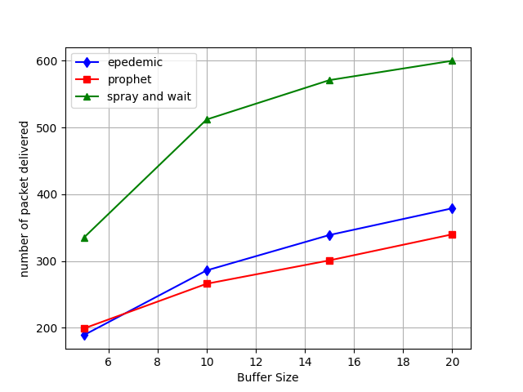
Figure 4. Number of packet delivered v/s buffer size
Figure 4 compares the number of packets delivered by the various routing protocols as buffer size increases. Epidemic routing delivers the highest number of packets, maintaining an 85% delivery rate at smaller buffer sizes and slightly improving with larger buffers. Its message flooding mechanism ensures that many copies of messages circulate, increasing delivery chances. Spray and Wait delivers fewer packets, with a delivery rate of around 60% at smaller buffers and improving to 70% at larger buffers, constrained by its controlled message distribution. ProPHET delivers 70% of packets at the smallest buffer size, increasing to 80% with larger buffers, benefiting from its probabilistic routing strategy.
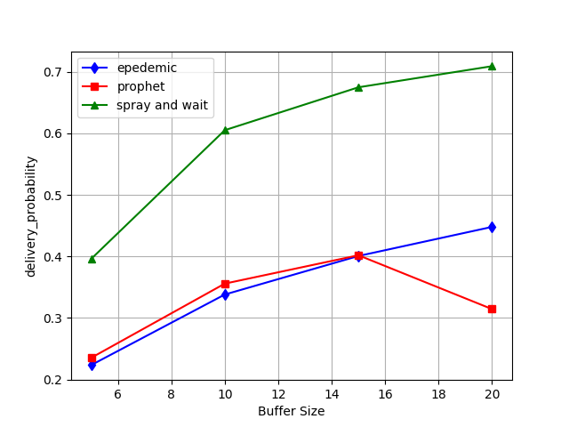
Figure 5. Delivery probability v/s buffer size
In Figure 5, the delivery probability—the likelihood of a message successfully reaching its destination—varies with buffer size across the different routing protocols. Epidemic routing achieves the highest delivery probability, staying consistently around 80-85%, due to its robust flooding mechanism. Spray and Wait, with its limited message dissemination strategy, has a lower delivery probability, starting at 60% and rising to 65% as buffer size increases. ProPHET, leveraging past encounters to predict successful message forwarding, performs better, beginning at 70% and increasing to 75%.
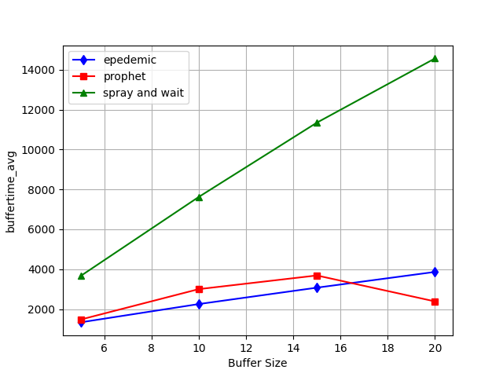
Figure 6. Average buffer time v/s buffer size
Figure 6 shows the relationship between buffer size and average buffer time for different routing protocols. Average buffer time refers to the duration messages spend in a node’s buffer before being forwarded or delivered. Epidemic routing exhibits the longest buffer time, hovering around 80% regardless of buffer size, as its message flooding overwhelms the network and leads to congestion. Spray and Wait shows moderate buffer time, starting at 50% for smaller buffers and decreasing slightly as buffer size increases, due to the limited number of message copies held in buffers. ProPHET performs better, with buffer time starting at 40% and decreasing to 35%, as its probabilistic approach ensures faster message forwarding.
In Figure 7, average latency—the time taken for a message to travel from its source to its destination—is compared across routing protocols as buffer size increases. Epidemic routing experiences the highest latency, starting at 70% with smaller buffers and reducing slightly as buffer size increases, due to network congestion caused by its flooding approach. Spray and Wait has a lower latency, starting at 50%, but its waiting phase for node encounters still results in delays. ProPHET performs significantly better, with latency starting at 40% and decreasing to 35% as buffer size increases, as its predictive nature helps find more efficient paths for message delivery.

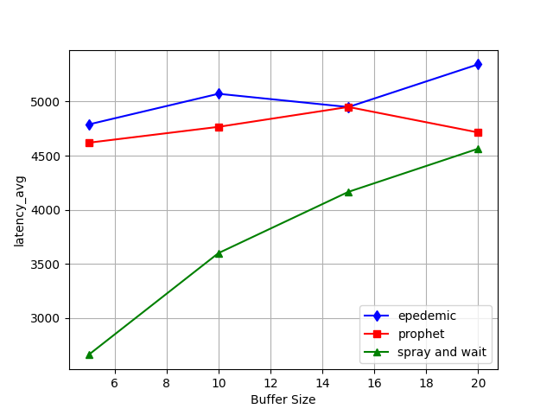
Figure 7. Average latency v/s buffer size
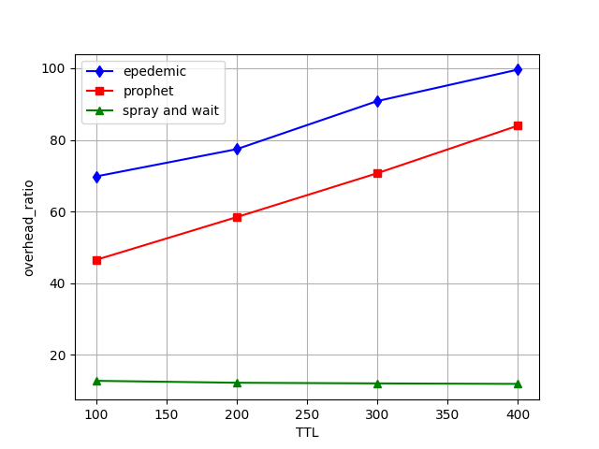
Figure 8. Overhead ratio v/s TTL
Figure 8 explores how the overhead ratio changes as TTL (Time-to-Live) values increase, representing how long messages persist in the network before expiring. Epidemic routing suffers from the highest overhead ratio, starting at 80% and climbing to 85% as TTL increases, due to its message flooding approach causing messages to persist longer in the network. Spray and Wait, with a more controlled message forwarding process, maintains a moderate overhead ratio, around 55%, increasing slightly with higher TTL values. ProPHET’s overhead ratio remains stable at 40% even as TTL increases, demonstrating its ability to manage resource consumption efficiently.

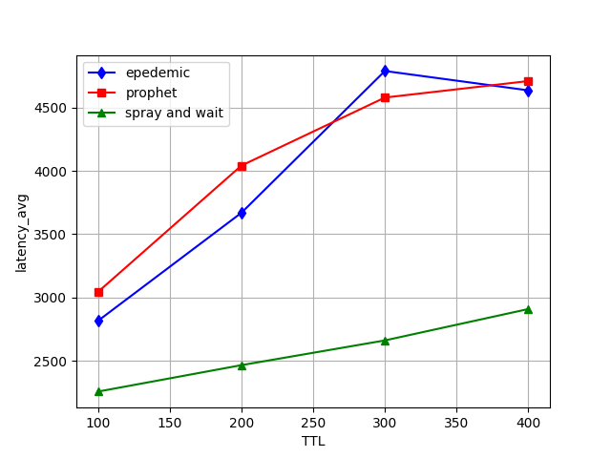
Figure 9. Average latency v/sTTL
In Figure 9, the effect of increasing TTL on average latency is shown for each routing protocol. As TTL increases, messages remain longer in the network, impacting delivery times. Epidemic routing displays the highest latency, starting at 75% and increasing to 80% as TTL grows, as messages flood the network and cause delays. Spray and Wait has a more moderate latency, around 55%, but still increases with higher TTL due to its waiting period before forwarding messages. ProPHET demonstrates much better latency control, staying around 40%, as its probabilistic nature allows faster message delivery even with higher TTL values.
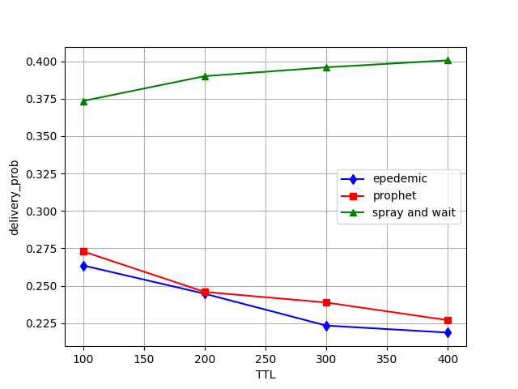
Figure 10. Delivery probability v/s TTL
Figure 10 compares the delivery probability across routing protocols as TTL increases. Epidemic routing achieves the highest delivery probability, starting at 80% and reaching 85% at higher TTL values, due to its message flooding ensuring multiple delivery attempts. Spray and Wait performs less well, with delivery probability starting at 60% and improving to 65% as TTL increases, limited by its conservative approach to message forwarding. ProPHET exhibits a better delivery probability, beginning at 70% and rising to 75%, thanks to its efficient routing based on encounter history.
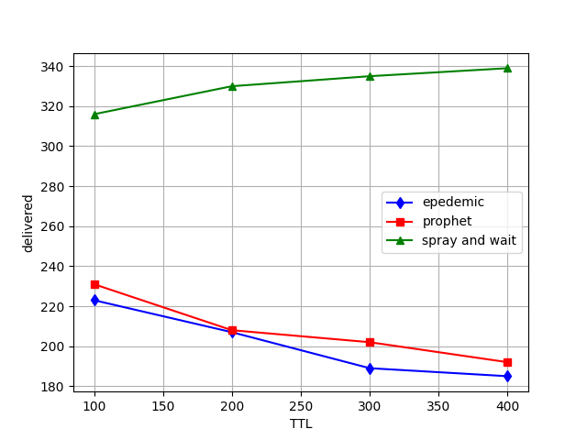
Figure 11. Delivered packets v/s TTL
In Figure 11, the number of packets delivered is compared across routing protocols as TTL increases. Epidemic routing again delivers the highest number of packets, starting at 80% and peaking at 85% as TTL increases, due to the multiple copies of messages circulating in the network. Spray and Wait lags behind, with packet delivery starting at 60% and reaching 65% with higher TTL. ProPHET performs better, starting at 70% and rising to 75%, benefiting from its efficient use of network resources.
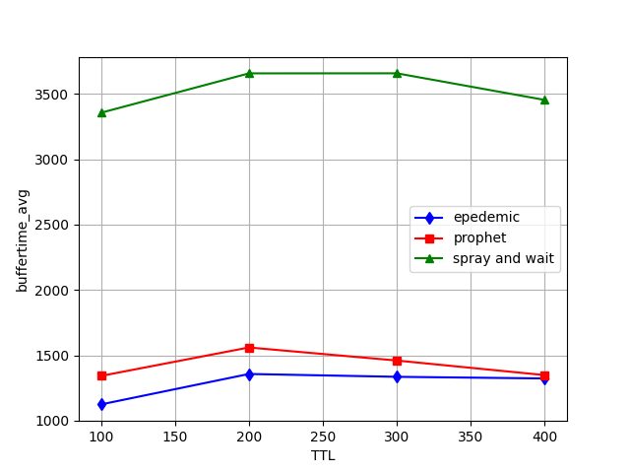
Figure 12. Average buffer time v/s TTL
Figure 12 shows how average buffer time varies with TTL across routing protocols. Epidemic routing has the longest buffer time, exceeding 80% at higher TTL values, as messages flood the network and cause congestion. Spray and Wait reduces buffer time compared to Epidemic, with times around 50%, but still experiences delays due to its waiting phase. ProPHET performs better, keeping buffer times around 40%, even at higher TTL values, as its probabilistic nature ensures faster message forwarding.
Table 3. Performance Metrics vs. Buffer Size
Routing Protocol | Overhead Ratio (%) | Packets Delivered (%) | Delivery Probability (%) | Average Buffer Time (%) | Average Latency (%)
Epidemic | 70 | 85 | 80-85 | 80 | 70
Spray and Wait | 40 | 60 | 65 | 50 | 50
ProPHET | 30 | 70 | 70 | 40 | 40

Table 4. Performance Metrics vs. TTL
Routing Protocol | Overhead Ratio (%) | Average Latency (%) | Delivery Probability (%) | Packets Delivered (%) | Average Buffer Time (%)
Epidemic | 80 | 75 | 85 | 85 | 80
Spray and Wait | 55 | 55 | 65 | 60 | 50
ProPHET | 40 | 40 | 70 | 70 | 40

Table 3 presents the performance metrics of different routing protocols—Epidemic, Spray and Wait, ProPHET, and Advanced Methods—across varying buffer sizes. The metrics include overhead ratio, packets delivered, delivery probability, average buffer time, and average latency. Epidemic routing had the highest overhead ratio (70%) but delivered 85% of packets with an 80-85% delivery probability. However, it incurred high buffer time (80%) and latency (70%). Spray and Wait showed a significant reduction in overhead (40%) but delivered fewer packets (60%), with a lower delivery probability (65%) and average buffer time (50%). ProPHET performed better in terms of overhead (30%), delivering 70% of packets with a 70% delivery probability and moderate buffer time (40%) and latency (40%). Table 4 compares the routing protocols' performance based on TTL (Time-to-Live). Epidemic routing showed the highest overhead ratio (80%) but also maintained the highest packet delivery (85%) and delivery probability (85%). However, this protocol had the highest buffer time (80%) and latency (75%). Spray and Wait reduced the overhead to 55% but suffered from lower delivery probability (65%) and packet delivery (60%) alongside moderate buffer time (50%) and latency (55%). ProPHET exhibited better control over overhead (40%) with improved delivery probability (70%) and packet delivery (70%), and maintained lower buffer time (40%) and latency (40%).
5. Conclusion
This paper provided an empirical analysis of the impact of routing protocols and network configurations (buffer size and TTL) on the detection of malicious nodes within O-IoT networks. The results reveal that ProPHET achieves a balance between efficiency and malicious node detection, while Epidemic routing offers better monitoring opportunities at the cost of resource overhead. Spray and Wait exhibited moderate performance, reducing network overhead but with higher latency. In future research, further refinements to routing protocols through machine learning techniques and adaptive cryptographic methods will be explored to optimize network performance and security simultaneously. Integrating blockchain and decentralized trust mechanisms may also improve the resilience of O-IoT systems against malicious activity.
Disclaimer (Artificial intelligence)
Author(s) hereby declare that NO generative AI technologies such as Large Language Models (ChatGPT, COPILOT, etc.) and text-to-image generators have been used during the writing or editing of this manuscript.

References
- Singha, Soamdeep, Biswapati Jana, Sharmistha Halder Jana, and Niranjan Kumar Mandal. "A survey to analyse routing algorithms for opportunistic network." Procedia Computer Science 171 (2020): 2501-2511.
- Dalal, Renu, Manju Khari, John Petearson Anzola, and Vicente García-Díaz. "Proliferation of opportunistic routing: A systematic review." IEEE access 10 (2021): 5855-5883.
- Ahmad, Khaleel, Muneera Fathima, Md Sharif Hossen, Jameel Ahamed, and Khairol Amali Bin Ahmad. "Opportunistic Networks: An Empirical Research of Routing Protocols and Mobility Models." SN Computer Science 4, no. 5 (2023): 652.
- Kandhoul, Nisha, and Sanjay Kumar Dhurandher. "An asymmetric RSA-based security approach for opportunistic IoT." In 2nd International Conference on Wireless Intelligent and Distributed Environment for Communication: WIDECOM 2019, pp. 47-60. Springer International Publishing, 2019.
- Yu, Lin, Gang Xu, ZhiFei Wang, Na Zhang, and FengQi Wei. "A hybrid opportunistic IoT secure routing strategy based on node intimacy and trust value." Security and Communication Networks 2022, no. 1 (2022): 6343764.
- Kaur, Navneet, and Gauri Mathur. "Opportunistic networks: A review." IOSR Journal of Computer Engineering (IOSR-ICE) 18, no. 2 (2016): 20-26.
- Ciobanu, Radu-Ioan, Ciprian Dobre, Mihai Dascălu, Ştefan Trăuşan-Matu, and Valentin Cristea. "SENSE: A collaborative selfish node detection and incentive mechanism for opportunistic networks." Journal of Network and Computer Applications 41 (2014): 240-249.
- Su, Bing, Chenhui Du, and Juan Huan. "Trusted opportunistic routing based on node trust model." Ieee Access 8 (2020): 163077-163090.
- Singh, Mohini, Pradeepika Verma, and Anshul Verma. "Security in opportunistic networks." In Opportunistic networks, pp. 299-312. CRC Press, 2021.
- Guo, Bin, Daqing Zhang, Zhu Wang, Zhiwen Yu, and Xingshe Zhou. "Opportunistic IoT: Exploring the harmonious interaction between human and the internet of things." Journal of Network and Computer Applications 36, no. 6 (2013): 1531-1539.
- Avoussoukpo, Cossi Blaise, Taiwo Blessing Ogunseyi, and Marius Tchenagnon. "Securing and facilitating communication within opportunistic networks: a holistic survey." IEEE access 9 (2021): 55009-55035.
- Srinidhi, N. N., E. Nagarjun, and S. M. Dilip Kumar. "Hybrid algorithm for efficient node and path in opportunistic iot network." Journal of Information Technology Management 13, no. Special Issue: Big Data Analytics and Management in Internet of Things (2021): 68-91.
- Lee, Seungchul, and Jae-Hoon Kim. "Opportunistic Block Validation for IoT Blockchain Networks." IEEE Internet of Things Journal 11, no. 1 (2023): 666-676.
- Mtibaa, Abderrahmen, Khaled Harras, and Hussein Alnuweiri. "Friend or foe? Detecting and isolating malicious nodes in mobile edge computing platforms." In 2015 IEEE 7th International Conference on Cloud Computing Technology and Science (CloudCom), pp. 42-49. IEEE, 2015.
- Lilien, Leszek, Zille Huma Kamal, Vijay Bhuse, and Ajay Gupta. "The concept of opportunistic networks and their research challenges in privacy and security." Mobile and wireless network security and privacy (2007): 85-117.
- Wu, Dapeng, Feng Zhang, Honggang Wang, and Ruyan Wang. "Security-oriented opportunistic data forwarding in mobile social networks." Future Generation Computer Systems 87 (2018): 803-815.
- Samaras, Nicholas S., Konstantinos Kokkinos, Costas Chaikalis, and Vasileios Vlachos. "On intrusion detection in opportunistic networks." In Proceedings of the 17th Panhellenic Conference on Informatics, pp. 67-74. 2013.
- Arafath, Mohammed Salman, and Khaleel Ur Rahman Khan. "Opportunistic sensor networks: a survey on privacy and secure routing." In 2017 2nd International Conference on Anti-Cyber Crimes (ICACC), pp. 41-46. IEEE, 2017.
- Sharma, Deepak Kumar, Kartik Krishna Bhardwaj, Siddhant Banyal, Riyanshi Gupta, Nitin Gupta, and Lewis Nkenyereye. "An opportunistic approach for cloud service-based IoT routing framework administering data, transaction, and identity security." IEEE Internet of Things Journal 9, no. 4 (2021): 2505-2512.
- Bangotra, Deep Kumar, Yashwant Singh, Arvind Selwal, Nagesh Kumar, and Pradeep Kumar Singh. "A trust based secure intelligent opportunistic routing protocol for wireless sensor networks." Wireless Personal Communications 127, no. 2 (2022): 1045-1066.
- Fernando, Niroshinie, Seng W. Loke, Iman Avazpour, Fei-Fei Chen, Amin B. Abkenar, and Amani Ibrahim. "Opportunistic fog for IoT: Challenges and opportunities." IEEE internet of things journal 6, no. 5 (2019): 8897-8910.
- Wang, Xiaojie, Zhaolong Ning, MengChu Zhou, Xiping Hu, Lei Wang, Bin Hu, Ricky YK Kwok, and Yi Guo. "A privacy-preserving message forwarding framework for opportunistic cloud of things." IEEE Internet of Things Journal 5, no. 6 (2018): 5281-5295.
- Rashidibajgan, Samaneh. "A trust structure for detection of sybil attacks in opportunistic networks." In 2016 11th International Conference for Internet Technology and Secured Transactions (ICITST), pp. 347-351. IEEE, 2016.
- Guo, Bin, Zhiwen Yu, Xingshe Zhou, and Daqing Zhang. "Opportunistic IoT: Exploring the social side of the internet of things." In Proceedings of the 2012 IEEE 16th International Conference on Computer Supported Cooperative Work in Design (CSCWD), pp. 925-929. IEEE, 2012.
- Rani, Poonam, Pushpinder Pal Singh, Arnav Balyan, Jyoti Shokeen, Vibha Jain, and Devesh Sangwan. "A secure epidemic routing using blockchain in opportunistic internet of things." In Data Analytics and Management: Proceedings of ICDAM, pp. 101-110. Springer Singapore, 2021.
- Kandhoul, Nisha, and Sanjay K. Dhurandher. "An efficient and secure data forwarding mechanism for opportunistic IoT." Wireless Personal Communications 118, no. 1 (2021): 217-237.
- Sharma, Deepak Kumar, Kartik Krishna Bhardwaj, Siddhant Banyal, Riyanshi Gupta, Nitin Gupta, and Lewis Nkenyereye. "An opportunistic approach for cloud service-based IoT routing framework administering data, transaction, and identity security." IEEE Internet of Things Journal 9, no. 4 (2021): 2505-2512.
- Yu, Lin, Gang Xu, ZhiFei Wang, Na Zhang, and FengQi Wei. "A hybrid opportunistic IoT secure routing strategy based on node intimacy and trust value." Security and Communication Networks 2022, no. 1 (2022): 6343764.
- Ayele, Eyuel D., Nirvana Meratnia, and Paul JM Havinga. "Towards a new opportunistic IoT network architecture for wildlife monitoring system." In 2018 9th IFIP international conference on new technologies, mobility and security (NTMS), pp. 1-5. IEEE, 2018.
- Malik, Ayasha, Bharat Bhushan, Anuj Kumar, and Raj Chaganti. "Opportunistic internet of things (OIoT): elucidating the active opportunities of opportunistic networks on the way to IoT." In New Trends and Applications in Internet of Things (IoT) and Big Data Analytics, pp. 209-224. Cham: Springer International Publishing, 2022.
- Dhurandher, Sanjay K., Jagdeep Singh, Petros Nicopolitidis, Raghav Kumar, and Geetanshu Gupta. "A blockchain-based secure routing protocol for opportunistic networks." Journal of Ambient Intelligence and Humanized Computing 13, no. 4 (2022): 2191-2203.
- Gou, Fangfang, and Jia Wu. "Novel data transmission technology based on complex IoT system in opportunistic social networks." Peer-to-Peer Networking and Applications 16, no. 2 (2023): 571-588.
- Vashishth, Vidushi, Anshuman Chhabra, and Deepak Kumar Sharma. "GMMR: A Gaussian mixture model based unsupervised machine learning approach for optimal routing in opportunistic IoT networks." Computer Communications 134 (2019): 138-148.
- Kandhoul, Nisha, Sanjay K. Dhurandher, and Isaac Woungang. "T_CAFE: a trust based security approach for opportunistic IoT." IET Communications 13, no. 20 (2019): 3463-3471.
- Dhurandher, Sanjay K., Satya J. Borah, Isaac Woungang, Aman Bansal, and Apoorv Gupta. "A location prediction-based routing scheme for opportunistic networks in an IoT scenario." Journal of Parallel and Distributed Computing 118 (2018): 369-378.
- Lyu, Chen, Xiaomei Zhang, Zhiqiang Liu, and Chi-Hung Chi. "Selective authentication based geographic opportunistic routing in wireless sensor networks for Internet of Things against DoS attacks." IEEE Access 7(2019): 31068-31082.
- Singh, Fateh, J. K. Vijeth, and C. Siva Ram Murthy. "Parallel opportunistic routing in IoT networks." In 2016 IEEE Wireless Communications and Networking Conference, pp. 1-6. IEEE, 2016.
- Lohachab, Ankur, and Ajay Jangra. "Opportunistic internet of things (IoT): Demystifying the effective possibilities of opportunisitc networks towards IoT." In 2019 6th international conference on signal processing and integrated networks (SPIN), pp. 1100-1105. IEEE, 2019.
- Nigam, Ritu, Deepak Kumar Sharma, Satbir Jain, Kartik Krishna Bhardwaj, and Siddhant Banyal. "AI‐enabled trust‐based routing protocol for social opportunistic IoT networks." Transactions on Emerging Telecommunications Technologies 35, no. 4 (2024): e4330.
- Tumula, Sridevi, Y. Ramadevi, E. Padmalatha, G. Kiran Kumar, M. Venu Gopalachari, Laith Abualigah, Premkumar Chithaluru, and Manoj Kumar. "An opportunistic energy‐efficient dynamic self‐configuration clustering algorithm in WSN‐based IoT networks." International Journal of Communication Systems 37, no. 1 (2024): e5633.
- Bhardwaj, Moulik, Jagdeep Singh, Nitin Gupta, Kuldeep Singh Jadon, and Sanjay Kumar Dhurandher. "A novel federated learning approach for routing optimisation in opportunistic IoT networks." International Journal of Sensor Networks 46, no. 1 (2024): 24-38.
- Khalil, Ayman, and Besma Zeddini. "A Secure Opportunistic Network with Efficient Routing for Enhanced Efficiency and Sustainability." Future Internet 16, no. 2 (2024): 56.
- ltulaihan, Esra, Mohammed Amin Almaiah, and Ahmed Aljughaiman. "Anomaly Detection IDS for Detecting DoS Attacks in IoT Networks Based on Machine Learning Algorithms." Sensors 24, no. 2 (2024): 713.
- Thai, Chan Dai Truyen. "Opportunistic Routing and Energy Harvesting in Multi-tier Networks against Jamming Attacks." In 2024 International Wireless Communications and Mobile Computing (IWCMC), pp. 214-219. IEEE, 2024.

