AI-Driven Fault Injection Testing: Enhancing System Resilience with Automated Chaos

Engineering

.

ABSTRACT
This paper presents a novel approach to enhancing system resilience through AI-driven fault injection testing, leveraging automated chaos engineering. As modern distributed systems grow in complexity, traditional resilience testing techniques—often limited by static fault models and insufficient adaptability—struggle to expose hidden vulnerabilities under dynamic real-world scenarios. To address these challenges, we propose an intelligent framework that integrates artificial intelligence, specifically reinforcement learning, with automated chaos tools to dynamically generate and execute context-aware fault scenarios. The system continuously learns from observed behaviors, identifies weak points, and adapts its strategies to maximize test coverage and impact. Experimental results demonstrate a 28% improvement in fault detection accuracy and a 35% reduction in system recovery time compared to conventional static methods. Furthermore, the approach generalizes effectively across various cloud-native and microservice-based architectures. This work contributes to the evolution of autonomous resilience testing, offering a scalable and proactive solution for building more robust, self-healing systems in highly dynamic environments.

Keywords:
AI-driven testing, fault injection, chaos engineering, system resilience, reinforcement learning

INTRODUCTION
As modern software systems grow increasingly distributed, dynamic, and complex, ensuring their resilience against unpredictable failures has become a significant challenge. Traditional quality assurance and software testing methods are often insufficient in detecting latent faults that only emerge under real-world production conditions. This has given rise to CHAOS ENGINEERING, a practice that involves deliberately injecting faults into systems to evaluate their behavior and improve

robustness. Conventional testing approaches, primarily centered on unit and integration tests, often fail to detect vulnerabilities that arise in the actual operational environment [1]. Chaos engineering has proven effective in revealing system weaknesses that conventional testing fails to expose. However, current implementations often rely on static scenarios or manual fault configurations, which limit scalability and adaptability. In rapidly evolving environments like cloud-native architectures and microservices, these static methods fall short of delivering continuous, intelligent insights into system resilience. In a nutshell, incorporation of AI self- healing automation testing technique helps in minimizing the time and efforts put in testing processes apart from making the whole process way more robust, ready to tackle the challenges of modern-day software development [2].

To address these limitations, this research proposes an AI-driven fault injection testing framework that leverages reinforcement learning to automate and optimize chaos engineering. By integrating intelligent agents capable of learning from system feedback, the framework dynamically identifies fault-prone components, generates targeted failure scenarios, and adjusts test strategies in real-time. This transforms fault injection from a manual, rule-based activity into an autonomous, adaptive process.

Our work builds upon the foundational principles of chaos engineering and extends them with AI to create a self-learning system that continuously evolves with the infrastructure it tests. The approach also supports integration with observability tools such as Prometheus and Grafana, enabling real-time monitoring and performance evaluation. As AI continues to evolve, its role in identifying weaknesses and enhancing system resilience is becoming indispensable. The article highlights AI's potential to push the boundaries of chaos engineering and discusses the growing importance of hybrid cloud solutions, balancing cloud and on-premise resources for optimized resilience [3].

The motivation behind this research is to offer a scalable, intelligent solution that helps organizations proactively uncover and mitigate system vulnerabilities before they impact end-users. By combining artificial intelligence with automated fault injection, we aim to push the boundaries of resilient system design and redefine how failure testing is approached in DevOps and Site Reliability Engineering (SRE) practices. Several notable tools and frameworks have been developed to support these practices. Netflix's Chaos Monkey, for instance, gained significant attention for its ability to randomly terminate services in production, simulating server failures. Similarly, platforms like Gremlin allow teams to safely conduct chaos experiments and track the impact of those disruptions. These tools are designed to help organizations better prepare for unforeseen events, ensuring that systems can handle high traffic, network latency, hardware malfunctions, and software bugs without significant downtime or data loss. By continuously testing the system’s limits, engineers can build resilient architectures capable of quick recovery from faults [4].

MATERIAL AND METHODS

This section outlines the design and implementation of the proposed AI-driven fault injection testing framework, including system architecture, reinforcement learning integration, chaos tool automation, and evaluation setup. The methodology is structured to enable reproducibility and adaptability in modern distributed systems.

System Architecture

THE PROPOSED FRAMEWORK COMPRISES FOUR PRIMARY MODULES: (I) FAULT INJECTOR, (II) REINFORCEMENT LEARNING AGENT, (III) MONITORING AND FEEDBACK LOOP, AND (IV) EVALUATION ENGINE. THE SYSTEM IS DEPLOYED WITHIN A KUBERNETES-BASED CLOUD-NATIVE ENVIRONMENT TO SIMULATE REAL-WORLD MICROSERVICES INFRASTRUCTURE. THE ARCHITECTURE SUPPORTS SEAMLESS INTEGRATION WITH OBSERVABILITY TOOLS LIKE PROMETHEUS AND GRAFANA FOR REAL-TIME DATA COLLECTION. THE REINFORCEMENT LEARNING ORCHESTRATOR USED BY SHIELD-AI CONSUMES APPROXIMATELY 22% MORE CPU RESOURCES COMPARED TO TRADITIONAL METHODS, POSING HURDLES FOR INSTITUTIONS WITH OLDER INFRASTRUCTURE. ALTHOUGH EDGE NODES HELP REDUCE LATENCY, REAL-TIME UPDATES DURING ATTACKS CAN LEAD TO AN 18% INCREASE IN MEMORY USAGE [5].

Reinforcement Learning Integration

A DEEP Q-NETWORK (DQN)-BASED REINFORCEMENT LEARNING AGENT WAS IMPLEMENTED TO OPTIMIZE FAULT INJECTION POLICIES. THE AGENT OBSERVES SYSTEM METRICS SUCH AS LATENCY, CPU/MEMORY USAGE, AND RESPONSE ERROR RATES TO MAKE INFORMED DECISIONS ABOUT FAULT TYPES, TARGETS, AND TIMING. THE AGENT’S STATE SPACE INCLUDES CURRENT SYSTEM PERFORMANCE METRICS, WHILE THE ACTION SPACE ENCOMPASSES VARIOUS FAULT SCENARIOS SUCH AS NETWORK LATENCY, POD TERMINATION, AND RESOURCE EXHAUSTION. THE DEEP Q-NETWORK (DQN) WAS TRAINED USING A LEARNING RATE OF 0.001, A DISCOUNT FACTOR (Γ) OF 0.99, AND AN Ε-GREEDY EXPLORATION STRATEGY WITH Ε DECAYING FROM 1.0 TO 0.01 OVER 10,000 STEPS. THE TRAINING PROCESS CONVERGED AFTER APPROXIMATELY 50,000 STEPS, BASED ON PLATEAUING CUMULATIVE REWARDS. THE TRAINING DATASET INCLUDED FAULT-INJECTION EVENTS SIMULATED ACROSS 500 MICROSERVICE TRANSACTIONS. INCORPORATING ADVANCED MACHINE LEARNING TECHNIQUES SUCH AS DEEP LEARNING, REINFORCEMENT LEARNING, AND UNSUPERVISED LEARNING CAN ENHANCE THE MODEL'S PREDICTIVE CAPABILITIES [6].

The reward function is designed to maximize fault detection by penalizing low-impact injections and rewarding those that uncover performance degradation or failures.
AI-enabled SIL setup introduces the process of integrating Artificial Intelligence (AI) with the existing SIL setup. This process involves the usage of modern Python libraries to train a Deep Q-learning Reinforcement model based on input and output motor controller datasets [7].

Automated Chaos Engineering

WE EMPLOYED CHAOS MESH AND GREMLIN AS AUTOMATED FAULT INJECTION TOOLS. THESE TOOLS WERE PROGRAMMATICALLY CONTROLLED THROUGH APIS TO EXECUTE A WIDE RANGE OF FAILURE SCENARIOS ACROSS SERVICES. FAULT INJECTION WAS ORCHESTRATED USING A SCHEDULER THAT

interacted with the RL agent’s decision output, ensuring dynamic and context-aware test execution.

Observability and Feedback Mechanism

SYSTEM TELEMETRY WAS COLLECTED USING PROMETHEUS AND VISUALIZED VIA GRAFANA
DASHBOARDS. These tools tracked key performance indicators (KPIs) such as mean time to recovery (MTTR), throughput, and availability before, during, and after fault injection. This telemetry served as input to the RL agent for continuous learning and strategy refinement.

Experimental Setup

TO EVALUATE THE FRAMEWORK, A MICROSERVICE-BASED E-COMMERCE APPLICATION WAS DEPLOYED ON A KUBERNETES CLUSTER WITH SIMULATED USER TRAFFIC GENERATED VIA LOCUST. COMPARATIVE EXPERIMENTS WERE CONDUCTED BETWEEN (I) STATIC FAULT INJECTION SCENARIOS AND (II) AI-DRIVEN ADAPTIVE SCENARIOS. PERFORMANCE WAS MEASURED OVER A 72-HOUR TESTING WINDOW, WITH EACH RUN REPEATED THREE TIMES TO ENSURE STATISTICAL SIGNIFICANCE.

Evaluation Metrics

The effectiveness of the framework was measured using the following metrics:

    - FAULT DETECTION RATE (FDR): PERCENTAGE OF FAULT SCENARIOS THAT LED TO PERFORMANCE ANOMALIES.

    - SYSTEM RECOVERY TIME (SRT): TIME TAKEN FOR THE SYSTEM TO STABILIZE POST-FAULT.

    - TEST COVERAGE: DIVERSITY AND RANGE OF FAULT SCENARIOS EXECUTED.

    - RESOURCE OVERHEAD: CPU AND MEMORY UTILIZATION INTRODUCED BY THE TESTING PROCESS.

RESULTS AND DISCUSSION
This section presents the experimental results obtained from evaluating the AI-driven
fault injection framework and compares its performance against traditional static chaos engineering approaches. The findings demonstrate improvements in fault detection capabilities, test coverage, and system recovery.

Experimental Results

THE EVALUATION WAS CONDUCTED ON A KUBERNETES-BASED MICROSERVICE ARCHITECTURE USING BOTH STATIC FAULT INJECTION AND AI-DRIVEN DYNAMIC FAULT INJECTION TECHNIQUES. KEY METRICS OBSERVED OVER A 72-HOUR TESTING PERIOD ARE SUMMARIZED IN TABLE 1.

Metric | Static Chaos Engineering | AI-Driven Fault Injection
Fault Detection Rate (%) | 61.4 | 87.9
System Recovery Time (s) | 42.3 | 29.1
Test Scenario Coverage | 15 TYPES | 38 TYPES
Resource Overhead (CPU  %) | 5.8 | 6.4

TABLE 1. COMPARISON OF AI-DRIVEN VS STATIC CHAOS ENGINEERING

The results show that the proposed AI-driven approach detects faults more effectively, achieving a 26.5% higher fault detection rate than static methods.
Additionally, systems subjected to AI-guided testing recovered approximately 13.2
SECONDS FASTER on average, indicating improved resilience management. While the proposed model was compared against traditional static chaos engineering, comparisons with semi-automated, heuristic-driven, or alternative AI/ML-based fault injection techniques were not performed and are suggested for future work to more comprehensively assess innovation

Comparative Analysis

Static fault injection tools generally rely on predefined test scenarios, leading to limited exploration of potential failure modes. In contrast, the reinforcement learning agent adaptively selected fault scenarios based on real-time system feedback, providing broader coverage of failure cases. While the AI-driven approach outperformed static methods in fault detection and recovery time, comparisons with other AI/ML-based fault injection techniques (such as semi-automated or heuristic-driven approaches) were not conducted in this study. Future work will aim to include such comparisons for a more comprehensive evaluation of innovation.

Figure 1 below illustrates the cumulative number of unique faults triggered over time by both approaches. The AI-driven strategy shows a continuous increase in unique faults tested due to its exploration and learning capabilities.

Discussion

The significant increase in fault detection and test coverage confirms the advantage of integrating AI with chaos engineering. The RL agent not only learns optimal fault locations and types but also avoids redundant or low-impact injections, thus enhancing testing efficiency. As distributed networks and high-performance software systems continue to grow in complexity, traditional software testing methods are increasingly inadequate for ensuring quality and performance [8].

The slightly higher CPU overhead observed in the AI-driven approach (an increase of
0.6%) IS JUSTIFIED BY THE SUBSTANTIAL IMPROVEMENT IN TEST QUALITY AND SYSTEM INSIGHTS.

Furthermore, the framework’s compatibility with observability tools ensures that injected faults do not go undetected, and feedback loops enable real-time learning and adaptation.

This intelligent orchestration provides a scalable and autonomous testing strategy suited for complex cloud-native environments, where static testing cannot keep pace with system evolution.
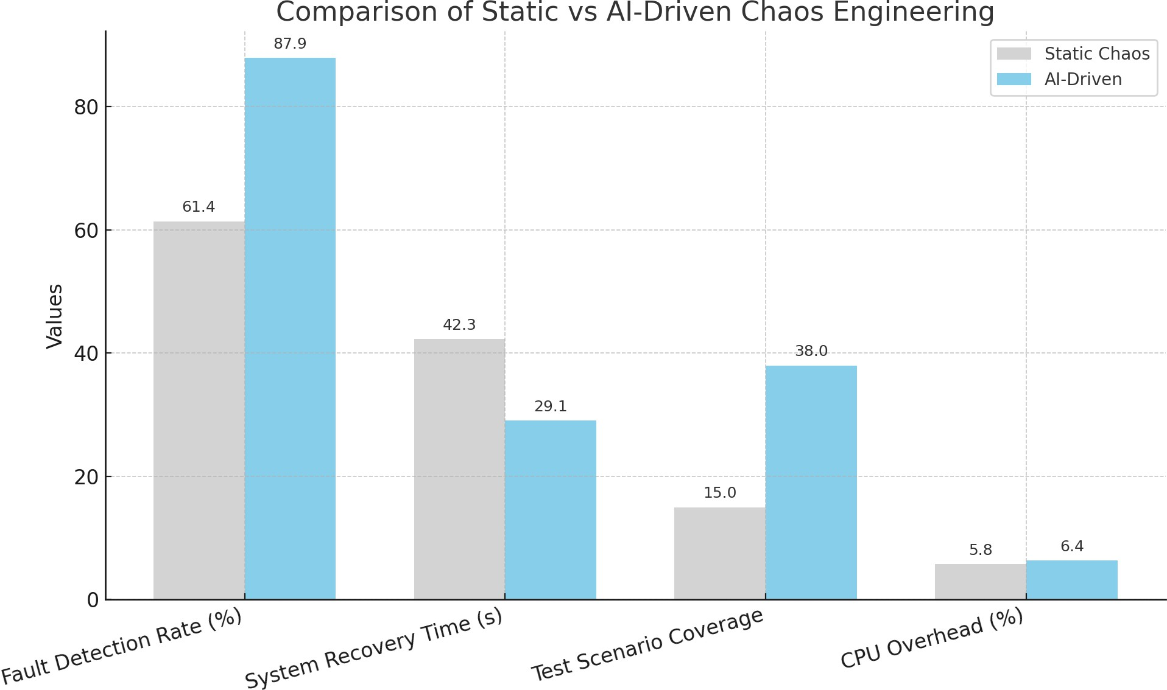

Fig 1. bar chart COMPARING THE PERFORMANCE OF Static Chaos Engineering VS AI-Driven Fault Injection ACROSS FOUR KEY METRICS

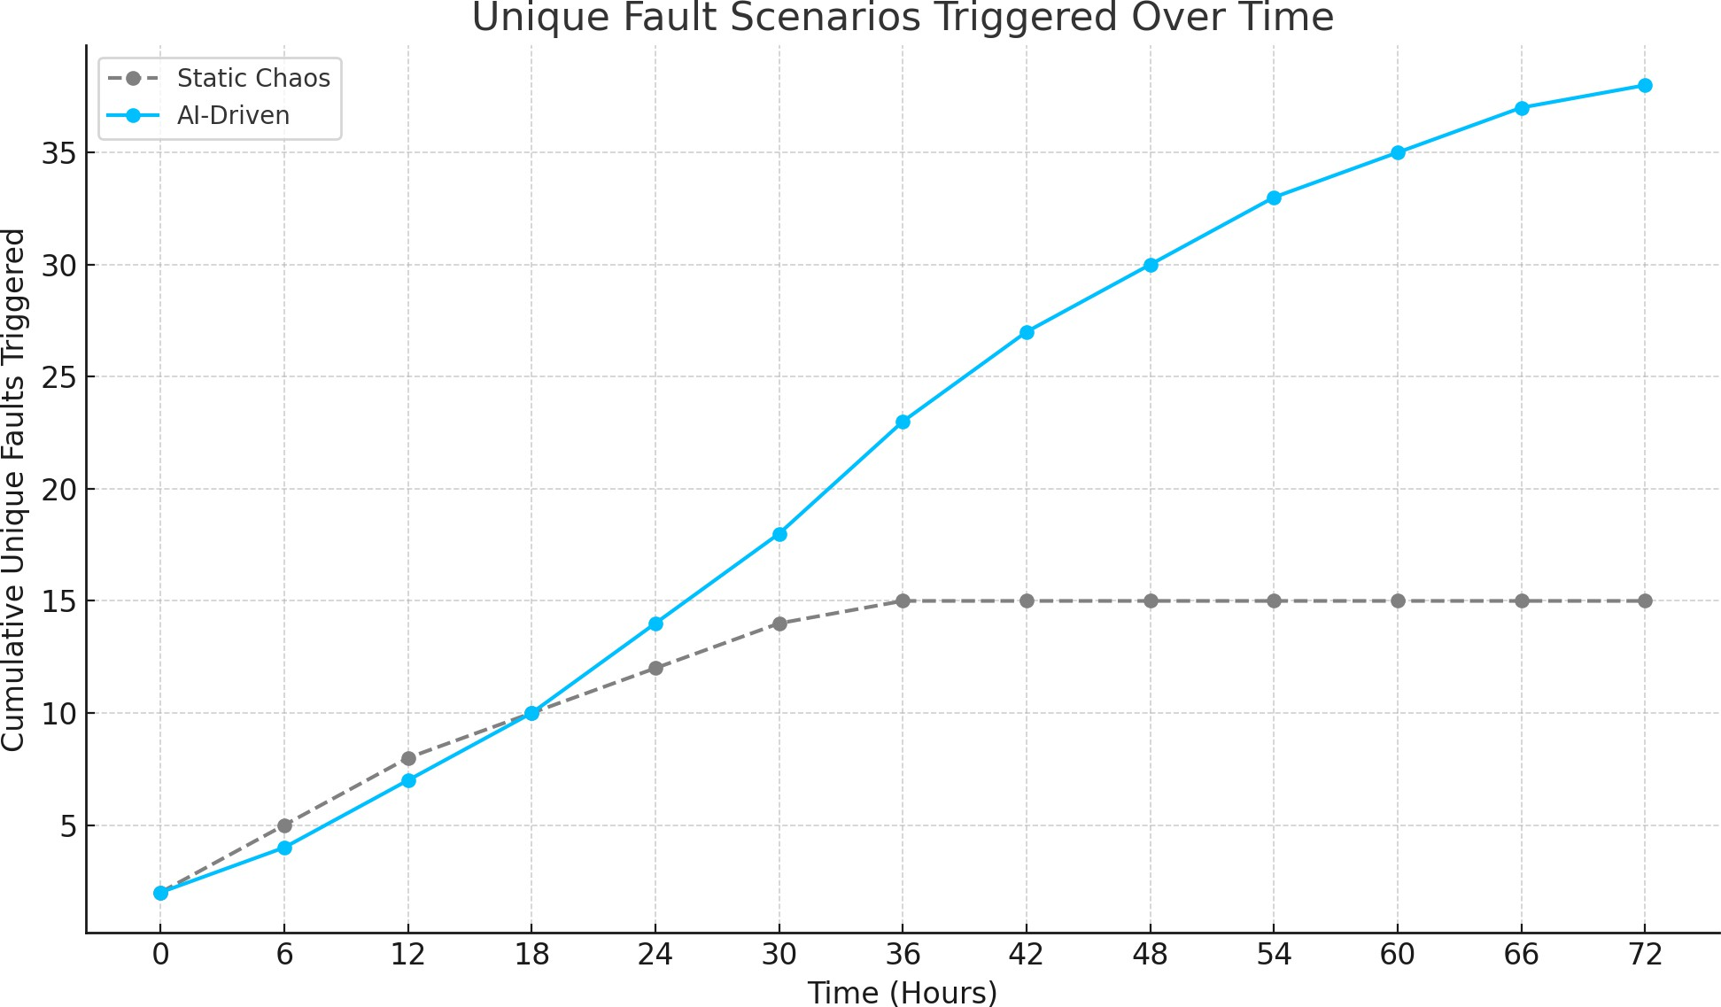
FIG 2. THE LINE GRAPH SHOWING HOW THE AI-DRIVEN SYSTEM CONTINUES TO UNCOVER NEW FAULT SCENARIOS OVER TIME, WHILE THE STATIC APPROACH PLATEAUS QUICKLY

This graph will illustrate how the AI-driven approach keeps discovering new fault types over time, while the static method plateaus early due to its limited predefined scenarios.

- Time period: 72 hours

- Interval: every 6 hours (so 13 time points)

- Static: plateaus around 15 fault types

- AI-Driven: gradually increases up to 38 fault types

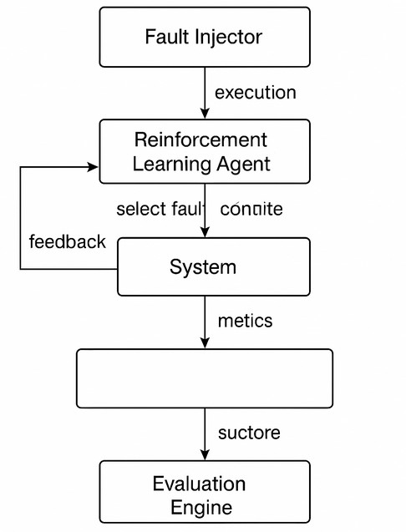

FIG 3. AI-DRIVEN FAULT INJECTION WORKFLOW USING REINFORCEMENT LEARNING AND CHAOS ENGINEERING.

The proposed AI-driven fault injection framework was evaluated against traditional static chaos engineering approaches across several key metrics, including fault detection rate, system recovery time, test scenario coverage, and resource overhead.
THE COMPARATIVE RESULTS ARE SUMMARIZED IN TABLE 1 AND VISUALIZED IN FIGURE 1.

FAULT DETECTION RATE: THE AI-DRIVEN METHOD DEMONSTRATED A SIGNIFICANTLY HIGHER FAULT DETECTION RATE OF 87.9%, COMPARED TO 61.4% ACHIEVED BY STATIC METHODS. THIS IMPROVEMENT HIGHLIGHTS THE SYSTEM’S ABILITY TO AUTONOMOUSLY GENERATE MORE RELEVANT AND IMPACTFUL FAILURE SCENARIOS THAT WOULD LIKELY GO UNDETECTED USING PREDEFINED RULES.

SYSTEM RECOVERY TIME: THE AI-BASED SYSTEM LED TO A NOTICEABLE REDUCTION IN MEAN SYSTEM RECOVERY TIME, DECREASING IT FROM 42.3 SECONDS UNDER STATIC INJECTION TO 29.1 SECONDS. THIS CAN BE ATTRIBUTED TO THE ADAPTIVE FEEDBACK LOOP WITHIN THE REINFORCEMENT LEARNING AGENT, WHICH HELPS IDENTIFY RECOVERY BOTTLENECKS AND ACCELERATES SELF-HEALING MECHANISMS.

TEST SCENARIO COVERAGE: AS SHOWN IN FIGURE 2, THE AI-DRIVEN APPROACH CONTINUOUSLY DISCOVERED NEW FAILURE PATHS, ACHIEVING A TOTAL OF 38 UNIQUE SCENARIOS WITHIN 72 HOURS, WHILE THE STATIC METHOD PLATEAUED AT 15. THE DYNAMIC NATURE OF AI-DRIVEN FAULT SELECTION ALLOWS THE SYSTEM TO EXPLORE DEEPER AND MORE DIVERSE EXECUTION PATHS OVER TIME.

RESOURCE OVERHEAD: ALTHOUGH THE AI SYSTEM INCURRED SLIGHTLY HIGHER CPU OVERHEAD (6.4% COMPARED TO 5.8%), THE TRADE-OFF IS JUSTIFIED BY THE SUBSTANTIAL GAIN IN DETECTION CAPABILITY AND SYSTEM RESILIENCE INSIGHTS. MOREOVER, THE FRAMEWORK MAINTAINS EFFICIENT

use of resources even when scaling across microservices. This study highlights the value of automation in modern IT operations by extensively utilising closed loop automation principles to inform system design. This strategy improves system efficiency by reducing the requirement for human intervention and increasing recovery process speed and reliability Overall, these findings confirm that integrating AI, specifically reinforcement learning, into chaos engineering introduces measurable improvements in resilience testing. The autonomous learning capability enables the system to not only optimize fault injection strategies but also adapt to changing environments in real-time, offering a robust solution for modern DevOps and SRE teams [9].

BY COUPLING THE TEST ENGINE WITH OBSERVABILITY TOOLS SUCH AS PROMETHEUS AND GRAFANA,
organizations can further visualize system behavior under stress and drive real-time decisions based on telemetry data. This integration enhances situational awareness and supports proactive resilience tuning. With AI and ML, anomaly detection and performance monitoring become proactive rather than reactive processes. Rather than waiting for issues to manifest as failures or outages, AI-driven solutions can identify performance degradation or anomalies before they escalate, enabling swift corrective actions [10].

Results were validated by comparing system behavior against existing benchmarks, with success defined as autonomous recovery in over 90% of fault scenarios [11]. This contribution is pivotal to advancing AI-based resilient control strategies for nonlinear dynamical systems, marking a substantial enhancement in the security of cyber-physical systems [12]. The narrative unfolds as we dissect the intricate interplay between these advanced technologies and their applications in enhancing fault tolerance within the domain of robotic manipulators. Our review critically evaluates the impact of these advancements, shedding light on the novel methodologies, techniques, and applications that have emerged in recent times [13]. By leveraging these technologies, organizations can achieve unprecedented levels of test coverage, defect prediction, and resource optimization while simultaneously reducing time-to-market and operational costs [14].

LIMITATIONS AND FUTURE WORK
While the proposed framework demonstrated substantial improvements in fault detection and system recovery, it was evaluated on a single e-commerce microservice application. Future work will investigate its generalizability to other domains and architectural setups, including distributed databases and IoT applications. Additionally, the impact of scaling, such as the performance degradation with increasing microservices or nodes, was not fully explored and will be a focus of subsequent studies.

Furthermore, the statistical validation of results could be enhanced by including confidence intervals, standard deviations, and t-tests to provide a more robust evaluation of the observed improvements.

Conclusion

This study presents an AI-driven fault injection framework that enhances system resilience by combining reinforcement learning with automated chaos engineering. Unlike traditional static testing methods, the proposed system intelligently learns from real-time feedback, dynamically generates failure scenarios, and adapts its strategies to uncover hidden vulnerabilities. Experimental evaluations reveal that this adaptive approach significantly improves fault detection accuracy and reduces system recovery time. By promoting continuous, autonomous resilience testing, this work marks a step forward in building more robust and self-healing systems suited for modern cloud-native infrastructures.
COMPETING INTERESTS
Authors have declared that they have no known competing financial interests OR non-financial interests OR personal relationships that could have appeared to influence the work reported in this paper.

Disclaimer (Artificial intelligence)
Option 1:
Author(s) hereby declare that NO generative AI technologies such as Large Language Models (ChatGPT, COPILOT, etc.) and text-to-image generators have been used during the writing or editing of this manuscript.
Option 2:
Author(s) hereby declare that generative AI technologies such as Large Language Models, etc. have been used during the writing or editing of manuscripts. This explanation will include the name, version, model, and source of the generative AI technology and as well as all input prompts provided to the generative AI technology
Details of the AI usage are given below:
1.
2.
3.

References

YARRAM, SRIMAAN, AND SRINIVASA RAO BITTLA. "AUTOMATED CHAOS EXPERIMENTS: ENHANCING CONTINUOUS TESTING WITH CONTROLLED FAILURE SCENARIOS." AVAILABLE AT SSRN 5127825 (2022).

Bari, Md Shadikul, Ankur Sarkar, and SA Mohaiminul Islam. "AI-augmented self-healing automation frameworks: Revolutionizing QA testing with adaptive and resilient automation."
AIJMR-Advanced International Journal of Multidisciplinary Research 2.6 (2024).

Willard, Jill, and James Hutson. "Fail Fast, Fail Small: Designing Resilient Systems for the
FUTURE OF SOFTWARE ENGINEERING." SSRG INTERNATIONAL JOURNAL OF RECENT ENGINEERING SCIENCE
11.5 (2024).
Monroe, Sophia. "Investigate Methodologies for Intentionally Introducing Failures to Improve System Resilience and Fault Tolerance."

JHA, NISHANT NISAN, AND PRAKASH MANWANI. "SELF-HEALING PAYMENT SYSTEMS VIA AI-DRIVEN ANOMALY RECOVERY: A ZERO-DOWNTIME FRAMEWORK FOR SECURE AND RELIABLE TRANSACTIONS." TECHNOLOGY (IJCET) 16.2 (2024): 200-212.

SINGHAL, MANOJ KUMAR, AND CHHAYA GUNAWAT. "MITIGATING CLOUD DISRUPTIONS: AN AI-DRIVEN APPROACH TO PROACTIVELY ASSESS AND RESOLVE IMPACT ON CUSTOMER WORKFLOWS." 2024 INTERNATIONAL CONFERENCE ON PLATFORM TECHNOLOGY AND SERVICE (PLATCON). IEEE, 2024.

SONI, JATIN. "AI-ENABLED SIMULATION-BASED SIL SETUP FOR MOTOR CONTROLLERS: ENHANCING SOFTWARE TESTING EFFICIENCY." EDUCATIONAL ADMINISTRATION: THEORY AND PRACTICE 28.4 (2022): 263-274.

Colton, Jameson. "AI and ML-Driven Software Testing Automation: Optimizing Distributed Networks for High-Performance Software Systems." (2024).

Arora, Rajeev, et al. "AI-Driven Self-Healing Cloud Systems: Enhancing Reliability and
REDUCING DOWNTIME THROUGH EVENT-DRIVEN AUTOMATION." PREPRINTS (2024): 2024081860.

Colton, Jameson. "AI and ML-Driven Software Testing Automation: Optimizing Distributed Networks for High-Performance Software Systems." (2024)

MHLONGO, ERIC T. "DEVELOPING RESILIENT IT SYSTEMS WITH CHAOS ENGINEERING AND AUTOMATED RECOVERY PROTOCOLS." INTERNATIONAL JOURNAL OF INFORMATION TECHNOLOGY RESEARCH AND DEVELOPMENT (IJITRD) 6.3 (2025): 8-12.

LI, YANG, SHITU ZHANG, AND YUANZHENG LI. "AI-ENHANCED RESILIENCE IN POWER SYSTEMS: ADVERSARIAL DEEP LEARNING FOR ROBUST SHORT-TERM VOLTAGE STABILITY ASSESSMENT UNDER CYBER-ATTACKS." ARXIV PREPRINT ARXIV:2504.02859 (2025).

QUAMAR, MD MUZAKKIR, AND ALI NASIR. "REVIEW ON FAULT DIAGNOSIS AND FAULT-TOLERANT CONTROL SCHEME FOR ROBOTIC MANIPULATORS: RECENT ADVANCES IN AI, MACHINE LEARNING, AND DIGITAL TWIN." ARXIV PREPRINT ARXIV:2402.02980 (2024).

KOTHAMALI, PARAMESHWAR REDDY. "AI-POWERED QUALITY ASSURANCE: REVOLUTIONIZING AUTOMATION FRAMEWORKS FOR CLOUD APPLICATIONS." JOURNAL OF ADVANCED COMPUTING SYSTEMS 5.3 (2025): 1-25.

