ML-BASED ENSEMBLE LEARNING DATA MODEL FOR CLASSIFICATION PROBLEMS IN BANK MARKETING PREDICTION

Abstract: This new data modelling strategy is aimed at improving predictions for telemarketing campaigns targeting potential customers for long-term deposit products at a Portuguese retail bank. The dataset includes detailed information about clients, the bank’s products, and various socio-economic factors, some of which reflect the impact of the financial crisis. Starting from an initial pool of 150 features, the model narrows this down to 21 key variables, including the target label. Our approach leverages ensemble learning and treats each feature type independently during preprocessing, followed by normalization to enhance overall predictive accuracy. To evaluate the efficiency of this technique, we compare the throughput of five widely-used classification algorithms, both individually and as part of an ensemble. The results demonstrate that integrating these techniques within an ensemble framework leads to consistently higher accuracy across all models.
Keywords: AI, Ensemble Learning, Data Model, Classification Problems, Bank Marketing Prediction
- Introduction
Marketing to the right audience has always been a key challenge for banks striving for long-term success. To reach potential clients, banks typically rely on channels like social media, digital advertising, customer service, and strategic partnerships. However, the question remains: how can banks target specific locations, demographics, or social groups with greater precision?

Thanks to advancements in machine learning, the way banks approach marketing has significantly evolved. By harnessing data and analytics, financial institutions can now craft targeted strategies to identify customers who are more likely to subscribe to particular financial products.

In this project, we explore how a Portuguese bank can leverage machine learning to prioritize and target clients most likely to open a term deposit account. The dataset used originates from the bank’s direct marketing campaigns, which primarily involved phone calls. Often, multiple calls were made to the same client to determine whether they would ultimately subscribe to the deposit. Additionally, we introduce the concept of a 'Multi-Banking System' interface—an extended banking solution designed for clients with multiple accounts across different banks. This unified platform integrates services from various banks, offering both retail and corporate users a centralized way to manage their finances. It serves as a bridge between customers and multiple banking institutions, allowing users to log in once and carry out transactions across different accounts seamlessly. The backend ensures that all necessary operations are executed efficiently to complete each transaction without disruption. Figure 1 shows the Bank marketing campaign analysis with Machine Learning.

Figure 1: Bank marketing campaign analysis with Machine Learning

The following paper deals with the background analysis in section 2. Section 3 deals with the methods and architecture of bank marketing. Section 4 discusses statistical outcomes and investigation. The final segment accomplishes the paper.

- Background Analysis
In the world of banking, machine learning has become a powerful tool for improving marketing strategies. By analysing customer data, banks can deliver personalized experiences, run more targeted campaigns, and assess risks more effectively. This results in greater efficiency and deeper customer engagement.

The prime goal of this paper is to develop a scheme that can integrate multiple bank accounts into a single software-based platform. We propose a Composite Multi-Banking Application that allows users to access all of their bank accounts using just one username and password. This solution offers a simple, fast, and secure way for customers to manage accounts from various banks through one unified interface.

This multi-banking system is an innovative web application intended to help users keep track of and interact with multiple financial accounts. Many individuals maintain accounts across several banks, and it can be inconvenient to remember separate login credentials for each one. Typically, customers need to log into different banking portals to carry out transactions, which can be time-consuming and raise security concerns. With our proposed system, users can save time and enjoy all the essential features of their respective banks within a single platform.

Currently, while there are many banks in the market, users can only transact with one bank at a time—either in person or through that bank’s dedicated website. No existing solution allows seamless access to all banks through a single portal. As a result, users are forced to juggle multiple usernames and passwords, increasing complexity and inconvenience. To solve this, we introduce a Multi-Banking System through a shared gateway that consolidates access to various banks. Together, these components ensure that customers can conduct secure banking operations across multiple institutions from one centralized location.

- Proposed System and Architecture
The main objective of this application is to enable customers with accounts across different banks to access and manage all their accounts through a single platform. With this solution, users no longer need to log into each bank’s individual website or app. Everything can be handled in one place.

The system includes an Admin role, responsible for managing and maintaining the application. The admin can add new banks, update existing bank details, and review customer registration requests—either approving or rejecting them. The platform is designed to support both bank administrators and customers by offering a range of services tailored to their specific needs. In this system, the admin functions as the overall controller with full system privileges. Any customer with an active bank account can use the web-based application to access their accounts.

When it comes to building the application, software design plays a crucial role. Software design is the process of planning and creating software solutions to meet specific goals while working within defined constraints and using available resources. It involves both high-level architectural planning and detailed component-level design. Depending on the context, software design can refer either to the broad process of conceptualizing, planning, and modifying complex systems or, more specifically, to the stage that follows requirement gathering and precedes actual coding in the software development lifecycle.

A system architecture diagram helps visualize the structure of the application. It typically uses blocks to represent core components or functions, and lines to illustrate how those components interact. These diagrams are used to give a clear, high-level understanding of the system’s overall structure, focusing more on concept than implementation details.

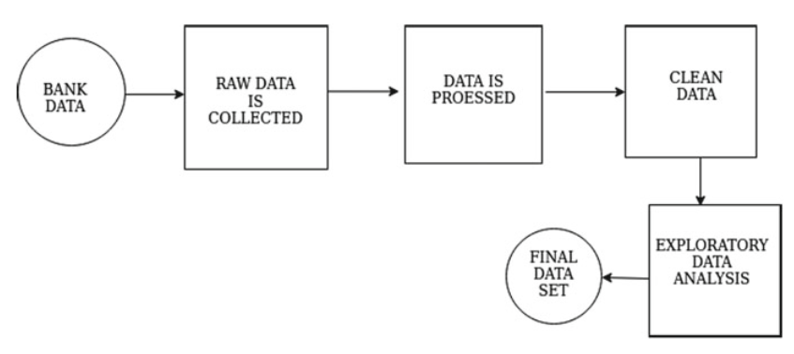
Figure 2: Procedure of Raw Data converted to original data

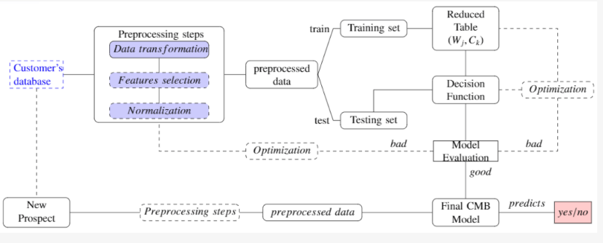
Figure 3: The global process of a predictive classification system

4. Statistical Analysis and Results
4.1 Dataset Description
Kaggle supports a wide range of dataset formats, but it strongly recommends that data publishers use open, non-proprietary formats whenever possible. These formats not only ensure broader accessibility across various tools and platforms but also make it easier for a wider audience to work with the data.

In this study, the dataset used originates from a direct marketing campaign carried out by a Portuguese bank. Facing a decline in revenue, the bank conducted an internal review and discovered that one of the main reasons was a lack of customer investment in long-term deposit products. As a result, the bank aimed to identify customers who are more inclined toward long-term deposits, allowing it to focus its marketing efforts and budget more effectively on this segment.

Five sample entries were randomly selected from the original dataset for preliminary analysis. The full dataset is accessible through the UCI ML Repository. After processing and normalizing various string attributes, a total of 58 features were retained to be used as inputs for the ML models. To evaluate the throughput and reliability of the predictive model, the dataset was separated into training and testing sets using an 80/20 split.
Table 1: Sample Dataset
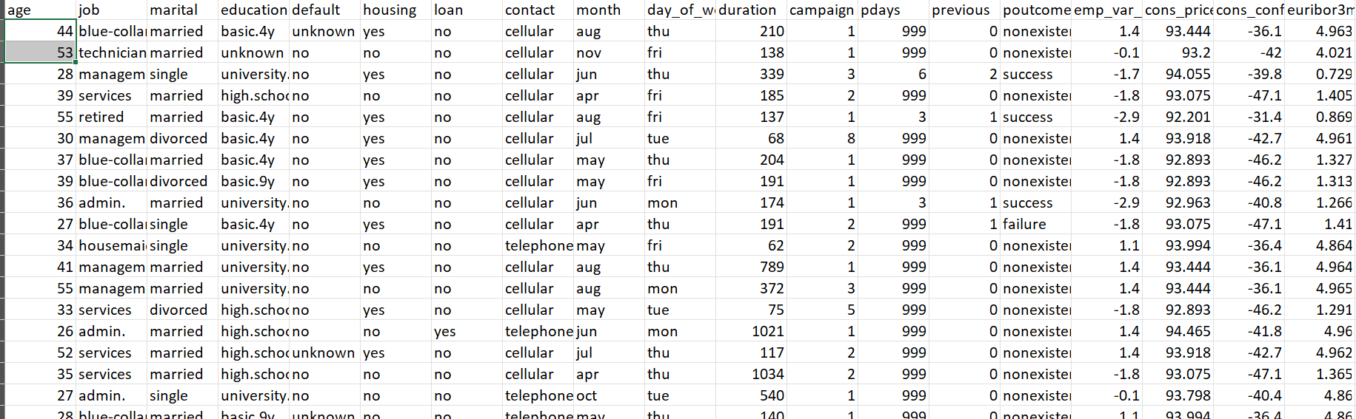
4.2 Data Collection: The dataset includes stock market dimensions, including Date, Low, Open, High, Close, Volume, and the Tweet sentiments. The data consists of 1000 rows and 7 attributes, facilitating a robust analysis of stock price fluctuations influenced by social media trends.
4.3 Data Preprocessing To ensure data consistency, categorical sentiment scores are converted into numerical values. Additionally, feature correlation analysis is conducted to identify highly correlated attributes, reducing redundancy.
4.4 Model Implementation
4.4.1 Feature Selection Selected independent variables include Open, High, Low, Volume, and Tweet Sentiment, while Close price is chosen as the dependent variable.
4.4.2 Model Selection and Evaluation The following models are implemented and compared based on predictive accuracy.

4.5 Model Accuracy
4.5.1 Logistic Regression
It estimates the likelihood of an event belonging to one of two classes by analysing the relationship between one or more input features and a binary target variable. In this analysis, logistic regression attained an accuracy of 0.8928, an F1 score of 0.2114, and the ROC curve (AUC) of 0.8604, indicating strong overall performance in terms of classification probability.
4.5.2 Decision Tree
Decision trees are a powerful tool in ML for making informed decisions. They visually map out a problem along with all potential outcomes, helping users evaluate various possibilities. As the model is exposed to more data, it becomes better at identifying patterns and creating forecasts on novel, unseen data. In this case, the decision tree algorithm achieved an accuracy of 0.8762, an F1 score of 0.4286, and an AUC of 0.6796, reflecting its efficiency in classification tasks with a moderate balance between precision and recall.
4.5.3 SVM
Support Vector Machine algorithm that works by identifying the optimal hyperplane to separate data into distinct classes. It's commonly applied to classification problems, but it can also be used for regression tasks and detecting outliers. In this analysis, the SVM model attained an accuracy of 0.8906, an F1 score of 0.0000, and an AUC of 0.8378. While the model shows strong overall accuracy and the curve, the F1 score indicates potential challenges with class imbalance or precision-recall performance.

4.5.4 Neural Network
A neural network approach that enables computers to interpret and learn from data in the human brain. A subset of machine learning, and involves layers of interconnected nodes often referred to as neurons, that work together to recognize patterns and make predictions. In this case, the neural network attained an accuracy of 0.8939, an F1 score of 0.3333, and an AUC of 0.8673, indicating solid performance in handling classification tasks.

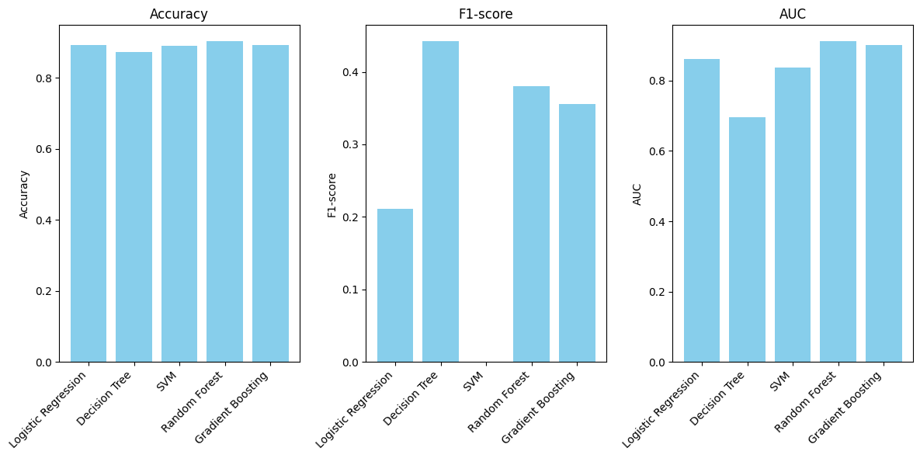
Figure 4: The Accuracy, F1 Score, and AUC of multiple algorithms
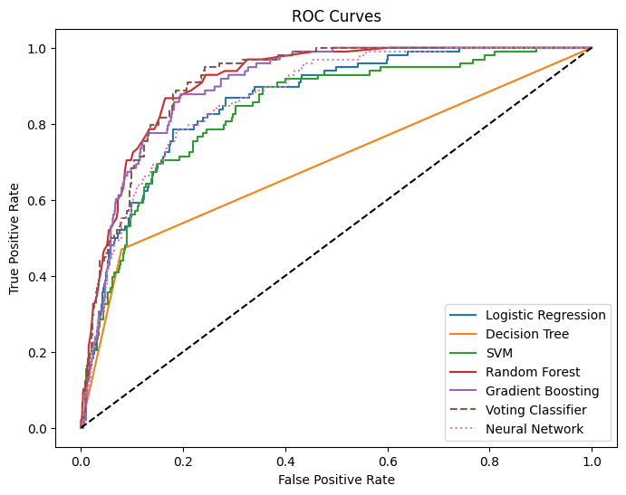
Figure 5: The ROC Curve of multiple machine learning algorithms

Figure 5 demonstrates the ROC Curve of numerous machine learning algorithms. In machine learning, a correlation matrix is a table showing correlation coefficients amid variables, helping to understand relationships and inform feature selection and model building. Figure 6 shows the correlation heat map of different models.

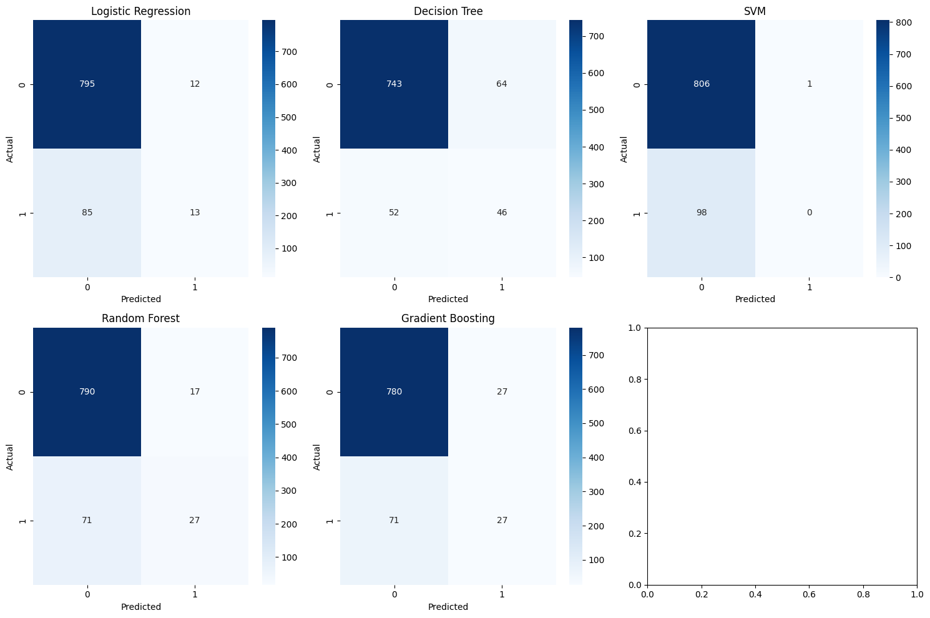
Figure 6: Correlation Heat Map
4.5.5 Ensemble Learning of Two Algorithms
Figure 7 shows the Ensemble learning of (Random Forest + Gradient Boosting) - Accuracy: 0.8961, F1: 0.3649, AUC: 0.9128.
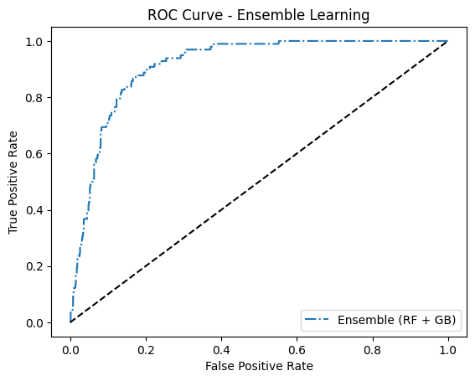
Figure 7: Ensemble Learning of Random Forest Trees and Gradient Boosting Algorithms

4.5.5 Ensemble Learning of Three Algorithms
Figure 8 shows the Ensemble learning of (LR + SVM + DT) - Accuracy: 0.8939, F1: 0.3514, AUC: 0.8756

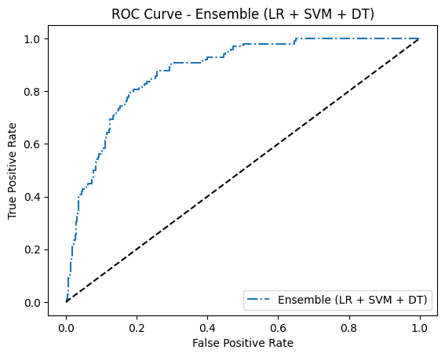
Figure 8: Ensemble Learning of LR, SVM, and DT

A confusion matrix is a valuable tool for assessing the throughput of a classification model. Represented in a table format, it proposes a detailed view of the model’s forecasts compared to actual results. By breaking down true +Ve, true -Ve, false +Ve, and false -Ve, it helps data practitioners identify where the model is performing well and it may be making errors. This insight is essential for refining and improving the model through further tuning and optimization. Figure 9 expresses the Confusion Matrix of the Logistic regression model.

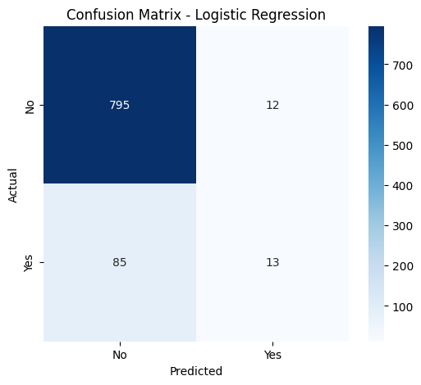
Figure 9: Confusion Matrix of Logistic Regression

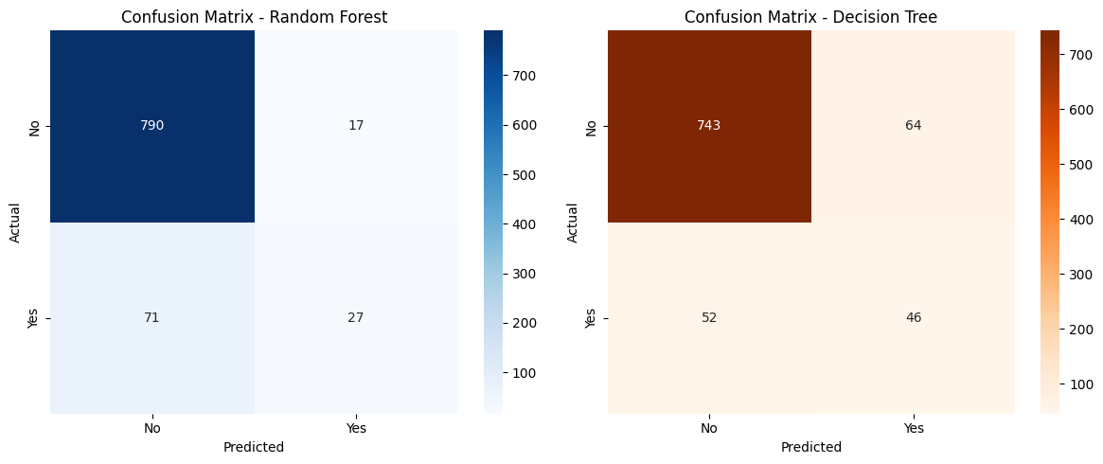
Figure 10: Confusion Matrix of Random Forest and Decision Tree

Figure 10 demonstrates the Confusion Matrix of the Random Forest model and the Decision Tree model, and Figure 11 displays the Confusion Matrix of Gradient Boosting and SVM.

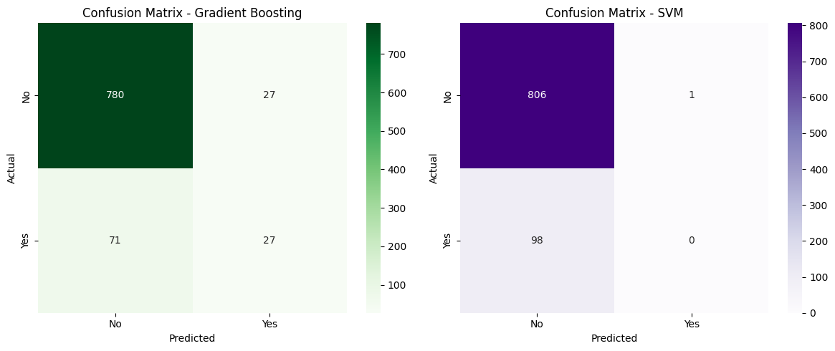
Figure 11: Confusion Matrix of Gradient Boosting and SVM

4.6 Comparative Study
The study found that all machine learning and ensemble learning methods achieved a higher accuracy rate. There is no difference between an ensemble and machine learning accuracy point of view. Table 2 states the Comparative study table between ensemble learning.

Table 2: Comparative study table between ensemble learning
S. No. | Name of the Model | Accuracy | F1 Score | AUC
1 | Logistic Regression | 0.8928 | 0.2114 | 0.8604
2 | Decision Tree | 0.8762 | 0.4286 | 0.6796
3 | SVM | 0.8906 | 0.0000 | 0.8378
4 | Neural Network | 0.8939 | 0.3333 | 0.8673
5 | Random Forest + Gradient Boosting | 0.8961 | 0.3649 | 0.9128
6 | LR + SVM + DT | 0.8939 | 0.3514 | 0.8756

- Conclusion
This study introduces a new data modelling strategy aimed at improving predictions for telemarketing campaigns targeting potential customers for long-term deposit products at a Portuguese retail bank. The dataset includes detailed information about clients, the bank’s products, and various socio-economic factors, some of which reflect the impact of the financial crisis. Starting from an initial pool of 150 features, the model narrows this down to 21 key variables, including the target label. Our approach leverages ensemble learning and treats each feature type independently during preprocessing, followed by normalization to enhance overall predictive accuracy.

References
- Dr. Sunil Bhutada and Subhani Shaik,” Composite Multi-banking Application”, IRJET, Vol. 7, Issue 2, Feb. 2020.
- Subhani Shaik and Dr. R. Vijay Kumar Reddy,” Bank Marketing using Intelligent Targeting”, 1st International Conference on Machine Intelligence and Soft Computing (ICMISC-2020), Vignan University, Guntur, 3rd & 4th September 2020.
- Subhani Shaik and Dr. Uppu Ravibabu “Classification of EMG Signal Analysis based on Curvelet Transform and Random Forest tree Method” Paper selected for Journal of Theoretical and Applied Information Technology (JATIT), Vol. 95, December 2017.
- KP Surya Teja, Vigneswara Reddy, and Subhani Shaik,” Flight Delay Prediction Using Machine Learning Algorithm XGBoost”, Journal of Advanced Research in Dynamical & Control Systems, Vol. 11, No. 5, 2019.
- Dr. Sunil Bhutada and Subhani Shaik, “IPL Match Prediction using Machine Learning”, IJAST, Vol 29, Issue 5, April 2020.
- Dr. R. Vijaya Kumar Reddy, Shaik Subhani, Dr. G. Rajesh Chandra, Dr. B. Srinivasa Rao,” Breast Cancer Prediction using Classification Techniques”, International Journal of Emerging Trends in Engineering Research, Vol. 8, No.9,2020.
- Mr. Sujan Reddy, Ms. Renu Sri, and Subhani Shaik,” Sentimental Analysis using Logistic Regression”, International Journal of Engineering Research and Applications (IJERA), Vol.11, Series-2, July 2021.
- Ms. Mamatha, Srinivasa Datta and Subhani Shaik,” Fake Profile Identification using Machine Learning Algorithms”, International Journal of Engineering Research and Applications (IJERA), Vol.. 11, Series-2, July 2021.
- J. Lavanya, M. Ramesh, J. Sravan Kumar, G. Rajaramesh and Subhani Shaik,” Hate Speech Detection Using Decision Tree Algorithm”, Journal of Advances in Mathematics and Computer Science, Volume 38, Issue 8, Page 66-75, June 2023.
- V. Kakulapati, Shaik Subhani, Gowripriya Kukunuri, Pallavi KSL Lakkoju,” Demographic Factors Based On Predicting Mental Health Of Coronavirus Victims”, International Journal Of Pharmaceutical Sciences (0975-4725), Vol. 2, Issue 4, April 2024.
- V Kakulapati, Shaik Subhani, Deepthi Madireddy, Ramavath Mounika, and Ananthoju Bhargavi,” Fingerprint Recognition Using the HoG and Lime Algorithm”, Acta Scientific Computer Sciences, Volume 6, Issue 6, May 2024.
- Neeraja, Anupam, Sriram, Subhani Shaik, and V. Kakulapati,” Fraud Detection of AD Clicks Using Machine Learning Techniques”, Journal of Scientific Research and Reports, Volume 29, Issue 7, Page 84-89, June 2023.
- M. Jagan Chowhaan, D. Nitish, G. Akash, Nelli Sreevidya, Subhani Shaik, “Machine Learning Approach for House Price Prediction” Asian Journal of Research in Computer Science, Volume 16, Issue 2, Page 54-61, June 2023.
- Md. Samiuddina, G. Rajender, K. Sai Abhiram Varma, A. Ravi Kumar, and Subhani Shaik,” Health Insurance Cost Prediction Using Deep Neural Network”, Asian Journal of Research in Computer Science, Volume 16, Issue 2, Page 46-53, June 2023.
- Subhani Shaik, P. Santhosh Kumar S. Vikram Reddy, K. Sai Srinivas Reddy, and Sunil Bhutada,” Machine Learning based Employee Attrition Predicting”, Asian Journal of Research in Computer Science, Volume 15, Issue 3, Page 34-39, March 2023.
- Dr. Vijayalakshmi K and Subhani Shaik, “Predictive Analytics of Employee Attrition using K-Fold Methodologies”, I. J. Mathematical Sciences and Computing, March 2023, 1, 23-36.

