EXPERIMENTAL DATA ANALYSIS TO RECOGNIZE AND VISUALISE THE FACTORS CONTRIBUTING TO BANK CUSTOMER CHURN PREDICTION USING ENSEMBLE LEARNING MODELS

Abstract
Customer churn happens when a client breaks down using a specific corporation's services and goods. It distresses the profit of industries heavily on their revenues. A novel customer acquisition is valuable up to five times more than absorbing an existing one. The target of this paper comprehend and predict customer churn in the banking sector. The bank wants to create more value out of its customer data. Analyse the data and propose how internal and external utilization of the analysis results increases the bank's revenues. We focus on exploratory data analysis to recognize and visualize features causative of client churn. This analysis predicts the purpose of constructing machine models. These models perform classification tasks for the given dataset. Multiple models were tested in our present research for bank customer churn prediction. Among all models, the LGBM model predicts the highest accuracy, 82.1%.
Keywords: Exploratory Data Analysis, Identify, Visualise, Bank Customer Churn, Prediction, Ensemble Machine Learning Models
- INTRODUCTION
Customer churn refers to the loss of customers over a given period. Understanding and managing churn is crucial for any business, and here’s why it’s so important. New customer acquisition is also most important for the growth of their company [1]. It is most valuable compared to retaining existing customers. You find out the exact reason for the customer's issue for their churn. Search for an exact marketing strategy to attract customers and try to stay a long time with their company [2].

Figure 1: Customer churn prediction model [11]
Imagine a company gains 1,000 customers a month but loses 900 to churn. Net growth is only 100 customers/month despite large acquisition efforts. That’s inefficient and unsustainable.
Every time, identify the behaviour and their interests. Identify such type of customers, actively communicate every time, and maintain them on your customer list. You know about marketing activities for individual customers, and these tips are most effective. Customer churn is a measurement of their success or failure of a business [3].

The following paper remains with the projected architecture in the second section. Section three discusses outcomes analysis and comparative study of the paper. The final section concludes with a conclusion.
- PROPOSED ARCHITECTURE
A novel customer acquisition is worth up to five times more than an existing one. The target of this paper comprehend and predict customer churn for the banking sector [4]. The bank wants to create more value out of its customer data. Analyse the data and propose how internal and external utilization of the analysis results increases the bank's revenues [5]. We focus on exploratory data analysis to recognize and visualization of issues causative of customer churn. This scrutiny predicts purpose construct machine models [6].
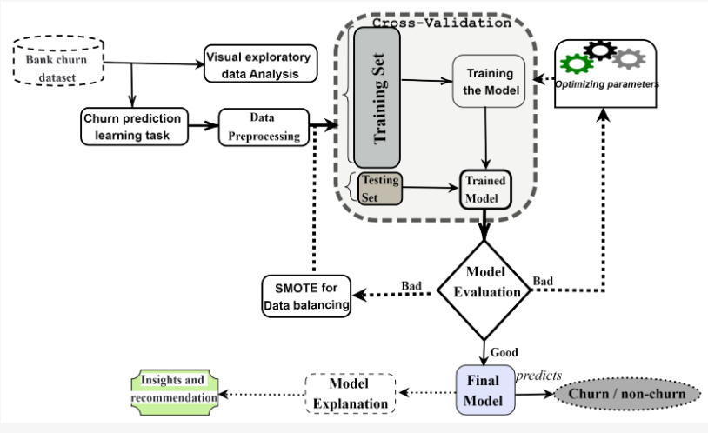
Figure 2: Proposed Architecture[12]
The following Figure 2 describes the starting point with the bank churn dataset. Pre-process the dataset to avoid missing values and abnormal values. Select a suitable algorithm for the dataset size and type. After that data can be divided into training and testing data. Now the model is constructed based on the algorithm. And then run the model, and finally predict the result.
- RESULTS AND ANALYSIS

3.1 Parameters and Variables
It is established a few parameters and variables have been established for the project, and we have to use different functions for our research implementations.

plot_continuous()

plot_categorical()

plot_conf_mx()

plot_learning_curve()

clf_performance()

plot_feature_imp()

test_func()

3.2 Dataset description
The dataset was collected from the Kaggle website. Fourteen attributes and a thousand records were imported for our research [7]. Analyze the data and propose how internal and external utilization of the analysis results increases the bank's revenues. We focus on exploratory data analysis to recognize and visualize features causative of client churn.
Table 1: Dataset
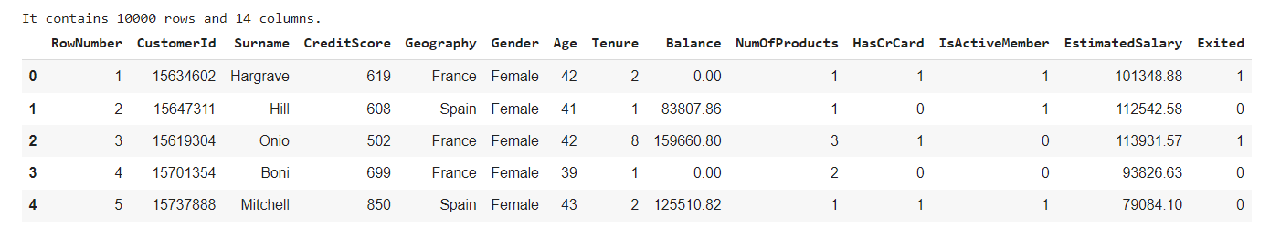
Table 2: Types of attributes
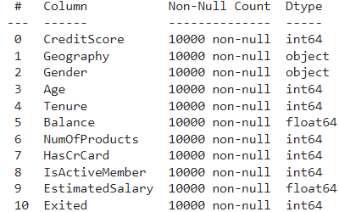
There are no missing values in our DataFrame. But four features drop from our dataset. Data preprocessing in machine learning is the crucial process of preparing raw data into a format suitable for analysis and model training. It involves cleaning, transforming, and organizing data to address issues like missing values, inconsistencies, and irrelevant information, ultimately improving model accuracy and efficiency.
Table 3: Summary of the numerical features of the dataset
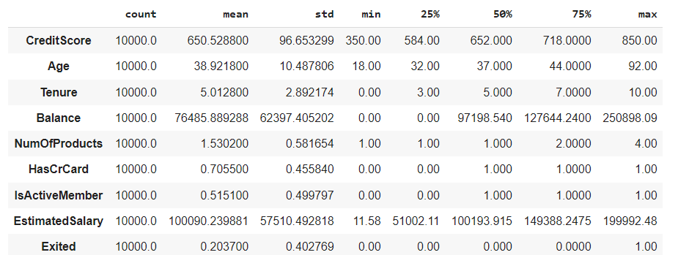

3.2.1 Creating a Test Set

The dataset was split into training data and testing data [8]. The cleanliness test uses stirring, pressure, ultrasonic washing, and other methods to clean the contaminated particles on the surface of the parts, filter the cleaning solution, and collect the contaminated particles.

3.2.2 Experimental Data Analysis
The goal variable is previously prearranged and can take 2 likely values: 0 for not churn and 1 for churn of customers [9]. Experimental data analysis involves a systematic approach to analysing results from experiments to determine if they support or refute a
hypothesis.
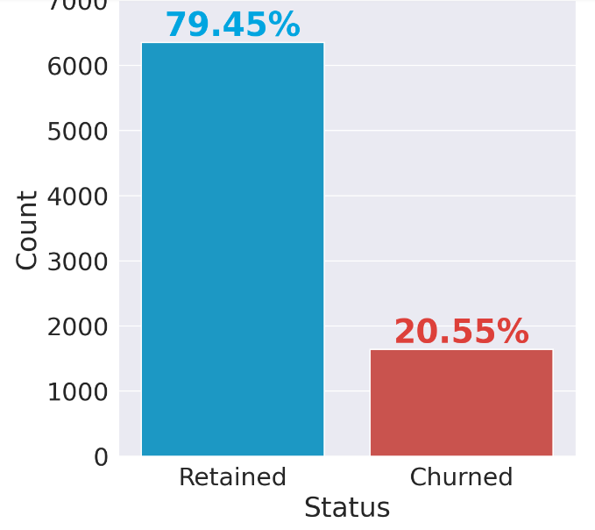

Figure 3: Exploratory Data Analysis
It includes gathering and compiling data, identifying patterns, and interpreting findings while considering potential biases and errors. The bank kept 80% of its clientele, and 20% churned.

3.2.3 Continuous Variables
A continuous variable is a variable that can take on an infinite number of values within a range. It can be a number that includes fractions, decimals, and can be positive or negative. The following Figure 4 for the design of a histogram for every four nonstop numeric characteristics:
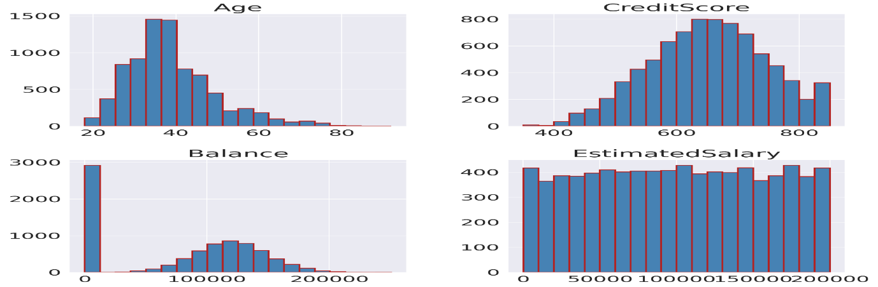

Figure 4: histogram for data analysis
- Age is somewhat weighty, i.e., it spreads more and in addition to the median.
- Most standards for 'Credit Score’ are above 600.
- Balance follows an equally normal distribution.
- The Estimated Salary is more or less uniform and delivers less information.

3.2.4 Look for Correlations
Correlation analysis is a statistical method used in research to measure the strength of the linear relationship between two variables and compute their association. Calculate the correlation coefficient between each pair of continuous features [10].
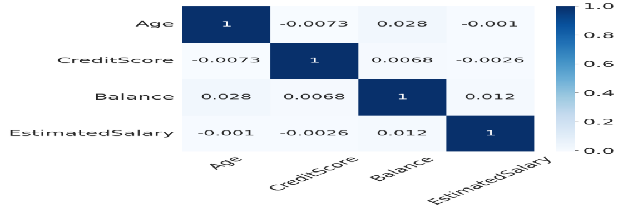
Figure 5: Confusion matrix for correlation
A confusion matrix is a table that shows how well a machine learning model classifies data. It's a performance evaluation tool that compares the model's predictions to the actual values. There is no important intercorrelation between our features.
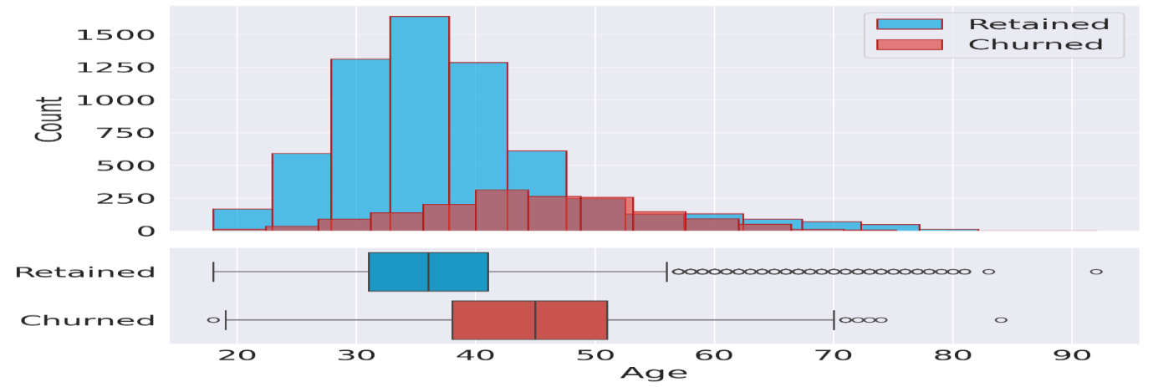
Figure 6: intercorrelation of feature age
There is a strong chance amid age clusters since past clientele are set to churn. This reflection could possibly specify that predilections modify with age, and the bank hasn't modified its plan to meet the needs of past clients [11].

3.2.5 Credit Score
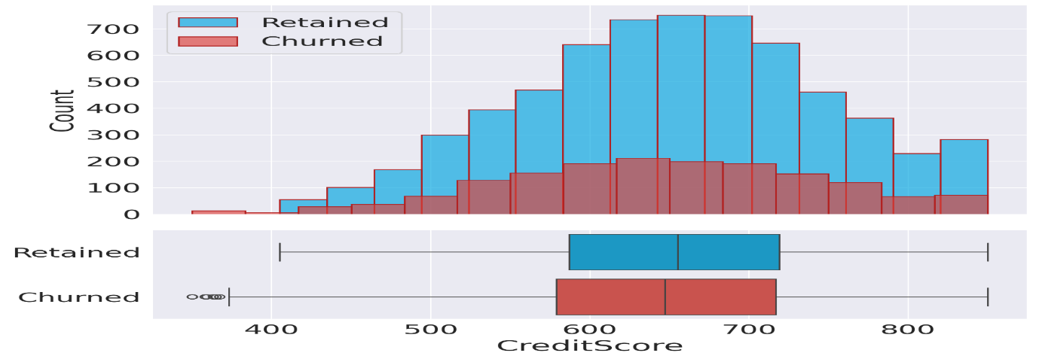
Figure 7: engaged and churned clients in credit score
Machine learning (ML) is revolutionizing credit scoring by enabling more accurate and personalized risk assessments. ML algorithms analyse vast datasets and identify patterns that are difficult for traditional models to detect, leading to more precise predictions of future credit risk. The following figure 7 shows no important alteration between engaged and churned clients and their credit scores.

5.2.6 Balance
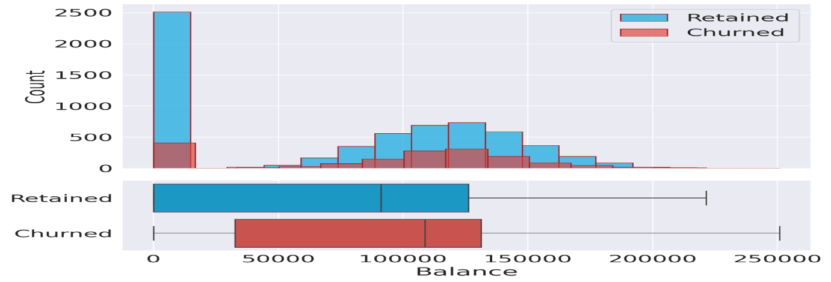
Figure 8: non-churned clients with a small account balance
It's when a customer ceases to be a customer. Customer churn is measured using the customer churn rate. That's the number of people who stopped being customers during a set period of time, such as a year, a month, or a financial quarter. Two deliveries are fair. There is a large ratio of non-churned clientele with a little balance.

3.2.7 Projected Salary
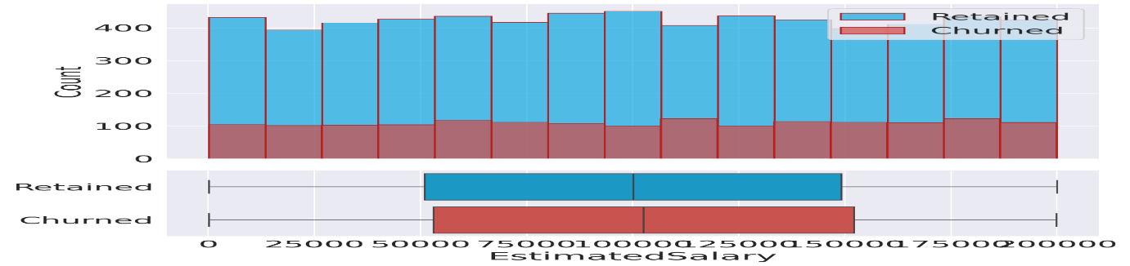
Figure 9: Estimated salary distribution
It's when a customer ceases to be a customer. Customer churn is measured using the customer churn rate. That's the number of people who stopped being customers during a set period of time, such as a year, a month, or a financial quarter. Churned and engaged clientele show the same delivery in their salaries.

3.2.8 Categorical Variables
The following figure is 10 for every categorical feature.
- There are added male clients than females,
- A minor ratio leaf within the primary year.
- A majority of the clientele has a credit card.
- 50% of clients are not active.
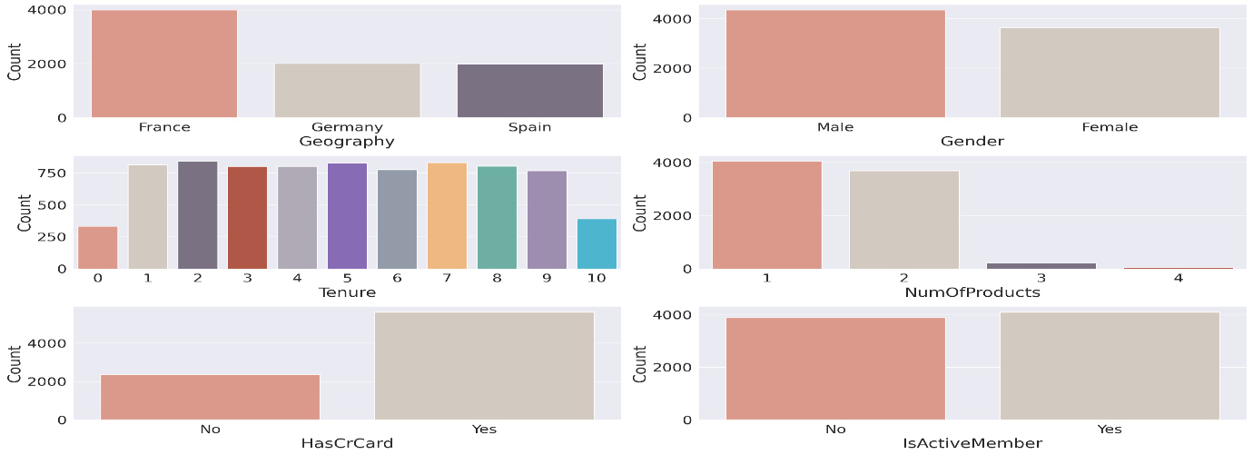
Figure 10: Total categorical Variables representation

3.2.8.1 Geography
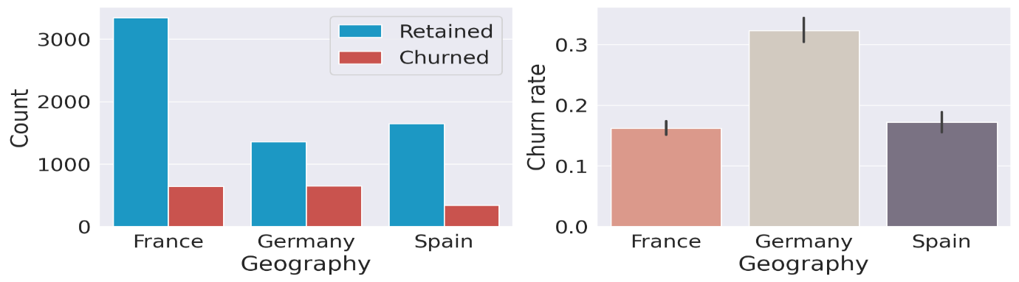
Figure 11: Geography Variables representation of Germany
Geographic variables are characteristics of a place, beyond just its location, that can influence how a business or researcher might approach a market, a study, or a particular area. Clients in Germany are more likely to churn than clients in the added two countries. The churn rate is double compared of Spain and France [12].

3.2.8.2 Gender
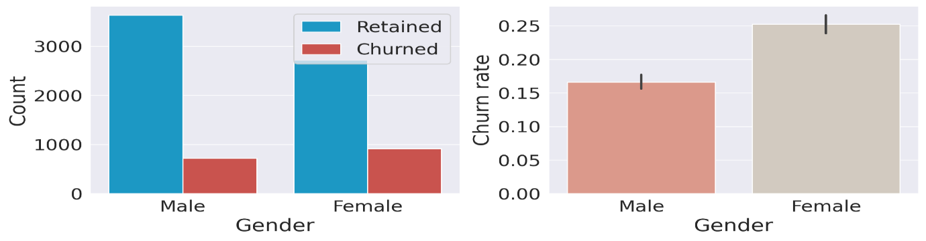
Figure 12: Gender-based customer churn
Customer churn is the percentage of customers who stopped purchasing your business's products or services during a certain period of time. Your customer churn rate indicates how many of your existing customers are not likely to make another purchase from your business. Female customers are more likely to churn.

3.2.8.3 Tenure
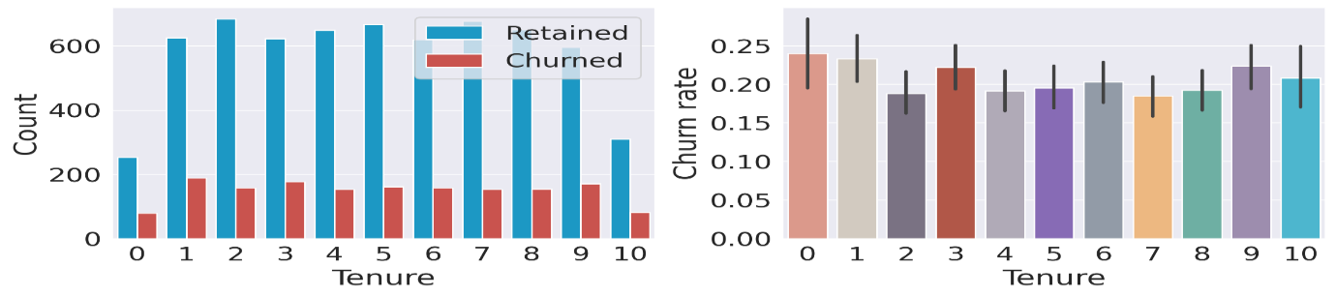
Figure 13: Tenure-based customer churn
The statement "The tenure rate does not appear to affect the churn rate" is generally incorrect. While the relationship between tenure and churn is complex, longer customer tenure is often associated with lower churn rates. The tenure rate does not appear to affect the churn rate.

3.2.8.4 Number of Products
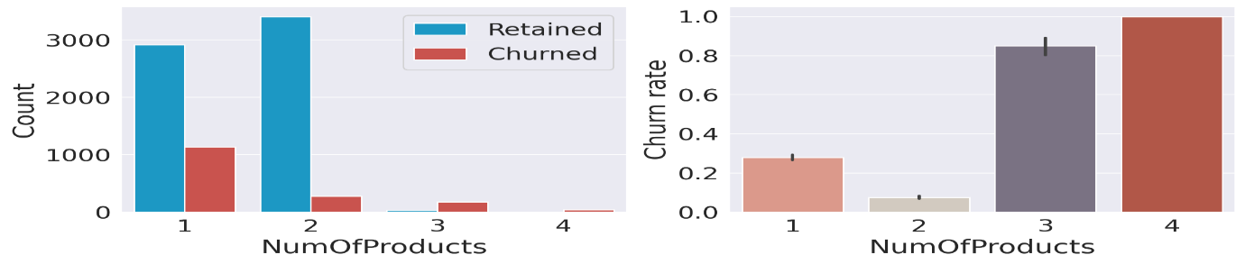
Figure 14: Number of product-based customer churn
Churn is the measure of how many customers stop using a product. This can be measured based on actual usage or failure to renew (when the product is sold using a subscription model). Often evaluated for a specific period of time, there can be a monthly, quarterly, or annual churn rate. 3 or 4 products knowingly increase the likelihood of churn.

3.2.8.5 Card Holders
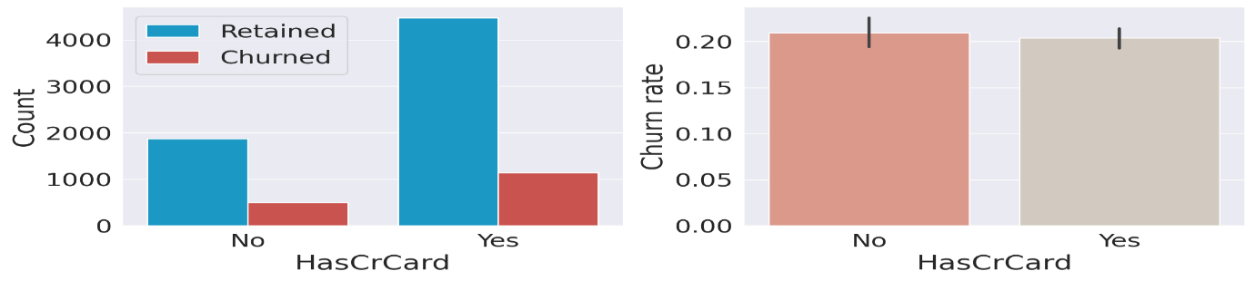
Figure 15: Card Holders-based customer churn
While credit card churning may not heavily affect your score, it can significantly impact how credit card issuers view you as a customer in the future. Here are other ways that credit card churning may affect your credit: Number of applications: Whenever you apply for a new credit card, a hard inquiry is generated. Credit cards do not affect the churn rate. It's not the most significant that sedentary clientele are added to the butter churn.

3.2.8.6 Active Members
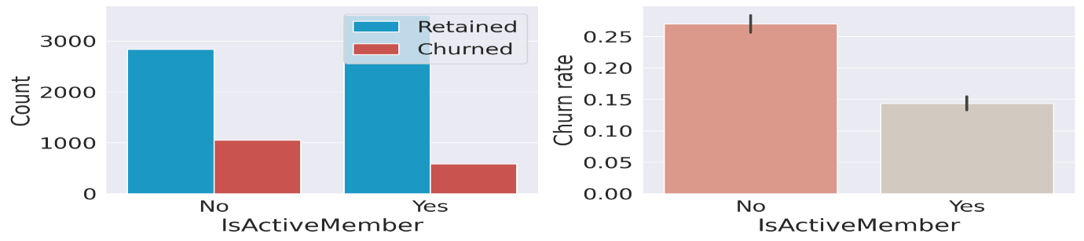
Figure 16: Active members-based customer churn

3.4 Construction of Machine Learning Models

3.4.1 Baseline Models
Baseline models like RF, DT, and XGBoost models evaluate K-fold cross-validation [13].

3.4.2 Model Tuning
Module tuning" broadly refers to optimizing the performance or parameters of a specific module within a system, whether it's a software module, a hardware module, or a component within a larger system like a machine or instrument. Model tuning means Hyperparameters cover non-optimized models. They provide optimal performance.

Decision Tree
In machine learning, a decision tree is a supervised learning algorithm used for both classification and regression problems.
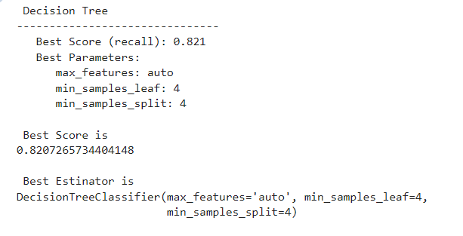
It represents a tree-like structure where each node represents a test on an attribute, each branch represents the outcome of the test, and each leaf node represents a class label or a predicted value. F1 score is 0.76.
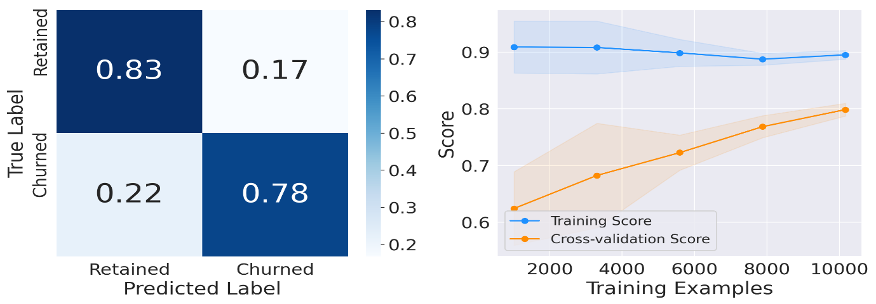
Figure 17: Decision tree score

Support Vector Classifier
Support Vector Machines (SVMs) are supervised machine learning algorithms used for both classification and regression. They work by finding the optimal hyperplane that separates data points into different classes, while maximizing the margin between the hyperplane and the closest data points of each class. SVMs are known for their effectiveness in high-dimensional spaces and their ability to handle non-linear data using the "kernel trick". F1 score is 0.65.

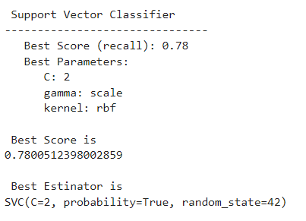
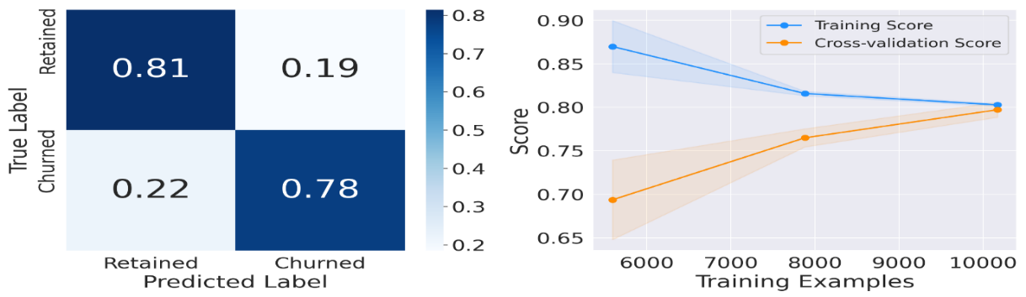
Figure 18: support vector machine score
  - Random Forest
A Random Forest in machine learning is an ensemble of decision trees used for both classification and regression tasks. It works by combining the predictions of multiple decision trees to improve accuracy and stability compared to a single decision tree, says Kaggle. F1 score is 0.78.
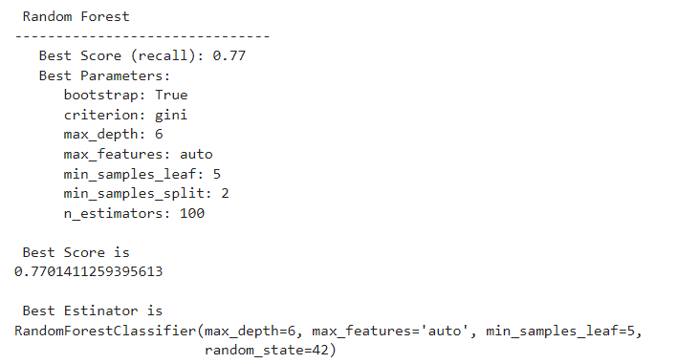
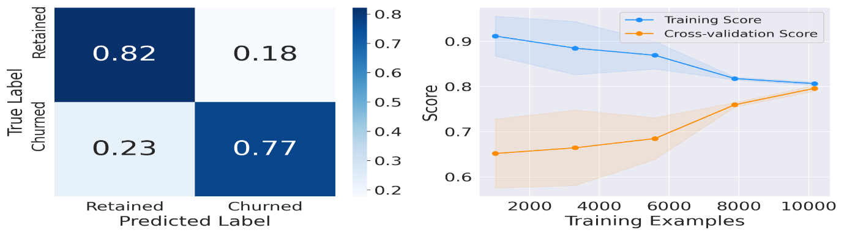
Figure 19: Random forest score

3.8 Gradient Boosting Classifier
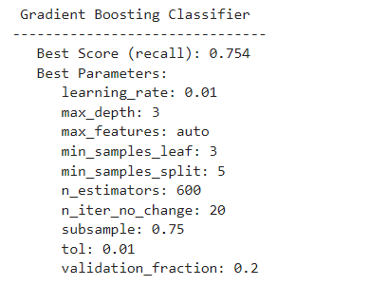
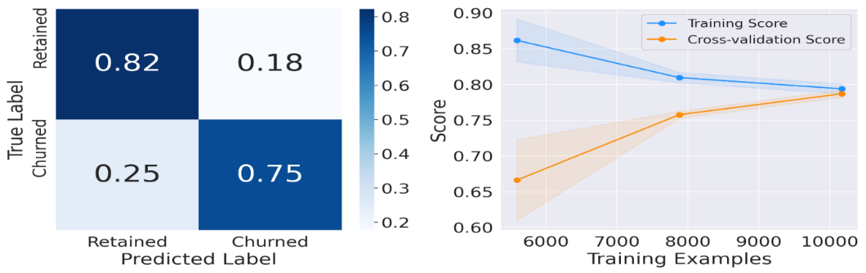
Figure 20: Gradient boosting score
Gradient boosting is a powerful ensemble machine learning technique that combines multiple weak learners, often decision trees, to create a strong, more accurate predictive model. It works iteratively, with each new model focusing on correcting errors made by previous models, ultimately minimizing the overall prediction error. The number of estimators after early stopping is 284, F1 score of Gradient Boosting is 0.78.

3.9 XGBoost Classifier
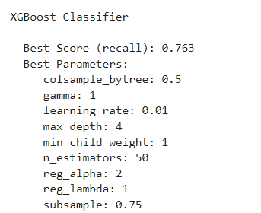
XGBoost (eXtreme Gradient Boosting) is a powerful and widely used machine learning algorithm known for its high accuracy and efficiency, particularly with large datasets. It's an optimized implementation of gradient boosting, a technique that combines predictions from multiple weak models to create a strong predictive model. XGBoost is particularly well-suited for tasks like classification, regression, and ranking. F1 score of XGBoost is 0.79.
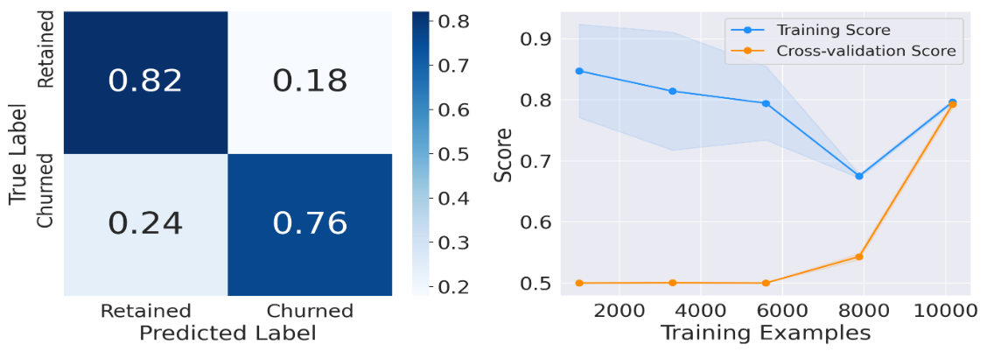
Figure 21: XGboost Score

3.10 LGBM Classifier
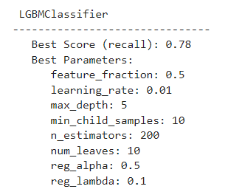
LightGBM is a gradient boosting ensemble method that is used by the Train Using AutoML tool and is based on decision trees. As with other decision tree-based methods, LightGBM can be used for both classification and regression. LightGBM is optimized for high performance with distributed systems. The F1 score of LightGBM is 0.78.
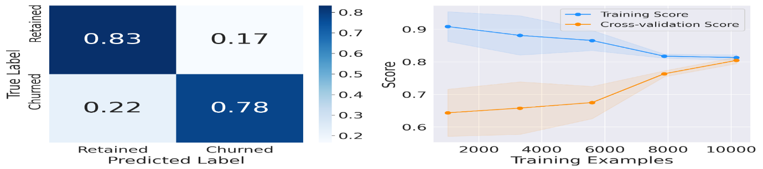
Figure 22: LGBM score

3.11 Learning Curves
Among all models, there is a little difference between the two curves. This reflection shows that we d’t overfit the training set [14].
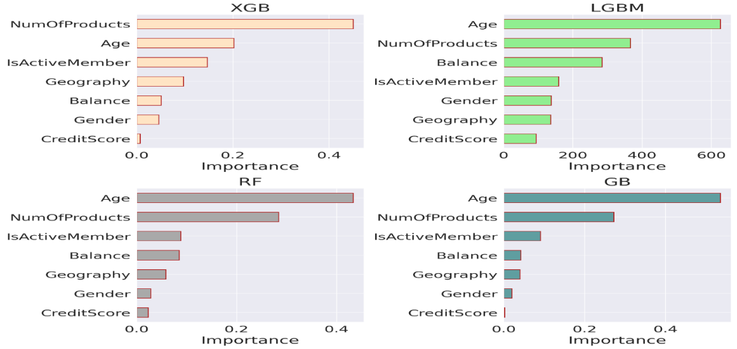
Figure 23: Visualize the feature importance of classifiers
Age and total products most valuable features for all classifiers. Credit Score is the least important feature for all, apart from LGBM.

3.12 Performance Comparison
Table 4 provides comparative different models with different metrics like recall, and area under the ROC curve, Accuracy, precision, recall, and area under the ROC curve.
Table 4: Performance Comparison of metrics
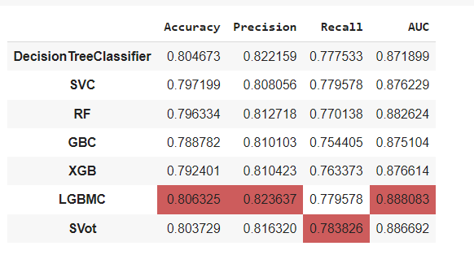
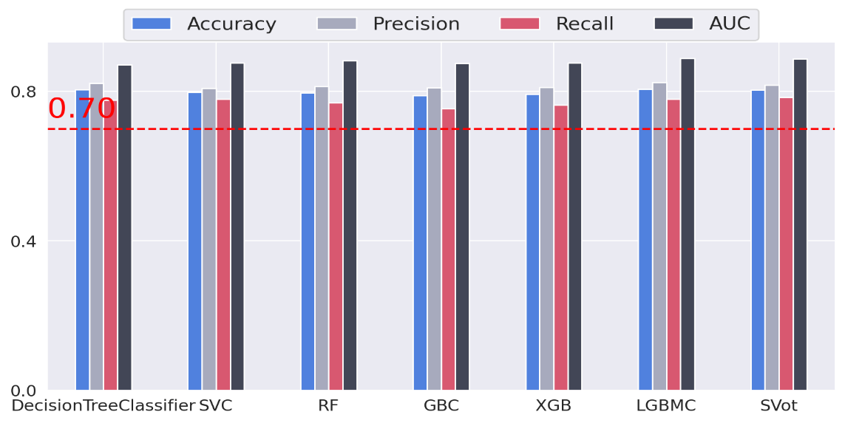
Figure 24: Performance Comparison metrics of classifiers in a line chart
XGB is the model with the highest recall, 78.5 %. Finally, the LGBM classifier has the best overall performance with the highest accuracy, precision, and AUC. The ROC curve is a graph. It plots the true positive rate against the false positive rate.
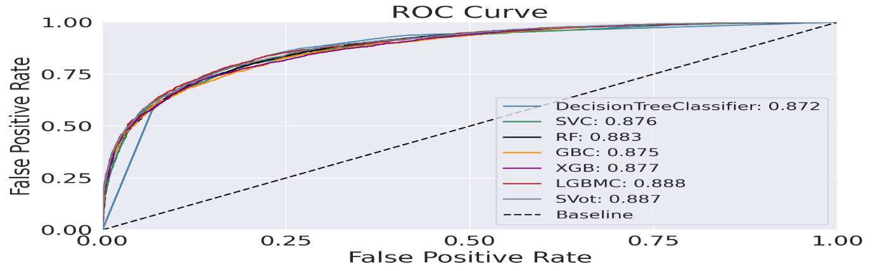
Figure 25: Performance Comparison metrics of classifiers in line chart
LGBM performs better than the remaining classifiers and slightly higher AUC of 0.888. Actually, our target is 50% churn, the model will pick more than 80%. This analysis predicts the purpose of constructing machine models. These models perform classification tasks for a given dataset. Multiple models were tested in our present research for bank customer churn prediction. Among all models, LGBM predicts the highest accuracy is 82%.
- CONCLUSION
Customer churn happens when a customer stops using a specific company's services and products. Customer churn distresses the profit of industries, as revenues heavily depend. A novel customer acquisition is worth up to five times more than an existing one. The target of this paper comprehends and predict customer churn for the banking sector. The bank wants to create more value out of its customer data. Analyse the data and propose how internal and external utilization of the analysis results increases the bank's revenues. We focus on exploratory data analysis to recognize and visualize of factors causative of customer churn. This analysis predicts purpose construct machine models. These models perform a classification task for a given dataset. Multiple models were tested in our present research for bank customer churn prediction. Among all models, LGBM predicts the highest accuracy is 82%.

Disclaimer (Artificial intelligence)
Option 1:
Author(s) hereby declare that NO generative AI technologies such as Large Language Models (ChatGPT, COPILOT, etc.) and text-to-image generators have been used during the writing or editing of this manuscript.
Option 2:
Author(s) hereby declare that generative AI technologies such as Large Language Models, etc. have been used during the writing or editing of manuscripts. This explanation will include the name, version, model, and source of the generative AI technology and as well as all input prompts provided to the generative AI technology
Details of the AI usage are given below:
1.
2.
3.
REFERENCES
- GK Reddy, NR Vullam, GS Sekhar, D Sundaragiri, S Shaik,” Ensemble Learning Algorithms based on Road Accident Data Prediction”, International Conference on Contemporary Pervasive Computational Intelligence, Sreenidhi University, Hyderabad, 27-28 September 2024.
- Aseena Babu Shaik, Rajeswara Reddy, Nagagopi Raju Vullam, Gondi Konda Reddy, Subhani Shaik,” An Effective Method for Detecting Cyber Attacks on Computer Networks from the NSL-KDD Data Set”, International Conference on Contemporary Pervasive Computational Intelligence, Sreenidhi University, Hyderabad, 27-28 September-2024.
- Nagagopiraju Vullam, Subhani Shaik, Gondi Konda Reddy, Korivi Vamshee Krishna, Aseena Babu Shaik, Forest fire prediction using K-Nearest Neighbour Model”, International Conference on Contemporary Pervasive Computational Intelligence, Sreenidhi University, Hyderabad, 27-28 September 2024.
- Subhani Shaik and Dr. Uppu Ravibabu “Classification of EMG Signal Analysis based on Curvelet Transform and Random Forest tree Method” Paper selected for Journal of Theoretical and Applied Information Technology (JATIT), Vol. 95, December 2017.
- KP Surya Teja, Vigneshwara Reddy, and Subhani Shaik,” Flight Delay Prediction Using Machine Learning Algorithm XGBoost”, Journal of Advanced Research in Dynamical & Control Systems, Vol. 11, No. 5, 2019.
- Dr. Vijayalakshmi K and Subhani Shaik, “Predictive Analytics of Employee Attrition using K-Fold Methodologies”, I. J. Mathematical Sciences and Computing, March 2023, 1, 23-36.
- R. Vijaya Kumar Reddy, Subhani Shaik, B. Srinivasa Rao, “Machine learning based outlier detection for medical data” Indonesian Journal of Electrical Engineering and Computer Science, Vol. 24, No. 1, October 2021.
- V Kakulapati, Shaik Subhani, Deepthi Madireddy, Ramavath Mounika, and Ananthoju Bhargavi,” Fingerprint Recognition Using the HoG and Lime Algorithm”, Acta Scientific Computer Sciences, Volume 6, Issue 6, May 2024.
- Egamamidi Rishika Reddy, Sai Durga Satturi, Medavarapu Harshini, and Subhani Shaik,” Rose Plant Leaf Disease Recognition Using Machine Learning Methodologies”, Asian Journal of Research in Computer Science, Volume 17, Issue 11, Page 65-72, June 2024.
- Ravi Kumar A, C. Sunil Kumar, Subhani Shaik, K. R. Praneeth,” Machine learning techniques to predict and manage knee injury in sports medicine”, International Journal of Emerging Trends in Health Sciences Volume 8, Issue 2, (2024) 26-35.
- Shiva Keertan J and Subhani Shaik,” Machine Learning Algorithms for Oil Price Prediction”, International Journal of Innovative Technology and Exploring Engineering, Volume-8 Issue-8, 2019.
- Dr. Sunil Bhutada and Subhani Shaik, “IPL Match Prediction using Machine Learning”, IJAST, Vol 29, Issue 5, April 2020.
- Dr. R. Vijaya Kumar Reddy, Shaik Subhani, Dr. G. Rajesh Chandra, Dr. B. Srinivasa Rao,” Breast Cancer Prediction using Classification Techniques”, International Journal of Emerging Trends in Engineering Research, Vol. 8, No.9,2020.
- Subhani Shaik, P. Santhosh Kumar, S. Vikram Reddy, K. Sai Srinivas Reddy, and Sunil Bhutada,” Machine Learning based Employee Attrition Predicting”, Asian Journal of Research in Computer Science, Volume 15, Issue 3, Page 34-39, March 2023.

