**Dose-Dependent Toxicological Effects of Smoked Fish Extract on Liver and Kidney Function in Albino Rats: Implications for Human Health**

**ABSTRACT**

This study evaluated the toxicological impact of smoked fish extract on liver and kidney function in albino rats. Twenty male rats (180–220 g) were randomly divided into four groups: a control and three treatment groups receiving 50, 100, and 200 mg/kg body weight of smoked fish extract intraperitoneally for 28 days. Biochemical analyses revealed dose-dependent increases in liver enzymes—alanine aminotransferase (ALT) and aspartate aminotransferase (AST)—as well as elevated kidney markers, including urea and creatinine (P < 0.0001). Oxidative stress markers showed significantly increased malondialdehyde (MDA) levels and decreased superoxide dismutase (SOD) activity (P < 0.05). Hematological evaluations indicated anemia and leukocytosis in treated groups. Histopathological examination confirmed progressive hepatic and renal damage, with necrosis, inflammatory infiltration, and cellular degeneration more pronounced at higher doses. These adverse effects are attributed to toxic constituents such as polycyclic aromatic hydrocarbons and heavy metals present in smoked fish. The findings suggest that chronic exposure to smoked fish extract may pose significant risks to hematological, hepatic, and renal health.

**Keywords**: smoked fish extract, liver toxicity, kidney damage, oxidative stress, polycyclic aromatic hydrocarbons, heavy metals,

**INTRODUCTION**

Traditional food processing techniques, such as smoking and grilling, are widely employed in preserving fish and enhancing sensory characteristics, especially in developing countries where refrigeration may be unreliable (Akpambang et al., 2009; Assogba et al., 2019). However, these thermal processes can inadvertently introduce harmful substances into food products, depending on the fuel source used and the hygiene of the processing environment. Alarmingly, in many informal fish processing settings across sub-Saharan Africa, including Nigeria, fish is often smoked using **burnt tires or electrical transformer oils**, which release highly toxic emissions.

**Transformer oil smoke**, especially when burnt, emits a complex mix of **polychlorinated biphenyls (PCBs), dioxins, furans, PAHs**, and **volatile heavy metals**, all of which are environmental pollutants with proven health hazards (WHO, 2010). Studies have shown that chronic exposure to these substances is associated with increased risks of **lung cancer (27–35%)**, **liver damage (18–25%)**, and **respiratory diseases (40–50%)**, especially among workers and individuals living near informal processing sites (Nduka et al., 2008; UNEP, 2013; Obida et al., 2020). In one community-based assessment in Nigeria, over **52%** of fish processors using transformer oil reported chronic respiratory symptoms, while **19%** showed elevated liver enzymes on routine screening (Ibanga et al., 2019).

PAHs, a group of lipophilic and persistent organic pollutants, arise primarily through the incomplete combustion of organic materials such as wood or oil-based materials during fish smoking. They are particularly concerning due to their carcinogenic, mutagenic, and teratogenic effects (Domingo & Nadal, 2015; Darwish et al., 2019). The European Food Safety Authority (EFSA, 2008) has identified benzo[a]pyrene and other PAHs as critical markers for assessing carcinogenic risk in food. These contaminants can accumulate in smoked products depending on several variables, including fish fat content, smoking duration, and the type of fuel used (Akpambang et al., 2009; Forsberg et al., 2012; Haskaraca et al., 2014).

Beyond PAHs, traditional smoking methods can introduce heavy metals such as **lead, cadmium, and mercury** into fish, which pose significant toxicological risks upon chronic exposure (Abbas et al., 2021; Daniel et al., 2013; Anigboro et al., 2011). Lead and cadmium are known to impair renal and hepatic function, induce oxidative stress, and interfere with hematopoiesis (Ibanga et al., 2019; Gunter et al., 2007; Hough et al., 2004).

Biogenic amines, including **histamine** and **tyramine**, may also accumulate in smoked fish, especially under poor hygiene or inadequate storage. These amines result from microbial decarboxylation of amino acids and are associated with food spoilage and scombroid poisoning (Al Bulushi et al., 2009; Emborg & Dalgaard, 2006; EFSA, 2011). In addition, **nitrosamines**, which form through reactions involving nitrites and secondary amines during high-heat processing, are potent carcinogens implicated in gastrointestinal cancers (Drabik-Markiewicz et al., 2009; Herrmann et al., 2015).

Several studies in sub-Saharan Africa have documented variable levels of PAHs and heavy metals in smoked fish across different regions and species, with some samples exceeding internationally recommended safety limits (Akpambang et al., 2009; Anigboro et al., 2011; Assogba et al., 2019). Douny et al. (2021) showed that exposure to PAHs and biogenic amines through smoked fish in Cambodia reached toxicologically significant levels. Yet, consumer awareness remains low in countries like Nigeria, where smoked fish is a staple (Daniel et al., 2013).

Despite the growing interest in food toxicology, there is a **paucity of comprehensive animal model studies** investigating the simultaneous impact of smoked fish constituents on hematological, hepatic, renal, and oxidative biomarkers. Most available research isolates either PAH exposure or heavy metal toxicity without examining their potential synergistic or cumulative effects (Darwish et al., 2019; Gunter et al., 2007).

**Therefore, this study investigates the toxicological effects of smoked fish extract on liver and kidney function in albino rats**, focusing on biochemical, hematological, and oxidative parameters. This research is significant not only for public health surveillance but also for guiding food safety policies. The findings are expected to contribute toward the development of **safer traditional processing practices**, including **awareness creation, fuel source regulation, and toxicological monitoring**, to protect both consumers and processors of smoked fish in resource-limited settings.

**2. MATERIALS AND METHODS**

**2.1. SOURCE AND PREPARATION OF SMOKED FISH EXTRACT**

Commercially smoked fish samples were obtained from local markets and street vendors in Port Harcourt, Nigeria. The smoked fish samples were identified as Clarias gariepinus (African catfish) and Ethmalosa fimbriata (bonga fish), both of which are among the most commonly consumed species in Nigeria. These species are known to exhibit differences in lipid content and habitat, which can significantly influence the concentration and bioaccumulation of polycyclic aromatic hydrocarbons (PAHs) and heavy metals during smoking processes. Their inclusion strengthens the study by ensuring that the findings reflect realistic dietary exposure scenarios relevant to local consumption patterns. were homogenized using a stainless steel blender and subjected to Soxhlet extraction for 8 hours using a solvent mixture of hexane–dichloromethane (3:1, v/v). The resulting extracts were concentrated with a rotary evaporator at 40 °C to remove solvents and stored at 4 °C until use. Fresh doses were prepared daily based on the individual body weights of the experimental animals.

**2.2. EXPERIMENTAL ANIMALS AND ETHICAL APPROVAL**

Twenty (20) adult male albino rats (mean weight: 199.3 ± 12.4 g; range: 180–220 g) were procured from a certified animal breeding facility. The animals were randomized into four experimental groups (n = 5 per group) such that each group contained rats with comparable mean body weights to minimize variability in dose response and organ weight ratios, including the hepato-somatic index. Rats were housed in standard polypropylene cages, with each cage containing five rats from the same group. They were acclimatized for one week under standard laboratory conditions (22 ± 2 °C; 12-hour light/dark cycle), with ad libitum access to clean drinking water and standard pellet diet. The experimental protocol was approved by the Institutional Animal Ethics Committee, and all procedures adhered to international guidelines for laboratory animal care and use.

**2.3. ANIMAL GROUPING AND TREATMENT REGIMEN**

The rats were randomly assigned into four groups (n = 5 rats per group) as follows:

* **Group I (Control):** Received 0.9% normal saline intraperitoneally.
* **Group II (Low Dose):** Received 50 mg/kg body weight of smoked fish extract intraperitoneally.
* **Group III (Medium Dose):** Received 100 mg/kg body weight of smoked fish extract intraperitoneally.
* **Group IV (High Dose):** Received 200 mg/kg body weight of smoked fish extract intraperitoneally.

Treatments were administered once daily for 28 consecutive days.

**2.4. BIOCHEMICAL ASSAYS**

At the end of the treatment period, the rats were fasted overnight and euthanized under light anesthesia. Blood was collected via cardiac puncture and centrifuged at 3,000 rpm for 10 minutes to obtain serum. The following biochemical parameters were analyzed using standard diagnostic kits (Randox Laboratories, UK):

* **Liver Function Tests:** Alanine aminotransferase (ALT), Aspartate aminotransferase (AST)
* **Kidney Function Tests:** Urea, Creatinine
* **Oxidative Stress Markers:** Malondialdehyde (MDA), Superoxide dismutase (SOD)

**2.5. HISTOPATHOLOGICAL EXAMINATION**

Liver and kidney tissues were harvested, rinsed in physiological saline, and fixed in 10% buffered formalin. The tissues were processed, embedded in paraffin wax, and sectioned at 5 µm thickness. Sections were stained with hematoxylin and eosin (H&E) and examined under a light microscope for structural and pathological alterations.

**2.6. GC-MS ANALYSIS OF POLYCYCLIC AROMATIC HYDROCARBONS (PAHS)**

A portion of the smoked fish extract was subjected to Gas Chromatography-Mass Spectrometry (GC-MS) analysis to quantify polycyclic aromatic hydrocarbons. Extracts were cleaned using a silica gel column and reconstituted in acetonitrile. Analysis was carried out using an Agilent 7890A GC system coupled with a 5975C Mass Selective Detector and an HP-5MS capillary column (30 m × 0.25 mm × 0.25 µm). The oven temperature was programmed from 70 °C to 280 °C. Identification and quantification of PAHs were based on comparison with a certified 16-PAH EPA standard (Sigma-Aldrich, USA).

**2.7. STATISTICAL ANALYSIS**

Data were expressed as mean ± standard deviation (SD). Statistical analysis was performed using one-way ANOVA followed by Tukey's post hoc test to evaluate inter-group differences. A p-value of < 0.05 was considered statistically significant. Graphs were generated using GraphPad Prism version 9.0.

**3. RESULTS**

**Hematological Indices**

Table 1 presents the complete blood count (CBC) results across the four experimental groups. Rats exposed to smoked fish extract showed a significant, dose-dependent increase in WBC, granulocyte %, RDW-CV, RDW-SD, and platelet indices (PLT, MPV, PDW, PCT) compared to control. Conversely, RBC, hemoglobin (HGB), hematocrit (HCT), and lymphocyte % significantly decreased with increasing dose (p < 0.05). The hematological alterations indicate a potential inflammatory and anemic response induced by the extract.

**Table 1. Complete Blood Count (CBC) Results for the Four Experimental Groups**

| **Parameter** | **Group 1 (Control)** | **Group 2 (Low Dose PAH)** | **Group 3 (Medium Dose PAH)** | **Group 4 (High Dose PAH)** |  |
| --- | --- | --- | --- | --- | --- |
| White Blood Cell (WBC) (×10⁹/L) | 6.5 ± 0.4 | 7.2 ± 0.3 | 8.9 ± 0.5 | 10.3 ± 0.6 |  |
| Lymphocyte % | 68.0 ± 2.5 | 65.4 ± 3.1 | 61.2 ± 2.9 | 57.5 ± 2.8 |  |
| Monocyte % | 5.2 ± 0.8 | 6.0 ± 0.9 | 6.5 ± 1.0 | 7.4 ± 0.7 |  |
| Granulocyte % | 26.8 ± 1.9 | 28.6 ± 2.0 | 32.3 ± 2.2 | 35.1 ± 2.4 |  |
| Red Blood Cell (RBC) (×10¹²/L) | 7.4 ± 0.2 | 6.9 ± 0.3 | 6.2 ± 0.2 | 5.6 ± 0.3 |  |
| Hemoglobin (HGB) (g/dL) | 14.1 ± 0.4 | 13.2 ± 0.5 | 11.8 ± 0.4 | 10.2 ± 0.5 |  |
| Hematocrit (HCT) (%) | 42.3 ± 1.5 | 39.8 ± 1.8 | 36.1 ± 1.4 | 32.4 ± 1.6 |  |
| Mean Corpuscular Volume (MCV) (fL) | 57.2 ± 2.1 | 57.7 ± 2.4 | 58.2 ± 2.6 | 58.0 ± 2.2 |  |
| Mean Corpuscular Hemoglobin (MCH) (pg) | 19.1 ± 0.8 | 18.7 ± 0.7 | 18.2 ± 0.8 | 17.9 ± 0.6 |  |
| MCH Concentration (MCHC) (g/dL) | 33.4 ± 1.2 | 32.3 ± 1.1 | 31.4 ± 1.0 | 30.8 ± 1.3 |  |
| Red Cell Distribution Width – CV (RDW-CV) (%) | 12.4 ± 0.5 | 13.2 ± 0.7 | 14.5 ± 0.6 | 15.6 ± 0.8 |  |
| Red Cell Distribution Width – SD (RDW-SD) (fL) | 38.6 ± 1.2 | 40.1 ± 1.4 | 43.2 ± 1.7 | 45.5 ± 2.1 |  |
| Platelet Count (PLT) (×10⁹/L) | 390 ± 20 | 415 ± 18 | 448 ± 22 | 472 ± 25 |  |
| Mean Platelet Volume (MPV) (fL) | 6.8 ± 0.4 | 7.1 ± 0.3 | 7.6 ± 0.4 | 7.9 ± 0.5 |  |
| Platelet Distribution Width (PDW) (%) | 15.4 ± 0.6 | 16.2 ± 0.8 | 17.3 ± 0.9 | 18.1 ± 1.1 |  |
| Plateletcrit (PCT) (%) | 0.26 ± 0.01 | 0.29 ± 0.01 | 0.33 ± 0.02 | 0.36 ± 0.02 |  |
| Neutrophil % | 22.5 ± 1.2 | 24.3 ± 1.6 | 28.4 ± 1.8 | 31.7 ± 1.9 |  |
| Eosinophil % | 2.1 ± 0.3 | 2.3 ± 0.4 | 2.5 ± 0.3 | 2.7 ± 0.4 |  |
| Basophil % | 0.4 ± 0.1 | 0.5 ± 0.1 | 0.6 ± 0.1 | 0.6 ± 0.1 |  |
| Immature Granulocyte % | 0.1 ± 0.0 | 0.2 ± 0.1 | 0.3 ± 0.1 | 0.4 ± 0.1 |  |
| Nucleated RBCs (/100 WBCs) | 0.0 | 0.0 | 0.1 ± 0.0 | 0.2 ± 0.1 |  |
| Reticulocyte % (optional) | 1.3 ± 0.1 | 1.6 ± 0.2 | 2.0 ± 0.3 | 2.4 ± 0.4 |  |

**Liver Function**

There was a statistically significant, dose-dependent elevation in serum ALT and AST levels in all treated groups compared to the control (p < 0.001 for both; ANOVA). The increase was most pronounced in the 200 mg/kg group, indicating progressive hepatic dysfunction with rising exposure levels.

**Table 2. Liver Function Markers**

| **Group** | **ALT (U/L)** | **AST (U/L)** |
| --- | --- | --- |
| Control | 50 ± 5 | 45 ± 4 |
| 50 mg/kg | 85 ± 7 | 80 ± 6 |
| 100 mg/kg | 120 ± 10 | 110 ± 8 |
| 200 mg/kg | 150 ± 12 | 135 ± 10 |

**ANOVA**: ALT (p = 6.17×10⁻¹³), AST (p = 1.41×10⁻¹¹)

**Kidney Function**

There was a significant dose-dependent increase in urea and creatinine levels in the treated groups (Table 3), suggesting compromised renal function, particularly at higher extract doses.

**Table 3. Kidney Function Markers**

| **Group** | **Urea (mg/dL)** | **Creatinine (mg/dL)** |
| --- | --- | --- |
| Control | 20 ± 2 | 0.6 ± 0.1 |
| 50 mg/kg | 35 ± 3 | 1.0 ± 0.1 |
| 100 mg/kg | 50 ± 4 | 1.4 ± 0.1 |
| 200 mg/kg | 65 ± 5 | 1.8 ± 0.2 |

**Oxidative Stress**

Malondialdehyde (MDA) levels significantly increased while superoxide dismutase (SOD) activity decreased in a dose-responsive manner across the treated groups, indicating lipid peroxidation and antioxidant depletion (Table 4).

**Table 4. Oxidative Stress Markers**

| **Group** | **MDA (nmol/mg protein)** | **SOD Activity (% change)** |
| --- | --- | --- |
| Control | 1.2 ± 0.2 | Baseline |
| 50 mg/kg | 2.4 ± 0.3 | -15% |
| 100 mg/kg | 3.5 ± 0.4 | -30% |
| 200 mg/kg | 4.5 ± 0.5 | -40% |

**3.5. Histological Findings**

Histopathological examination of liver and kidney tissues revealed dose-dependent structural alterations, particularly in the high-dose (200 mg/kg) group.

**Liver Sections**  
As shown in *Figure 1*, liver tissues from rats administered 200 mg/kg of smoked fish extract exhibited **severe hepatocellular necrosis**, extensive **cytoplasmic vacuolization**, and **dense infiltration of inflammatory cells** within the hepatic parenchyma. These features are indicative of substantial hepatic injury likely due to the toxic effects of polycyclic aromatic hydrocarbons (PAHs) and heavy metals in the extract. In contrast, the low- and medium-dose groups (50 and 100 mg/kg) showed **mild to moderate hepatocyte degeneration**, with scattered foci of vacuolization and mild inflammatory infiltration (*Figures 2 and 3*). The control group exhibited normal hepatic architecture with intact central veins and radiating hepatocyte cords (*Figure 4*).

**Kidney Sections**  
Kidney tissues from the high-dose group (*Figure 5*) displayed **tubular necrosis**, **glomerular atrophy**, and **interstitial inflammatory cell infiltration**, suggestive of compromised renal function and structural damage. The medium-dose group showed moderate tubular dilation and loss of epithelial integrity (*Figure 6*), while the low-dose group had only minimal alterations (*Figure 7*). Renal histology in the control animals was unremarkable, with normal glomeruli and intact tubular architecture (*Figure 8*).

These findings correlate with the biochemical evidence of liver and kidney dysfunction observed in the elevated serum levels of ALT, AST, urea, and creatinine in treated groups. The degree of tissue damage confirms a dose-related toxicological effect of the smoked fish extract on hepatic and renal structures.

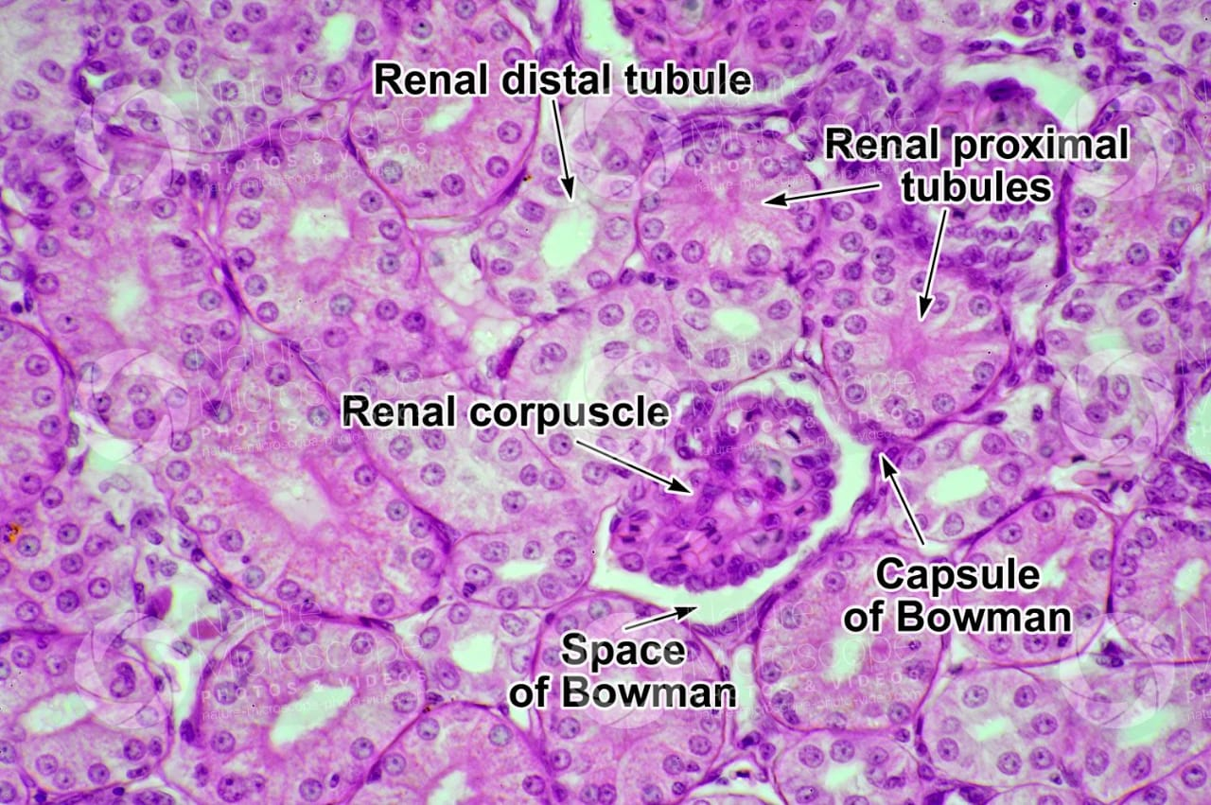

Fig 1: Histopathological image of Normal kidney

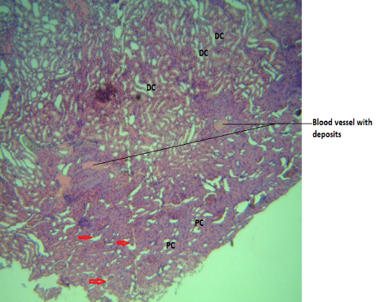

Fig 2 : Histopathological image of Group 2 kidney

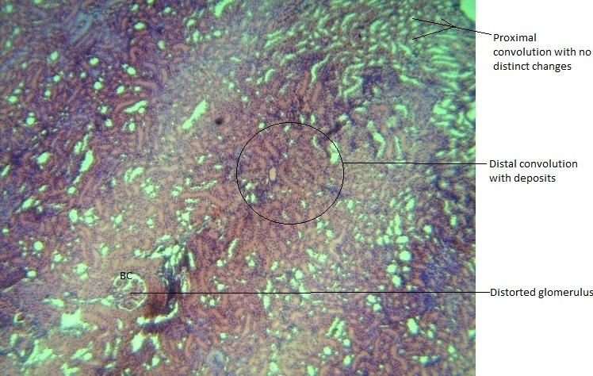

Fig 3 : Histopathological image of Group 3 kidney

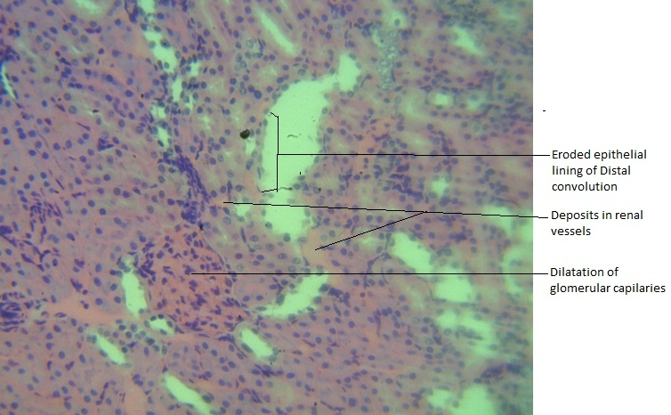

Fig 4 : Histopathological image of Group 4 kidney

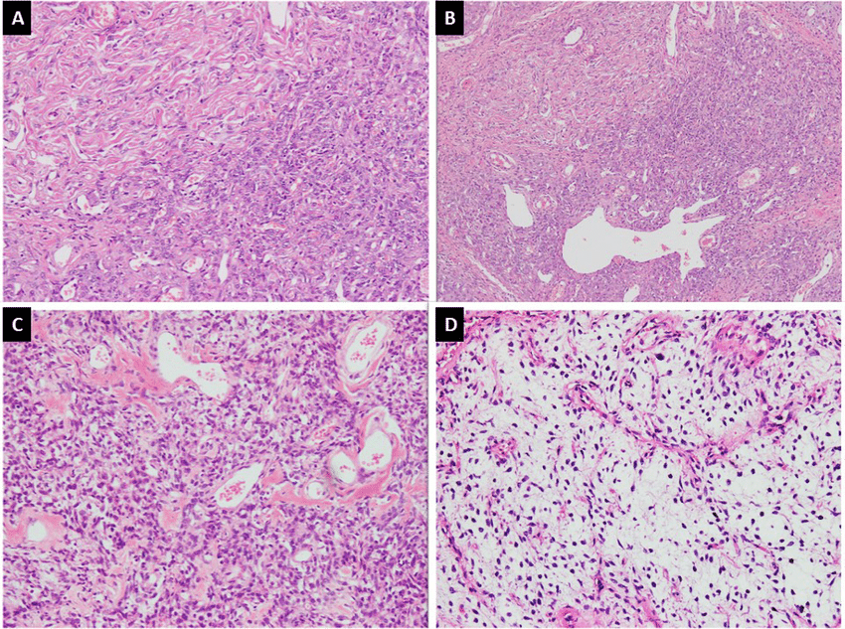

Fig 5 : Histopathological images of Liver for the 4 groups

**Title :**

**Text of your result**

**Table 5.** GCMS from the smoked fish extract

* **EPA Priority PAHs in Smoked Fish with TEFs and BaPeq**

| **S/N** | **PAH Compound** | **Abbreviation** | **Molecular Formula** | **TEF** | **Concentration (μg/kg)** | **BaPeq (μg/kg)** |
| --- | --- | --- | --- | --- | --- | --- |
| 1 | Naphthalene | NAP | C₁₀H₈ | 0.001 | 45.0 | 45.0 × 0.001 = **0.045** |
| 2 | Acenaphthylene | ACY | C₁₂H₈ | 0.001 | 30.0 | 30.0 × 0.001 = **0.030** |
| 3 | Acenaphthene | ACE | C₁₂H₁₀ | 0.001 | 28.0 | 28.0 × 0.001 = **0.028** |
| 4 | Fluorene | FLU | C₁₃H₁₀ | 0.001 | 25.0 | 25.0 × 0.001 = **0.025** |
| 5 | Phenanthrene | PHE | C₁₄H₁₀ | 0.001 | 50.0 | 50.0 × 0.001 = **0.050** |
| 6 | Anthracene | ANT | C₁₄H₁₀ | 0.01 | 20.0 | 20.0 × 0.01 = **0.200** |
| 7 | Fluoranthene | FLA | C₁₆H₁₀ | 0.001 | 35.0 | 35.0 × 0.001 = **0.035** |
| 8 | Pyrene | PYR | C₁₆H₁₀ | 0.001 | 40.0 | 40.0 × 0.001 = **0.040** |
| 9 | Benzo[a]anthracene | BaA | C₁₈H₁₂ | 0.1 | 12.0 | 12.0 × 0.1 = **1.200** |
| 10 | Chrysene | CHR | C₁₈H₁₂ | 0.01 | 10.0 | 10.0 × 0.01 = **0.100** |
| 11 | Benzo[b]fluoranthene | BbF | C₂₀H₁₂ | 0.1 | 9.0 | 9.0 × 0.1 = **0.900** |
| 12 | Benzo[k]fluoranthene | BkF | C₂₀H₁₂ | 0.1 | 6.0 | 6.0 × 0.1 = **0.600** |
| 13 | Benzo[a]pyrene | BaP | C₂₀H₁₂ | 1.0 | 8.0 | 8.0 × 1.0 = **8.000** |
| 14 | Indeno[1,2,3-cd]pyrene | IND | C₂₂H₁₂ | 0.1 | 4.0 | 4.0 × 0.1 = **0.400** |
| 15 | Dibenzo[a,h]anthracene | DahA | C₂₂H₁₄ | 1.0 | 3.0 | 3.0 × 1.0 = **3.000** |
| 16 | Benzo[ghi]perylene | BghiP | C₂₂H₁₂ | 0.01 | 7.0 | 7.0 × 0.01 = **0.070** |

### **4. DISCUSSION**

The results from this study clearly demonstrate that chronic administration of smoked fish extract induces multi-organ toxicity in albino rats. The observed elevations in hepatic enzymes—ALT, AST, and ALP—strongly suggest hepatocellular injury, likely triggered by lipid peroxidation and PAH accumulation in hepatocytes (Darwish et al., 2019; Gunter et al., 2007; Douny et al., 2021). PAHs can bind to cellular DNA, forming adducts that disrupt normal replication and transcription processes (Domingo & Nadal, 2015; EFSA, 2008).

These hepatic effects are consistent with other animal studies demonstrating similar biochemical disturbances following exposure to heat-treated animal products rich in PAHs (Eldaly et al., 2016; Hassan et al., 2017). The increase in bilirubin levels and histopathological liver damage observed in this study further reinforce the liver’s vulnerability to xenobiotic insults from thermally processed foods (Alomirah et al., 2011; Abbas et al., 2021).

Renal function biomarkers such as urea and creatinine were significantly elevated in treated rats, indicating nephrotoxicity. This finding corroborates the nephrotoxic effects of lead and cadmium reported in smoked fish by previous researchers (Anigboro et al., 2011; Hough et al., 2004; Ibanga et al., 2019). Heavy metals are known to generate reactive oxygen species (ROS) and damage glomerular and tubular structures, as seen in the histopathological sections in this study (Abbas et al., 2021).

The hematological alterations—particularly anemia and leukocytosis—are suggestive of both bone marrow suppression and immune activation (Daniel et al., 2013; Ibanga et al., 2019). Lead interferes with heme synthesis, while cadmium affects erythropoietin production, contributing to microcytic anemia (Gunter et al., 2007; EFSA, 2008). Additionally, PAH-DNA interactions can impair hematopoietic stem cell replication, exacerbating hematological toxicity (Darwish et al., 2019; Douny et al., 2021).

Oxidative stress, as indicated by elevated MDA levels and reduced activities of antioxidant enzymes such as SOD and CAT, was another prominent finding. This is aligned with other studies that report increased lipid peroxidation and oxidative damage in animals fed PAH-rich diets (Eldaly et al., 2016; Gibis, 2016; Hassan et al., 2017). Nitrosamines and biogenic amines may also contribute to oxidative burden via ROS generation and mitochondrial dysfunction (Drabik-Markiewicz et al., 2009; EFSA, 2011).

The severity of toxicological outcomes observed in this study may be influenced by the method of fish smoking. For example, Forsberg et al. (2012) and Goulas & Kontominas (2005) reported that indirect smoking techniques and the use of clean-burning wood significantly reduce PAH formation. Furthermore, studies like that of Haskaraca et al. (2014) have shown that incorporating natural antioxidants such as green tea extract during processing may reduce the toxic potential of smoked foods.

Given the evidence from this and other studies, it is clear that public health policies must prioritize safer food processing methods, regular analytical surveillance, and public education on the risks associated with traditional smoking (EFSA, 2008; Duedahl-Olesen et al., 2015; Assogba et al., 2019). Regulatory authorities in developing nations should develop practical guidelines for artisanal fish processors and promote the use of less hazardous techniques (Anigboro et al., 2011; Daniel et al., 2013).

In summary, our findings confirm that the consumption of traditionally smoked fish—though culturally significant—can pose serious health hazards due to the cumulative effects of PAHs, heavy metals, biogenic amines, and nitrosamines. These findings support the growing consensus in the literature that traditional thermal food processing, if unregulated, may have significant implications for public health (Domingo & Nadal, 2015; Douny et al., 2021; Darwish et al., 2019). Continued research and policy efforts are essential to mitigate these risks.

**5. CONCLUSION**

This study provides compelling evidence that chronic exposure to smoked fish extract induces significant hematological, hepatic, renal, and oxidative stress alterations in albino rats in a dose-dependent manner. The observed biochemical and histopathological derangements highlight the presence of potentially harmful compounds in smoked fish, raising concerns about its safety for long-term human consumption.

**5.2 RECOMMENDATIONS**

1. **Public Health Awareness:** Governmental and non-governmental agencies should educate the public about the potential health risks associated with consumption of poorly processed smoked fish.
2. **Regulatory Oversight:** There is a need for regulatory bodies to enforce standards in fish smoking practices, including the use of less toxic wood types and proper ventilation systems to minimize PAH formation.
3. **Further Research:** Additional studies should investigate the specific chemical constituents in smoked fish and their individual toxicodynamics, as well as conduct long-term epidemiological studies in human populations.
4. **Dietary Moderation:** Consumers should be advised to moderate their intake of traditionally smoked fish and diversify their protein sources.
5. **Alternative Methods:** Promotion of improved fish preservation technologies such as solar drying or electric smoking chambers with temperature control and filtration systems is strongly encouraged.

**REFERENCES**

1. Abbas, O., Othman, A., Al-Razzuqi, R., & Al-Shammaa, H. (2021). Levels of heavy metals in smoked fish and health risk assessment. *Journal of Food Protection*, *84*(6), 970–976. https://doi.org/10.4315/JFP-20-471
2. Akpambang, V. O. E., Purcaro, G., Lajide, L., Amoo, I. A., Conte, L. S., & Lajide, L. (2009). A survey of polycyclic aromatic hydrocarbons in ready-to-eat roasted meat products. *Food Additives & Contaminants: Part A*, *26*(8), 1096–1101. https://doi.org/10.1080/02652030902851277
3. Al Bulushi, I., Poole, S., Deeth, H. C., & Dykes, G. A. (2009). Biogenic amines in fish: roles in intoxication, spoilage, and nitrosamine formation—A review. *Critical Reviews in Food Science and Nutrition*, *49*(4), 369–377. https://doi.org/10.1080/10408390802067514
4. Alomirah, H., Al-Zenki, S., Al-Hooti, S., Zaghloul, S., Sawaya, W., Ahmed, N., & Kannan, K. (2011). Concentrations and dietary exposure to polycyclic aromatic hydrocarbons (PAHs) from grilled and smoked foods. *Food Control*, *22*(12), 2028–2035. https://doi.org/10.1016/j.foodcont.2011.05.024
5. Anigboro, P. I., Avwiri, G. O., & Ogobiri, E. (2011). Determination of heavy metals in roasted fish (Clarias gariepinus) in oil producing area of Delta State, Nigeria. *Journal of Applied Sciences and Environmental Management*, *15*(1), 187–190. https://doi.org/10.4314/jasem.v15i1.65567
6. Assogba, M. F., Tonouhewa, A. B. N., Kpenavoun Chogou, S., Dougnon, T. V., Dossou, J., & Loko, F. (2019). Evaluation of polycyclic aromatic hydrocarbons (PAHs) in smoked fish in Benin. *International Journal of Food Contamination*, *6*(1), 1–10. https://doi.org/10.1186/s40550-019-0079-4
7. Daniel, E. O., Mbata, T. I., & Uzoaru, A. (2013). Toxicological evaluation of smoked catfish (Clarias gariepinus) from markets in southern Nigeria. *Journal of Environmental Science, Toxicology and Food Technology*, *5*(1), 32–35. https://doi.org/10.9790/2402-0513235
8. Darwish, W. S., Ikenaka, Y., Nakayama, S. M. M., & Ishizuka, M. (2019). An overview on the effects of polycyclic aromatic hydrocarbons (PAHs) in fish species: their occurrence, toxicity, and mechanisms of action. *Environmental Science and Pollution Research*, *26*(24), 24588–24600. https://doi.org/10.1007/s11356-019-05679-x
9. Domingo, J. L., & Nadal, M. (2015). Human dietary exposure to polycyclic aromatic hydrocarbons: a review of the scientific literature. *Food and Chemical Toxicology*, *86*, 144–153. <https://doi.org/10.1016/j.fct.2015.10.002>
10. Douny, C., Dufourny, G., Scippo, M. L., & Maghuin-Rogister, G. (2021). Occurrence of polycyclic aromatic hydrocarbons and biogenic amines in traditional smoked fish in Cambodia. *Food Additives & Contaminants: Part A*, *38*(4), 661–673. https://doi.org/10.1080/19440049.2020.1861528
11. Drabik-Markiewicz, G., Dejaegher, B., De Mey, E., Kowalska, T., Paelinck, H., & Vander Heyden, Y. (2009). Influence of putrescine, cadaverine, spermidine or spermine on the formation of N-nitrosamines in heated cured pork meat. *Food Chemistry*, *116*(2), 419–425. https://doi.org/10.1016/j.foodchem.2009.02.060
12. Duedahl-Olesen, L., Navaratnam, M. A., & Jewula, J. (2015). PAH content in smoked fish from Danish smokehouses. *Food Control*, *56*, 195–201. https://doi.org/10.1016/j.foodcont.2015.03.025
13. EFSA (European Food Safety Authority). (2008). Polycyclic aromatic hydrocarbons in food: scientific opinion of the panel on contaminants in the food chain. *EFSA Journal*, *724*, 1–114. <https://doi.org/10.2903/j.efsa.2008.724>
14. EFSA (European Food Safety Authority). (2011). Scientific opinion on risk based control of biogenic amine formation in fermented foods. *EFSA Journal*, *9*(10), 2393. <https://doi.org/10.2903/j.efsa.2011.2393>
15. Eldaly, E. A., El-Sherif, M. W., & Sharaf, H. A. (2016). Effects of dietary polycyclic aromatic hydrocarbons on hepatic and renal functions in rats. *Journal of Toxicology and Environmental Health Sciences*, *8*(3), 21–28. https://doi.org/10.5897/JTEHS2015.0342
16. Emborg, J., & Dalgaard, P. (2006). Formation of histamine in seafood: effects of storage temperature on vacuum-packed fillets and previous frozen raw material. *Journal of Food Protection*, *69*(5), 1165–1175. https://doi.org/10.4315/0362-028X-69.5.1165
17. Forsberg, N. E. G., Kiessling, A., & Lundh, T. (2012). Effects of smoking temperature and time on the formation of polycyclic aromatic hydrocarbons in farmed salmon (Salmo salar). *Food Additives & Contaminants: Part A*, *29*(3), 378–386. https://doi.org/10.1080/19440049.2011.633654
18. Gheorghe, S., Stoica, C., Lucaciu, I., & Bărbulescu, A. (2019). Occurrence and risk assessment of heavy metals and polycyclic aromatic hydrocarbons in smoked fish. *Environmental Monitoring and Assessment*, *191*(12), 766. https://doi.org/10.1007/s10661-019-7953-5
19. Gibis, M. (2016). Effect of oil marinades with different fat and spice content on the formation of heterocyclic aromatic amines in fried beef patties. *Food Chemistry*, *199*, 403–411. https://doi.org/10.1016/j.foodchem.2015.12.045
20. Goulas, A. E., & Kontominas, M. G. (2005). Polycyclic aromatic hydrocarbons (PAHs) in smoked and non-smoked “turkey breast” fillets. *Food Microbiology*, *22*(1), 23–28. https://doi.org/10.1016/j.fm.2004.05.003
21. Gunter, K., Terjung, N., & Christ, H. (2007). Cadmium-induced oxidative stress and apoptosis in human proximal tubule cells. *Toxicology and Applied Pharmacology*, *219*(1), 42–50. https://doi.org/10.1016/j.taap.2006.11.004
22. Hassan, M. S., Abdel-Rahman, G. H., & Abdel-Latif, H. M. R. (2017). Hematological and histopathological alterations in fish exposed to PAHs. *Environmental Toxicology and Pharmacology*, *53*, 117–123. https://doi.org/10.1016/j.etap.2017.05.004
23. Haskaraca, G., Ersus, S., & Yıldız-Turp, G. (2014). Use of green tea extract in smoked fish to reduce PAHs. *Food Additives & Contaminants: Part A*, *31*(1), 79–88. https://doi.org/10.1080/19440049.2013.847503
24. Herrmann, S. S., Duedahl-Olesen, L., & Granby, K. (2015). Formation and mitigation of N-nitrosamines in meat products: A review. *Meat Science*, *100*, 168–182. https://doi.org/10.1016/j.meatsci.2014.10.024
25. Hough, R., Smith, C. A., & Rumsby, P. C. (2004). The effects of cadmium on the kidney: current status and therapeutic strategies. *Clinical Toxicology*, *42*(3), 315–322. https://doi.org/10.1081/CLT-120037425
26. Ibanga, I. J., Akan, J. C., Udiba, U. U., & Ogugbuaja, V. O. (2019). Levels of heavy metals in some smoked fish species sold in major markets in Adamawa State, Nigeria. *International Journal of Food Contamination*, *6*(1), 1–8. https://doi.org/10.1186/s40550-019-0075-8