**Systematic Evaluation of Signs, Symptoms and Severity of Tartrazine and Carmoisine Azo Dyes Acute Toxicity in Albino Rats**

**Abstract**

Coloursare an important component of food and food products stimulating the desired psychological satisfaction, particularly in children. The study was designed to evaluate the severity, signs, and symptoms of tartrazine and carmoisine toxicity in albino rats. A total of 160 rats (male and female) rats weighing approximately 0.15kg were used for the experiment. Pilot studies were done to establish the LD100 of tartrazine and carmoisine in both intraperitoneal and oral routes of administration in the experimental animals. Following the LD 100 determination, doses of tartrazine intraperitoneally administered ranged from 0.0g/kg, to 8.33g/kg, while doses of tartrazine orally administered ranged from 0.0g/kg, to 20.0g/kg, Regarding carmoisine, the doses of carmoisine administered intraperitoneally ranged from 0.0g/kg, to, 2.0g/kg while doses orally administered ranged from 0.0g/kg, to 22.5g/kg. The severity, signs, and symptoms of toxicity were monitored for 24 hours immediately after administration. Signs and symptoms of toxicity such as pigmentation, sedation, respiratory distress, coma, and death were observed. More so, other signs of toxicity such as loss of appetite, yellowish or reddish urine andsoft stool, watery stool, low motor activities, nosebleeds, drooling, loss of furs, and generalized fatigue were observed particularly in the dose/rats where respiratory distress, coma, and death occurred. Data obtained were analysed using GraphPad Prism and statistical significance was seen at P<0.05. The time of onset of the signs and symptoms of toxicity were inversely proportional to the dose while the severity of the toxicity was proportional to the dose administered. The severity, signs, and symptoms of azo dye toxicity in treated rats vary based on the dose administered and the time of exposure. The signs and symptoms of pigmentation appeared at 80.23±7.41 minutes at the dose 1.67g/kg while death occurred firstly 316±0.13minutes at dose of 5.0g/kg in rats treated with tartrazine intraperitoneally. Meanwhile, pigmentation appeared at 98.35±19.16minutes at the dose 2.5g/kg while death occurred firstly 352±5.66minutes at dose of 10g/kg in rats treated with tartrazine orally. Regarding carmoisine, pigmentation appeared at 94.25±4.35minutes at the dose 0.17g/kg while death occurred firstly 361±4.24minutes at dose of 2.0g/kg in rats treated with carmoisine intraperitoneally. In addition, oral administration of carmoisine showed pigmentation appearing at 110±11.17minutes at the dose 5.0g/kg while death occurred firstly 418±0.23minutes at dose of 2.0g/kg in rats treated with carmoisine orally. Finally, the severity of toxicity in the Rats indicated a toxicological score of 60+ at the highest dose (LD50) administered in all the forms of treatment. Rats treated with higher doses of tartrazine and carmoisine showed severe indicators of toxicity including death. Therefore, the consumption of high doses of carmoisine or tartrazine in food or food products even on a short-term basis should be avoided.

**Keywords:** Signs and Symptoms, Toxicity, Severity, Pigmentation, Sedation, Respiratory Distress, Coma,

Death, Azo Dye, Health Issues

**1. Introduction**

Colours are a vital components of food and food products that stimulates the desired psychological satisfaction in most consumers, particularly children and young adults [1, 2]. Tartrazine and carmoisine are examples of edible synthetic food dyes that impact yellowish and reddish appearances on food and food products [2, 3]. These azo dyes are mainly derived from organic compounds (coal tar)that can reflect light [3. 4].

The consumption of synthetic azo food dyes has been reported to induce nephrotoxicity, hepatotoxicity[5, 6], reduced haemoglobin, and haematocrit levels, distortions of WBC quantity and morphology [7, 8], as well as severe interference with enzyme [8, 9, 10].It has further been documented, particularly in children that consumption of tartrazine and carmoisine in food products is associated with most attention deficit disorders, and allergic and intolerance reactions when consumed in high concentration[9, 10]. Structurally, a molecule of carmoisine has two pairs of benzene rings linked by an azo bond (N = N), with one pair consisting of sodium sulphate, nitrogen, and hydroxyl group while the other pair consist sodium sulphate and nitrogen. In contrast, tartrazine has a three benzene rings linked with azo bond (N=N), of which two of the rings have sodium sulphate, nitrogen, and hydroxyl group while the mid-benzene ring harbours a carboxyl and nitrogen groups as shown in Figure 1

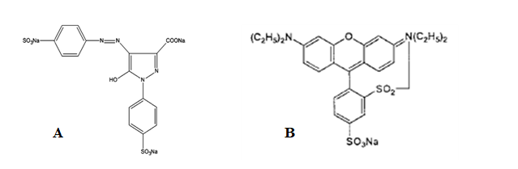

**Figure 1**: Structure of tartrazine dye (A) [10]and Carmoisine Dye (B)[11]

Tartrazine and carmoisine are water-soluble azo dyes with maximum acceptable daily intake (ADI) of7.5mg/kg/bw and 4.0mg/kg/bw respectively [11, 12, 13].The toxicity of carmoisine and tartrazine is linked with the reductive biotransformation of the azo bond during their metabolism in the liver and in the gut following microbial actions [14]. Their metabolism leads to the production of reactive amines, aryl amines, and free radicals that are associated with their toxicity [14, 15]. Therefore, laws and regulations are in place to regulate synthetic food dye use [9, 10]. This study tends to investigate the major signs and symptoms of toxicities, the onset of toxicity, as well as the severity of tartrazine and carmoisine toxicity in albino rats in an acute state.

**2. Materials and Methods**

**2.1 Animals**

Male and female rats weighing approximately 0.15kg were used for this experiment. A total of 160 rats weighing 0.15 kg were used for the study, 80 for tartrazine and another 80 for carmoisine treatments (Table 1a and Table 1b). All the animals were obtained through breeding except the parent rats purchased from the University of Port Harcourt animal farm. The rats were kept in a well-ventilated plastic cage in the animal house of the Faculty of Medical Laboratory Science, Rivers State University of Science, Port Harcourt. The rats were fed with rat pre-mix rat feed and water *ad libitum*.

**2.2 Carmoisine and Tartrazine food dyes**

Industrial grade tartarzine and carmoisine were purchased from Fiorio Colori spa, Gesste, Italy in a granular formof87.9% purity.

**2.3 Preparation of Carmoisine and Tartrazine food dyes**

**2.3.1 Intraperitoneal Treatment**

Two (2) grams of the tartrazine and carmoisine dyes were weighed separately and dissolved in their respective sterile containers containing 8 ml of distilled water followed by vigorous mixing for 30 minutes. This implies that 1.0 ml of each respective dye solution contains 0.25 grams.

* + 1. **Oral Treatment**

In this case, 3.0 grams of the tartrazine and carmoisine dyes were weighed separately and dissolved in their respective sterile containers containing 8 ml of distilled water followed by vigorous mixing for 30 minutes. This implies that 1.0 ml of eachrespective dyesolution contains 0.375 grams.

**2.4 Equipment**

Materials used include an Ohausweighing balance, timer, and oro-gastric/gavage tubes.

**2.5 Determination of LD100 of Tartrazine and Carmoisine**

Pilot studies weredone to establish the minimum dose that caused 100% deaths (LD100) in the experimental animals. The LD100of tartrazine administered intraperitoneally and orally were 8.33 g/kg and 20.0 g/kg respectively while the LD100 of carmoisine administered intraperitoneally and orally was 2.0g/kg and 22.5 g/kg respectively using Karber’s method as described by Dede et al., [16].

**2.6 Dose Calculation**

Following the LD 100 determination, doses of tartrazine intraperitoneally administered were 0.0g/kg, 1.68g/kg, 3.33g/kg, 5.0g/kg, 6.67g/kg, 8.33g/kg, 10.0g/kg, 13.33g/kg, and 16.67g/kg while doses of tartrazine orally administered were 0.0g/kg, 2.5g/kg, 5.0g/kg, 10.0g/kg, 15.0g/kg, 20.0g/kg, 22.5g/kg, 30.0g/kg, 35.0g/kg, and 40.0g/kg (Table 1a and Table 1b). Regarding carmoisine, the doses of carmoisine administered intraperitoneally were 0.0g/kg, 0.17g/kg, 0.50g/kg, 1.0g/kg, 1.53g/kg, 2.0g/kg, 2.5g/kg, 3.33g/kg, 4.17g/kg, and 5.0g/kg while doses orally administered were, 0.0g/kg, 5.0g/kg, 10.0g/kg, 12.5g/kg, 17.5g/kg, 22.5g/kg, 25.0g/kg, 32.5g/kg, 37.5g/kg, and 40.0g/kg(Table 1a and Table 1b).

**2.7 Monitoring of Signs and Symptoms of Toxicity**

The two sets of tartrazine and carmoisine (orally and intraperitoneally) treated rats were monitored for signs and symptoms of tartrazine toxicity including death for 24 hours. Signs and symptoms such as pigmentation of body parts, convulsion, sedation, respiratory distress, coma, and death were monitored for 24 hours immediately after administration.

**2.8 Statistical Analysis**

Data obtained were analysed using GraphPad Prism, version 8.02. Data were presented as Mean±SD. ANOVA alongside Tukey’s posthoc was employed. Statistical significance was seen at P < 0.05.

**3. RESULTS**

**3.1 Signs and Symptoms of Toxicity**

**3.1.1 Approximate Time in Minutes of Appearance of Signs and Symptoms of Toxicity of Tartrazine Intraperitoneally Administered**

Pigmentation and sedation of the rats occurred at all doses. The time of both pigmentation and sedation onset at 8.33g/kg was significantly shorter than that of 6.67g/kg. In addition, the time of pigmentation and sedation onset at 3.33g/kg, 5.0g/kg, 6.67g/kg, and 8.33g/kg were significantly shorter than 1.67g/kg. More so, respiratory distress occurred from 3.33g/kg to 8.33g/kg doses. The time of respiratory distress onset at 8.33g/kg was significantly shorter than that of 6.67g/kg, 5.0g/kg, and 3.33g/kg. In addition, the time of respiratory distress onset at 6.67g/kg was significantly shorter than 3.33g/kg. Furthermore, it was observed that coma and death of the rats occurred at 5.0g/kg, 6.67g/kg, and 8.33g/kg doses. Coma as well as death at 8.33g/kg and 6,67g/kg were significantly shorter than that of 5.0g/kg (Table 2).

**3.1.2 Approximate Time in Minutes of Appearance of Signs and Symptoms of Toxicity of Tartrazine Orally Administered**

It was observed that pigmentation and sedation of the rats occurred at all doses. The time of pigmentation and sedation onset at 20.0g/kg was significantly shorter than that of 10.0g/kg, 5.0g/kg, and 2.5g/kg except 15.0g/kg. In addition, the time of pigmentation and sedation onset at 15.0g/kg was also significantly shorter than 10.0g/kg. More so,respiratory distress occurred at 5.0g/kg, 10.0g/kg, 15.0g/kg, and 20.0g/kg. The time of respiratory distress onset at 20.0g/kg was significantly shorter than that of 5.0g/kg, and 10.0g/kg. In addition, there was a significantly shorter time between 15.0g/kg and 10.0g/kg. Furthermore, coma and death occurred at doses, 10.0g/kg, 15.0g/kg, and 20.0g/kg. The onset of coma and death between 10.0g/kg, 15.0g/kg, and 20.0g/kg were significantly shorter as the doses were increased (Table 3).

**3.1.3 Approximate Time in Minutes of Appearance of Signs and Symptoms of Toxicity Carmoisine Intraperitoneally Administered**

It was observed that pigmentation of the rats occurred at all doses. The time of pigmentation onset between dosages indicated a significantly shorter time as the doses were increased except between 2.0g/kg and 1.53g/kg. In addition, sedation occurred at all doses. The time of sedation onset between dosages indicated a significantly shorter time as the doses were increased except 0.5g/kg and 1.0g/kg. Respiratory distress in the rats occurred at 0.5g/kg, 1.0g/kg, 1.53g/kg, and 2.0g/kg. There were significantly shorter times of onset between dosages. More so, it was observed that coma and death occurred at 1.0g/kg, 1.53g/kg, and 2.0g/kg. The time of onset of coma and death at 2.0g/kg dose was significantly shorter than 1.0g/kg. However, there was no significant time difference between1.0g/kg and 1.53g/kg and 1.53g/kg and 2.0g/kg (Table 4).

**3.1.4 Approximate Time in Minutes of Appearance of Signs and Symptoms of Toxicity of Carmoisine Orally Administered**

It was observed that pigmentation of the rats occurred at all doses. The time of pigmentation onset indicated a significantly shorter time between the dosages except5.0g/kg and 10.0g/kg and between 17.5g/kg and 22.5g/kg in a dose-dependent pattern. In addition,sedation occurred at all doses. The time of sedation onset indicated a significantly shorter time between the dosages except between 12.5g/kg and 10.0g/kg. Furthermore, it was observed that respiratory distress in the rats occurred at 10.0g/kg, 12.5g/kg, 17.5g/kg, and 22.5g/kg doses. The time of respiratory distress onset at 10.0g/kg, 12.5g/kg, 17.5g/kg, and 22.5g/kg doses had significantly shorter onset as the doses were increased. More so, it was observed that coma of the rats occurred at 10.0g/kg, 12.5g/kg, 17.5g/kg, and 22.5g/kg doses. The time of coma onset at 22.5g/kg was significantly shorter than 10.0g/kg, 12.5g/kg, and 17.5g/kg. However, there were no significant differences between 10.0g/kg and 12.5g/kg and between 12.5g/kg and 17.5g/kg. Finally, it was observed that the death of the rats occurred at 10.0g/kg, 12.5g/kg, 17.5g/kg, and 22.5g/kg doses. There were significantly shorter times in the time of death onset between the dosages (Table 5).

**3.2 Assessing the Severity of Symptoms of Toxicity**

The severity of symptoms of tartrazine and carmoisine azo dyes used for the study were quantified using the following score: + Pigmentation, 2+ Sedation, 3+ Respiratory distress, 4+ Coma, and 5+ Death. The score multiplied by the number of rats affected gave the total severity score at each dose.

In terms of tartrazine administered intraperitoneally, it was observed that at 1.67g/kg only pigmentation and sedation occurred, while at 3.33g/kg, pigmentation, sedation, and respiratory distress occurred, and finally at 5.0g/kg, 6.67g/kg and 8.33g/kg, respiratory distress, coma, and death occurred (Table 6). Regarding tartrazine administered orally, it was observed that at 2.5g/kg, only pigmentation and sedation occurred, while at 5.0g/kg, pigmentation, sedation, and respiratory distress occurred, and finally at 10.0g/kg, 15.0g/kg, and 20.0g/kg, respiratory distress, coma, and death occurred (Table 7). In addition, concerning carmoisine administered intraperitoneally, it was shown that at 0.17g/kg only pigmentation and sedation occurred, while at 0.5g/kg, pigmentation, sedation, and respiratory distress occurred, and finally at 1.0g/kg, 1.5g/kg and 2.0g/kg, respiratory distress, coma, and death occurred (Table 8). Regarding carmoisine orally administered, it was also observed that at 5.0g/kg, pigmentation and sedation occurred, while at 10.0g/kg, pigmentation, sedation, and respiratory distress occurred. Finally, at 12.5g/kg, 17.5g/kg, and 22.5g/kg, respiratory distress, coma, and death occurred (Table 9).In these cases, the score given multiplied by the number of rats affected generated the total severity score at each dose which was used to plot the severity of symptoms versus doses of dyes graphs (Figure 2 -6).

**Table 1a: Determination of LD100 of Tartrazine and Carmoisine Intraperitoneally Treated Rats**

|  |  |  |  |  |  |  |  |  |  |  |
| --- | --- | --- | --- | --- | --- | --- | --- | --- | --- | --- |
| Tartrazine Treated Group | | | | |  | Carmoisine Treated Group | | | | |
| Group | **No of Rats** | **Volume (ml)** | **Dose (g/kg)** | **All Dead?** |  | **Group** | **No of Rats** | **Volume (ml)** | **Dose (g/kg)** | **All Dead?** |
| ATI | 4 | 0.0 | 0.0 | NO |  | ACI | 4 | 0.0 | 0.0 | NO |
| BTI | 4 | 1.0 | 1.67 | NO |  | BCI | 4 | 0.10 | 0.17 | NO |
| CTI | 4 | 2.0 | 3.33 | NO |  | CCI | 4 | 0.30 | 0.50 | NO |
| DTI | 4 | 3.0 | 5.00 | NO |  | DCI | 4 | 0.60 | 1.0 | NO |
| ETI | 4 | 4.0 | 6.67 | NO |  | ECI | 4 | 0.90 | 1.53 | NO |
| *FTI | 4 | *5.0 | *8.33 | YES |  | *FCI | 4 | *1.20 | *2.0 | YES |
| GTI | 4 | 6.0 | 10.0 | YES |  | GCI | 4 | 1.50 | 2.5 | YES |
| HTI | 4 | 8.0 | 13.33 | YES |  | HCI | 4 | 2.0 | 3.33 | YES |
| ITI | 4 | 9.0 | 15.0 | YES |  | ICI | 4 | 2.50 | 4.17 | YES |
| JTI | 4 | 10.0 | 16.67 | YES |  | JCI | 4 | 3.0 | 5.0 | YES |

LD100= 8.33g/kg and 2.0g/kg for tartrazine and carmoisine intraperitoneally administration respectively

**Table 1b: Determination of LD100 of Tartrazine and Carmoisine Orally Treated Rats**

|  |  |  |  |  |  |  |  |  |  |  |
| --- | --- | --- | --- | --- | --- | --- | --- | --- | --- | --- |
| Tartrazine Treated Group | | | | |  | Carmoisine Treated Group | | | | |
| Group | **No of Rats** | **Volume (ml)** | **Dose (g/kg)** | **All Dead?** |  | **Group** | **No of Rats** | **Volume (ml)** | **Dose (g/kg)** | **All Dead?** |
| ATO | 4 | 0.0 | 0.0 | NO |  | ACO | 4 | 0.0 | 0.0 | NO |
| BTO | 4 | 1.0 | 2.50 | NO |  | BCO | 4 | 2. 0 | 5.0 | NO |
| CTO | 4 | 2.0 | 5.0 | NO |  | CCO | 4 | 4.0 | 10.0 | NO |
| DTO | 4 | 4.0 | 10.0 | NO |  | DCO | 4 | 5. 0 | 12.5 | NO |
| ETO | 4 | 6.0 | 15.01 | NO |  | ECO | 4 | 7.0 | 17.5 | NO |
| *FTO | 4 | *8.0 | *20.0 | YES |  | *FCO | 4 | *9.0 | *22.5 | YES |
| GTO | 4 | 9.0 | 22.5 | YES |  | GCO | 4 | 10.0 | 25.0 | YES |
| HTO | 4 | 12.0 | 30.0 | YES |  | HCO | 4 | 13.0 | 32.5 | YES |
| ITO | 4 | 14.0 | 35.0 | YES |  | ICO | 4 | 15.0 | 37.5 | YES |
| JTO | 4 | 16.0 | 40.0 | YES |  | JCO | 4 | 16.0 | 40.0 | YES |

LD100 = 20.0g/kg and 22.5g/kg for tartrazine and carmoisine orally administration respectively

**Table 2: Approximate Time in Minutes of Appearance of Signs and Symptoms of Toxicity in Tartrazine Intraperitoneally Treated Rats.**

|  |  |  |  |  |  |
| --- | --- | --- | --- | --- | --- |
| Dose (g/kg) | Pigmentation | Sedation | Respiratory Distress | Coma | Death |
| 0.0 | - | - | - | - | - |
| 1.67 | 80.25±7.41a | 81.75±4.99a | - | - | - |
| 3.33 | 63.75±4.27a | 72.50±4.79a | 91.50±9.98a | - | - |
| 5.0 | 56.50±7.33b | 64.75±9.97b | 83.25±10.05a | 145±0.21a | 316±0.13a |
| 6.67 | 44.50±5.50b | 56.50±8.58b | 65.50±4.79b | 126.7±5.13b | 281±11.72b |
| 8.33 | 19.50±6.95c | 30.75±5.85c | 46.00±9.85c | 118±6.50c | 213±8.51c |
| P value | <0.001* | <0.001* | <0.001* | <0.001* | <0.001* |
| F value | 102.70 | 87.16 | 120.70 | 102.5 | 2303 |

*Significant p value. PostHoc: values in the same column with different superscripts differ significantly at p<0.05.

**Table 3: Approximate Time in Minutes of Appearance of Signs and Symptoms of Toxicity in Tartrazine Orally Treated Rats**

|  |  |  |  |  |  |
| --- | --- | --- | --- | --- | --- |
| Dose (g/kg) | Pigmentation | Sedation | Respiratory Distress | Coma | Death |
| 0.0 | - | - | - | - | - |
| 2.5 | 98.75±19.16a | 94.25±5.56a | - | - | - |
| 5.0 | 82.75±5.50a | 78.50±5.80a | 117.80±17.33a | - | - |
| 10.0 | 73±7.394a | 73.50±8.58a | 96±10.33b | 165±4.24a | 352±5.66a |
| 15.0 | 44.50±5.51b | 57.25±4.43b | 73±9.256b | 139.3±6.66b | 294.7±9.45b |
| 20.0 | 29.25±3.90c | 36.75±9.71c | 53.25±10.24c | 128.30±2.87c | 228.8±12.69c |
| P value | <0.001 | <0.001 | <0.001 | <0.001 | <0.001 |
| F value | 60.15 | 110.10 | 96.37 | 2346 | 1814 |

*Significant p value. PostHoc: Values in the same column with different superscripts differ significantly at p<0.05.

**Table 4: Approximate Time in Minutes of Appearance of Signs and Symptoms of Toxicity in Carmoisine Intraperitoneally Treated Rats**

|  |  |  |  |  |  |
| --- | --- | --- | --- | --- | --- |
| Dose (g/kg) | Pigmentation | Sedation | Respiratory Distress | Coma | Death |
| 0.0 | - | - | - | - | - |
| 0.17 | 94.25±4.35a | 129.8±8.26a | - | - | - |
| 0.5 | 81.75±7.93a | 106.3±8.88b | 173±8.87a | - | - |
| 1.0 | 52.75±6.70b | 93±12.81b | 154±11.22b | 264.5±19.09a | 361.0±4.24a |
| 1.53 | 26±4.97c | 78.75±8.92c | 125.5±8.58c | 239.5±12.02b | 329.5±12.02b |
| 2.0 | 18.75±3.30d | 53±3.92d | 103±11.43c | 221±10.23b | 283.5±18.70b |
| P value | <0.001 | <0.001 | <0.001 | <0.001 | <0.001 |
| F value | 204.5 | 123.0 | 335.3 | 922.1 | 1183.4 |

*Significant p value. PostHoc: Values in the same column with different superscripts differ significantly at p<0.05.

**Table 5 : Approximate Time in Minutes of Appearance of Signs and Symptoms of Toxicity in Carmoisine Orally Treated Rats**

|  |  |  |  |  |  |
| --- | --- | --- | --- | --- | --- |
| Dose (g/kg) | Pigmentation | Sedation | Respiratory Distress | Coma | Death |
| 0.0 | - | - | - | - | - |
| 5.0 | 110.0±11.17a | 135.3±7.54a | - | - | - |
| 10.0 | 97.50±9.11a | 117.3±12.84b | 194.5±5.51a | 298±0.12a | 418.0±0.23a |
| 12.5 | 62.75±6.18b | 107.0±7.39b | 170.8±7.59b | 276±11.31a | 370.5±2.12b |
| 17.5 | 40.0±5.12c | 86.75±6.13c | 139.8±8.26c | 258.0±9.16b | 346.3±6.43c |
| 22.5 | 31.75±4.92c | 61.75±6.33c | 109.0±9.31d | 228.3±20.76c | 294.8±13.38d |
| P value | <0.001 | <0.001 | <0.001 | <0.001 | <0.001 |
| F value | 139.8 | 160.4 | 287.4 | 515.6 | 2389 |

*Significant p value. PostHoc: Values in the same column with different superscripts differ significantly at p<0.05.

**Table 6: Severity of Symptoms of Toxicity versus Dose of Tartrazine Intraperitoneally Administered**

|  |  |  |  |  |  |  |
| --- | --- | --- | --- | --- | --- | --- |
| Dose (g/kg) | Pigmentation | Sedation | Res. distress | Coma | Death | Total |
| 0.00 | 0 | 0 | 0 | 0 | 0 | 0 |
| 1.67 | 4+ | 8+ | 0 | 0 | 0 | 12+ |
| 3.33 | 4+ | 8+ | 3+ | 0 | 0 | 15+ |
| 5.0 | 4+ | 8+ | 6+ | 4+ | 5+ | 27+ |
| 6.67 | 4+ | 8+ | 9+ | 12+ | 15+ | 48+ |
| 8.33 | 4+ | 8+ | 12+ | 16+ | 20+ | 60+ |

Key symptoms = (Pigmentation +; Sedation 2+; Res. Distress 3+; Coma 4+; Death 5+) × no of rats affected.

**Table 7: Severity of Symptoms of Toxicity versus Dose of Tartrazine Orally Administered**

|  |  |  |  |  |  |  |
| --- | --- | --- | --- | --- | --- | --- |
| Dose (g/kg) | Pigmentation | Sedation | Res. distress | Coma | Death | Total |
| 0.00 | 0 | 0 | 0 | 0 | 0 | 0 |
| 2.5 | 4+ | 8+ | 0 | 0 | 0 | 12+ |
| 5.0 | 4+ | 8+ | 6+ | 0 | 0 | 18+ |
| 10.0 | 4+ | 8+ | 9+ | 8+ | 10+ | 39+ |
| 15.0 | 4+ | 8+ | 12+ | 12+ | 15+ | 51+ |
| 20.0 | 4+ | 8+ | 12+ | 16+ | 20+ | 60+ |

Key symptoms = (Pigmentation +, Sedation 2+, Res. Distress 3+, Coma 4+, Death 5+) × no of rats affected.

**Table 8: Severity of Symptoms of Toxicity versus Dose of Carmoisine Intraperitoneally Administered**

|  |  |  |  |  |  |  |
| --- | --- | --- | --- | --- | --- | --- |
| Dose (g/kg) | Pigmentation | Sedation | Res. distress | Coma | Death | Total |
| 0.0 | 0 | 0 | 0 | 0 | 0 | 0 |
| 0.17 | 4+ | 8+ | 0 | 0 | 0 | 12+ |
| 0.5 | 4+ | 8+ | 6+ | 0 | 0 | 18+ |
| 1.0 | 4+ | 8+ | 9+ | 8+ | 10+ | 39+ |
| 1.5 | 4+ | 8+ | 12+ | 8+ | 10+ | 42+ |
| 2.0 | 4+ | 8+ | 12+ | 16+ | 20+ | 60+ |

Key: symptoms = (Pigmentation +, Sedation 2+, Res. Distress 3+, Coma 4+, Death 5+) × no of rats affected.

**Table 9: Severity of Symptoms of Toxicity versus Dose of Tartrazine Orally Administered**

|  |  |  |  |  |  |  |
| --- | --- | --- | --- | --- | --- | --- |
| Dose (g/kg) | Pigmentation | Sedation | Res. distress | Coma | Death | Total |
| 0.0 | 0 | 0 | 0 | 0 | 0 | 0 |
| 5.0 | 4+ | 8+ | 0 | 0 | 0 | 12+ |
| 10.0 | 4+ | 8+ | 6+ | 4+ | 5+ | 27+ |
| 12.5 | 4+ | 8+ | 9+ | 8+ | 10+ | 39+ |
| 17.5 | 4+ | 8+ | 12+ | 12+ | 15+ | 51+ |
| 22.5 | 4+ | 8+ | 12+ | 16+ | 20+ | 60+ |

Key symptoms = (Pigmentation +, Sedation 2+, Res. Distress 3+, Coma 4+, Death 5+) × no of rats affected.

**3.3 Graphical Representation of the Approximate Time (Minutes) of Appearance of Signs and Symptoms of Toxicity**

The graphical representation of the approximate time (minutes) of the appearance of signs and symptoms of toxicity is shown in figure 2 -5.

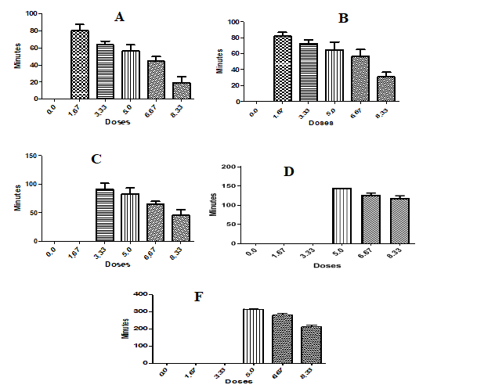

**Figure 2:** Graph of Approximate time (min) of appearance of Pigmentation (A), Sedation (B), Respiratory distress (C), Coma (D), and Death (F) in Rats administered with tartrazine intraperitoneally

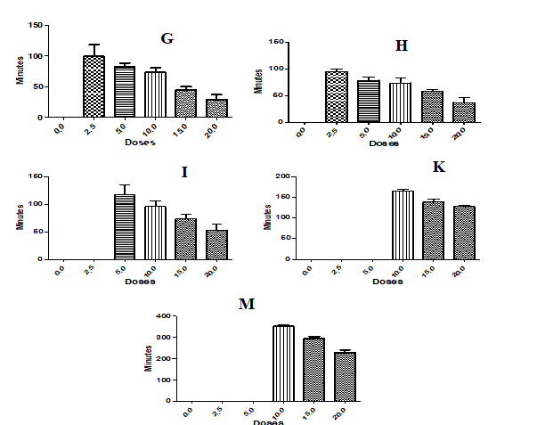

**Figure 3**: Approximate time (min) of appearance of Pigmentation (A), Sedation (H), Respiratory Distress (I), Coma (K), and Death (M) in Rats orally treated with Tartrazine

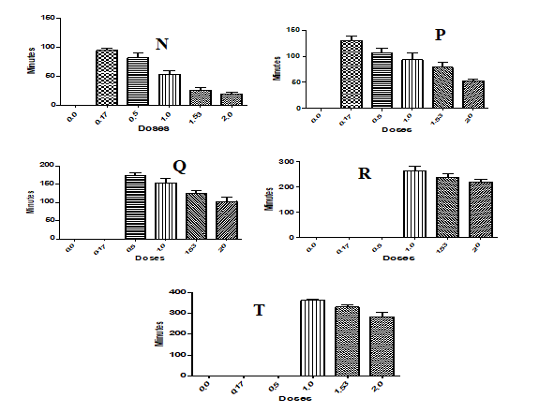

**Figure 4:** Approximate time (min) of appearance of Pigmentation (N), sedation (P), res. Distress (Q), Coma (R), and Death (T) in Rats treated intraperitoneally with carmoisine

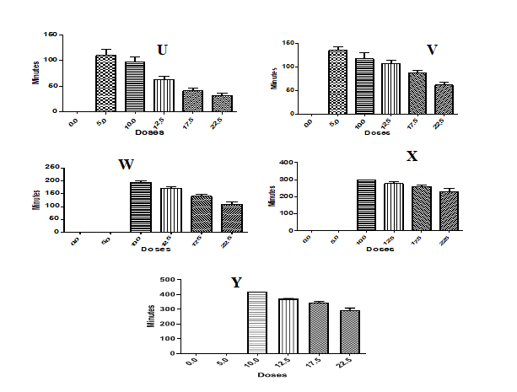

**Figure 5:** Approximate time (min) of appearance of Pigmentation (U), Sedation (V), Res. Distress (W), Coma (X), and Death (Y) with an increased dose of carmoisine orally administered

**3.4 Graphical Representation of Severity of Symptoms for Tartrazine and Carmiosine Treated Rats**

The severity of toxicity of tartrazine and carmiosine dyes in treated rats is shown in Figure 6.

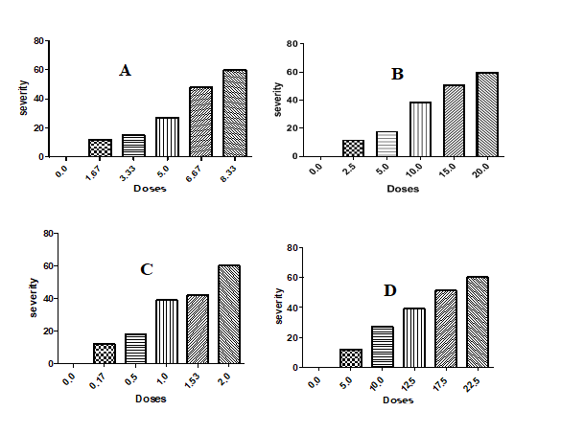

Figure 6: Severity of symptoms on tartrazine-treated rats (intraperitoneally) (A), Tartrazine-treated rats (orally) (B), carmoisine-treated rats (intraperitoneally) (C), and carmoisine-treated rats (orally) (D).

**4. Discussion**

The results of the LD100 of tartarzine and carmoisine for intraperitoneal and oral routes of administration using the Arithmetic Method of Karber could be classified as slightly toxic for intraperitoneal administration while when administered orally, it is a practically non-toxic substance following the Matsumura, [17] chemical rating. The differences in the values of the LD100 of the intraperitoneally and orally treated rats in both dyes are possibly due to the route of administration. In the oral route, the interaction of dyes with intestinal secretions, food materials, digestive and non-digestive enzymes, and microbial actions as well as hepatic first-by pass could account for the reduced degree of toxicity as indicated by the LD100 values in contrast to intraperitoneal route administration were systemic circulation is achieved quickly. The results observed are similar to our previous studies; Elekima et al., [18], when one rat per group was used to determine LD100 and LD50 of azo dyes in albino rats. Our findings further affirm that the smaller the value of the LD100, the more toxic the substance, and the larger the LD100 value the lesser the toxicity of azo dyes as obtainable in other chemicals.

More so, the onset signs and symptoms of tartrazine and carmoisine dyes such as pigmentation, sedation, respiratory distress, coma, and deathall occurred in a dosage-dependent pattern. This implies that, as the doses were increased, the time of onset of the signs and symptoms of toxicity such as pigmentation, sedation, respiratory distress, coma, and death were shorter or faster. The onset of signs and symptoms is inversely related to time. The higher the dose administered the higher the severity of the toxicity. That is, the severity of the toxicity in these dyes was also dose-dependent.

However, coma and death were noticed at the LD100 doses and doses closer to the LD100 in both dyes. Besides, the documented signs and symptoms of toxicity, there were other signs such as loss of appetite, yellowish or reddish soft stool (depending on the dye, tartrazine or carmoisine), watery stool, low motor activities, and generalized fatigue were observed significantly in the dose/rats whererespiratory distress, coma, and death occurred.More so, signs and symptoms of toxicity such as nosebleeds, the yellowish or reddish colouration of the urine, drooling, and loss of furs were also observed in the rats. Our findings concur with the report of Ai-Mashhedy & fijer, [1], who reported clinical signs of toxicity such as loss of appetite, drowsiness, tachycardia, and decrease in locomotion, and anorexia in azorubine-treated white Sprague Dawley® mice. Likewise, Qasim & Lafta [19], observed that the animals that were administered with 15 g/kg BW of sunset yellow and carmoisineazo dyes showed signs of loss of appetite, tachycardia, drowsiness, and eventual death over a period of 7 days. Qasim & Lafta [19], further observed that doses of 2, 3, 4, and 5 g/kg body weight (BW) orally for 7 days did not show clinical symptoms. However, they did not report the mortality of mice in the treated group. More so, Sattir & Amin [13], documented no signs and symptoms of clinical and behavioral toxicity in albino rats fed with azorubine for 30 days at doses of 5, 15, and 20mg/kg. The discrepancies between our findings and the reports of others could be related to the differences in the treatment doses. In our study, the lowest dose was 1.67g/kg and 0.17g/kg for tartrazine and carmoisine intraperitoneal treatment and 2.5g/kg and 5.0gkg for carmoisine and tartrazine oral administration respectively.

The capacity to excrete large concentration of unabsorbed dyes through the faeces, and the metabolic influence of the liver, intestinal secretions, and intestinal microbial interactions with the dye could have accounted for the reduced severity of toxicity in the oral groups compared to intraperitoneal groups. Coma and death could also be associated with organ failures such as that of the liver and renal system. The organ failures are associated with the capacity of these azo dyes to generate reactive oxygen species (ROS) and reactive nitrogen species (RNS) linked with cell lesions, tissue peroxidation, and loss of cell and tissue physiological functions.

The dose-dependent severity of dyes in the rats could be linked with the overwhelming activity of ROS and RNS (oxidative stress) on the antioxidant state of the rats. The mopping up of free radicals by the anti-oxidant systems of the rats would have been exhausted leading to indirect and direct insults on the cells and tissues of the organ-systems of the rats. Velioglu et al., [20] and Petra et al., [21], have also documented that azo dyes such as tartrazine at a very high dose of 500 mg/kg has been shown to significantly deplete anti-oxidant enzymes and increase oxidative stress markers after 3 weeks of administration to rats, which may lead to DNA damage.Megahed et al., [22], particularly indicated a drastic significant fall in Superoxide dismutase (SOD) and catalase (CAT) antioxidant enzymes activities in rats treated with 300mg/kg for 30 days.Therefore, the higher the dose administered, the greater the insult to the cells and tissues of the organsystem of the rats.

**5. Conclusion**

The severity, signs, and symptoms of azo dye toxicity in rats treated do vary based on the dose administered and the time of exposure. Rats treated with higher doses of tartrazine and carmoisine showed several severe indicators of toxicity including death. The signs and symptoms of toxicity observed were pigmentation (of the skin, eyes, stool, urine, tails, and limbs), sedation, respiratory distress, coma, and death. More so, nose-bleeding, drooling, loss of appetite, confusion, and fatigue were also seen. These observed signs of toxicity should be looked out for particularly in children addicted to consumption of coloured food products containing tartrazine or carmoisine to help curtail their toxicological effects. Therefore, the intake of high doses of carmoisine or tartrazine in food or food products even on a short-term basis should be avoided.

**ETHICAL APPROVAL**

We hereby declare that the Principles of laboratory animal care (NIH publication No. 85 23, revised 1985) were followed, as well as specific national laws where applicable. All experiments have been examined and approved by the Rivers State University research/ethics committee with file No: RSU/CV/APU/74/VOL.VIII/104.

**Acknowledgment**

Our sincere appreciation goes to Ejike Godwin, Godswill Orji, and Harrison Nwosu of the Faculty of Medical Laboratory Science, Rivers State University, Port Harcourt, Nigeria for their dedication in taking good care of the animals.

**Disclaimer (Artificial intelligence)**

The authors hereby declare that NO generative AI technologies such as Large Language Models (ChatGPT, COPILOT, etc.) and text-to-image generators have been used during the writing or editing of this manuscript.

**References**

1. Ai-Mashhedy AML, Fijer NA. (2016). Acute toxicity of food additives tartrazine and carmiosine on white male mice. International Journal of PharmTech Research, 2016; 9(4): 364 – 367
2. Elekima I, Ollor AO. Effect of carmiosine orally administered on thyroid hormones and thyroid stimulating hormone of albino rats. International Journal of Science and Research, 2016; 5(10): 29 – 32.
3. Dermirkol O, Zhang X, Ercal N. Oxidative effect of tartrazne (Cas No. 1934-21-0) and new coccin (Cas No. 2611-82-7) azo dyes on CHO cells. Journal of Consumer Protection and Food Safety, 2012;7: 229 – 236.
4. Reza, SA., Hasan M, Kamruzzaman M, Hossian I, Bari L, Abedin Z, Khandaker AR, Khalid-Bin-Ferdaus K, Haque F, Khairul I. Mahtab UA. Study of a Common Azo Food Dye in Mice Model: Toxicity Reports and Its Relation to Carcinogenicity. Food Science & Nutrition, 2019;7: 667-677.
5. Ramez AB, Elshamy AM, Amer AI. Study of the Protective Effect of Nigella Sativa Oil on Tartrazine-Induced Hematological Disorders in Rats. Medical Journal of Cairo University, 2019; 87(7): 4661-4670.
6. Elekima I, Obisike UA, Brown H, Waribo HA, Brisibe N, George-Opuda I, Ben-Chioma A, Onwuli DO. Assessment of Nephro-, Hepato-, and Sex-Dependent Toxicity of Carmoisine Exposure in Albino Rats. Journal of Biosciences and Medicines, 2023; 11: 63-78
7. Elekima I., Christian SG. Toxicity Induced Haematological Alterations after Acute and Chronic Administration of Tartrazine (E102) in Albino Rats. International Journal of Research and Reports in Hematology 2(3): 1-17, 2019;
8. Daffallah AA, Abdellah MA, Abdel-Rahim AE, Ahmed AS. Physiological effects of some artificial and natural food colouring on young male albino rats. Journal of Food Technology. 2015;2(2):21-32.
9. Arnold EL, Lofthouse N, Hurt E. Artificial food colours and attention-dificient/hyperactivity symptoms: Conclusion to dye for. Neurotherapeutics, 2012;1: 599 – 609.
10. Pan X, Qin P, Liu R, Wang, J. Characterizing the Interaction between Tartrazine and Two serum Albumin by Hybrid Spectroscopic Approach. Journal of Agricultural and Food Chemistry, 2011;59: 6650 – 6656.
11. Elekima I, Nworgu AO, Anyalebechi EO. Acute assessment of azorubine exposure on testosterone, progesterone, estradiol, follicle stimulating hormone, luteinizing hormone, and prolactin in male and female albino rats. Asian Journal of Research and Reports in Endocrinology, 2025; 8(1): 57-68
12. Amin AK, Hameid II AH, Abd Elstar HA. Effects of food azo dyes tartrazine and carmoisine on biochemical parameter related to renal, hepatic function and oxidative stress biomarkers in young male rats. Food and Chemical Toxicology. 2010; 48:2994–3999.
13. Sattar, F A, Amin M. Pathophysiological Effects of Azorubine on Female Reproductive Organs and Hormones in Sprague Dawley® Rat. International Journal of Medical Research & Health Sciences, 2018, 7(6): 57-62
14. Chequer FMD, DortaDJ,de Oliveira DP. Azo dyes and their metabolites: Does the discharge of the azo dye into water bodies represent human and ecological risks? In: Hauser, P. J. (Eds), Advances In Treating Texile Effluent*.* Croatia: In Tech publishers. 2011
15. Amin KA, Al-Shehri FS. Toxicological and safety assessment of tartrazine as a synthetic food additive on health biomarkers: A review. African Journal of Biotechnology , 2018; 17(6), 139-149.
16. Dede EB, Kagbo HD, Igbigbi PS. Determination of LD50 value of metekelfin in rats. Journal of Science and Metascience. 1997;1:1–7.
17. Matsumura F. Mode of action of insecticide. In toxicology of insecticides. Plenum Publishers, New York, 1975; 105–134.
18. Elekima I, Nwachuku EO, Boisa N. Determination of LD100 And LD50 Of Carmiosine Intraperitoneally and orally administered In albino rats. World Journal of Pharmaceutical and Life Sciences, 2017, 3 (8), 23-27
19. Qasim DA, Lafta IJ. Characterization of food color additives and evaluation of their acute toxicity in Wistar albino rats. Vet World. 2024;17(10):2329-2337.
20. VeliogluC,   ErdemliME,  Gul M,   Erdemli Z,   ZaymanE, Bag HG,  Altinoz E. Protective effect of crocin on food azo dye tartrazine-induced hepatic damage by improving biochemical parameters and oxidative stress biomarkers in rats. Gen. Physiol. Biophys., 2019; 38,73-82
21. Petra A, Filip S, Jana R. Safety of tartrazine in the food industry and potential protective factors.Heliyon,2024; 10(18), e38111,<https://doi.org/10.1016/j.heliyon.2024.e38111>.
22. Megahed RM, Barghash SS, Hasan RA. Sub-chronic toxic effects of tartrazine on the heart and brain of adult male albino rats and the protective effect of vitamin E. Journal of Recent Advances in Medicine, 2022; 3(1):19-30.