Original Research Article

Hematobiochemical and Histological Evaluation of Tissue Biopsies in Calves with Long Bone Fractures Treated Via Internal Fixation

ABSTRACT
Background: For better clinical care of long bone fractures in animals, open reduction with plate fixation and wire suture is practical for restoring a fractured limb's functionality.
Aim: The purpose of this study was to evaluate Hematobiochemistry, histology of tissue biopsies and bacteriology at different post-operative days with long bone fractures with internal fixation in calves.
Methods: The calves were treated with open reduction, internal fixation with bone plate (group- I), and full cerclage SS wire (group- II). On days 0, 14, and 28 following surgeries, the haemato-biochemical, bacterial, histological, and clinical outcomes with or without complications were evaluated.
Results: In this study, there were substantial changes in the neutrophil, lymphocyte, and total leukocyte counts (TLC). Alkaline Phosphatase (ALP), C- reactive protein, calcium, phosphorus, and creatinine activities were significantly (P< 0.05) affected in both groups. Bacteriological analysis revealed that complicated fracture sites had acute infections with a substantial number of contaminating bacteria, including Staphylococcus aureus and Escherichia coli. Tissue biopsies from complicated fracture sites either exhibited infections with plasma cells, lymphocytes, or with a massive number of granulocytes. After clinical and radiographic evaluation, plate fixation was associated with a much greater risk of complications (62.5%), as opposed to the full-cerclage wire, which was associated with a significantly lower incidence of complications.
Conclusions: Based on biochemical and postoperative results, cerclage wire seems to be the preferred method of repairing long bone open fractures in calves, leading to quick secondary bone healing and the return of limb function.

Keywords: Bacteriology, fracture healing, haemato-biochemistry, histology, intraskeletal fixation.

- INTRODUCTION
Fracture is the most frequent reason for loco-motional impairment in humans and animals. Due to an increase in farm animals, fast urbanization, and rising trauma rates, musculoskeletal injuries, in particular long bone fractures, are becoming more common (Akter et al., 2022a; Das et al., 2022). The main objectives of fracture care are to achieve a healed fracture with normal bone alignment and the prompt restoration of function to the injured limb. A range of external and internal fixation devices, especially internal fixation devices, are now available due to advancements in veterinary clinical practice, with successful outcomes (Komnenou et al., 2005). Animals with long bone fractures are difficult to treat because successful fracture repair requires the right implant to be chosen, for it to be administered with the appropriate surgical approach, and for it to be properly managed after the procedure (Coutinho, 2015).
The physiological process of bone healing is intricate and involves a wide range of cellular and tissue-level mechanisms. It involves many types of cells, biochemical regulating factors and expression of several thousand genes (Barradas et al., 2011). Numerous biomaterials have demonstrated the capacity to osteoinduce bone growth when implanted at fracture sites. Such osteoinductive biomaterials have enormous promise for the development of innovative bone regeneration treatments (Barradas et al., 2011). Alkaline phosphatase, calcium, and phosphorus may be linked to osteoblastic activity in the early stages of fracture healing in normal fracture healing, while osteocalcin may be linked to mineralization of the woven bone in the late stages of fracture healing (Muljacic et al., 2013). After sustained fractures, alkaline phosphatase (ALP) may operate as a marker for the form and efficiency of bone healing (Akesson et al., 2005).
Successful treatment of long-bone fractures in food animals is always questionable. Many obstacles are reported associated with fracture repair as well as fracture healing (Prabhakar et al., 2012). Insufficient management systems are the root cause of fracture fixation failure. Infection after fracture fixation (IAFF) is one of the most dreaded and difficult consequences in the treatment of musculoskeletal trauma. IAFF can delay healing, result in permanent functional loss, or even require amputation of the injured limb (Alcantra et al., 2018). However, if sufficient care is not provided, gangrene of the limbs, suppuration and injured soft tissues can all happen (Aithal et al., 2010). The earliest possible treatment for patients is necessary to prevent these kinds of problems. Thus, the following goals have been set for this research: to assess the changes in various haemato-biochemical parameters during fracture healing; to isolate and identify the bacteria responsible for the wound infection following internal fixation and to assess the histological changes of infected tissues.

- MATERIALS AND METHODS
2.1 Experimental Animals
This clinical research on the consequences of long bone fracture healing following internal fixation in bovine calves was conducted on the patients admitted to the Veterinary Teaching Hospital (VTH), Bangladesh Agricultural University (BAU), Mymensingh. The method of fracture repair was selected depending on the patients’ assessment, bony involvement and type of fracture.

2.2 Clinical Examination
Calves were checked for deformity, discomfort, and crepitation at the fracture site as well as loss of function of the damaged limb. There were also indications of infection and fluid or exudation from the fracture site.

2.3 Patient Preparation, Anaesthesia, and Fluid Resuscitation
The broken limb was surgically prepared with 70% ethanol and povidone-iodine (Povin®, Opsonin Pharmaceuticals Ltd., Bangladesh). The calves were sedated with atropine sulphate (Atrovet®, Techno Drugs Limited, Narsingdi, Bangladesh) at a dose rate of (0.04 mg/kg body weight, IM) and xylazine hydrochloride (Xyla®, Interchemie Werken, Holland) at the dosage of 0.08 mg/kg body weight. During the surgical process, local anaesthetic was used to maintain analgesia. Intravenous fluid therapy with normal saline solution was started prior to surgery and maintained throughout the operation procedure.
2.4 Surgical Procedures
The size of the patient, the type of fracture, and the diameter of the bone as evaluated by radiography were taken into consideration while choosing the types of bone plate and wire. Over the fracture site, a skin incision was made. The traditional method of reduction was used to align shattered bones in cases of transverse fracture (extension, counter extension, and manipulation). Appropriate bone plates and screws were used to conduct internal fixation. Alternatively, fractured bones were united together using stainless steel wire by full cerclage and hemicerclage suture patterns. Muscles and skin were apposed with Vicryl® and nylon respectively. After even rolling with gauze, bamboo splints (made of bamboo sticks and wrapped with cotton) were applied over the broken part. Ceftriaxone (Trizon Vet®, Acme Laboratories Ltd., Dhaka, Bangladesh) was given intramuscularly (IM) once daily for seven days following surgery at a dose of 1 mg/kg/body weight. Nonsteroidal anti-inflammatory drug Ketoprofen (Keto-A-Vet®, Acme Laboratories Ltd., Dhaka, Bangladesh), was given intramuscularly (IM) once day at a dose of 3 mg/kg body weight for three days. Pheniramine Maleate, an antihistaminic, was administered intramuscularly (IM) once daily at a rate of 1 mg/kg body weight for five days (Astavet®, Acme Laboratories Ltd., Dhaka, Bangladesh). Owners were advised to restrict the animals’ movement for the first two weeks following surgery before. Skin stitches were removed after 14 days.

2.5 Postoperative Radiography
Postoperative radiographs were taken to examine fracture repair and evaluate healing progress. Postoperative radiographs could not be taken in several animals because they were not brought to VTH for follow-up treatment. In such cases, the outcomes were noted by talking with the owner using phone calls.

2.6 Haemato- biochemical Examinations
Five ml of blood was taken from the jugular vein of the experimental calves on the operation day, as well as on days 14 and 28 post-operation and 3 ml of blood was transferred to a vacutainer without anticoagulant (clot activator tube) for serum separation and the remaining 2 ml was transferred to EDTA tube for routine blood examination. The serum samples were analyzed to assay Calcium, Phosphorus, Alkaline Phosphatase (ALP), Total Protein, Albumin, Creatinine, Creatinine Kinase (CK), C-reactive Protein, and Urea. The serum biochemistry was performed by using T80 UV/VIS Spectrophotometer (USA) through photometric method.

2.7 Post-operative Bacteriological Evaluation
Swab samples from complicated fracture surface were taken aseptically using sterile cotton buds. The swab samples were transferred in nutrient broth and cultured at 37° C for two hours for bacterial enrichment. These selective media included Blood, MacConkey, and Mannitol Salt (MS) agar, and the samples were dispersed throughout them. Gram's staining was performed on pure cultures of isolated bacteria to analyze bacterial morphology, organization, and staining features under a 10x light microscope.

2.8 Histopathological Examinations
On the 14th and 28th days following surgery, full thickness skin tissue as well as underlying muscular tissues were collected from complicated wound. The samples were embedded in melted paraffin after being fixed in 10% formalin for 48 hours followed by a process of dehydration with graded alcohol. Sections of 5 µm thickness were cut and stained with hematoxylin and eosin. With a few small alterations, the entire procedure was carried out using the method used by Ashraf et al. (2019). The slides were then observed under photographic microscope (Micros®, Austria).

2.9 Statistical Analyses
Statistical analyses were performed using one-way ANOVA (Analysis of variance) factor-1 analysis using Statistical Package for the Social Sciences (SPSS) version 20.0. Probability P< 0.05 or less was considered statistically significant. Data were expressed as mean± standard error of mean.

RESULTS
3.1 Radiographic Evaluation of Plate Fixation and Suture Wiring
Radiographs obtained on day 14 post-operation in calves revealed unsatisfactory alignment, bending of a bone plate, and loosening of the screws in the animals of group I whereas satisfactory alignment with partial loosening of wire suture were observed in the animals of group II.
3.2 Haematobiochemical Evaluation
When compared to pretreatment control values on days 14 and 28, the variations in haemoglobin (Hb) levels in the group I and group II animals were not statistically significant (P>0.05) (Fig. 1a). There was no significant (P>0.05) variation in packed cell volume (PCV) between groups I and II across any of the time points (Fig. 1b). On days 14 and 28, neither group I nor II showed a significant (P>0.05) change in erythrocyte count (Fig. 1c). The total leucocyte counts in group I differed significantly (P< 0.05) on days 14 and 28. On the other hand, over the duration of the various time intervals, the animals in group II did not exhibit any significant (P>0.05) changes (Fig. 1d). The cellular components of leukocytes fluctuated either significant or insignificantly as depicted in Fig 2a-e.

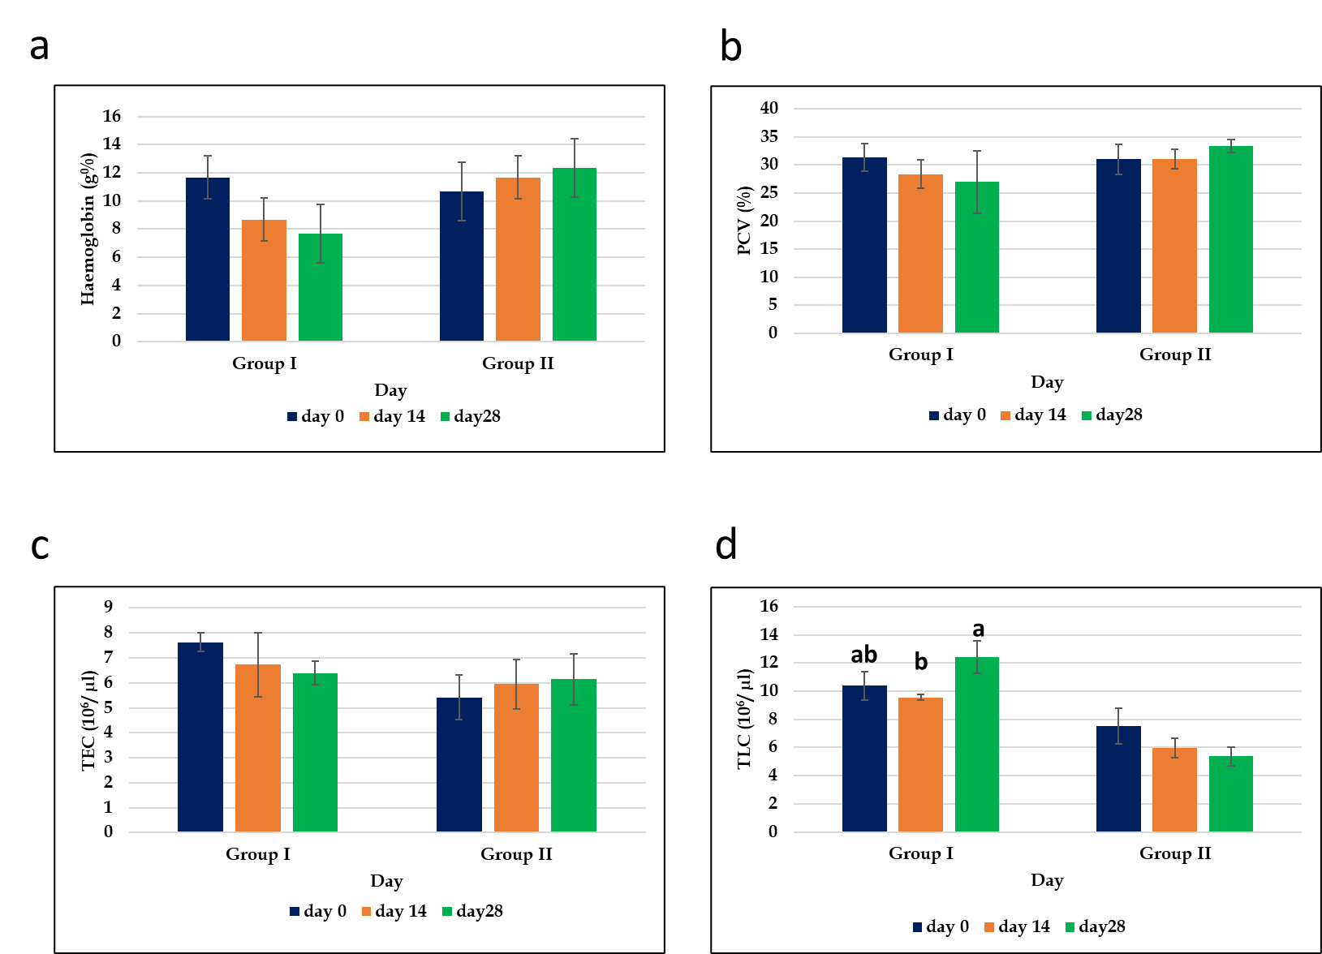
Fig. 1: Haematological changes in calves with long bone fracture after internal fixation in group-I and II. Values of (a) Haemoglobin, (b) PCV, (c) TEC, and (d) TLC on day 14 and day 28 post-surgery were compared with presurgical control values in both groups. Data are presented as Mean ± SEM. Values of a, b, and c in the same group differ significantly at P< 0.05.

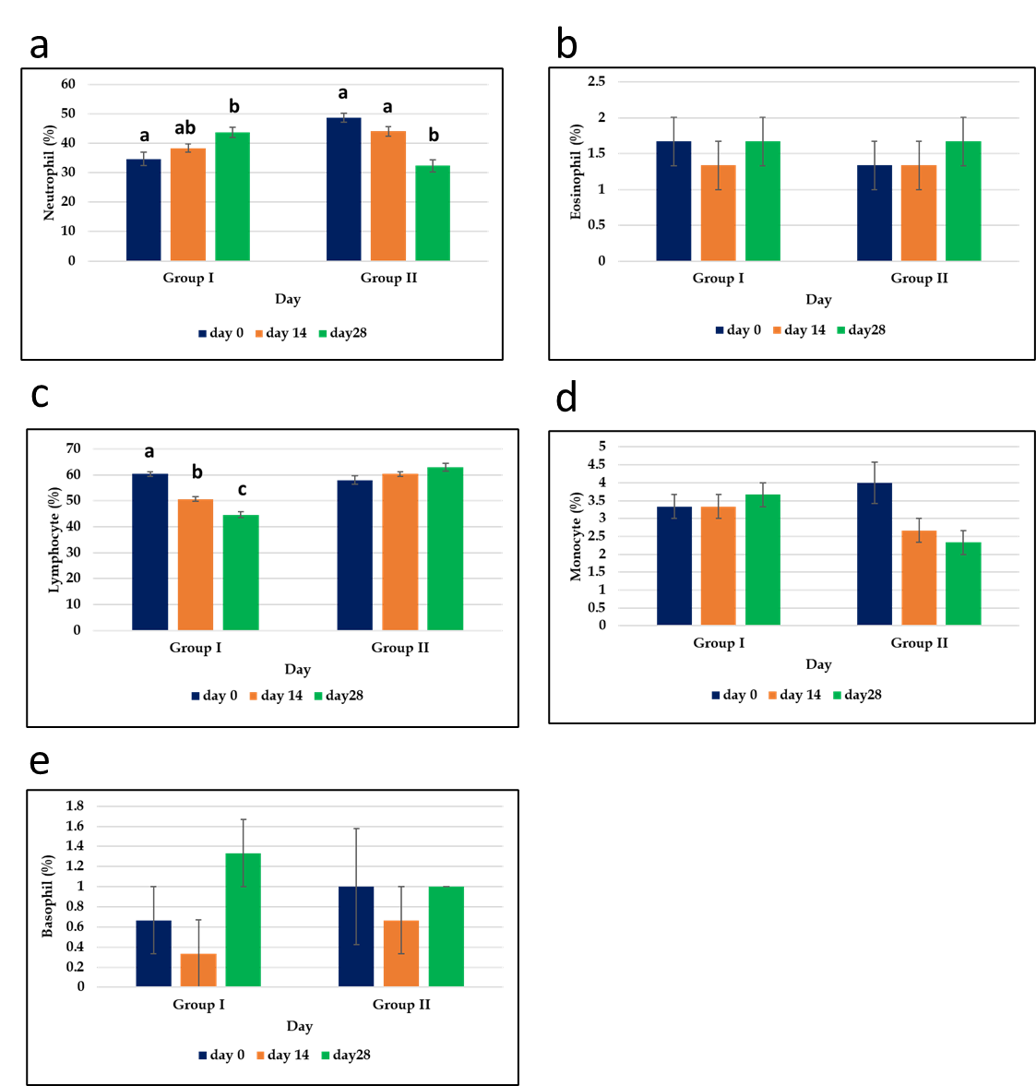
Fig. 2: Changes in DLCs in calves with long bone fracture after internal fixation in group-I and II. Values of (a) neutrophil, (b) eosinophil, (c) lymphocytes, (d) basophil, and (e) monocytes on day 14 and day 28 post-surgery were compared with presurgical control values in both groups. Data are presented as Mean ± SEM. Values of a, b, and c in the same group differ significantly at P< 0.05.

On day 28, the value of total protein displayed a significant (P<0.05) difference in the animals in group I. The animals in groups I and II showed no discernible variation in blood albumin levels over time. The animals in groups I and II showed a considerable increase in serum calcium levels on days 14 and 28 following procedures. The serum phosphorus values differed significantly on days 14 and 28 in group I. Whereas, in group II, the value of serum phosphorous steadily increased on day 14 and changes were substantial (P< 0.05) on day 28 post-operation. When compared to pretreatment control values on days 14 and 28, serum ALP indicated a highly significant (P< 0.05) difference in group I. While the changes in group II were not statistically significant (P>0.05) on days 14 and 28 post- operation. The animals in group I showed no significant changes on serum creatinine levels on days 14 and 28 as compared with pretreatment control values. Whereas the changes in group II showed substantial variations. On days 14 and 28 following surgery, the creatinine kinase and C- reactive protein values in groups I and II showed a significant (P< 0.05) difference. Urea revealed no significant (P>0.05) difference at different time interval in group I but in group II significant (P<0.05) difference was observed on days 14 and 28 post- operation as compared with pretreatment control values (Table 1).

Table 1: Biochemical changes in calves with long bone fracture after internal fixation
SL NO | Parameter | Groups | Day 0 | Day 14 | Day 28
1 | Total Protein  (g/ dl) | Group I | 8.11±0.056 ª | 8.25±0.155 ª | 6.66±0.070^{b}
 |  | Group II | 7.474±0.997 ª | 7.42±0.577 ª | 8.217±0.375ª
2 | Albumin  (g/ dl) | Group I | 3.543±0.564 ª | 3.827±0.189 ª | 3.654±0.286 ª
 |  | Group II | 3.72±0.796 ª | 3.48±0.455 ª | 2.967±0.758 ª
3 | Calcium  (mg/ dl) | Group I | 10.226±0.104ª | 10.707±0.343^{ab} | 10.825±0.152^{b}
 |  | Group II | 9.689±0.636 ª | 13.754±0.774^{b} | 14.53±0.482 ^{b}
4 | Phosphorus  (mg/ dl) | Group I | 4.264±0.123 ª | 4.184±0.090 ª | 4.21±0.246 ª
 |  | Group II | 3.94±0.069ª | 4.06±0.153ª | 4.54±0.256^{b}
5 | ALP (IU/L) | Group I | 12.7±2.096 ª | 17.334±0.404 ª | 14.867±0.763^{b}
 |  | Group II | 10.234±1.66ª | 10.734±0.850 ª | 12.90±1.699 ª
6 | Creatinine  (mg/ dl) | Group I | 1.177±0.117 ª | 1.09±0.060 ª | 1.167±0.172 ª
 |  | Group II | 1.42±0.081 ª | 1.173±0.096^{b} | 1.117±0.076 ^{b}
7 | Creatinine Kinase (CK) (IU/L) | Group I | 140.05±9.675ª | 31.344±3.453 ^{b} | 27.92±3.434 ^{b}
 |  | Group II | 216.88±30.72ª | 29.95±1.943 ^{b} | 23.417±2.23 ^{b}
8 | C- reactive Protein (mg/ dl) | Group I | 0.717±0.256 ª | 0.3±0.1 ^{b} | 0.883±0.076 ª
 |  | Group II | 1.067±0.152 ª | 0.7±0.1^{b} | 0.567±0.152 ^{b}
9 | Urea (mg/ dl) | Group I | 45.970±1.246 ª | 40.739±2.598 ª | 46.603±3.730 ª
 |  | Group II | 50.545±1.227^{ab} | 55.3424±3.640ª | 47.28±2.870^{b}
Values given in table represents MEAN ± SEM value;
Values with different superscript letters (a, b) in the same row differed significantly at P< 0.05.

3.3 Bacteriological Findings
Staphylococcus spp. and E. coli were identified in wounds associated with fracture complications. The Staphylococcus spp. developed a golden yellow colony on Mannitol Salt Agar (MSA) (Fig. 3a). E. coli generated a deep pink colony on MacConkey Agar (Fig. 3b). Staphylococcus aureus colonies of a golden yellow color were identified on MSA (Fig. 4a), and E. coli colonies of a dark pink tint with a metallic sheen were detected on MacConkey Agar (Fig. 4b). Staphylococcus aureus showed Gram-positive, spherical-shaped clusters (Fig. 5a) on Gram's staining, whereas E. coli demonstrated Gram-negative rod-shaped organisms clustered in a single or short chain-like fashion (Fig. 5b).
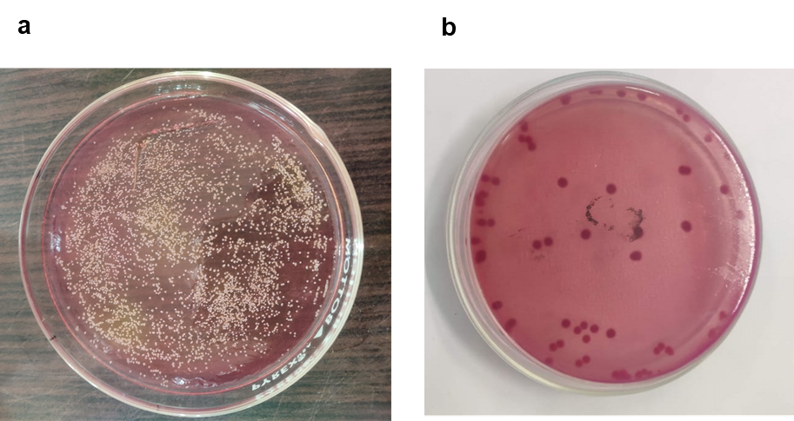

Fig. 3. Isolated bacteria from wound samples (a) Growth of Staphylococcus aureus in Mannitol Salt Agar (b) Growth of E. coli in MacConkey Agar.

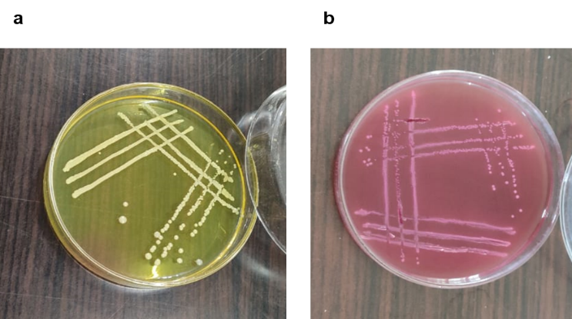

Fig. 4. Colony characteristics of bacteria (a) Golden yellow color colony was found which was suspected as Staphylococcus aureus, (b) dark pink color colony was found with a metallic sheen which was suspected as E. coli.

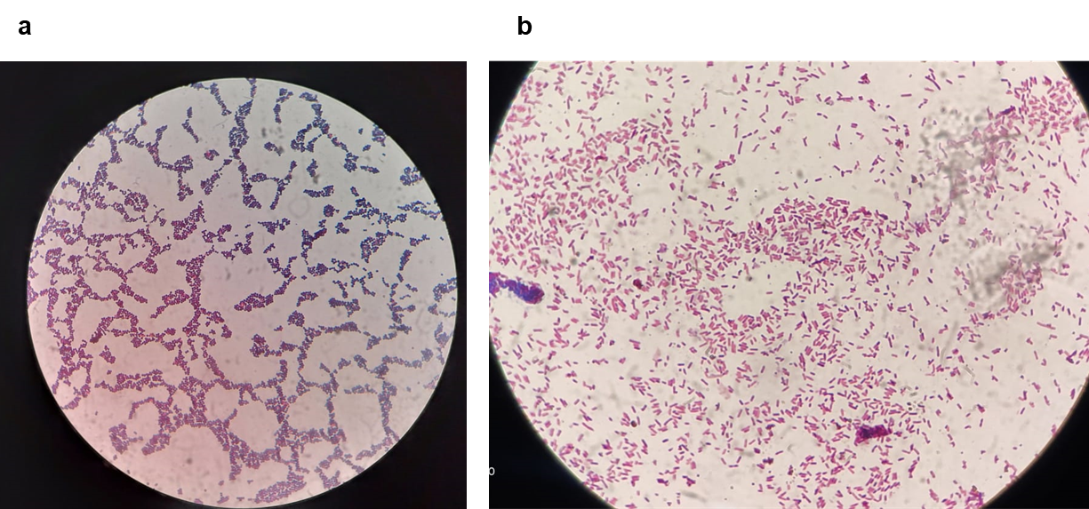
Fig. 5. Staining characteristics of bacteria (a) Staphylococcus aureus (b) E. coli

Histopathological Evaluation
The histopathological examination of biopsy specimens obtained from wounds of postoperative complication of orthopedic surgery showed well-shuffled granulation tissue and reduced inflammatory infiltrate. We also found mononuclear cell infiltration in the granulation tissue in the wound and skeletal muscle. The angiogenesis rich vascular network was seen in the depth of the wound (Fig. 6a). However, on day 28 of open reduction and immobilization by bone plate and screws, there was a relative hemorrhage in the epidermis, irregular few cellular collagen fibers, mononuclear cells around blood vessels in the wound, it also showed immature granulation tissue beneath the dermis (Fig. 6b).

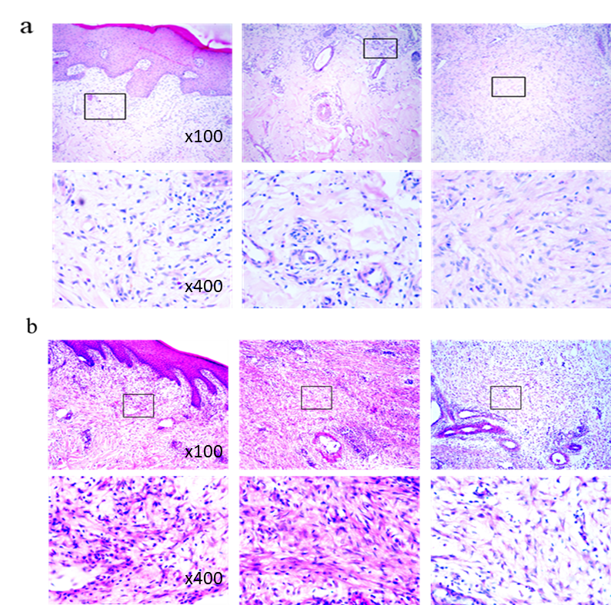

Fig. 6. Histopathology of tissues obtained on different days of fracture healing, (a) biopsy shows a thick epithelial layer with fewer inflammatory infiltration, mature granulation tissue, and regularly arranged collagen fiber on day 14. On the other hand, on day 28, there is massive immature granulation tissue and angiogenesis characterized by numerous immature blood vessels, irregular cellular collagen fiber, and huge mononuclear cells around blood vessels (b). Image: upper panel: x100 and lower panel x400 magnification in both a and b.

DISCUSSION
In this study, the Hb and PCV levels in group I were gradually reduced up to day 28 following surgery. The results shown above are consistent with those of Patil et al. (2017). Even on day 28 following surgery, haemoglobin and packed cell volume levels were gradually raised in the animals of group II. These findings coincide with Buning et al. (2017). In group I, the total erythrocyte count (TEC) did not change significantly on days 14 and 28 following surgery. The observations are similar with Patil et al. (2017). When compared to the pretreatment control value, the TEC in group II was higher on day 28 postoperative. This observation implies erythropoiesis, and this conclusion was supported by Komnenou et al. (2005). The total leukocyte count (TLC) in group I dramatically reduced on day 14 after surgery and subsequently significantly increased on day 28. In group II, the TLC displayed a non-significant decreasing pattern at each operational interval. This outcome was consistent with the findings of the prior report (Coutinho, 2015). In group I, the neutrophil count significantly increased over the course of the investigation. This result agreed with the report by Komnenou et al. (2005). In contrast, group II had a considerably lower neutrophil count. The use of biomaterials at the fracture site may be responsible for this, as they minimize inflammatory reactions and promote progressive fracture healing free of invasion (Patil et al., 2017). A substantial reduction in lymphocyte count was noted on day 14 and day 28 following surgery in group I. According to Khan et al. (2011) a gradual rise in the lymphocyte count was seen. The eosinophil, basophil, and monocyte count showed no significant difference at different postoperative intervals in all the animals of both the groups (I and II). Similar findings were also reported by (Hansda et al., 2012).
In this study, postoperative total protein and albumin levels varied in group I and group II animals. This finding agreed with the (Kumaravel, 2012). Systemic mineral homeostasis is impacted by the local process of bone repair and may be responsible for this result. Group I and II both showed increased postoperative serum calcium levels. Komnenou et al. (2005) used dynamic compression plating and locking compression plating on animals, and they showed minor hypercalcemia on various postoperative days, which was consistent with our findings. When compared to group I, the serum phosphorus level in group II patients increased considerably up to day 28 after operation. The findings of this study are consistent with those of Kumaravel, (2012), who observed a significant elevation in serum phosphorus levels up to the 30th postoperative day. Serum ALP levels substantially increased in group I animals on day 14 after surgery, decreased on day 28 after surgery, and gradually increased in group II animals on various postoperative days. The results agreed with (Chakraborty et al., 2023; Hansda et al., 2012). According to Komnenou et al. (2005), changes in blood alkaline phosphatase activity were noted during the study period and were linked to muscle, skin, and early stages of bone healing. Creatinine kinase levels greatly decreased in all group I and group II animals during the experiment. Similar to the results of this study, Buning et al. (2017) demonstrated that during the fracture healing phase, the level of creatinine kinase steadily dropped. All the animals in groups I and II experienced a considerable increase in the C- reactive protein levels at various postoperative intervals. These elevated values can be the result of severe agony brought on by fractures, according to Neumaier and Scherer (2008). Renal function alterations can be detected using the marker serum creatinine, which is produced when muscle tissue is digested. When compared to group I, a significant difference was seen in group II at various postoperative intervals. The findings of this study are consistent with Stuart and Gupta's (2014) report of variations in blood creatinine levels during fracture healing at various time points. According to this study, at different postoperative times, the animals in group II displayed a significant change in serum urea level. Similar findings were also reported by Alexander et al. (2018).
Early infection, which is defined as starting up to two weeks after the surgical procedure, is thought to be caused by intraoperative infiltration and/or highly pathogenic bacteria (Tan et al., 2021). Early infection presents a therapy challenge since it occurs in a non-united fracture, where the implant's sturdiness is essential. Nevertheless, the duration of the infectious process is significantly influenced by the implant's presence in the wound (Akter et al., 2023; Gristina and Costerton, 2007). Particularly if drill-hole necrosis from overheating already present, cortical bone infection spreads throughout the plate bed and around pins or screws (Ochsner and Hailemariam, 2006). In our bacteriological study, it was determined that the fractured calves' infected wound contained Staphylococcus aureus and E. coli. Infections associated with fracture-fixation devices are related to microorganisms such as Staphylococcus aureus, Coagulase-negative staphylococci, Gram-negative bacilli, Streptococci and Pseudomonas sp. (Andrej and Werner, 2006). After internal repair of fractures when the fracture has not yet healed, early infection has been seen. The same results were also reported by Alcantara et al. (2018); Akter et al. (2022b).
In our study, on day 14 histological analysis revealed acute inflammation with a significant number of mononuclear cells and some immature granulation tissue. Irregular few cellular collagen fibers, mononuclear cells around blood vessels in the wound, immature granulation tissue beneath the dermis observed on day 28 of histological assessment. Even though a vascular network with a high angiogenesis density could be visible in the depth of the incision, plate bed infection prevented fracture healing. Similar findings were also reported by Sultana et al. (2022); Ochsner and Hailemariam (2006); Trampuz and Zimmerli (2006).

- CONCLUSIONS
In total contrast, for plate fixation, fractures with soft tissue damage are associated with postoperative wound healing problems and wound infections. Changes in the haemato- biochemical parameters at different post-operative days are correlated with the different phases of fracture healing. The histological examination of tissue biopsies is necessary for the evaluation of bacteria-containing tissues that hindered the healing of the fracture.

ETHICAL APPROVAL
Animal experimentation was carried out with the approval and in accordance with the rules and recommendations of the Animal Welfare, Experimentation and Ethics Committee (AWEEC) of the Faculty of Veterinary Science, Bangladesh Agricultural University, Mymensingh. Permission Number: AWEEC/BAU/2023(08).

Disclaimer (Artificial intelligence)

Author(s) hereby declares that NO generative AI technologies such as Large Language Models (ChatGPT, COPILOT, etc.) and text-to-image generators have been used during the writing or editing of this manuscript.

REFERENCES
Aithal, H.P., Kinjavdekar, P., Amarpal., Pawde, A.M., Singh, G.R., & Setia, H.C. (2010). Management of tibial fractures using a circular external fixator in two calves. Veterinary Surgery, 39, 621-626.

Akesson, K., Käkönen, S.M., Josefsson, P.O., Karlsson, M.K., Obrant, K.J., & Pettersson, K. (2005). Fracture-induced changes in bone turnover: A potential confounder in the use of biochemical markers in osteoporosis. Journal of Bone and Mineral Metabolism, 23, 30-5.
Akter, A., Rahman, S., Hanif, A., Rahman, M., Juyena, N. S., Alam, M. (2023). Clinicopathological Evaluation of Naturally Occurring Septic Arthritis in the Bovine Calves. Iranian Journal of Veterinary Medicine, 17(4), 301-308. http://dx.doi.org/10.32598/ijvm.17.4.1005368

Akter, M.A., Alam, M.M., & Alam, M.R. (2022a). Occurrence and associated risk factors of long bone fractures in food and pet animals in Mymensingh district of Bangladesh: A retrospective study. World Journal of Advanced Research and Reviews, 15, 263–267.

Akter, M.A., Alam, M.R., & Alam, M.M. (2022b). Surgical management of metatarsal fracture using wire suture in a sheep: A case report. Bangladesh Journal of Veterinary Medicine, 20, 59- 64.

Alcantara Junior, J.E., Aguiar, R.A., Sampaio Neto, J.G.L., Azi, M.L., Sadigursky, D., & Alencar, D.F. (2018). Factors associated with the development of early infection after surgical treatment of fractures. Acta Ortopedica Brasileira, 26, 22-6.

Alexander, F., Leon, D.R., Wichat, S., & Paul, N.S. (2018). Prognostic significance of serum urea concentration at admission in older patients with hip fracture. Open Orthopaedics Journal, 12, 536-553.

Andrej, T., & Werner, Z. (2006). Diagnosis and treatment of infections associated with fracture-fixation devices. Injury, 37, 59- 66.

Ashraf, M.B., Akter, M.A., Saha, M., Mishra, P., Hoda, N., & Alam, M.M. (2019). Clinicopathological evaluation on capture myopathy due to chemical immobilization in spotted deer. Turkish Journal of Veterinary Research, 3, 73-79.

Barradas, M.C., Yuan, H., VanBlitterswijk, C.A., & Habibovic, P. (2011). Osteoinductive biomaterials: current knowledge of properties, experimental models and biological mechanisms. European Cells and Materials, 21, 407- 429.

Buning, J.W., Dimova, L.G., Perton, F.G., Tietge, U.J.F., Van Beek, A.P., & Dullaart, R.P.F. (2017). Downregulation of cholesteryl ester transfer protein by glucocorticoids: a randomised study on HDL. European Journal of Clinical Investigation, 47, 494–503.

Chakraborty, S., Akter, M.A., Rahman, M.S., Yesmin, N., Juyena, N.S., Alam, M.M. (2023). Congenital digital flexural deformity (knuckling): Epidemiology, the association of trace elements and surgical treatment in neonatal bovine calves. Journal of Advance Veterinary Animal Research, 10(1): 88–95. http://doi.org/10.5455/javar.2023.j656

Coutinho, N., Singh, V., & Lokhande, D.U. (2015). Management of unstable diaphyseal fractures of long bones with dynamic compression plate fixation in six dogs. Indian Journal Veterinary Surgery, 36, 63.
Das, S., Akter, M.A., Alam, M.R., Runa, R.A. 2022. Surgical affections of newborn calves in selected upazilas of Bagerhat district, Bangladesh. Research in Agriculture Livestock and Fisheries, 9 (1): 43-48.

Gristina, A.G., & Costerton, J.W. (2007). Bacterial adherence to biomaterials and tissue: The significance of its role in clinical sepsis. Journal of Bone and Joint Surgery, 67, 264-273.

Hansda, P., Gahlod, B.M., Akhare, S.B., Dhakate, M.S., Upadhye, S.V., & Panchbhai, V.S. (2012). Comparative evaluation of Steinmann pin, Kuntscher nail and interlocking nail for femur fracture repair in dog. Indian Journal Veterinary Surgery, 33, 53-54.

Khan, S.A., Epstein, J.H., Olival, K., Hassan, M.M., Hossain, M.B., & Rahman, K.B.A. (2011). Hematology and serum chemistry reference values of stray dogs in Bangladesh. Open Veterinary Journal, 1, 13-20.

Komnenou, A., Karayannopoulou, M., Polizopoulou, Z.S., Constantinidis, T.C., & Dessiris, A. (2005). Correlation of serum alkaline phosphatase activity with the healing process of long bone fractures in dogs. Veterinary Clinical Pathology, 34, 35-8.

Kumaravel, S., (2012). A review on the article: Role of common biochemical markers for the assessment of fracture union. Indian Journal of Clinical Biochemistry, 27, 422-5.

Muljacic, A., Poljak-Guberina, R., Zivkovic, O., Bilic, V., Guberina, M., & Crvenkovic, D. (2013). Course and rate of post-fracture bone healing correlation with bone-specific alkaline phosphatase and bone callus formation. Collegium Antropologicum, 37, 1275-83.

Neumaier, M., & Scherer, M.A. (2008). C-reactive protein levels for early detection of postoperative infection after fracture surgery in 787 patients. Acta Orthopaedics, 79, 428–32.

Ochsner, P., & Hailemariam, S., (2006). Histology of osteosynthesis associated bone infection. Injury, 37, 49- 58.

Patil, M., Dilipkumar, D., Shivaprakash, B.V., Kasaralikar, V.R., Tikare, V.P., & Ramesh, B.K. (2017). Physiological and haemato-biochemical changes during repair of femur fracture in dogs. Journal of Pharmaceutical Innovation, 6, 381.
Prabhakar, V., Raghunath, M., Singh, S.S., Mohindroo, J., Singh, T., & Verma, P., (2012). Clinical management of metacarpal and metatarsal fractures in two buffalo-calves. Intas Polivet, 13, 395–398.

Stuart, F., & Gupta, A., (2014). Serum creatinine profiles in hip fracture patients, an observational study. Bone Abstract, 3, 232.
Sultana, M.J., Akter, M.A., Yesmin, N., Haque, M.A., Rahman, M., Alam, M.M. (2022). Wound healing effects and antibacterial properties of heterologous platelet-rich plasma on Staphylococcus aureus induced septic wounds in rabbits. Journal of Advance Veterinary Animal Research, 9(3):481–489. http://doi.org/10.5455/javar.2022.i617

Tan, A.A., Akter, M.A., Rahman, M.S., Rahman, M., & Alam, M.M., (2020). Standardization of surgical site preparation with different formulations of povidone-iodine, chlorhexidine-gluconate and chlorxylenol in caprine model: a comparative study. Journal of Innovative Science, 6, 34-40.
Trampuz, A., & Zimmerli, W. (2006). Diagnosis and treatment of infections associated with fracture-fixation devices. Injury, 37, 59–66.

