Original Research Article

The influence of different seasons on the motility and kinetics parameters of deep-frozen semen in Simmental bulls

A B S T R A C T
The aim of the research work was to study the influence of seasons on sperm motility and kinetics parameters of deep frozen semen in Simmental bulls. The study included 43 bulls whose semen was collected and deep-frozen during the summer, autumn, spring, and winter. The semen was analyzed using computer-assisted semen analysis (CASA), whereby 0.25 mL straws were thawed in a water bath at 38 °C for 20 seconds. Present study revealed that the season had no effect on sperm concentration, total and progressive motility, the percentage of fast and slow sperm, sperm moving in circles or in place, or immotile sperm (p > 0.05). Additionally, no seasonal effect (p > 0.05) was observed on sperm kinetic parameters: velocity curved line (VCL), velocity straight line (VSL), velocity average path (VAP), distance curvilinear line (DCL), distance straight line (DSL), distance average path (DAP), amplitude of lateral head displacement (ALH), head activity (HAC), wobble (WOB), linearity (LIN), and straightness (STR). Further, it was revealed that the values for beat cross frequency (BCF) were found to be only season-dependent, showing significantly lower values when semen was collected and deep-frozen during the summer compared to spring and winter (p < 0.05).
Key words: spermatozoa, deep-frozen semen, Simmental bulls, CASA
- INTRODUCTION

The Simmental breed of cattle is one of the oldest multipurpose breeds. In most countries, the Simmental breed is used for meat production through crossbreeding with beef and dairy cattle breeds (Sadikova et al., 2023). Artificial insemination (A.I.), as an important tool of biotechnology which plays a crucial role in improving the genetic quality of animals, especially in cattle (Hapsari et al., 2022). Presently, sorting bovine sperm based on their sex has significant potential, as using sexed semen can minimize the production of excess male calves, easing the challenges of bull management. Bull semen contains approximately 50% X chromosome-bearing sperm and 50% Y chromosome-bearing sperm. The differences between these sperm types include size, weight, density, swimming speed, electrical surface charges, and protein composition. Sexed semen, which is enriched with either X or Y sperm, enables the production of offspring of a desired sex with 80–90% accuracy(Sharma, Prachi, and Mridula Sharma,2024). Artificial insemination also significantly reduces the risk of spreading infectious diseases (Konenda et al., 2020). The success of A.I. is largely influenced by semen quality. Numerous factors can affect semen quality, with genetic and environmental factors being the most significant (Isnaini et al., 2021). Indicators of good-quality semen include a high concentration of spermatozoa, a high percentage of progressively motile sperm, normal sperm morphology, and an intact acrosome (Dipaz-Berrocal et al., 2024). Spermatogenesis is a complex process of sperm production within the seminiferous tubules of the testes, which can be significantly influenced by environmental factors. Therefore, it is of great importance to ensure optimal conditions for bulls involved in livestock breeding programs (Harrison et al., 2022). It is considered that the optimal ambient temperature for sperm production is between 15 and 18 ºC throughout the entire spermatogenesis period, i.e., 65 to 70 days before semen collection (Parkinson, 1987; Valeanu et al., 2015).
According to Netherton et al. (2022), individual bulls can be classified as either "heat-tolerant," meaning they produce good-quality semen throughout the year regardless of temperature, or "heat-sensitive," meaning they produce good-quality semen only during the summer period.
Regarding the influence of season on the semen quality of bulls, there are differences in the literature. Sabes-Alsina et al. (2017) found that the semen quality of the Holstein breed in Spain was significantly better during the spring. In Simmental bulls, a significantly higher percentage of pathologically altered spermatozoa was observed during the summer compared to the winter period (Nichi et al., 2006). The seasonal influence on semen quality depends on temperature, humidity, day length, and reproductive centre management practices (Fuerst-Valtl et al., 2006). Few reports in the literature (Mathevon et al., 1998; Brito et al., 2002) suggests that there was no seasonal influence on the quality of semen. In contrast, many researchers in the literature reported the seasonal influence on semen quality (Vilakazi and Webb, 2004; Nichi et al., 2006; Murphy et al., 2018; Nongbua et al., 2020). Therefore, the present study was undertaken to examine the effect of season on the semen quality of Simmental bulls, whose semen was collected and deep-frozen during different seasons (summer, autumn, spring, and winter).
- MATERIALS AND METHODS

2.1. OVERVIEW OF THE QUALITY OF DEEP-FROZEN BULL SEMEN

The deep-frozen bull semen was delivered to the Laboratory of the Department of Obstetrics and Sterility for analysis, transported in a container with liquid nitrogen at –196 ºC, where semen motility and kinetics parameters were assessed using the computer-assisted sperm analysis (CASA) system (Minitube, AndroVision, Germany). A total of 43 semen samples from Simmental bulls were analyzed, with semen collected and frozen during the summer, autumn, spring, and winter. Before analysis, 0.25 mL straws were thawed in a water bath at 38 ºC for 20 seconds. After thawing, the semen was transferred from the straws into Eppendorf tubes on a heating plate (Minitube, Tiefenbach, Germany).
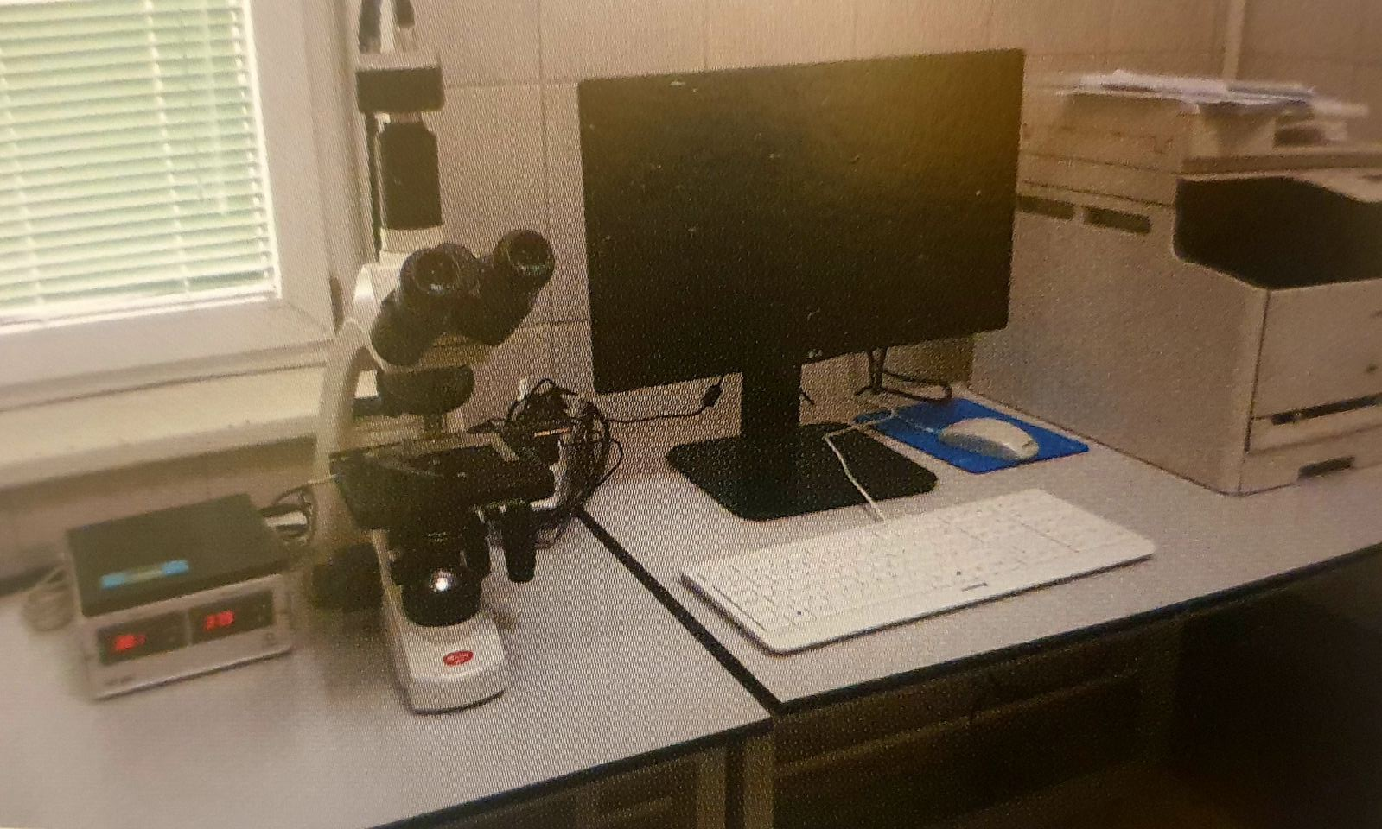
Picture 1. CASA system for examining sperm motility parameters and kinetics (Minitube, AndroVision, Germany), Laboratory of the Department of Obstetrics, Sterility and A.I., Faculty of Veterinary Medicine, Belgrade
After careful mixing, 2.7 µL sample of semen was examined using the CASA system in a Leja chamber (Leja, GN Nieuw Vennep, Netherlands). Semen was analyzed under ten fields of view using a phase-contrast microscope (Motic BA310, Barcelona, Spain) equipped with a heating plate. Motility and kinetics parameters were automatically analyzed using the AndroVision software (Minitube Manual 12500/0000, AndroVision, Germany). The CASA system measured the following parameters: concentration, total and progressive motility, the percentage of fast and slow sperm, sperm moving in circles or in place, and immotile sperm. Additionally, kinetic parameters were measured: velocity curved line (VCL), velocity straight line (VSL), velocity average path (VAP), distance curvilinear line (DCL), distance straight line (DSL), distance average path (DAP), amplitude of lateral head displacement (ALH), beat cross frequency (BCF), head activity (HAC), wobble (WOB), linearity (LIN), and straightness (STR).
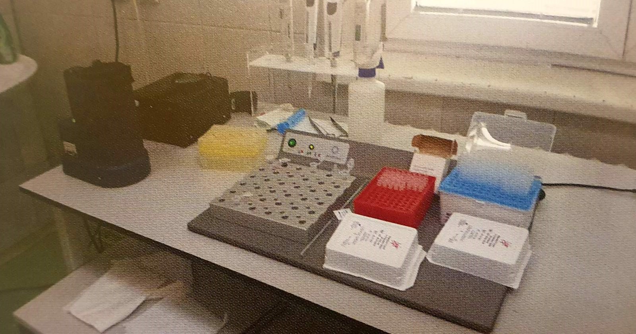
Picture 2. Eppendorf tubes and heating plate (Minitube, Tiefenbach, Germany), Leja chamber (Leja, GN Nieuw Vennep, The Netherlands), phase contrast microscope (Motic BA310, Barcelona, ​​Spain), Laboratory of the Department of Obstetrics, Sterility and A.I., Faculty of Veterinary Medicine, Belgrade
2.2. STATISTICAL DATA ANALYSIS
The normality of the data distribution was tested using the Shapiro-Wilk test. Since the data were normally distributed (Shapiro-Wilk test), analysis of variance (ANOVA) was applied, and subsequent comparisons were made using the Tukey test. The data are presented in graphical form. Statistical analysis was performed using GraphPad Prism version 8 software (GraphPad, San Diego, CA, USA).
- RESULTS AND DISCUSSION

The quality of bull semen can be significantly influenced by the characteristics of the breed itself (Sabés‐Alsina et al., 2017). It is well-known that semen quality varies between different cattle breeds, with genetics playing a significant role (de Lucio et al., 2014). However, there is no consensus in the literature regarding the effect of season on bull semen quality. Some studies have confirmed the seasonal influence (Vilakazi and Webb, 2004; Nichi et al., 2006; Murphy et al., 2018; Nongbua et al., 2020), while others have not found any seasonal effect on semen quality (Mathevon et al., 1998; Brito et al., 2002).
Figure 1 shows the summarized results of total sperm motility, progressive sperm motility, the percentage of fast, slow, and immotile sperm, as well as their concentration.
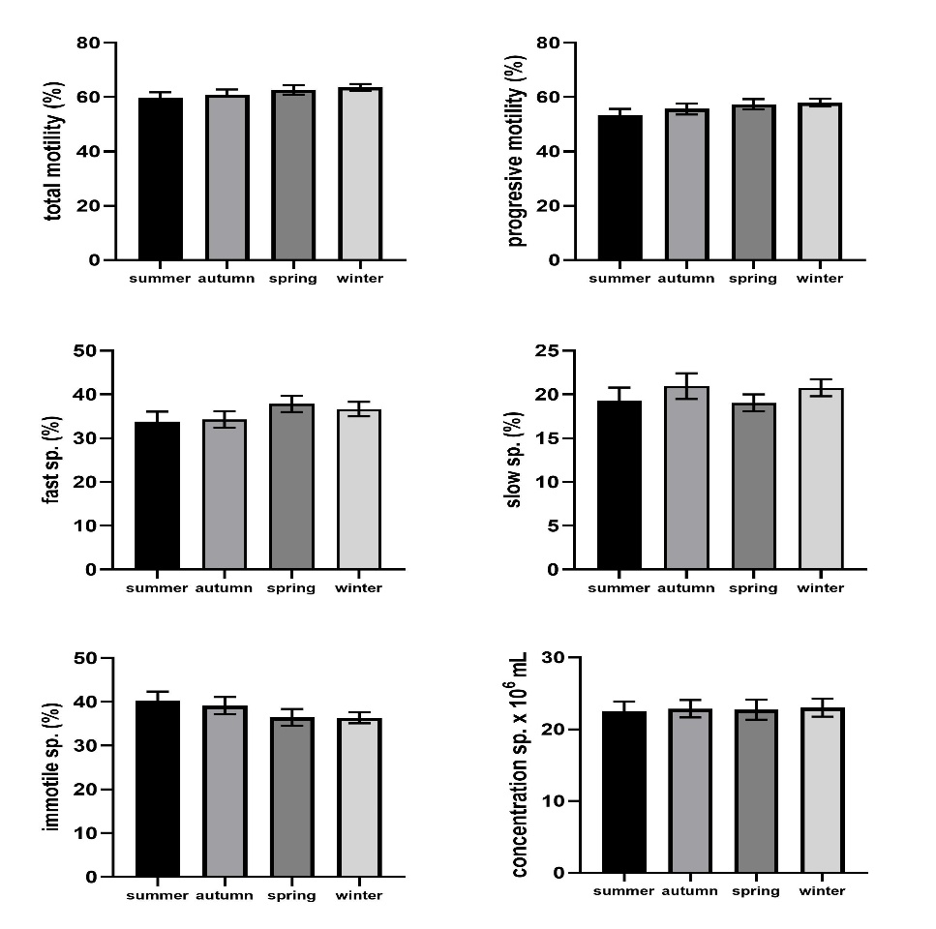
Fig 1. Graphical representation (mean ± SE) of total and progressive sperm motility, percentage of fast, slow, immotile sperm, and sperm concentration in Simmental cattle depending on the seasons (summer, autumn, spring, and winter).
Statistically significant difference p > 0.05
The computer-assisted sperm analysis (CASA) system is crucial for the objective determination of sperm motility, kinetics, and concentration (Bastan, 2024). In our study, the highest total motility percentage of sperm was found in the winter period, with 6.08% compared to summer (4.32%), autumn (1.49%), and spring without statistical significance (p > 0.05, Fig. 1). Also, as seen in Fig. 1, the highest percentage of progressively motile sperm was found in the winter period, with 7.79% compared to summer (4.02%), autumn (1.03%), and spring, but without statistical significance (p > 0.05). Similar to our findings, Nongbua et al. (2020) observed no significant differences in volume, concentration, or sperm motility between winter and summer in bulls in Thailand. Although no statistical significance (p > 0.05) was found in our study, the highest percentage of fast sperm was noted in spring, with 10.68% compared to summer (9.30%), autumn (3.12%), and winter (Fig. 1). The highest percentage of slow sperm was found in autumn (Fig. 1), with 7.92% compared to summer, 9.16% compared to spring, and only 0.86% compared to winter, but without statistical significance (p > 0.05). Although no statistically significant differences (p > 0.05) were observed, the highest percentage of immotile sperm was found in the summer period, with 2.81% vs. autumn, 9.47% vs. spring, and 9.64% vs. winter (Fig. 1). High temperatures and humidity are believed to have negative effects on sperm production (Suriyasomboon et al., 2004). In contrast to the present study, Sabés‐Alsina et al. (2017) found higher values of total and progressive sperm motility in Holstein cattle samples collected in spring compared to those collected in winter.

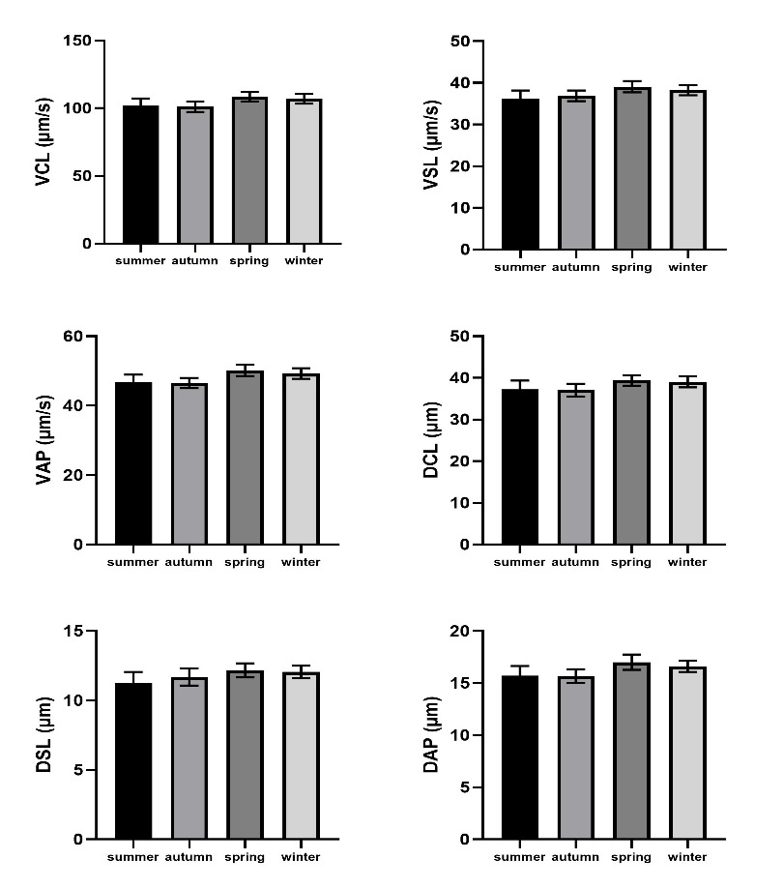

Fig 2. Graphical representation (mean ± SE) of sperm kinetics parameters: velocity curved line (VCL), velocity straight line (VSL), velocity average path (VAP), distance curvilinear line (DCL), distance straight line (DSL), distance average path (DAP) in Simmental cattle depending on the seasons (summer, autumn, spring, and winter).
Statistically significant difference p > 0.05

Although no statistically significant difference was found (p > 0.05), the highest values for VCL were observed in spring, with 6.27% compared to summer, 6.91% compared to autumn, and 1.29% compared to winter (Fig. 2). It is considered that VCL values are associated with low fertilizing capacity of sperm (Oliveira et al., 2012). Also, in our study, the highest values for VSL were observed in spring (Fig. 2), with 7.19% compared to summer, 5.61% compared to autumn, and 2.07% compared to winter, but without statistical significance (p > 0.05). Sabés‐Alsina et al. (2017) found higher average values of VAP and VSL in spring compared to summer in Holstein cattle, which is in line with our findings. In spring, the highest values for DCL were also observed, although without statistical significance (p > 0.05, Fig. 2), with 5.38% compared to summer, 5.92% compared to autumn, and 0.91% compared to winter. Additionally, in our study, the highest values for DSL were observed in spring, with 7.64% compared to summer, 4.02% compared to autumn, and 0.99% compared to winter, but without statistical significance (p > 0.05, Fig. 2). In the study by Sinha et al. (2021), the highest values for VSL, VCL, DSL, and LIN were found during the winter period, with values significantly decreasing during the summer period.
In Fig. 3, the summarized values of the kinetic parameters of the deep-frozen semen of Simmental bulls (ALH, BCF, HAC, WOB, LIN, and STR) are shown for the summer, autumn, spring, and winter periods.

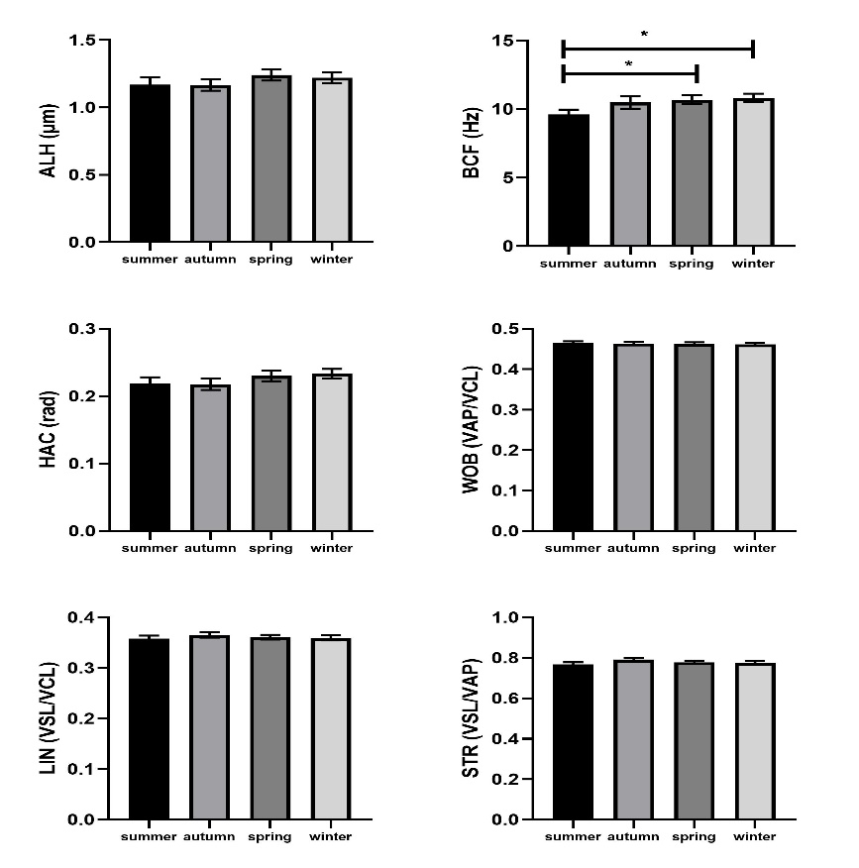
Fig 3. The Graphical representation (mean ± SE) evaluation of spermatozoa kinetic parameters: amplitude of lateral head displacement (ALH), beat cross frequency (BCF), head activity (HAC), wobble (WOB), linearity (LIN), and straightness (STR) in Simmental cattle, depending on the seasons (summer, autumn, spring, and winter).
Statistically significant difference (*) p < 0.05 BCF summer vs spring and winter

Although no statistically significant difference was found (p > 0.05, Fig. 3), the highest values for ALH in our study were observed in spring, being 5.80% higher compared to summer, 5.96% higher compared to autumn, and 1.69% higher compared to winter. The highest values for BCF (Fig. 3) were found in the winter period, with a 11.18% increase compared to summer (P < 0.05), a 3.14% increase compared to autumn, and a 1.20% increase compared to spring. Statistically significant lower values for BCF were found in the summer period compared to spring, with a 10.10% decrease (P < 0.05). According to Oliveira et al. (2012), total motility, progressive motility, or BCF can be predictors of high fertilization potential of spermatozoa.
In our study, the highest values for HAC were found in the winter period, with an increase of 6.51% compared to summer, 6.77% compared to autumn, and 1.41% compared to spring. However, this increase was not statistically significant (p > 0.05, Fig. 3). Nearly uniform values (p > 0.05, Fig. 3) for WOB, LIN, and STR were found across all seasons. These results are consistent with the findings of Sabés‐Alsina et al. (2017), who reported that spring semen samples from Holstein cattle in Spain exhibited better quality compared to those collected during other seasons. Similarly, Sinha et al. (2021) found that values for VAP, DAP, and STR were significantly higher during the winter and autumn periods compared to the spring period. These authors also noted that there were no statistically significant differences in ALH and BCF values across the investigated seasons.

- CONCLUSIONS

In our study, it was found that the seasons had no impact on the quality of deep-frozen semen in Simmental cattle, except for the beat cross frequency (BCF) of spermatozoa, whose values were significantly lower when semen was collected and deep-frozen during the summer period compared to spring and winter.

DECLARATION OF COMPETING INTERESTS

The authors declared no potential conflicts of interest with respect to the research, authorship, and/or publication of this article.

Disclaimer (Artificial intelligence)
Option 1:
Author(s) hereby declare that NO generative AI technologies such as Large Language Models (ChatGPT, COPILOT, etc.) and text-to-image generators have been used during the writing or editing of this manuscript.
Option 2:
Author(s) hereby declare that generative AI technologies such as Large Language Models, etc. have been used during the writing or editing of manuscripts. This explanation will include the name, version, model, and source of the generative AI technology and as well as all input prompts provided to the generative AI technology
Details of the AI usage are given below:
1.
2.
3.

REFERENCES
Bastan I,2024. Comparison of computer-assisted sperm analysis and smartphone-applied sperm analysis for evaluation of frozen–thawed bull semen. Reproduction in Domestic Animals. 59, 8. https://doi.org/10.1111/rda.14695
Brito LFC, Silva AEDF, Rodrigues LH, Vieira FV, Deragon LAG and Kastelic JP, 2002. Effects of environmental factors, age and genotype on sperm production and semen quality in Bos indicus and Bos taurus AI bulls in Brazil. Animal Reproduction Science 70 (3-4): 181–190. https://doi.org/10. 1016/s0378-4320(02)00009-x
de Lucio AC, Ferraudo AS, de Oliveira LZ, do Carmo AS, Alves BG, Alves KA, Almeida S, Deragon LA, Pereira W, Carneiro LC and de Lima VFMH, 2014. Exploratory analysis of differences in sperm morphology in Nelore and Gir (Bos indicus) bulls. Tropical Animal Health and Production,46:765–770 https://doi.org/10.1007/s11250-014-0561-1
Dipaz-Berrocal D, León S, Figueroa D, Mamani R ,Ramirez J, Alvarez-García WY, Estrada R, Carlos Quilcate ,2024. Season and Breed Effect in Fresh Semen Parameters at a Bull Semen Production Center in Peru. International Journal of Veterinary Science. 14(1): 8-15. https://doi.org/10.47278/journal.ijvs/2024.209.
Fuerst-Waltl B, Schwarzenbacher H, Perner C and Sölkner J, 2006. Effects of age and environmental factors on semen production and semen quality of Austrian Simmental bulls. Animal Reproduction Science 95 (1-2): 27–37. https://doi.org/10.1016/j.anireprosci.2005.09.002
Hapsari FR , Samsudewa D, Setiatin ET, Ondho YS ,Setiaji A,Harsi T, Irfan IZ , Syamsono O, Sukmawati E.,2022. Seasonal effect on semen quality of Limousine and Simmental bulls. J. Indonesian Trop. Anim. Agric. 47(4): 340-345. DOI: 10.14710/jitaa.47.4.340-345.
Harrison TD, Chaney EM, Brandt KJ, Ault-Seay TB, Schneider LG, Strickland LG, Schrick FN and McLean KJ, 2022. The effects of differing nutritional levels and body condition score on scrotal circumference, motility, and morphology of bovine sperm. Translational Animal Science 6, 1–7. https://doi.org/10.1093/tas/txac001
Isnaini, N., T. Harsi., A.D. Lapoliwa, M.M. Chabiburochman and A.D Amarsyah,2021. Seasonal variation in semen quality of pasundan bulls in their native tropical environtment. Am. J. Anim.Vet. Sci. 16 (2):124- 129.
Konenda, M.T.K., Y.S. Ondho, D. Samsudewa, E. Herwijanti, A. Amaliya and I.A. Setiawan, 2020. Seasonal variation and agerelated changes in semen quality of Limousine bull in Indonesian artificial insemination center. Int. J. Vet. Sci. 9(4):553-557.
Mathevon M, Buhr MM and Dekkers JCM, 1998. Environmental, management, and genetic factors affecting semen production in Holstein Bulls. Journal of Dairy Science 81 (12): 3321– 3330. https://doi.org/10.3168/jds.S0022-0302(98)75898-9
Murphy EM, Kelly AK, O’Meara C, Eivers B, Lonergan P and Fair S, 2018. Influence of bull age, ejaculate number, and season of collection on semen production and sperm motility parameters in Holstein Friesian bulls in a commercial artificial insemination centre. Journal of Animal Science 96: 2408–2418. https://doi.org/10.1093/jas/sky130
Netherton JK, Robinson BR, Ogle RA, Gunn A, Villaverde AISB, Colyvas K, Wise C, Russo T, Dowdell A, Baker MA. Seasonal variation in bull semen quality demonstrates there are heat-sensitive and heat-tolerant bulls. Sci Rep.,2022 Sep 12;12(1):15322. doi: 10.1038/s41598-022-17708-9.
Nichi M, Bols PEJ, Züge RM, Barnabe VH, Goovaerts IGF, Barnabe RC and Cortada CNM, 2006. Seasonal variation in semen quality in Bos indicus and Bos taurus bulls raised under tropical conditions. Theriogenology 66 (4): 822–828. https://doi.org/10.1016/j.theriogenology.2006.01.056
Nichi M, Bols PEJ, Züge RM, Barnabe VH, Goovaerts IGF, Barnabe RC and Cortada CNM, 2006. Seasonal variation in semen quality in Bos indicus and Bos taurus bulls raised under tropical conditions. Theriogenology 66 (4): 822–828. https://doi.org/10.1016/j.theriogenology.2006.01.056
Nongbua T, Utta A, Am-in N, Suwimonteerabutr J, Johannisson A and Morrell JM, 2020. Effects of season and single layer centrifugation on bull sperm quality in Thailand. AsianAustralasian Journal of Animal Sciences 33 (9) 1411–1420. https://doi.org/10.5713/ajas.19.0624
Nongbua T, Utta A, Am-in N, Suwimonteerabutr J, Johannisson A, Morrell J.,2020- Effects of season and single layer centrifugation on bull sperm quality in Thailand. Anim Biosci 2020;33(9):1411-1420. https://doi.org/10.5713/ajas.19.0624

Oliveira LZ, de Arruda RP, de Andrade AFC, et al.,2012, Assessment of field fertility and several in vitro sperm characteristics following the use of different Angus sires in a timed-AI program with suckled Nelore cows. Livest Sci.;146:38–46. https://doi.org/10.1016/j.livsci.2012.02.018
Sabés‐Alsina M, Johannisson A, Lundeheim N, Lopez‐Bejar M and Morrell JM, 2017. Effects of season on bull sperm quality in thawed samples in northern Spain. Veterinary Record 180 (10): 251–251. https://doi.org/10.1136/vr. 103897
Sadikova Ch S , Siddikov IN, Akhtamova MT, Mengliyev AS,2023. Some biological characteristics of Simmental bulls of different production types. E3S Web of Conferences 462, 01026. https://doi.org/10.1051/e3sconf/202346201026
Sharma, Prachi, and Mridula Sharma. 2024. “Immunological Approaches for Sexing Bovine Sperm: A Comprehensive Overview”. Journal of Scientific Research and Reports 30 (7):995-1007. https://doi.org/10.9734/jsrr/2024/v30i72209.

Sinha R , Bhakat M, Mohanty TK, Kumar R , Ranjan A , Rahim A , Lone SA , Shah N , Paray AR , Patil CS, Singh A,2021. Seasonal variation of sperm kinematics in murrah bulls under the tropical climatic condition. Bufalo Bulletin, 40, 1.
Suriyasomboon A, Lundeheim N, Kunavongkrit A, Einarsson S. Effect of temperature and humidity on sperm production in Duroc boars under different housing systems in Thailand. Livest Prod Sci., 2004;89:19–31. https://doi.org/10.1016/j.livprodsci.2003.12.008

Valeanu S, Johannisson A, Lundeheim N, Morrell JM,2015. Seasonal variation in sperm quality parameters in Swedish red dairy bulls used for artificial insemination,Livestock Science,173, 111-118 https://doi.org/10.1016/j.livsci.2014.12.005.
Vilakazi DM and Webb EC,2004. Effect of age and season on sperm morphology of Friesland bulls at an artificial insemination centre in South Africa. South African Journal of Animal Science 34 (1): 62–69. https://doi.org/10.4314/ saj

