**Original Research Article**

**Epidemiological Survey of Clinical Conditions in Companion Animals in Dhaka, Bangladesh: A Retrospective Analysis**

**ABSTRACT**

|  |
| --- |
| A case-control study was conducted to ascertain the prevalence of clinical diseases and conditions of dogs and cats attended at the Vet and Pet Care (VNPC), Dhaka, from March 2023 to January 2025. A total of 1926 cases of different clinical diseases and conditions were recorded during the study period. These cases were primarily categorized as infectious, non-infectious, and non-specific diseases, and the prevalence of clinical conditions was estimated on the basis of age and breed. It was analyzed that the highest prevalence was recorded in infectious diseases in both dogs and cats (49.79% and 52.43%, respectively), but non-infectious diseases were found to be the lowest in both dogs and cats (18.93% and 18.75%, respectively). Among them, disease-specific prevalence was seen significantly in dogs: anorexia (7.41%), mange (6.38%), fever (6.17%), accidental injury (5.76%), maggot infestation (5.56%), etc. Meanwhile, noticeable cases were diagnosed in cats as feline panleukopenia (FPV) (7.22%), abscess (5.97%), neutering (5.90%), salmonellosis (5.35%), etc. The prevalence of anorexia in dogs (3.7%) and abscesses in cats (3.68%) was found to be the highest at the older age (> 36 months), whereas anorexia (2.88%) and FPV (4.58%) were estimated to be the highest in dogs and cats below 12 months’ age, respectively. In relation to breed, abscess in local dogs and fever in other exotic breeds at the same 2.67% and FPV in mixed breeds (3.19%) were found to be the most prevalent diseases. While the study is limited by its focus on a single clinic and missing details like control data and diagnostics, it still offers valuable insights that can help improve pet care and disease preventive strategies in developing countries like Bangladesh. |

Keywords: *Pet animals; prevalence; clinical diseases; insights.*

1. **INTRODUCTION**

Nowadays, rearing pets is getting more and more popular in Bangladesh, particularly in Dhaka city. People love to spend their leisure time taking care of pets like dogs and cats (Hossain & Kayesh, 2014). Dogs and cats provide several benefits to society, including companionship, playing with children, house guarding, alerting owners about potential problems, and serving as gifts for special events and economic purposes (Parvez et al., 2014). Excluding companionship, pet ownership provides physiological and psychological well-being as well (Centers for Disease Control and Prevention, [2023, 2024]; Herzog, 2011). Additionally, it has been documented that pet owners visit their doctor less frequently, use fewer medications, and have lower blood pressure and cholesterol levels than non-pet owners (Headey & Grabka, 2000). Furthermore, despite the beneficial impacts, there are certain health risks related to pet ownership (Hui Gan et al., 2020). Pets are sometimes responsible for transmitting zoonotic diseases to humans that can make people sick (CDC, 2023; CDC, 2024).

Several clinical diseases commonly affect pets. Among these, viral diseases like rabies, infectious canine hepatitis, canine distemper, canine parvovirus infections, feline panleukopenia, and feline calicivirus infections are highly widespread across the Indian subcontinent, including Bangladesh (Samad, 2011). Bacterial diseases such as leptospirosis, septic abscess, kennel cough, clostridial infection, etc., are more common in pets (Jatav et al., 2024). Because of the high prevalence of infectious diseases in pets and the close interactions in which dogs and cats live with people, the risk of disease transfer to humans appears to be obvious in Bangladesh's densely populated Dhaka city (Tarafder & Samad, 2010). Regarding the close interactions between pet animals and humans, as well as the growing popularity of pet rearing, it is crucial to know the status of diseases of pet and stray animals and the awareness of owners about this in Dhaka city. According to the literature, few investigations have been done on the prevalence of pet animal diseases in Dhaka City, Bangladesh, so far (Hossain & Kayesh, 2014; Parvez et al., 2014). Therefore, the purpose of this study was to determine the prevalence of clinical diseases and conditions in connection to the age and breed of pet animals in Dhaka City, Bangladesh, as well as to analyze risk factors affecting systems of the body and the etiology of pet diseases.

1. **MATERIAL AND METHODS**

A cross-sectional study was carried out using a previously formed questionnaire as well as clinical case records, focusing on the information about the pet animals. Socio-demographic variables such as age, sex, breed, vaccination history, and body weight were collected by interviewing pet owners.

**2.1 Study area**

The study was carried out in the Vet and Pet Care (VNPC) Clinic located at Iqbal Road, Mohammadpur, in Dhaka City (Figure 1) from the period of March 2023 to January 2025.



**Fig. 1. Geographical location of Vet and Pet Care (VNPC) Clinic**

**2.2 Study period**

The study was conducted from March 2023 to January 2025 in Dhaka, Bangladesh.

**2.3 Study population**

A total of 1926 cases were examined during the study period; out of them, 486 (25.23%) were dogs and 1440 (74.77%) were cats, which were sub-categorized under different groups of diseases and disorders such as infectious (bacterial, viral, parasitic, fungal, etc.), non-infectious (dystocia, fracture, accidental injury), and non-specific (anorexia, alopecia, nervous disorder, fever, jaundice, etc.). Mostly the diagnosis of diseased animals was determined based on the owner’s complaints, clinical examination, and physical examination. Besides supporting examinations like hematology, bio-chemical tests and rapid kit tests (FPV, CPV, and FIP) were performed in this study also (Appendix).

**2.4 Diagnosis of disease**

A tentative diagnosis of disease was performed at VNPC by considering the owner’s complaint, clinical examination, physical examination, rapid kit tests (Feline Panleukopenia, Feline Infectious Peritonitis, Canine Parvovirus infection), X-rays, ultrasonography, and biochemical tests. Owner complaints: During the examination of the animals, the owner's objections were considered. Clinical examination of animals: At first, a thorough examination of the patient's overall disposition—alertness, dullness, or depression—was determined from a distance. Also, based on the conditions of pet animals, posture and gait (whether normal or abnormal) were determined. A visual examination was undertaken to make a comprehensive assessment of the animals after the distant inspection. Three approaches were undertaken to identify anomalies: parting the hair, mild palpation, and close direct inspection. The location, distribution, and type of lesions were also investigated. Physical Examination: Temperature and pulse rate were recorded for the diagnosis of diseases or disease conditions. Anesthesia was performed to manage the surgical interference. In case of diseases or disorders of digestive system, frequency of defecation, dehydration, vomiting, contents of vomits, stool consistency, stool contents, color and odor of stool, and vaccination history were investigated for clinical diagnosis. Similarly, dyspnea, respiratory rales, coughing, sneezing, types of cough, duration of illness were considered for diagnosis of respiratory diseases.

**2.5 Statistical analysis**

The data collected from each patient were input into MS Excel (Microsoft Office Excel-2007, USA). Data management and descriptive analysis were carried out in Excel.

The data were then expressed as prevalence, which was calculated by following formula:

Prevalence $=\frac{Number of current cases \left(new and preexisting\right) at a specified point in time}{Population at the same specified point in time}×100$

**3. RESULTS AND DISCUSSION**

A total of 1926 pet animals (dogs 486 and cats 1440) were observed; among them, dogs and cats were 25.23 % and 74.77 %, respectively. The findings of this study are in agreement with Hasan et al. (2024), who reported 24.61% cats and 75.39% dogs in their study. Non-specific disease was found the most (31.28%) in dogs, whereas protozoan disease was observed the least (1.44%) (Figure 2). Another study by Rahima et al. (2022) revealed that the prevalence of non-infectious diseases was 40.7% in dogs. In cats, the highest prevalence was found (28.82%) in non-specific disease, and protozoan disease was the lowest (1.60%) as well (Figure 2), which was supported by the previous study of Hasan et al. (2024), as they reported the highest prevalent diseases in cats were non-specific diseases (33.43%). In dogs, the highest prevalence (7.41%) was found in anorexia, while feline panleukopenia was the most prominent (7.22%) disease in cats, which was almost coherent with the findings of Hasan et al. (2024), where they documented anorexia in dogs at 3.4% and feline panleukopenia at 4.12%. On the other hand, the lowest prevalence was found in dystocia (0.82%) and cat scratch disease (0.35%) in dogs and cats, respectively (Table 1 & Table 2). These findings are in agreement with Hasan et al. (2024), as they found dystocia at the lowest rate (0.46%) among dogs. In contrast, they found lice infestation to be the lowest (0.48%) in cats.

**Fig. 2. Overall prevalence of dog and cat diseases**

**3.1 Age-wise prevalence of diseases of dogs and cats**

The overall highest prevalence of dogs was observed in over 36 months (43.62%), and the lowest was in >12-36 months (17.9%) (Table 1). The overall highest prevalence of cat diseases was found in the age group over 36 months (43.68%), and the lowest prevalence was in the age group within 12-36 months (21.39%) (Table 2). These findings were opposite to Hasan et al. (2024), where they observed the age groups between 12 and 36 months and below 12 months were the highest prevalent age groups in dogs and cats, respectively (34.5% and 46.43%, respectively). The incoordination between recent and previous findings might be due to study area, study period, and vaccination status among the pets. Among the age groups, infectious disease (viral, bacterial, parasitic, protozoan, and fungal) was found the most (19.14%), followed by non-specific diseases (17.7%) in dogs over 36 months old, whereas parasitic infestation was the highest (7.61%), followed by bacterial diseases (5.97%) in this particular age group. Sultana et al. (2016) and Tarafder & Samad, (2010) validated these results as they also stated that older dogs were more disease-prevalent than young ones (35.81% and 48.12%, respectively). In another study, Uddin et al. (2021) reported that parasitic infestation (12.8%) was found to be higher than bacterial disease (5.5%) in adult dogs, which is in agreement with our present study. Conversely, the lowest prevalence of protozoan, viral, and non-infectious diseases was recorded within the 12-36 months (0.21%, 1.44%, and 2.88%, respectively). The study revealed that the highest prevalence (3.7%) was found in anorexia in dogs above 36 months old, followed by fever (3.5%), accidental injury (3.29%), alopecia, and dermatitis (2.47% both). Hasan et al. (2024) reported that maggot infestations (6.80%) were found as the most prevalent in this particular age group, followed by dermatitis (4.85%) and pyometra (2.43%). The difference between my findings and the findings of the previously published report is due to the differences in the duration of the study period and geographical area. Bacterial, fungal, non-infectious, and non-specific diseases were found the most (11.39%, 3.26%, 7.15%, and 14.24%, respectively) in cats over 36 months, whereas viral (6.81%) and parasitic (4.38%) diseases were the highest in cats below 12 months old. According to the reports of Hasan et al. (2024), viral (8.87%) and parasitic (4.75%) diseases were found to be the highest in cats below 12 months of age, and only bacterial (1.74%) was found to be the most prevalent in older cats, which was partially coherent with this study. On the other hand, the lowest prevalence of parasitic, viral, bacterial, and non-specific diseases was documented within 12-36 months (1.67%, 2.22%, 3.54%, and 5.90%, respectively).

**Table 1. Association of age with the prevalence of dog diseases**

|  |  |  |  |  |  |
| --- | --- | --- | --- | --- | --- |
| **Diseases and conditions** | **Types of diseases** | **≤12 months** | **>12-36 months** | **>36 months** | **Total** |
| Infectious-disease |  |  |  |  |  |
| Bacterial | Abscess | 6(1.23%) | 12(2.47%) | 8(1.65%) | 26(5.35%) |
|  | Leptospirosis | 3(0.62%) | 2(0.41%) | 0(0%) | 5(1.03%) |
|  | Kennel cough | 3(0.62%) | 1(0.21%) | 7(1.44%) | 11(2.26%) |
|  | Pyometra | 2(0.41%) | 5(1.03%) | 7(1.44%) | 14(2.88%) |
|  | Salmonellosis | 5(1.03%) | 4(0.82%) | 1(0.21% | 10(2.06%) |
|  | UTI | 0(0%) | 2(0.41%) | 6(1.23%) | 8(1.65%) |
|  | Total Bacterial | 19(3.91%) | 26(5.35%) | 29(5.97%) | 74(15.23%) |
| Viral | Rabies | 3(0.62%) | 0(0%) | 3(0.62%) | 6(1.23%) |
|  | CPV | 12(2.47%) | 4(0.82%) | 2(0.41%) | 18(3.70%) |
|  | ICH | 4(0.82%) | 2(0.41%) | 0(0%) | 6(1.23%) |
|  | CD | 4(0.82%) | 1(0.21%) | 2(0.41%) | 7(1.44%) |
|  | Total Viral | 23(4.73%) | 7(1.44%) | 7(1.44%) | 37(7.61%) |
| Parasitic | Endo-parasitic | 6(1.23%) | 3(0.62%) | 5(1.03%) | 14(2.88%) |
|  | Flea infestation | 4(0.82%) | 2(0.41%) | 4(0.82%) | 10(2.06%) |
|  | Maggot | 11(2.26%) | 6(1.23%) | 10(2.06%) | 27(5.56%) |
|  | Tick infestation | 2(0.41%) | 0(0%) | 5(1.03%) | 7(1.44%) |
|  | Mange | 11(2.26%) | 7(1.44%) | 13(2.67) | 31(6.38) |
|  | Total Parasitic | 34(7%) | 18(3.7%) | 37(7.61) | 89(18.31%) |
| Protozoan | Babesiosis | 4(0.82%) | 1(0.21%) | 2(0.41%) | 7(1.44%) |
|  | Total Protozoan | 4(0.82%) | 1(0.21%) | 2(0.41%) | 7(1.44%) |
| Fungal | Dermatophytosis | 8(1.65%) | 3(0.62%) | 11(2.26%) | 22(4.53%) |
|  | Others | 4(0.82%) | 2(0.41%) | 7(1.44%) | 13(2.67%) |
|  | Total Fungal | 12(2.47%) | 5(1.03%) | 18(3.7%) | 35(7.2%) |
| Subtotal |  | 92(18.93%) | 57(11.73%) | 93(19.14%) | 242(49.79%) |
| Non-Infectious | Dystocia | 4(0.82%) | 0(0%) | 0(0%) | 4(0.82%) |
|  | Fracture | 6(1.23%) | 2(0.41%) | 7(1.44%) | 15(3.09%) |
|  | Accidental injury | 8(1.65%) | 4(0.82%) | 16(3.29%) | 28(5.76%) |
|  | Dog bite | 6(1.23%) | 2(0.41%) | 1(0.21%) | 9(1.85%) |
|  | Spaying | 7(1.44%) | 3(0.62%) | 2(0.41%) | 12(2.47%) |
|  | Neutering | 10(2.06%) | 2(0.41%) | 4(0.82%) | 16(3.29%) |
|  | Hematoma | 4(0.82%) | 1(0.21%) | 3(0.62%) | 8(1.65%) |
| Subtotal |  | 45(9.26%) | 14(2.88%) | 33(6.79%) | 92(18.93%) |
| Non-Specific | Allergy | 8(1.65%) | 3(0.62%) | 10(2.06%) | 21(4.32%) |
|  | Alopecia | 3(0.62%) | 1(0.21%) | 12(2.47%) | 16(3.29%) |
|  | Anorexia | 14(2.88%) | 4(0.82%) | 18(3.7%) | 36(7.41%) |
|  | Dermatitis | 4(0.82%) | 6(1.23%) | 12(2.47%) | 22(4.53) |
|  | Nervous disorder | 10(2.06%) | 0(0%) | 8(1.65%) | 18(3.7%) |
|  | Fever | 11(2.26%) | 2(0.41%) | 17(3.5%) | 30(6.17%) |
|  | Cataract | 0(0%) | 0(0%) | 9(1.85%) | 9(1.85%) |
| Subtotal |  | 50(10.29%) | 16(3.29%) | 86(17.7%) | 152(31.28%) |
| Grand total |  | 187(38.48%) | 87(17.9%) | 212(43.62%) | 486(100%) |

**Table 2. Association of age with the prevalence of cat diseases**

|  |  |  |  |  |  |
| --- | --- | --- | --- | --- | --- |
| **Diseases and conditions** | **Types of diseases** | **≤12 months** | **>12-36 months** | **>36 months** | **Total** |
| Infectious-disease | | | | | |
| Bacterial | Abscess | 23(1.60%) | 10(0.69%) | 53(3.68%) | 86(5.97%) |
|  | UTI | 3(0.21%) | 8(0.56%) | 26(1.81%) | 37(2.57%) |
|  | Conjunctivitis | 20(1.39%) | 7(0.49%) | 16(1.11%) | 43(2.99%) |
|  | Pyometra | 0(0.00%) | 8(0.56%) | 28(1.94%) | 36(2.50%) |
|  | Salmonellosis | 40(2.78%) | 12(0.83%) | 25(1.74%) | 77(5.35%) |
|  | Cat scratch disease | 4(0.28%) | 0(0.00%) | 1(0.07%) | 5(0.35%) |
|  | Otitis media | 21(1.46%) | 6(0.42%) | 15(1.04%) | 42(2.92%) |
|  | Total Bacterial | 111(7.71%) | 51(3.54%) | 164(11.39%) | 326(22.64%) |
| Viral | Rabies | 2(0.14%) | 0(0.00%) | 5(0.35%) | 7(0.49%) |
|  | FPV | 66(4.58%) | 18(1.25%) | 20(1.39%) | 104(7.22%) |
|  | FIP | 10(0.69%) | 5(0.35%) | 5(0.35%) | 20(1.39%) |
|  | URTIs | 20(1.39%) | 9(0.63%) | 14(0.97%) | 43(2.99%) |
|  | Total Viral | 98(6.81%) | 32(2.22%) | 44(3.06%) | 174(12.08%) |
| Parasitic | Endo-parasitic | 12(0.83%) | 3(0.21%) | 8(0.56%) | 23(1.60%) |
|  | Flea infestation | 16(1.11%) | 7(0.49%) | 14(0.97%) | 37(2.57%) |
|  | Mite (Mange) | 26(1.81%) | 6(0.42%) | 12(0.83%) | 44(3.06%) |
|  | Tick infestation | 3(0.21%) | 2(0.14%) | 6(0.42%) | 11(0.76%) |
|  | Maggot | 6(0.42%) | 6(0.42%) | 19(1.32%) | 31(2.15%) |
|  | Total Parasitic | 63(4.38%) | 24(1.67%) | 59(4.10%) | 146(10.14%) |
| Protozoan | Babesiosis | 10(0.69%) | 3(0.21%) | 3(0.21%) | 16(1.11%) |
|  | Toxoplasmosis | 1(0.07%) | 2(0.14%) | 4(0.28%) | 7(0.49%) |
|  | Total Protozoan | 11(0.76%) | 5(0.35%) | 7(0.49%) | 23(1.60%) |
| Fungal | Dermatophytosis | 13(0.90%) | 17(1.18%) | 38(2.64%) | 68(4.72%) |
|  | Rhinosporidiosis | 3(0.21%) | 6(0.42%) | 9(0.63%) | 18(1.25%) |
|  | Total Fungal | 16(1.11%) | 23(1.60%) | 47(3.26%) | 86(5.97%) |
| Subtotal |  | 299(20.76%) | 135(9.38%) | 321(22.29%) | 755(52.43%) |
| Non-Infectious | Dystocia | 4(0.28%) | 3(0.21%) | 1(0.07%) | 8(0.56%) |
|  | Fracture | 8(0.56%) | 8(0.56%) | 12(0.83%) | 28(1.94%) |
|  | Accidental injury | 13(0.90%) | 7(0.49%) | 13(0.90%) | 33(2.29%) |
|  | Dog bite | 8(0.56%) | 2(0.14%) | 6(0.42%) | 16(1.11%) |
|  | Spaying | 23(1.60%) | 26(1.81%) | 11(0.76%) | 60(4.17%) |
|  | Neutering | 21(1.46%) | 36(2.50%) | 28(1.94%) | 85(5.90%) |
|  | Poisoning | 2(0.14%) | 2(0.14%) | 4(0.28%) | 8(0.56%) |
|  | Urolithiasis | 0(0.00%) | 4(0.28%) | 28(1.94%) | 32(2.22%) |
| Subtotal |  | 79(5.49%) | 88(6.11%) | 103(7.15%) | 270(18.75%) |
| Non-Specific | Allergy | 12(0.83%) | 4(0.28%) | 14(0.97%) | 30(2.08%) |
|  | Anorexia | 24(1.67%) | 7(0.49%) | 23(1.60%) | 54(3.75%) |
|  | Alopecia | 3(0.21%) | 8(0.56%) | 15(1.04%) | 26(1.81%) |
|  | Dermatitis | 4(0.28%) | 9(0.63%) | 17(1.18%) | 30(2.08%) |
|  | Cataract | 0(0.00%) | 0(0.00%) | 7(0.49%) | 7(0.49%) |
|  | Nervous disorder | 16(1.11%) | 3(0.21%) | 8(0.56%) | 27(1.88%) |
|  | Fever | 20(1.39%) | 8(0.56%) | 22(1.53%) | 50(3.47%) |
|  | Vomiting | 12(0.83%) | 7(0.49%) | 10(0.69%) | 29(2.01%) |
|  | Jaundice | 2(0.14%) | 8(0.56%) | 20(1.39%) | 30(2.08%) |
|  | Pneumonia | 3(0.21%) | 8(0.56%) | 23(1.60%) | 34(2.36%) |
|  | Food poisoning | 13(0.90%) | 9(0.63%) | 16(1.11%) | 38(2.64%) |
|  | Constipation | 13(0.90%) | 8(0.56%) | 6(0.42%) | 27(1.88%) |
|  | Gastritis | 3(0.21%) | 4(0.28%) | 13(0.90%) | 20(1.39%) |
|  | Gingivitis | 0(0.00%) | 2(0.14%) | 11(0.76%) | 13(0.90%) |
| Subtotal |  | 125(8.68%) | 85(5.90%) | 205(14.24%) | 415(28.82%) |
| Grand total |  | 503(34.93%) | 308(21.39%) | 629(43.68%) | 1440(100.00%) |

**3.2 Breed-wise prevalence of diseases of dogs and cats**

The study showed that the highest prevalence (23.25%) was found in local dogs, followed by others (18.52%) and the German Shepherd breed (18.11%) (Table 3), which was validated by Parvez et al. (2014), as they revealed that the highest prevalence was found in local dogs (50.61%), followed by other exotics (17.6%) and the German Shepherd breed (14.5%). Overall, the lowest prevalence was seen in the Golden Retriever (8.85%) breed. The highest prevalence of viral, bacterial, and non-infectious diseases was reported in local breeds (4.32%, 4.94%, and 5.35%, respectively), and non-specific diseases were highest in other dog breeds (7.82%), followed by Spitz (4.94%) and German Shepherd (4.94%). Likewise, Hasan et al. (2024) found that viral, bacterial, and non-infectious diseases were documented as the highest in local dogs (4.85%, 3.88%, and 5.34%, respectively); in contrast, non-specific diseases (10.67%) were the most prevalent in German Shepherd breeds, which is almost coherent with this study. In this result, fungal (1.6%) and parasitic (3.50%) diseases were observed the most in the German Shepherd breed. Results of breed-wise prevalence of cats revealed that the overall highest prevalence (27.36%) was seen in the mixed breeds, followed by local breeds (24.58%), Persian (24.24%), and other breeds (15.76%), while the lowest prevalence was seen in the British Shorthair (3.54%) and Maine Coon (4.51%) (Table 4). Meanwhile, Yadav et al. (2017) stated that the local breeds (79.70%) had the highest prevalence of diseases compared to other breeds in their study, which was much higher than our findings. This might be because they only studied three breed categories: local, Persian, and Bengal breeds. In mixed breeds, bacterial, viral, parasitic, and fungal diseases were the highest (6.81%, 4.72%, 3.13%, and 1.74%, respectively); therefore, non-infectious (6.46%) and non-specific (7.71%) diseases were the most prevalent in Persian breeds. The findings of Hasan et al. (2024) were in contrast with our study, as they found the highest numbers of parasitic, fungal, and non-infectious diseases in local breeds (4.12%, 1.90%, and 8.72%, respectively). This reason might be due to different study areas and study periods. Non-specific diseases were the least prevalent in Maine Coons (0.83%), while the lowest prevalence of non-infectious diseases was seen in British Shorthairs (0.49%). This study revealed that the abscess (2.08%), feline panleukopenia virus infection (3.19%), upper respiratory infections (URTIs) (0.90%), flea infestation (1.04%), and accidental injury (0.69%) were the most prevalent in the mixed breeds; therefore, conjunctivitis (1.18%), mite infestation (1.46%), dermatophytosis (1.46%), anorexia (1.39%), and urolithiasis (0.9%) were the highest in the Persian breeds. These findings are totally opposite to Yadav et al. (2017), who reported that feline panleukopenia, upper respiratory infections (URTIs), flea infestation, conjunctivitis, mite infestation, and accidental injury were found to be higher in local cats than in other breeds. These disagreements might be due to different breed categories, vaccination status, number of animals investigated, study area, etc.

**Table 3. Association of breed with the prevalence of dog diseases**

|  |  |  |  |  |  |  |  |  |  |
| --- | --- | --- | --- | --- | --- | --- | --- | --- | --- |
| **Diseases & Conditions** | **Types of Diseases** | **German Shepherd** | **Golden Retriever** | **Rottweiler** | **Pomeranian** | **Local** | **Spitz** | **Other** | **Total** |
| Infectious diseases | | | | | | | | | |
| Bacterial | Abscess | 3(0.62%) | 0(0.00%) | 2(0.41%) | 0(0.00%) | 13(2.67%) | 2(0.41%) | 6(1.23%) | 26(5.35%) |
| Leptospirosis | 1(0.21%) | 0(0.00%) | 0(0.00%) | 2(0.41%) | 2(0.41%) | 0(0.00%) | 0(0.00%) | 5(1.03%) |
| Kennel cough | 0(0.00%) | 1(0.21%) | 2(0.41%) | 0(0.00%) | 5(1.03%) | 0(0.00%) | 3(0.62%) | 11(2.26%) |
| Pyometra | 4(0.82%) | 0(0.00%) | 2(0.41%) | 2(0.41%) | 3(0.62%) | 2(0.41%) | 1(0.21%) | 14(2.88%) |
| Salmonellosis | 1(0.21%) | 2(0.41%) | 3(0.62%) | 0(0.00%) | 1(0.21%) | 3(0.62%) | 0(0.00%) | 10(2.06%) |
| UTI | 2(0.41%) | 3(0.62%) | 2(0.41%) | 0(0.00%) | 0(0.00%) | 1(0.21%) | 0(0.00%) | 8(1.65%) |
| Total Bacterial | 11(2.26%) | 6(1.23%) | 11(2.26%) | 4(0.82%) | 24(4.94%) | 8(1.65%) | 10(2.06%) | 74(15.23%) |
| Viral | Rabies | 0(0.00%) | 0(0.00%) | 0(0.00%) | 0(0.00%) | 6(1.23%) | 0(0.00%) | 0(0.00%) | 6(1.23%) |
| CPV | 3(0.62%) | 0(0.00%) | 1(0.21%) | 0(0.00%) | 12(2.47%) | 0(0.00%) | 2(0.41%) | 18(3.70%) |
| ICH | 2(0.41%) | 0(0.00%) | 0(0.00%) | 1(0.21%) | 2(0.41%) | 0(0.00%) | 1(0.21%) | 6(1.23%) |
| CD | 1(0.21%) | 2(0.41%) | 0(0.00%) | 0(0.00%) | 1(0.21%) | 1(0.21%) | 2(0.41%) | 7(1.44%) |
| Total viral | 6(1.23%) | 2(0.41%) | 1(0.21%) | 1(0.21%) | 21(4.32%) | 1(0.21%) | 5(1.03%) | 37(7.61%) |
| Parasitic | Endo-parasitic | 6(1.23%) | 3(0.62%) | 2(0.41%) | 2(0.41%) | 0(0.00%) | 1(0.21%) | 0(0.00%) | 14(2.88%) |
| Flea infestation | 0(0.00%) | 2(0.41%) | 1(0.21%) | 3(0.62%) | 0(0.00%) | 4(0.82%) | 0(0.00%) | 10(2.06%) |
| Maggot | 5(1.03%) | 1(0.21%) | 5(1.03%) | 0(0.00%) | 8(1.65%) | 3(0.62%) | 5(1.03%) | 27(5.56%) |
| Tick infestation | 3(0.62%) | 3(0.62%) | 0(0.00%) | 1(0.21%) | 0(0.00%) | 0(0.00%) | 0(0.00%) | 7(1.44%) |
| Mange | 3(0.62%) | 3(0.62%) | 6(1.23%) | 0(0.00%) | 9(1.85%) | 2(0.41%) | 8(1.65%) | 31(6.38%) |
| Total Parasitic | 17(3.50%) | 12(2.47%) | 14(2.88%) | 6(1.23%) | 17(3.50%) | 10(2.06%) | 13(2.67%) | 89(18.31%) |
| Protozoan | Babesiosis | 0(0.00%) | 0(0.00%) | 1(0.21%) | 2(0.41%) | 0(0.00%) | 1(0.21%) | 3(0.62%) | 7(1.44%) |
| Total Protozoan | 0(0.00%) | 0(0.00%) | 1(0.21%) | 2(0.41%) | 0(0.00%) | 1(0.21%) | 3(0.62%) | 7(1.44%) |
| Fungal | Dermatophytosis | 5(1.03%) | 4(0.82%) | 5(1.03%) | 2(0.41%) | 1(0.21%) | 1(0.21%) | 4(0.82%) | 22(4.53%) |
| Others | 3(0.62%) | 2(0.41%) | 0(0.00%) | 2(0.41%) | 3(0.62%) | 1(0.21%) | 2(0.41%) | 13(2.67%) |
| Total Fungal | 8(1.65%) | 6(1.23%) | 5(1.03%) | 4(0.82%) | 4(0.82%) | 2(0.41%) | 6(1.23%) | 35(7.20%) |
| Subtotal | | 42(8.64%) | 26(5.35%) | 32(6.58%) | 17(3.50%) | 66(13.58%) | 22(4.53%) | 37(7.61%) | 242(49.79%) |
| Non-Infectious | Dystocia | 0(0.00%) | 0(0.00%) | 0(0.00%) | 2(0.41%) | 0(0.00%) | 1(0.21%) | 1(0.21%) | 4(0.82%) |
| Fracture | 2(0.41%) | 0(0.00%) | 2(0.41%) | 0(0.00%) | 6(1.23%) | 2(0.41%) | 3(0.62%) | 15(3.09%) |
| Accidental injury | 7(1.44%) | 4(0.82%) | 3(0.62%) | 1(0.21%) | 9(1.85%) | 0(0.00%) | 4(0.82%) | 28(5.76%) |
| Dog bite | 1(0.21%) | 0(0.00%) | 0(0.00%) | 0(0.00%) | 4(0.82%) | 2(0.41%) | 2(0.41%) | 9(1.85%) |
| Spaying | 4(0.82%) | 0(0.00%) | 2(0.41%) | 2(0.41%) | 2(0.41%) | 1(0.21%) | 1(0.21%) | 12(2.47%) |
| Neutering | 5(1.03%) | 0(0.00%) | 2(0.41%) | 0(0.00%) | 5(1.03%) | 0(0.00%) | 4(0.82%) | 16(3.29%) |
| Hematoma | 3(0.62%) | 2(0.41%) | 3(0.62%) | 0(0.00%) | 0(0.00%) | 0(0.00%) | 0(0.00%) | 8(1.65%) |
| Subtotal | | 22(4.53%) | 6(1.23%) | 12(2.47%) | 5(1.03%) | 26(5.35%) | 6(1.23%) | 15(3.09%) | 92(18.93%) |
| Non-specific | Allergy | 4(0.82%) | 0(0.00%) | 5(1.03%) | 4(0.82%) | 2(0.41%) | 5(1.03%) | 1(0.21%) | 21(4.32%) |
| Alopecia | 2(0.41%) | 0(0.00%) | 0(0.00%) | 2(0.41%) | 6(1.23%) | 1(0.21%) | 5(1.03%) | 16(3.29%) |
| Anorexia | 7(1.44%) | 2(0.41%) | 1(0.21%) | 10(2.06%) | 2(0.41%) | 8(1.65%) | 6(1.23%) | 36(7.41%) |
| Dermatitis | 5(1.03%) | 3(0.62%) | 0(0.00%) | 0(0.00%) | 4(0.82%) | 3(0.62%) | 7(1.44%) | 22(4.53%) |
| Nervous disorder | 0(0.00%) | 0(0.00%) | 2(0.41%) | 3(0.62%) | 4(0.82%) | 3(0.62%) | 6(1.23%) | 18(3.70%) |
| Fever | 2(0.41%) | 4(0.82%) | 3(0.62%) | 1(0.21%) | 3(0.62%) | 4(0.82%) | 13(2.67%) | 30(6.17%) |
| Cataract | 4(0.82%) | 2(0.41%) | 1(0.21%) | 2(0.41%) | 0(0.00%) | 0(0.00%) | 0(0.00%) | 9(1.85%) |
| Subtotal | | 24(4.94%) | 11(2.26%) | 12(2.47%) | 22(4.53%) | 21(4.32%) | 24(4.94%) | 38(7.82%) | 152(31.28%) |
| Grand total | | 88(18.11%) | 43(8.85%) | 56(11.52%) | 44(9.05%) | 113(23.25%) | 52(10.70%) | 90(18.52%) | 486(100.00%) |

**Table 4. Association of breed with the prevalence of cat diseases**

|  |  |  |  |  |  |  |  |  |
| --- | --- | --- | --- | --- | --- | --- | --- | --- |
| **Disease & Conditions** | **Types of Diseases** | **Persian** | **Maine Coon** | **Local** | **Mixed** | **British Shorthair** | **Others** | **Total** |
| Infectious diseases | | | | | | | | |
| Bacterial | Abscess | 10(0.69%) | 3(0.21%) | 26(1.81%) | 30(2.08%) | 6(0.42%) | 11(0.76%) | 86(5.97%) |
| UTI | 9(0.63%) | 5(0.35%) | 0(0.00%) | 13(0.90%) | 7(0.49%) | 3(0.21%) | 37(2.57%) |
| Conjunctivitis | 17(1.18%) | 3(0.21%) | 7(0.49%) | 10(0.69%) | 0(0.00%) | 6(0.42%) | 43(2.99%) |
| Pyometra | 8(0.56%) | 0(0.00%) | 10(0.69%) | 12(0.83%) | 0(0.00%) | 6(0.42%) | 36(2.50%) |
| Salmonellosis | 12(0.83%) | 4(0.28%) | 26(1.81%) | 20(1.39%) | 3(0.21%) | 12(0.83%) | 77(5.35%) |
| Cat scratch disease | 0(0.00%) | 1(0.07%) | 1(0.07%) | 1(0.07%) | 0(0.00%) | 2(0.14%) | 5(0.35%) |
| Otitis media | 6(0.42%) | 0(0.00%) | 13(0.90%) | 12(0.83%) | 0(0.00%) | 11(0.76%) | 42(2.92%) |
| Total Bacterial | 62(4.31%) | 16(1.11%) | 83(5.76%) | 98(6.81%) | 16(1.11%) | 51(3.54%) | 326(22.64%) |
| Viral | Rabies | 0(0.00%) | 0(0.00%) | 6(0.42%) | 1(0.07%) | 0(0.00%) | 0(0.00%) | 7(0.49%) |
| FPV | 7(0.49%) | 0(0.00%) | 36(2.50%) | 46(3.19%) | 0(0.00%) | 15(1.04%) | 104(7.22%) |
| FIP | 2(0.14%) | 0(0.00%) | 5(0.35%) | 8(0.56%) | 3(0.21%) | 2(0.14%) | 20(1.39%) |
| URTIs | 6(0.42%) | 2(0.14%) | 10(0.69%) | 13(0.90%) | 2(0.14%) | 10(0.69%) | 43(2.99%) |
| Total Viral | 15(1.04%) | 2(0.14%) | 57(3.96%) | 68(4.72%) | 5(0.35%) | 27(1.88%) | 174(12.08%) |
| Parasitic | Endo-parasitic | 3(0.21%) | 0(0.00%) | 6(0.42%) | 8(0.56%) | 0(0.00%) | 6(0.42%) | 23(1.60%) |
| Flea infestation | 8(0.56%) | 6(0.42%) | 4(0.28%) | 15(1.04%) | 0(0.00%) | 4(0.28%) | 37(2.57%) |
| Mite (Mange) | 21(1.46%) | 2(0.14%) | 4(0.28%) | 8(0.56%) | 3(0.21%) | 6(0.42%) | 44(3.06%) |
| Tick infestation | 2(0.14%) | 0(0.00%) | 2(0.14%) | 6(0.42%) | 1(0.07%) | 0(0.00%) | 11(0.76%) |
| Maggot | 2(0.14%) | 0(0.00%) | 16(1.11%) | 8(0.56%) | 0(0.00%) | 5(0.35%) | 31(2.15%) |
| Total Parasitic | 36(2.50%) | 8(0.56%) | 32(2.22%) | 45(3.13%) | 4(0.28%) | 21(1.46%) | 146(10.14%) |
| Protozoan | Babesiosis | 3(0.21%) | 0(0.00%) | 3(0.21%) | 8(0.56%) | 0(0.00%) | 2(0.14%) | 16(1.11%) |
| Toxoplasmosis | 5(0.35%) | 0(0.00%) | 1(0.07%) | 0(0.00%) | 0(0.00%) | 1(0.07%) | 7(0.49%) |
| Total Protozoan | 8(0.56%) | 0(0.00%) | 4(0.28%) | 8(0.56%) | 0(0.00%) | 3(0.21%) | 23(1.60%) |
| Fungal | Dermatophytosis | 21(1.46%) | 4(0.28%) | 13(0.90%) | 20(1.39%) | 3(0.21%) | 7(0.49%) | 68(4.72%) |
| Rhinosporidiosis | 3(0.21%) | 3(0.21%) | 1(0.07%) | 5(0.35%) | 2(0.14%) | 4(0.28%) | 18(1.25%) |
| Total Fungal | 24(1.67%) | 7(0.49%) | 14(0.97%) | 25(1.74%) | 5(0.35%) | 11(0.76%) | 86(5.97%) |
| Subtotal | | 145(10.07%) | 33(2.29%) | 190(13.19%) | 244(16.94%) | 30(2.08%) | 113(7.85%) | 755(52.43%) |
| Non-Infectious | Dystocia | 2(0.14%) | 0(0.00%) | 0(0.00%) | 4(0.28%) | 0(0.00%) | 2(0.14%) | 8(0.56%) |
| Fracture | 8(0.56%) | 0(0.00%) | 10(0.69%) | 4(0.28%) | 0(0.00%) | 6(0.42%) | 28(1.94%) |
| Accidental injury | 10(0.69%) | 3(0.21%) | 4(0.28%) | 10(0.69%) | 0(0.00%) | 6(0.42%) | 33(2.29%) |
| Dog bite | 2(0.14%) | 0(0.00%) | 6(0.42%) | 4(0.28%) | 0(0.00%) | 4(0.28%) | 16(1.11%) |
| Spaying | 20(1.39%) | 6(0.42%) | 16(1.11%) | 13(0.90%) | 0(0.00%) | 5(0.35%) | 60(4.17%) |
| Neutering | 36(2.50%) | 7(0.49%) | 20(1.39%) | 15(1.04%) | 3(0.21%) | 4(0.28%) | 85(5.90%) |
| Poisoning | 2(0.14%) | 0(0.00%) | 2(0.14%) | 2(0.14%) | 0(0.00%) | 2(0.14%) | 8(0.56%) |
| Urolithiasis | 13(0.90%) | 4(0.28%) | 1(0.07%) | 3(0.21%) | 4(0.28%) | 7(0.49%) | 32(2.22%) |
| Subtotal | | 93(6.46%) | 20(1.39%) | 59(4.10%) | 55(3.82%) | 7(0.49%) | 36(2.50%) | 270(18.75%) |
| Non-specific | Allergy | 10(0.69%) | 2(0.14%) | 8(0.56%) | 8(0.56%) | 0(0.00%) | 2(0.14%) | 30(2.08%) |
| Anorexia | 20(1.39%) | 2(0.14%) | 11(0.76%) | 12(0.83%) | 2(0.14%) | 7(0.49%) | 54(3.75%) |
| Alopecia | 7(0.49%) | 0(0.00%) | 8(0.56%) | 6(0.42%) | 0(0.00%) | 5(0.35%) | 26(1.81%) |
| Dermatitis | 6(0.42%) | 3(0.21%) | 13(0.90%) | 8(0.56%) | 0(0.00%) | 0(0.00%) | 30(2.08%) |
| Cataract | 3(0.21%) | 0(0.00%) | 0(0.00%) | 2(0.14%) | 0(0.00%) | 2(0.14%) | 7(0.49%) |
| Nervous disorder | 6(0.42%) | 0(0.00%) | 12(0.83%) | 6(0.42%) | 1(0.07%) | 2(0.14%) | 27(1.88%) |
| Fever | 13(0.90%) | 0(0.00%) | 6(0.42%) | 12(0.83%) | 4(0.28%) | 15(1.04%) | 50(3.47%) |
| Vomiting | 8(0.56%) | 2(0.14%) | 8(0.56%) | 5(0.35%) | 5(0.35%) | 6(0.42%) | 34(2.36%) |
| Jaundice | 7(0.49%) | 0(0.00%) | 8(0.56%) | 0(0.00%) | 2(0.14%) | 8(0.56%) | 25(1.74%) |
| Pneumonia | 4(0.28%) | 2(0.14%) | 12(0.83%) | 6(0.42%) | 0(0.00%) | 10(0.69%) | 34(2.36%) |
| Food poisoning | 13(0.90%) | 1(0.07%) | 6(0.42%) | 12(0.83%) | 0(0.00%) | 6(0.42%) | 38(2.64%) |
| Constipation | 6(0.42%) | 0(0.00%) | 8(0.56%) | 3(0.21%) | 0(0.00%) | 10(0.69%) | 27(1.88%) |
| Gastritis | 4(0.28%) | 0(0.00%) | 3(0.21%) | 10(0.69%) | 0(0.00%) | 3(0.21%) | 20(1.39%) |
| Gingivitis | 4(0.28%) | 0(0.00%) | 2(0.14%) | 5(0.35%) | 0(0.00%) | 2(0.14%) | 13(0.90%) |
| Subtotal | | 111(7.71%) | 12(0.83%) | 105(7.29%) | 95(6.60%) | 14(0.97%) | 78(5.42%) | 415(28.82%) |
| Grand total | | 349(24.24%) | 65(4.51%) | 354(24.58%) | 394(27.36%) | 51(3.54%) | 227(15.76%) | 1440(100.00%) |

**3.3 Prevalence of bacterial diseases in dogs and cats**

The study reveals that 15.23% of dogs had bacterial diseases, with abscess being the most common at 5.35%, followed by pyometra at 2.88%, kennel cough at 2.26%, salmonellosis at 2.06%, and urinary tract infections (UTI) at 1.65% (Figure 3). Our findings are partially supported by Hasan et al. (2024), who revealed 10.68% of bacterial diseases in dogs, where pyometra (4.85%) was reported as the most, followed by abscess (3.4%). Leptospirosis was found to be the lowest (1.03%) among the bacterial diseases in dogs. The findings showed that 22.64% of cat diseases were caused by bacteria, whereas abscess was the highest (5.97%), followed by salmonellosis, conjunctivitis, otitis media, UTI, and pyometra (5.35%, 2.99%, 2.92%, 2.57%, and 2.50%, respectively) (Figure 4). These findings are in contrast with Hasan et al. (2024), who documented only 4.12% bacterial diseases in cats, whereas pyometra (2.54%) was the most prevalent bacterial disease. Among the bacterial diseases, cat scratch disease was found to be the lowest (0.35%).

**Fig. 3. Bacterial diseases of dog**

**Fig. 4. Bacterial diseases of cat**

**3.4 Prevalence of viral diseases in dogs and cats**

The finding (Table 1) shows that 7.61% of dogs had viral diseases, whereas canine parvovirus infection (CPV) was the most prevalent (3.70%), followed by canine distemper (CD) (1.44%). Rabies and infectious canine hepatitis (ICH) were documented as the lowest prevalent (1.23% each) viral diseases of dogs (Figure 5). Recent findings of the prevalence of viral diseases were almost in agreement with the findings of Yadav et al. (2017), as they reported CPV infection was 2.33%, which was less than recent findings followed by 1.74% of canine distemper infection.

Rabies, a viral disease classified as a neglected tropical disease by the World Health Organization (WHO), kills thousands of people per year, primarily in underprivileged communities of Africa and Asia (Afzal et al., 2022). In our study, we found 6 dogs and 7 cats affected by rabies at 1.23% and 0.49%, respectively, which is in contrast to Mogano et al. (2022), who recorded 37.2% and 9.1% positive rabid dogs and cats in their study. These disagreements might be due to different geographical areas and lengths of research periods.

It was also documented that 12.08% of cat diseases were caused by viruses, with feline panleukopenia being the most common at 7.22%, followed by UTI at 2.99% and feline infectious peritonitis (FIP) at 1.39%, while rabies was found to be the least prevalent (0.49%) disease in cats (Figure 5). Yadav et al. (2017) and Hasan et al. (2024) reported that feline panleukopenia virus infection occurs in cats at 3.01% and 4.12%, which was less than in our study. The possibility of this reason might be due to different study areas, vaccination status, or study periods.

**Fig. 5. Viral diseases of dogs and cats**

**3.5 Others prevalence**

Apart from bacterial and viral diseases, dogs in the study area were affected by protozoa, parasitic, fungal, non-infectious, and non-specific diseases (1.44%, 18.31%, 7.20%, 18.93%, and 31.28%, respectively) as well (Figure 2). Among parasitic diseases, mange was found to be the highest (6.38%), followed by maggot infestation (5.56%) and endoparasitic diseases (2.88%), whereas flea infestation was the lowest (1.44%) (Table 1). According to the report of Sarker et al. (2015), parasitic infestation in dogs was approximately 17%, which validated the present study. On the other hand, Hasan et al. (2024) documented 24.27% parasitic diseases, whereas maggot infestation was the highest (15.05%), which is in contrast with the present study. In terms of non-infectious diseases, accidental injury, neutering, and fracture (5.76%, 3.29%, and 3.09%, respectively) were observed the most rather than dystocia, which was the lowest (0.82%). Anorexia (7.41%) and fever (6.17%) were listed as the most occurring non-specific diseases in dogs, followed by dermatitis, allergy, and nervous disorder (4.53%, 4.32%, and 3.7%, respectively). The present study was partially coherent with the study of Hasan et al. (2024), who found accidental injury at 5.33%, fracture at 1.94%, and anorexia at 3.39%. It was also documented that cats were affected by protozoa, parasitic, fungal, non-infectious, and non-specific diseases alike as dogs in this study area (1.60%, 10.14%, 5.97%, 18.75%, and 28.82%) (Figure 2), which are in alignment with Hasan et al. (2024), who revealed almost the same percentages of prevalence in cats. In the case of parasitic diseases, mite infestation was the most prevalent (3.06%) in cats, followed by flea (2.57%) and maggot infestation (2.15%) (Table 2), which were in agreement with Yadav et al. (2017), who found mite infestation at 3.01%, followed by flea (3.01%) and maggot infestation (2.26%). Neutering and spaying cases were found in significant amounts (5.90% and 4.17%, respectively), along with accidental injury (2.29%) and urolithiasis (2.22%) among non-infectious diseases in cats, while poisoning and dystocia were in the lowest amounts (0.56%). Our study is consistent with Yadav et al. (2017), who documented neutering (3.76%) and spaying (3.01%) in their study, while accidental injury was much higher (18.05%). The difference in accidental injury may be due to counting accidental wounds and dog bites as accidental injuries and also to different geographical areas. In terms of non-specific diseases, anorexia (3.75%) was documented as the most occurring disease, followed by fever, food poisoning, and pneumonia (3.47%, 2.64%, and 2.36%, respectively), whereas cataracts (0.49%) and gingivitis (0.90%) were the least common diseases in cats, which was almost aligned with Hasan et al. (2024), who reported the prevalence of anorexia was 4.44%, followed by pneumonia (3.65%) and food poisoning (2.38%).

**4. CONCLUSION**

This study offers a comprehensive overview of the prevalence of clinical diseases in dogs and cats based on age and breed within the study area. The incidence and prevalence of diseases and disorders arise from various factors, including vulnerable age, inadequate management, owner ignorance, habitat, exposure to different regions, and diverse geographical distribution. Additionally, pet owners' attitudes toward deworming and vaccination were found to be lacking. Infectious diseases were more common than non-infectious diseases. Raising pet owners' awareness about the management of diseases affecting their animals through targeted campaigns, appropriate treatment approaches, and timely vaccinations is crucial for preventing and controlling pet diseases. Moreover, the insights gained from this study could lay the groundwork for future comprehensive research. This knowledge could be vital in designing successful disease control and treatment management strategies, including the establishment of suitable vaccination programs and public awareness initiatives. Additional study is required to develop a preventive and control strategy for these clinical diseases in Bangladesh.

**Disclaimer (Artificial intelligence):**

Author(s) hereby declare that NO generative AI technologies such as Large Language Models (ChatGPT, COPILOT, etc.) and text-to-image generators have been used during the writing or editing of this manuscript.

**REFERENCES**

Afzal, S., Nasir, M., Bhaya, M. N., Junaid, K., Arshad, A., Raza, M. Z., ... & Yasobant, S. (2022). Multifactorial Complexity and Zoonotic Aspects of Dog-Mediated Human Rabies in Pakistan. *Pakistan Veterinary Journal*, *42*(4).

Centers for Disease Control and Prevention. (2024, April 15). Cats. U.S. Department of Health & Human Services. <https://www.cdc.gov/healthy-pets/about/cats.html>

Centers for Disease Control and Prevention. (2023, November 8). Dogs. U.S. Department of Health & Human Services. <https://www.cdc.gov/healthy-pets/about/dogs.html>

Hasan, R., Das, C. R., Akther, K. A., & Hossain, M. M. (2024). Disease Prevalence in Pets at Various Pet Hospitals in Bangladesh. *Sch J Agric Vet Sci*, *7*, 121-132.

Headey, B., & Grabka, M. (2000). Pet ownership is good for your health and saves public expenditure too. *The Australian Social Monitor*, *5*.

Herzog, H. (2011). The impact of pets on human health and psychological well-being: fact, fiction, or hypothesis? *Current directions in psychological science*, *20*(4), 236-239.

Hossain, S., & Kayesh, M. (2014). Common diseases of pet animals in Dhaka city and their zoonotic importance. *International Journal of Natural and Social Sciences*, *1*, 81-84.

Hui Gan, G. Z., Hill, A.-M., Yeung, P., Keesing, S., & Netto, J. A. (2020). Pet ownership and its influence on mental health in older adults. *Aging & mental health*, *24*(10), 1605-1612.

Jatav, R. S., Pratap, A., Vaishnav, N., & Sharma, N. (2024). General aspects of introduction to diseases, diagnosis, and management of dogs and cats. In *Introduction to Diseases, Diagnosis, and Management of Dogs and Cats* (pp. 3-17). Elsevier.

Mogano, K., Suzuki, T., Mohale, D., Phahladira, B., Ngoepe, E., Kamata, Y., ... & Makita, K. (2022). Spatio-temporal epidemiology of animal and human rabies in northern South Africa between 1998 and 2017. *PLoS Neglected Tropical Diseases*, *16*(7), e0010464.

Parvez, M. A., Prodhan, M. A. M., Das, B. C., & Khatun, R. (2014). Prevalence of clinical conditions in dogs and cats at teaching veterinary hospital (TVH) in Chittagong veterinary and animal sciences university, Bangladesh. *Res. J. Vet. Pract*, *2*(6), 99-104.

Rahima, F. F., Jalil, M. A., Hossain, M. R., Sayeed, M. A., & Das, A. K. (2022). Epidemiological Investigation of Different Diseases of Pet Animals at Dhaka City, Bangladesh. *Research in Agriculture Livestock and Fisheries*, *9*(3), 299-306.

Samad, M. (2011). Public health threat caused by zoonotic diseases in Bangladesh. *Bangladesh Journal of Veterinary Medicine*, *9*(2), 95-120.

Sarker, M. S., Ahaduzzaman, M., Kabır, M. N., Rahman, M. K., Hossaın, F., Nath, S. K., & Bupasha, Z. B. (2015). Prevalence of clinical conditions in dogs and cats at central veterinary hospital (CVH) in Dhaka, Bangladesh. *Van Veterinary Journal*, *26*(2), 101-105.

Sultana, R. N., Uddin, A. S., Asmaul, H., Yesmin, R. N., Sabina, Y., ATM, B., Sadikul, I. M., Monira, N., & Jahengir, A. K. (2016). Prevalence of diseases in pet animals at Dhaka city of Bangladesh. *Ann. Vet. Anim. Sci*, *3*, 1-5.

Tarafder, M., & Samad, M. (2010). Prevalence of clinical diseases of pet dogs and risk perception of zoonotic infection by dog owners in Bangladesh. *Bangladesh Journal of Veterinary Medicine*, *8*(2), 163-174.

Uddin, M. M., Talukder, H., Islam, O., Asaduzzaman, M., Das, M., Ahsan, M. I., & Islam, S. (2021). Magnitudes of diseases in dogs vary among different levels of age, gender, breed, and season: A hospital-based, retrospective cross-sectional study. *Heliyon*, *7*(11).

Yadav, U., Zuhra, F., Rahman, M., & Ahmed, M. (2017). Epidemiological investigation of clinical diseases and conditions of pet animals at Chittagong city area, Bangladesh. *Bangladesh Journal of Veterinary Medicine*, *15*(1), 63-70.

Appendix

1. 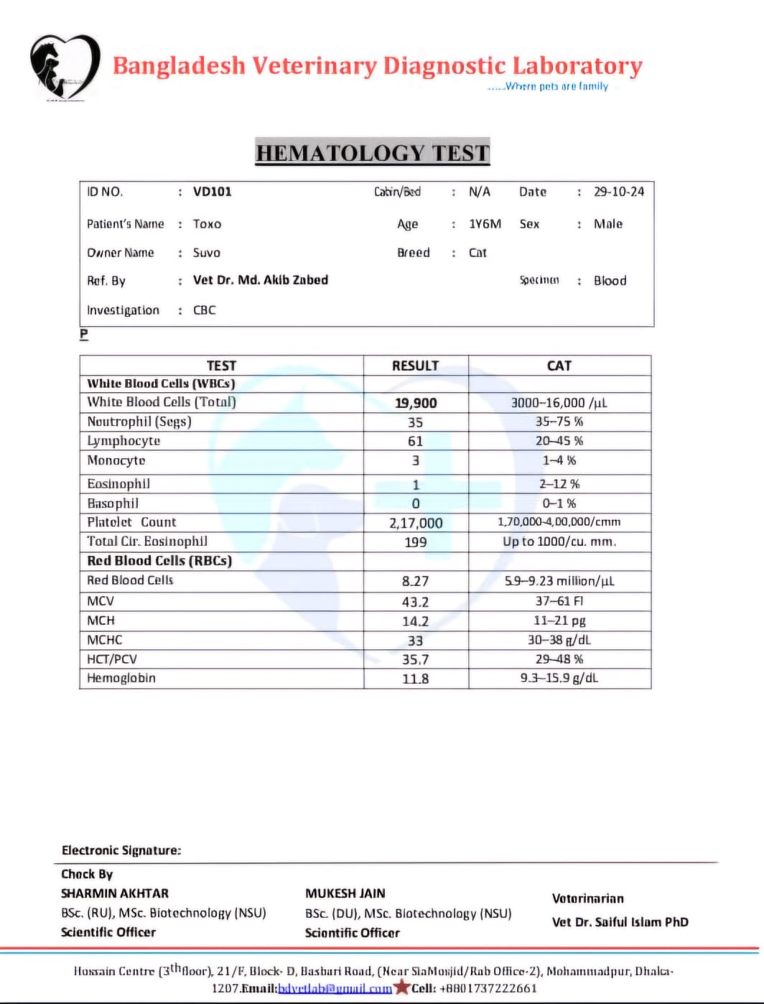Reports of hematological test:

Fig 1: Report of hematological test.

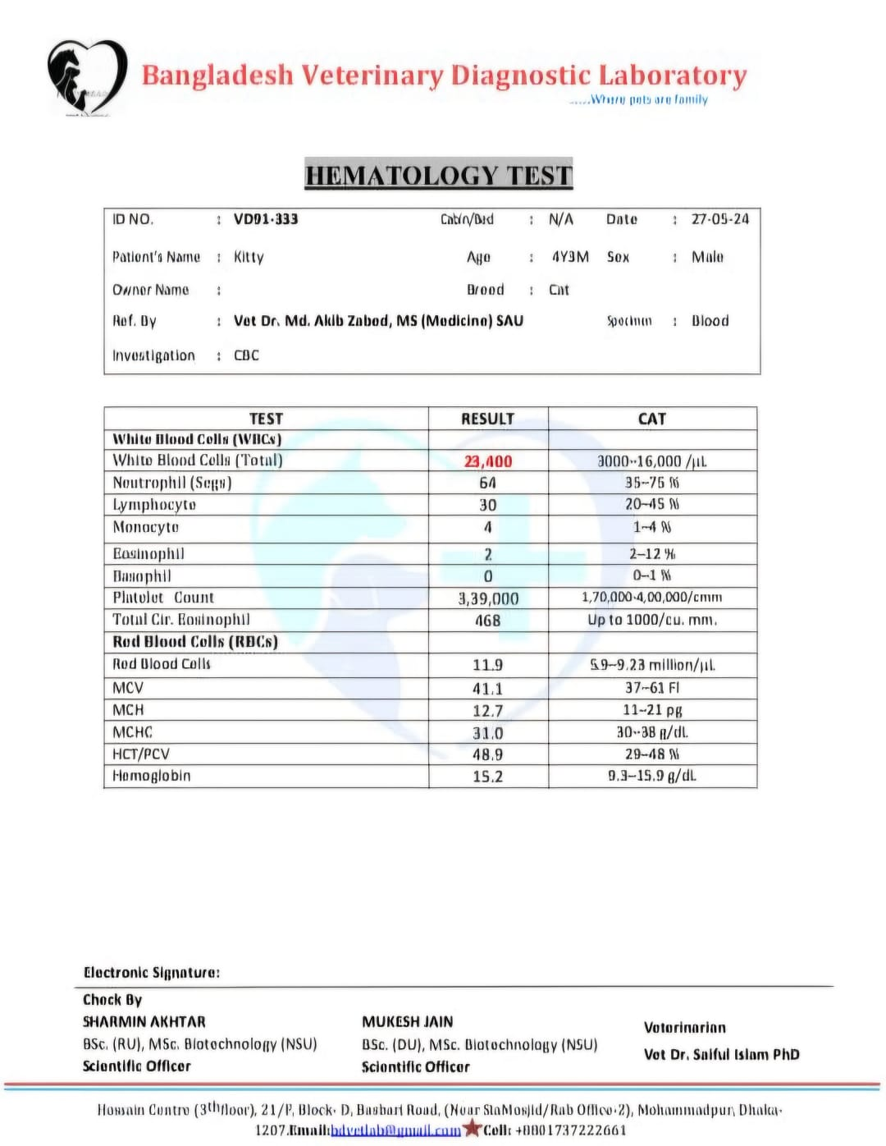

Fig 2: Report of hematological test.

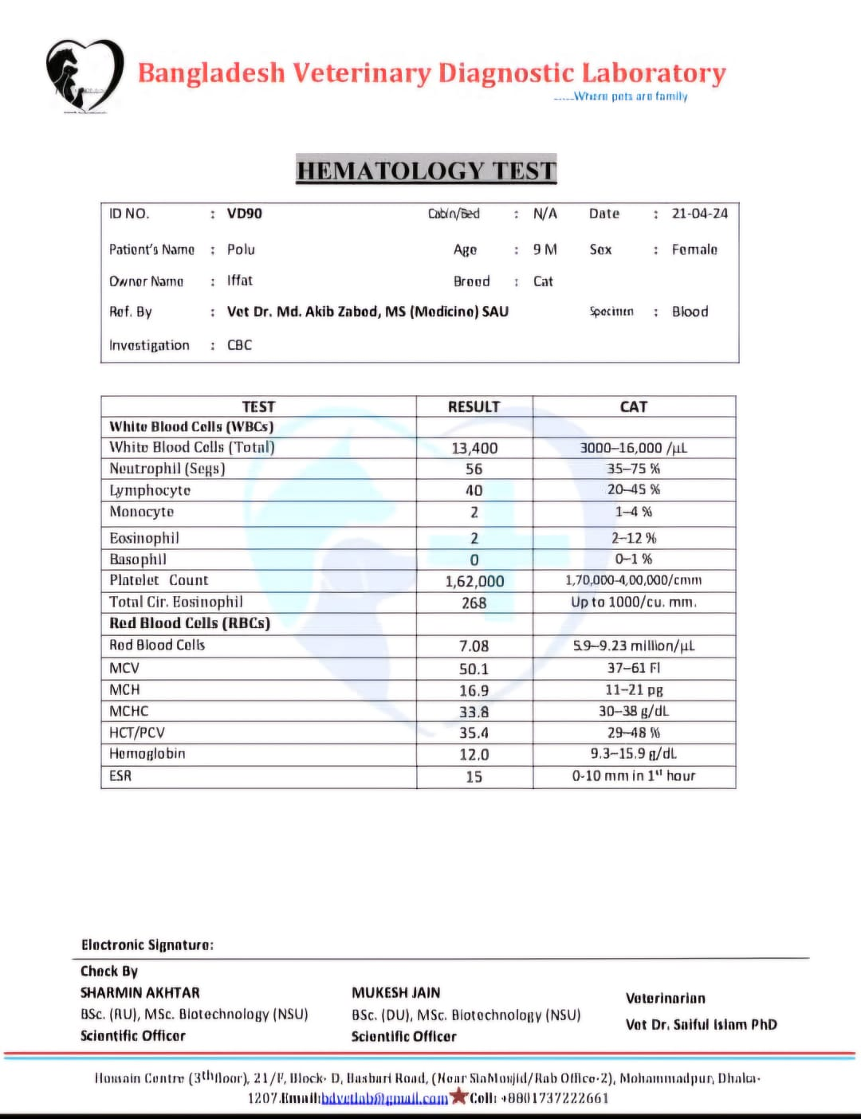

Fig 3: Report of hematological test.

1. Reports of bio-chemical test:

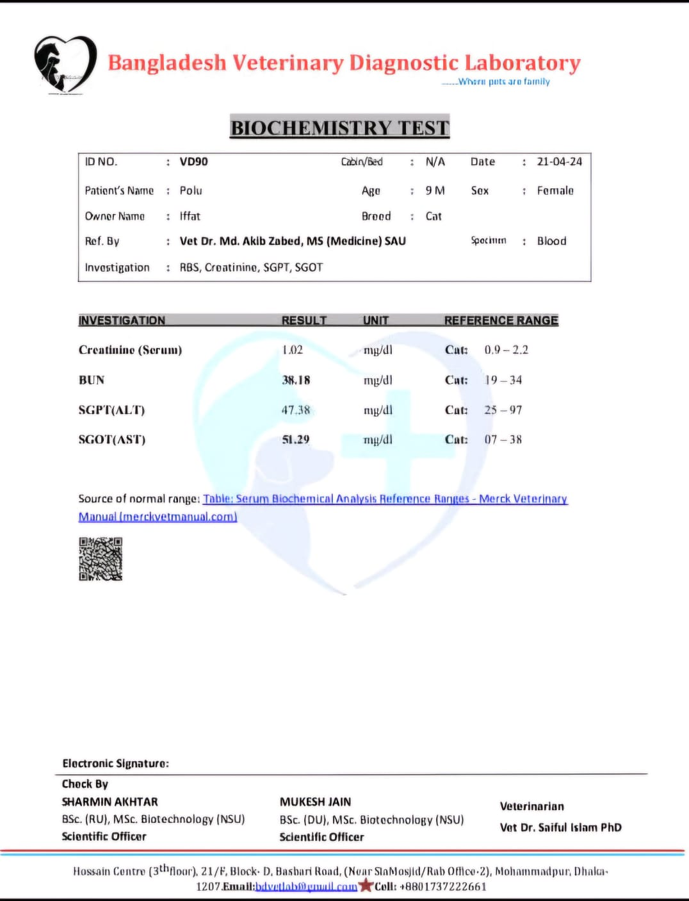

Fig 4: Reports of serum bio-chemistry.

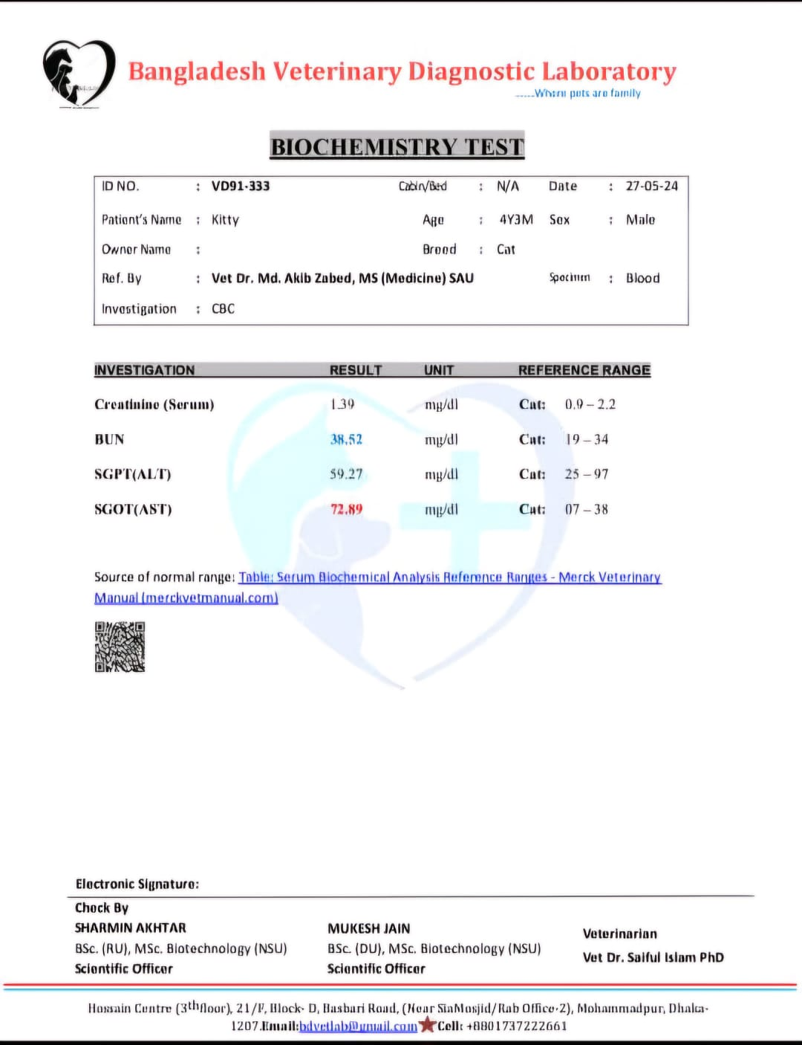

Fig 5: Reports of serum bio-chemistry.

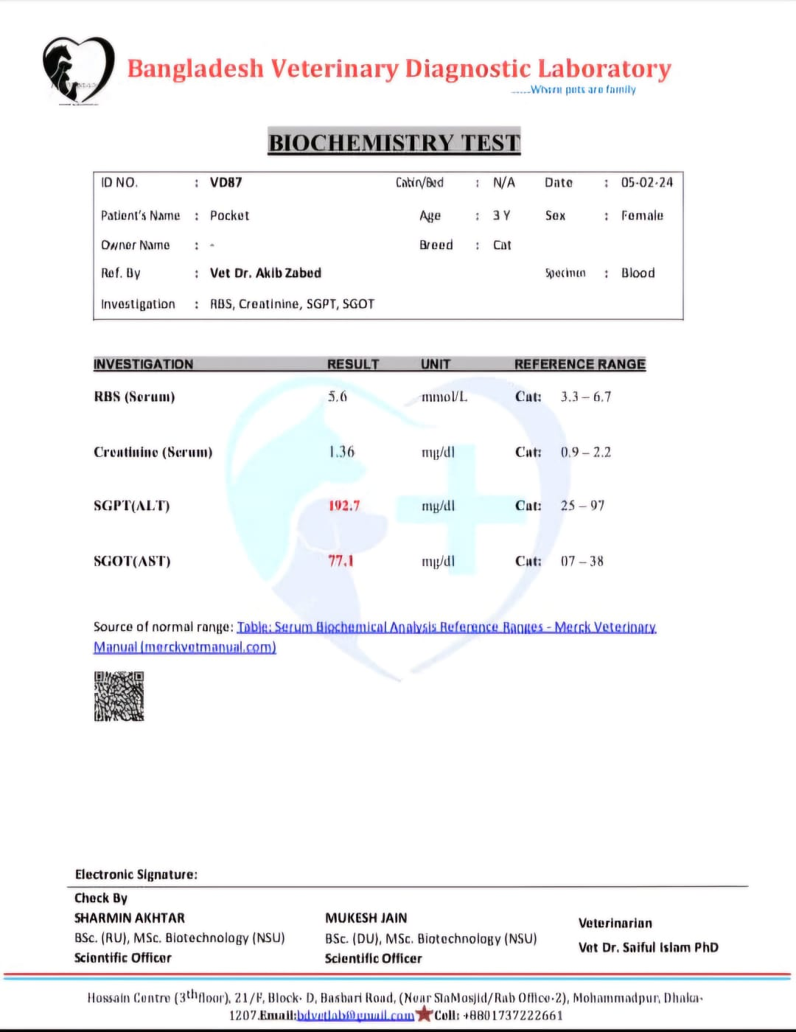

Fig 6: Reports of serum bio-chemistry.

1. Rapid diagnostic test:

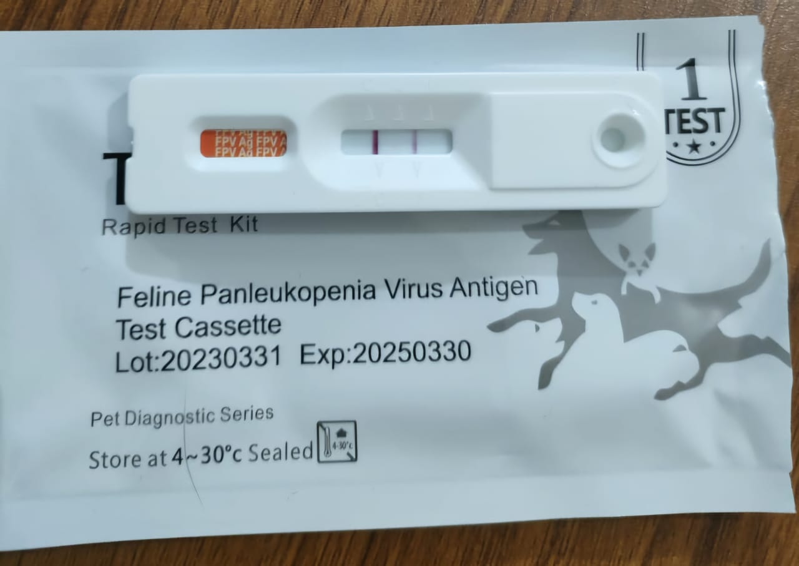



Fig 7: Feline panleukopenia virus antigen test showing FPV positive.

Fig 8: Feline panleukopenia virus antigen test showing FPV positive.