The role of ecosystem transformation and agricultural expansion and its effect on some soil properties in Shingra and Birgonj National Forests, Dinajpur, Bangladesh

Abstract
Soil quality has critical implications for ecosystem health and agricultural productivity, particularly in regions where land-use practices have transformed natural habitats to a large extent. The paper studied two national forests of Dinajpur, Bangladesh, the Shingra and Birganj National Forests soils, in which their adjacent soils were samples, and their physical and chemical properties were compared of forest soils (FS) with adjacent agricultural soils (AS) to evaluate the physicochemical changes occurred due to ecosystem transformation from forest to agricultural in these two forest areas. Analysis of soil pH, electrical conductivity (EC), organic matter (OM), total nitrogen(TN), available phosphorus (P), exchangeable potassium (K), available sulfur (S), and cadmium (Cd). Agricultural soils had significantly lower OM, TN, and plant nutrients than forest soils (p < 0.001). For instance, organic matter (OM) content was 1.74% (in forest soils) and 1.26% (in agricultural soils) in Shingra whereas 1.53% (in forest soils) and 1.12 (in agricultural soils) in Birganj. Available phosphorus was 15.1 g kg⁻¹ (in forest soils) and 69.9 g kg⁻¹ (in agricultural soils) in Shingra whereas 15.5 g kg⁻¹ (in forest soils) and 51.0.9 g kg⁻¹ (in agricultural soils) in Birganj. On the other hand, cadmium content was 0.61 mg kg⁻¹ (in forest soils) and 3.68 m kg⁻¹ (in agricultural soils) in Shingra whereas 0.53 mg kg⁻¹ (in forest soils) and 2.35 m kg⁻¹ (in agricultural soils) in Birganj. These results suggest that beside changes of other physic-chemical properties, significant increase of Ca contamination occurs due to high application of phosphorus fertilizers. Keywords: Soil Quality, Land Use Change, Cadmium Contamination, Agriculture Lands, Forest Lands

Introduction
Soil health is a key factor in the productivity of agriculture and natural ecosystems. In ecologies, such as in Dinajpur, Bangladesh, where agriculture and forest conservation often coexist, land use drives soil characteristics. Generally, agricultural practices deplete soil nutrients, while forests recycle or accumulate nutrients through organic matter (Mahmood et al., 2021; Kadoya et al. 2022). Soil quality is generally better than agricultural practices. Assessing these impacts is critical for developing sustainable land management practices and conserving ecosystem services.
Conversion of forests to agricultural lands in Bangladesh is inevitable due to socio-economic challenges, including poverty, population growth, and food security needs (Gol, 2009, Islam & Weil, 2000). Forest cover is a biodiversity hotspot and provides overall ecosystem resilience by regulating nutrient cycling, carbon storage, hydrological cycles, and minimizing soil erosion (Willy et al. 2019). However, as more and more forests were cleared, these ecological services were disrupted, resulting in environmental devastation (Gol 2009). Forest soils contain higher organic matter and nutrients due to the continuous decomposition of plant material, which, in turn, replenishes soil nutrients compared to agricultural soils (Khan & Hoque, 2025). On the other hand, chemical fertilizers and pesticides in high-input farming can lead to low soil quality via increased salinity, acid-saturation, and heavy metal pollution (Nath et al., 2001, Sharma et al., 2023). Pollution of agricultural soils with heavy metals is a significant global problem, especially by cadmium (Cd) contamination as a result of the misuse of industrial fertilizers and irrigation with wastewater (Bayabil et al., 2021; Sikdar et al. 2022). Furthermore, low soil organic matter and nitrogen in agricultural soils lower soil fertility and microbial activity, leading to decrease in soil quality (Willy et al., 2019, Kehokhunu et al., 2024).
The short-term gains of producing crops drive agricultural expansion into forests but do so at long-term ecological and economic costs. Besides the high O and stability of forest soil structure, they are the foundations for the growth of plants. Nevertheless, these soils have radically and suddenly changed when they are transformed into farmland through mechanical tillage, chemical input, and irrigation. Tillage kills soil aggregates and reduces carbon sequestration potential, and fertilizers alter pH and nutrient dynamics. Higher electrical conductivity in soils (Rahman et al. 2001) suggests irrigation worsens salinity.
Research in the tropics and subtropics shows how forests contribute to soil resilience and nutrient cycling. The disruption of these processes leads to nutrient leaching and the deposition of salts and heavy metals, impeding the transformation of forests into agricultural lands (Li et al., 2024).
The current study was undertaken at the Shingra and Birganj forests in Dinajpur, where the properties of the soil have dramatically changed over the past 30 years due to the expansion of agriculture. Shingra and Birganj sites with varying land-use intensity and management practices were used to study the localized effects of forest-to-agriculture conversion. The study offers essential insights into soil health by establishing the interrelations between the physicochemical properties of soil (pH, organic matter, nitrogen, phosphorus, potassium, EC, and cadmium content). It provides suggestions on ameliorating soil health by the appropriate use of land. This study aimed to characterize forest-harvest soils from two diverse agricultural systems for potential comparison with soils from natural forest systems.
In this study, the forest and agricultural soils of the Shingra and Birganj National forests were examined and compared for some soil characteristics. We analyzed soil pH, electrical conductivity (EC), organic matter (OM), total nitrogen (TN), available phosphorus (P), exchangeable potassium (K), available sulfur (S), and cadmium (Cd) to evaluate how different land uses affect soil quality. This is an important comparison for understanding how sustainable and beneficial land use practices may be in the long term, including impacts on soil health.
Thus, the present study's purpose was to compare the physical and chemical properties of forest soils and agricultural soils from Shingra and Birganj National Forests and investigate agricultural practices response to influencing soil nutrient availability and contaminants (cadmium) in the soils of the area, which should eventually assist in formulating realistic proposals of soil health enhancing sustainable practices in this region.

Materials and Methods
Study Area
Shingra and Birganj are two national forests in the Dinajpur district. These forests are located in an agricultural matrix, enabling comparison of forest and agricultural soil properties.
Soil Sampling
Soil samples were taken from forest soils (FS) and neighboring agricultural soils (AS). Ten sampling spots were allocated in Shingra, whereas five were allowed in Birganj. Soil was collected from each site at 0—15 cm depth. The specimens were carried to the laboratory in clean containers for analysis under precise conditions. Sampling sites were selected to contrast soil types typical of forest and agricultural land.
Soil Properties Analysis
Soil pH was measured using a digital pH meter in a 1:2.5 soil-water suspension. Soil electrical conductivity (EC) was measured with an EC meter in a 1:5 soil-water suspension. Soil organic matter (OM) was quantified as described by Walkley-Black (Walkley & Black, 1934). Total nitrogen (TN) was determined using the Kjeldahl method (Bremner, 1996). Available phosphorus (P) was extracted using the Bray-1 method (Bray & Kurtz 1945) and analyzed spectrophotometrically. Exchangeable potassium was extracted with NH₄-Acetate and was determined using a flame photometer (Jackson 1973). Available sulfur was extracted using a 0.15% CaCl₂ solution and was determined by the turbidimetric method (Fox et al., 1964). Cadmium (Cd) content was measured using atomic absorption spectrophotometry (AAS) (Khan et al. 2009).
Statistical Analysis
Statistical data analysis was calculated using Tukey's HSD test on the differences among forest and agricultural soils of both the locations. Data are presented as mean Â± standard error of the mean (SEM), and p<0.05 was considered statistically significant.

Results and Discussion
Soil pH
The average soil pH of the forest soil was 4.11 (in forest soil) and 4.53 (in agricultural soil) in Shingra whereas 3.97 (in forest soil) and 4.39 (in agricultural soil) in Birganj (Figure 1A). Soil pH of the agricultural soils were significantly higher than that of forest soils in both Shingra and Birganaj. Both the forest soils and agricultural soils were found very acidic in both the locations. The increase of pH in agricultural soil than forest soils indicates a long term might be due to application of lime with consequences on soil and crop productivity (Khan et al., 2006).

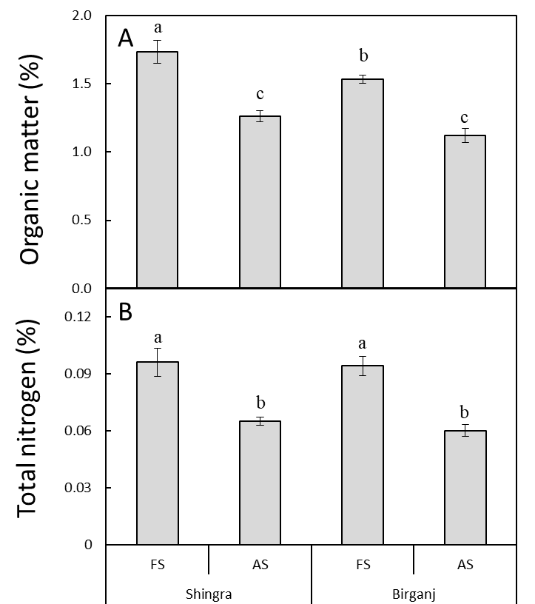
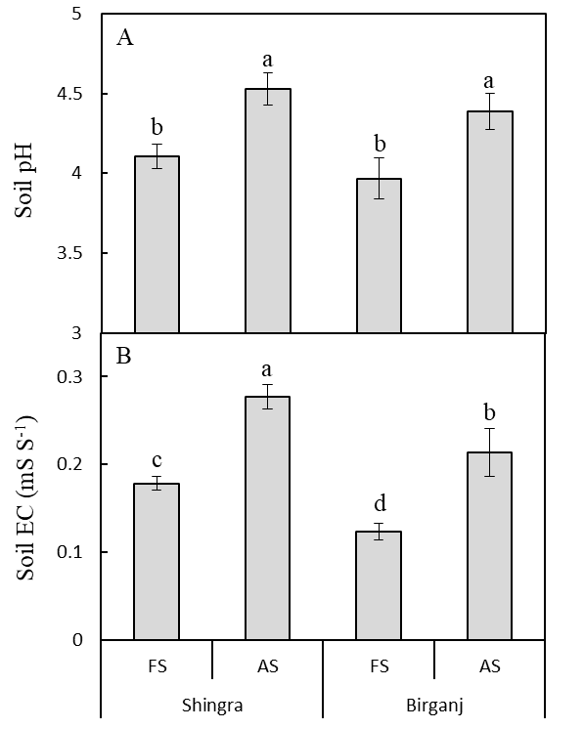
Figure 1. Soil pH (A) and electrical conductivity (EC) (B) of forest soils (FS) and adjacent agricultural soils (AS) from Shingra and Birganj national forests, Dinajpur, Bangladesh. Bars indicates mean ± standard error. For Shingra, data are average of 10 spots; for Birganj, data are average of 5 spots. Bars indicates mean ± standard error. Means with different letters indicate significant differences at the P≤0.05 level according to Tukey's HSD test. | Figure 2. Soil organic matter (OM) (A) and total nitrogen (TN) (B) of forest soils (FS) and adjacent agricultural soils (AS) from Shingra and Birganj national forests, Dinajpur, Bangladesh. Bars indicates mean ± standard error. For Shingra, data are average of 10 spots; for Birganj, data are average of 5 spots. Means with different letters indicate significant differences at the P≤0.05 level according to Tukey's HSD test.

Soil electrical conductivity (EC)
Soil EC was 0.178 mS S⁻¹ for forest soils and was 0.277 mS S⁻¹ for agricultural soils in Shingra whereas EC was 0.123 mS S⁻¹ for forest soils and was 0.213 mS S⁻¹ for agricultural soils in Birganj (Figure 1B). Soil EC was significantly higher in agricultural soils than that of forest soils in both Shingra and Birganj. It was also evident that EC of Shingra soils was slightly higher for both forest soils and agricultural soils. The increasing level of EC is likely to be associated with the overuse of fertilizers in agriculture that has led to a rise in concentrations of various ions. Different agricultural practices, including chemical fertilizers and irrigation practices, have increased salinity and EC, which has an indefinite effect on soil structure and growth (Khan et al., 2011).
Organic Matter (OM) and Total Nitrogen (TN)
In general, forest soil had a significantly higher amount of organic matter (1.735% and 1.534% in Shingra and Birganj, respectively) than agricultural soil (1.264% and 1.122% in Shingra and Birganj, respectively) has been represented in Figure 2A. The OM content showed a 27.1% decrease in agricultural soils of Shingra forest. A similar trend was observed in Birganj too where OM content was decrease 26.9% in agricultural soils than that of forest soils. Such discrepancies are consistent with previous studies identifying undisturbed forest ecosystems as significant contributors to higher organic matter (Kadoya et al. 2022). Organic matter is key in promoting soil structure, water retention, and nutrient cycling, so soil health depends heavily on it (Li et al., 2024). Due to the constant buildup of woody plant biomass in forests and leaf litter, they generally receive greater organic input, from which decomposition occurs to increase nutrient availability for soil biota (Kadoya et al. 2022).
Similarly, forest soils had higher total nitrogen than agricultural soil. In Shingra, total nitrogen was 1.9% (forest soils) and 0.8% (agricultural soils) (Figure 2B). Nitrogen is a critical nutrient for plant growth, whereas high nitrogen contents in forest soils arise from natural biological processes such as nitrogen fixations and decomposition of organic matter. Since crops take up nitrogen for their growth, this nitrogen becomes depleted in the soil, and agricultural soils are normally nitrogen deficient (Khan & Hoque, 2025) unless fertilizers are added.
Phosphorus (P), potassium (K), and sulfur (S) status in forest and agricultural soils
Forest soils in Shingra exhibited an average available phosphorus (P) concentration of 15.14 mg kg⁻¹, compared to 69.93 mg kg⁻¹ in adjacent agricultural soils. In Birganj, available P concentrations were 15.51 mg kg⁻¹ (forest soils) and 50.98 mg kg⁻¹ (agricultural soils) (Figure 3A). Similarly, exchangeable potassium (K) levels in Shingra averaged 0.214 mg kg⁻¹ (forest soils) and 0.257 mg kg⁻¹ (agricultural soils), while Birganj recorded 0.204 mg kg⁻¹ (forest soils) and 0.220 mg kg⁻¹ (agricultural soils) (Figure 3B). Available sulfur (S) concentrations were highest in Shingra’s forest soils (21.29 mg kg⁻¹) and lowest in Birganj’s agricultural soils (15.08 mg kg⁻¹), with intermediate values observed across other land-use categories (Figure 3C).
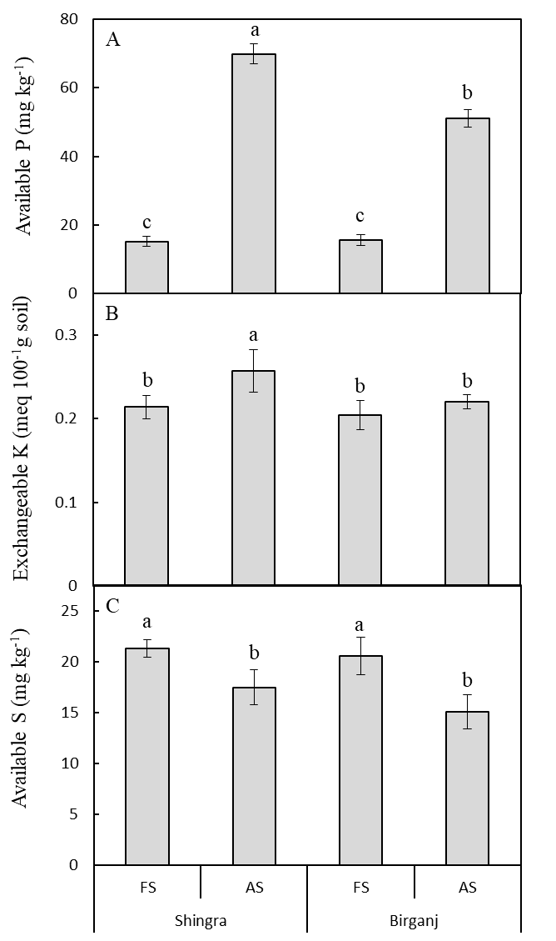
Figure 3. Available phosphorus (P) (A), exchangeable potassium (K) (B) and available sulfur (S) (C) of forest soils (FS) and adjacent agricultural soils (AS) from Shingra and Birganj national forests, Dinajpur, Bangladesh. Bars indicates mean ± standard error. For Shingra, data are average of 10 spots; for Birganj, data are average of 5 spots. Means with different letters indicate significant differences at the P≤0.05 level according to Tukey's HSD test.

These findings are also in line with other studies showing that natural forest ecosystems have a greater ability to cycle nutrients, making nutrients available in greater abundance in the forests than in agriculture (Mahmood et al., 2021). However, many of the earth's agricultural soils have been stripped of nutrients due to the natural nutrient cycling through the soils being interrupted due to continuous monoculture cropping without replenishment of soil nutrients. While we use chemical fertilizers with phosphorus they can also cause an imbalance in other nutrients (potassium and sulfur, for example), which causes deficiencies (Hoque and Khan, 2024, Khan et al., 2001). The high phosphorus loading originating from fertilizers to agricultural systems disturbs the natural process of phosphorus cycling (Maranguit et al,. 2017), which would cause nutrient imbalance and soil degradation. Hence, the absence of difference in available sulfur in forest vs. agricultural soils strongly supports the view that sulfur availability in global soils is less susceptible than some other nutrients (particularly phosphorus and potassium) to change due to land use (Khan et al., 2006).
Cadmium (Cd) Contamination and Phosphorus-Cadmium Correlation
One important outcome from this is elevated cadmium levels in agricultural soils compared with forest soils. The cadmium content in Shingra agricultural soils (farm) was 3.68 µg kg⁻¹, while forest soil in Shingra only had 0.61 µg kg⁻¹ (Figure 4). In Birganj agricultural soils, they are 2.35 µg kg⁻¹ instead of 0.53 µg kg⁻¹. The progressive use of chemical fertilizers normally applied in small amounts and containing heavy metals has resulted in soil infusion with cadmium in fields (Khan et al., 2011). Due to its toxicity to human health and the environment, cadmium (Cd) has raised worldwide concern and is increasingly invading agricultural soils. Long-term contamination by cadmium poses a health risk to plants and humans owing to its accumulation through food crops grown in contaminated soils (Kadoya et al., 2022). The other inferred source of cadmium in agricultural soils is the addition of phosphate fertilizers, sewage sludge, and industrial effluents (Islam and Weil 2000).
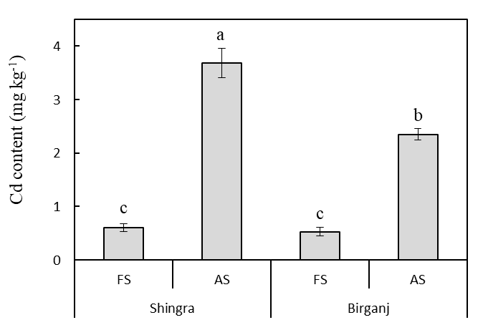
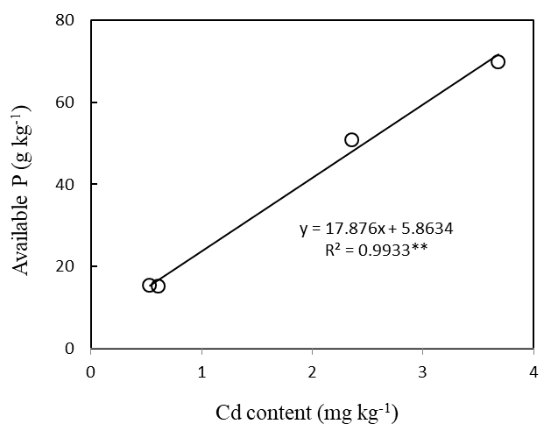

Figure 4. Cadmium content of forest soils (FS) and adjacent agricultural soils (AS) from Shingra and Birganj national forests, Dinajpur, Bangladesh. Bars indicates mean ± standard error. For Shingra, data are average of 10 spots; for Birganj, data are average of 5 spots. Bars with different letters indicate significant differences at the P≤0.05 level according to Tukey's HSD test. | Figure 5. Correlation between available P and that of Cd content of forest soils and adjacent agricultural soils from Shingra and Birganj national forests, Dinajpur, Bangladesh.
Cumulated data of available phosphorus and cadmium contents were significantly correlated, particularly in agricultural soil (Figure 5). This positive correlation suggests that further agricultural soil phosphorus application is conducive to cadmium uptake and accumulation. Studies indicate that increased phosphorus availability in soils promotes cadmium bioavailability in plants (Al Yeamin et al. 2025). The available phosphorus was positively correlated with cadmium in agricultural land, with a strong positive correlation (r= 0.72, p < 0.01), indicating that phosphorus fertility can increase its bioavailability in the soil (hydro) (Akhter et al., 2009). The interactions of phosphorous and different heavy metals (e.g., cadmium) in soils are less understood, and thus, investigation is needed to understand how phosphorous could aid in animal husbandry and help improve heavy metal uptake in crops.
Soil health highlights the importance of conservation of natural ecosystems like (forests). One example of a natural environment that issues these benefits is forest soils, which are abundant in organic carbon and nutrients that biota need to increase biodiversity through improved water retention and long-term soil fertility (Islam and Weil, 2000). Agricultural soils, in contrast, can produce crops but are subject to degradation if not managed. It is recommended to use sustainable practices such as organic farming, lower fertilizer application, and crop rotation to restore and maintain soil quality (Khan & Hoque, 2025). The increased soil cadmium levels in agricultural soils highlight the possible hazards of heavy metals contamination to human health through the food web. Furthermore, this soil degradation highlights the necessity of the shift toward the use of organic alternative fertilizers with lower heavy metals (Al Yeamin et al., 2025).

Conclusion
Forest soils contained a higher carbon and nitrogen content along with essential nutrients, whereas agricultural soil was more degraded, exhibiting features like depletion of nutrients and heavy metal contamination. These results reveal the detrimental effects of agricultural patterns and the importance of sustainable agriculture practices to guard soil fertility and prevent pollution.

Disclaimer (Artificial intelligence)
Option 1:
Author(s) hereby declare that NO generative AI technologies such as Large Language Models (ChatGPT, COPILOT, etc.) and text-to-image generators have been used during the writing or editing of this manuscript.
Option 2:
Author(s) hereby declare that generative AI technologies such as Large Language Models, etc. have been used during the writing or editing of manuscripts. This explanation will include the name, version, model, and source of the generative AI technology and as well as all input prompts provided to the generative AI technology
Details of the AI usage are given below:
1.
2.
3.

References

Akhter A, Khan MSH, Egashira H, Tawaraya K, Rao IM, Wenzl P, Ishikawa S and Wagatsuma T. 2009. Greater contribution of low-nutrient tolerance to the growths of sorghum and maize under combined stress conditions with high-aluminum and low-nutrients in solution culture simulating the nutrient status of tropical acid soils. Soil Science and Plant Nutrition. 55: 394-406. https://doi.org/10.1111/j.1747-0765.2009.00372.x
Al Yeamin A, Mia M.Y, Khan SR, Rahman MS, Senapathi V, Islam ARM. (2025) Innovative strategies for pollution assessment in Northern Bangladesh: Mapping pollution areas and tracing metal(loid)s sources in various soil types. PLoS ONE 20(2): e0311270. https://doi.org/10.1371/journal.pone.0311270
Bayabil, H.K., Li, Y., Tong, Z., & Gao, B. (2021). Potential management practices of saltwater intrusion impacts on soil health and water quality: a review. Journal of Water and Climate Change. 12(5): 1327-1343. doi: 10.2166/wcc.2020.013
Bray, R.H., & Kurtz, L.T. (1945). Determination of total organic and available forms of phosphorus in soils. Soil Science, 59, 39-45.
Bremner, J.M. (1996). Nitrogen-Total. In: D.L. Sparks (Ed.), Methods of Soil Analysis: Part 3 Chemical Methods. pp. 1085–1121 SSSA, Madison, WI.
Fox, R. L., Olson, R. A. & Rhoades, H. F. (1964). Evaluating the sulfur status of soils by plant and soil tests. Soil Sci. Soc. Amer. Proc. 28: 243-246
Gol, C. (2009). The effects of land use change on soil properties and organic carbon at Dagdami river catchment in Turkey. Journal of Environmental Biology. 30(5): 825-830. https://www.jeb.co.in/journal_issues/200909_sep09_supp/paper_09.pdf
Hoque, M.R., & Khan, M.S.H. (2024). Greater growth and yield response of nano urea with conventional urea for potato (Solanum tuberosum) cultivation. International Journal of Biological Engineering and Agriculture, 3(3), 378-385. https://doi.org/10.51699/ijbea.v3i3.69
Islam, K.R., & Weil, R.R. (2000). Land use effects on soil quality in a tropical forest ecosystem of Bangladesh. Agriculture, Ecosystems and Environment. 79: 9-16. https://doi.org/10.1016/S0167-8809(99)00145-0
Jackson, M.L. (1973). Soil Chemical Analysis. Second edition. Printice Hall of India, New Delhi. p. 498.
Kadoya, T., Takeuchi, Y., Shinoda, Y., & Nansai, K. (2022). Shifting agriculture is the dominant driver of forest disturbance in threatened forest species’ ranges. Communications Earth & Environemnt. 3: 1-8. https://doi.org/10.1038/s43247-022-00434-5
Kehokhunu, Sakhong, R., Jaiswal, P., Yosung, L., Shukla, Y. K., & Kumari, S. (2024). Technology Innovation: A Green Approach to Soil Health. International Journal of Plant & Soil Science, 36(12), 613–622. https://doi.org/10.9734/ijpss/2024/v36i125235
Khan MSH, Abedin Mian MJ and Ahammed MS. (2001). Phosphorus sorption behaviour of soils amended with organic and inorganic fertilizers. Indian Journal of Surface Science and Technology. 17: 141-148.
Khan MSH, Akhter A, Wagatsuma T, Egashira H, Rao IM and Ishikawa S. (2011). Tolerance to aluminum and nutrient stress in sorghum grown under simulated conditions of tropical acid soils. In: TD Pereira (Ed.) Sorghum: Cultivation, Varieties and Uses. Nova Science Publishers Inc., New York. pp. 109-128. ISBN: 978-1-61209-688-9.
Khan, M. S. H., Abedin Mian, M. J., Akhter, A., & Khosruzzaman, M. (2006). Physico-chemical changes of paddy soils under long-term intensive fertilization. Asian Journal of Plant Science, 5, 105-111. https://www.cabidigitallibrary.org/doi/full/10.5555/20063045771
Khan, M.S.H., & Hoque, M.R. (2025). Optimizing NPKS Fertilization for Onion Yield and Soil Health in Dinajpur, Bangladesh. International Journal of Plant and Soil Science, 37(3), 87-95. https://doi.org/10.9734/ijpss/2025/v37i35350
Li, Y., Liu, M., Wang, H. et al. (2024). Effects of different phosphorus fertilizers on cadmium absorption and accumulation in rice under low-phosphorus and rich-cadmium soil. Environ Sci Pollut Res. 31: 11898–11911. https://doi.org/10.1007/s11356-024-31986-y
Mahmood, H., Ahmed, M., Islam, T., Uddin, M.Z., Ahmed, Z.U. & Saha, C. (2021). Paradigm shift in the management of the Sundarbans mangrove forest of Bangladesh: Issues and challenges. Trees, Forests and People. 5: 1-14. https://doi.org/10.1016/j.tfp.2021.100094

Maranguit, D., Guillaume T., & Kuzyakov Y. (2017). Land-use change affects phosphorus fractions in highly weathered tropical soils. CATENA. 149: 385-393. https://doi.org/10.1016/j.catena.2016.10.010
Nath, A., Samanta, S., Banerjee, S., Danda, A.A., & Hazra, S. (2001). Threat of arsenic contamination, salinity and water pollution in agricultural practices of Sundarban Delta, India, and mitigation strategies. SN Applied Sciences. 3 : 560-374. https://doi.org/10.1007/s42452-021-04544-1

Rahman, M.M., Mostafa, G., Razia, S., & Shoaib J.U. (2001). Land degradation in Bangladesh. In: Bridges, E.M. (2001). Response to Land Degradation (1st ed.). CRC Press. https://doi.org/10.1201/9780429187957
Sharma, S., Lishika, B., Shubham, & Kaushal, S. (2023). Soil Quality Indicators: A Comprehensive Review. International Journal of Plant & Soil Science, 35(22), 315–325. https://doi.org/10.9734/ijpss/2023/v35i224139
Sikdar, A., Jeyasundar, P.G.S.A., Debnath, B., Hossain, M.S., Islam, M.A. & Ahammed, G.J. (2022). Cadmium Contamination in the Soil Environment: Impact on Plant Growth and Human Health. In: M. Naeem et al. (eds.), Agrochemicals in Soil and Environment. pp. 367-408. https://doi.org/10.1007/978-981-16-9310-6_16

Walkey, A. & Black, I.A. (1934). An examination of the Degtjareff method for determining soil organic matter, and a proposed modification of the chromic acid titration method. Soil Science, 34, 29 – 38. https://doi.org/10.1097/00010694 193401000-00003, 2-s2.0-84929047274.

Willy, D.K., Muyanga, M., Mbuvi, J., & Jayne, T. (2019). The effect of land use change on soil fertility parameters in densely populated areas of Kenya. Geoderma. 343: 254-262. https://doi.org/10.1016/j.geoderma.2019.02.033.

