Evaluation of Wideband Channel Characteristics and Path-Loss Models for 5G Macro-Cell Networks in Nigeria

.

ABSTRACT

|  |
| --- |
| This study evaluates the performance of wideband channels and path-loss models in 5G macro-cell deployments across diverse terrains in Abuja, with a particular emphasis on urban and rural areas. The study uses a standardised empirical model to investigate the effect of mobility, environmental conditions, and propagation scenarios on signal quality. Extensive field measurements were performed utilising drive tests, spectrum analysers, and 5G-enabled user equipment to analyse characteristics such as signal-to-noise ratio (SNR), delay spread, Doppler spread, and route loss at various mobility speeds and ambient conditions. The findings show that mobility severely reduces signal quality in urban contexts, with RSSI declining from -91.35 dBm at 30 km/h to -114.29 dBm at 100 km/h. SNR decreased appropriately, whereas delay spread rose considerably owing to multipath effects. Rural areas, while less blocked, nonetheless showed significant route loss and interference, with Doppler spread staying reasonably steady. The 3GPP TR 38.901 wideband channel model was used to simulate propagation in several deployment conditions, which confirmed field findings. Comparisons of clear and moist meteorological circumstances demonstrated the susceptibility of 5G signals to environmental variations. The study emphasises the need of specialised path-loss models and adaptive network design in improving 5G performance across different Nigerian terrains. It gives vital insights for maximising coverage, minimising interference, and maintaining reliable connection, helping to efficient 5G implementation plans in Sub-Saharan Africa. |

*Keywords: 5G Networks, Wideband Channel, Path Loss Modeling, Signal Quality, Drive Test Analysis*

1. INTRODUCTION

In telecommunication, a wideband channel refers to a communication channel that has a broad frequency bandwidth available for transmitting signals. It is characterized by a wide range of frequencies allocated for data transmission, allowing for the transfer of a large amount of information at high speeds. Wideband channels are essential for various telecommunication applications (Farid et al., 2013; Shakir et al., 2023). They are used in wireless cellular networks, satellite communications, broadband internet connections, and other high-speed data transfer systems (Zhimwang et al., 2023). Wideband channels in telecommunication systems provide the necessary bandwidth to support high-speed data transmission, enabling the delivery of a wide range of communication services (Ma et al., 2019; Rajatheva et al., 2020). They facilitate the efficient transfer of large volumes of data and play a crucial role in meeting the increasing demand for bandwidth-intensive applications and services in modern telecommunication networks (Qiu et al., 2005; Siriwongpairat and Liu 2007). In a 5G mobile network, a wideband channel refers to the wireless communication channel that carries the signals between the transmitter (base station) and the receiver (GSM, Computer) over a wide frequency bandwidth. It encompasses the transmission medium and the physical environment through which the signals propagate (Hamad-ameen, 2008; Tikhomirov et al., 2017).

Path-loss modeling is essential for predicting the signal attenuation between the transmitter and receiver in wireless communication systems (Zakaria et al., 2021). In the context of 5G networks, accurate path-loss modeling is imperative for optimizing network coverage, capacity planning, and resource allocation. Path-loss models incorporate factors such as distance, frequency, antenna heights, terrain, and building morphology to estimate the signal attenuation in urban environments (Popoola et al., 2019; Oladimeji et al., 2022). By developing customized path-loss models tailored to the characteristics of the urban micro-cell environment of Nigeria, researchers can enhance the accuracy of coverage predictions and network planning for 5G deployments (Obeidat et al., 2018; Oladimeji et al., 2022; Thomas et al., 2023)

5G wireless technology introduces several transformative features that enable advanced communication and connectivity as shown in Figure 1. With significantly higher data rates, 5G offers ultra-fast download and upload speeds, revolutionizing how we consume and share content. The ultra-low latency of 5G ensures near real-time communication, making applications like autonomous vehicles and remote surgeries a reality. Another standout feature is the ability to support massive device connectivity, allowing for the seamless connection of a vast number of devices, from smartphones and IoT devices to smart cities and industrial automation (Elmezughi and Afullo, 2021). Furthermore, 5G provides enhanced network reliability and energy efficiency, making it a game-changer for mission-critical applications and sustainable infrastructure. Overall, 5G wireless technology offers unparalleled speed, responsiveness, and scalability, paving the way for innovative applications and services across various industries. 5G wireless technology brings several salient features that set it apart from previous generations (Osseiran et al., 2016).

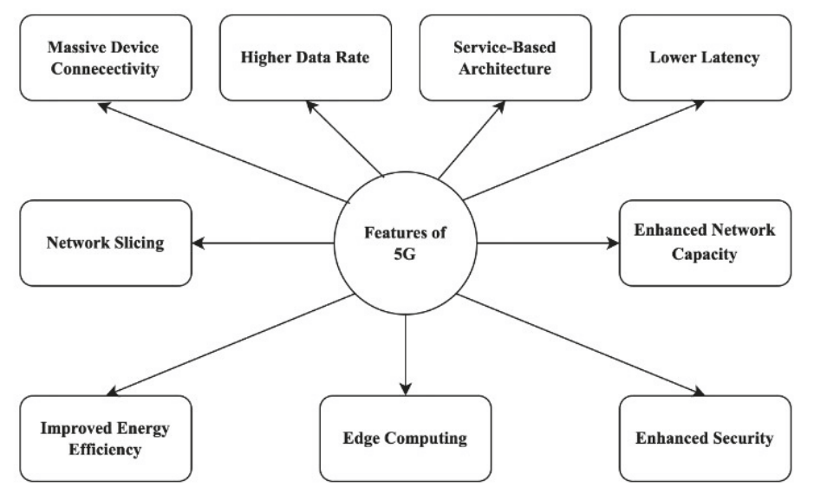

Figure 1: 5G Features

1. **Higher data rates:** 5G offers significantly higher data rates compared to its predecessors. It can provide peak data rates of up to 10 Gbps, enabling faster downloads, streaming, and real-time communication (Nuriev et al., 2024).
2. **Lower latency:** 5G aims to deliver ultra-low latency, reducing the time it takes for data to travel between devices and the network. It offers latency as low as 1 millisecond (ms), which is crucial for real-time applications like autonomous vehicles, remote surgery, and augmented/virtual reality (Nuriev et al., 2024).
3. **Massive device connectivity:** 5G is designed to support a massive number of connected devices. It offers higher device density and capacity, allowing for seamless connectivity and efficient management of Internet of Things (IoT) devices and smart city infrastructure.
4. **Enhanced network capacity:** 5G addresses the increasing demand for network capacity by utilizing advanced technologies like millimeter-wave (mmWave) frequencies, massive MIMO, and beamforming. These technologies enable higher network capacity to accommodate more devices and data traffic.
5. **Network slicing:** 5G introduces network slicing, which allows the network infrastructure to be partitioned into multiple virtual networks. Each network slice can be customized to meet the specific requirements of different applications, services, or industries, ensuring optimal performance, security, and resource allocation.
6. **Improved energy efficiency:** 5G incorporates energy-saving mechanisms, such as sleep modes and optimized signaling procedures, to improve overall network energy efficiency. This is crucial for supporting the proliferation of IoT devices and reducing the environmental impact of wireless networks (Odida, 2024).
7. **Edge computing:** 5G architecture leverages edge computing capabilities, bringing computing resources closer to the network edge. This enables faster processing, reduced latency, and improved reliability for applications that require real-time data analysis and low-latency responsiveness.
8. **Enhanced security:** 5G focuses on enhancing network security with features like stronger encryption, improved authentication methods, and network slicing isolation. It aims to provide a more secure and reliable communication environment, especially as the number of connected devices and potential vulnerabilities increase (Salman et al., 2023).

A macro-cell network is a large-scale wireless communication system designed to offer comprehensive coverage and connection across huge geographical areas, such as urban, suburban, and rural settings (Zerihun, 2019; Borralho et al., 2021). Macro-cells are often deployed via high-power base stations (BS) with enormous antennas installed on towers, roofs, or specialised poles. These cells use transmission power levels ranging from 20W to 40W, with coverage ranging from 1 km to 30 km depending on environmental conditions (Rappaport et al., 2019).

In 5G networks, macro-cells are critical to enabling seamless mobile broadband services, voice communications, and enormous Internet of Things (IoT) connections (Alsharif et al., 2017). They offer backbone communication to mobile devices and serve as a key hub in the hierarchical cellular network structure, collaborating with smaller cells such as micro-cells, pico-cells, and femtocells. Macro-cells operate at high-power levels (typically 20W–40W) and cover distances of 1-30 km, making them ideal for providing cellular services over vast areas (Heath and Lozano 2018; 3GPP, 2020). Due to their high elevation, they minimize shadowing and improve line-of-sight (LoS) coverage. Macro-cells can simultaneously support multiple radio access technologies (RATs), ensuring backward compatibility with older networks (3G, 4G LTE) while enabling advanced 5G capabilities. A 5G macro-cell network consists of various interconnected components that facilitate efficient communication.

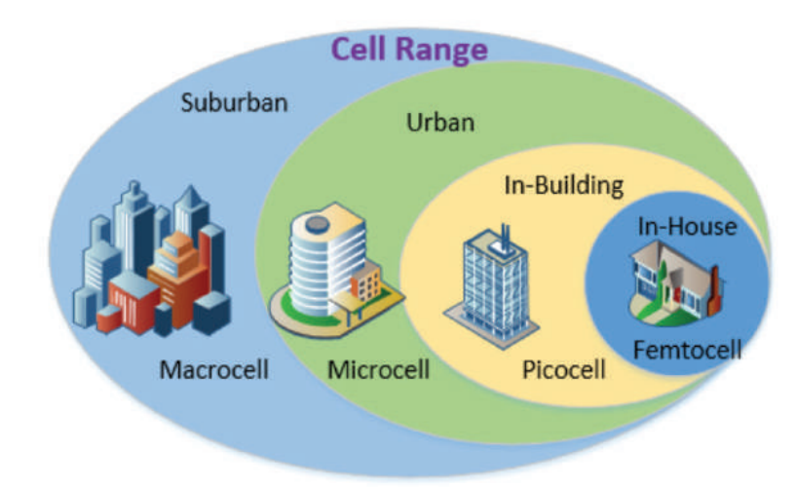

Figure 2: Cell Range (Casillas et al., 2020)

Small cells, also sometimes referred to as micro or Pico cells as shown in Figure 2, typically have a smaller base station and limited number or just a single antenna and are deployed in urban environments to provide the bandwidth, latency and connection density needed. These small cells also fill in areas where the macrocell signal may be impeded by buildings or other signal obstructions as the highest frequency bands have the highest bandwidth, there is a challenge to provide the highest data rates inside offices, residential building and malls because the building may absorb the high frequency radio waves.

**PATHLOSS MODELING**

Radio transmission in mobile communication system often takes place over irregular terrain. Different path loss empirical models have been proposed and classified based on terrain, operating frequency range, mobile generation, and technologies. In recently published work, path loss models are mainly developed based on experimental data to fit a particular scenario or environment. The received signal power decay rate variations with distance follow the free-space propagation law with a path-loss exponent of about 1.9–2.2 With directional antennas. A number of propagation models are available to predict path loss over different types of terrain ( Zhang et al., 2019)

**Hata Model**

Hata Model is an empirical formulation of graphical path loss data provided by Okumura model. The Hata model gives prediction of the median path loss. The standard formula for urban area is

$P_{L\left(urban\right)}\left(dB\right)=69.55+26.16\log_{10}\left(f_{c}\right)-13.82\log_{10}\left(h_{b}\right)-a\left(h_{m}\right)+(44.9-6.55\log_{10}\left(h_{b}\right))\log_{10}(d)$ (1)

Where fc in MHz and for frequency range of 150MHz to 1500 MHz, hb is the Base Station (BTS) effective transmitter antenna height in meter ranging from, hm is the effective mobile receiver antenna height in meter ranging from 1m to 10m, d is the distance between Base Station (Bs) and the Mobile Station (Ms) in Kilometers. a(hm) is the correction factor for effective Ms antenna height which is a function of the size of the coverage area. For a small to medium size city, the mobile antenna correction factor is given by (Salous et al., 2020)

|  |  |
| --- | --- |
|  | (2) |

To obtain the path loss in suburban area, equation (1) is modified to

|  |  |
| --- | --- |
|  | (3) |

The predication of Hata model compares very closely with the original Okumura model as long as d exceeds 1km. This model is suitable for large cell system, but not personal communication systems (PCS) which have cells of the 1km radius

**Cost-231 Hata Model**

The European Cooperative for Scientific and Technical research (EURO-COST) formed the COST-231 working committee to develop an extended version of the Hata model. Cost-231 proposed path loss model is

$P_{L\left(urban\right)}\left(dB\right)=46.3+33.9\log_{10}\left(f_{c}\right)-13.82\log_{10}\left(h_{b}\right)-a\left(h_{m}\right)+\left(44.9-6.55\log_{10}\left(h_{b}\right)\right)\log_{10}\left(d\right)+C_{m}$ (3)

Where $a\left(h_{m}\right)=\left(1.1\log_{10}\left(f_{c}\right)-0.7\right)h_{m}-\left(1.56\log_{10}\left(f_{c}\right)-0.8\right) dB$ (4)

Cm = 3dB for Metropolitan areas while for suburban areas Cm = 0

The Cost-231 extension of the Hata model is restricted to the following range of parameters, fc is 1500 MHz to 2000 MHz, hb is 30m to 200m, hm is 1m to 10m and d is 1km to 20km.

**ITU-R Path loss Model**

The ITU-R model is to be used for the outdoor to indoor and pedestrian (microcell) in urban and suburban environment. The path loss is given as:

|  |  |
| --- | --- |
|  | (5) |

Where: d is the distance between the base station and the mobile unit in km, fc is the frequency to 2000 MHz, L in no circumstances to be less than free space loss. The model is for Non-Line of Sight (NLOS) case only and describes worst condition deviation of 10dB for outdoor users (Obeidat et al., 2018; Salous et al., 2020)

**ERICSSON Model**

Model 9999 is the Ericsson's implementation of Hata model. In this model parameter is possible according to propagation environment. The path loss PL is given as

$$P_{L}\left(dB\right)=a_{0}+a_{1}\log\left(d\right)+a_{2}\log\left(h_{b}\right)+a_{3}\log\left(h_{b}\right)\log\left(d\right)-3.2(\log\left(11.75h_{m}\right))^{2}+g(f)$$

Where $g\left(f\right)=44.49\log\left(f\right)-4.78(log⁡(f))^{2}$ (6)

The parameters ao , a1 , a2 and a3 are constants, and can be change for better fitting specific propagation conditions. Default values are ao = 36.2, a1=30.2, a2=-12, and a3=0.4

2. material and methods

**Experimental Site**

The research was conducted across several areas in Abuja, Nigeria. These areas were randomly chosen to capture a variety of environmental factors and geographical features, ranging from densely populated urban centres to sparsely populated suburban and rural regions. This is to assess how different geographic and demographic conditions affect the performance of a 5G network in terms of signal strength, signal-to-noise ratio (SNR), multi-path fading, delay spread, interference, and overall network reliability

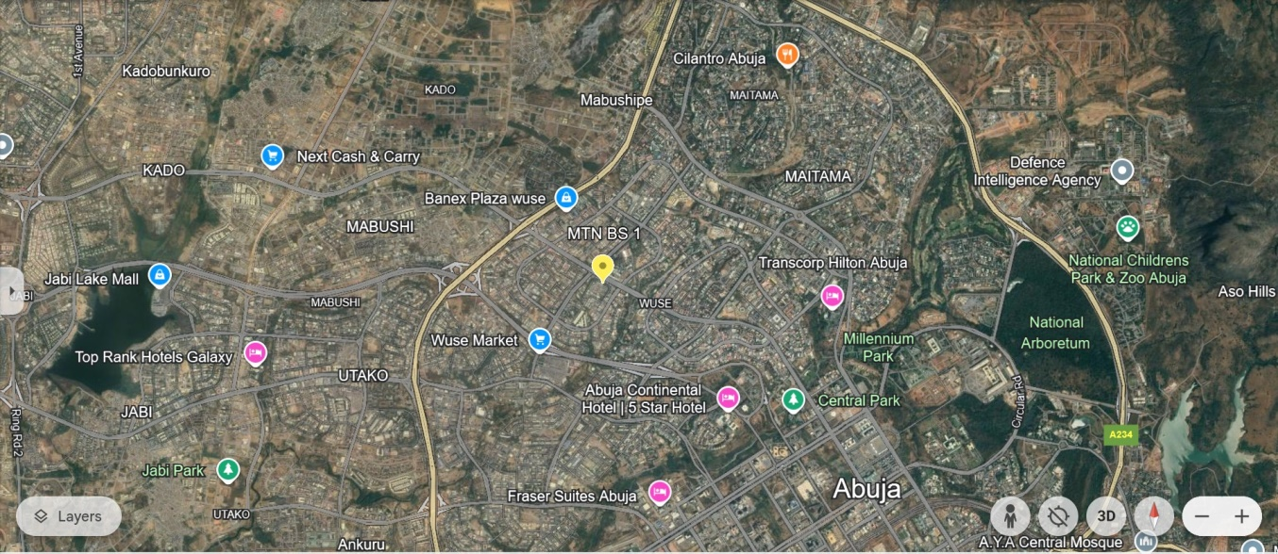

Figure 3. Environmental Set-up of the Experimental Site

**Equipment Used**

1. **Spectrum Analyzer:** A spectrum analyzer was used to measure the strength of electromagnetic signals. In this research, it was employed to observe and detect any interference or signal distortion. The device scans a wide frequency range and provides real-time information about the power level of the signal.
2. **Drive Test Equipment (DT Equipment)**: Drive test equipment was used to collect network performance data in real-world conditions by driving through the research areas. This equipment typically includes mobile handsets, GPS systems, and software that records signal strength, coverage, and network quality. It measures several parameters such as Received Signal Strength Indicator (RSSI), Signal-to-Noise Ratio (SNR), and call drop rates during motion.
3. **5G Mobile Handset/UE (User Equipment):** A 5G-enabled mobile handset was used to assess the actual user experience on the network, measuring parameters such as throughput, latency, call drop rate, and error rates. The mobile handset interacts directly with the 5G network and records the performance metrics experienced during calls or data transfers.
4. **Power Meter**: A power meter was used to measure the transmit power and the received power of the 5G signals at various points throughout the test areas. The power meter records the strength of the signal being transmitted and received in dBm (decibels relative to one milliwatt).

**Wideband Channel Model for 5G Networks**

The 3rd Generation Partnership Project (3GPP) TR 38.901 was adopted for this study which is a standardized channel model designed for evaluating and simulating 5G radio propagation across different frequency bands ranging from 0.5 GHz to 100 GHz. It provides a comprehensive framework for analyzing radio wave propagation in urban, suburban, and rural environments, addressing the unique challenges associated with massive MIMO, beamforming, mmWave communications, and frequency-selective fading (3GPP, 2020). The TR 38.901 channel model is widely used for system-level simulations in 5G New Radio (NR) networks and supports both Line-of-Sight (LoS) and Non-Line-of-Sight (NLoS) conditions, making it essential for evaluating network performance under realistic scenarios as indicated in Table 1.

**Table 1: Propagation Scenarios in TR 38.901**

|  |  |
| --- | --- |
| **Scenario** | **Description** |
| **Urban Macro (UMa)** | Used for large-scale outdoor deployments in cities, with high base station (BS) antennas (>25 m). |
| **Urban Micro (UMi)** | Represents dense urban environments with street-level BS deployments and smaller cell coverage. |
| **Indoor Office** | Models signal propagation inside office buildings, accounting for walls and furniture. |
| **Indoor Factory** | Simulates industrial environments with machinery and equipment affecting wave propagation. |
| **Rural Macro (RMa)** | Represents long-distance coverage in sparsely populated rural areas. |

The model defines different propagation environments to accurately simulate real-world 5G deployments. Each scenario includes specific path loss models, shadowing parameters, and multipath fading effects to ensure accurate predictions of signal behaviour.

For urban macro-cell deployments, the path loss (PL) in dB is given by:

|  |  |
| --- | --- |
|  | (7) |

where: d = Distance between transmitter and receiver (meters) and f = Carrier frequency (GHz).

For Non-Line-of-Sight (NLoS) propagation, an additional correction factor is applied:

|  |  |
| --- | --- |
|  | (8) |

where PL′ is another empirical formula considering environmental obstructions.

Rural Macro (RMa) Path Loss Model with minimal obstructions is given as:

|  |  |
| --- | --- |
|  | (9) |

This model considers the lower attenuation effects of open terrains.

3. results and discussion

Table 2: Impact of Mobility on 5G Network in Urban Environment

|  |  |  |  |  |  |
| --- | --- | --- | --- | --- | --- |
| Speed (km/h) | RSSI (dBm) | SNR (dB) | Delay-Spread (ns) | Transmit-Power (dBm) | Frequency (GHz) |
| 30 | -91.35 | 45.19 | 127.11 | 20 | 3.5 |
| 40 | -96.58 | 44.19 | 625.95 | 20 | 3.5 |
| 50 | -95.07 | 43.52 | 948.42 | 20 | 3.5 |
| 60 | -96.535 | 41.69 | 1131.96 | 20 | 3.5 |
| 70 | -101.36 | 38.27 | 1150.69 | 20 | 3.5 |
| 80 | -105.59 | 34.13 | 1288.028 | 20 | 3.5 |
| 90 | -108.47 | 29.63 | 1302.12 | 20 | 3.5 |
| 100 | -114.29 | 20.09 | 1425.14 | 20 | 3.5 |

Table 2 provides the wideband channel characteristics of the 5G network in an urban environment under varying mobility conditions (speeds ranging from 30 km/h to 100 km/h). The parameters analyzed include RSSI, SNR, and Delay Spread at a fixed transmission frequency of 3.5 GHz and a constant transmit power of 20 dBm. As mobility increases (speed rises), RSSI consistently decreases from -91.35 dBm at 30 km/h to -114.29 dBm at 100 km/h. This behavior aligns with the expectation that higher speeds lead to increased path loss and signal attenuation in urban environments, where obstacles such as buildings cause more frequent signal blockages. At higher speeds, signals experience more interruptions as the mobile device rapidly moves through zones of varying signal strength. The SNR also decreases as mobility increases, dropping from 45.19 dB at 30 km/h to 20.09 dB at 100 km/h. As speed increases, the combination of higher path loss, multipath effects, and interference causes a reduction in SNR. At higher speeds, the network struggles to maintain a clear signal due to reflections, obstructions, and noise, leading to a higher proportion of noise in the signal. Lower SNR results in poorer signal quality, which can lead to higher error rates, reduced throughput, and increased latency. The ability of the network to deliver high-speed data, especially for applications like video streaming or real-time communications, will degrade. The delay spread increases significantly as speed increases, from 127.11 ns at 30 km/h to 1425.14 ns at 100 km/h.

Delay spread is a measure of multipath propagation, where the transmitted signal arrives at the receiver via multiple paths of different lengths. At higher speeds, the mobile device moves through environments with more reflections and obstructions, resulting in greater variations in the arrival times of the signal components. This increase in delay spread indicates a more significant impact of multipath fading as mobility increases. A higher delay spread leads to inter-symbol interference (ISI), making it harder for the receiver to distinguish between transmitted symbols. This affects the network’s data throughput and may require advanced equalization techniques to mitigate these effects.

Table 3. Drive test evaluation of 5G Network in Rural environments

|  |  |  |  |  |  |
| --- | --- | --- | --- | --- | --- |
| Speed (km/h) | RSS (dBm) | Doppler-Spread (Hz) | Path-Loss (dB) | Delay-Spread (ns) | Interference-Levels (dBm) |
| 30 | -88.20 | 800 | 85.60 | 1200 | -124.10 |
| 40 | -80.85 | 750 | 80.90 | 762 | -116.25 |
| 50 | -84.10 | 750 | 83.32 | 1137 | -118.85 |
| 60 | -83.10 | 816 | 80.37 | 1233 | -109.23 |
| 70 | -86.80 | 800 | 84.50 | 1300 | -106.30 |
| 80 | -85.40 | 950 | 81.20 | 1500 | -114.90 |

Table 3 evaluates the 5G network performance in rural areas with speeds ranging from 30 km/h to 80 km/h. It includes metrics such as RSSI, Doppler Spread, Path Loss, Delay Spread, Interference Levels, and information about terrain and obstructions. RSSI values fluctuate between -80.85 dBm and -88.20 dBm, which suggest that the signal strength is fairly weak, even in rural areas with fewer obstructions. This is due to the distance from the base station and specific terrain factors such as trees.

Doppler Spread remains relatively consistent between 750 Hz and 950 Hz, which implies that the mobility factor (speed) does not significantly affect the Doppler shift in rural settings.

Path Loss ranges from 80.37 dB to 85.60 dB, with higher path loss values indicating greater signal attenuation. Delay Spread ranges from 762 ns to 1500 ns, which reflects potential multi-path effects in these environments due to the terrain features such as trees. Interference Levels vary between -106.30 dBm and -124.10 dBm. These high levels of interference resulted to weak signals, leading to increased interference from noise or other distant base stations.

Figure 4. Comparing Path Loss, RSSL and SNR against distance under clear air condition at South-West direction of the transmitter

Figure 4 Compared Path Loss, RSSL, and SNR against Distance under Clear Air Conditions, This figure shows the inverse relationship between distance and RSSL, SNR and the relationship between distance and path loss. As distance increases, both RSSL and SNR decrease, while path loss increases. This demonstrates how signal quality degrades over distance due to free-space loss. However, in Figure 5, the pathloss and signal loss is more severe due to the impact of precipitation in the atmosphere

Figure 5. Comparing Path Loss, RSSL, SNR and rainfall rate against distance under wet air condition

4. Conclusion

The evaluation of wideband channel characteristics and path-loss models in Nigeria's 5G macro-cell networks shows that mobility and environmental factors have a major influence on network performance. Because of the dense blockage and quick shift in signal quality in urban contexts, increased mobility leads in poorer RSSI and SNR, as well as larger delay spread. Rural areas, while less blocked, nonetheless face significant route loss and signal interference. The 3GPP TR 38.901 wideband model closely matches observed data, demonstrating its applicability to Nigerian macro-cell situations. These findings highlight the significance of environment-specific path-loss modelling and robust network planning for effective and resilient 5G deployment.

Authors’ Contributions

Author OCE designed the study, performed the statistical analysis, wrote the protocol, and wrote the first draft of the manuscript. Author OEP and Author ZJT managed the analyses of the study and managed the literature searches. All authors read and approved the final manuscript.”

Disclaimer (Artificial intelligence)

Option 1:

Author(s) hereby declare that NO generative AI technologies such as Large Language Models (ChatGPT, COPILOT, etc.) and text-to-image generators have been used during the writing or editing of this manuscript.

Option 2:

Author(s) hereby declare that generative AI technologies such as Large Language Models, etc. have been used during the writing or editing of manuscripts. This explanation will include the name, version, model, and source of the generative AI technology and as well as all input prompts provided to the generative AI technology

Details of the AI usage are given below:

1.

2.

3.

References

1. 3GPP (2020). *Study on channel model for frequencies from 0.5 to 100 GHz (TR 38.901)*. 3rd Generation Partnership Project.
2. Alsharif, M. H., Kim, J., & Kim, J. H. (2017). Green and sustainable cellular base stations: An overview and future research directions. *Energies*, *10*(5), 587
3. Borralho, R., Mohamed, A., Quddus, A. U., Vieira, P., & Tafazolli, R. (2021). A survey on coverage enhancement in cellular networks: Challenges and solutions for future deployments. *IEEE Communications Surveys & Tutorials*, *23*(2), 1302-1341.
4. Elmezughi, M. K., & Afullo, T. J. (2021). An efficient approach of improving path loss models for future mobile networks in enclosed indoor environments. *IEEE Access*, *9*, 110332-110345.
5. Farid, F., Shahrestani, S., & Ruan, C. (2013). Quality of Service Concerns in Wireless and Cellular Networks. Communications of the IBIMA, September, 1–15. https://doi.org/10.5171/2013.794626
6. Hamad-ameen, J. J. (2008). Frequency planning in GSM mobile Frequency Planning in GSM Mobile. 7th WSEAS Int. Conf. on TELECOMMUNICATIONS and INFORMATICS (TELE-INFO ’08), Istanbul, Turkey.
7. Heath, R. W., & Lozano, A. (2018). *Foundations of MIMO communication*. Cambridge University Press.
8. Ma, Z., Xiao, M., Xiao, Y., Pang, Z., Poor, H. V., & Vucetic, B. (2019). High-reliability and low-latency wireless communication for internet of things: Challenges, fundamentals, and enabling technologies. *IEEE Internet of Things Journal*, *6*(5), 7946-7970.
9. Nuriev, M., Kalyashina, A., Smirnov, Y., Gumerova, G., & Gadzhieva, G. (2024). The 5G revolution transforming connectivity and powering innovations. In *E3S Web of Conferences* (Vol. 515, p. 04008). EDP Sciences.
10. Obeidat, H. A., Asif, R., Ali, N. T., Dama, Y. A., Obeidat, O. A., Jones, S. M. R., Shuaieb, W. S., Al‐Sadoon, M. A., Hameed, K. W., Alabdullah, A. A., & Abd‐Alhameed, R. A. (2018). An Indoor Path Loss Prediction Model Using Wall Correction Factors for Wireless Local Area Network and 5G Indoor Networks. Radio Science, 53(4), 544–564. https://doi.org/10.1002/2018RS006536
11. Odida, M. O. (2024). The evolution of mobile communication: A comprehensive survey on 5g technology. *Journal of Sensor Networks and Data Communications*, *4*(1), 1-11
12. Oladimeji, T. T., Kumar, P., & Oyie, N. O. (2022). Heliyon Propagation path loss prediction modelling in enclosed environments for 5G networks : A review. Heliyon, 8(March), e11581. https://doi.org/10.1016/j.heliyon.2022.e11581
13. Oladimeji, T. T., Kumar, P., & Oyie, N. O. (2022). Propagation path loss prediction modelling in enclosed environments for 5G networks: A review. *Heliyon*, *8*(11).
14. Osseiran, A., Monserrat, J. F., & Marsch, P. (2016). 5G mobile and wireless communications technology. In 5G Mobile and Wireless Communications Technology. https://doi.org/10.1017/CBO9781316417744
15. Popoola, S. I., Jefia, A., Atayero, A. A., Kingsley, O., Faruk, N., Oseni, O. F., & Abolade, R. O. (2019). Determination of neural network parameters for path loss prediction in very high frequency wireless channel. *IEEE access*, *7*, 150462-150483.
16. Qiu, R. C., Liu, H., & Shen, X. (2005). Ultra-wideband for multiple access communications. *IEEE Communications Magazine*, *43*(2), 80-87.
17. Rajatheva, N., Atzeni, I., Bjornson, E., Bourdoux, A., Buzzi, S., Dore, J. B., ... & Xu, W. (2020). White paper on broadband connectivity in 6G. *arXiv preprint arXiv:2004.14247*.
18. Rappaport, T. S., Xing, Y., MacCartney, G. R., & Sun, S. (2019). Propagation and radio system design issues in mobile millimeter-wave systems. *Proceedings of the IEEE, 107*(4), 852-866.
19. Salman, H. A., Alsajri, A., Kalakech, A., & Steiti, A. (2023). Difference Between 4G and 5G Networks. *Babylonian Journal of Networking*, *2023*, 41-54
20. Salous, S., Lee, J., Kim, M. D., Sasaki, M., Yamada, W., Raimundo, X., & Cheema, A. A. (2020). Radio propagation measurements and modeling for standardization of the site general path loss model in International Telecommunications Union recommendations for 5G wireless networks. Radio Science, 55(1), 1–12. https://doi.org/10.1029/2019RS006924
21. Shakir, Z., Mjhool, A. Y., Al-thaedan, A., Al-sabbagh, A., & Alsabah, R. (2023). Key performance indicators analysis for 4 G ‑ LTE cellular networks based on real measurements. International Journal of Information Technology, March. https://doi.org/10.1007/s41870-023-01210-0
22. Siriwongpairat, W. P., & Liu, K. R. (2007). *Ultra-wideband communications systems: multiband OFDM approach*. John Wiley & Sons.
23. Tikhomirov, A., Omelyanchuk, E., & Semenova, A. (2017). Link budget estimation for ultra high speed radio downlink for prospective remote sensing systems. 2016 International Conference on Control Instrumentation Communication and Computational Technologies, ICCICCT 2016, 14, 420–424. https://doi.org/10.1109/ICCICCT.2016.7987986
24. Zakaria, Y. A., Hamad, E. K., Elhamid, A. A., & El-Khatib, K. M. (2021). Developed channel propagation models and path loss measurements for wireless communication systems using regression analysis techniques. *Bulletin of the National Research Centre*, *45*, 1-11
25. Zerihun, B. (2019). Performance Analysis of Spectrum Scenarios for Outdoor LTE Small Cell Planning: The Case of Addis Ababa, Ethiopia.
26. Zhang, J., Dai, L., Han, S., Wang, X., & Tan, J. (2019). On the spectral efficiency of massive MIMO systems with low-resolution ADCs. *IEEE Transactions on Communications, 67*(10), 6735-6749.
27. Zhimwang J.T., E. P. Ogherohwo, A. A. Alonge, A. O. Ezekiel and S. O. Samuel, (2023). Effect of the Variation of Atmospheric Refractive Index on Signal Transmission for Digital Terrestrial Television in Jos, Nigeria, *2023 IEEE AFRICON, Nairobi, Kenya*, pp. 1-4, http://dx.doi.org/10.1109/AFRICON55910.2023.10293714